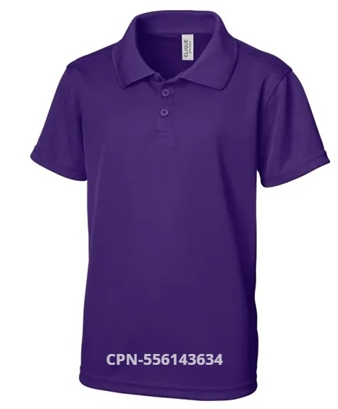

YOUTH POLO
$22.00 (XS-XL)
Black; Dusty Blue; Dark Navy; Gala Pink; Pure Slate; Red; Royal Purple; Royal Blue; White

