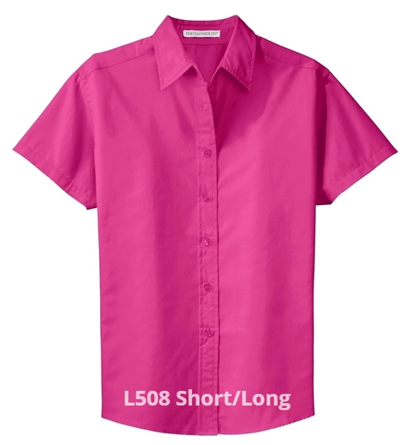
L508 WOMEN’S BUTTON-DOWN SHIRT SHORT SLEEVE
$27.00 (S-XL) $29.00 (2X) $30.00 (3X)

L608 WOMEN’S BUTTON-DOWN SHIRT LONG SLEEVE
$29.00 (S-XL) $31.00 (2X) $33.00 (3X)
COLORS: Royal/ Classic Navy; White w/ Light Stone; Burgundy w/ Light Stone; Dark Green; Navy; Light Pink; Clover Green; Ultramarine Blue; Teal Green; Black w/Light Stone; Red w/ Light Stone; Light Blue w/ Light Stone; Steel Grey w/ Light Stone; Purple/ Light Stone

