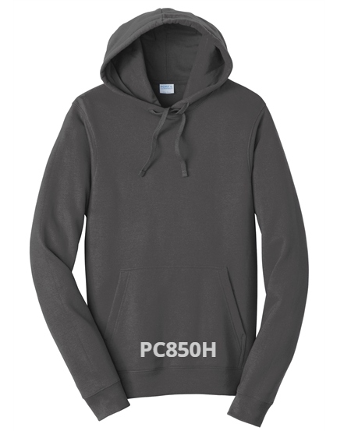
HOODIE
$ 36.00 (XS-XL) $41.00 (2X and up)
Colors: Athletic Heather; Bright Red; Charcoal; Forest Green; Jet Black; Orange; Sapphire; Navy; Purple; Royal; Dark Heather Gray

