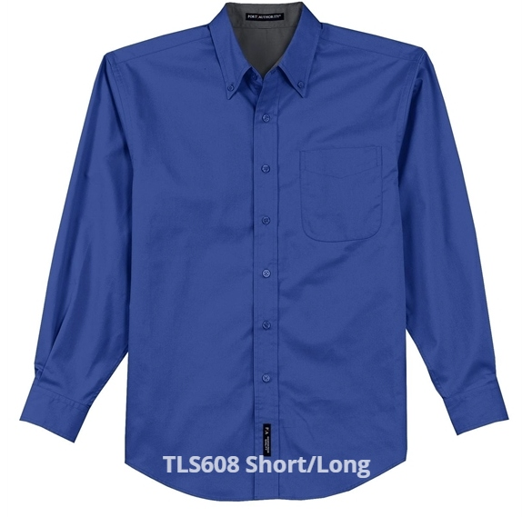
MEN’S BUTTON-DOWN SHIRT LONG AND SHORT SLEEVE
$37.00 Short Sleeve Sizes (XS-XL) $42.00 (2X and up)
$42.00 Long Sleeve Sizes (XS-XL) $47.00 (2X and up)
(Tall upon Request)
Colors: Black/ Light Stone; Royal/ Classic Navy; Light Pink; Teal Green; Strong Blue; Purple/ Light Stone; Burgundy/ Light Stone; Dark Green/ Navy; Navy/ Light Stone; Red/ Light Stone, Light Blue/ Light Stone; Steel Grey/ Light Stone

