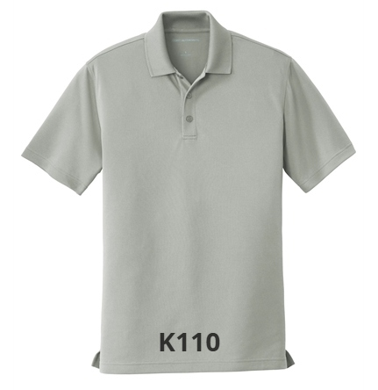

MEN’S POLO
$21.00 (S-XL) $23.00 (2X) $24.00 (3X)
Colors: Aquamarine; Bright Kelly Green; Carolina Blue; Deep Black; White; True Royal; Rich Red; Gusty Grey; Graphite; Deep Forest Green

