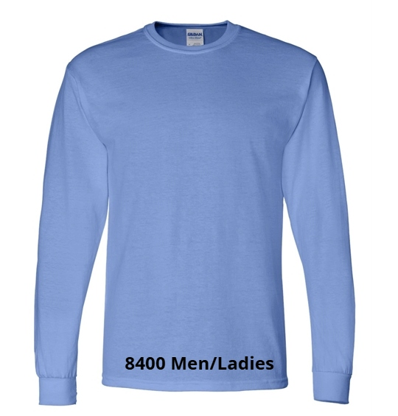

Me and Women Long Sleeve Tee
$23.00 (S-XL)
$28.00 (2X and up)
Colors: Black; Carolina Blue; Dark Heather Gray; Forest Green; Graphite Heather; Maroon; Navy; Orange; Red; Royal

