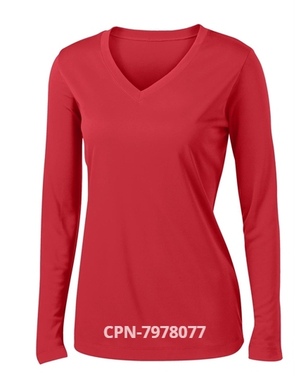

Ladies Long Sleeve T-Shirt
$23.00 (XS-XL)
$25.00 (2X and up)
Colors: Black; Silver; True Navy; True Red; True Royal; White; Hot Coral; Iron Grey; Lime; Forest Green; Neon Pink; Purple; Carolina Blue

