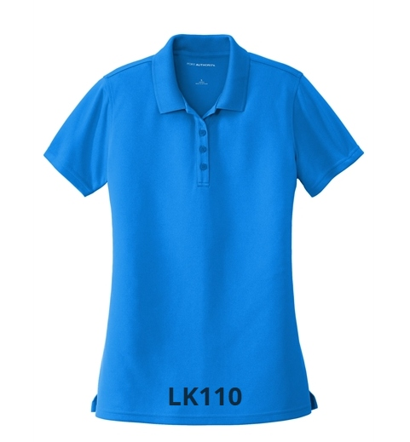
Ladies Polo
$31.00 (XS-Xl)
$36.00 (2X and up)
Colors: Aquamarine; Bright Kelly Green; Burgundy; Carolina Blue; Coral Splash; Deep Black; Deep Forest Green; Graphite; Gusty Grey; Rich Red; River Blue Navy; Safety Yellow; Sunburst Yellow; True Royal; White

