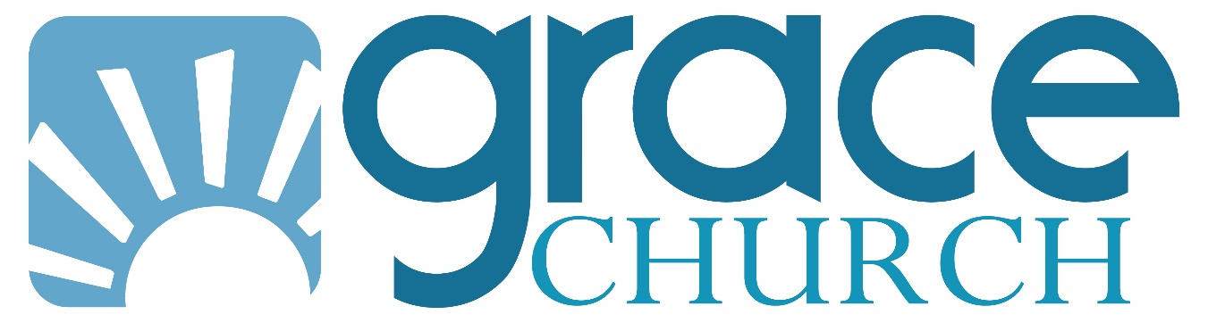

Mental Health Resources

RESOURCES FOR HELP WITH MENTAL HEALTH

Suggested Counselors

Cindy Matthes-Loy, PhD, LCSW
4531 DeLeon Street, Unit 206
Fort Myers
239-822-7880
www.cindymatthes-loy.com

Greg Hasek, MA/MFT
SW Florida Christian Counseling
2 locations:
24840 Burnt Pine Drive, Suites 1 & 2
Bonita Springs
239-301-4464
Or
Naples Christian Church
8000 Goodlette-Frank Road, N.
Naples
239-301-4464
www.swflchristiancounseling.org

Recovery

Rochelle Figur, Director of Recovery Ministries
Grace Church
rfigur@egracechurch.com
239-574-7161

Celebrate Recovery Services

Grace Church, Cape Coral campus
13 SE 21st Place
Cape Coral
Fridays at 6:45 PM

Grace Church, Central campus
2415 Grand Avenue
Fort Myers
Mondays at 6:45 PM

Grace Church, Fort Myers Shores Campus
14036 Matanzas Drive
Fort Myers
Wednesdays at 6:30pm

Emergency Help Lines

NAMI National Helpline
800-950-6264

National Suicide Prevention Lifeline
800-273-8255
Spanish 1-888-628-9454
Text: Connect to 85511 for those who prefer not to speak or can't hear.

Mobile Crisis Hotline
844-395-4432
(Lee, Hendry, Glades, Collier, Charlotte)
https://progressandexcellence.com/mobile-crisis
responds quickly, home visit, or telephone call within the hour, does suicide assessment

Local and Regional Organizations with Mental Health Programs

National Alliance on Mental Illness
NAMI of Lee, Charlotte, & Hendry Counties
8191 College Parkway, #205
Fort Myers
239-337-9024
www.namilee.org

Banyan Treatment Center – (877) 693-3606 Men / Women
Ft. Lauderdale, FL
24 hour helpline, free insurance verification, nationwide drug and alcohol treatment programs, and dual diagnosis treatment.

Harvest House – (941) 953-3154 Men / Women
209 N. Lime Avenue, Sarasota, FL 34237
This is a faith-based environment for men and women with a 9 month commitment. There is limited space available for those without funds and they will be entered ‘on account’ until employed.

Celadon Recovery Campus – (239) 880-3990 Men / Women
3331 E. Riverside Drive, Fort Myers, FL 33916
This is primarily a mental health program with drug addiction. You will work with psychiatrists and counselors on a 30-day program for up to 1 year. Follow up treatment is provided.

Florida Treatment for Change – (239) 202-8993
2180 Maravilla Lane, Fort Myers, FL 33901
Outpatient services - counseling for substance abuse and mental health. Classes for drug addiction, 12 steps, drug testing, and reported to agency upon request. Sober living and halfway housing.

TLS – (239) 997-7770 Men / Women
13971 N. Cleveland Avenue, Fort Myers, FL 33903
Outpatient services - counseling for substance abuse, mental health, and anger management. Classes for drug addiction and drug testing done and reported to agency upon request.

Salvation Army – (239) 334-3745 Men / Women
2400 Edison Avenue, Fort Myers, FL 33901
Free short-term shelter in order to establish low-income housing or HUD housing. Women and children unless married. Three meals provided daily to families during their stay.

David Lawrence Center – (239) 455-8500 Men / Women
6075 Bathey Lane, Naples, FL 34116
Offers services for mental health and substance abuse for adults and the elderly. This includes inpatient, outpatient, and partial hospitalization for children to elderly.

Next Step – (239) 362-0144 Men / Women
6314 Corporate Court #110, Fort Myers, FL 33919
Sober living and outpatient drug alcohol rehabilitation option including day treatment and intensive outpatient treatment.

The Willough at Naples – (239) 775-4500 Men / Women
9001 Tamiami Trail E., Naples, FL 34113
Hospital that specializes in the treatment of adults with dual diagnosis and/or mental illness, offering multiple levels of care to meet the needs of their patients.

Hazelden Betty Ford Foundation – (866) 831-5700 Men / Women
950 6th Avenue N., Naples, FL 34102
Offers both inpatient and outpatient addiction treatment mental health programs for youth to elderly and LGBTQ Integrative Treatment. Also offers onsite structured recovery housing.

Coastal Behavioral Healthcare – (941) 552-1950 Men / Women
1565 State Street, Sarasota, FL 34236
Wide range of programs for children to elderly from substance abuse, to mental health court, and critical stabilization unit.

Teen Challenge of Fort Myers – (239) 275-1974 Women
18 and up faith-based inpatient facility to bring you closer to God and to allow Him to heal your addictions.

St Matthew’s House and Justin’s Place Recovery – (239) 774-0500 Men x 125 / Women x 107
Faith-based 12-step residential recovery treatment. 12 month men and women housed in separate locations. Continued accountability after treatment. Medical and mental help also available during treatment.

Salus Care
239-275-3222
Entry point for Lee County mental health free or reduced fees, detox

Samaritan Health and Wellness Center
239-257-3094
643 Cape Coral Parkway East, Unit B, Cape Coral, FL 33904
Body, Mind, Spirit care for uninsured and underinsured.
https://capesamaritan.com/#welcome

Park Royal Men/Women
1 (855) 564-0136
9241 Park Royal Dr. Ft, Myers FL 33908
Adults and elderly, Specializing in mental health and substance abuse services include -Baker act- medical detox- impatient and outpatient treatment.

Books

Seen: Healing Despair and Anxiety in Kids and Teens through the Power of Connection, by Will Hutcherson

Emotionally Healthy Spirituality, by Peter Scazzero

Boundaries: When to Say Yes, How to Say No to Take Control of Your Life by Henry Cloud and John Townsend

Necessary Endings, Dr. Henry Cloud

Beyond the Spiral: Why You Shouldn’t Believe Everything Anxiety Tells You by Will Hutcherson

Grace Church Message Series
www.egracechurch.com/sermons

Come Alive
Cave Time
Change Me
Epic Fails
God Still Speaks
Identity Theft
What’s So Amazing About Grace

