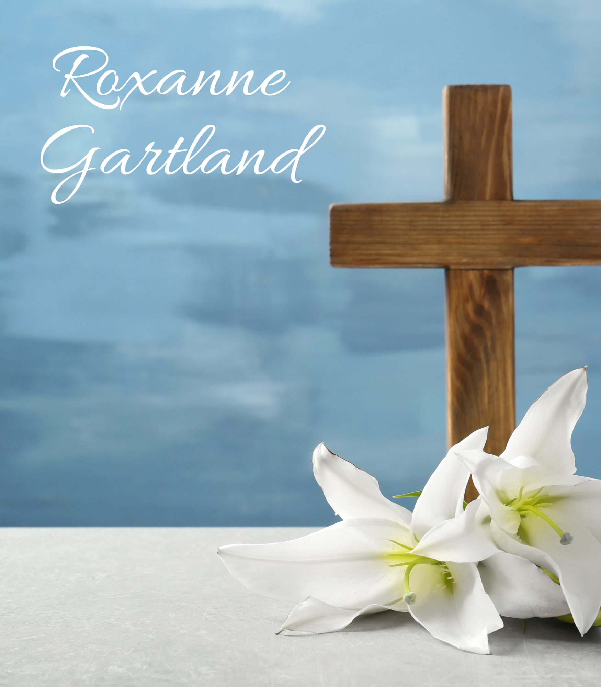

Service of Remembrance & Thanksgiving

Roxanne Gartland

September 8, 1972 – March 23, 2024

April 6, 2024
11:00AM

Hope Lutheran Church
Wake Forest, North Carolina

Processional Hymn “Amazing Grace”
Leanne Herrmann

Congregation stands for the processional

THE PASTORAL GREETING

FAMILY REMEMBRANCES

INVOCATION & THE REMEMBRANCE OF BAPTISM
P: In Holy Baptism, Roxanne was clothed with the robe of Christ’s righteousness that covered all her sin. St. Paul says, “Do you not know that all of us who have been baptized into Christ Jesus were baptized into his death?”
C: “We were buried therefore with him by baptism into death, in order that, just as Christ was raised from the dead by the glory of the Father, we too might walk in newness of life. For if we have been united with him in a death like his, we shall certainly be united with him in a resurrection like his.” (Romans 6:3-5)
P: “Blessed be the God and Father of our Lord Jesus Christ, the source of all mercy and the God of all consolation. He comforts us in all our sorrows so that we can comfort others in their sorrows with the consolation we ourselves have received from God.”
(2 Corinthians 1:3-4)
C: Thanks be to God.
THE HYMN “Holy Holy Holy”

THE PRAYER OF THE DAY
P: The Lord be with you.
C: And also with you.
P: Let us pray. O God of grace and glory, we remember before you today our sister in Christ, Roxanne. We thank you for giving her to us to know and to love as a companion in our pilgrimage on earth. In your boundless compassion, console those who mourn. Give us your aid, so we may see in death the gate to eternal life, that we may continue our course on earth in confidence, until we are reunited with those who have gone before us; through your Son, Jesus Christ our Lord.
C: Amen.

Congregation is seated
THE OLD TESTAMENT LESSON Psalm 46
God is our refuge and strength, an ever-present help in trouble. ² Therefore we will not fear, though the earth give way and the mountains fall into the heart of the sea, ³ though its waters roar and foam and the mountains quake with their surging. ⁴ There is a river whose streams make glad the city of God, the holy place where the Most High dwells. ⁵ God is within her, she will not fall; God will help her at break of day. ⁶ Nations are in uproar, kingdoms fall; he lifts his voice, the earth melts. ⁷ The Lord Almighty is with us; the God of Jacob is our fortress. ⁸ Come and see what the Lord has done, the desolations he has brought on the earth. ⁹ He makes wars cease to the ends of the earth. He breaks the bow and shatters the spear; he burns the shields with fire. ¹⁰ He says, “Be still, and know that I am God; I will be exalted among the nations, I will be exalted in the earth.” ¹¹ The Lord Almighty is with us; the God of Jacob is our fortress.

THE EPISTLE LESSON 2 Timothy 4:7-8
I have fought the good fight, I have finished the race, I have kept the faith. ⁸ Now there is in store for me the crown of righteousness, which the Lord, the righteous Judge, will award to me on that day—and not only to me, but also to all who have longed for his appearing.

Congregation stands
THE HOLY GOSPEL Matthew 11:28-30
“Come to me, all you who are weary and burdened, and I will give you rest. ²⁹ Take my yoke upon you and learn from me, for I am gentle and humble in heart, and you will find rest for your souls. ³⁰ For my yoke is easy and my burden is light.”

Congregation is seated
THE HYMN “Love Divine All Loves Excelling”

THE HOMILY

Congregation stands

THE CONFESSION OF FAITH
I believe in God, the Father Almighty, maker of heaven and earth.

And in Jesus Christ, his only Son, our Lord, who was conceived by the Holy Spirit, born of the virgin Mary, suffered under Pontius Pilate, was crucified, died and was buried. He descended into hell. The third day he rose again from the dead. He ascended into heaven and sits at the right hand of God the Father Almighty. From thence he will come to judge the living and the dead.

I believe in the Holy Spirit, the holy Christian Church, the communion of saints, the forgiveness of sins, the resurrection of the body, and the life everlasting. Amen.

THE PRAYERS OF GOD’S PEOPLE
Each section of the prayers concludes as follows:
P: Lord, in your mercy,
C: Hear our prayer.

THE LORD’S PRAYER

Congregation is seated

THE COMMENDATION

THE BENEDICTION

THE HYMN “The Strife is o’er, the Battle Done”

Congregation stands for the recessional

All are invited to the Children’s Center to greet the family and for a brief reception.

SERVING TODAY
Pastor Devin Murphy, Officiant
Rob Varner, Organist

Roxanne Gartland

September 8, 1972 – March 23, 2024



Roxanne Gartland, 51, was born in Pgh., PA to Kathleen Carol Pisciuneri and Rocco Vincent Pisciuneri on Sept. 8, 1972. We lost her way too soon after a five-year battle with breast cancer on March 23, 2024.

Roxanne‘s many different talents led to her having various successful careers over the years. Her most recent career was through AT&T where she worked in the commercial government sector. She was also passionate about helping others and giving back! She organized multiple collections for the homeless and she and her family personally delivered them. Her positive spirit and easy connectability to people blessed everyone around her!

She is survived by: her husband Jonathan D. Gartland, her children Kennedy Q. O’Donnell and Brodie V. O’Donnell, her stepchildren Sidney C. Gartland (Richard), Ahlora R. Gartland, Brodie F. Gartland and Brenna J. Gartland, parents Kathleen and Rocco, her sister Tracy L. Gentry (Brian) and her nephews Kaden and Carter Gentry and her niece Olivia P. Gentry, and her grandfather Dwight S. Wherry (Dora) and many loving aunts, uncles and friends.

If desired, donations may be made to the UNC/Rex Cancer Center, Susan G. Komen (Koman.org) and the American Cancer Society.

