2026 06 14/ Acts 1:12-14, 4:31
Rev. Dr. Hae-Jeong Yoon

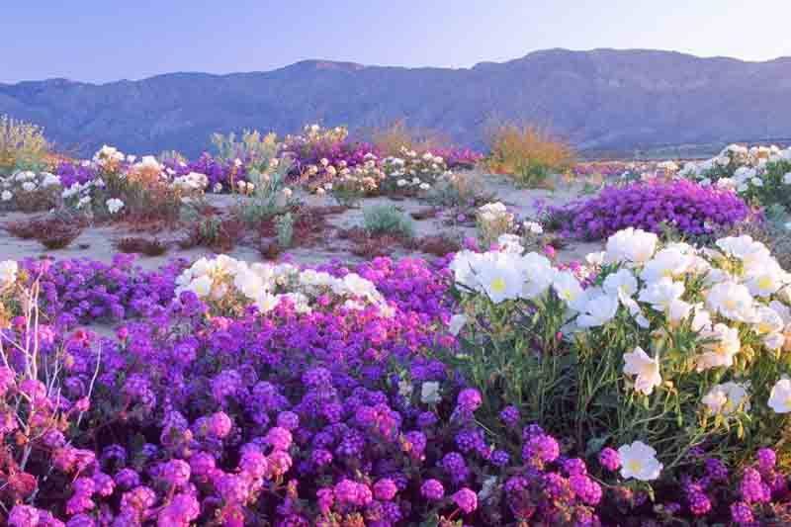
Waiting for the Rain II

What do you see in the picture? Desert? Flowers? Yes! It is the flowers in the desert. Desert is the place where arid and parched space endlessly spreads to the horizon. Deserts typically have two main seasons: a dry season and a brief, intense rainy season. When ground receives the rain, all the seeds in the soil are awakened, and make the land a beautiful tapestry. The rain did not create the seeds — the seeds were always there. But without the rain, they are there simply as seeds.

Typically, in spiritual matters, when life is dry, when there is no presence of God in your heart, humans don’t know what they are missing. Because the worldly spirit paralyzes us, we feel that life is just tired and hard. You tend to follow worldly formulas because we are simply living in the middle of the world. You think, “I need more financial security. I fear my future because of the unstable, unpredictable world around me. I worry about this and that.” We are bombarded by worldly values. All these lead us to self-centeredness and depressions. It leads us to spiritual death.

We need to walk with God yearning for heavenly water, rain, the daily word of God. Through reading and meditation of the word, we are hydrated. We must be equipped daily with more than seven thousand promises of God to combat the worldly spirit and logic. Did you choose to engage in devotion when you wake up in the morning? Unless we reside in the word of God, we are living in a desert.

Two weeks ago, we started this conversation about revival. I have a question for you. What is the first step in revival? It’s personal revival—cleansing your heart and welcoming Jesus into your heart through morning devotion. This means you become a revival person. This is the prerequisite for revival to meet the standard of God pouring the Holy Spirit upon the corporate body of the church.

Today’s question is about what actually opens the ground to receive that rain from heaven collectively. What creates the conditions for God to pour Himself out on a group of people?

The answer is not a new program. It is not a new building. It is not a new strategy. It is prayer. Specifically, it is corporate prayer — the gathered, unified, persistent prayer of God's people together. Currently, I am encouraging you to pray 111 prayers.

So the corporate prayer creates an environment of pouring of the Holy Spirit as a faith community. The rain of the Holy Spirit does not fall on a church that is too busy to pray. It falls on a people who have been seeking, waiting, and crying out together — just like those disciples in the upper room, just like John Wesley and his friends at Oxford.

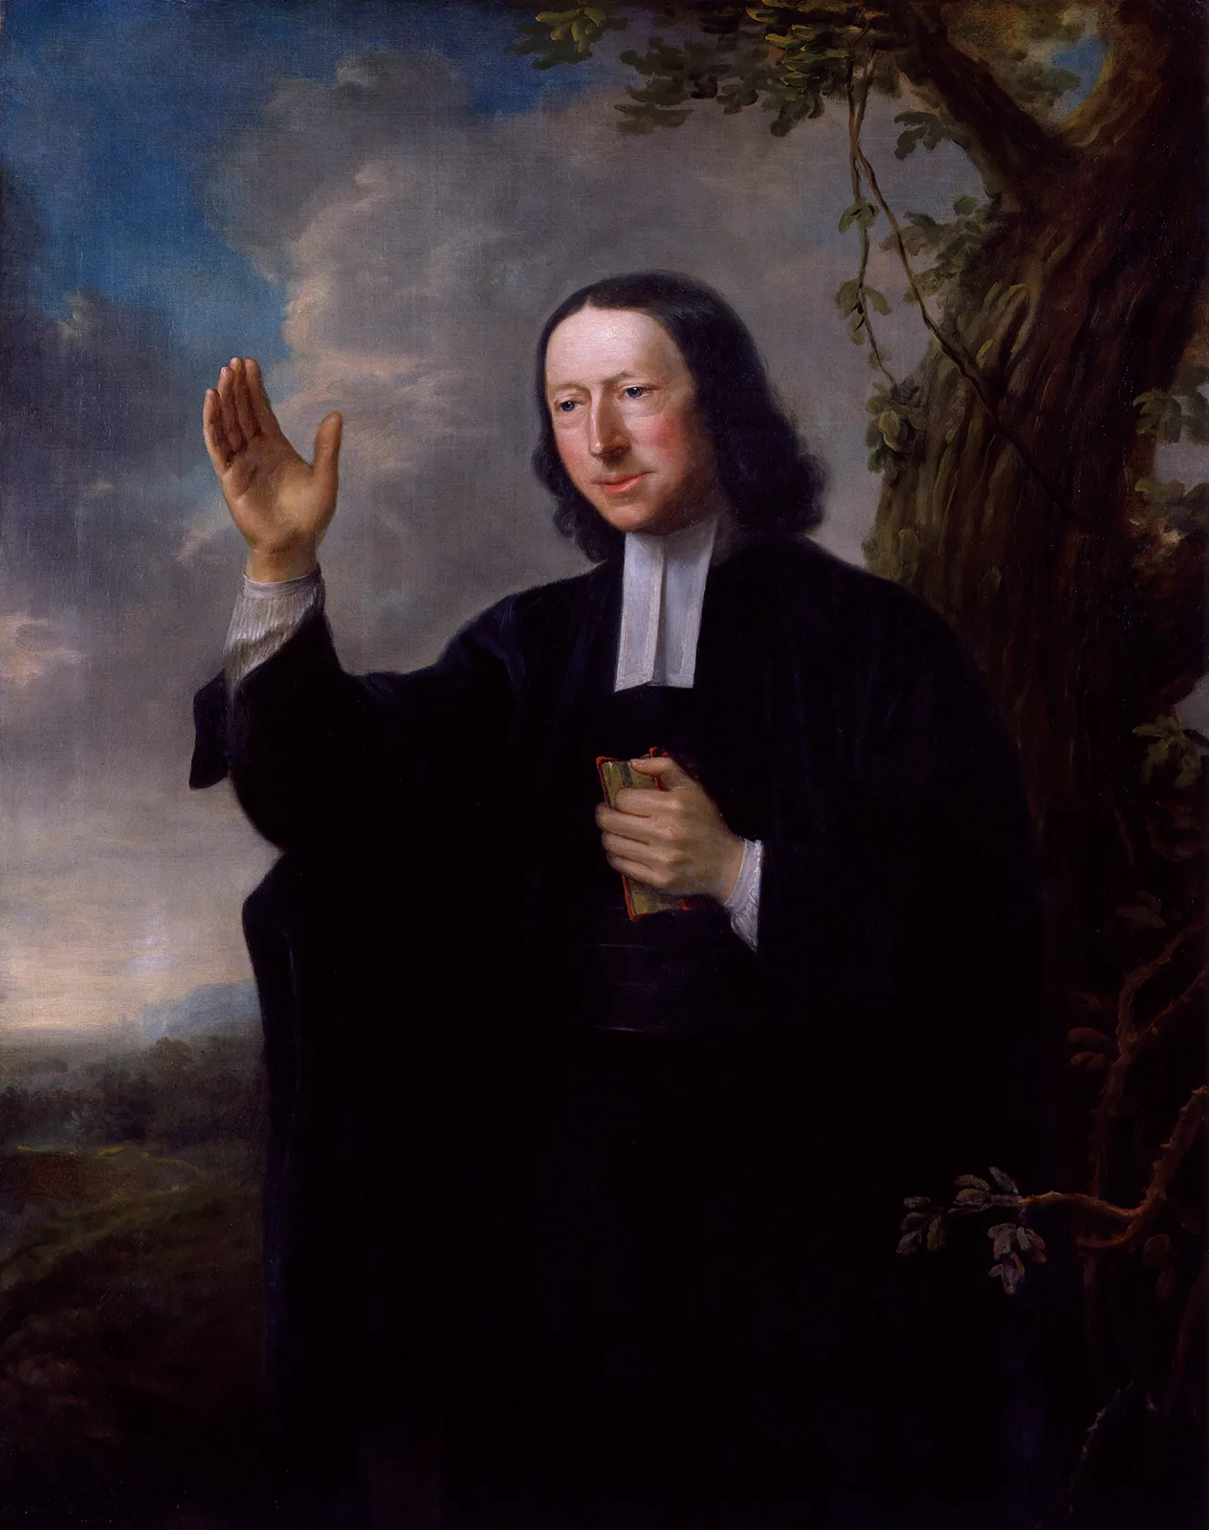
A Small Cloud, A Coming Rain
John Wesley is the father of the UMC in the 18th century. He is brilliant, deeply disciplined, and profoundly spiritual. His brother Charles was there. A handful of other young men gathered around them during his Oxford student time. They met together weekly to pray, to study Scripture, to hold one another accountable in their faith. They received communion together. They visited prisoners. They cared for the poor. But at the very center of everything they did is this one thing: they pray together. They called themselves the Holy Club. Others mocked them as Methodists, which became our denomination’s name. They were a small group of young men praying together week after week. That was it. Nothing that would make the headlines. But something was happening in that room.

From those dedicated prayer meetings, God planned a movement that would sweep across England, cross the Atlantic Ocean, shake the American frontier, and eventually give rise to the very denomination we belong to today. Our UMC was birthed through their seemingly insignificant and small prayer meeting; a small group of faithful people, showing up week after week, seeking God together. I think we can do that. We need to start this small group prayer meeting.

They Waited, and the Rain Came Down
Look with me at Acts chapter 1, verse 14. After the resurrection, after the ascension of Jesus, the disciples are gathered in Jerusalem — waiting, as Jesus had told them, for the promised Holy Spirit. Here is what the Bible tells us: “They all met together and were constantly united in prayer, along with Mary the mother of Jesus, several other women, and the brothers of Jesus.” I want you to notice just three things in that one verse.

First — they were ALL 120 people there. Second — they were UNITED. One accord. One spirit. One purpose. No division. No distraction. They came together around one focus, one longing, one Lord. Third — they were CONSTANTLY doing this. They were waiting for the heavenly empowerment. After 10 days, the Holy Spirit descended upon the praying disciples. Pentecost erupts. Three thousand people are added to the church in a single day.

The church was growing, but now facing real opposition. The authorities had threatened them, commanded them to stop speaking in Jesus' name. And what did the early church do in response? They prayed. Together.

Acts 4:31 tells us: When they had prayed, the place where they were assembled was shaken, and they were all filled with the Holy Spirit and began to speak the word of God boldly. The place was shaken. Not metaphorically. Physically shaken. This is what corporate prayer does. It creates the conditions for God to move in ways that shake the very foundations around us. From the upper room of waiting prayer to the shaking room of answered prayer — this is the trajectory of a church that prays together.

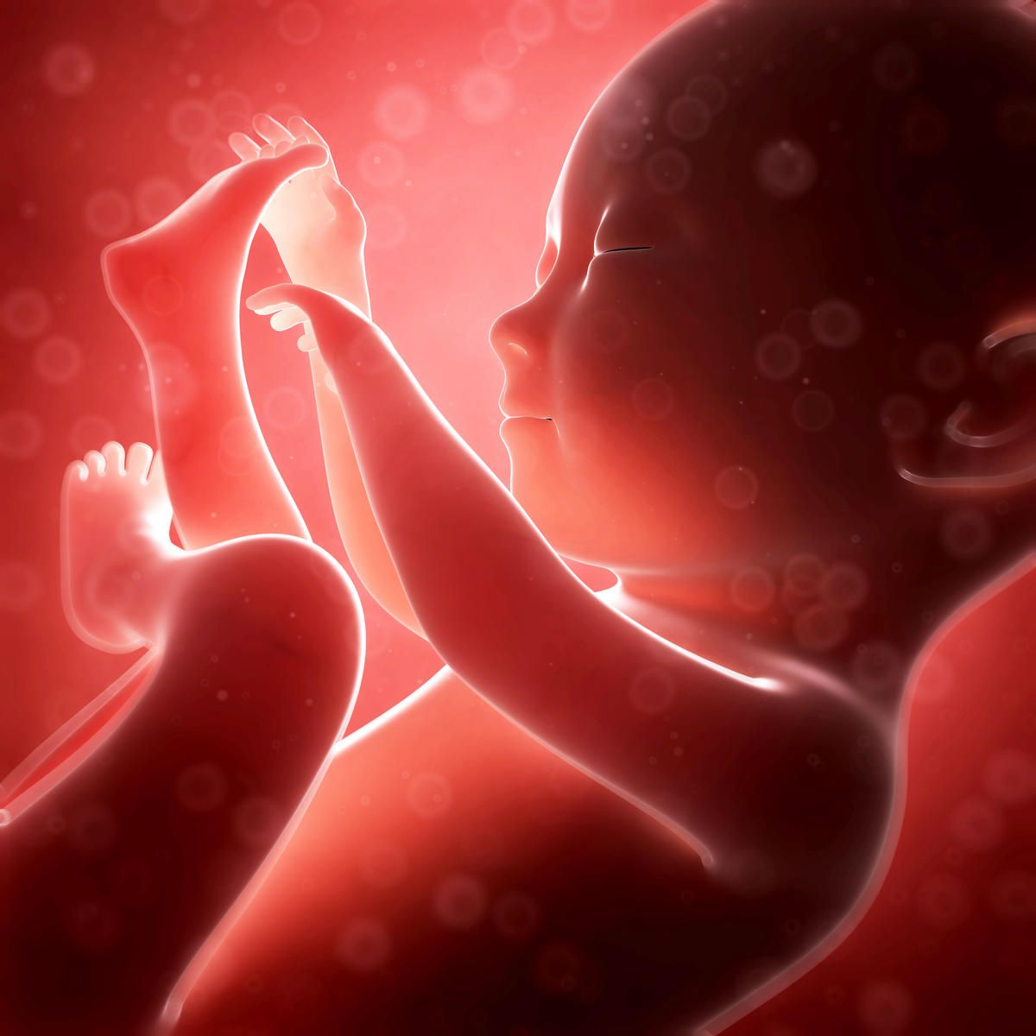
Revival Is Birthed, Not Built
So, Revival cannot be manufactured. We are accustomed to getting what we want when we want it. However Revival never comes from the right series of sermon, or special event. Revival comes only through God’s special touch upon people at the Kairos time when we pray. It could come earlier or later depending one how we sincerely pray. Revival is birthed. And like any birth, it requires a season — a season of carrying, of waiting, of pressing through in the hidden place before anything becomes visible in the public place.

What the disciples did was position themselves for it — by gathering together, by praying continually, by being united in one spirit of expectation. And then God moved. The pattern is beautifully consistent across every great movement of God in history. Before the outpouring, there is always the prayer room. Before the public breakthrough, there is always the corporate seeking in the hidden place.

The revivalist writer Leonard Ravenhill once said that no man is greater than his prayer life. This morning I want to gently extend that: no church is greater than its corporate prayer life.

Prayer is the engine of the church. Where the engine is, there is the energy being generated. It is the place where real church work gets done. The prayer meeting is not a side event on the church schedule. Prayer meetings is the center of the church.

Open the Ground, Let the Rain Fall
Think about the promise of God given to us. James 5:18. "Then he prayed again, and the sky gave rain, and the land produced its fruit.” The timing is dependent on how we wait for the rainfall in sincere and focused prayer.

I want to invite you to our weekly prayer meeting, to the most vital engine room. During the summer season, many of us will be out in the nature. Still you can do 111 prayer. I will create a zoom link to join the prayer virtually wherever you are. And I will open a church space to gather together and pray with one heart once a week.

As a church, we are holding the baby, the promise, in our church’s womb. 111 prayer, weekly prayer meeting, and weekly zoom prayer meeting. These will be our corporate yes to what God has been speaking. Let's take a moment of silence together.

My Phone Nr is 608 633 8613
Please text me your name and the kind of prayer you want to join 111, zoom prayer meeting, Small group prayer meeting. We will decide together the time and space.

