ADULT Choir CALENDAR
(APRIL – AUGUST 2025)
Revised 4-23-2025

APRIL 2025
Wed: 23 7p-9p Choir Rehearsal
Sun: 27 11:15a Traditional Svc – Choir sings (10:20 call)
Wed: 30 NO REHEARSAL

MAY & JUNE - NO WED NIGHT REHEARSALS
FULL CHOIR WILL SING EVERY SUNDAY

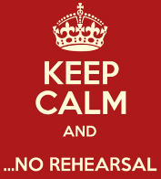
MAY 2025
Sun: 4, 11, 18, 25 11:15a Traditional Svc – Choir sings (10:20a call)

JUNE 2025
Sun: 1, 8, 15, 22, 29 11:15a Traditional Svc – Choir sing (10:20a call)



JULY thru AUGUST
MDPC’s Staff Singers will sing
Full choir off all of July thru Aug 24th

JULY 2025
Sun: 6, 13, 20, 27 11:15a Trad. Svc – small ensemble of staff singers (10:20a call)

AUGUST 2025
Sun: 3, 10, 17 11:15a Trad. Svc – small ensemble of staff singers (10:20a call)

Full choir returns Sun, Aug 24 . Wed night rehearsals resume Wed, Aug 27

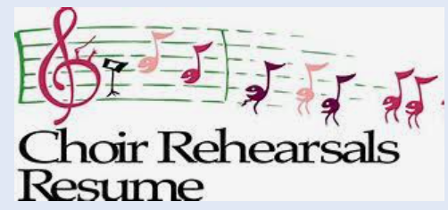
Sun: 24, 31 11:15a Traditional Svc – Choir sings (10:20a call)

Wed: 27 7p-9p Choir Rehearsal

For more info, contact Tracy Curtis-Stidam | tstidam@mdpc.org
choir.mdpc.org

