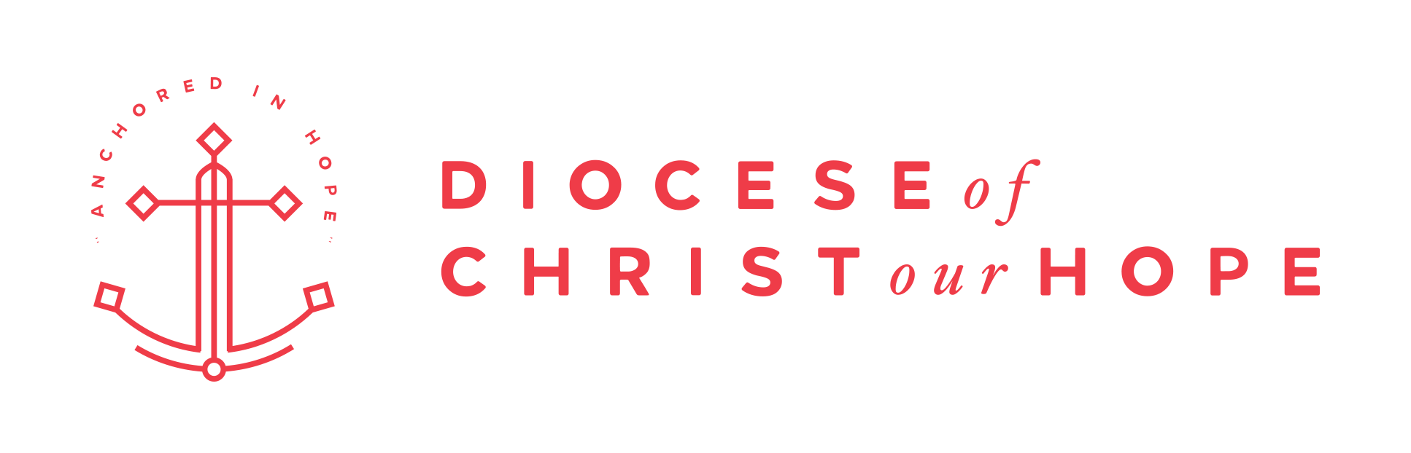

**Ministry Grants:**

**Summary and Process**

**Last update 1.13.2025**

Over the years, the Diocese of Christ Our Hope (DCOH) has grown through church planting, church growth, and ministry expansion. We are deeply committed to sacrificial investment of our diocesan resources in Gospel expansion and church planting. Our clergy, diocesan staff, and Diocesan Council collaborate through an ordered process to seek the mind of the Lord together concerning where and how we invest funds for the sake of the Gospel. Our discernment process requires a well-constructed Ministry Grant Application, and this summary is meant to guide your preparation. If you eventually submit a grant request, keep in mind that we consistently receive more requests than we can fund. In the end, the Diocesan Council has to make choices, and we take this charge seriously and prayerfully. We ask you to pray with us as we work together for the Gospel in support of all the churches in the Diocese of Christ our Hope.

The DCOH Ministry Grants (“Grants”) are overseen by the Diocesan Council Ministry Grant Working Group (“Working Group”). The Working Group consists of two members of the Diocesan Council plus 3-5 church members within the diocese with experience in granting processes. Members of the working group will recuse themselves from grant applications for the church they attend. The Working Group is assisted by the Chief Operating Officer. The Working Group can be contacted by email at ministrygrants@adhope.org

# 

# Ministry Grant Prerequisites & Standards

Eligibility for funding is contingent on churches contributing faithfully to the diocese.

* Before considering the application, the Diocesan Council will verify with the Diocesan COO that applicants parishes (if applicable) are consistently supporting the diocese with at least 10% of their undesignated offerings, or have an active plan to this level of support. If your parish is not currently meeting these standards but still would like to apply, please contact Lee Hilts ([lhilts@adhope.org](mailto:lhilts@adhope.org)) to create a plan for reaching the support requirement.
* Church Plants are recommended to set their budgets to include diocesan support with 10% of their undesignated offerings. The diocese support will be transferred monthly into a parish level designated fund (can be named Diocesan Support). At the end of the year, the diocese will authorize the plant (vicar and proto-vestry) to use the funds for development of the church. The funds would be to use it to shore up operational reserves, make capital purchases needed by the church, or fund an expansion ministry in the coming year. If the plant desires to send some of the support to the diocese at year end they could make that decision as a gift.
* When the parish enters the Mission status, they are considered able to support the "vicar" and would begin sending their diocesan support as normal.

Funding must be used only for the purpose for which it was requested and granted. Changes to the purpose of the funding must be requested in advance in writing to the Working Group ([ministrygrants@adhope.org](mailto:ministrygrants@adhope.org)). Redirection of funding without permission from the Diocesan council will result in withdrawal of the grant.

Grant Recipients are required to submit semi-annual reports to the Working Group regarding the status of the project funded by the grant. Reports are due on January 31 and July 31 every year for the duration of the grant. Failure to submit a report in a timely manner may result in withdrawal of the grant.

# 

# Ministry Grant Categories

There are three funding categories for Ministry Grants (“Grant”), described briefly below. The percentage beside each title notes the target percentage of overall Grant funding that will be allocated to each category. These percentages are set by the Diocesan Council each year.

## Church Planting (40%)

The standard Church plant grant is a 6 year grant totalling $210,000. The amount given per year is recommended as 20k-40k-60k-50k-30k-10k. The final amount, length, and allocation can vary from recommendations. Any variance is explained in the application. It is understood that some rural or regional plants may require additional funding.

Church Planting is the creation of a new DCOH congregation that has an eye towards these three long term goals. Namely, that the church becomes:

1. Self-governing – the congregation is led internally with a properly selected and confirmed rector in conformity with our diocesan Constitution and Canons, and naturally develops an elected, rotating vestry (leadership council) in conformity with our Constitution and Canons.

2. Self-replicating – the congregation grows toward the capacity and vision to be able to participate actively in planting new Anglican churches in the Diocese through the normal deanery mission strategies and faithful 10% support of the diocese. Additionally, a self-replicating church will, by definition, expand its own Gospel mission in other strategic, creative, and prayerful ways in coordination with DCOH leaders and clergy, other Anglican entities, etc.

3. Self-sustaining – the congregation is able to fund its basic ministry operations, diocesan support, and the Rector’s full-time compensation from monies generated internally.

A Church Planting Grant is designed to contribute substantially to the creation of a new church plant by supporting one of the two pathways:

1. A new work that has a church planter in place with approximately 20 participating adults.
2. An existing congregation to support a church planter who is actively being trained and supported to plant a daughter church out of their existing congregation. The development of the daughter church includes the recruiting, training, empowering, and releasing of a church planter with a launch team. Such a process is assumed to be completed and a new church well-launched in no more than 6 years. In this case, the new plant would not be eligible for an additional church planting grant once the 6 years of funding for the grant are completed.

*All church planters within the diocese receiving grant funds must participate in the Diocesan church planter assessment, training, and coaching process of the diocese.

## Curacy Accelerator Program (40%)

To provide consistent, quality training for newly (or soon-to-be) ordained deacons and priests, churches can apply for funds to support the creation of a 10 year Curacy Accelerator Program (CAP). This program, built on the Made to Flourish Foundation model will offer a DCOH-designed curriculum for training curates and will be funded over the course of multiple years, tapering off year by year, with the expectation that the local church will make up the balance of costs each year until they are able to fully support curacies from within their own budget for years ahead. We do encourage churches applying for a curacy incubator to also apply for funds through Made to Flourish. The diocese model for a curacy incubator is aimed at developing newly graduated seminary students who are beginning their formation as clergy.

The standard CAP Grant is a six year grant for $210,000. The amount given per year as 60k-50k-40k-30k-20k-10k

## Flexible Funding (20%)

The Diocese supports several ongoing programs listed below using Ministry grants. In addition, funds are allocated yearly to allow for one year grant requests for special projects.

* Deanery Support: Each deanery receives $5,000+ yearly to support the development of the deaneries
* Strategic Ministry Initiatives: The Canon for Leadership Development manages a $25,000 yearly grant to support the seven current diocesan initiatives
* Anglican Youth Mission (AYM): The diocese issues a yearly $25,000 grant to contract AYM to run the diocesan youth camps Booyah and Booyah BRR
* In Year Grants: Each year, 10% of total funding is allocated to respond to one time opportunities brought to the Diocese outside of the standard grant timeline.

Flexible Funding requests are made using the standard Grant application process and are sent to the Working Group for evaluation during the calendar year.

# 2026 Available Funds

Grant applications submitted in 2025 are for funding that will start in 2026. The majority of the available 2026 funding has already been allocated to existing grants. The Diocese estimates the following amounts will be available for new grants.

Estimated Total Diocesan Funds $794,000

Funds Allocated to existing Grants -605,000

Remaining Flexible Fund Allocations -74,000

**Funds available for new Grant requests $115,000**

The available funds are estimated to be sufficient to support new grants for:

* One or two church plants
* One curacy accelerator program.

Churches seeking to start a curacy accelerator program are encouraged to connect with the Made to Flourish (MTF) organization as soon as possible. They host sessions early in the year (~March) and grant substantial amounts of support to curacy programs within the diocese. In 2024, four churches were granted funds through MTF.

Please contact Canon Jeff Bailey ([jbailey@adhope.org](mailto:jbailey@adhope.org)) for more information on MTF.

# 

# Grant Application Timeline

In order to properly evaluate and discern funding opportunities, Grant applications must adhere to the following timeline. For applications to the Flexible Funds (one time funding for opportunities occurring after the normal granting timeline), still use the application process below.

All Grant application steps are to be completed before the dates noted below.

**February 1st:** All Ministry Grant Applications are sent to their Dean and Deanery.

**before March 1st**: Deanery meeting held to give the applicant feedback, not approval. This meeting is recommended to be separate from the Deanery Retreat. The Diocese requests it be done via a recorded virtual meeting process (Zoom, Google Meet…). The recording will be submitted as part of the application process.

**April 1st**: Final Grant Application is submitted via the Diocesan website (<https://adhope.org/mission-expansion/>)

**May 15th**: The Working Group reviews applications, interviews applicants and produces a Report of Recommended Grants to the Diocesan Council.

**June 30th**: The Diocesan Council votes on final grant decisions.

**Before July 30th**: All Grant applicants are notified if their application has been funded.