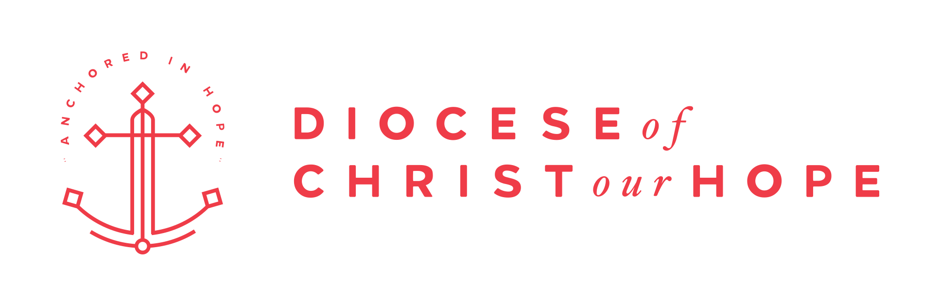

January 13th, 2025

Dear clergy and lay leaders of the Diocese of Christ our Hope,

Greetings from the Diocesan Council and from Bp. Alan Hawkins! We are honored to serve you and the staff of our diocese. We thank the Lord for your faithfulness in ministry during 2024, and we await with expectation the Lord’s leading in 2025.

We are launching the Ministry Grant Process for 2025 that allocates funds for 2026 and beyond. Resources for this process as well as the application link are on our website here.

A summary of the process and timeline for the Ministry Grants can be found here. Please review it as guidance for the coming year. Here are some key guidances in the document that are highlighted below:

- Ministry Grant Working Group: The grant process will be overseen by a working group consisting of two Diocesan Council members and 3-5 congregational members with experience in grant processes. This team will be evaluating all the requests and providing proposed funding to the Diocesan Council for final approval.
- Reporting on Approved Grants: Reports are required twice yearly (Jan and July)
- Funding Categories and Definition for 2025 grants: For the 2025 grant cycle, there will be two areas of emphasis for the diocese based on the amount of funds available for 2026
  - Church plants standard funding will be $210k over 6 years
  - Curacy Accelerator standard funding will be $210k over 6 years
- Guidance on 2026 Available Funds: A major learning from past years is that it is important to set reasonable expectations regarding the level of funding available for the coming year as well as how that will affect the criteria for funding applications. Due to a large amount of currently running grants, the expected 2026 funds available are:
  - $115,000 of general funds
  - $74,000 in Flexible Funds (which are occasionally used for general funding but preferred toward one year grants)
- The available funds are estimated to be sufficient to support new
grants for:
  - One or two church plants
  - One curacy accelerator program

There is also an overview of the grant process timeline which is largely the same. We are encouraging Deaneries to set aside a time outside their deanery retreats that is specifically for a peer review (not approval) of proposed grants.

We are excited to see where the Spirit is moving in our Diocese in the coming year and participate in His redemptive work. We pray that 2026 will be a year in which our existing parishes are strengthened, new churches are planted, and the Good News is boldly proclaimed.

It is a privilege to serve our churches through the Ministry Grant process, and we look forward to receiving your applications.

In Christ,

Alan Hawkins, Bishop Coadjutor
Jerald Walz, Vice Chair, Diocesan Council
Lee Hilts, Chief Operating Officer (lhilts@adhope.org for questions)

