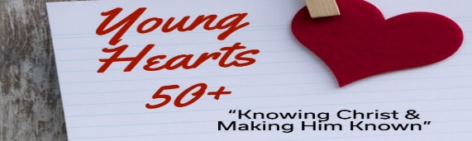

Young Hearts 50+ Newsletter & Events
Hello Young Hearts 50+,
"Stand firm. Let nothing move you. Always give yourselves fully to the work of the Lord, because you know that your labor in the Lord is not in vain". 1 Cor 15:58
We open with this scripture amidst the things going on in this world. I am sure if we are all honest it is concerning. You notice it opens with Stand Firm not Sit Firm. The Lord wants us ready for action on our feet to do the work of the Lord. . The verse also says Give Yourself Fully not Give Yourself Half Empty. We need to excel in our zeal and passion.in our love for Jesus and the desire to point others to know Jesus; then our labor will not be in vain. . Listen to that sometimes small voice of the Holy Spirit that speaks to you daily. Look around at all the people searching to fill this void in their life. Love on them, care for them and share the most wonderful message ever given to mankind. If you have a hard time doing this with adults start with the little ones in your life. If you need help in communicating to the younger generation come to our Legacy Imperative Class and be equipped to minster to these young ones as Jesus did.
Be inspired by this 30 sec. video by our granddaughter Amy Landers (17)
. https://youtube.com/shorts/XeC5oyciUCg?si=DzfnZZj5L5qog0F8
Blessing to you,
Mark and Diane Fechter YH50+ Ministry Leaders
Seniors: Make an Eternal Impact Our Children’s Ministry-Discovery Land needs faithful hearts for simple roles—Shepherd (sit with the children), Worship Leader, or Scripture Reader.
These are low-demand opportunities with just a one Sunday commitment monthly.
Times for West Bend 10:00-11:00am & North Church 9:30-10:30am.
Your experience and love for the Lord can help shape young hearts and leave a lasting Gospel legacy. I
Interested? Call the church office or email jaimebranham@westbendchurch.org —we’d be honored to have you serve.

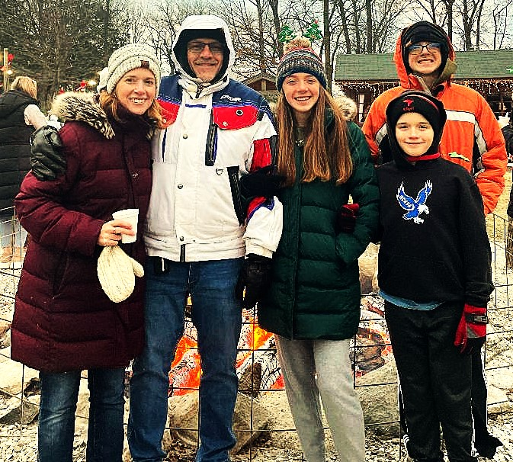
YOUNG HEARTS 50+ INVITES YOU TO A LUNCHEON!
Wednesday March 18, 11:00am-1:00pm
Community Church 2005 S. Main St. West Bend
Guest Singers-Speakers:
Revoredo Family
The Revoredo Family will be bringing their musical talents and wisdom. They will be sharing about running and finishing the race well while abiding in Christ. “Life is a marathon, not a sprint, and as a family we are teammates running together to reach the joy at the finish line.”
Great fellowship and door prizes! Cousins Subs provides lunch, so please arrive 10 minutes early to order food. Free event, no need to sign up, just come and enter behind church. Donations welcomed for food. Open to the public, invite friends. Questions go to: seniors@westbendchurch.org

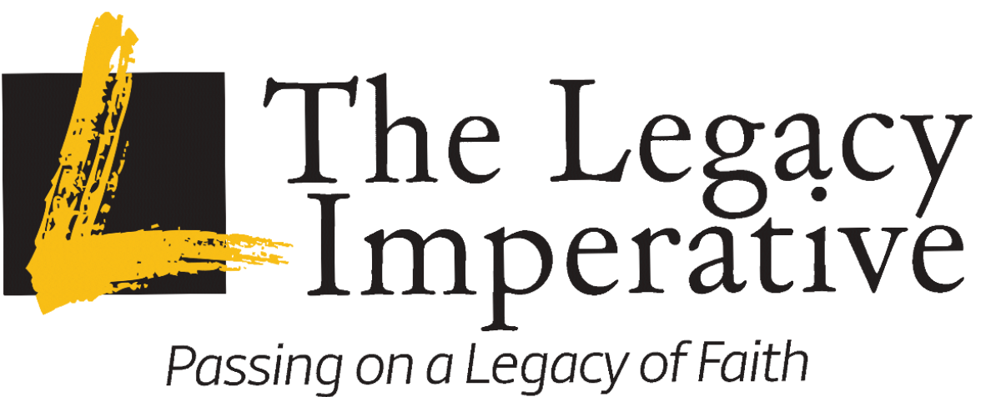
We cordially invite you to the Legacy Imperative Virtual Summit
Wednesday mornings on April 8, 15, 22 from 9:00-11:00 AM
Continental Breakfast at 8:30 with program starting at 9:00 promptly.
Held at Community Church 2005 S. Main St. Fellowship Hall
Event for seniors, future 50+ empty nesters, church youth workers.
This 3-week summit will change your thinking on how to connect with the next generation. Be inspired, learn the tools and set the vision to reach and transform the next generations. Each session contains inspirational teaching, media and film clips, and interaction to impart content in an entertaining way. Watch the promo: Reaching Digital Land There will be two topics covered every week followed by discussions.
Led virtually by Dr. Robert Petterson, best-selling author, pastor, and riveting speaker.
Get re-fired, empowered, and equipped to effectively disciple and evangelize the next generations in our Millennial and Gen Z children and grandchildren in a language and manner that are meaningful to them. Learn how to bridge the generational divide. Turn despair into hope. Discuss “hot-button” issues in their “language” and cultural context. All in a spell-binding, episodic “Netflix-meets-the-History Channel” format. Learn how to impart Biblical values and bridge the generational divide. The event is free but you must register. For information & registration go to: https://westbendchurch.org/ Then click on Ministries, then Senior tab.
Please feel free to make copies of poster and handouts to share with others.
Mark and Diane Fechter Legacy Summit Coordinators
Young Hearts 50+ Ministry Leaders seniors@westbendchurch.org

