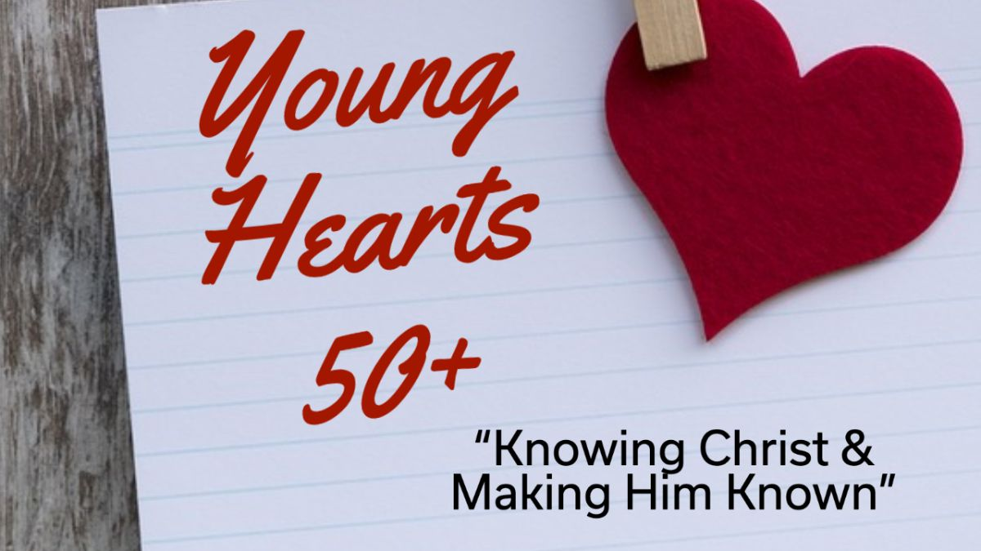

Invites you to a luncheon!

Wednesday October 7th, 11:00am-1:00pm

Community Church 2005 S. Main St. West Bend
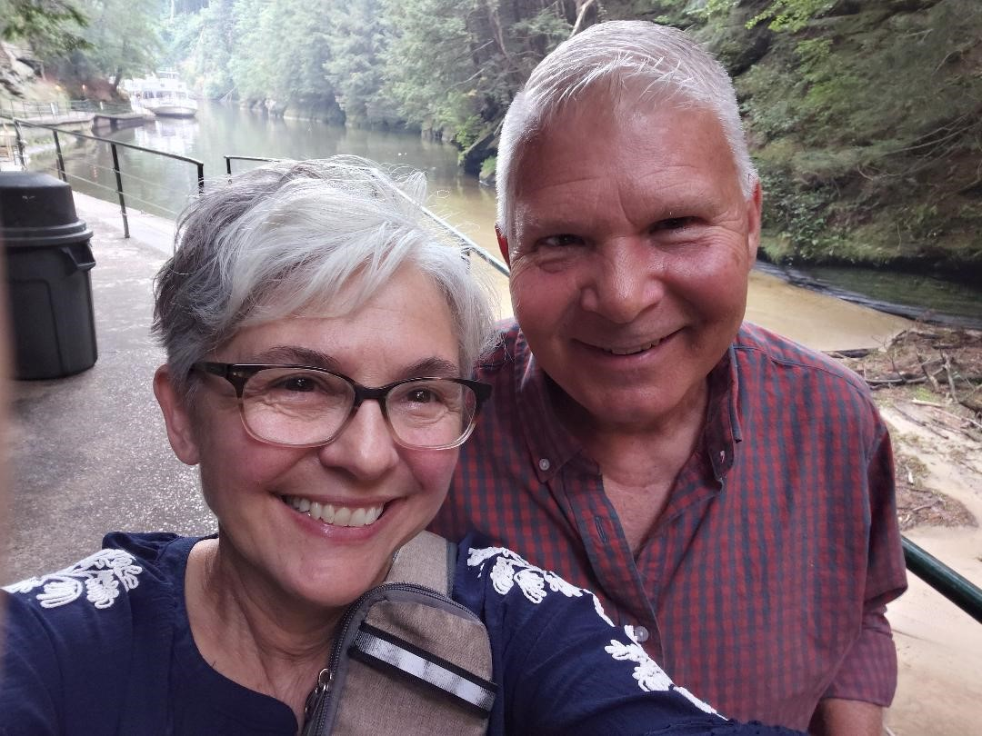

Our Guest Speakers: Alan & Renee Lull

Come hear the inspiring Faith Walk Journey of Alan & Renee. They are shining examples of a life transformed by Jesus Christ. They will be talking about what they are learning in their personal devotion life and also sharing 16 practical ways to encourage the next generation. Get ready to laugh, be encouraged and have your personal Faith Walk Journey stepped up a notch!

Great fellowship and door prizes! Cousins Subs provides lunch, so please arrive 15 minutes early to order food. Free event, no need to sign up, just come and enter behind church. Donations welcomed for food. Open to the public, invite friends. Questions: seniors@westbendchurch.org

