YOUNG HEARTS 5O+
OCT.& NOV. NEWSLETTER
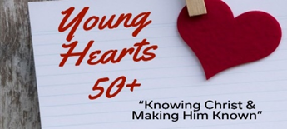
Hello Young Hearts 50+,
RELATIONSHIPS: We see them everywhere: In marriage, at work, in church, families, neighborhoods, school. Do you know that God wants us to be good stewards of every relationship He has put in our path? He wants us to be concerned, helping, encouraging, praying for, and serving one another. This all takes time and commitment. In a selfish world, this is out of the norm for our society. Over and above relationships with people in our lives, we need to place a higher priority to our relationship to Jesus Christ. Heb 12:2 “Let us fix our eyes on Jesus, the author and perfecter of our faith”. You see a lot of people know a lot about the historical facts and religious impact Jesus has had on our society, but very few have a daily relationship with Jesus. They have heard the gospel and have not received it by faith and it seems like their relationship with Jesus has no value. Heb 4:2 says, “For we also have had the gospel preached to us just as they did but the message they heard was of no value to them, because those who heard it did not combine it with faith”. Our purpose is to encourage people to consider Jesus Christ as Savior. Our prayer is that they have the faith to believe. Heb 4:14, “Let us hold firmly to the faith we profess”.
Mark and Diane Fechter Young Hearts 50+ Ministry Leaders
YH50+ luncheon! Wednesday October 7th, 11:00am-1:00pm Community Church 2005 S. Main St. West Bend
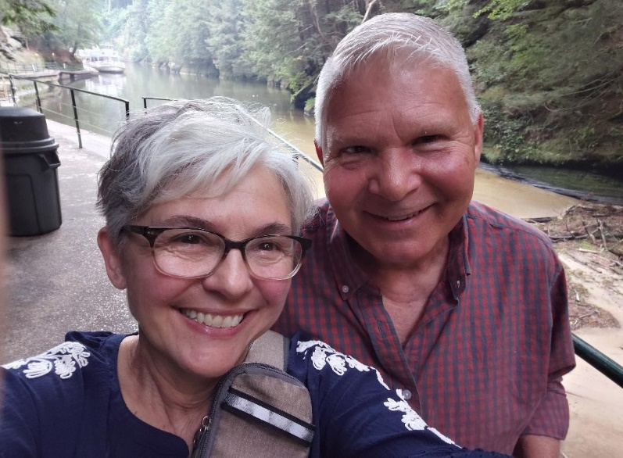
Our Guest Speakers: Alan & Renee Lull
Come hear the inspiring Faith Walk Journey of Alan & Renee. They are shining examples of a life transformed by Jesus Christ. They will be talking about what they are learning in their personal devotion life and also sharing 16 practical ways to encourage the next generation. Get ready to laugh, be encouraged and have your personal Faith Walk Journey stepped up a notch!
Great fellowship and door prizes! Cousins Subs provides lunch, so please arrive 15 minutes early to order food. Free event, no need to sign up, just come and enter behind church. Donations welcomed for food. Open to the public, invite friends. Questions contact: seniors@westbendchurch.org

YH50+ luncheon!

Wednesday November 18 11:00am-1pm
Community Church 2005 S. Main St. West Bend

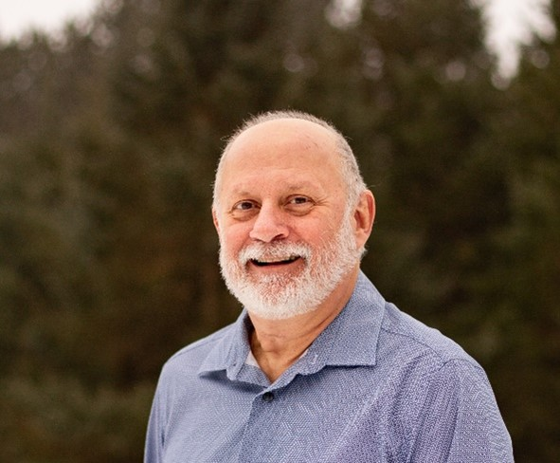
With special guest speaker Michael Lane
Michael has been the recipient of numerous prestigious state and national teaching awards. His resume includes many roles such as science teacher, curriculum writer, biologist, marine biologist, microbiologist, archeology researcher, and author. Come and be encouraged. Michael’s web site www.evidence4faith.org Great fellowship, door prizes, for those who are 50+. Cousins Subs provides lunch, come 15 min. early to order food. Donations welcomed for food. Questions: seniors@westbendchurch.org

Also Homeschool event in the afternoon 2:00pm-3:30pm. Michael will be giving a presentation for homeschool families on God's miraculous creation. The event is free. No childcare available.
YH 50+ seniors are also invited.
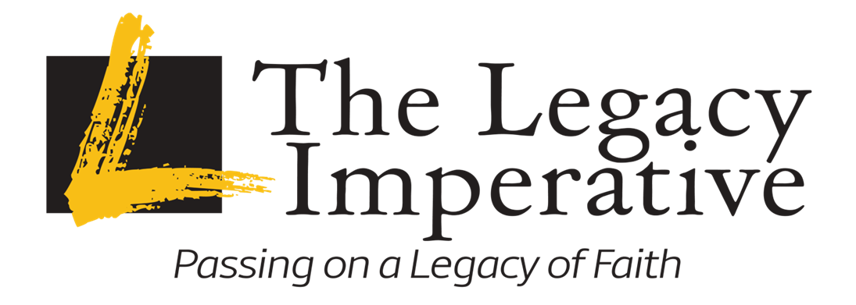Great News, Free Legacy Video Series!
We have had over 110 attenders at Community Church over the last years go through the 7-episode program with great reviews after viewing this valuable resource information. Legacy has now allowed us to promote this “Call to Action Series” for you to watch for FREE at your home or bible study group. The series also comes with printable notes for each of the 7 episodes! Watch the promo: Reaching Digital Land
It is led virtually by Dr. Robert Petterson, best-selling author, pastor, and riveting speaker.
Let us equip ourselves to reach the next generations in a biblical and practical way and not miss an opportunity to touch their lives. Connect to web site at: LegacyImperative.org or better yet click on this link to start your journey: Episode 1: The Imperative | Legacy Imperative

Let us know if you have been inspired by the “Call to Action Series”. This includes those who have seen it the past years.
You can email us at: seniors@westbendchurch.org

