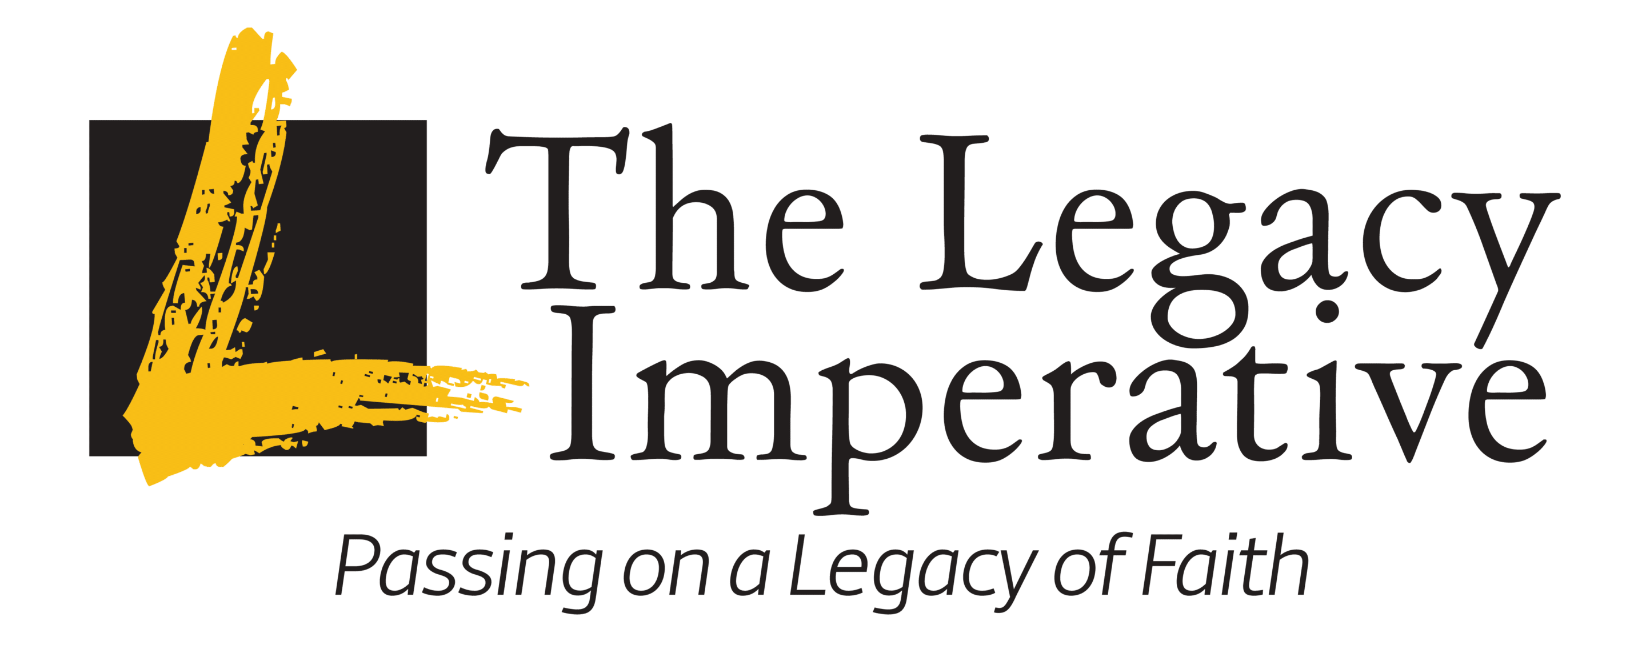
Hello YH50+,

We have had over 110 attenders at Community Church over the last years go through the 7-episode program with great reviews after viewing this valuable information. Legacy has now allowed us to promote this “Call to Action Series” for you to watch for FREE at your home or bible study group. The series also comes with a printable note for each of the 7 episodes! Watch the promo: Reaching Digital Land
This summit will change your thinking on how to connect with the next generation. Be inspired, learn the tools and set the vision to reach and transform the next generations. Each session contains inspirational teaching, media and film clips, and interaction to impart content in an entertaining way.
Led virtually by Dr. Robert Petterson, best-selling author, pastor, and riveting speaker.
Get re-fired, empowered, and equipped to effectively disciple and evangelize the next generations in our Millennial and Gen Z children and grandchildren in a language and manner that are meaningful to them. Learn how to bridge the generational divide. Turn despair into hope. Discuss “hot-button” issues in their “language” and cultural context. All in a spell-binding, episodic “Netflix-meets-the-History Channel” format. Learn how to impart Biblical values and bridge the generational divide.
Let us equip ourselves to reach the next generations in a biblical and practical way and not miss an opportunity to touch their lives. Connect to web site at: LegacyImperative.org or better yet click on this link to start your journey: Episode 1: The Imperative | Legacy Imperative

Let us know if you have been inspired by the “Call to Action Series”. This includes those who have seen it the past years. You can email us at: seniors@westbendchurch.org
Knowing Christ and Making Him Known,

Mark & Diane Fechter
YH50+ CC Ministry Leaders
Legacy Imperative Coordinators

