Thank you for offering to provide school supplies for our community families! Shopping for these items is less expensive in-stores verses online, but we appreciate any amount you can do. Please deliver the items to Church of the Incarnation (3966 McKinney Ave.) Mon-Thurs from 9am-5pm.

Item – Middle/High School | Quantity per Bkpk  (150 Bkpk)
Clear Backpack (17in+) | 1
Binder (2in w/ cover pocket) | 1
Pocket Folder (w/prongs) | 4 (different colors)
5-Tab or 8-Tab Dividers | 1pk
Notebook Paper (College ruled) | 1pk (150+ sheets)
Spiral Notebook (College ruled) | 2
Index Cards (size 3x5) | 1 (100pk)
Clear Pencil Bag | 1
#2 Pencil | 12
Pens | 10 (4 blue, 4 black, 2 red)
Colored Pencils | 1 (12pk)
Highlighter | 2 (1 yellow, 1 color)
Pointed Tip Scissors (7in) | 1
Glue Sticks | 2
Large Eraser | 2
Eraser Caps | 10
Pencil Sharpener | 1
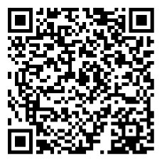

Backpacks & School Supplies Walmart Wish List:

