Elementary Supply List | Quantity per Bkpk  (150 Bkpk)
Clear Backpack (17inch+) | 1
Pocket Folders (w/prongs) | 4 (different colors)
Notebook Paper (wide ruled) | 1pk (150+ sheets)
Spiral Notebook (wide ruled) | 2
Composition Book | 1
Colored Markers | 1 (10pk)
Clear Pencil box or Bag | 1
#2 Pencils | 12
Crayons | 1 (24pk)
Glue Sticks | 2
Dry Erase Marker | 2 (1 black, 1 color)
Dry Erase Eraser | 1
Index Cards (size 3x5) | 1 (100pk)
Blunt tip Scissors | 1
Large Erasers | 2
Eraser Caps | 10
Pencil Sharpener | 1
Thank you for offering to provide school supplies for our community families! Shopping for these items is less expensive in-stores verses online, but we appreciate any amount you can do. Please deliver the items to Church of the Incarnation (3966 McKinney Ave.) Mon-Thurs from 9am-5pm.
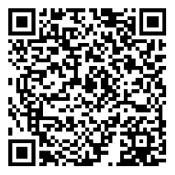

Backpacks & School Supplies Walmart Wish List:

