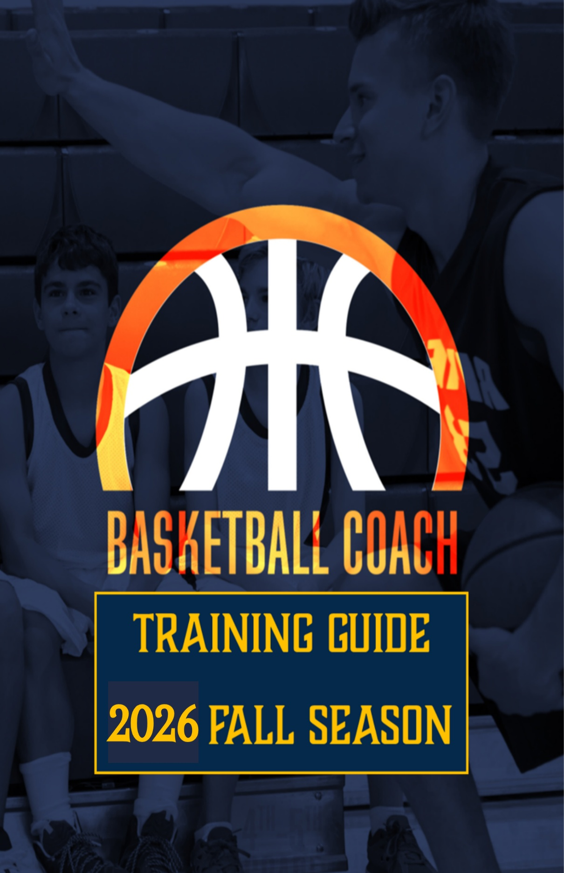
Table of Contents
Mission Statement…………………………………………3
Purpose of Compass Sports ……………………………... 3
Experience/Philosophy …………………………………... 4
Fundamentals of Compass Sports ………………………. 5
Division Rules ……………………………………………. 7
Making the Most of Practice Time …………………….. 10
Successful Coaching Philosophies That Create Best Experience for the Whole Family ……………………… 11
Conflict Management …………………………………... 13
Parental Relationships …………………………………. 16
Team Meetings ………………………………………….. 17
First Aid Policy & Safety Procedures …………………. 18
Weather/Game Cancellations ………………………….. 20
Sports Connect ………………………………………….. 20
League Substitutions …………………………………… 21
Substitution Forms ……………………………………. 29
What Does the Compass Sports Logo Represent? …… 37

Sports Connect:
Username ____________________________
Password _____________________________

Mission Statement
Compass Sports is a Gospel-Centered ministry where sports serve as a tool for outreach and discipleship. Our goal is to glorify God by using athletics to teach biblical principles, foster community, and develop servant leadership. Sports remain secondary to our mission of sharing Christ’s love and truth.
“Whatever you do, do it all for the glory of God.” – 1 Corinthians 10:31
Purpose of Compass Sports
The purpose of Compass Sports is to glorify God by using sports as a platform for discipleship, spiritual growth, and the proclamation of the Gospel. Our mission is to provide every participant with the opportunity to grow in their understanding of Jesus Christ while developing discipline, teamwork, and perseverance through athletics.
At the heart of Compass Sports is a commitment to spiritual transformation. We believe that character shaped by Christ is far more important than any skill gained on the field or court. While competition has its place, it is always secondary to our greater purpose—helping athletes and families encounter the truth of the Gospel and be conformed to the image of Christ. Through intentional discipleship, biblical teaching, and servant leadership, we aim to equip young athletes not just for the game, but for a life rooted in faith and obedience to God.
“Being transformed by the love of God and learning to live as Jesus lived.”

What You Will Experience Through Compass Sports
Compass Sports exists to provide a Christ-centered sports experience that prioritizes spiritual growth and discipleship above all else. Our ultimate goal is not merely athletic development but the transformation of lives through the power of the Gospel. We believe that sports are a powerful tool for teaching biblical truth, developing godly character, and fostering relationships that glorify God. Through the dedication of our recreation team and servant leaders, every participant and family involved in Compass Sports will experience:
Philosophy Of Compass Sports
Compass Sports exists to provide a Christ-centered sports experience that nurtures both spiritual and physical growth. While developing athletic skills is important, our ultimate goal is to use sports as a platform for discipleship, shaping young athletes and their families in the truth of the Gospel.
Fundamental to our program is the belief that true growth begins with a relationship with Jesus Christ. We integrate the teaching and reinforcement of biblical values into every aspect of the sports experience, ensuring that participants not only gain skills on the field but also develop godly character that lasts a lifetime.
Compass Sports prioritizes creating and preserving a Christian environment where competition is framed within the greater calling of glorifying God. Through intentional discipleship, Christ-centered mentorship, and the joy of the game, we aim to equip young athletes to reflect Christ in all they do—both in sports and in life.

Fundamentals of Compass Sports

Gospel-Centered Competition
We believe that competition should be an opportunity for growth, not just in skill but in character and faith. By striving to create balanced teams and fair play, we ensure that every participant can develop both athletically and spiritually. Just as Scripture calls us to “run in such a way as to get the prize” (1 Corinthians 9:24), we encourage each athlete to give their best effort while honoring Christ in their attitude and actions.
Everyone Participates with Purpose
Every child is valued as an image-bearer of God, and their participation is not based on skill alone. Our structured substitution system ensures equal playing time, reinforcing that our worth is not measured by performance but by who we are in Christ. This approach fosters teamwork, humility, and encouragement, mirroring the unity that believers are called to have in the body of Christ (Romans 12:4-5).
Christlike Character Development
We desire to see each participant not only improve athletically but, more importantly, grow in their character through the example and teachings of Jesus Christ. By integrating biblical discipleship into the sports experience, we provide opportunities for athletes to develop qualities such as integrity, humility, perseverance, and servant leadership. As 1 Corinthians 10:31 reminds us, “Whatever you do, do it all for the glory of God.” Through sports, we encourage athletes to live in a way that honors Christ both on and off the field.
Family Discipleship and Engagement
We recognize that spiritual growth happens not just on the field but within the home. Families play a vital role in a child’s development, and we encourage parents to be actively involved in their child’s sports experience. Whether coaching, officiating, serving in game-day operations, or simply cheering from the sidelines, parental participation strengthens the mission of Compass Sports and reinforces the biblical values we seek to instill. Our goal is to equip families to disciple their children, modeling the love and leadership of Christ in all areas of life (Deuteronomy 6:6-7).
Excellence, Knowledge, and Joy in Christ
We believe that learning the fundamentals of a sport is valuable, but even more important is learning how to apply biblical truths through competition. With knowledge comes confidence, and with confidence comes a deeper enjoyment of the game. However, if a child is not experiencing joy, their desire to continue diminishes. That is why we prioritize creating an environment where fun, fellowship, and faith intersect. True joy is found not just in victory on the field but in knowing and following Jesus Christ (John 15:11).
To ensure consistency and excellence in all youth sports under Compass Sports, we have established clear guidelines that align with our commitment to first-class service, Christ-centered mentorship, and spiritual formation. By keeping the Gospel at the center, we seek to develop athletes who not only grow in their sport but, more importantly, grow in their walk with Christ.
Servant Leadership in Compass Sports:
At Compass Sports, we believe that serving in this ministry is a calling, not just a responsibility. Those who step into leadership roles are entrusted with the privilege of discipling young athletes and their families through the platform of sports. Every servant leader is first and foremost a follower of Christ, called to reflect His love, integrity, and grace in both word and action. Our commitment is to ensure that all who serve in Compass Sports do so with a heart for the Gospel and a desire to glorify God through their role.

DIVISION RULES

KINDERGARTEN - 1ST GRADE (COED)
Basic Information
- Practices and Games will occur each Saturday of the season and be 90 minutes in length. Teams will practice and then play a game. Teams will practice for 20 minutes before they play their game. All games will be 18-minute halves. Substitutions will be made every 6 minutes. Half-time will be 5 minutes in length.
- Coaches will deliver a short devotion during half-time.
- Games will be played 4 v 4
- Visiting team has possession to start each game. Home team has possession to start 2nd half
- Home Team: Wears White/Light Colored Jersey’s
- Away Team: Wears Dark/Colored Jersey’s
- 8-ft basket
- 27-inch ball
- Defense to pick up offense at foul line-NOT half court
- No stealing off the dribble; however, passes may be stolen by the defense
- No fast breaks. After a steal, the team possessing the ball must wait for the defense to set up
- One coach from each team will referee the game
- Coaches will receive a roster prior to the first practice. During the first and second practice, coaches should evaluate the skill level of all players and rank them. Please refer to the “Substitution Chart” to view how to fill out the substitution chart and ranking. Coaches will fill out their chart based on the following sequence for the number of players on their team.
- 1,3,5,7,9,2,4,6,8 - This will help even out the skill level on the court and allow for more competitive play.

2ND AND 3RD GRADE BOYS/GIRLS
- Visiting team has possession to start each game. Home team has possession to start 2nd half
- Home Team: Wears White/Light Colored Jersey’s
- Away Team: Wears Dark/Colored Jersey’s
- 9-ft basket
- 27-inch ball
- Girls will play 3 V 3
- Boys will play 3 V 3
- Defense to pick up offense at line provided on the court which is past half court line (this will be demonstrated at the facility).
- Score will be kept for all games. At a 20-point advantage, the score will be kept at the scorer’s table and not on the scoreboard (current score will remain on scoreboard). When the score returns to a 10-point advantage, the scoreboard will be updated and run.
- Level 2 will play 18-minute halves. Substitutions will be made at 6-minute intervals.
- Stealing is allowed
- Man-to-man defense only. In a man to man defense at this level, when a screen is set on the defensive player, the defensive team has the option to “switch” or “roll out” with the offensive player to make a defensive stop (if this was being demonstrated, then we would say the switch can be made and new defender can be used to stop the penetration in a “help side” manner). However, the original defender must return to guarding the original player once an immediate attempt to stop the offense is made. The defensive player who switched must then switch back to the original player as well. Switching in this context is allowed so that the offensive team does work to “beat the development system” by not allowing switching on defense and basically matching up a one-on-one scenario each time. Again, this is a development level. Fast breaks may occur after a steal
- Any player may defend a fast break and switch back to the player they should be guarding when possible.
- After a defensive rebound, the team possessing the ball must wait 3 seconds to allow the opposing team to set up their defense. Referees will assist and let players know when they may advance the ball.
- Coaches will receive a roster prior to the first practice. During the first and second practice, coaches should evaluate the skill level of all players and rank them. Please refer to the “Substitution Chart” to view how to fill out the substitution chart and ranking. Coaches will fill out their chart based on the following sequence for the number of players on their team.
- 1,3,5,7,9,2,4,6,8,10 - This will help even out the skill level on the court and allow for more competitive play.

MAKING THE MOST OF YOUR PRACTICE TIME

“Practice, in order to be effective, must be meticulously organized. Otherwise, it’s no different than kids running around on the playground at recess.” – John Wooden
For most coaches, practice time is limited. You may only have one day a week and 1-2 hours on each of those days. How you use this time is very important to the development of your team on game day. Here are five ideas for organizing your practices:
- Have a plan. Prior to the season, sit down and really think through what it is you want to accomplish. Start with these questions: What do my players need to know by the first game?
What will we need to do in the week before that game? What will we need to do the week before that?
- Determine how you will use the space you have available. Field space often goes to waste with kids only running drills in a small area. Ask yourself: Can I set up more than one drill station to allow kids twice as many reps in the same amount of time? Another thought to factor in is what kids you want in specific drills, either together as an offensive or defensive unit or at different locations on the field to allow you to focus on coaching specifically what each player needs. It’s difficult to keep track of what each kid needs to be coached through when you have your entire team in the same drill. If you split the group up and talk with your assistant coaches, players tend to get more personalized attention.
- Determine what drills you will use. Each drill should have a purpose that relates back to your offense and defense, transition game, etc. While running any drill can help with skill development, try to be deliberate in using and modifying drills to meet your goals. For example, if you are going to spend time passing, use a drill that mimics the part of your offense that results in the pass play. Use or create drills that would be realistic to get your offense working. Thinking through the drills and their purpose will cut down on the amount of time you need to “teach” things like team offense. Use a progressive series of drills that mimicked parts of the offense. In one hour, you can take a specific number of players and have them running a team offense.
- “Adjust we must.” Even the best-planned practice sometimes fails. Don’t be afraid to stop a drill short if it isn’t working or to extend it longer if the kids are having fun and finding success. You can’t control things like players missing practice or bad weather cutting your day short. It’s okay to move something to another day when the right personnel is available or to scrap a less important drill to save time because you must end practice early.
- Know How to Relate to Players. Every coach has to spend the first few weeks/practices learning the personalities of their players. It’s the coaches’ position to learn how to listen and communicate with each player.
RULES OF PRACTICE FOR YOUTH SPORTS
Fun! If practice is fun, the players will be focused. They will give 100 percent, and they certainly will look forward to each and every practice.
Keep them moving. Players should not be standing around. They should always be moving or learning.
Always focus on positives. Learn to communicate the negatives from a positive perspective.

SUCCESSFUL COACHING PHILOSOPHIES THAT CREATE BEST EXPERIENCES FOR THE WHOLE FAMILY

Prioritize Practice Time: Good coaches plan practices to the minute.
They develop written plans that utilize the time they have efficiently. They discuss the practice plans with assistant coaches prior to the start of each practice and how they want the coaches to carry out their responsibilities.
Limit Players Standing Around: If you keep the players busy during practice, discipline is less likely to be needed. When doing drills have no more than 3 players standing to wait for their turn. Create multiple lines or stations and get coaches involved in a variety of ways with kids.
Basketball not Calisthenics: The kids didn’t pay to become cross-country athletes. Focus more on football fundamentals, techniques and drills that improve the skill they must perform. The players do need physical conditioning but coaches that find ways to work conditioning into skills/ technique drills have more success.
Find a proven Offense and Defensive scheme/system: Most coaches have never invented a system or designed a series. They have taken them from someone else. Research offensive and defensive schemes that have already been done. Find one system and get good at it. If you want to put your own spin on some things do them sparingly. Good offensive and defensive systems are good for a reason. Understand the responsibility and technique of each position so you can implement the system. USA Football Web Site is a great resource for different schemes. (http://usafootball.com/coach)
Limit Your Playbook: Stress getting proficient at a core group of plays.
Focus on being efficient with the set of plays you want to run. Typically, 5-8 base plays are enough with a few formation changes. Coaches that have perfected just a couple of plays are much more successful than the coach that has practiced 100 plays once.
Limit Scrimmaging: Keep scrimmaging to a minimum, unless you have enough coaches to really watch players and make corrections. Successful coaches like to have players freeze after each step of the play. This way they can coach the players on their responsibilities and techniques for each play. If you don’t have enough, ask parents to help.
Players in Every Position: Too many coaches automatically think certain age or size kid should play specific positions. This is not the case. As a league, we desire each player to have an opportunity to play multiple positions. Remember you are developing players, and they need to experience a variety of options.
Positive correction techniques: Praise is more effective than criticism. There is only one type of criticism allowed in coaching and that is constructive. Youth players respond much better to “That was good hand placement on that flag pull and here is how you can do it even better” instead of “That was awful you need to pull the flag harder”. Kids in this age group typically lack confidence. Continuous negative correction destroys confidence and limits performance. Try to find something positive to say about every player on your team. Early on with less developed players it can be difficult to find a specific thing to praise kids about. Even if it’s just lining up right for calls or doing high knees in warmups well ... find something to praise the kids about.
Conflict Management
“If your brother sins against you, go and tell him his fault, between you and him alone. If he listens to you, you have gained your brother.” – Matthew 18:15
At Compass Sports, we recognize that conflict is inevitable in any community—but it is also an opportunity for growth, healing, and deeper relationships in Christ. Our commitment is to handle every concern and conflict in a way that reflects the heart of the Gospel: reconciliation, grace, truth, and restoration.
We follow the biblical model of reconciliation as outlined in Matthew 18:15–17, addressing issues directly and respectfully, with the goal of restoring relationships and glorifying God through our responses.
Process for Handling Conflict
When a concern or conflict arises, the following steps should be followed:
- Begin with direct, personal conversation.
The person with a concern—whether a coach, parent, or league member—should first approach the individual involved directly and privately (Matthew 18:15). Most misunderstandings are resolved when handled promptly and respectfully.
- Escalate to leadership if needed.
If the issue is not resolved through individual dialogue, the League Director will coordinate a meeting between the involved parties to listen, mediate, and work toward resolution (Matthew 18:16).
- Final decision and action.
If resolution is still not reached, the League Director, in partnership with the Director of Recreation and Fitness, will assess the severity of the situation and determine the appropriate next steps. This may include verbal warnings, accountability measures, or in some cases, removal from league participation.

Biblical Principles for Resolving Conflict
In all circumstances, we encourage everyone involved to reflect the heart and attitude of Christ. This includes:
- Initiating conversation in love
“If your brother sins against you, go and tell him his fault…” (Matthew 18:15)
- Speaking truth with grace
“Speak the truth in love… let no corrupting talk come out of your mouths, but only such as is good for building up.” (Ephesians 4:15, 29)
- Listening with humility
“…if he listens to you, you have gained your brother.” (Matthew 18:15)
- Demonstrating self-control and patience
“But if he does not listen… take one or two others along with you…” (Matthew 18:16)
- Pursuing unity, not victory
The goal is not to win an argument but to gain a brother or sister through understanding, empathy, and reconciliation (Matthew 18:15).
Disciplinary Actions
Discipline will always be approached through a lens of grace, aiming to restore rather than punish. Actions taken will reflect the seriousness of the issue and the heart posture of the individuals involved. Possible steps include:
- Verbal Warning
A private conversation to address undesirable conduct and reaffirm the mission and values of Compass Sports.
- Accountability Plan
A structured plan that may include coach mentoring or follow-up conversations to encourage growth and restoration, helping individuals remain active in the league whenever possible.
- Removal from Game or League Participation
In the rare case where an individual fails to respond to biblical correction or continues in disruptive behavior, temporary or long-term removal from practices, games, or league involvement may be necessary. These decisions will be made by the League Director and Director of Recreation and Fitness, with the goal of pursuing peace and protecting the unity of the ministry.

Our Heart
The ultimate aim of conflict management at Compass Sports is not control—it is Christ. Every challenge is an opportunity to glorify God, deepen community, and model the Gospel of grace, truth, and reconciliation.
“Blessed are the peacemakers, for they shall be called sons of God.” – Matthew 5:9
PARENTAL RELATIONSHIPS
Coaches must communicate with parents effectively as part of their coaching duties. Parents can be your greatest ally or greatest struggle. If you communicate properly, parents can be an asset. Many parents show up to the first couple of practices to make sure their son or daughter is in good hands. Some continue to observe practices and usually the younger the players’; the more parents observe your practice.
The typical issues that arise are as follows:
- They are upset that their child is not playing in the position that they think he/she should.
- They are upset that their child is not playing enough.
- They undermine your coaching by teaching him different techniques.
- They undermine your coaching by complaining behind your back to other parents and to their own child.
- They are out of control at games and yell at referees and other teams.
Most issues can be mitigated by good communication and emphasis on team play. Here are some recommendations that help foster healthy relationships with parents:
- Conduct a pre-season team meeting and explain in detail how you are going to adhere to the leagues playing and substitution system. This will help parents understand how the league functions and how the players are played and rotated.
- End practices on time. Parents have schedules and more kids to chase.
- At the end of practice, bring players together and remind them to thank their parents for allowing them to play football.
- Make a rule that you will not discuss problems with parents immediately after games. Emotions are high after games, and this is the worst time to address parents.
- Make time for parents and make sure you communicate often with them.
- Some coaches send personal notes or emails to parents about player’s exceptional performance and how they can improve.
TEAM MEETINGS
The pre-season team meeting is essential in establishing communication, setting expectations and letting parents feel confident that their child is going to be in good hands. We recommend conducting the team meeting prior to beginning your first practice.
Introduction: Let them know your experience with coaching youth. If you don’t have a lot of experience, then tell them about the research that you have done and tell them coaching is a passion for you.
- Philosophy: Tell them about your approach to coaching and that player safety is your number #1 priority. (Concussion Awareness/Heat Illness). The following are some examples.
  - Stress Teamwork
  - Christmanship
  - Football Fundamentals and Skill Development
  - Have Fun!
- Communication: Discuss how you are going to communicate with the team such as if you need to cancel a practice or game change. Make sure you have all the correct phone numbers or emails. Advise them to check the league Facebook site.
- Team Rules/Expectations: Discuss team rules such as practices, no profanity, respect teammates, respect referees, and fellow competitors. This is a good time to speak with parents about sideline behavior during games. Discuss missed practices or games and let you know when they are going to miss ahead of time.
- Discuss equipment: What the league has and what they are expected to have such as mouthpieces, water bottles, cleats to be molded rubber. Put names on water bottles! Discuss the importance of mouthpieces. You must have a mouthpiece to practice or play in a game.
- Practice: Discuss what a typical practice will look like.
- Games: Tell them when you expect them to arrive before a game.
- Positions and playing time: This is a great time to tell them about the substitution system provided by the league.
FIRST AID POLICY & SAFETY PROCEDURES
1. First Aid Kit
a. Available in the Pavilion.
2. Steps in an Emergency Medical Plan
a. The coach is responsible for the care of each of his/her athletes. Other participants, spectators, referees, etc., should be supported by those in the immediate vicinity. Immediate care for an injured athlete/participant is the utmost importance for ensuring the best treatment for the athlete and maintaining a safe environment. Listed below are people who should be notified immediately in case of emergency.
i. Coach/Referee ii. Parent iii. League Directors iv. Emergency Medical Personnel
b. Coaches are encouraged to be first aid or CPR trained or equipped. It is the responsibility of coaches to be safety conscious and protect the participants from injury. Look for unsafe situations and correct them yourself or immediately inform the leadership of Compass Sports. c. Parents or guardians should notify the coach of any pre-existing conditions that might affect the player during the course of the season.
3. Being aware of medical personnel at the facility will also help in ensuring proper medical attention to the injured athlete or participant. Whoever is responsible for seeking medical attention must remain calm, responsible, and familiar with the emergency medical plan. Majority of injuries will not require major medical attention. Coaches will face an array of minor injuries such as scraps, bruises, and sprains.
- If an injury occurs, follow these steps: (to be determined by level of injury)
- Do not immediately move an injured athlete
- Assess & evaluate the injury
- Administer basic First Aid
- Remove player from contest if he/she cannot walk, run, jump, etc.
- Contact the players parent for discussion of injury
- Contact Emergency Medical personnel (CALL 911), if necessary
- Assist emergency medical personnel in transporting the athlete or participant to the medical facility.
- Designate someone to go with the person if parents/family members are not available. Assistant coaches or team parents are good candidates for this job.
ix. Complete an injury report form that includes details of the event and injury (those involved and contact information)
4. Concussions
Participants of sports may experience head or neck injuries which could cause a concussion or concussion symptoms.
- All coaches will be provided with concussion training that will teach the importance of recognizing a concussion. Coaches will receive and are asked to carry a concussion response card during practice and games.
- Any player experiencing concussion symptoms or that receives a concussion diagnosis must be removed from play and cannot return without proper authorization from medical personnel and family permission.
- Video training is available at: www.cdc.gov/headsup

WEATHER/GAME CANCELLATIONS/ LIGHTNING

Weather & Safety Policy

a). The safety of all players, coaches, families, and staff is our primary concern in cases of inclement weather. Since basketball is played indoors, practices and games will generally continue as scheduled during rain or cold weather. However, snow, ice, or other hazardous travel conditions may result in delays, cancellations, or early dismissals to ensure everyone can travel safely. Once inside the facility, coaches and staff are responsible for the safety of players and will follow gym protocols if any emergency arises.
b. The league will provide timely updates regarding cancellations or schedule changes through social media, email, and Sports Connect. Families are encouraged to check these communication channels regularly when inclement weather is expected.
SPORTS CONNECT
Sports Connect will be the hub for your team. From communicating with parents to viewing your game schedules, you will want to check this multiple times per week.
To send a message to your team, log in to your Sports Connect account. On the main page, click the messages button on the left-hand side of the toolbar. Click “compose new message” and select your team.
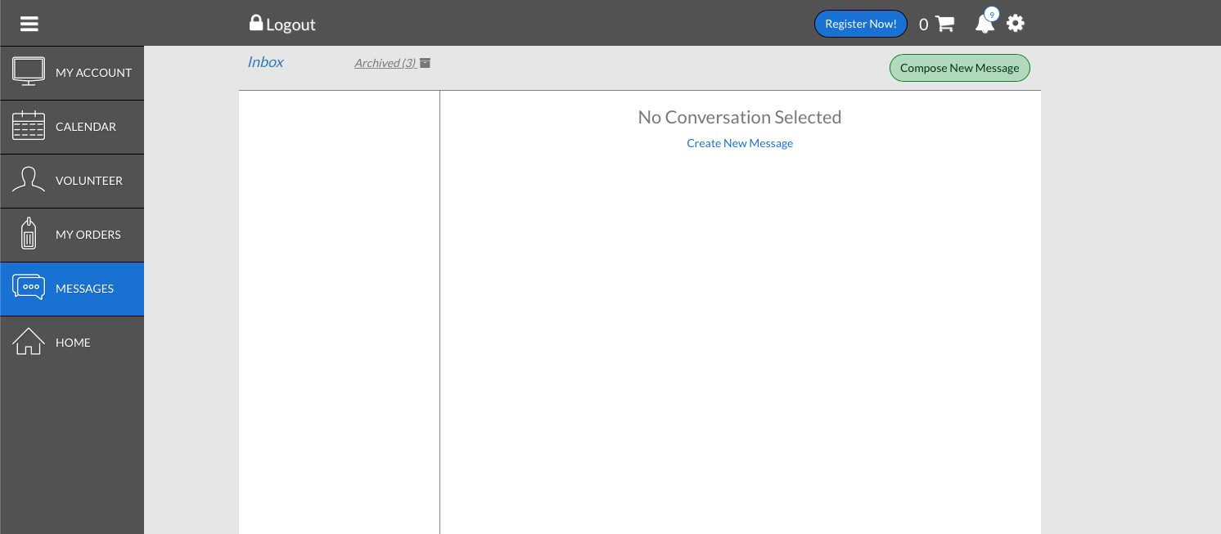

LEAGUE SUBSTITUTION SYSTEM
This substitution system is designed to provide every player with an equal opportunity for improvement. The substitution system ensures that no player sits out more than one possession at a time, every player plays offense and defense in every game, in most cases, each player will play against someone of equal ability, coaches are not able to make unfair substitutions or to be accused of doing so, coaches do not have to monitor playing time for each player, and playing time for all players is virtually even over the course of the season.
Be prepared with a potential lineup before coming to the field and then be ready to make changes once you get to the field (bring a blank sheet along with the examples below). You will most likely make some kind of change after connecting with the opposing coaches and seeing their lineup. KEY DO’S AND DO NOT’S
- You must rank your players according to their abilities.
- You must fill out the system below by alternating their rank (we will show this below).
- The first player in the first column each week will be based on the game week number (week 1 start with player 1, week 2 start with second player, etc.) We will show this below.
- Do not change the rotation during the season.
- Do not substitute offense and defense in a time segment.
- Do not switch any columns at halftime.

HOW TO FILL OUT THE SUBSTITUTION SYSTEM
- Rank your Players A-H based on their abilities. A is your “best” player and your H player is the player who need most improvement.
- Fill out the system in order by A,C,E,G,I,B,D,F,J,H on the form.

HOW TO FILL OUT THE SUBSTITUTION SYSTEM
Rank your Players A-H based on their abilities. A is your “best” player and your H player is the player who need most improvement.

Fill out the system in order by A,C,E,G,I,B,D,F,J,H on the form.
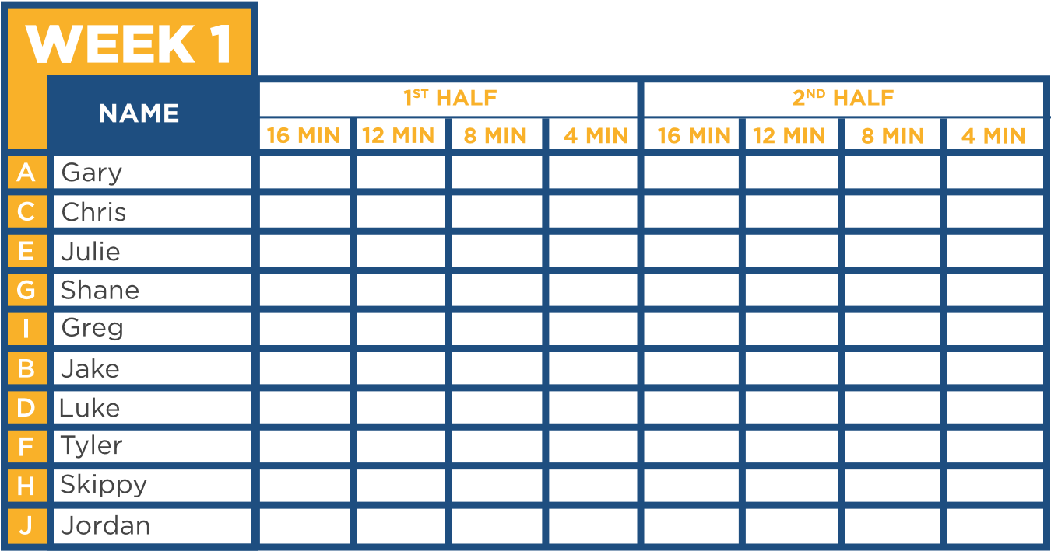

Beginning with your first player in the first column, place an “X” for the first five players.

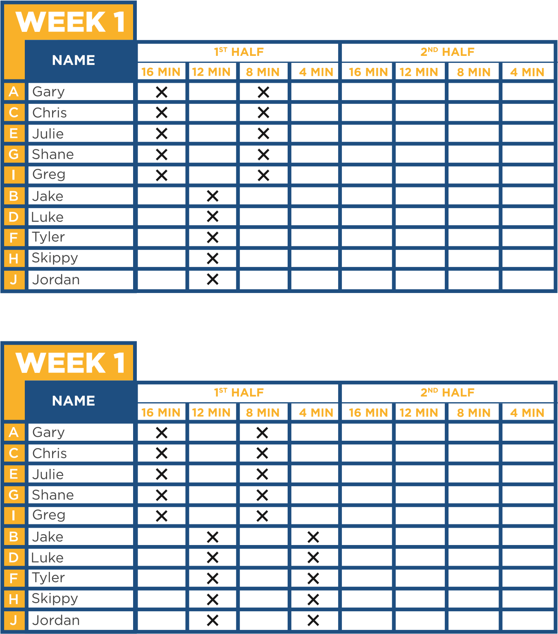
If you have less than 10 players, you simply skip the line and go down to the next line in the column (or go back up to the top if you are at the bottom)
For example, let’s say Greg and Jordan will miss the first game. Here is what would happen.
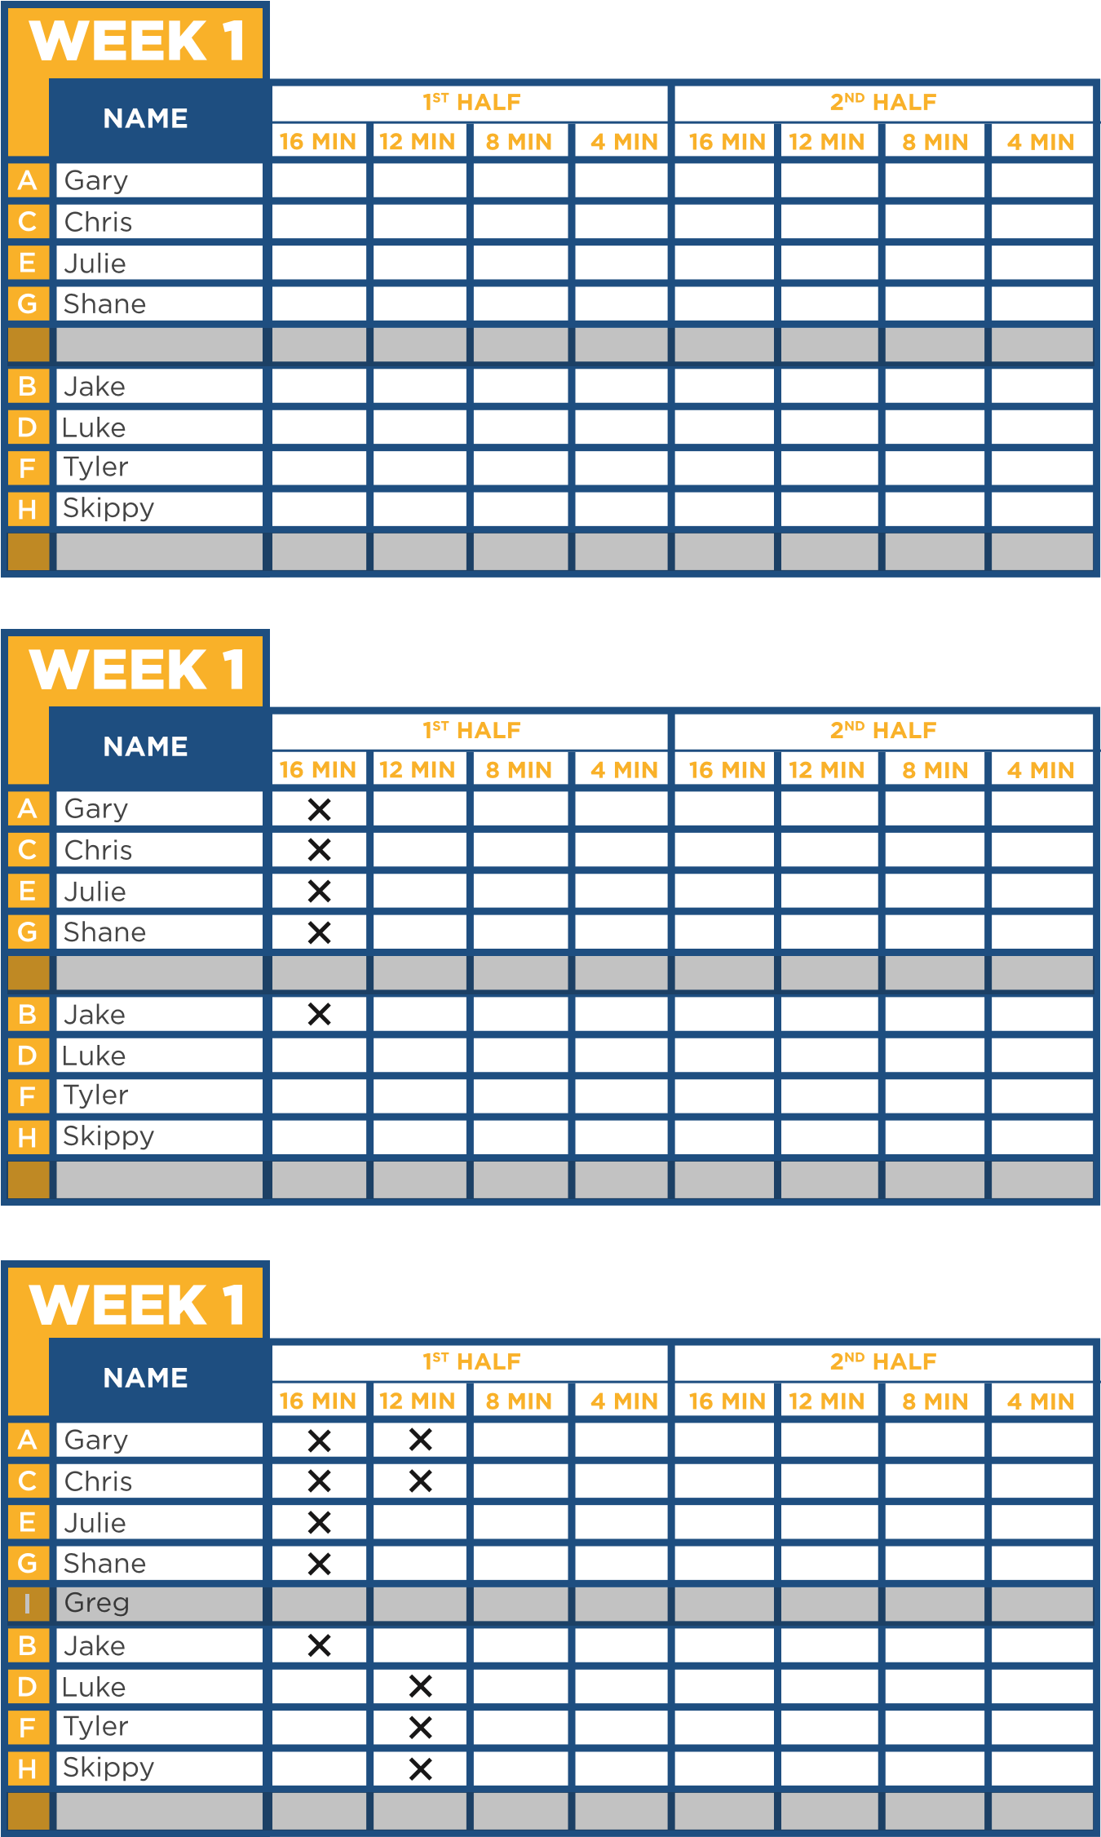
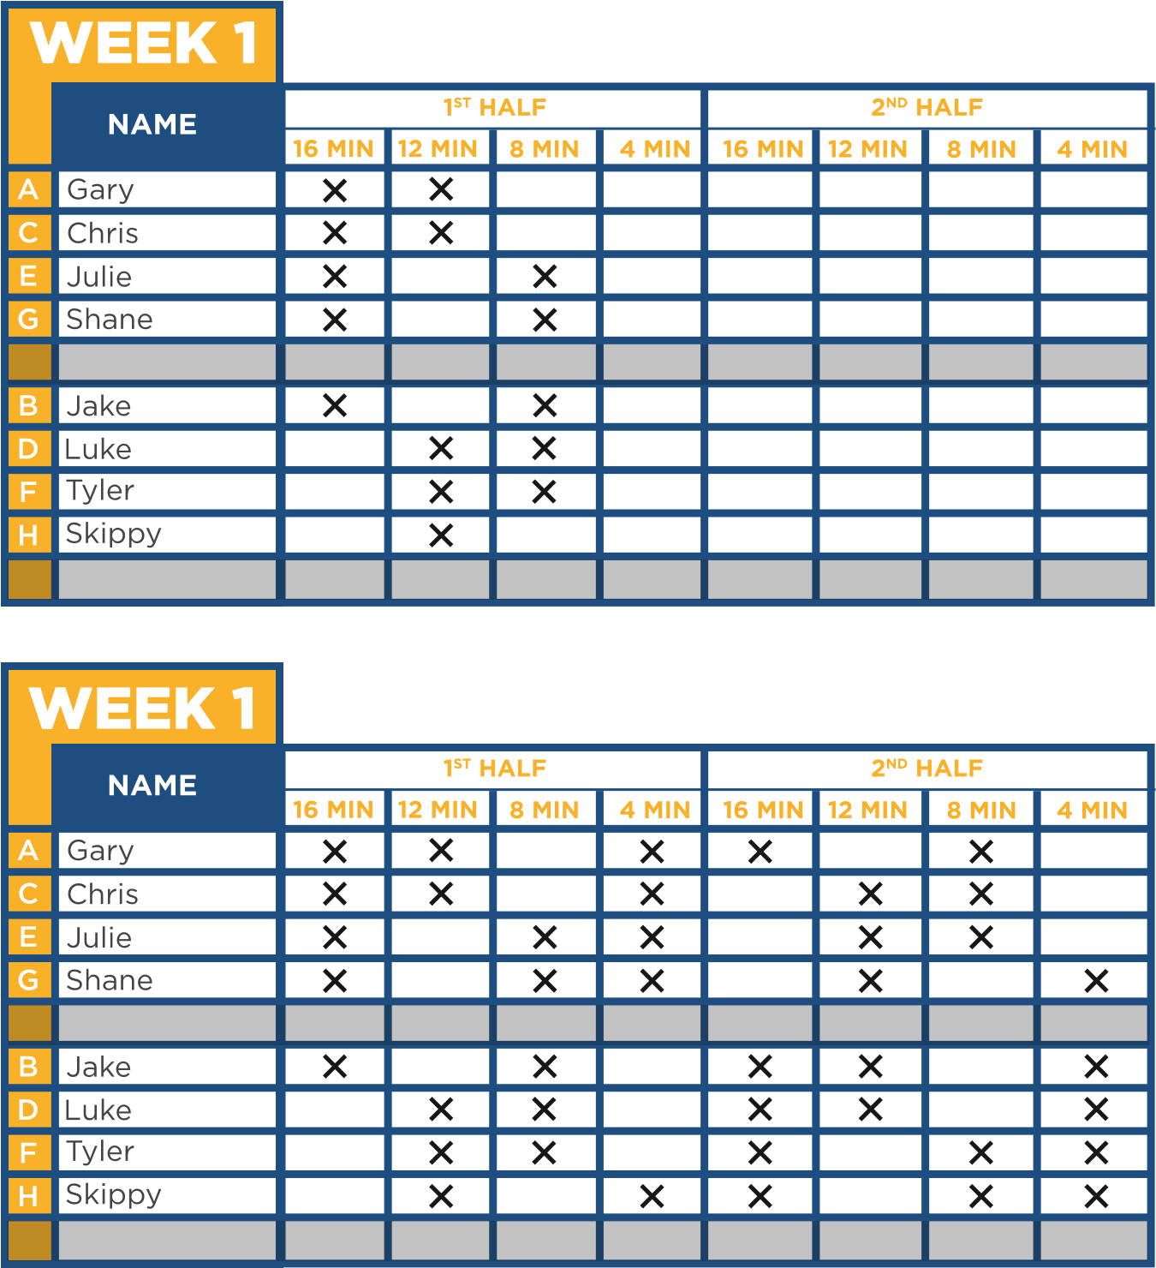
What if you only have 8 players on your whole roster? Or
only 9 players on your roster?

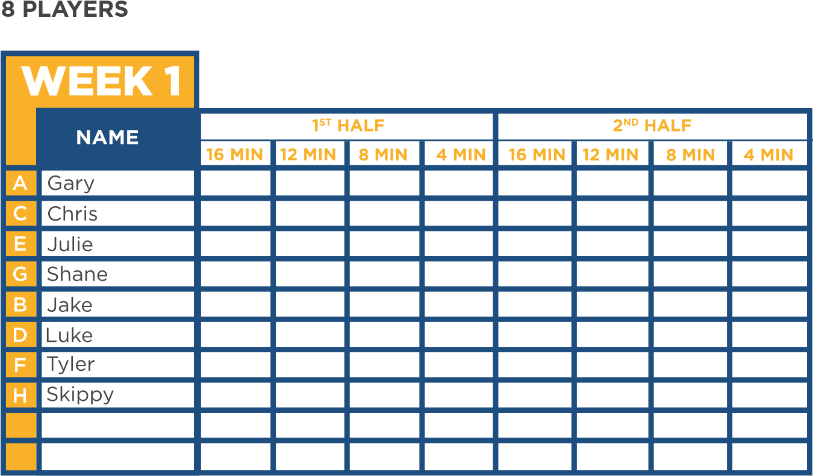

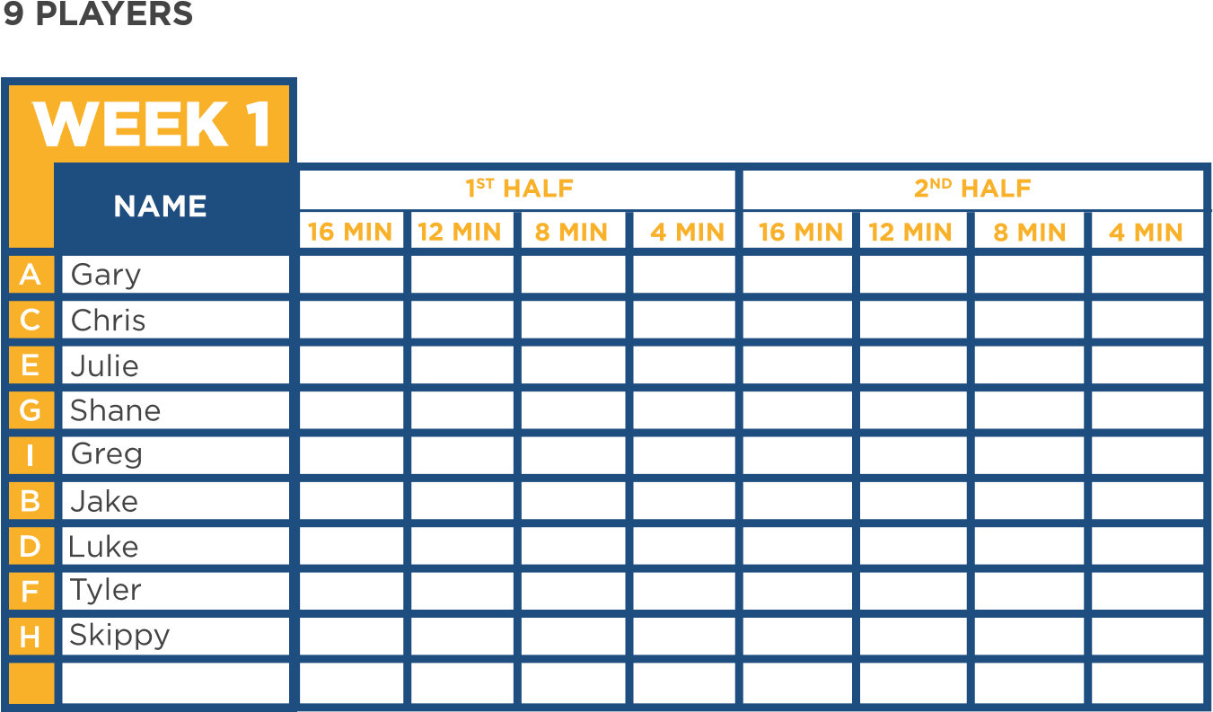

Now let’s go to week #3 and assume we only have 9 players
(out of 10 total). Shane will not be there.

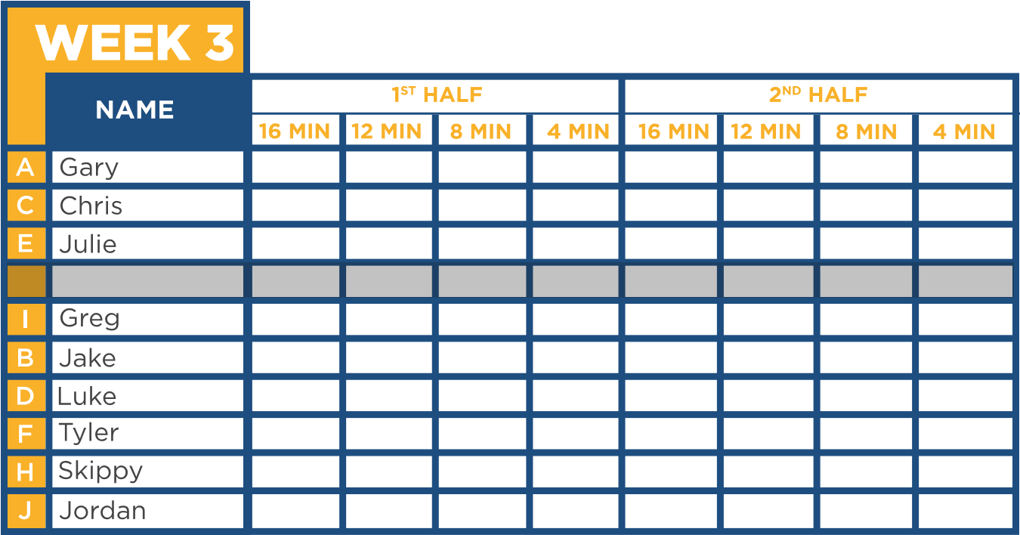
Since this is week #3, we will start with the 3rd player on the
rotation.

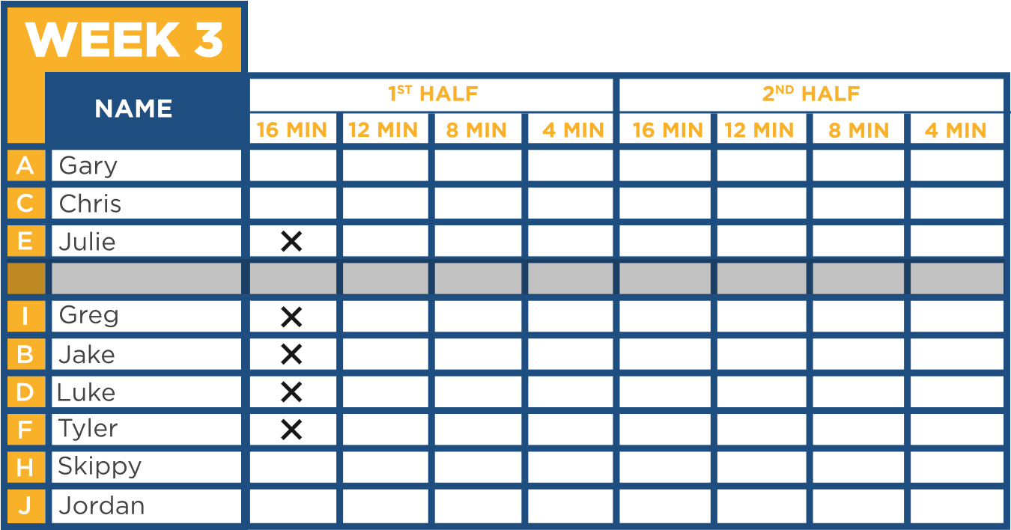
We then will go over to the next column for the second time
period.

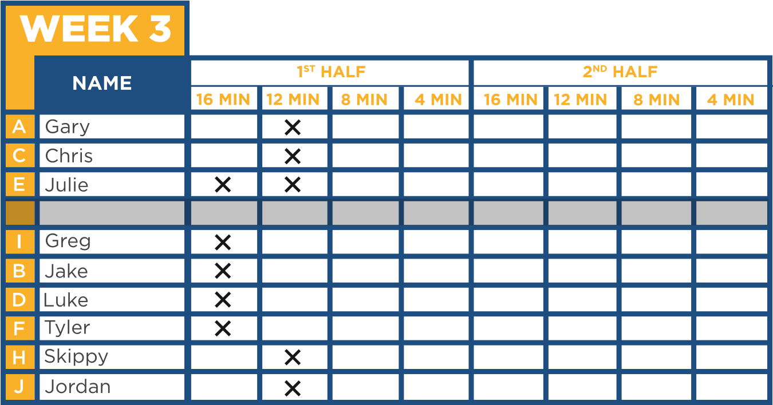

We will then finish going all the way across the rotation.

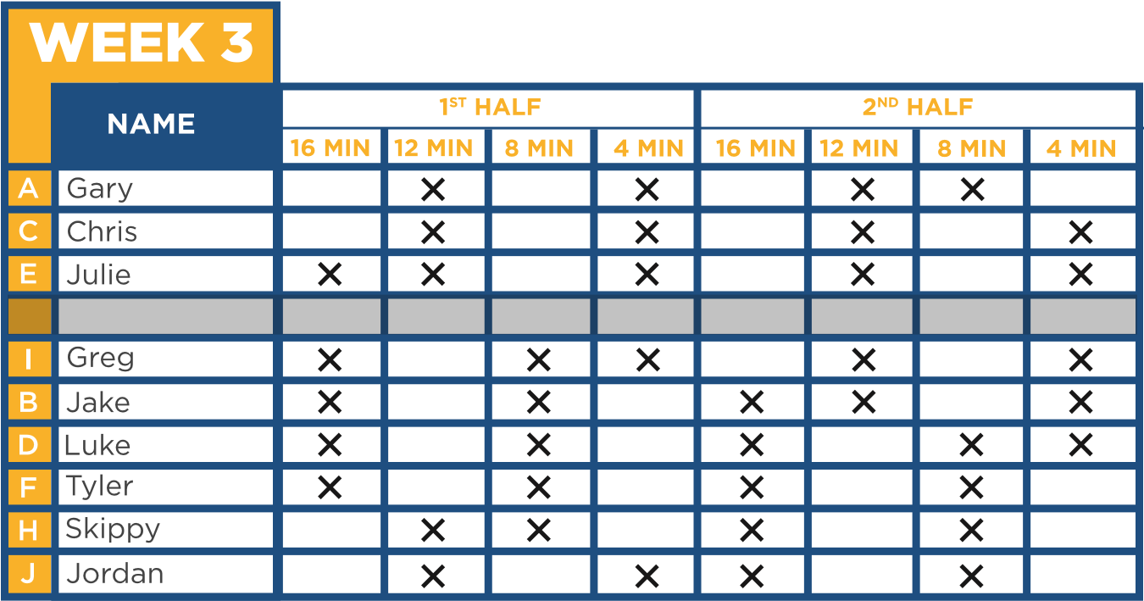

NAME
1
ST
HALF
2
ND
HALF
WEEK 1
A
C
E
G
I
B
D
F
H
J

NAME
1
ST
HALF
2
ND
HALF
WEEK 1
A
C
E
G
I
B
D
F
H
J

NAME
1
ST
HALF
2
ND
HALF
WEEK 1
A
C
E
G
I
B
D
F
H
J

NAME
1
ST
HALF
2
ND
HALF
WEEK 1
A
C
E
G
I
B
D
F
H
J

NAME
1
ST
HALF
2
ND
HALF
WEEK 1
A
C
E
G
I
B
D
F
H
J

NAME
1
ST
HALF
2
ND
HALF
WEEK 1
A
C
E
G
I
B
D
F
H
J

NAME
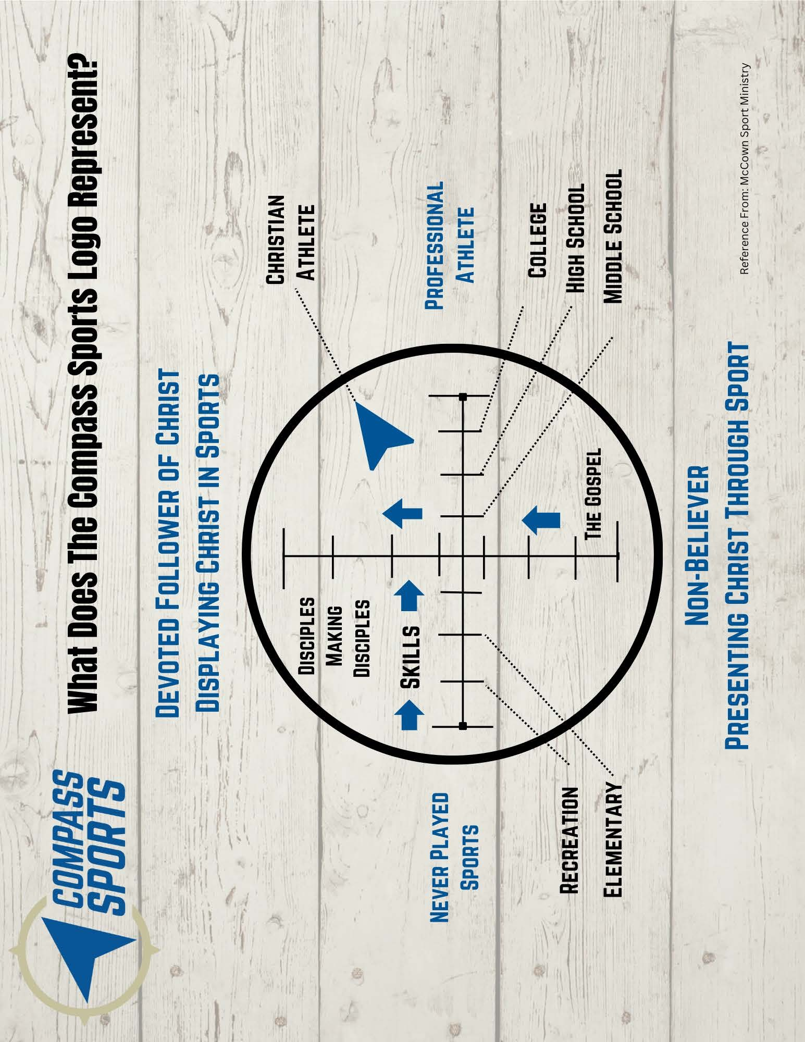

coolspring.org/sports
facebook.com/CompassSportsRVA

