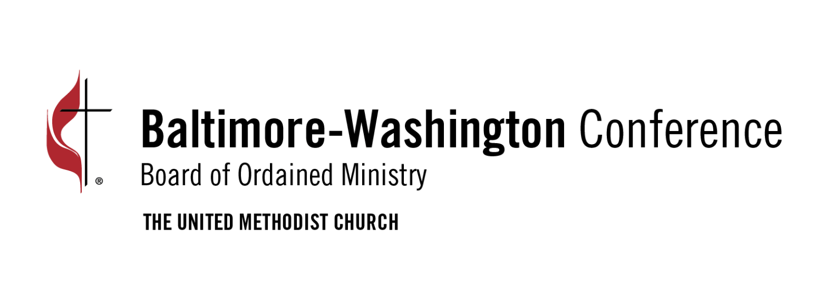

Instructions for Full Member Written Responses to the Book of Discipline
Due September 15

Your written examination responses must be submitted through the form indicated on the Full Member Checklist by the due date of September 15. Please use the template provided on the Full Member webpage and pay close attention to the following formatting requirements:
- The document should be in PDF format.
- Your responses should be in 12 point type and Times New Roman font.
- Margins should be one inch.
- Each page must be numbered at the bottom right, and the text must be double spaced.
- Type your name on the top right-hand corner of each page.
- Type the text of each question at the top of the page.
- Begin each question on a new page.
- Limit your response to no more than 3 pages per question.

We acknowledge the growing use of AI tools such as ChatGPT. These tools may be helpful for research; however, they should not be used to generate your responses. Your work should reflect your own knowledge, understanding, experience, and faith. As with all research sources, any information obtained through AI tools must be properly documented and cited. The Board of Ordained Ministry follows the plagiarism policy established by GBHEM and expects all candidates to do the same.

Failure to follow these formatting requirements may impact the review of your submission.

A template for the written responses and the grading rubric are available for download on the Full Member webpage.

- VOCATION ¶330.5/335.8-- b).(1), c).(2) & 3)
  - How has your experience of ministry shaped your understanding of your vocation as an ordained deacon OR elder?
  - Describe and evaluate your personal gifts for ministry and how they have resulted in fruitful ministry. What would be your areas of strength and areas in which you need to be strengthened in order to be more fruitful in ministry?
  - For the sake of the mission of Jesus Christ in the world and the most effective witness to the Christian gospel, and in consideration of your influence as an ordained minister, are you willing to make a complete dedication of yourself to the highest ideals of the Christian life; and to this end will you agree to exercise responsible self-control by personal habits conducive to bodily health, mental and emotional maturity, integrity in all personal relationships, social responsibility, faithful sexual intimacy expressed through fidelity, monogamy, commitment, mutual affection and respect, careful and honest communication, mutual consent, and growth in grace and the knowledge of the love of God? Explain how you will live into this commitment.

PLUS these three additional questions:
Q1. How do you discern spiritual maturity in yourself and in others? (Wesley's concept of growing and being made perfect in love)
Q2. How do you hear and discern God's will in the clutter of your life?
Q3. Do you have a personal and public accountability network, such as a clergy study group, covenant discipleship group, etc? Describe the effect of this group on your life and ministry.

- CALL AND SPIRITUAL LIFE ¶330.5/335.8 -- a).1.(a) & (b) & (c)
Give examples of how the practice of ministry has affected your experience and understanding of:
  - God;
  - Humanity; and,
  - The need for divine grace.

PLUS these two additional questions:
Q4. What spiritual disciplines and habits do you practice to keep your faith and ministry growing and vital? Q5. How do you share your faith with a local congregation or ministry setting and beyond?

- THEOLOGY OF CHURCH AND SACRAMENTS ¶330.5/335.8 -- a).(1). (d) & (e) a.(2), a).(1).(f), a).(3)
Give examples of how the practice of ministry has affected your experience and understanding of:
  - The Lordship of Jesus Christ; and,
  - The work of the Holy Spirit.
  - How do you understand the following traditional evangelical doctrines: repentance; justification; regeneration; sanctification? What are the marks of the Christian life?
  - Give examples of how the practice of ministry has affected your experience and understanding of the meaning and significance of the sacraments.
  - How has the practice of ministry informed your understanding of the nature and mission of the Church? What are its primary challenges today?

PLUS this additional Question:
Q6. What are the means of grace and how do these serve as resources for ordained ministry over time?

- THEOLOGY OF GOD ¶330.5/335.8-- a.4, a.(1).(g) & (h)
  - The United Methodist Church holds that Scripture, tradition, experience, and reason are sources and norms for belief and practice, but that the Bible is primary among them. What is your understanding of this theological position of the Church, and how has your practice of ministry been affected by this understanding?

Give examples of how the practice of ministry has affected your experience and understanding of:
  - The kingdom of God; and,
  - Resurrection and eternal life

PLUS these two additional questions:
Q7. Explain the Wesleyan concept of grace, including prevenient, justifying and sanctifying grace. Reflect on this concept theologically from the perspective of your experience as a provisional deacon or provisional elder. Q8. What major theologians or theological streams have influenced your personal theology? Give examples that show how you have incorporated them into your working theology.

- PRACTICE OF MINISTRY ¶330.5/335.8-- c).(1), c).(4) & (6)

DEACON candidates only:
  - Do you offer yourself to be appointed by the bishop to a primary appointment, and when required a secondary appointment, that supports the church’s mission? How has the practice of ministry affected your understanding of the expectations in non-itinerant ministry?

ELDER candidates only:
- How has the practice of ministry affected your understanding of the expectations and obligations of the itinerant system? Do you offer yourself without reserve to be appointed and to serve as the appointive authority may determine?
- Provide evidence of your willingness to relate yourself in ministry to all persons without regard to race, color, ethnicity, national origin, social status, gender, sexual orientation, age, economic condition, or disability.
- Provide evidence of experience in peace and justice ministries.

PLUS these two additional questions:
aQ9. Discuss your understanding of clergy authority. In your particular calling (Deacon or Elder) what does this authority entail? How do you set boundaries around the power that clergy authority confers?
Q10. Explain the Baltimore-Washington Conference policy clergy transition, where can it be found and why it is important. How do you uphold this policy?

CHRISTIAN ETHICS & SPIRITUAL LEADERSHIP: Answer all questions
  - What is your understanding of Christian ethics? Please provide your working definition of Christian ethics.
  - An ethical dilemma occurs when moral values are in conflict. Choose two ethical dilemmas that you have faced in your practice of ministry, one which deals primarily with an issue of personal morality and one which deals primarily with an issue of systemic morality. For each ethical dilemma, describe how you handled it. While pastoral concerns are relevant, the ethical issues and process should be at the heart of your response. Demonstrate the ethical process that helped you deal with each issue. What sources informed your process? What ethical issues are at stake and what response can be made from a Christian perspective?
  - Describe a conflict you had to handle in your ministry. How did you resolve it? To whom/what did you turn for help? What did you learn from it? What did you do right? What would you do differently in the future?
  - What is your usual or preferred leadership style? Describe how you would lead a group to reach a decision on an issue where there is a lot of divisiveness and/or passion around the issue, such that the two sides have difficulty hearing each other.
  - Will you regard all pastoral conversation of a confessional nature as a trust between the person concerned and God? Under what circumstances might you break such a trust? (based on 335.c.5)

