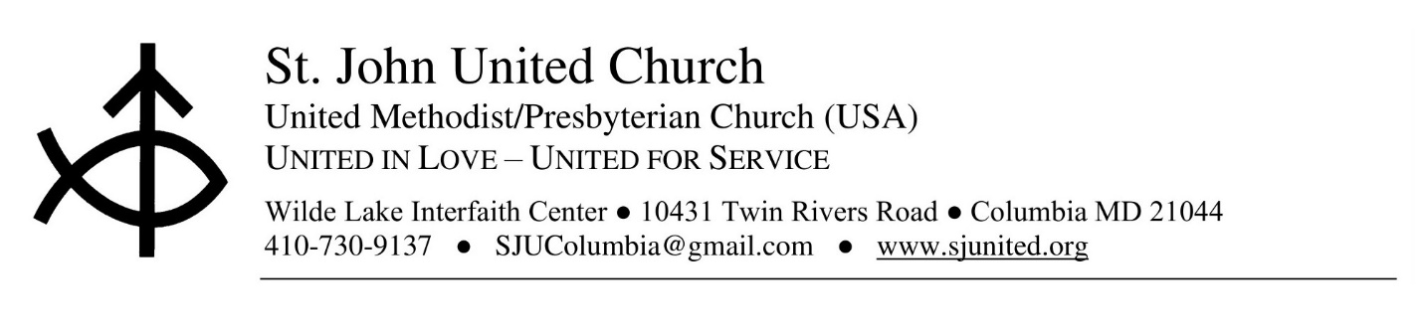
St. John United Church was established over 50 years ago during the creation of Columbia, Maryland. It has a rich history of ecumenical ministry that transforms communities, changes lives and welcomes all through its doors. We are seeking someone with skills to effectively manage the church office in downtown Columbia at the Wilde Lake interfaith Center

POSITION: Church Administrator (Part-Time)

SUPERVISOR: Pastor

QUALIFICATIONS
- Proficient in the use of PC, and Google products with a special emphasis on Microsoft Word and PowerPoint.
- Willingness to learn new software applications.
- Knowledge of the fundamentals of email and experience with quick books or other accounting software.

- Good communication and organization skills.
- Good verbal and writing skills.
- Knowledge of basic church operations.
- Ability to maintain confidentiality.
RESPONSIBILITIES

- Digital communication: Church email blasts, updating social media pages, and creating event flyers.
- Typing.
- Assists with photocopying.
- Organizing and filing documents.
- Entering church data – updating Membership data and assisting with conference reporting.
- Producing and collating church bulletins.
- Handling church / Pastor’s correspondence.
- Greeting visitors.
- Interacting with Vendors on the church’s behalf.
- Yearly Charge Conference reporting.
- Attend BWC webinars / trainings applicable to your position.
- Other duties as assigned.

HOURS AND COMPENSATION
The position is part-time, 20 hours per week
Flexible hours between 8:00am - 6:00pm
30 minutes for lunch or two 15-minute breaks
Please send cover letter and resume to Pamila.brown@mdcourts.gov . Please provide two references. All applicants subject to background check.

