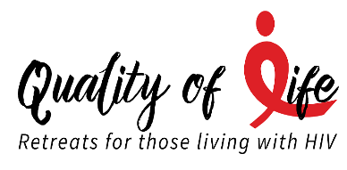
CELEBRATE LIFE!
Caring * Connecting * Supporting


NIFTEE THRIFTEE SHOPPE
The Niftee Thriftee Shoppe is operated as a non-profit project of the United Women in Faith since opening in 1973. This shop is run entirely by dedicated volunteers whose commitment helps them support missions to serving the needs of women and children. They rely solely on donations and are grateful for the generosity from the community which enables them to support local, national, and international organizations.
The Quality of Life Retreats has been a recipient of generous proportions from this organization for the past few years. We are grateful for their magnificent support.
All proceeds from the Thrift Shop benefit the following organizations:

Local 80%
- Anne Arundel Food Bank
- Mary’s Center (Catholic Pregnancy Center)
- Sarah’s House
- Quality of Life Retreats
- Anne Arundel Meals on Wheels
- Child Hunger Outreach Partners
- Helping Up Missions
- Chrysalis House
- Westminster Rescue Mission
- Sexual Assault/Spousal Abuse Resource Center
- House of Ruth
- YWCA
- Opportunities Ministries (Provides affordable housing to people overcoming substance abuse)
- Susanna Wesley House
National – 10%
- Red Bird Mission
- Henderson Settlement
- MD Bible Study
International – 10%
- UMCOR
- Doctors Without Borders
- Heifer International
- Mercy Ships

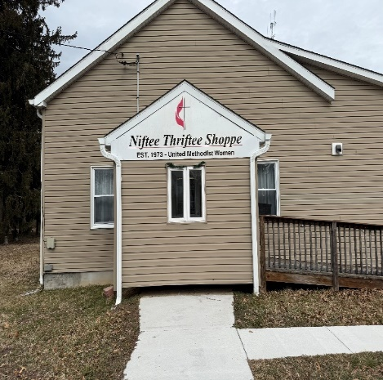
3703 Mountain Road
Pasadena, MD 21122

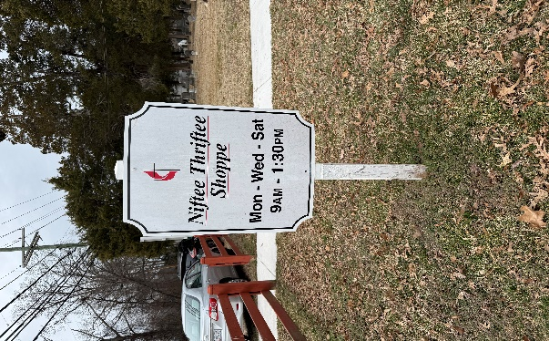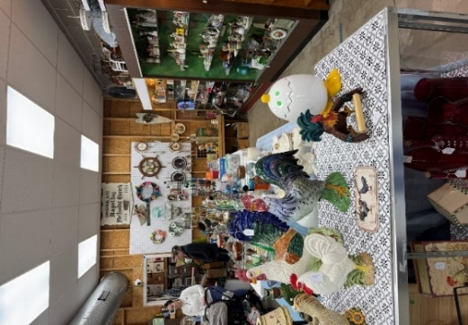


Upcoming 2026 Events
July 18: QLR Board Meeting (In person)
Sept. 10-13: Retreat – Manidokan Camp & Retreat Center
Nov. 14: QLR Board Meeting (ZOOM)
Dec. 7-10, 2026 –Retreat - Bon Secours Retreat & Conference Center



Organizations/Churches

We continue to give thanks for the following organization/churches that have continued to annually support us through financial gifts, snacks, gift bags and drinks:
- Grace United Methodist Church of Baltimore
- Linden-Linthicum United Methodist Church in Clarksville
- Asbury United Methodist Church in Arnold
- Ebenezer United Methodist Church in Lanham
- Niftee Thriftee Shoppe of Magothy United Methodist Church (all proceeds from their sales come to QLR)
- Baltimore/Washington Annual Conference
Thanks to each one of you for your continued dedication to this ministry.

LIFE IS A JOURNEY
WOMEN’S RETREAT
May 4-7, 2026



The theme for this Retreat was “Life is a Journey” and it was held at the West River United Methodist Church Retreat Center, in West River, Maryland. The participants enjoyed outdoor activities that included cookout and campfire. Communion and Healing services were held.
Life is a journey filled with up and downs, challenges and triumphs. It’s easy to feel discouraged when we stumble or face setbacks, but it’s important to remember that true strengths and glory come from our ability to rise after every fall. Each time we get back up, we become stronger, wiser, and more resilient. Embrace your failure as stepping stones to success. Every setback is an opportunity to learn and grow. Keep pushing forward, and let each fall inspire you to rise higher than before. Remember life is a journey and only you hold the map.

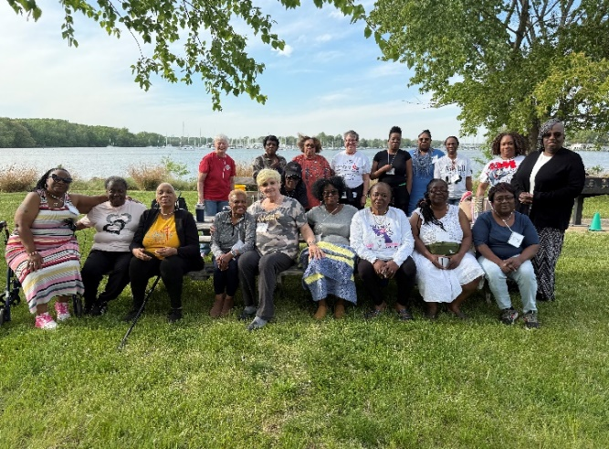

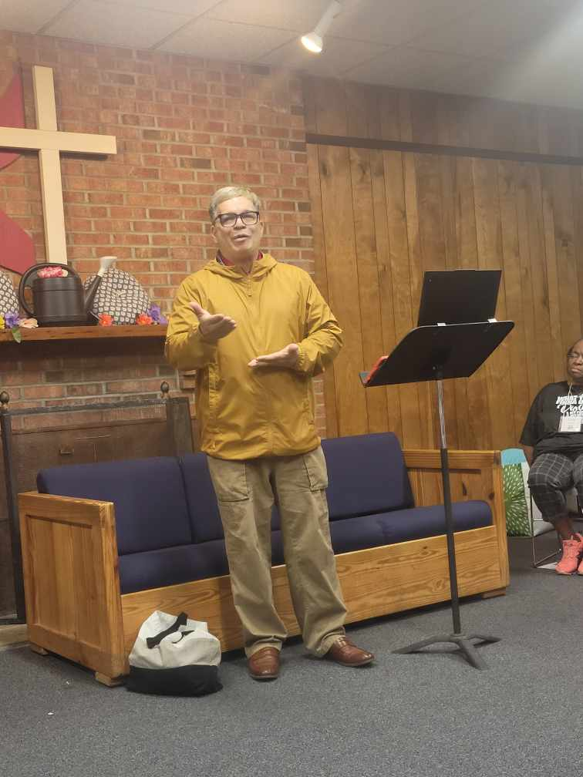
We had a guest speaker (Alfredo Santiago, a member of the QLR Board of Directors). He spoke on “April Showers Make May Flowers.” The focus was on finding growth, hope, and beauty within temporary hardship. The core message is that challenges and discomfort (the “showers”) are necessary precursors for success and joy (the “flowers”).

Honoring Nancy Green and Judith Travers


Pastor Nancy Green entered eternal rest on March 30, 2026 at age 75. She was an elementary art teacher where she found joy in helping children discover their creativity and express themselves through art. She answered a deeper call to ministry and served faithfully as a pastor for 20 plus years. Her ministry extended beyond the church when she served as a Board Member and Retreat Director for Quality of Life Retreats for people living with HIV/AIDS, offering compassion, dignity, and hope to those in need. Her service in this area touched lives in profound ways and demonstrated her commitment to living out her faith in action. The QLR Board of Directors will deeply miss Nancy and will remember her not only for what she did, but the gentle and loving way she did it.



On March 8, 2025 Judy earned her heavenly wings at the age of 80. Judy served for over 20 years in the Army National Guard where she was classified as a “sharpshooter”. She was a member of St. Luke’s Roman Catholic Church and served in every capacity where the Church required assistance. She was very active in many clubs including the Knights of Peter Claver Ladies Auxiliary, the Red Hat Society and was an activist for the HIV/AIDS Awareness. When Judy’s son was diagnosed with HIV, she promised him she would get involved in the causes related to HIV. She became a crusader not for one or two years but it turned into a lifetime of involvement from AIDS Walks, AIDS Rides to the Quality of Life Retreats. In the early 1990’s she co-directed our December Retreats. Judy was devoted to this ministry and had established unending friendships with many of the participants. The QLR Board of Directors will remember Judy for her unwavering kindness and ability to bring joy to everyone around her.

