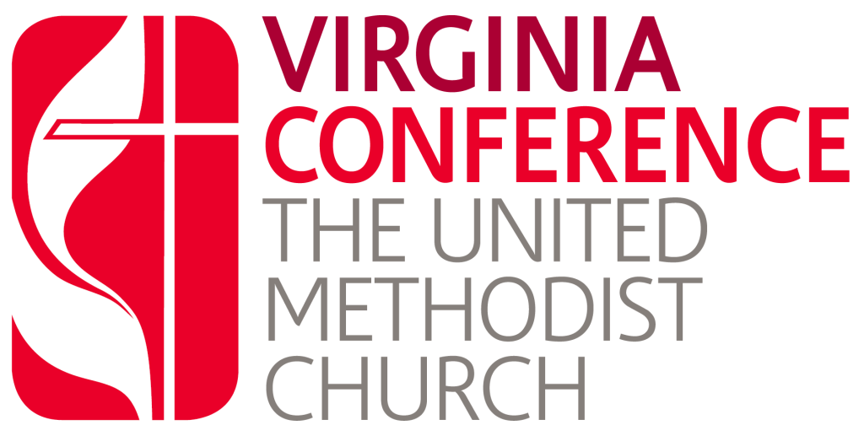
Executive Assistant to the Bishop
The Virginia Conference of The United Methodist Church is seeking a highly organized, adaptable, and professional Executive Assistant to the Bishop. This exempt position provides comprehensive administrative support to the Bishop and assists the Cabinet and Assistant to the Bishop /COO as needed.
The Executive Assistant will manage the Bishop’s calendar, coordinate meetings and travel, arrange accommodations, support the Cabinet’s regular meetings, assist with planning for Annual Conference, and connect the work of the Bishop’s office with the denominational boards and agencies. The position also oversees administrative aspects of the Bishop’s Office budget, including immigration, budget preparation, expense reimbursements, supply purchasing, and expense monitoring.
Successful candidates will have:
- A high school diploma; a bachelor’s degree is preferred
- Administrative experience and experience working within The United Methodist Church
- Deep knowledge of United Methodist organizational structure
- Strong project-management, communication, and interpersonal skills
- Proficiency with Microsoft Word, Excel, and Google Workspace
- The ability to handle confidential information with discretion
- Flexibility to respond to emergencies or other high-priority situations
This is primarily an office-based position with occasional travel for Conference events such as Annual Conference. The role requires regular computer use, document review, written and verbal communication, and the ability to manage multiple priorities in a fast-paced environment. The salary range is $50,000-$65,000.
Applications should be sent to Rev. Doug Forrester at assistanttothebishop@vaumc.org by August 26, 2026.

