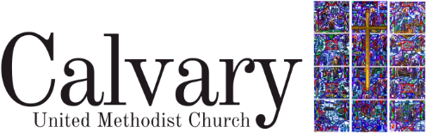
Annapolis, Maryland.

Director of Children and Family Ministry

Calvary United Methodist Church – Annapolis, Maryland
Part-Time • 15 Hours Per Week including Sundays (9:00 AM- 11:30 AM), weekly staff meetings, church council meetings every other month plus quarterly events; remaining hours flexible to accommodate project and event planning.

Position Summary
The Director of Children and Family Ministry provides visionary, relational, and administrative leadership for ministries serving children ages 4 through 5th grade and their families. This role helps children grow in the love, grace, and knowledge of Jesus Christ, while supporting parents and caregivers as spiritual disciplers in the home.

Primary Responsibilities
- Design, implement, and evaluate programming for children and families.
- Create and lead quarterly events including Easter Festival, Trunk or Treat, Advent/Winter Festival, and Vacation Bible School.
- Coordinate Children’s Sunday School scheduling, materials, and teaching (as lead teacher or a volunteer rotation).
- Build relationships with families and develop outreach strategies.
- Recruit and support volunteers.
- Work cooperatively with all staff and volunteers.
- Maintain organized, up-to-date records, supplies and ministry spaces.
- Prayerfully develop pathways for welcoming new children and families into church life.
- Communicate needs and progress regularly with the Pastor and attend weekly staff meetings.
- Supplement and maintain children’s worship activity bags.

Qualifications
- Bachelor’s degree, knowledge in Biblical interpretation, child development, faith development and educational theory preferred.
- Experience in children/family ministry or education in a church, school or organizational setting.
- Growing Christian faith and ability to express theology.
- Strong interpersonal and organizational skills. Ability to work effectively in multi-generational, multicultural and diverse settings.
- Highly self-motivated; able to prioritize effectively and handle confidential information with discretion.
- Must meet Calvary’s Safe Sanctuary Policy requirements.

Key Strengths & Attributes
Strategic Thinker, Relationship Builder, Proactive Leader, Excellent Communicator, Warm & Energetic Presence.

Our Core Values
Accountability, Character, Collaboration, Discovery, Excellence.
Compensation
$21,000-$25,000 per year

