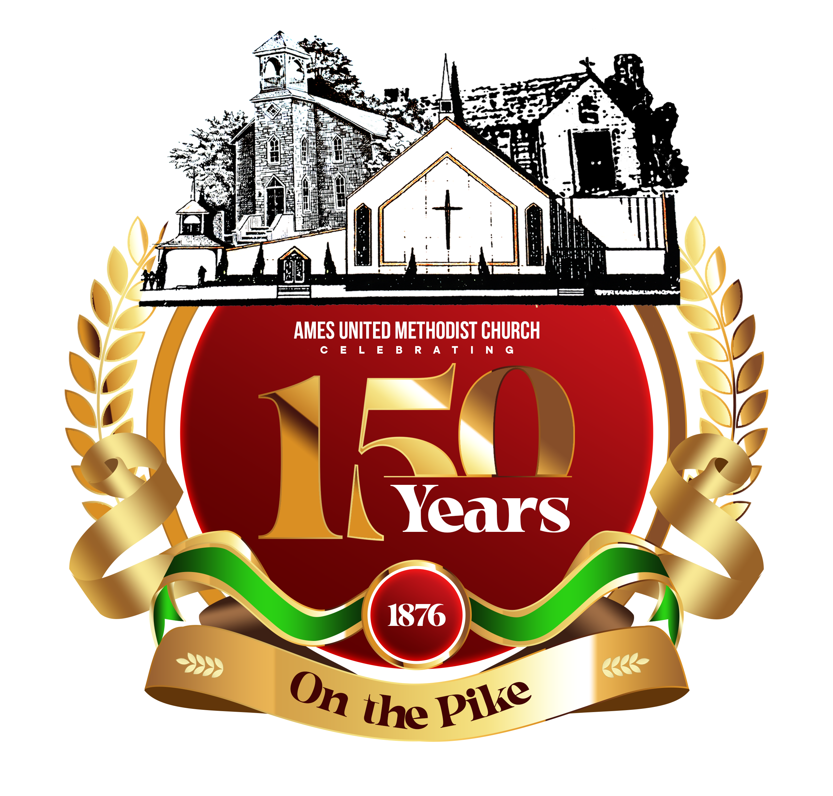
Join the celebration for 150 years of Ames United Methodist Church in 2026.
From 1876, this place of worship has been a focal point for spiritual renewal, community service in Bel Air & beyond and highlighting the awareness of African American History for the citizens of Harford County. We are recognizing the achievements of Ames UMC by sponsoring an event or activity for each month of 2026.

January 24 | Black History Presentation- Dr. James Karmel
February 7 | Black Business Career Expo
March 22 | Food Basket Raffle
April 25 | Fashion Show –facilitated by Lenora Robinson
May 16 | Anniversary Gala- Maryland Golf and Country Club  Speaker- Rev. Dr. Albert Mosley- President of Bethune-Cookman University
June 14 | Bake Sale
July | Fun in the Park- Community Event
August 22 | Recognizing the Senior Adult Disciples of Ames
September 13 | Cultural Explosion
October 25 | Choir Day- featuring local choirs of Harford/Baltimore County  Homecoming Service
November | Heritage Sunday- honoring disciples who grew up in Ames
December 6 | Culminating Luncheon at Ames

In addition, there will be special recognitions on the 5th Sundays to include but not limited to: Hat and Suits Day, School teams and/or Sports Jerseys Day, specific colors, African Attire and Heritage Day. We will have a Prayer Box located in the lobby for your prayer requests. Several local restaurant fundraisers (Community Events) will be sponsored throughout the year.

Please visit our church website for more information-www.amesumc.org or call Joan Wiggins (410-322-6249)-150th Church Anniversary Chair for more details. We solicit your prayers as we endeavor to make this a commemorative year.

