African American History Highlighted as Part of Williamsburg Tourism
by Brenda C. SilerJuly 31, 2024

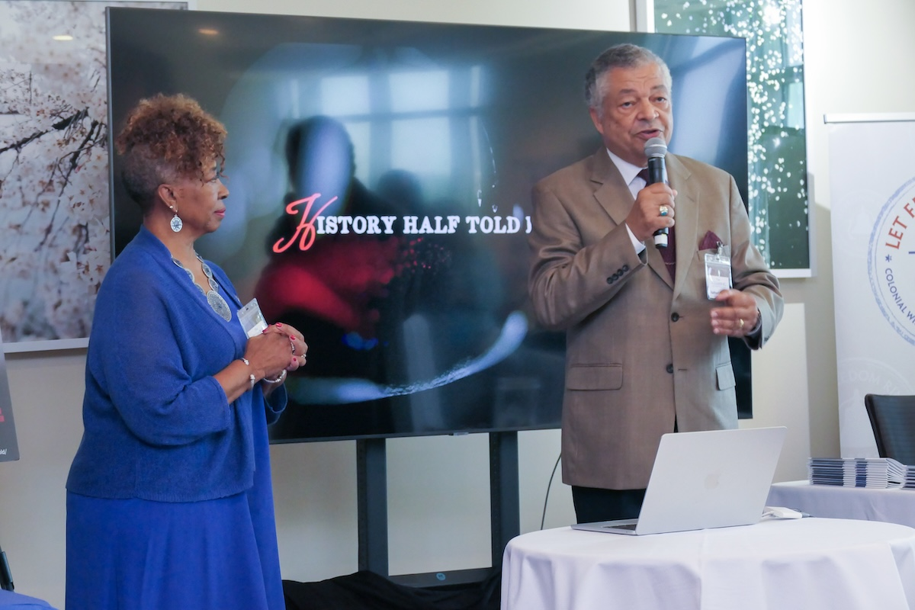

Foundation President Connie Matthews Harshaw and Board Member Nathaniel “Nat” Brown presenting information about the Let Freedom Ring Foundation based in Williamsburg, Virginia. The presentation occurred at a Williamsburg tourism showcase at the Salamander DC Hotel. (Shevry Lassiter/The Washington Informer)
There’s more to Williamsburg, Virginia than what’s in history books or knowing that to get there from D.C. one has to take Interstate 64, and a recent overview of the historic city and the surrounding area at the Salamander DC Hotel in Southwest, offered an opportunity to hear about lodging, dining, entertainment, recreational activities, shopping, and unknown stories..
When visiting historic Williamsburg, tour guides do not skip the legacy of the African Americans who were forced to maintain the large homes of slave owners in Williamsburg, while working to hold onto and create their own traditions, customs and means of survival.
Janice Canaday, supervisor of Interpretation at the Randolph Peyton House, welcomed Laurita and Lauren. She escorted them through the property to show the areas where slaves worked and lived. Next, the mother and daughter went to the Archeological Collections Building in Colonial Williamsburg, where excavation research has occurred for over 100 years. This stop opened the door to another chapter in Williamsburg’s history.

Discovered Artifacts and Burial Sites
The Let Freedom Ring Foundation is committed to uplifting Black history in Williamsburg. Washington Informer Denise Rolark Barnes interviewed Foundation President Connie Matthews Harshaw and Board Member Nathaniel (Nat) Brown on WIN-TV’s digital program “Let’s Talk.” They discussed that the first slaves landed in Virginia in 1619. For 150 years after that important year, African Americans worked, lived, and worshiped in the Williamsburg area.
“We have uncovered that the city of Williamsburg was 52% Black in 1776, freed and enslaved,” said Harshaw. “We can’t forget about this because we are still struggling with it.”
The Foundation also advocates that African American history is American history through a documentary, “History Half Told is Untold.” The film is about the oldest Black church in America, First Baptist Church in Williamsburg.
“That documentary tells a more complete story of our history,” said Brown. “We’ve made a concerted effort to get this documentary out to everyone in Williamsburg and beyond.
The foundation is now connected with one of the most significant archeology projects in the country. Artifacts from the original Baptist church were found after it was relocated, and 62 intact burials were found. Markers have been laid on those burial locations indefinitely. Visitors to the former church and burial sites do not have to pay to view the area.
Further, the College of William and Mary, located in Williamsburg, has digitized the church artifacts.
The foundation is collaborating with Michael Blakey, Ph.D., National Endowment for the Humanities Professor of Anthropology, Africana Studies, and American Studies at William and Mary to ensure proper research for what has been found in Williamsburg.
Blakey, who grew up in Washington, D.C., and graduated from Calvin Coolidge High School in Northwest D.C., has worked with many African burial projects nationwide.
To learn more about the Let Freedom Ring Foundation, visit the website at firstbaptistchurch1776.org.
For more information about Williamsburg, check out visitwilliamsburg.com

