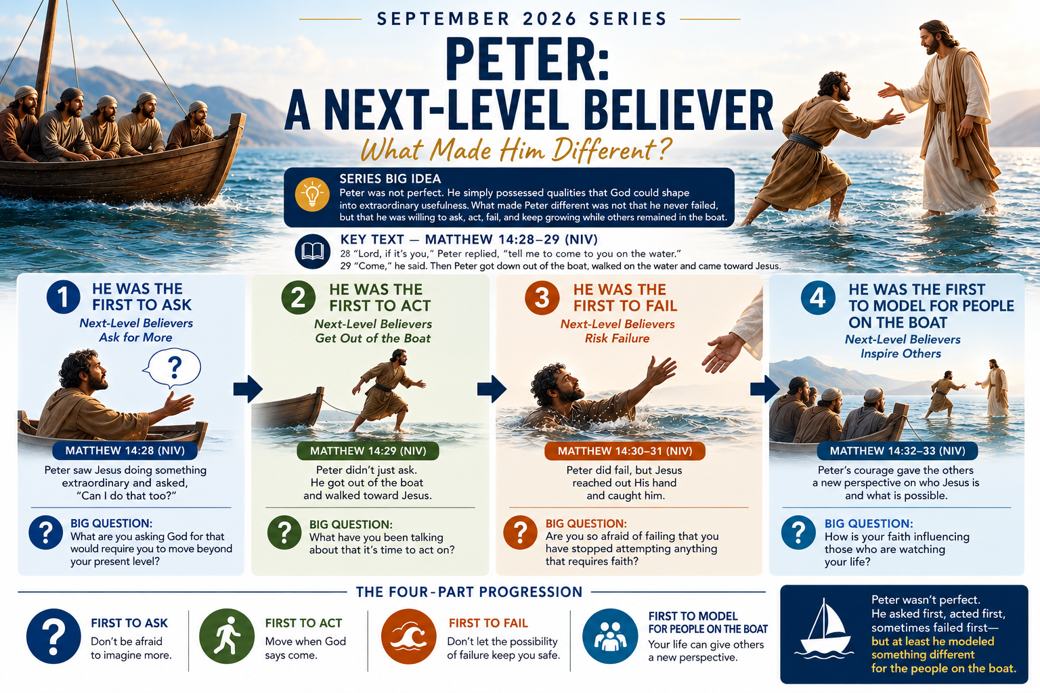


Peter: A Next-Level Believer
(What Made Him Different?)
“He Was the First to Ask”
Sunday, September 6, 2026
Series Big Idea:
Peter was not perfect. He simply possessed qualities that God could shape into extraordinary usefulness. What made Peter different was not that he never failed, but that he was willing to ask, act, fail, and keep growing while others remained in the boat.

Key Text — Matthew 14:28–29 (NIV)
28 “Lord, if it’s you,” Peter replied, “tell me to come to you on the water.”29 “Come,” he said.
Then Peter got down out of the boat, walked on the water and came toward Jesus

I. What the First to Ask Looks Like
The Setting: After feeding the 5,000 people he goes to the Sea of Galilee (or Lake Kinneret)
²² Immediately Jesus made the disciples get into the boat and go on ahead of him to the other side, while he dismissed the crowd. ²³ After he had dismissed them, he went up on a mountainside by himself to pray. Later that night, he was there alone, ²⁴ and the boat was already a considerable distance from land, buffeted by the waves because the wind was against it.
²⁵ Shortly before dawn Jesus went out to them, walking on the lake. ²⁶ When the disciples saw him walking on the lake, they were terrified. “It’s a ghost,” they said, and cried out in fear.
²⁷ But Jesus immediately said to them: “Take courage! It is I. Don’t be afraid.²⁸ “Lord, if it’s you,” Peter replied, “tell me to come to you on the water.²⁹ “Come,” he said. 28 “Lord, if it’s you,” Peter replied, “tell me to come to you on the water.”Peter saw Jesus doing something extraordinary and essentially asked: “Can I do that too?”

Being the first to ask:
A. Can feel isolating
B. Can look unusual
C. Can leave people amazed
D. Can appear dangerous
E. Can look foolish
Big Question:What are you asking God for that would require you to move beyond your present level?

Key Thought: Sometimes your next level begins with the courage to ask a question nobody else is asking.

II. Things I Regret Asking For
- Revenue-Based Relationships — Friendships with people who saw me only as an income-producing unit.
- Romance Without Roots — Relationships built on attraction but lacking substance.
- Rooms Without Reason — Facilities built merely to seat more people. The pursuit of a new sanctuary, building, or home can become a trap.
- Recycled Programs — Programs borrowed from others without a clear purpose or definition of success.
- Relentless Schedules — Calendars so demanding that they denied me opportunities to rest and caused life to become a blur.
Note: Growth has changed both what I ask for and why I ask for it.

III. Things I Am Asking for Now
- Resources — What I need to fulfill the vision.
- Relationships — People who advance the vision and share my values.
- Room — Time and space to implement what I now see as important.
- Resilience — The health, strength, and stamina needed for the years ahead.
Question: What are you asking for and why?

Appendix: The Sea of Galilee or called today, Lake Kinneret
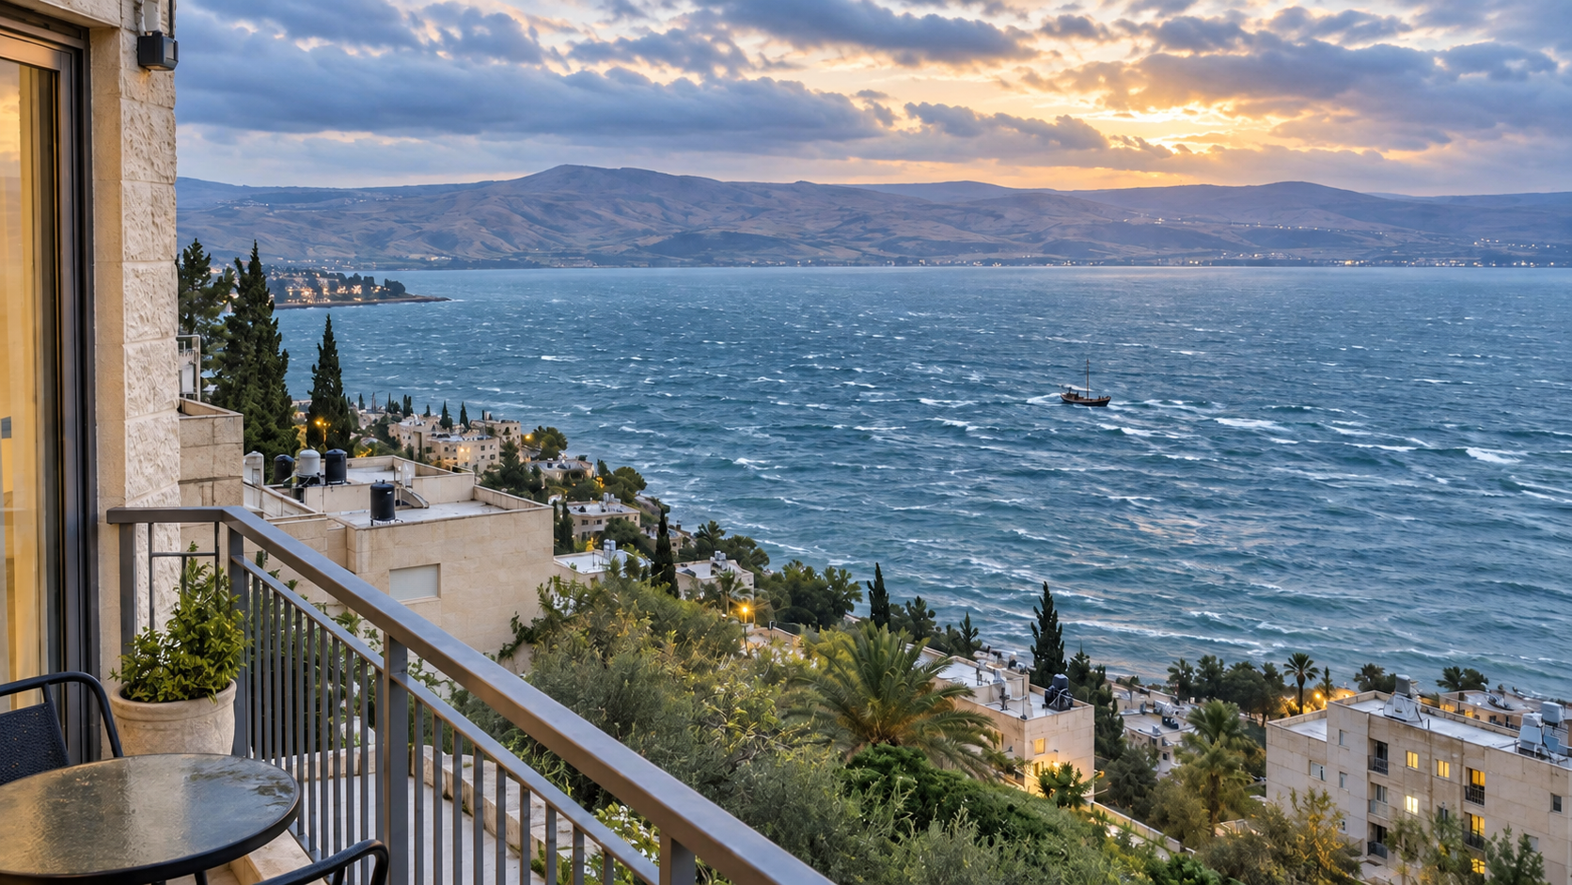

Smart People Question: Why did they call it a Sea when it was a lake.
Answer: They called it the Sea of Galilee because the biblical word translated as “sea” could refer to a large body of water, not only to an ocean.
In Hebrew, the word is yam (יָם), meaning a sea or large body of water. In Greek, the Gospel writers used thalassa (θάλασσα), which can also describe a large lake.
The Sea of Galilee is substantial—approximately 13 miles long and 8 miles wide. From the shoreline, especially during strong winds and storms, it can look and behave like a small sea. It was also large enough to support fishing communities, commercial boat traffic, and dangerous waves.

