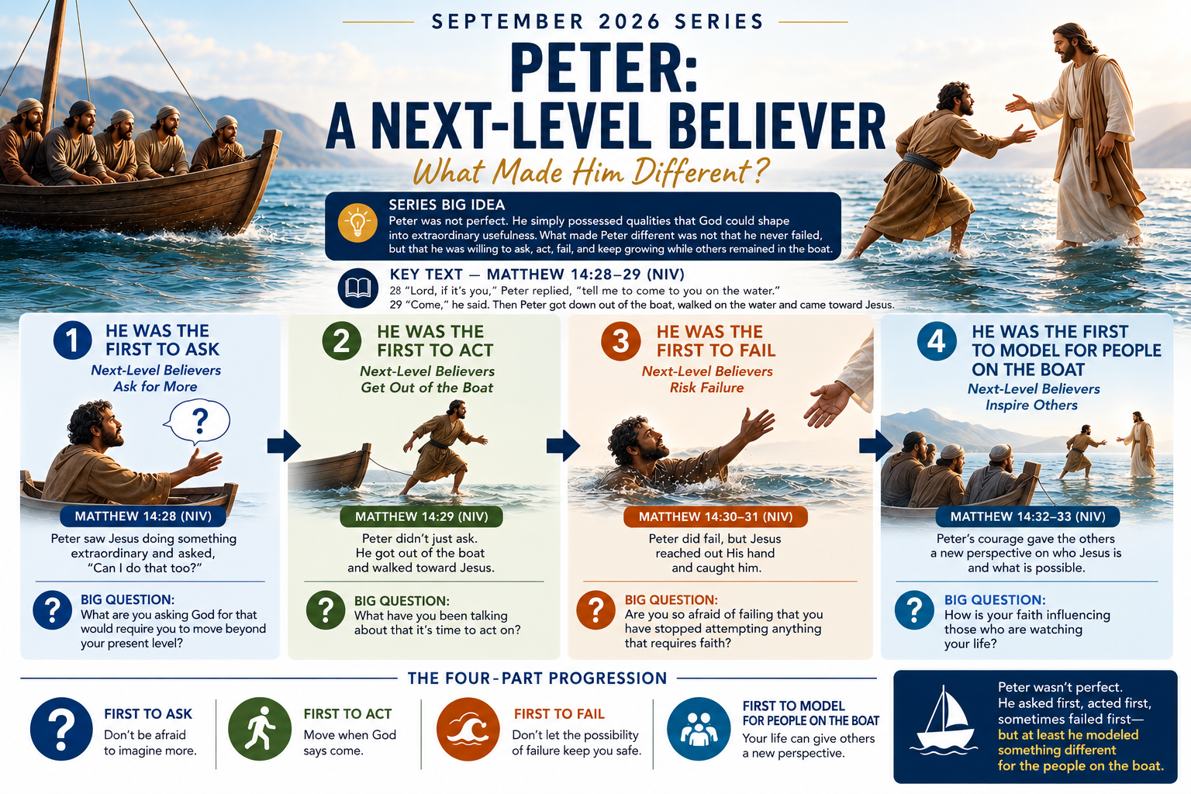

Peter: A Next Level Believer
(The First to Model for People on the Boat)

Sunday, September 27, 2026

Big Question: For whom are you modeling what it means to walk on water?
Scripture — Matthew 14:22-28 (NIV)

²² Immediately Jesus made the disciples get into the boat and go on ahead of him to the other side, while he dismissed the crowd. ²³ After he had dismissed them, he went up on a mountainside by himself to pray. Later that night, he was there alone, ²⁴ and the boat was already a considerable distance from land, buffeted by the waves because the wind was against it.
²⁵ Shortly before dawn Jesus went out to them, walking on the lake. ²⁶ When the disciples saw him walking on the lake, they were terrified. “It’s a ghost,” they said, and cried out in fear.
²⁷ But Jesus immediately said to them: “Take courage! It is I. Don’t be afraid.²⁸ “Lord, if it’s you,” Peter replied, “tell me to come to you on the water.²⁹ “Come,” he said. 28 “Lord, if it’s you,” Peter replied, “tell me to come to you on the water.”Peter saw Jesus doing something extraordinary and essentially asked: “Can I do that too?”

The Four-Part Progression of This Series:
Peter | Next-Level Principle
First to Ask | Don’t be afraid to imagine more.
First to Act | Move when God says come.
First to Fail | Don’t let the possibility of failure keep you safe.
Not Looking from the Boat | Experience gives you a perspective spectators cannot have.

Note: Peter was not perfect. He asked first, acted first, and sometimes failed first—but at least he was not looking at his future from the boat.

Important Balance: We are responsible to guard our hearts!
“Above all else, guard your heart, for everything you do flows from it.” (Proverbs 4:23)
Statement:
God designed us to live primarily by wise principles, not by constantly looking for walk-on-water or Red-Sea-opening moments. Most of life is lived on ordinary ground, where God expects us to use wisdom, plan carefully, work diligently, seek counsel, manage our resources, practice self-control, and make responsible decisions. Extraordinary miracles were never intended to replace ordinary wisdom.
Every day is not designed to be a walk-on-water day. Peter probably walked thousands of miles on land and only once walked on water. Israel crossed the Red Sea once, but afterward they had to walk through the wilderness one day at a time. Build your life around wise principles, but remain ready for those extraordinary moments when God says, “Come.”
Questions That We Need to Explore:
- What if the people around you don’t want to get off the boat?
- Accept their level of dream for themselves. Try to inspire without becoming addicted with the desire to change their perspective.
- Are you required to walk on the water all the time?
- You can’t be, it is emotionally destructive to try
- How do you get over the embarrassment of sinking in front of everyone watching on the boat?
- Ignore them, what can they say if they never tried?
- Expect you will potentially sink at times and keep reaching
- What if you are just not walking on the water type? God has other gifts
Note: Other Gifts: I Corinthians 12
- Word of Wisdom — A Wise Advisor
1 Corinthians 12:8
- Word of Knowledge — A Knowledgeable Advisor
1 Corinthians 12:8
- Faith — A High-Capacity Believer
1 Corinthians 12:9
- Gifts of Healing — Someone Who Facilitates Healing
1 Corinthians 12:9
- Working of Miracles — A Water Walker
1 Corinthians 12:10
- Prophecy — A Message Deliverer
1 Corinthians 12:10
- Discerning of Spirits — A Person With Spiritual Insight
1 Corinthians 12:10
And the verse that explains the purpose of all the gifts is 1 Corinthians 12:7: the Spirit gives these manifestations “for the profit of all”—in other words, God gives you a gift to help somebody else.

