Persisting Love in Bearing Reproach
Lesson Sixty-One • Hebrews 13:9-14

23 Commands in Hebrews 13 for Persisting Love to Move Forward to Our Final Salvation!*
PERSISTING LOVE  for One Another!  (vv. 1-6) | PERSISTING LOVE  with Church Leaders!  (vv. 7, cf. 17, 24) | PERSISTING LOVE  by the Changeless Christ!  (v. 8) | PERSISTING LOVE  in Bearing Reproach!  (vv. 9-14) | PERSISTING LOVE  as Believer Priests!  (vv. 15-17) | PERSISTING LOVE  from the Great Shepherd!  (vv. 20-21) | PERSISTING LOVE  to Keep Moving Forward!  (vv. 18-19, 22-25)
8 Commands in 4 Pairs  Y’all persist in brotherly love and avoid the pitfalls  (sexual immorality & material idolatry)  with godly motivation! | 9 Commands  2 + 0 + 2 + 5  Let us keep going outside the camp to bear the reproach of Jesus as believer priests by imitating  past leaders who finished well (v. 7) and obeying present leaders who teach and lead well (v. 17)  according to the sound doctrine about the changeless Christ, rather than  being carried away by strange doctrines! |  |  |  | NO COMMANDS!  Only blessing from God  through JESUS our Lord to equip us to will and work what is pleasing to God! | 6 Various Commands  Move forward together.  with conviction in community  by God’s ordinary means  of grace!

*15 explicit commands plus 8 implicit ones due to grammatical structure.

“JESUS CHRIST, yesterday and today, the SAME, and into FOREVER!” Hebrews 13:8

Persisting Love Chooses to Bear the Reproach of Jesus

- Refuse to Be CARRIED AWAY by Whatever Is the Latest and Greatest. (13:9-10)

“Do not be carried away by varied and strange teachings;” (v. 9a)

- Being carried away with the latest and greatest bears NO reproach. (v. 9a)

- What might carry you away from Christ?

Curiosity?

Novelty?

Popularity?

Exclusivity?

- What are the various kinds of strange teachings? Ephesians 4:14

- The benefits of being biblically BORING. (v. 9b-10)

Only the Changeless Christ Provides Life-Changing Grace!

The grace of God in Jesus Christ does what no EXTERNAL rule or ritual or religious person can.

Be Biblically Boring but Blessedly Changed

- Grace strengthens us internally in God’s PURPOSES.

“for it is good for the heart to be strengthened by grace, not by foods, through which those who were so occupied were not benefited.” (v. 9b)

Colossians 2:6-12

- Grace brings us into God’s PRESENCE like nothing else can.

“We have an altar…” (v. 10a)

Hebrews 4:14-16
- Grace gives us God’s PRIVILEGES that are greater than any reproach or whatever this world offers.

“We have an altar from which those who serve the tabernacle have no right to eat.” (v. 10)

We presently “have”: [1] a great high priest in Jesus (4:14; 8:1); [2] things (fruit) that have to do with salvation (6:9); [3] the know-so hope of entering the Holy of holies to anchor our souls (6:19); [4] bold confidence to enter by the blood of Jesus (10:19); [5] better eternal possessions in heaven (10:34); [6] an unshakeable kingdom for which we have/show gratitude (12:28); [7] an eternal city we are seeking since we don’t have a lasting one here on earth (13:14); and [8] clear consciences like the pastor teacher (13:18; cf. 9:9, 14; 10:2, 22).

- Grace fulfills God’s PICTURES in the prophecies, people, places, and promises of the Old Testament.

- Remember Jesus Bore OUR Reproach on the Cross. (13:11-12)

Background: The Day of Atonement in Leviticus 16

“For the bodies of those animals whose blood is brought into the holy place by the high priest as an offering for sin, are burned outside the camp. (v. 11)

- The Frequency of Access: Once a year and only the High Priest entered with blood into the Holy of holies.

- The Blood: The blood of these sin offerings was taken inside the Holy of Holies and sprinkled on the mercy seat to cleanse the tabernacle and the people.

- The Cleansing: Unlike regular sin offerings done throughout the year for individual or specific unintentional sins, the Day of Atonement sin offerings cleansed the entire sacred space and the whole community at once.

- The Bull and the Two Goats: Unlike other offerings where the priests would eat a portion of the sacrifice, the blood of these sacrifices were brought directly into the Holy of holies by the High Priest, but the bodies were burned outside the camp!

- The Scapegoat: Alongside the sin offering goat, a second goat (the scapegoat) had the sins of the people confessed over it and was sent away into the wilderness – outside the camp!

Fulfillment: Jesus on earth outside the city gate on the cross and in heaven at the right hand of God in the Holy of holies.

“Therefore Jesus also, that He might sanctify the people through His own blood, suffered outside the gate.” (v. 12)

- Jesus did it all for us with an OBEDIENT life.

- Jesus bore it all for us with a SACRIFICAL death.

- Jesus paid it all for us with a RESURRECTED life, ascension, exaltation, session, and intercession.

- Resolve to Bear Jesus’ Reproach by Always Going OUTSIDE the Camp. (13:13-14)

- Let us keep MOVING toward Jesus who is “outside the camp”!

“So, let us go out to Him outside the camp, bearing His reproach.” (v. 13)
“Alexamenos worships his god.”

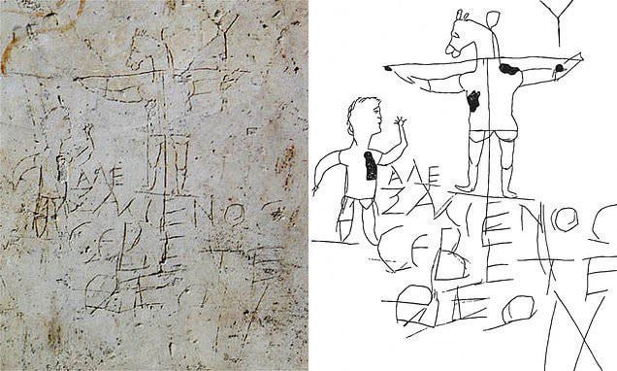

History mocks what heaven honors!

Hebrews 11:24-27; 10:32-34

- Let us keep SEEKING the heavenly city of God where Jesus already is and will one day bring down from heaven!

“For here we do not have a lasting city, but we are seeking the city which is to come.” (v. 14)

Embrace His disgrace as we move forward in persisting love!

Persisting Love Keeps Moving Forward to Bear the Reproach of Christ Outside the Camp!

“Let us go out to Him outside the camp, bearing His reproach. For here we have do not have a lasting city,
but we are seeking the city to come.”

