
Opening: What does God look like?
______________________________________________________________________________________________________________________________________________________________________________________________________________________
Revelation 22:4-5 – They will see his face, and his name will be on their foreheads. 5 And night will be no more. They will need no light of lamp or sun, for the Lord God will be their light, and they will reign forever and ever.

Covenant Renewal (Exodus 34:10; 27-28)
______________________________________________________________________________________________________________________________________________________________________________________________________________________
The Shining (of Moses) (Exodus 34:29-35)
_________________________________________________________________________________________________________________________________________________________________________________________________________________________________________________________________________________________________________________________________
Our Unveiled Faces (II Corinthians 3:12-18)
_________________________________________________________________________________________________________________________________________________________________________________________________________________________________________________________________________________________________________________________________
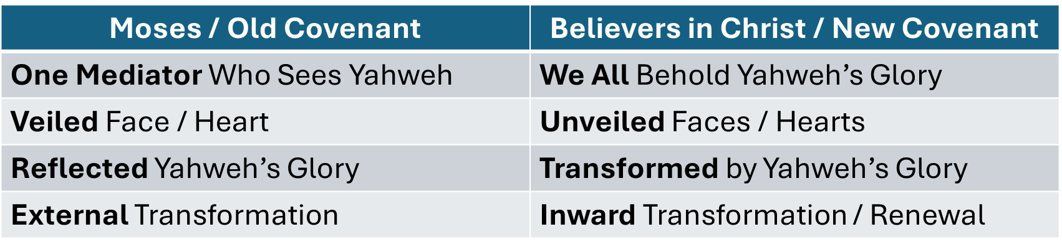
I. A New Year (Exodus 40:16-17)
_________________________________________________________________________________________________________________________________________________________________________________________________________________________________________________________________________________________________________________________________
II. A New Covenant (Exodus 40:18-20)
_________________________________________________________________________________________________________________________________________________________________________________________________________________________________________________________________________________________________________________________________
III. A New Kingdom / Dwelling (Exodus 40:34)
______________________________________________________________________________________________________________________________________________________________________________________________________________________
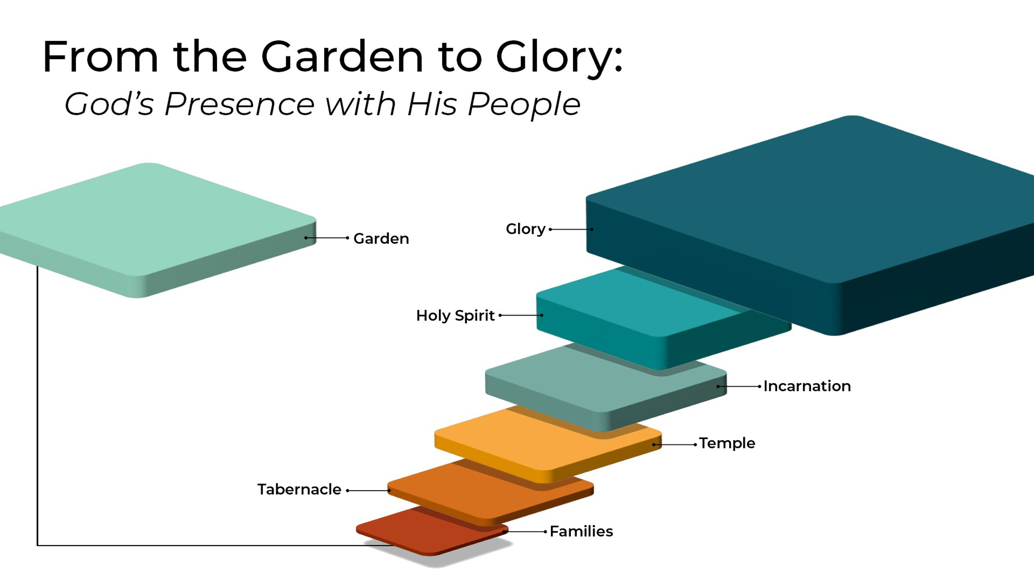
IV. A New Leader (Exodus 40:36-38)
_________________________________________________________________________________________________________________________________________________________________________________________________________________________________________________________________________________________________________________________________
V. A New Problem (Exodus 40:35)
_________________________________________________________________________________________________________________________________________________________________________________________________________________________________________________________________________________________________________________________________
FINAL TAKEAWAYS:
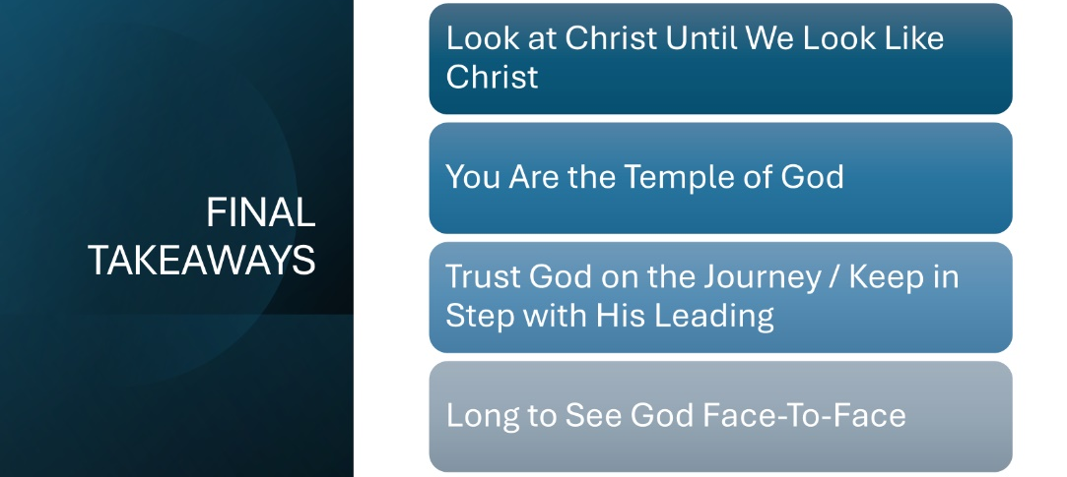
Life Group Questions:
- Remember to open your life group with a time to “preach” to each other.
- What aspect of tonight’s lesson was new, challenging, confusing, or convicting to you?
- When you imagine God, what do you picture (and why)?
  - How have culture, family, church background, or personal experience shaped the way you “see” God?
  - What’s one way you’ve noticed yourself wanting God to look more like you (your preferences, expectations, or values)?
- Look at Christ Until We Look Like Christ (Moses absorbed and reflected God’s glory, but we behold Christ and are transformed)
- What are the practical rhythms that help you “behold Christ” (Scripture, prayer, worship, community, obedience)?
- Which of these rhythms is easiest for you? Which is currently hardest?
- Where have you noticed the Spirit slowly transforming you “from one degree of glory to another”? (Think of character, habits, relationships, emotional responses.)
- You Are the Temple of God
- What part of your life would look different if you lived with a greater awareness that you carry God’s presence? (Examples: Choices? Speech? Purity? Courage?)
- As a collective temple (the Church), we’re called to unity. What threatens spiritual unity with your siblings in Christ most in your season of life (comparison, apathy, unmet expectations, politics, preferences, busyness, something else)?
- Trust God on the Journey / Keep in Step with His Leading
  - Where do you tend to get “out of step” with God? Running ahead because you’re restless? Lagging behind because you’re fearful? Share a real situation where this is happening.
  - If God were to set the pace for your life this week, what would change about your schedule, attitudes, decisions, or priorities?
- Long to See God Face-to-Face
  - Revelation 22 promises that one day we will see God’s face. When was the last time that reality actually stirred hope, desire, or longing in you?
  - What competes for your ultimate hope? (Career, relationships, comfort, security, experiences, reputation, success, pleasure?) How can you reorient your longings toward Christ?
Close by sharing prayer requests / praying as a group.

