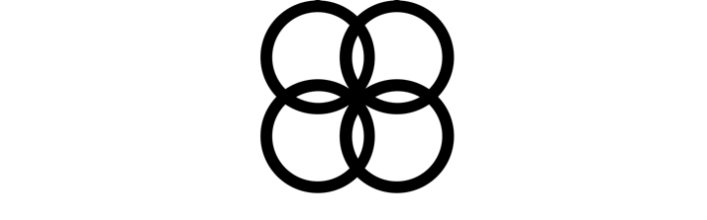
For class on
March 2

The Law/Gospel Distinction
Lesson Seven
A Spiritual Understanding of God’s Law

How do you know God’s will? How does God speak to you? How does He lead you and guide you? When we talk about “gospel for growth,” by “growth” we mean increasing loving obedience to God’s will revealed in Scripture out of growing gratitude for who He is and what He's done for us in Christ, all with the help the Spirit provides.

- What words does Paul use to describe God’s law in Romans 7:12, 14 (below)?
So then, the Law is holy, and the commandment is holy and righteous and good… For we know that the Law is spiritual, but I am of flesh, sold into bondage to sin.

- What words does the psalmist in Psalm 19:7-10 add (below)?
The law of the LORD is perfect, restoring the soul; The testimony of the LORD is sure, making wise the simple. The precepts of the LORD are right, rejoicing the heart; The commandment of the LORD is pure, enlightening the eyes. The fear of the LORD is clean, enduring forever; The judgments of the LORD are true; they are righteous altogether. They are more desirable than gold, yes, than much fine gold; Sweeter also than honey and the drippings of the honeycomb.

- In Matthew 5:21-22 and 5:27-28 (below), does Jesus say the law applies only to our actions and behaviors? Explain.
^{21 “}You have heard that the ancients were told, ‘You shall not commit murder’ and ‘Whoever commits murder shall be liable to the court.’ ²² But I say to you that everyone who is angry with his brother shall be guilty before the court… ²⁷ You have heard that it was said, ‘You shall not commit adultery’; ²⁸ but I say to you that everyone who looks at a woman with lust for her has already committed adultery with her in his heart.”

Westminster Larger Catechism, Q&A 99
What rules are to be observed for the right understanding of the ten commandments?
For the right understanding of the ten commandments, these rules are to be observed:
1. That the law is perfect, and binds everyone to full conformity in the whole man unto the righteousness thereof, and unto entire obedience forever; so as to require the utmost perfection of every duty, and to forbid the least degree of every sin. (Ps. 19:7, James 2:10, Matt. 5:21–22)
2. That it is spiritual, and so reaches the understanding, will, affections, and all other powers of the soul; as well as words, works, and gestures. (Rom. 7:14, Deut. 6:5, Matt. 22:37–39, Matt. 5:21–22,27–28,33–34,37–39,43–44)
3. That one and the same thing, in divers respects, is required or forbidden in several commandments. (Col. 3:5, Amos 8:5, Prov. 1:19, 1 Tim. 6:10)
4. That as, where a duty is commanded, the contrary sin is forbidden; (Isa. 58:13, Deut. 6:13, Matt. 4:9–10, Matt. 15:4–6) and, where a sin is forbidden, the contrary duty is commanded: (Matt. 5:21–25, Eph. 4:28) so, where a promise is annexed, the contrary threatening is included; (Exod. 20:12, Prov. 30:17) and, where a threatening is annexed, the contrary promise is included. (Jer. 18:7–8, Exod. 20:7, Ps. 15:1,4–5, Ps. 24:4–5)
5. That what God forbids, is at no time to be done; (Job 13:7–8, Rom. 3:8, Job 36:21, Heb. 11:25) what he commands, is always our duty; (Deut. 4:8–9) and yet every particular duty is not to be done at all times. (Matt. 12:7)
6. That under one sin or duty, all of the same kind are forbidden or commanded; together with all the causes, means occasions, and appearances thereof, and provocations thereunto. (Matt. 5:21–22,27–28, Matt. 15:4–6, Heb. 10:24–25, 1 Thess. 5:22, Jude 23, Gal. 5:26, Col. 3:21)
7. That what is forbidden or commanded to ourselves, we are bound, according to our places to endeavor that it may be avoided or performed by others, according to the duty of their places. (Exod. 20:10, Lev. 19:17, Gen. 18:19, Josh. 24:15, Deut. 6:6–7)
8. That in what is commanded to others, we are bound, according to our places and callings, to be helpful to them; (2 Cor. 1:24) and to take heed of partaking with others in what is forbidden them. (1 Tim. 5:22, Eph. 5:11)

