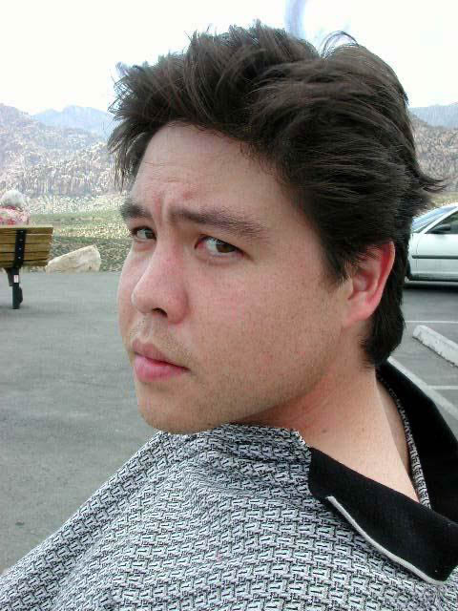
A Celebration of Life: Michael Hwang
Michael Hwang Obituary
Obituary originally published on Legacy.com by Memorial Park Funeral

Home & Cemetery on Apr. 3, 2026.
Michael P. Hwang, age 56, of Houston, Texas passed away peacefully on March 17, 2026.
Born on September 17, 1969, in Ponca City, Oklahoma, Michael was the son of Joanna Chamberlain Hwang and the late Dr. Philip T.R. Hwang. The family moved to Memphis in 1976. Michael was known for his humor, loyalty and kindness.
Michael attended Central High School in Memphis and Rice University in Houston. He fell in love with Texas while attending Rice University. Michael continued to live in Texas except for a brief return to Memphis to help with his father when his father's health declined.
Michael worked as a Senior System Architect for Gene By Gene in Houston. He previously worked as a System Architect for consulting firms in Houston that specialized in computer systems supporting the oil and gas industry. He worked for Software Earnings while living in Memphis. Michael loved sports and was an avid Texans fan.
Michael is survived by his mother, brother Philip P.C. Hwang of San Bernardino CA and nephew Jonah Lien Hwang of San Bernardino CA.
A graveside service will be held on Monday, April 13 at 12 p.m. at Memorial Park Cemetery. Visitation will be at the Memorial Park Funeral Home from 11:00 a.m. to 12:00 p.m. prior to the service.
In lieu of flowers, memorial contributions may be made to St. Jude Children's Research Hospital or Calvary Episcopal Church.
Michael's memory will forever live on in the hearts of those who knew and loved them.
All stand.

I am Resurrection and I am Life, says the Lord.
Whoever has faith in me shall have life,
even though he die.
And everyone who has life,
and has committed himself to me in faith,
shall not die for ever.

As for me, I know that my Redeemer lives
and that at the last he will stand upon the earth.
After my awaking, he will raise me up;
and in my body I shall see God.
I myself shall see, and my eyes behold him
who is my friend and not a stranger.

For none of us has life in himself,
and none becomes his own master when he dies.
For if we have life, we are alive in the Lord,
and if we die, we die in the Lord.
So, then, whether we live or die,
we are the Lord’s possession.

Happy from now on
are those who die in the Lord!
So it is, says the Spirit,
for they rest from their labors.

Celebrant The Lord be with you.
People And also with you.
Celebrant Let us pray.

O God, who by the glorious resurrection of your Son Jesus
Christ destroyed death, and brought life and immortality to
light: Grant that your servant Michael, being raised with him, may
know the strength of his presence, and rejoice in his eternal
glory; who with you and the Holy Spirit lives and reigns, one
God, for ever and ever. Amen.

Most merciful God, whose wisdom is beyond our understanding: Deal graciously with Micheal’s family in their grief. Surround them with your love, that they may not be overwhelmed by their loss, but have confidence in your goodness, and strength to meet the days to come; through Jesus Christ our Lord. Amen.

The people sit.

The Liturgy of the Word

A Reading from Isaiah

The spirit of the Lord God is upon me
because the Lord has anointed me;
he has sent me to bring good news to the oppressed,
to bind up the brokenhearted,
to proclaim liberty to the captives
and release to the prisoners,
to proclaim the year of the Lord’s favor
and the day of vengeance of our God,
to comfort all who mourn,
to provide for those who mourn in Zion—
to give them a garland instead of ashes,
the oil of gladness instead of mourning,
the mantle of praise instead of a faint spirit.
They will be called oaks of righteousness,
the planting of the Lord, to display his glory.

Reader The Word of the Lord.
People Thanks be to God.

Psalm 23

The LORD is my shepherd; I shall not want. He maketh me to lie down in green pastures; he leadeth me beside the still waters.
He restoreth my soul; he leadeth me in the paths of righteousness for his Name's sake.
Yea, though I walk through the valley of the shadow of death,
I will fear no evil; for thou art with me; thy rod and thy staff, they comfort me.
Thou preparest a table before me in the presence of mine enemies; thou anointest my head with oil; my cup runneth over.
Surely goodness and mercy shall follow me all the days of my life, and I will dwell in the house of the LORD for ever.

A Reading from Revelation

After this I looked, and there was a great multitude that no one could count, from every nation, from all tribes and peoples and languages, standing before the throne and before the Lamb, robed in white, with palm branches in their hands. They cried out in a loud voice, saying, “Salvation belongs to our God who is seated on the throne and to the Lamb!”

And all the angels stood around the throne and around the elders and the four living creatures, and they fell on their faces before the throne and worshiped God, singing, “Amen! Blessing and glory and wisdom and thanksgiving and honor and power and might be to our God forever and ever! Amen.”

Then one of the elders addressed me, saying, “Who are these, robed in white, and where have they come from?” I said to him, “Sir, you are the one who knows.” Then he said to me, “These are they who have come out of the great ordeal; they have washed their robes and made them white in the blood of the Lamb. For this reason they are before the throne of God and worship him day and night within his temple, and the one who is seated on the throne will shelter them.
They will hunger no more and thirst no more; the sun will not strike them, nor any scorching heat, for the Lamb at the center of the throne will be their shepherd, and he will guide them to springs of the water of life, and God will wipe away every tear from their eyes.”

Reader The Word of the Lord.
People Thanks be to God.
All stand. Sing first three verses.
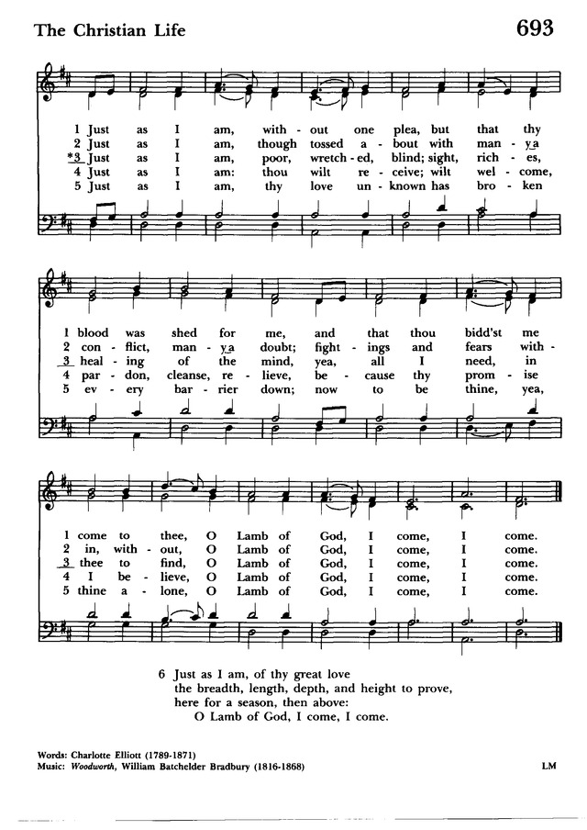
The Gospel

Celebrant The Holy Gospel of our Lord Jesus Christ according to John.
People Glory to you, Lord Christ.

“Do not let your hearts be troubled. Believe in God; believe also in me. In my Father’s house there are many dwelling places. If it were not so, would I have told you that I go to prepare a place for you? And if I go and prepare a place for you, I will come again and will take you to myself, so that where I am, there you may be also. And you know the way to the place where I am going.” Thomas said to him, “Lord, we do not know where you are going. How can we know the way?” Jesus said to him, “I am the way and the truth and the life. No one comes to the Father except through me.

Celebrant The Gospel of the Lord.
People Praise to you, Lord Christ.

Eulogy Mr. Tony Coffman, friend of Michael

Homily The Rev. Beth Anne Nelson

How Great Thou Art Nidia Guevara-Nolasco, Mezzo-soprano

Apostles Creed

Celebrant In the assurance of eternal life given at Baptism, let us
proclaim our faith and say together,

I believe in God, the Father almighty,
creator of heaven and earth.

I believe in Jesus Christ, his only Son, our Lord.
He was conceived by the power of the Holy Spirit
and born of the Virgin Mary.
He suffered under Pontius Pilate,
was crucified, died, and was buried.
He descended to the dead.
On the third day he rose again.
He ascended into heaven,
and is seated at the right hand of the Father.
He will come again to judge the living and the dead.
I believe in the Holy Spirit,
the holy catholic Church,
the communion of saints,
the forgiveness of sins,
the resurrection of the body,
and the life everlasting. Amen.

The Lord’s Prayer

Our Father, who art in heaven,
hallowed be thy Name,
thy kingdom come,
thy will be done,
on earth as it is in heaven.
Give us this day our daily bread.
And forgive us our trespasses,
as we forgive those who trespass against us.
And lead us not into temptation,
but deliver us from evil.
For thine is the kingdom, and the power, and the glory,
for ever and ever. Amen.

The Prayers

For our brother Michael, let us pray to our Lord Jesus
Christ who said, “I am Resurrection and I am Life.”

Lord, you consoled Martha and Mary in their distress; draw near to us who mourn for Michael, and dry the tears of those who weep.
Hear us, Lord.

You wept at the grave of Lazarus, your friend; comfort us in
our sorrow.
Hear us, Lord.

You raised the dead to life; give to our brother eternal life.
Hear us, Lord.

You promised paradise to the thief who repented; bring our
brother to the joys of heaven.
Hear us, Lord.

Our brother was washed in Baptism and anointed with the Holy Spirit; give him fellowship with all your saints.
Hear us, Lord.

He was nourished with your Body and Blood; grant him a place at the table in your heavenly kingdom.
Hear us, Lord.

Comfort us in our sorrows at the death of our brother; let our faith be our consolation, and eternal life our hope.

Silence may be kept.

The Celebrant continues

Lord Jesus Christ, we commend to you our brother Michael, who was reborn by water and the Spirit in Holy Baptism.
Grant that his death may recall to us your victory over death,
and be an occasion for us to renew our trust in your Father’s
love. Give us, we pray, the faith to follow where you have led
the way; and where you live and reign with the Father and
the Holy Spirit, to the ages of ages. Amen.

Father of all, we pray to you for Michael, and for all those whom
we love but see no longer. Grant to them eternal rest. Let
light perpetual shine upon them. May his soul and the souls
of all the departed, through the mercy of God, rest in peace.
Amen.

Celebrant Let us go forth in the name of Christ.
People Thanks be to God.

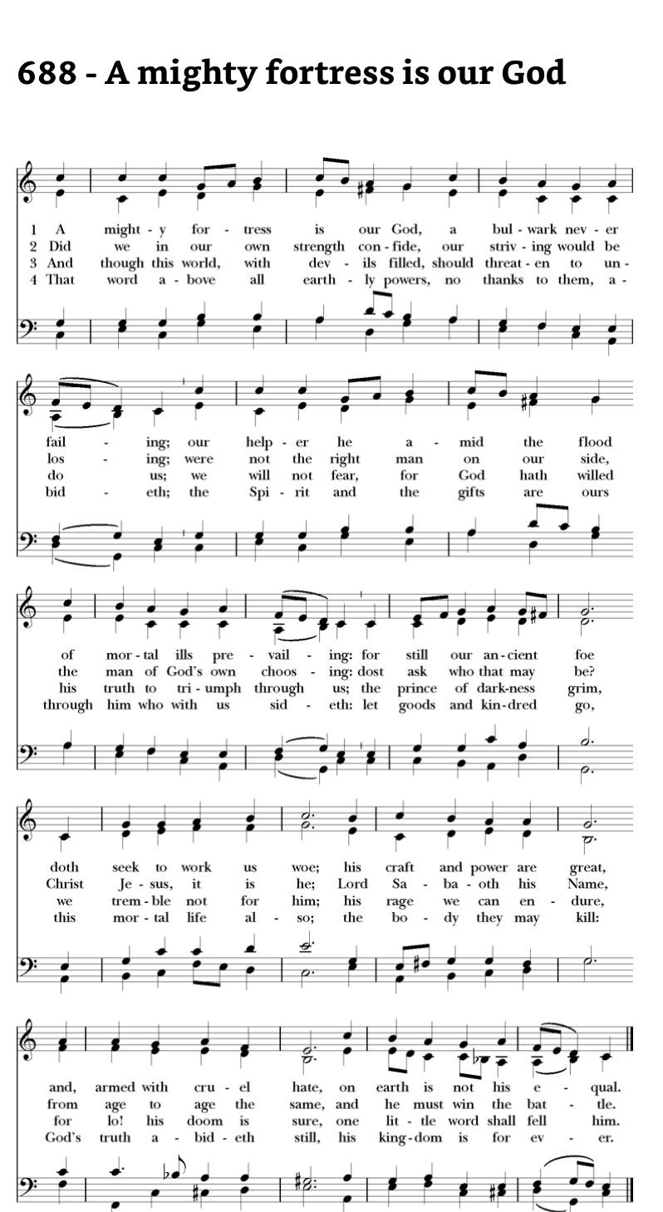

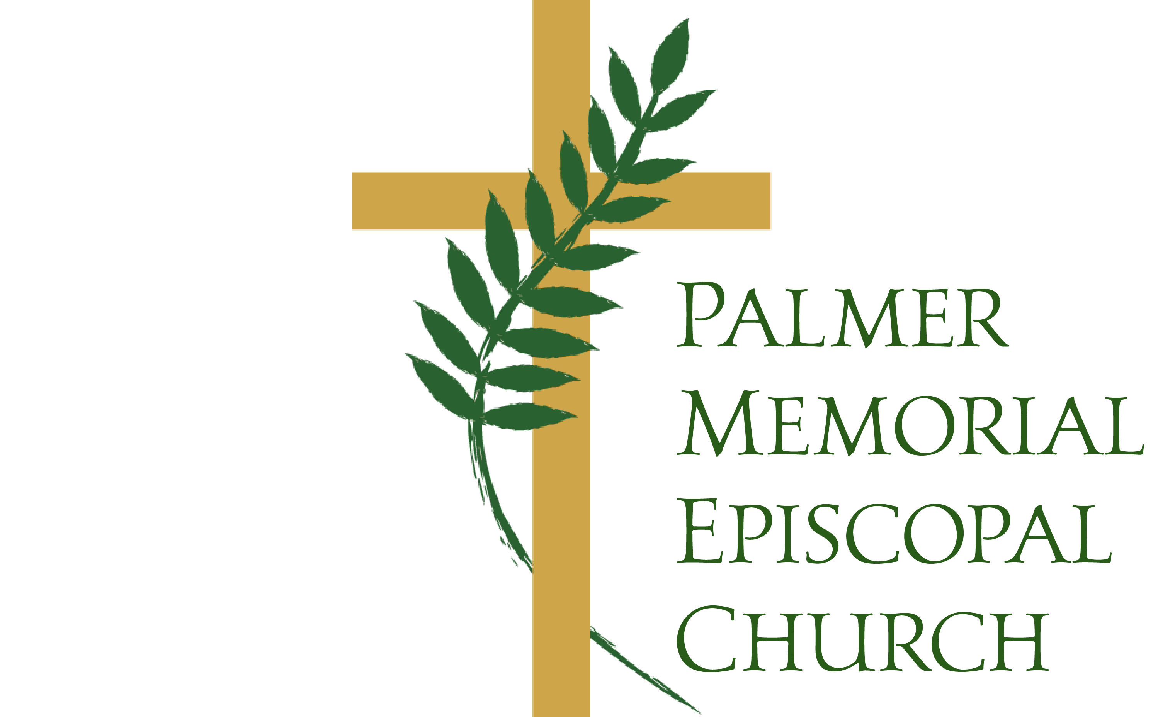

Our Mission
To know and boldly share the love of Jesus Christ through deep understanding of our relationship with God, ourselves, and our neighbors, in a joyfully engaged and welcoming community, dedicated to thoughtful and focused service, and inspired by worship that renews curiosity about all of creation.

