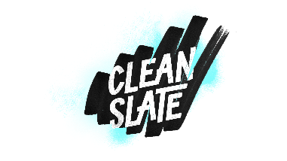**Born Blind**

**John 9:35-41**

Clean Slate but not a **_BLANK_** slate.

The neighbors:

* **QUESTIONED** the man’s identity
* **MADE NO DECISION** about the healing
* **MADE NO DECISION** about the Healer

The Pharisees/Leaders:

* **ACCUSED** the Healer
* **QUESTIONED** the healing
* **ACCUSED** the man

The Parents:

* Confirmed their son’s previous identity
* **REFUSED TO COMMENT** on their son’s healing
* **REFUSED TO ACKNOWLEDGE** the Healer

Does your faith **GO BEYOND** what you can see?

*What is the Lord speaking to me personally today? ______________________________________________________*

*______________________________________________________*

____________________________________________________

Scott Hilderbrand | New Life Church | October 27, 2024