Augmented Reality Applications for Multilingual Learning with
Intuitive Understanding

Hajime Mochizuki
Institute of Global Studies
Tokyo University of Foreign Studies
Japan
motizuki@tufs.ac.jp

Abstract: Learning applications can be designed to be more interactive and engaging through augmented reality (AR) technology; however, drawing sophisticated model of 3D objects is labour-intensive even if modeling software is relatively easy to use. There are at least two methods that can be employed to resolve this problem: (1) adopting alternative methods of creating a large number of objects that can be easily used for AR, or (2) reusing an object that has multiple markers. We have developed language-learning applications that use AR technology. In this paper, we discuss our applications, focusing on the multilingualism of AR learning materials. We also describe the development of our two multilingual applications. The first application uses simple 3D letter-string objects instead of fine-grade 3D objects in different languages and the second application uses the same 3D animated objects to teach syntax, word order, and sentence structure in English and Japanese.

Introduction

We have developed language-learning applications that use augmented reality (AR) technology. This technology overlays computer-generated objects, such as 2D and 3D models, text, pictures, and video images, with physical objects, such as specific markers, on images captured by a video camera in real time (Krevelen and Poelman, 2010). Composite images with AR objects are viewed with the help of various computer devices, such as a head-mounted display, projector, or computer screen. Augmented reality applications afford a novel experience in which the real world is enhanced through projected virtual objects that the user perceives to be present in the real world. Learning applications can be made more interactive and engaging through AR technology (Yuen, el al., 2001). In 2011, the Higher Education Edition of the New Media Consortium stated that “One of the most promising aspects of augmented reality is that it can be used for visual and highly interactive forms of learning, allowing the overlay of data onto the real world as easily as it simulates dynamic processes” (NMC, 2011). In 2016 the Higher Education Edition of the New Media Consortium emphasized the importance of AR and Virtual Reality (VR), stating that,
While the most prevalent uses of AR and VR thus far have been in the consumer sector, tools for creating fresh applications are becoming even easier to use and more viable in the education sector. VR constructs provide contextual learning experiences that foster exploration of real world data in virtual surroundings, while AR’s responsive interactivity enables students to construct broader understandings based on interactions with virtual objects. These two flexible, immersive technologies spark similar educational outcomes, bringing learners to deeper levels of cognition as they attain new perspectives on underlying data. (NMC,2016, p.40)
The use of AR creates a more aesthetic, interesting, and stimulating learning envrionment for users. Augmented reality not only inspires us as application users, but also as application developers. A language teacher might be inspired to prepare attractive teaching materials using AR. One example would be to devise a flashcard application that makes use of 3D objects overlaid with words. In our previous research, we developed two AR applications for language learning using multiple 3D objects and animated 3D objects; an AR noun card, and an AR verb card (Mochizuki, 2014). Figure 1 is an example of an AR noun card that uses ARToolKit. ARToolKit is a major open-source framework used for developing AR applications (Billinghrst et al., 2002; ARToolkit, 2002). In this example, a piece of paper is used as an AR marker for ARToolKit and is overlaid with a 3D picture of a bicycle. The 3D bicycle object was generated using Metasequoia, a shareware 3D modeling application. Figure 2 is a snapshot of the process of drawing a 3D bicycle object using Metasequoia.
Figure 3 is an examples of our verb card “dance.” This example shows one marker and one animated 3D object for “dance.” For this application, it is necessary to prepare AR markers and 3D animated models according to the number of words. The process for creating verb cards is similar to that used to create noun cards and includes programming, drawing of 3D models, and creation of animations. We use the 3D-animation tool RokDeBone2, which uses skeletal animation techniques (Mukundan, 2012), to create animation data from MQO 3D model data. Using ARToolKit with the GLMetaseq library can create 3D animation by rendering multiple frames of MQO data sequentially(Hashimoto, 2007; Hashimoto, 2008; Teraface, 2014). RokDeBone2 can generate sequential MQO data from a single sequence of animation data.

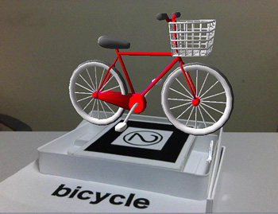
Figure 1: Simple AR noun card with a 3D object for the word “bicycle” on the AR marker.

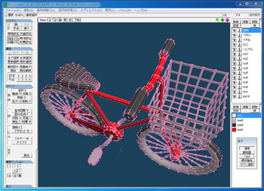
Figure 2: Drawing a 3D object using Metasequoia.

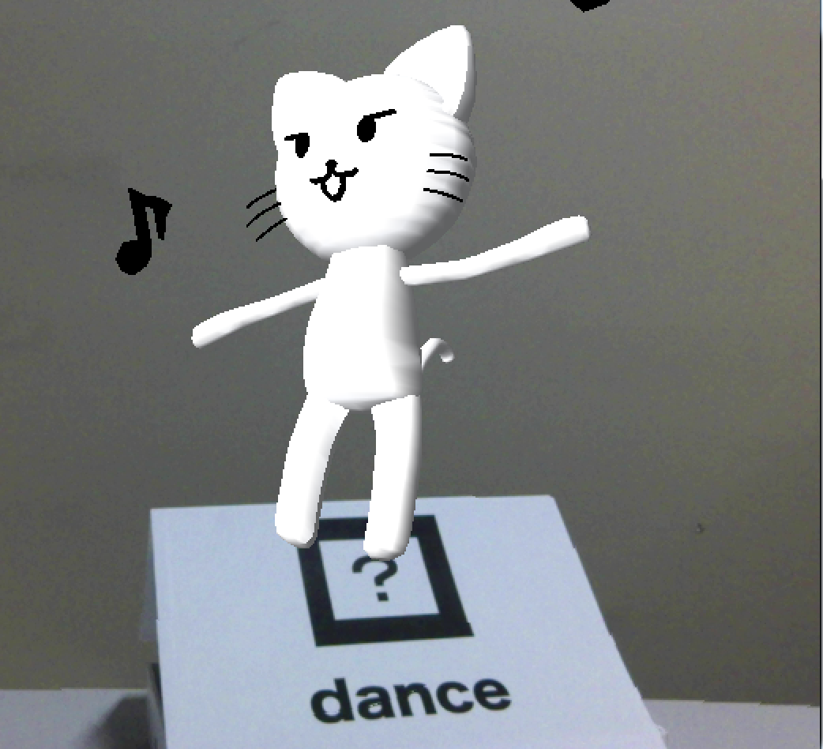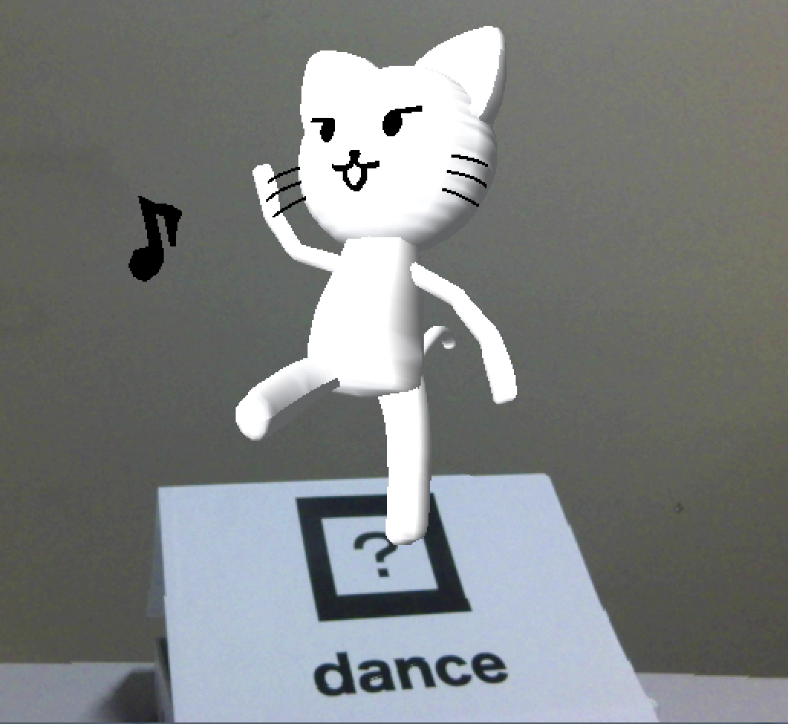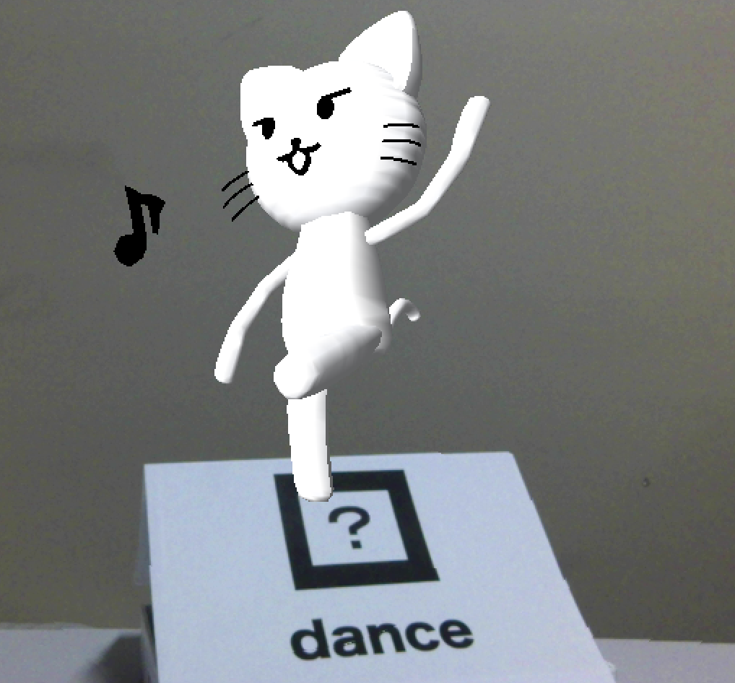
Figure 3: Simple AR verb card with an animated 3D object for the word “dance” on the AR marker.

We demonstrated in Figure 1 and Figure 3 show AR applications can provide a new and exciting user experience by projecting virtual objects onto a users' perceptions of the real world. A teacher or a person who is interested in language learning might be inspired to prepare attractive teaching materials using AR.
Drawing a sophisticated model of 3D object is labour-intensive, even if the modeling software is relatively easy to use: moreover, not all developers are good at creating 3D models. At least two methods can be employed to resolve this problem; (1) adopting alternative methods of creating a large number of objects that can be easily used for AR, or (2) reusing an object that has multiple markers.
In this paper, we discuss our application, focusing on the multilingualism of AR learning materials. We also discuss the development of two types of multilingual applications: (1) applications that use simple 3D letter-string objects instead of fine-grade 3D objects in different languages, and (2) applications that use the same 3D animated objects to teach syntax, word order, and sentence structure in English and Japanese.

Augmented Reality 3D Letter-String Labeling in Different Languages

For our application, we used simple 3D objects instead of fine-grade 3D objects. This allowed us to create a large number of objects easily; fortunately, sophisticated 3D objects are not required in language-learning applications. We created letter-string 3D objects by using the freeware program StringMQObject Builder. StringMQObject Builder is very easy to use; a user can generate a letter-string 3D object from a typed string using the application’s user-friendly graphical user interface (GUI). Figure 4 is an example of a drawing for the 3D letter-string object “cup.”

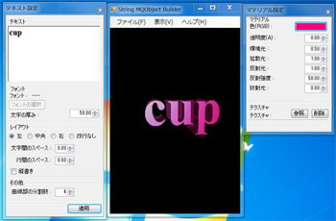
Figure 4: Drawing a 3D string object using StringMQObject Builder.

The process of creating our application involved creating 3D letter-string objects, and then creating real objects in which markers could be pasted. For example, we created a real coffee cup and a marker, and then we created 3D letter-string objects in different languages, such as “cup” (in English), カップ “kappu” (in Japanese), and “cawan” (in Malaysian). Figure 5 shows the examples of our 3D letter-string label application.

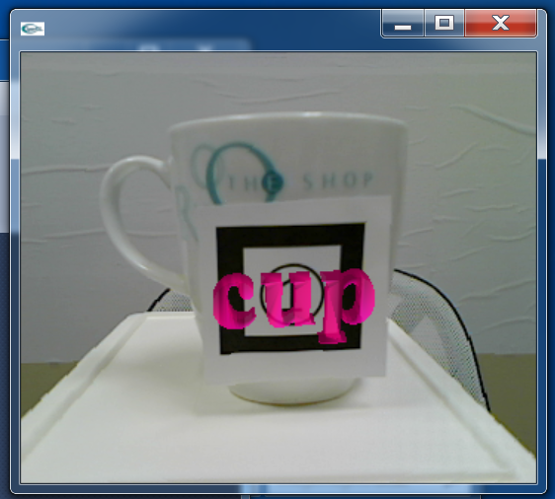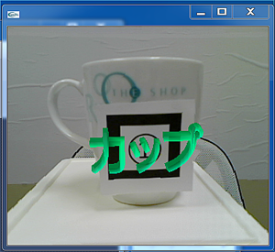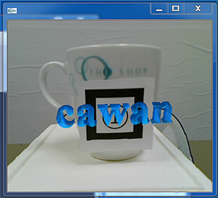
Figure 5: 3D letter-string labeled objects for the word “cup” in different languages on the same AR marker.
The letter string on the left in Figure 5 represents the English name of the real object, “cup,” the letter string in the middle is the Japanese name of the same real object, “コップ,” and the letter string on the right is the Malaysian name of the same real object, "cawan." Users can switch the displayed language by pressing bound keys. In our prototype application, we registered the keys E, J, and M for English, Japanese, and Malaysian respectively.
We can create new 3D objects for this application just by typing the name of the actual objects. We can easily add new real objects by creating new AR markers and new 3D objects in different languages.We can eaily expand our language base by adding new languages corresponding to existing AR markers, and real objects by creating new 3D objects in the new languages. The reason we believe that this application is excellent for learning languages is because the languages are overlaid on the objects, so it is easy to change languages just by pressing certain keys.

Learning Syntax, Word Order, and Sentence Structure

It is possible to reuse an object with multiple markers. In our application, we used the same 3D objects with multiple markers with different languages. Because it is difficult to draw large quantities of sophisticated 3D models, it is desirable to use each 3D model in as many applications as possible. We prepared a large quantity of markers corresponding to the same 3D models and we assigned different languages to each marker. In this way, we were able to develop English and Japanese applications for learning syntax, word order, and sentence structure.

Understanding Word Order in English Sentences

In many languages, English included, word order plays an important role in understanding the meaning of sentences. For example, one common structure of English sentences is the subject-verb-object strucure.
In our apple example, someone eats an apple, and I am that someone. The correct word order for a sentence in English is “I” + “eat” + “an apple.” If an English learner represents the sentence as, “an apple” + “eat(s)” + “I (me),” the meaning of the sentence changes completely.
Augmented reality can be used in tools that help learners understand the relationship between word order and the meaning of a sentence. We think that understanding become more intuitive when using images or animation to express how meaning varies depending on the order of words. Our AR application recognizes multiple markers and the order in which they appear, and it switches the order of 3D objects according to user input. A user first arranges the AR markers in what they understand to be the correct order. The system recognizes the markers, and interprets the meaning of the sentence that the markers express. The system then overlays the animated 3D object that corresponds to the sentence on the markers.
For example, when a learner arranges AR markers in the order of, “I” + “eat” + “an apple.” as shown in Figure 6, the learning system recognizes the markers as the sentence, “I eat an apple.” The system then overlays the animated 3D object that corresponds to the sentence, as shown in Figure 7.

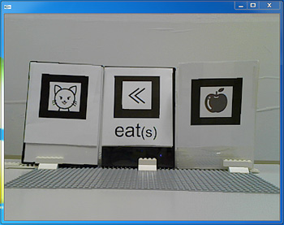
Figure 6: Collocated AR markers in the order of “I eat an apple.”

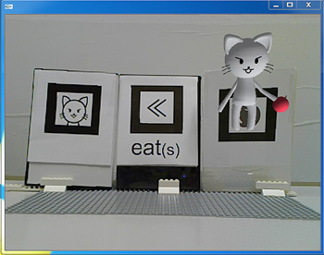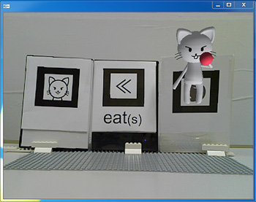
Figure 7: Animated 3D object for “I eat an apple.”

If the learner arranges the AR markers in the order “an apple” + “eat(s)” + “I(me).” as in Figure 8, an animated 3D object representing an apple a eating a human is overlaid, as shown in Figure 9.

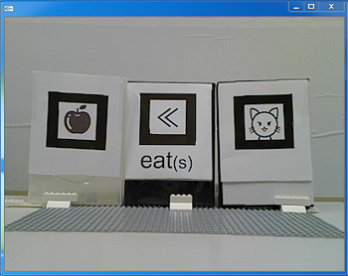
Figure 8: Collocated AR markers for “An apple eats me.”

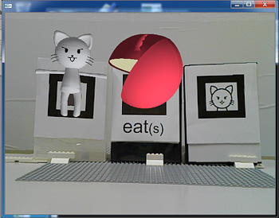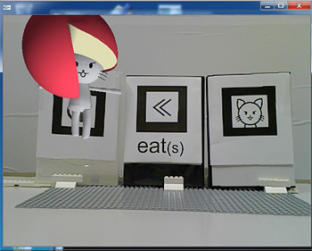
Figure 9: Animated 3D object for “An apple eats me.”

Understanding the Role of Particles in Japanese Sentence

The same 3D animated objects used for English can also be used in other languages. In this section, we discuss how our application can be used to understand Japanese sentences. Unlike English, a Japanese sentence is normally structured subject-object-verb, but Japanese is not limited to this structure; the order of object-subject-verb is also acceptable. For example, sentence (1) uses the subject-object-verb structure, and sentence (2) uses the object-subject-verb structure. Both sentences are accepted as being equally correct.

(1) 私が(Subj.)リンゴを(Obj.)食べる(Verb). (Watashi-ga ringo-wo taberu)
(2) 私を(Obj.)リンゴが(Subj.)食べる(Verb). (Watashi-wo ringo-ga taberu)

The meanings of sentences (1) and (2), however, are completely different. The differences lie in the locations of only two characters, “ga,” and “wo.” Watashi” in sentence (1) is marked with the particle “ga,” while “watashi” in sentence (2) is marked with the particle “wo.” These differences seem mirror, but the meanings of “watashi-ga” and “watashi-wa” are quite different.
In these examples, “Watashi-ga,” represents the subject of the sentence and an agent of the verb, while “watashi-wo” represents the object of the verb; hence, in sentence (2), the noun “watashi” (“I”) is interpreted as the object of the verb “taberu” (“eat”), and the noun “ringo” (“an apple”) is interpreted as the agent of the verb. Sentence (2), therefore, is interpreted as, “An apple eats me.” If you replace the particles “ga” with “wo” in the original sentence, or vice versa, you will make a sentence with the opposite meaning. Comprehension of particles is, therefore, critical in understanding Japanese sentences. Commonly used Japanese particles are listed in Table 1.

Particle | Main role(s)
は(wa) | Indicates the topic of a sentence
が(ga) | Indicates the subject of a sentence
に(ni) | Indicates a location, an object
を(wo) | Indicates the direct object of a verb
へ(e) | Indicates direction
で(de) | Indicates the location of an action, the instrument of an action
Table 1: Commonly used Japanese particles

Though Japanese speakers must have a good command of the particles in a sentence, it is difficult for a beginner to distinguish the different meanings when there is a difference in only one character. In order to teach the differences between the two sentences, “I eat an apple (私 が リンゴ を 食べる)” and “An apple eats me (私 を リンゴ が 食べる),” we used five Japanese AR markers corresponding to “私 (I or me),” “リンゴ (an apple),” “食べる (eat),” and the particles “が (ga)” and “を (wo).” We also used animated 3D objects that correspond to the two sentence. We reused the same animated 3D objects that we used for the English version. The user first arranges the AR markers in what they understand to be the correct order. The system recognizes the markers, and interprets the meaning of the sentence that the markers express. The system then overlays the animated 3D object that corresponds to the sentence on the markers.
For example, when a learner arranges AR markers in the order of, “私 (I)” + “が (ga)” + “リンゴ (an apple)” + “を (wo)” + “食べる (eat),” as shown in Figure 10, the learning system recognizes the markers as the sentence “I eat an apple.” The system then overlays the animated 3D object that corresponds to the sentence, as shown in Figure 11.

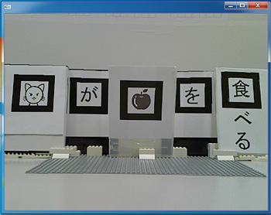
Figure 10: Collocated AR markers for “I eat an apple” in Japanese.

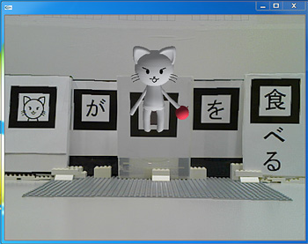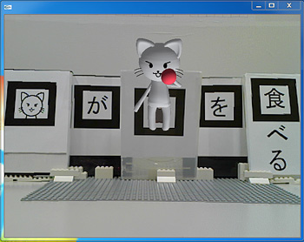
Figure 11: Animated 3D object for “I eat an apple” in Japanese.

If the learner arranges the AR markers in the order of, “私 (I)” + “を (wo)” + “リンゴ (an apple)” + “が (ga)” + “食べる (eat),” as in Figure 12, an animated 3D object representing an apple eating a human is overlaid, as shown in Figure 13.

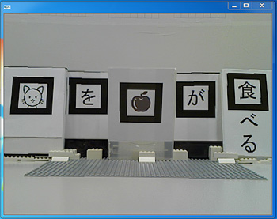
Figure 12: Collocated AR markers for “An apple eats me.”

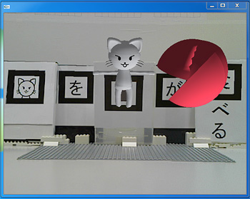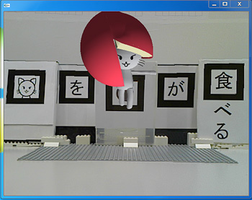
Figure 13: Animated 3D object for “An apple eats me.”

These examples show that animated 3D objects can be used the same way in different languages, thereby demonstrating the effectiveness of AR applications learning languages.

Conclusions

Drawing sophisticated 3D object models is labor-intensive, even if modeling software is relatively easy to use; moreover, not all developers are good at creating 3D models. There are at least two methods that can be employed to resolve this problem: (1) adopting alternative methods of creating a large number of objects that can be easily used for AR, or (2) reusing the same object that has multiple markers.
In this paper, we focused on the multilingualism of AR learning materials, and we described the development of two types of multilingual applications: applications that use simple 3D letter-string objects instead of fine grade-3D objects, and applications that use the same 3D animated objects to teach syntax, word order, and sentence structure in English and Japanese. We developed an application that uses AR 3D letter-string labeling, overlaid with existing physical objects in different languages. We believe that this application is excellent for learning languages because the languages are overlaid on the objects, and so it is easy to change languages just by pressing certain keys. The second applications that we developed teaches syntax, word order, and sentence structure in English and Japanese. This application helps learners understand the meanings of English and Japanese sentences by using AR. We believe that it is easier to recognize the intended meaning of a sentence from a picture than from plain text.
Our future work, includes increasing the number of languages that can be handled by our 3D letter-string labeling application and converting our application from marker-type AR to image recognition AR. The advances in computer-vision technology with artificial intelligence have made dynamic image recoginition via web cameras very practical. We believe that the ability to recognize real objects will become mainstream in the not-too-distant future.

Acknowledgments

I would like to express my gratitude to Ms. Hitomi Yasui. She drawn samples of refined 3D model data, and gave them to us.

References

ID.W.F. van Krevelen and R. Poelman (2010), A Survey of Augmented Reality Technologies, Applications and Limitations, The International Journal of Virtual Reality, Vol.9, No. 2, pp. 1-20, 2010.

S. Y uen, G. Y aoyuneyong, and E. Johnson (2011), Augmented Reality: An Overview and Five Directions for AR in Education, Journal of Educational Technology Development and Exchange, Vol. 4, No. 1, pp.119-140, 2011.

C. Y. Lin, M. Wu, J. A. Bloom, I. J. Cox, and M. Miller (2001), “Rotation, scale, and translation resilient public watermarking for images,” IEEE Trans. Image Process., vol. 10, no. 5, pp. 767-782, May 2001.

M. Billinghurst, A. Cheok, S. Prince, H. Kato (2002), Real World Teleconferencing, IEEE Computer Graphics and Applications, Vol. 22, No. 6, pp. 11-13, Nov/Dec., 2002.

R. Mukundan (2012). Skeletal Animation. In Advanced Methods in Computer Graphics (pp.53-76), Springer.

NMC. (2011). New Media Consortium, Horizontal Report 2011, Available:
http://www.nmc.org/sites/default/files/pubs/1316814265/2011-Horizon-Report(2).pdf

NMC. (2016). New Media Consortium, Horizontal Report 2016, Available: http://cdn.nmc.org/media/2016-nmc-horizon-report-he-EN.pdf

H. Mochizuki (2014). The Effectiveness of Slight Modification to Supplement Programs in the Development of AR Applications, World Conference on E-Learning in Corporate, Government, Healthcare, and Higher Education (E-Learn), Volume 2014, No. 1, pp. 1390-1396, Association for the Advancement of Computing in Education (AACE), October 2014.

ARToolKit Homepage (2002), [Online], 2002, Available: http://www.hitl.washington.edu/artoolkit/

S. Hashimoto (2007), Engineering Navi Homepage, [Online] 2007, Available: http://kougaku-navi.net/ARToolKit/.

S. Hashimoto (2008), ARToolKit: Introduction to programming in augmented reality (in Japanese), Ascii media works, 2008.

Tetraface Inc. (2014), Metasequoia file format specification, [Online] Feb. 2014, Available: http://www.metaseq.net/en/format.html.

