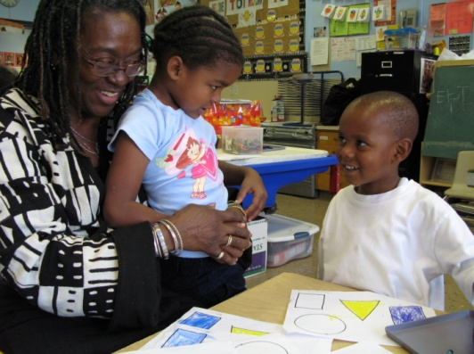
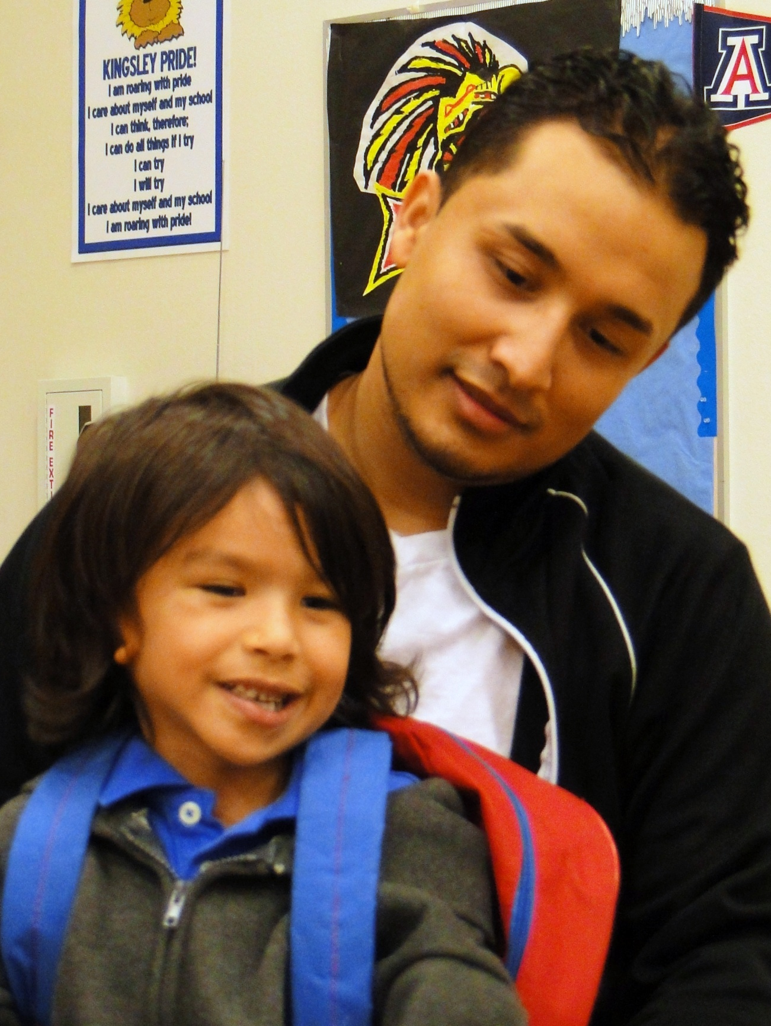
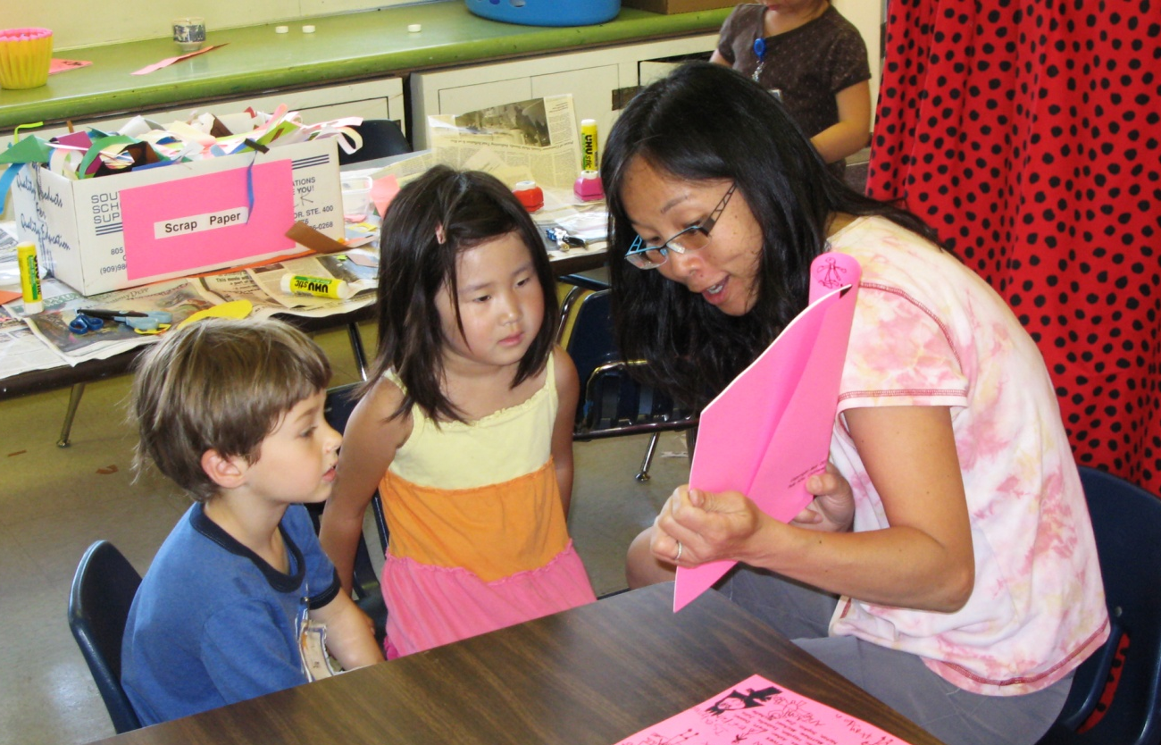
A Parent Outreach and Communications Resource for School Districts and Local Education Agencies Implementing Transitional Kindergarten
Transitional
Kindergarten
Parent
Outreach
Toolkit

The Kindergarten Readiness Act, signed into law in 2010, is one of the most significant educational reforms in California’s recent history. It made a fundamental change to kindergarten in our state, shifting the age of children entering kindergarten and creating transitional kindergarten for those students turning five between September 1 and December 2. Transitional kindergarten, the first year of a two-year kindergarten experience, will give children the gift of time to develop the skills that will prepare them for the challenges of elementary school. The new law will be phased in over three years beginning in 2012, and when fully implemented, 120,000 children statewide will benefit from transitional kindergarten.

About This Toolkit
Introduction
Transitional kindergarten gives California a tremendous opportunity to increase children’s kindergarten readiness. As school districts and other Local Education Agencies (LEAs) begin implementing transitional kindergarten, their success will depend on having an effective communications strategy in place that informs parents about the benefits of the program and addresses questions about the change in law. Understanding this, Preschool California conducted field research that can assist in developing effective communication strategies around transitional kindergarten. This toolkit has compiled this research into easy to use information and tools to help LEAs in their implementation and outreach efforts.

The contents of this toolkit are intended to assist school districts and other LEAs in the development of their communication strategies for the implementation of transitional kindergarten. The information in this toolkit can be used to develop talking points for staff, plan parent outreach strategies and create a parent brochure. Its purpose is to serve as a guide for those implementing transitional kindergarten and it can be changed and adapted to meet the needs of each LEA. It is an educational tool and is not intended for commercial use.

1
Contents
Section 1: Creating Transitional Kindergarten Experts

Facts about Transitional Kindergarten
A summary of important facts and statistics about transitional kindergarten and the change in California’s kindergarten law. These facts may be useful in providing depth and expertise in informing spokespersons and educators in your district about the benefits of transitional kindergarten.
Frequently Asked Questions about Transitional Kindergarten
A compilation of commonly asked questions by parents regarding transitional kindergarten, and a list of potential answers to those questions. This information can help school districts and LEAs prepare Frequently Asked Questions pamphlets or messaging points for staff.
Effective Messages about Transitional Kindergarten
A list of messages that tested well with parents in communicating the benefits of transitional kindergarten. These messages can be adapted for use in brochures, talking points and other outreach materials.

Section 2: Parent and Community Outreach Strategies

Parent Outreach Activities
A list of methods and activities that can be used to introduce parents and community members to transitional kindergarten and engage them in the process of implementation.
Messengers and Sources of Information
An overview of the most credible messengers and sources of information for parents, as well as tips on how to reach those messengers about transitional kindergarten.
Section 3: Outreach Tools

Sample Parent Recruitment Letter
A sample letter that can be adapted and used by districts launching transitional kindergarten in 2011 to communicate the benefits of the program.
Customizable Transitional Kindergarten Brochure
A template brochure that explains the Kindergarten Readiness Act and transitional kindergarten to families. The brochure has been developed based on parent input and is designed to be altered and branded by each local school district.
Transitional Kindergarten Resources
A list of recommended resources for additional information about transitional kindergarten.

2

Section 1:
Creating Transitional Kindergarten Experts
The following resources are intended to help school districts and LEAs create knowledgeable and informed leaders on transitional kindergarten.

3

Facts About
Transitional Kindergarten

These facts and figures can be shared with teachers, administrators, school board members and others to help them become familiar with the benefits of transitional kindergarten for California’s children and communities.

A head start for California’s children
- Research indicates that beginning kindergarten at an older age improves children’s social and academic development and boosts children’s test scores in math, reading and general knowledge.
- Studies suggest that changing California’s kindergarten entry date could increase test scores by as much as 27%.*
- Children who begin school at a later age also are less likely to be retained or to be misdiagnosed with a learning disability.*

A positive change for families and schools
- Transitional kindergarten gives parents an additional option to ensure their children enter kindergarten with the maturity and skills they need to excel.
- Schools will be able to do more with what they have because transitional kindergarten will help ensure children enter kindergarten ready to learn.

A winning solution for California
- Transitional kindergarten gives California an unparalleled opportunity to ensure our state’s youngest students are better prepared to succeed in kindergarten and beyond.
- Prior to the passage of the Kindergarten Readiness Act, California’s December 2 cutoff for kindergarten entry was one of the latest in the nation. In most states, children must turn five by September 1 in order to start kindergarten.
- California’s late cutoff allowed children as young as 4 years and 9 months old to be in kindergarten classes with children more than a year older.
- Approximately 120,000 children each year will benefit from the Kindergarten Readiness Act, including 50,000 English language learners and 74,000 served by Title I schools.
- California will ultimately save money because children will be better prepared for success in school and less likely to be placed in special education or retained in later grades.

*Cannon, J. & Lipscomb, S. (2008). Changing the Kindergarten Cutoff Date: Effects on California Students and Schools. Public Policy Institute of California.

4

Frequently Asked Questions
About Transitional Kindergarten

Parents have many questions about what transitional kindergarten is and how it will look in their local communities. Below are some of the questions families have asked most frequently about implementation, and suggested answers that may be helpful as districts and LEAs create their own materials to address parents’ questions. We recommend tailoring your answers to fit your own program’s approach.
Top 10 general questions about transitional kindergarten
Will transitional kindergarten be mandatory for children with birthdays between September and December?
Just like kindergarten, transitional kindergarten enrollment will be voluntary.
How is transitional kindergarten different from preschool?
The standards, curriculum and teaching requirements in transitional kindergarten will be different from preschool. Transitional kindergarten will be part of the K-12 public education system and it will be based on the kindergarten standards. It will build on the skills children may have learned in preschool to ensure they will be able to begin kindergarten with confidence.
How is transitional kindergarten different from traditional kindergarten?
Although the curriculum in transitional kindergarten will be based on the kindergarten standards, it will be modified to meet the academic, social and emotional needs of younger children. The transitional kindergarten environment will include more opportunities for social-emotional, language development and communication through dramatic play; small group instruction; and intentional teaching through hands-on activities.
Will transitional kindergarten provide support for children who do not speak English?
English learners in transitional kindergarten will have the same level of services as those in kindergarten.
Will transitional kindergarten be free or will I have to qualify based on income?
Transitional kindergarten will be free and open to all age-eligible children.
What kinds of qualifications will transitional kindergarten teachers have?
Transitional kindergarten teachers will be required to have a teaching credential, just like kindergarten teachers.

5

Frequently Asked Questions
About Transitional Kindergarten

How old will transitional kindergarteners be when they begin first grade?
Transitional kindergarteners will typically be 6 years old when they start first grade and turn 7 years old during the first few months of the school year.
Will children in transitional kindergarten be 19 years old when they graduate from high school?
No, they will be 18 years old when they graduate and will turn 19 years old several months after graduation.
How will this affect children in special education?
Districts will be required to offer the same services to transitional kindergarteners with Individualized Education Plans (IEPs) as they currently offer to children in kindergarten.
What grade will children go into after transitional kindergarten?
Transitional kindergarten is the first year of a two-year kindergarten experience. Most children will go on to kindergarten after completing transitional kindergarten, however some children may move to first grade if the school and the family agree that they are ready.

Frequently asked questions about local implementation and design
Answer these questions based on your local program design.
- Where will transitional kindergarten be offered?
- If the law goes into effect in 2012, when will these programs be available in our district?
- What curriculum will transitional kindergarten use?
- Is transitional kindergarten offered part day or full day?
- Do transitional kindergarteners have their own class?

Create your own FAQ: Adapt these questions for use in your own frequently asked questions (FAQ) document. Consider including it in parent outreach packets and on your website to help families better understand the details and benefits of the program.

Tip

6
7
The following messages were developed based on feedback from parents on the most persuasive statements about transitional kindergarten. These messages may be helpful as part of communications trainings for district staff and educators, and can also be incorporated into outreach materials for families.
California’s kindergarten curriculum and standards have changed over the years, and many of the skills children were once taught in first grade are now taught in kindergarten. Transitional kindergarten is the right program at the right time.
Transitional kindergarten serves as a bridge between preschool and kindergarten, giving children more time for hands-on, interactive learning.
Transitional kindergarten provides children with the gift of time to learn skills that will help them build a strong foundation for success in elementary school.
Transitional kindergarten gives children the opportunity to spend time learning important social, emotional and academic skills that will help them succeed in kindergarten and beyond.
Transitional kindergarten provides young learners with high-quality kindergarten readiness at no cost to parents, to ensure that they have an opportunity to continue learning.
Transitional kindergarten helps children adjust to the school environment & develop strong learning skills.
Transitional kindergarten provides young 5 year olds with an opportunity to start their kindergarten experience with children their own age, and with teachers that can tailor lesson plans to their needs.
Parents all over California recognize the benefits of transitional kindergarten, and many parents have already been enrolling their children in similar programs for years.

Develop messaging about transitional kindergarten: Work with your Public Information Office to develop a set of talking points that can articulate the benefits of transitional kindergarten. Wherever possible, incorporate important information about implementation in your district. These talking points can be provided to district administrators, school board members, school administrators, and school faculty and staff (elementary school teachers, front office staff, etc.) to ensure consistent messaging on the benefits of the new program.

Tip

Effective Messages
About Transitional Kindergarten

Section 2:
Parent and Community Outreach Strategies
This section provides some practical recommendations for districts to consider as part of their strategic plan for parent outreach. It offers concrete tips and suggestions for engaging families in transitional kindergarten implementation and outlines the most effective messengers and information sources for parents seeking information about their children’s education. This information can serve as a starting point as you work to create a comprehensive parent outreach plan.

8
One-on-one Conversations
Giving parents an opportunity to have one-on-one conversations with teachers and principals about transitional kindergarten is pivotal to outreach. This has been the most important recruitment tool for many school districts. Communicating with parents at this level gives them an opportunity to share their questions and concerns about transitional kindergarten. It also gives teachers and principals a chance to share positive information about the program and address misinformation parents might have heard.
Meetings
Parents feel strongly about the need for districts to organize parent meetings to discuss the changes to kindergarten and implementation of transitional kindergarten. They would like to learn about the changes directly from the district and schools in a forum where they can have a dialogue and ask questions. Small group meetings (three to six parents) have been shown to be much more effective than large group parent meetings, because they allow for more time and space to share information and provide an opportunity to correct misinformation in a productive way.

Classroom Tours
Using classroom tours to demonstrate the transitional kindergarten experience is a strategy that programs, even those that have been in existence for many years, still employ to recruit parents. If a nearby transitional kindergarten program exists, organize a trip for a small group of parents to visit the classroom. If possible, give parents an opportunity to meet the teacher and hear details on the program’s core curriculum. Be sure the tour also includes an opportunity to observe a kindergarten classroom so the participants can see the difference. Spend some time debriefing with the parent participants following the tour and talk with them about what they saw. If a tour of an existing class is not possible, take parents instead to the location of an upcoming transitional kindergarten classroom, and speak with them about what they expect to see in the class can offer an interactive way to discuss the program. This small group of parents can serve as parent ambassadors for the larger parent community.

When developing a parent outreach strategy, it is important to create opportunities to engage families directly through school events and resources. Parents have identified many effective activities districts and schools have used to engage them and share information about new programs like transitional kindergarten. The following three pages summarize some of those activities and can be a starting point as you work to create an outreach plan for parents and families.
Communicating Directly with Parents
How parents think about transitional kindergarten and whether they support it will be critical to the program’s success. Parents prefer to be engaged through “person to person” interactions, particularly when it comes to new programs or changes at the school. With transitional kindergarten, delivering information about the program in a personal, comfortable way is very important, particularly in the initial stages of implementation.

9
Parent Outreach
Activities

Parent Hotline
Parents and families appreciate having a phone number they can call when they have questions. Setting up a parent hotline gives parents a way to ask questions on their own time. The hotline does not need to be staffed full time, but make sure someone at the school checks the messages each day and passes them along to the transitional kindergarten liaison or someone similarly is equipped to answer questions. Make the hotline available in different languages if possible, and identify people at the school or district who can answer parents’ questions in different languages. Be sure to include the number for the hotline in all outreach materials.

Transitional Kindergarten Liaison
Districts should assign a designated staff member (or maybe a few staff members) to serve as a community liaison on transitional kindergarten. This person should be knowledgeable about how the district is implementing the Kindergarten Readiness Act and have access to all the outreach materials about the program to share with parents and families. Be sure to include the liaison’s contact information in letters and other materials, and have him or her present at parent information sessions to make parents feel more comfortable reaching out in the future.
Resource Table
Many parents will learn about the new law and transitional kindergarten during the school registration period. To address questions and concerns as they arise, make a resource table available for information about transitional kindergarten at school registration events. Suggest that parents with eligible children proceed to the transitional kindergarten table when they enter. If possible, staff the table with a transitional kindergarten teacher, transitional kindergarten liaison or other expert on the program.

10
Parent Outreach
Activities

Parent Outreach
Activities

Brochures
Brochures are helpful to introduce families to the concept of transitional kindergarten and communicate the benefits of the program. Create a brochure that summarizes the transitional kindergarten programs being offered at your school or district. Feel free to adapt the brochure provided in this toolkit. The design and content were developed based on feedback from parents.
Flyers
Flyers are a good way to summarize information about the program or announce parent information meetings. Develop hand outs that can be sent home with children, made available during student registration and posted on school campuses, childcare centers, libraries and community centers.

Written Outreach Materials
In addition to “person to person” activities, written materials are also an important part of any outreach strategy for families. Parents often rely on written updates to help them stay up to date on school events and schedules, so including information and positive messages about transitional kindergarten in written outreach materials can help increase families’ familiarity and comfort with the program.
11
Banners
Banners are a good way to get parents’ attention when promoting meetings or sharing contact information like a hotline number or website. Create a banner about transitional kindergarten and put it outside the school entrance.
Websites
Parents often rely on the district’s or school’s website to provide updates and information about new programs. Make sure there is ample parent-friendly information about transitional kindergarten available through the district’s and the school’s websites. Create a visible link or button on the home page of the websites to make information more easily accessible.

Messengers And
Sources Of Information

Parents rely on many messengers to learn about education issues and changes at their children’s schools. The following are some of the messengers parents have identified as being the most effective and trustworthy sources.

School Community
Teachers
Teachers are viewed as a direct and trusted source of education information. The classroom teacher is the most direct link between most parents and the educational system, and parents often look to them for information on any changes in the classroom, curriculum or new educational programs. Teachers will be critical messengers for parents during the implementation of transitional kindergarten.
During the implementation of your transitional kindergarten program, it will be important to invest ample resources and time into providing teachers, particularly elementary school teachers, with information and communications training on the new law and transitional kindergarten program. Additionally, districts should explore strategies to make kindergarten and transitional kindergarten teachers accessible to parents, particularly during the kindergarten registration period.

Offer trainings to ensure consistent messaging: Hold a series of trainings sessions for kindergarten and transitional kindergarten teachers to develop their transitional kindergarten acumen. Offer similar trainings to all grade level teachers and school staff (aides, front office staff, etc) so they, too, can confidently answer parents’ questions about transitional kindergarten. The communications material in this toolkit can be used to conduct these trainings and ensure all messengers at the school use consistent messaging.

Principals
Although teachers are often identified as the primary messenger for parents, principals are also viewed as trusted sources of information. When principals take the time to talk directly with parents about new programs like transitional kindergarten it speaks volumes to families about the value of the program. This is especially true in an intimate setting such as a one-on-one or small group meeting. This direct contact provides an opportunity for parents to become more familiar with the school and the program and helps to build the foundation for strong parent engagement overall.
School Support Staff
School support staff, such as front office staff, aides, librarians, paraprofessionals and counselors, play an important role at elementary schools. Many members of the staff – especially front office staff – interact regularly with families and can help parents stay up-to-date on items related to the school community. Make sure support staff are included in any trainings or information sessions related to transitional kindergarten at the school site.

Designate point people: Identify a few people at the school who can provide more in-depth information about transitional kindergarten to parents. If the transitional kindergarten teacher has already been chosen by the time recruitment begins, involve him or her in conversations and meetings to help to build the parent/teacher relationship.

Tip

Tip

12
Messengers And
Sources Of Information

Local Child Care and Child Development Centers
Child care and child development centers are an important source of information for parents and families. Parents often form a close, trusting relationship with their young children’s teachers and rely on them to help them make decisions about their children’s education. The leaders, teachers and staff at child development centers and family child care homes have direct access and frequent interaction with your community’s families and can be invaluable messengers for transitional kindergarten.

Share information: Provide local child care and child development centers with information about your transitional kindergarten program or implementation plans. Send them written materials and resources they can share with families about the law change.

Provide a tour: Invite local center directors and teachers to tour a transitional kindergarten classroom. Provide an opportunity for discussion following the tour so they can ask questions and provide feedback about the program.

Invite them to help with planning: Identify a few local leaders in the child care and development community and invite them to become part of planning and implementation meetings.

Parent Ambassadors
Parents trust other parents when it comes to information about their children’s education. They offer a peer-to-peer perspective that helps validate information from the school or district. Having parents who can act as ambassadors for transitional kindergarten has proven to be one of the strongest assets in recruitment efforts across the state. Candidates for parent ambassadors might include:
- Parents formally involved in school leadership councils
- Parent center staff and volunteers
- Trusted parents in the community who may not be in formal school leadership roles but are very involved in their community (churches, community based organizations, food pantries, etc.)

Hold a personalized briefing: Identify potential parent ambassadors and offer a personalized briefing with the principal or teachers to ensure all their questions are addressed. Provide them with written materials (such as those included in this toolkit) to distribute to other parents.

Identify formal involvement opportunities: Give parent ambassadors formal opportunities to be involved and voice their support for transitional kindergarten. Invite them to participate in parent informational meetings, serve as a panelist at community events or provide a quote or note of endorsement in the school’s parent bulletin.

Involve parents in planning: When possible, involve parent ambassadors in school or district-level planning outreach efforts. Invite them to planning meetings and give them opportunities to provide feedback on planning documents.

Tips
Tips

13
Messengers And
Sources Of Information

Media
Media is an important source of information for many families. Parents regularly use broadcast and print media to learn about education-related issues and keep up-to-date on news related to their community. Sharing news clips about transitional kindergarten can be a powerful tool to help parents understand the program’s value and show its success in other areas. In communities with a large ethnic population, ethnic media is an especially trusted source of information and can be an extremely powerful messenger for information about transitional kindergarten.

Share clips: Make newspaper articles and other media coverage available to parents in any outreach materials related to transitional kindergarten. Where possible, incorporate video clips into presentations about the benefits of transitional kindergarten.
Reach out to local media: Work with your Public Information Officer to reach out to local media outlets and present them with information about your transitional kindergarten program. This could be a press release outlining your implementation plans or a phone call to your local paper’s education reporter to explain the new program.
Offer a tour: Invite your local media outlets to visit the new transitional kindergarten classrooms and talk with parents about the program. If your class is not yet in session, invite them to preview transitional kindergarten classrooms and teachers and speak with a prospective transitional kindergarten parent.

Local Community Organizations
Many parents cite local community organizations as good sources of information about what’s happening in their community. In general, community organizations are viewed as advocates for the community and places where people can access or learn about free or affordable services. These organizations and their staff can be very helpful in your efforts to promote transitional kindergarten and build larger community awareness about the program. These organizations might include community centers, youth centers, libraries, churches, community-focused small businesses such as local bookstores and other community-based organizations.

Share information: Provide local community organizations in your area with information about the new law and your transitional kindergarten program. Try to focus on how it will impact the communities they serve. Make a district liaison or telephone number available for these organizations to ask questions.

Identify and brief potential community supporters: Target two to five community organizations that could champion your transitional kindergarten program and schedule for them to have informational meetings with the principal. Offer to hold the meeting at their offices, or invite them to come to school where they can take a tour and see the transitional kindergarten classroom in action.

Offer ways to be involved: Once a few community supporters have been identified, invite them to co-author a letter or notice to parents about transitional kindergarten. Also, ask them what other opportunities there are to include information about transitional kindergarten in their organizations’ newsletters, bulletins, websites, emails or other ongoing mass communication.

Tips
Tips

14

Section 3:
Outreach Tools
The following tools may be helpful in parent outreach efforts. They can be adjusted to meet the needs of each individual district and LEA and serve as a starting point for developing outreach materials for transitional kindergarten.

15
Sample Parent
Recruitment Letter

This letter is intended to be a guide for districts launching their transitional kindergarten program in the fall of 2011, prior to the required implementation starting in 2012. Feel free to adapt the language and information to fit your local program.

Dear Parents/Guardians,
Welcome to the beginning of an exciting adventure – the start of your child’s elementary school education. We at [SCHOOL/DISTRICT NAME] are pleased to be a part of this moment and look forward to discussing how we can work together with you to best support your child’s development.
This school year, [SCHOOL NAME] is pleased to announce the establishment of an exciting new program called “transitional kindergarten,” which will be open to children turning 5 years old between September 1 and December 2. This program will be a bridge between preschool and kindergarten that will give children whose birthdays fall late in the year an opportunity to learn important academic and social skills in a hands-on way that supports their development.
This is important because California’s kindergarten standards and curriculum have changed over the years, and many of the skills children were once taught in first grade are now expected in kindergarten. Transitional kindergarten is a wonderful new option that will allow families to give their children the gift of time to develop at their own pace and continue building the social, emotional and academic skills that will help them succeed in elementary school.
Using a unique, specialized curriculum based on the kindergarten standards, transitional kindergarten teachers will help children develop social skills through activities that build confidence and communication. They will expose children to reading and math in an exciting, interactive way by using educational games to teach children about words and sentences and help them understand mathematical concepts like counting and patterns. The social, emotional and academic skills children learn in transitional kindergarten will help them to succeed in kindergarten, become leaders in the classroom and confidently navigate the school day routine.
Transitional kindergarten is part of a statewide reform, which will be shifting the kindergarten entry date and offering transitional kindergarten to all children in California affected by the change. Providing transitional kindergarten to our youngest kindergarteners will help kids get the best start possible, with curriculum that is designed just for them.
We have enclosed some additional information about transitional kindergarten with this letter and would be happy to talk with you more about our program. Please feel free to call the [DISTRICT NAME/TRANSITIONAL KINDERGARTEN PARENT LIAISON] for more information at [PHONE NUMBER] or visit our website at [WEBSITE].
Sincerely,
[PRINCIPAL’S NAME]

16
Customizable Parent
Brochure
17
Be Specific: Whether you use the template brochure included in this toolkit or create your own, try to incorporate as many specifics about your local program as possible. Content that provides more details about curriculum and the learning environment help parents feel more comfortable with the program. Try to include Information about what children will learn in the classroom and how, teacher quality, curriculum standards and other similar information that will help parents understand why the program is beneficial for young kindergarteners.
Be positive: Be sure to use positive messages and statements when explaining what transitional kindergarten is, such as those presented in Section 1.
Make it personal: Parents appreciate stories and testimonials about transitional kindergarten. Having a story about a child who succeeded in transitional kindergarten as well as quotes from parents and teachers helps make the program more personal for families. It can also help build their confidence in the program.

Tips
About This Template
The following template brochure was developed based on parent feedback. It incorporates information about the Kindergarten Readiness Act and the creation of transitional kindergarten, and provides space for local implementers to tailor the information to their own program. It also includes graphics and photos that help illustrate what transitional kindergarten is and how children will learn in the program. The version below is in PDF format and cannot be edited, but an editable version is available in a separate document through. Visit www.tkcalifornia.org to download the editable version.

Using a brochure like the one below can be a powerful outreach tool for parents and families. During focus group discussions about transitional kindergarten, a number of parents felt the brochure was an effective way to inform them about transitional kindergarten and communicate the benefits of the program.



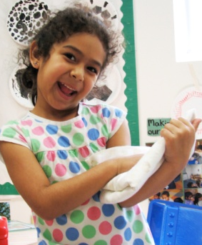
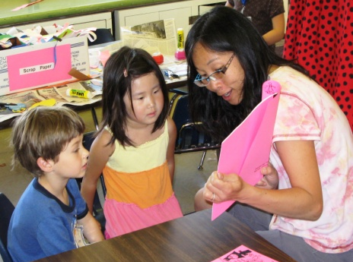
“I’m so glad we made the choice to
enroll my son in transitional
kindergarten. He’s very confident in
school now and he’s excited to learn
more.”

-Transitional Kindergarten Parent
What Happens in a
Transitional Kindergarten Classroom?
In transitional kindergarten, teachers help children develop social skills through activities that build confidence and communication. They also expose children to reading and math in an exciting, interactive way by using educational games to teach children about words and sentences and help them understand mathematical concepts like counting and patterns.


Why is Transitional Kindergarten
Good for Kids?
Transitional kindergarten provides children with an opportunity to learn in an enriching and academically challenging environment that nurtures their growth. Research shows that children who attend kindergarten readiness programs like transitional kindergarten are more likely to do well in school and attend college.

Parents all over California recognize the benefits of transitional kindergarten, and many parents have already been enrolling their children in similar programs, public and private, for years. Offering transitional kindergarten will help all of our kids get the best start possible, with curriculum that is designed just for them.
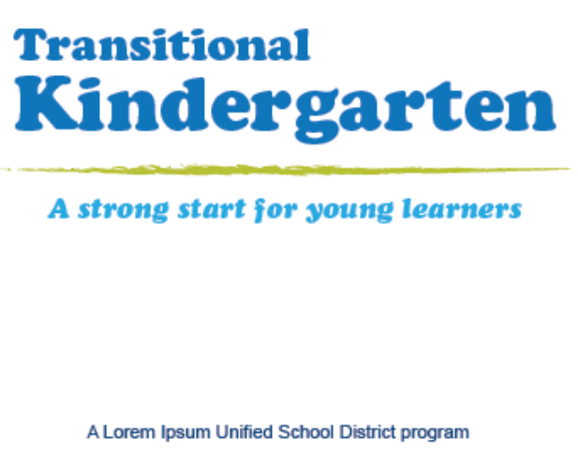

Insert text here with specific information about your program. Some examples are included below.

- Classroom facility and teacher: Transitional kindergarteners have their own classroom with their own teacher.
- Length of school day: They go to school every day from START TIME to END TIME
- Shared activities: They participate in all kindergarten activities such as music and art throughout the year.
- Curriculum and learning: They learn important new skills like X,Y and Z that build on what they may have learned in preschool and help them adjust to the elementary school environment.
- Learning environment: They learn by working with the teacher in small and large groups and also have opportunities for independent exploration.

Insert school district’s name and logo


How Can I Learn More?

To learn more about transitional kindergarten
in your area call

For answers to some frequently asked questions
on transitional kindergarten, visit

Add district’s website
Add district’s contact information
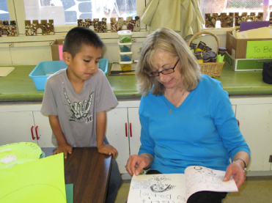
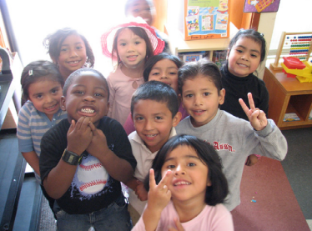
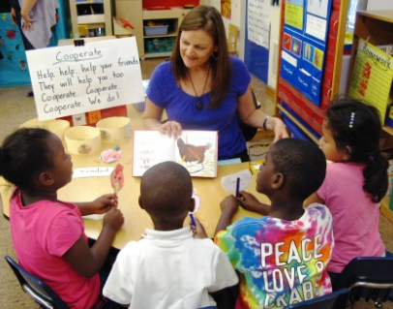
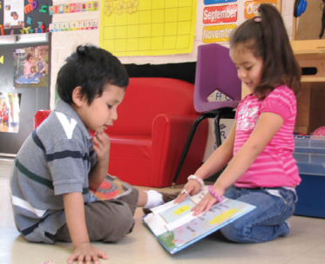
Who Attends
Transitional Kindergarten?
A new law was recently passed in California to change the age when children can begin kindergarten. Under this new law, children must turn 5 years old on or before September 1 to enroll in kindergarten. Previously, children could be enrolled in kindergarten if they turned 5 years old by December 2. While this change of a few months may seem small, it can mean a big difference during these early years when children are rapidly growing and developing.

The law also created transitional kindergarten, so the children who will be affected by this change – those with birthdays between September and December – will have an opportunity to continue building their skills and abilities. Their time in transitional kindergarten will help them to succeed in kindergarten, become leaders in the classroom and confidently navigate the school day routine.


What is Transitional Kindergarten?
Transitional kindergarten is a bridge between preschool and kindergarten for children turning 5 years old between September and December. It gives young learners a head start and provides them with an opportunity to learn and grow in an environment that is tailored to meet their academic and social needs.

Starting school is a very exciting time for children and their families! It begins a new chapter in their lives and sets the tone for children's future. But California’s kindergarten standards and curriculum have changed over the years, and many of the skills children were once taught in first grade are now expected in kindergarten. This can make the transition into kindergarten difficult for some children, and the youngest children entering the kindergarten classroom often struggle to adjust.

The good news is that California recently passed a law to create transitional kindergarten, giving children an opportunity to learn in a hands-on, interactive way that supports their development, while still maintaining the rigor and high standards of kindergarten.

In our district and throughout the state, transitional kindergarten will be offered to children turning 5 years old between September 1 and December 2 to give them an opportunity develop the social and academic skills and the confidence that will help them succeed in kindergarten and beyond.
Transitional kindergarten:

- Is part of the public school system and is free for families
- Uses a unique, specialized curriculum that is based on the kindergarten standards and is designed to support young 5 year olds
- Is taught by credentialed teachers with extra training to teach young kindergarteners
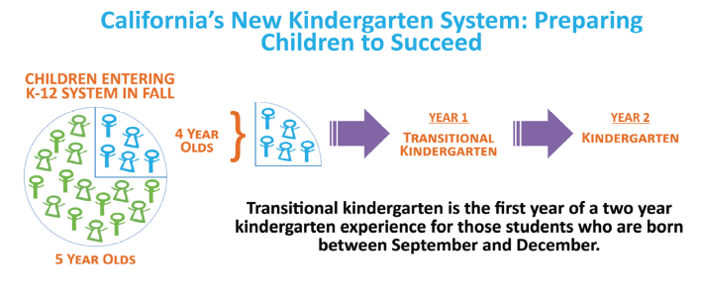
- Transitional Kindergarten Teacher
When Ryan first began transitional kindergarten, he had trouble focusing in class and struggled to write many words. After just a few months, Ryan’s focus is much better and he is now able to write sentences. “He feels so much more confident now,” says his mother, Monica. “Transitional kindergarten was
a perfect fit for him.”
If district is phasing in transitional kindergarten, explain phase-in process here.

“Transitional kindergarten gives the
gift of time to children who are smart and capable but need another year to grow.”

TK California
www.tkcalifornia.org
Offers resources and information on California’s transitional kindergarten implementation.
California Department of Education
www.cde.ca.gov/ci/gs/em/kinderfaq.asp
Provides answers to nearly 30 frequently asked questions about transitional kindergarten.

Preschool California
www.preschoolcalifornia.org
Offers fact sheets, press releases and other helpful resources to promote the benefits of transitional kindergarten. Also features a database of positive media coverage of transitional kindergarten and the Kindergarten Readiness Act.
State Senator Joe Simitian on SB 1381
www.senatorsimitian.com
Provides information about the Kindergarten Readiness Act, including press releases, fact sheets and media coverage.
California Kindergarten Association
www.californiakindergartenassociation.org
Includes a Power Point presentation on transitional kindergarten, sample lesson plans and tips for teachers, an catalog of instructional materials, workshop and conference information and other helpful links.

20
Transitional Kindergarten
Resources

