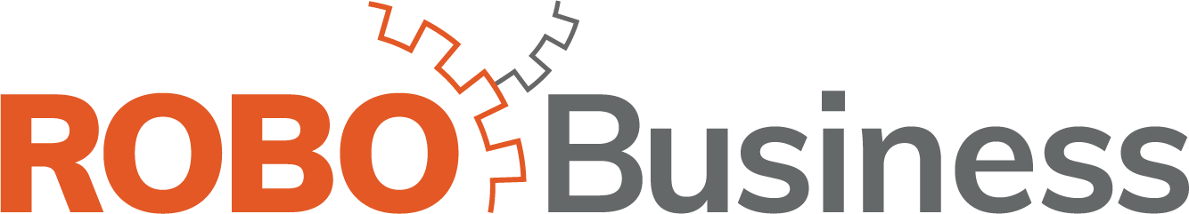

Exhibitor Bulletin #1

We are now 81 days away from RoboBusiness 2019, October 1-3 at the Santa Clara Convention Center!

Our Exhibitors & Sponsors are the mainstay of our event! We are here to assist and make your exhibiting experience simple and stress-free.

Over the summer, we will send you occasional bulletins like this one to keep you up-to-date and informed! You can reply to the email at any time for personal assistance. As we get closer to the event, Bulletins will be sent weekly.

The following highlights important information. We hope this is an easy transition to specific items of interest on our website. Never hesitate to contact us should you need assistance.

Website
On the Robobusiness website (https://www.robobusiness.com/), under Expo, For Current Sponsors, you will find resources such as Deadlines, Exhibitor Kit, Marketing Kit and so much more! Click here to visit the Current Sponsor page.

Registration
In the coming weeks, you will receive an email with instructions on how to register your booth staff along with customized promotional codes to send to your network. Look for this email from Jess Steinberg. Please contact Jess with any questions related to Registration.

Exhibitor Kit
Click here for the Exhibitor Kit.

Logos
Do we have your logo on file? If not, please email an .eps file to jsteinberg@ehpub.com.

Hotel
Have you booked your hotel room? RoboBusiness has reserved a block of rooms at the Hyatt Regency Santa Clara. Click here for more information or to book your stay! Book by September 8th. After this date, the room rate will increase if there is availability.

Need Assistance?
Please don’t hesitate to contact JoAnne at jgambrazzio@ehpub.com with questions.

