DOUBLE STRANDED STANCHION KIT ASSEMBLY INSTRUCTIONS
Item No. 959**-6 Kit contains the following:
6 each bases
6 each 24" poles
6 each 12" poles
6 each extensions
6 each ball tops
24 pairs O-rings
Chain is sold separately.
- Put O-rings into pairs, one male and one female. 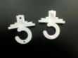 Put chain on O-rings 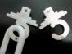 and snap O-rings together. 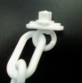 Set aside.
- Put 24” pole onto base, press firmly down until it stops. 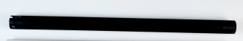
b
base
pole


- Take extension piece and slide part way into pole – approximately 1/4 of the length. 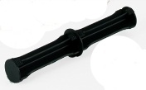
extension
piece

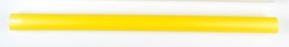
pole
- Take O-rings with chain attached and slide O-ring into slot on pole 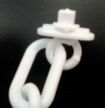 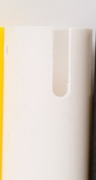 – -remember the extension has only been put in part way into the pole to allow the O-rings to be put into the slot on the pole.
Slot in top of
pole
O-ring and chain
- Push extension all the way down until it stops.
- Take 12” pole and slide onto top of extension, line up top pole slots with bottom pole slots.
- Take o-rings with chain attached and slide o-rings into slot on top pole. See pictures above.
- Place ball top onto top pole and press until it snaps into place.

