Ministry Leaders: A suggested email is provided for each session for you to customize if you desire and share with your families. You can also access a social media share square for each session on the Additional Resources page at gospelproject.com.
The Gospel Project At Home content is available in Ministry Grid for you to share with your families.
Unit 22, Session 1
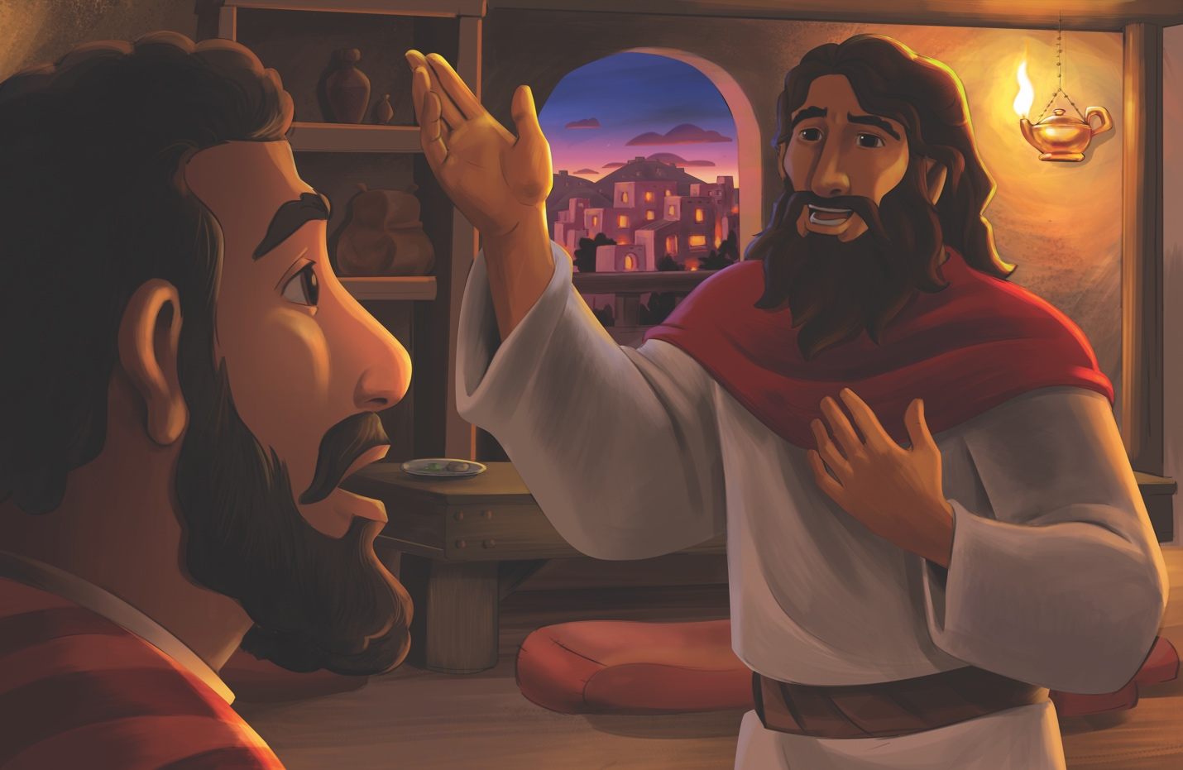
Jesus’ Second Miracle (John 4)

Dear families,
Jesus’ first recorded miracle of turning water into wine was immediately observable to His disciples and the servants who drew from the jars. His second miracle, however, required that a man trust Him without being able to see instantaneous proof that Jesus was at work.

A royal official found Jesus and humbly begged for a miracle only Jesus could provide—to come heal his son who was sick and close to death. Given the urgency of the man’s request, Jesus’ initial response—”Unless you people see signs and wonders, you will not believe”—may sound callous; however, Jesus was providing an opportunity for the man to see Him as more than just a prophet or healer, but as Savior and Lord. Did this official believe that Jesus is who He said He is, or was the official simply seeking signs and wonders?

The official asked Jesus to make the journey to heal his suffering child, but Jesus proved His power isn’t limited by proximity. Instead of traveling with the man, Jesus simply said the words, “Go, your son will live.” The official believed Jesus’ words and departed for his home. He was soon met by servants who informed him of the exact time his son was healed. It was the very moment Jesus declared him well! As a result, the official’s entire household placed their faith in Jesus!

This passage reveals that faith often involves believing in God’s provision even when we don’t see immediate results. The official’s willingness to return home, trusting Jesus at His word, illustrates the definition of faith given in Hebrews 11:1: “Now faith is the reality of what is hoped for, the proof of what is not seen.” The official didn’t have to immediately see his son healed to believe Jesus’ words of life.

Like the boy in this story, we need Jesus’ healing power. While we may not be on our physical death beds, we come to Jesus dead in our sins. By trusting in Jesus for salvation, we receive the spiritual healing of forgiveness and the promise of eternal life.

This week, lead your children to trust Jesus, especially in moments when they cannot see Him at work. Whether His answers to our prayers come quickly or seem delayed, we can trust in the power and goodness of our Savior who is always working for the good of those who love Him.

Check out The Gospel Project At Home for resources designed to help you lead a family worship experience as well as suggestions for morning and evening prayer times and family activities.

FAMILY TALKING POINTS

STORY POINT
This is the main point to emphasize from today’s Bible story.

- Preschool: Jesus healed an official’s son.
- Kids: Jesus healed an official’s son.

CHRIST CONNECTION
This is the big idea of how this week’s Bible story points to Jesus.

- Babies & Toddlers: Jesus came to save people from sin and give them a home with God forever.
- Younger Preschool: Jesus healed a boy who was very sick. Jesus did good things like healing, but He came to do something even better. Jesus came to take away sin and bring us to be with God forever.
- Older Preschool: The official believed in Jesus after He saved the man’s son from death. Jesus came to save people from sin and give them life with God forever.
- Kids: We all are dead in our sins, but Jesus provided the way to save us by dying for our sin and rising again. Everyone who repents and trusts in Him is saved from death and will live forever with God.

BIG PICTURE QUESTION & ANSWER
This is an important biblical truth that your child will encounter each week of this unit.

- Younger Preschool: Why did Jesus do miracles? Jesus did miracles to show He is the Son of God.
- Older Preschool: Why did Jesus perform miracles? Jesus performed miracles to show He is the Son of God.
- Kids: Why did Jesus perform miracles? Jesus performed miracles to glorify God, to show He is the Son of God, and to care for people.

KEY PASSAGE
This is a Bible verse that relates to what your child will encounter each week of this unit.

- Babies & Toddlers: How great and mighty are his miracles. His kingdom is forever. Daniel 4:3
- Younger Preschool: How great are his miracles and mighty his wonders! His kingdom is forever. Daniel 4:3
- Older Preschool: How great are his miracles, and how mighty his wonders! His kingdom is an eternal kingdom. Daniel 4:3
- Kids: How great are his miracles, and how mighty his wonders! His kingdom is an eternal kingdom, and his dominion is from generation to generation. Daniel 4:3

** Next week: Jesus Rejected in Nazareth (Luke 4)

Unit 22, Session 2
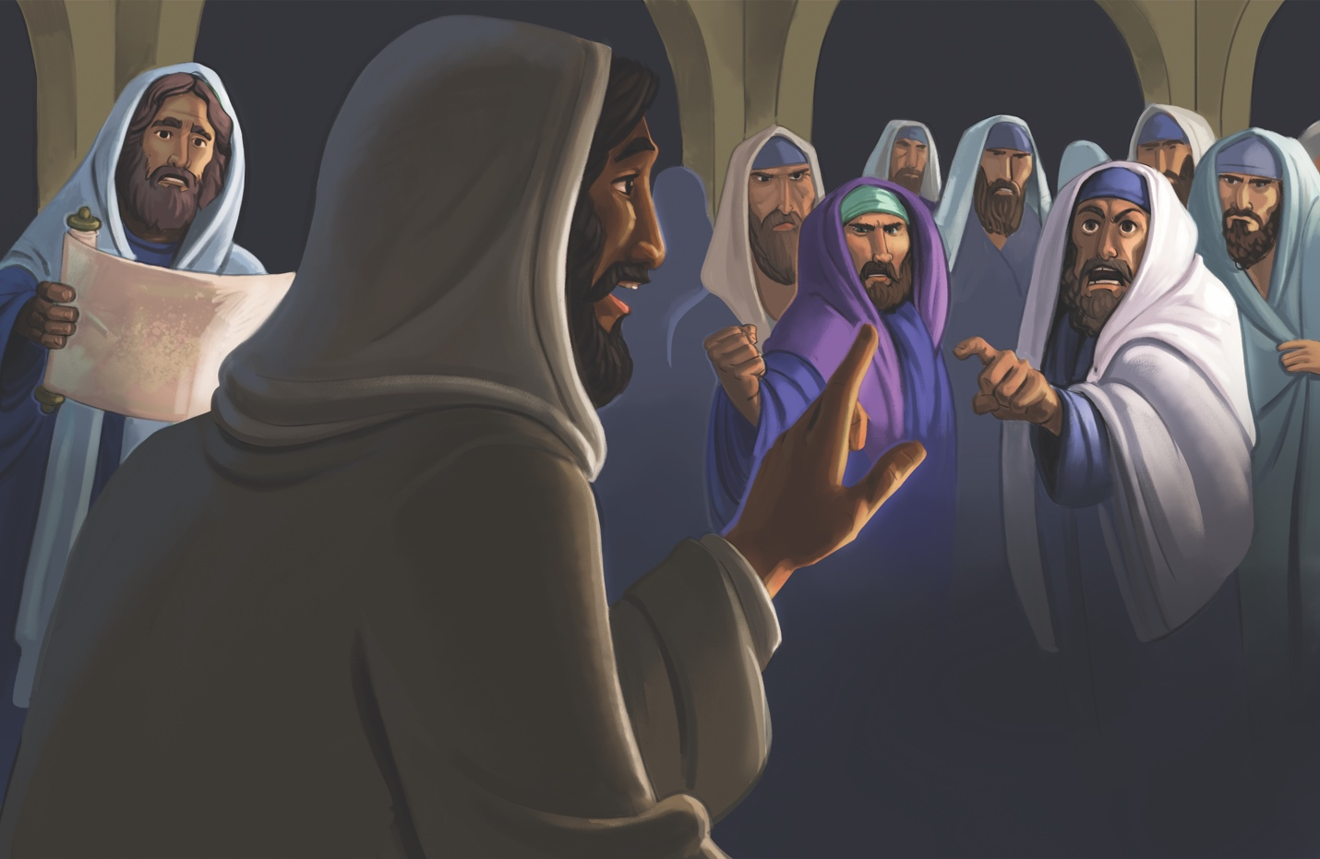
Jesus Rejected in Nazareth (Luke 4)

Dear families,
At the beginning of this week’s Bible story, the people’s eyes are fixed on Jesus, hanging onto His every word. At the end of the story, however, they are so angry at Jesus they plan on throwing Him off a cliff to shut Him up. What happened to trigger such an abrupt change in the people’s attitude toward Jesus?

For Jesus’ neighbors in Nazareth, it was a mix of pride and disbelief. The Jews had no problem when Jesus followed their customs by reading a scroll in their synagogue on the Sabbath. But when Jesus began to show how the Old Testament pointed to Him, the people began to murmur and doubt. How could the man they had seen grow up on their streets be the expected Messiah?

What’s more, Jesus began sharing scriptural examples of times when God’s people rejected His blessings and when grace and mercy were applied to Gentiles (non-Jews). This was the tipping point for those listening to Jesus, as they were appalled at the idea that God’s blessings were not theirs by default due to their ancestry.

This story offers two lessons to today’s listeners. First, we are not in God’s family because we go to church, live in a certain area, or have family members who love Jesus. Help kids see that each person must respond to the gospel individually with faith and repentance. It is only by grace through faith that we are saved.

Secondly, Jesus is a polarizing presence in a lost world. In today’s story we quickly see a fascination with Jesus turn into hatred of Him. This echoes Jesus’ words elsewhere in Scripture that “anyone who is not with Me is against Me, and anyone who does not gather with Me scatters” (Matthew 12:30). Help kids see that there is no neutral ground when it comes to considering Jesus. Every person must decide to either reject Him or worship Him as Lord.

Consider sharing with your kids the turning point in your life when you saw Jesus for who He really is and responded in faith and repentance. Help them see that Jesus really is the loving Messiah who came to redeem, forgive, and restore our relationship with God.

Check out The Gospel Project At Home for resources designed to help you lead a family worship experience as well as suggestions for morning and evening prayer times and family activities.

FAMILY TALKING POINTS

STORY POINT
This is the main point to emphasize from today’s Bible story.

- Preschool: Jesus taught that He is the Messiah.
- Kids: Jesus taught that He is the Messiah.

CHRIST CONNECTION
This is the big idea of how this week’s Bible story points to Jesus.

- Babies & Toddlers: Jesus taught good news. Jesus is the one God promised to send.
- Younger Preschool: Jesus said He is the special one God promised to send. Jesus came to tell the good news that He is the Savior.
- Older Preschool: Jesus taught that He is the Messiah. He came with good news! Jesus is the One God promised to send.
- Kids: All people sin and need a Savior, but not everyone will believe in Jesus. Only those who believe the good news about Jesus and repent will be rescued from sin and death.

BIG PICTURE QUESTION & ANSWER
This is an important biblical truth that your child will encounter each week of this unit.

- Younger Preschool: Why did Jesus do miracles? Jesus did miracles to show He is the Son of God.
- Older Preschool: Why did Jesus perform miracles? Jesus performed miracles to show He is the Son of God.
- Kids: Why did Jesus perform miracles? Jesus performed miracles to glorify God, to show He is the Son of God, and to care for people.

KEY PASSAGE
This is a Bible verse that relates to what your child will encounter each week of this unit.

- Babies & Toddlers: How great and mighty are his miracles. His kingdom is forever. Daniel 4:3
- Younger Preschool: How great are his miracles and mighty his wonders! His kingdom is forever. Daniel 4:3
- Older Preschool: How great are his miracles, and how mighty his wonders! His kingdom is an eternal kingdom. Daniel 4:3
- Kids: How great are his miracles, and how mighty his wonders! His kingdom is an eternal kingdom, and his dominion is from generation to generation. Daniel 4:3

** Next week: Healings in Capernaum (Mark 1; Luke 4)

Unit 22, Session 3
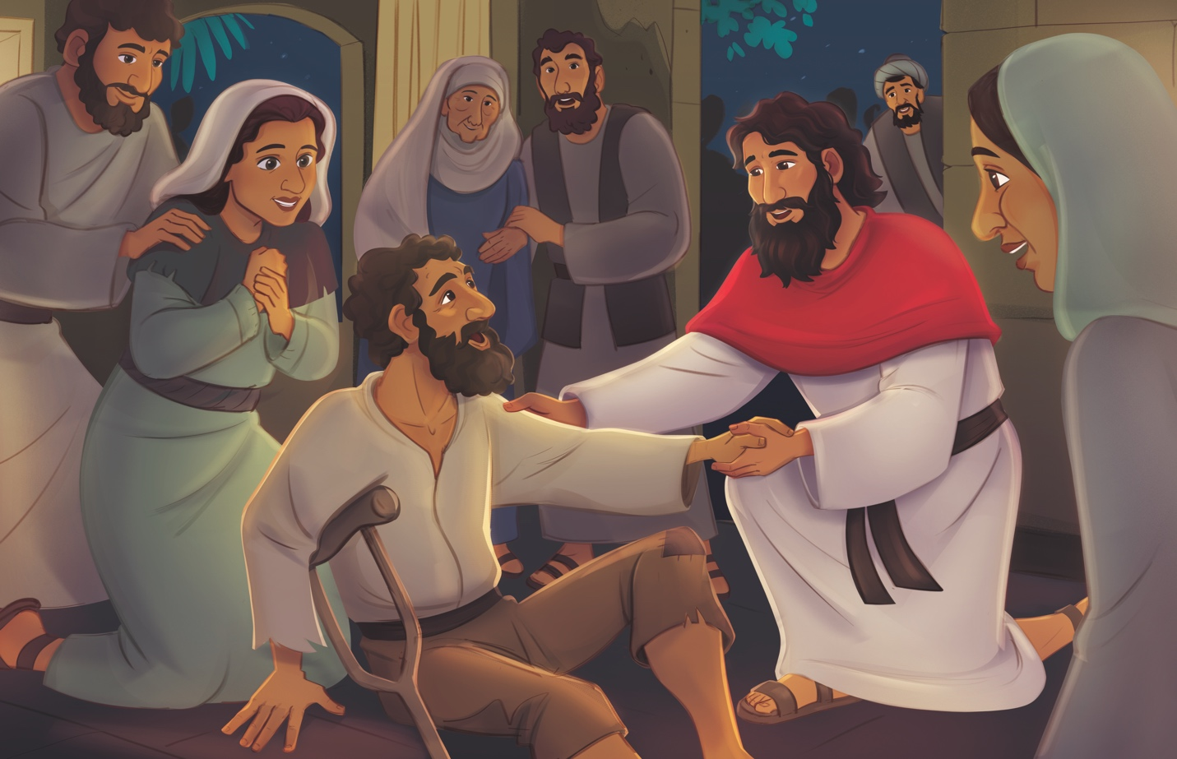
Healings in Capernaum (Mark 1; Luke 4)

Dear families,
Jesus’ power to heal the sick comprised an important part of His ministry—drawing people to Him in desperation, curiosity, and wonder. Though His signs and wonders led crowds to gather in His presence, Jesus did not perform healings as a mere party trick or performance. His healings pointed to a need much greater than they could see with their eyes or even feel within their bodies; Jesus came to save sinners from the power of sin and death.

When Jesus spoke in the synagogue, people listened intently, aware that He was different from the others who taught the Scriptures. Jesus spoke with authority, confidence, and a sincere reliance upon God’s Word. He had power that came from being one with His Father. Those gathered in His presence didn’t just hear His words; they witnessed His truth in action as He commanded unclean spirits and healed those in need. He didn’t just talk about God’s salvation; He demonstrated God’s desire to save those He created.

Healings were an important part of Jesus’ ministry because sickness is a reality that impacts lives deeply and personally. Jesus also knew, however, that our great physical need for healing would point to our even greater need for salvation. Jesus’ signs lead us to experience the truth that He came to save all who believe in Him by faith. This ability to repent and trust in Him for the hope of eternal life is the free gift offered to us by grace.

The man with the unclean spirit recognized the power and holiness of Christ and received healing in his time of need. Simon’s mother-in-law was bedridden and feverish until Jesus raised her up, and she began to serve her son’s household. Jesus went on to restore many more people who had been afflicted with sickness and unclean spirits. All these experienced healing, in contrast to those who believed themselves too righteous to need a Savior, unable to recognize Jesus as the true Son of God.

As you lead your kids this week, pray that they would look to Jesus as the one with all power, authority, and rule over their lives. Ask the Lord to make His truth evident in their lives, that they would repent of their sins and experience salvation in His name.

Check out The Gospel Project At Home for resources designed to help you lead a family worship experience as well as suggestions for morning and evening prayer times and family activities.

FAMILY TALKING POINTS

STORY POINT
This is the main point to emphasize from today’s Bible story.

- Preschool: With power, Jesus healed people.
- Kids: With authority and power, Jesus healed people.

CHRIST CONNECTION
This is the big idea of how this week’s Bible story points to Jesus.

- Babies & Toddlers: Jesus healed people and taught about God.
- Younger Preschool: Jesus healed sick people with His great power. Jesus is the King. One day, He will take away all sickness, sin, and sadness forever.
- Older Preschool: With power, Jesus healed people. He is the King who came to make all things right. Anyone who repents and trusts in Jesus will be forgiven of sin and can look forward to when sin, death, and sickness will no longer exist.
- Kids: Jesus has all authority and power to heal the sick and save sinners. Anyone who repents and trusts in Him will be forgiven of sin and can look forward to the new heaven and earth where sin, death, and sickness will no longer exist.

BIG PICTURE QUESTION & ANSWER
This is an important biblical truth that your child will encounter each week of this unit.

- Younger Preschool: Why did Jesus do miracles? Jesus did miracles to show He is the Son of God.
- Older Preschool: Why did Jesus perform miracles? Jesus performed miracles to show He is the Son of God.
- Kids: Why did Jesus perform miracles? Jesus performed miracles to glorify God, to show He is the Son of God, and to care for people.

KEY PASSAGE
This is a Bible verse that relates to what your child will encounter each week of this unit.

- Babies & Toddlers: How great and mighty are his miracles. His kingdom is forever. Daniel 4:3
- Younger Preschool: How great are his miracles and mighty his wonders! His kingdom is forever. Daniel 4:3
- Older Preschool: How great are his miracles, and how mighty his wonders! His kingdom is an eternal kingdom. Daniel 4:3
- Kids: How great are his miracles, and how mighty his wonders! His kingdom is an eternal kingdom, and his dominion is from generation to generation. Daniel 4:3

** Next week: Healings in Galilee (Mark 1; Luke 4-5)

Unit 22, Session 4
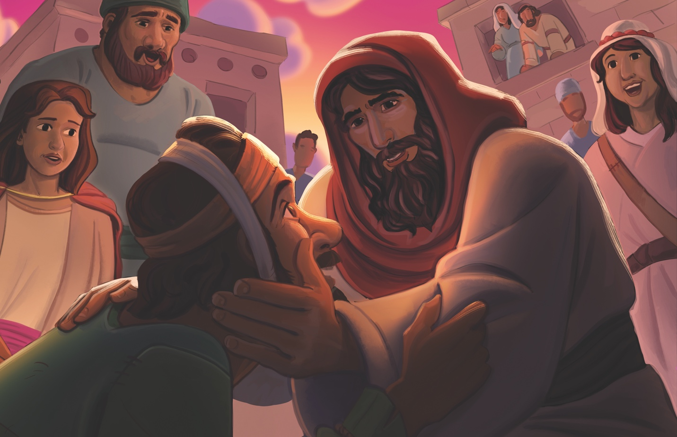
Healings in Galilee (Mark 1; Luke 4-5)

Dear families,
The healings Jesus performed from village to village weren’t like the spectacles put on by others who claimed to have divine power. Jesus didn’t come to seek applause of people looking for a show; He drew near to those experiencing affliction because of His great love for them and His Father. Jesus extended compassionate care to all who recognized their need for a Savior and trusted in Him for spiritual healing and wholeness.

In today’s passage, Jesus revealed His purpose for preaching: to proclaim the good news of His Father’s kingdom. This kingdom wasn’t what the people expected—it wasn’t for the most fortunate, educated, or impressive. Jesus’ heart was for all who found themselves in need of His healing, all who trusted in Him as their great Healer.

Jesus’ healing of the man with leprosy is one of the greatest examples of love and compassion found in Scripture. Luke 5:12 tells us his leprosy had spread all over his body, an advanced case leaving him isolated from community and desperate enough to fall facedown before the Lord. In an act of great faith, the man trusted in Jesus’ power to heal, knowing that His willingness to save him was all he would need.

Mark 1:41 says that compassion moved Jesus closer to the man in need. Jesus did more than speak healing words over him; Jesus reached out, touched him, and immediately healed him! In a society that often shunned lepers, Jesus offered His touch as a means of closeness and compassion. With His words, Jesus gave him next steps for cleansing and reentering his community.

The man was healed from leprosy and couldn’t keep the good news of Jesus to himself. In desperation, he turned to Jesus by faith, experiencing the Savior’s true healing. He believed in Jesus’ ability, power, and authority to heal. We can still approach Jesus by faith with our requests, trusting that He can accomplish whatever He wills.

The reason the crowds gathered all those centuries ago was to listen to Jesus and be healed. May your children hear Jesus’ words of life and experience the healing and wholeness that only He provides.

Check out The Gospel Project At Home for resources designed to help you lead a family worship experience as well as suggestions for morning and evening prayer times and family activities.

FAMILY TALKING POINTS

STORY POINT
This is the main point to emphasize from today’s Bible story.

- Preschool: Jesus showed His care for people.
- Kids: Jesus showed His care for people by healing them.

CHRIST CONNECTION
This is the big idea of how this week’s Bible story points to Jesus.

- Babies & Toddlers: Jesus came to heal us from our sin and forgive us when we ask.
- Younger Preschool: Jesus cared for a man who was very sick and made him better. Sin is like being sick inside, but Jesus can take away our sin when we ask Him.
- Older Preschool: Jesus showed His care for people by healing the man with the skin disease. Jesus shows His care for us by offering forgiveness for sin if we repent and believe in Him.
- Kids: Jesus was willing to heal the man's skin and make him clean. Jesus is also willing save those who humble themselves, repent of their sin, and trust in Him.

BIG PICTURE QUESTION & ANSWER
This is an important biblical truth that your child will encounter each week of this unit.

- Younger Preschool: Why did Jesus do miracles? Jesus did miracles to show He is the Son of God.
- Older Preschool: Why did Jesus perform miracles? Jesus performed miracles to show He is the Son of God.
- Kids: Why did Jesus perform miracles? Jesus performed miracles to glorify God, to show He is the Son of God, and to care for people.

KEY PASSAGE
This is a Bible verse that relates to what your child will encounter each week of this unit.

- Babies & Toddlers: How great and mighty are his miracles. His kingdom is forever. Daniel 4:3
- Younger Preschool: How great are his miracles and mighty his wonders! His kingdom is forever. Daniel 4:3
- Older Preschool: How great are his miracles, and how mighty his wonders! His kingdom is an eternal kingdom. Daniel 4:3
- Kids: How great are his miracles, and how mighty his wonders! His kingdom is an eternal kingdom, and his dominion is from generation to generation. Daniel 4:3

** Next week: Jesus Forgives and Heals (Matthew 9; Mark 2; Luke 5)

Unit 23, Session 1
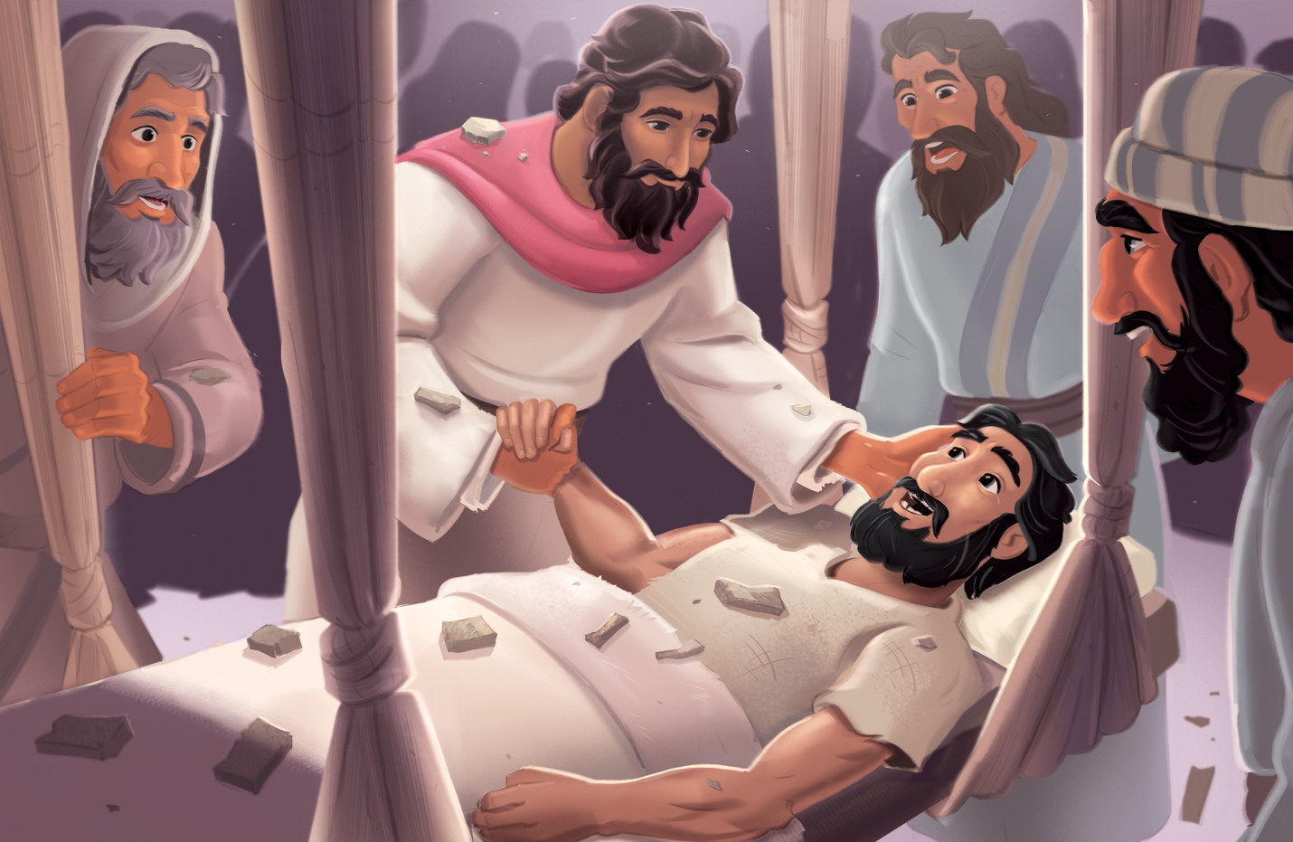
Jesus Forgives and Heals (Matthew 9; Mark 2; Luke 5)

Dear families,
Jesus posed an intriguing question in today’s passage: “Which is easier: to say to the paralytic, ‘Your sins are forgiven,’ or to say, ‘Get up, take your mat, and walk’?” We’re presented with quite a few crises in this story: a man suffering from paralysis was carried into Jesus’ presence by his friends, the house was too crowded to allow new guests, and the Jewish leaders watched it all unfold with cynical hearts. It appeared to be a lose-lose situation from every angle.

As Jesus kept teaching, the men devised a plan to get their friend to the Healer while the scribes and Pharisees continued to cry blasphemy in their hearts.

Yet Jesus was demonstrating this truth to every person involved: He alone has the power to forgive sin. In this scriptural account, we see Jesus’ authority—His power, ability, and willingness to intervene in the lives of God’s people through their faith. Though the religious leaders in the crowd were unable to see the state of the paralyzed man’s heart, they could witness Christ’s power to physically heal.

When Jesus saw the friends’ desperate, inventive, and faith-fueled means of bringing their friend to Him, He extended forgiveness to the man. However, Jesus’ forgiveness was viewed as an overstepping of authority. After all, the Jews knew that only God has the right to forgive sins. The scribes and Pharisees believed it would be more difficult for Jesus to forgive the man than to heal him. To prove His power to accomplish both, Jesus extended forgiveness and physical healing to the man in need.

Jesus meets the needs of the humble and lowly. He recognized the faith of the men who took such a great risk to deliver their friend at His feet. They believed they could boldly approach the one with the power to heal.

This week, lead your children to see that the Jesus in this story is the same Lord who desires to forgive their sins today! Ask the Lord to go before you as you bring your children to Him by teaching them His Word. May they trust in Him by faith, believing in His authority and desire to heal and save them also.

Check out The Gospel Project At Home for resources designed to help you lead a family worship experience as well as suggestions for morning and evening prayer times and family activities.

FAMILY TALKING POINTS

STORY POINT
This is the main point to emphasize from today’s Bible story.

- Preschool: Jesus showed His power by forgiving sin.
- Kids: Jesus showed His power by forgiving sin.

CHRIST CONNECTION
This is the big idea of how this week’s Bible story points to Jesus.

- Babies & Toddlers: Jesus can forgive sins and heal people because Jesus is God.
- Younger Preschool: Jesus helped a man who could not walk. Jesus also forgave the man’s sins. Jesus can do this because Jesus is God.
- Older Preschool: Jesus showed His power by forgiving sin and healing the man who could not walk. Jesus can forgive sins and heal people because Jesus is God.
- Kids: By forgiving the man's sins, Jesus revealed that He is God. Jesus has power to heal and forgive. Only through faith in Jesus can people be saved from their sins.

BIG PICTURE QUESTION & ANSWER
This is an important biblical truth that your child will encounter each week of this unit.

- Younger Preschool: What did Jesus teach when He was on earth? Jesus taught about God and His kingdom.
- Older Preschool: What did Jesus teach when He was on earth? Jesus taught about God and His kingdom.
- Kids: What did Jesus teach when He was on earth? Jesus taught about God and His kingdom. He taught that all Scripture is about Him.

KEY PASSAGE
This is a Bible verse that relates to what your child will encounter each week of this unit.

- Babies & Toddlers: Shine your light so others see your good works and give glory to God. Matthew 5:16
- Younger Preschool: Shine your light before others so they see your good works and give glory to God. Matthew 5:16
- Older Preschool: "Let your light shine before others, so that they may see your good works and give glory to your Father in heaven." Matthew 5:16
- Kids: "Let your light shine before others, so that they may see your good works and give glory to your Father in heaven." Matthew 5:16

** Next week: John Chose Disciples (Mark 2-3; Luke 6)

Unit 23, Session 2
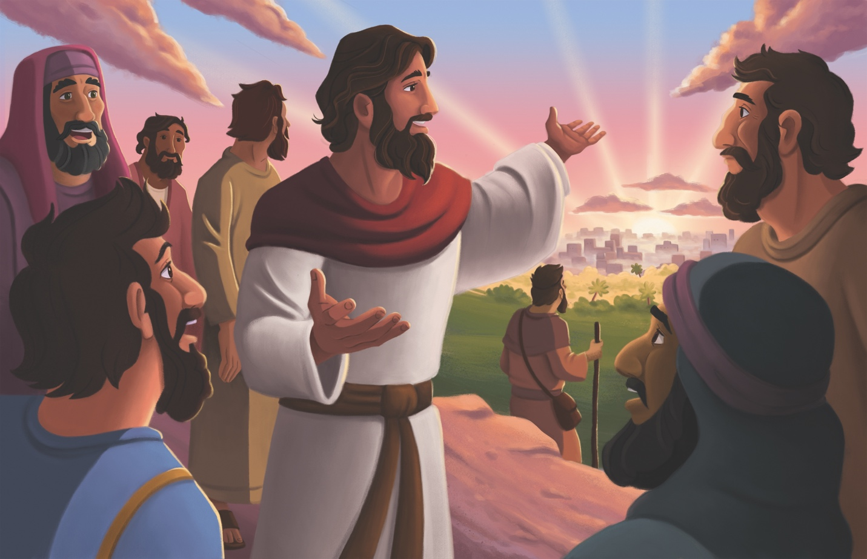
Jesus Chose Disciples (Mark 2-3; Luke 6)

Dear families,
In the early chapters of Mark and Luke’s Gospels, we discover Jesus’ inviting His first disciples to join Him in ministry. Jesus initiated relationships with each of these men, taking the first step to bring them into His inner circle. The type of people Jesus called as disciples may have seemed like odd choices to some; the Pharisees, after all, disapproved at the company Christ kept.

Jesus’ disciples included two pairs of brothers who worked as fishermen, some who joined forces with the Romans, others who abhorred the Romans, a tax collector whose profession was known for dishonest gain, and one who would eventually betray Him in exchange for 30 pieces of silver. It was a ragtag bunch.

Jesus' critics likely thought He should have picked disciples they deemed more qualified with cleaner reputations. But Jesus has a heart for the lost, sick, and searching, saying, “I didn’t come to call the righteous, but sinners” (Mark 2:17).

One detail we often overlook is that Jesus spent an entire night in prayer before selecting these men to join His inner circle. He invited them into a close relationship with Himself, knowing the optics of the situation, just as He still brings sinners into His fold. Even today, it’s a wonder why He would call any of us to follow Him. That’s the beauty of His grace.

Jesus was a friend of sinners, while the scribes and Pharisees believed themselves too holy for the likes of such company. When Jesus sensed this disapproval in the hearts of the religious elite, He addressed aloud their cynical concerns by sharing that only the sick need a doctor (Luke 5:31). In other words, only those who recognize their sin and need for the Savior will be able to receive new life in Him.

Just as He spent a night in prayer before calling the disciples to follow Him, Jesus still intercedes for His followers today (Romans 8:34). Pray that your children who are hearing Christ’s gospel invitation will see themselves through the lens of the disciples. Ask the Lord to reveal His love for the lost, along with His desire to restore their relationship with their Father in heaven.

Check out The Gospel Project At Home for resources designed to help you lead a family worship experience as well as suggestions for morning and evening prayer times and family activities.

FAMILY TALKING POINTS

STORY POINT
This is the main point to emphasize from today’s Bible story.

- Preschool: Jesus chose twelve men to follow Him.
- Kids: Jesus invited twelve men to follow Him as disciples.

CHRIST CONNECTION
This is the big idea of how this week’s Bible story points to Jesus.

- Babies & Toddlers: Jesus calls people to love Him, turn from sin, and trust and follow Him.
- Younger Preschool: Jesus still calls people to follow Him. He wants us to stop doing wrong things and trust in Him.
- Older Preschool: Jesus chose the disciples and still calls people to follow Him. Jesus wants us to turn from our sins and trust in Him as Lord and Savior.
- Kids: Jesus chose the disciples and still calls people to follow Him today. He invites all people to turn from their sins and trust in Him as Lord and Savior.

BIG PICTURE QUESTION & ANSWER
This is an important biblical truth that your child will encounter each week of this unit.

- Younger Preschool: What did Jesus teach when He was on earth? Jesus taught about God and His kingdom.
- Older Preschool: What did Jesus teach when He was on earth? Jesus taught about God and His kingdom.
- Kids: What did Jesus teach when He was on earth? Jesus taught about God and His kingdom. He taught that all Scripture is about Him.

KEY PASSAGE
This is a Bible verse that relates to what your child will encounter each week of this unit.

- Babies & Toddlers: Shine your light so others see your good works and give glory to God. Matthew 5:16
- Younger Preschool: Shine your light before others so they see your good works and give glory to God. Matthew 5:16
- Older Preschool: "Let your light shine before others, so that they may see your good works and give glory to your Father in heaven." Matthew 5:16
- Kids: "Let your light shine before others, so that they may see your good works and give glory to your Father in heaven." Matthew 5:16

** Next week: The Lord of the Sabbath (Matthew 12; Mark 2-3; Luke 6)

Unit 23, Session 3
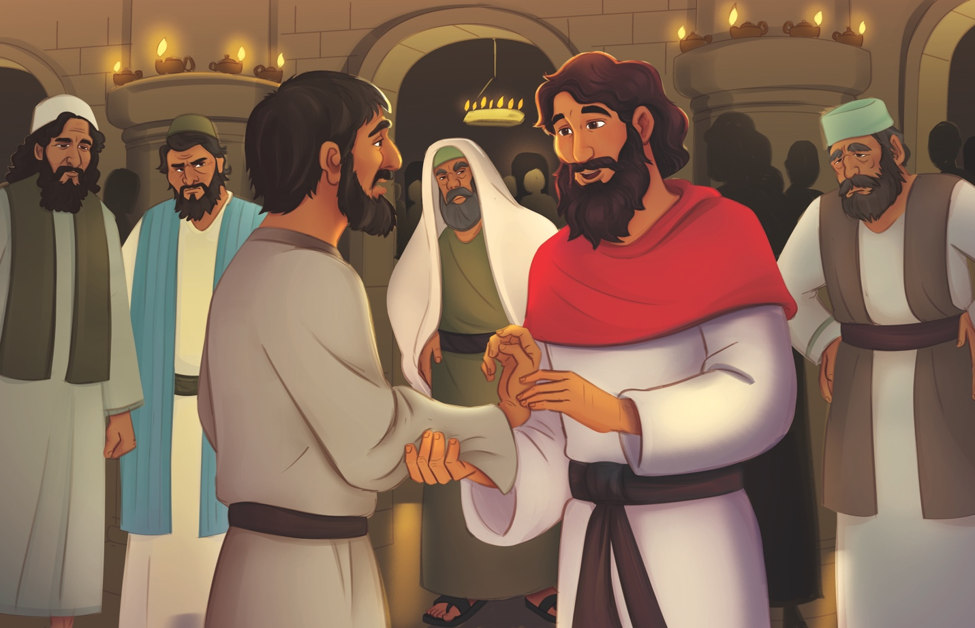
The Lord of the Sabbath (Matthew 12; Mark 2-3; Luke 6)

Dear families,
Jesus rules over all creation and cares deeply for His people's needs. From satisfying their hunger to healing their ailments, Jesus intervened in the lives of His followers. He defended His place as the Lord of the Sabbath and the one who fulfills God's laws.

While the Pharisees viewed their obedience to God’s rules as a means of self-righteousness, Jesus demonstrated that His Father’s commands are to help us and to point to our need for a Savior.

Jesus quoted the words of Scripture back to these experts of the law. In doing so, Jesus made weighty claims about Himself that would not please many in His audience. He once again claimed to be God, to be greater than the temple—God's dwelling place—and to be Lord over the Sabbath.

The Pharisees set their hearts on condemning Jesus and ridding themselves of the problems and competition they felt Jesus was continually creating for them. They stood ready to accuse Him of any perceived wrongdoing. They even tried to use Jesus’ selfless acts of healing to discredit Him!

Considering this, Jesus proposed a theological question about legalism and ethics to His dissenters: “Is it lawful to do good on the Sabbath or to do evil, to save life or to kill?” (Mark 3:4). Sadly, the men viewed Jesus’ healing on the Sabbath as a greater offense to the Lord than the murderous schemes they would soon devise against the Son of God.

The hardness of the men’s hearts grieved Jesus. Yet, He restored the man’s shriveled hand and met a tangible need through healing. In this simple Bible story, we witness Christ’s power and willingness to redeem and restore, even amid others’ doubts and criticism.

Pray that your children who hear this story would be moved by Christ’s heart for our needs—which includes salvation for those who have not yet responded to Jesus in faith. Pray that your kids see themselves like the hungry and hurting ones in this story who recognize their need for the Savior.

Check out The Gospel Project At Home for resources designed to help you lead a family worship experience as well as suggestions for morning and evening prayer times and family activities.

FAMILY TALKING POINTS

STORY POINT
This is the main point to emphasize from today’s Bible story.

- Preschool: Jesus rules over all.
- Kids: Jesus rules over all.

CHRIST CONNECTION
This is the big idea of how this week’s Bible story points to Jesus.

- Babies & Toddlers: Jesus died to show God’s love and came back to life to rescue sinners.
- Younger Preschool: Jesus taught people that God’s rules are good. Jesus is in charge of everything. One day, Jesus would die and come back to life to save us.
- Older Preschool: We sin, but Jesus obeyed all of God's rules perfectly. Because of this, Jesus' death on the cross and resurrection will save us from sin if we repent and believe in Him.
- Kids: Jesus showed that God gives us commands to help us, not to hurt us. Jesus rules over all. Jesus died on the cross and rose again to show God’s love and do good by rescuing sinners.

BIG PICTURE QUESTION & ANSWER
This is an important biblical truth that your child will encounter each week of this unit.

- Younger Preschool: What did Jesus teach when He was on earth? Jesus taught about God and His kingdom.
- Older Preschool: What did Jesus teach when He was on earth? Jesus taught about God and His kingdom.
- Kids: What did Jesus teach when He was on earth? Jesus taught about God and His kingdom. He taught that all Scripture is about Him.

KEY PASSAGE
This is a Bible verse that relates to what your child will encounter each week of this unit.

- Babies & Toddlers: Shine your light so others see your good works and give glory to God. Matthew 5:16
- Younger Preschool: Shine your light before others so they see your good works and give glory to God. Matthew 5:16
- Older Preschool: "Let your light shine before others, so that they may see your good works and give glory to your Father in heaven." Matthew 5:16
- Kids: "Let your light shine before others, so that they may see your good works and give glory to your Father in heaven." Matthew 5:16

** Next week: Jesus’ Sermon on the Mount (Matthew 5-7; Luke 6)

Unit 23, Session 4
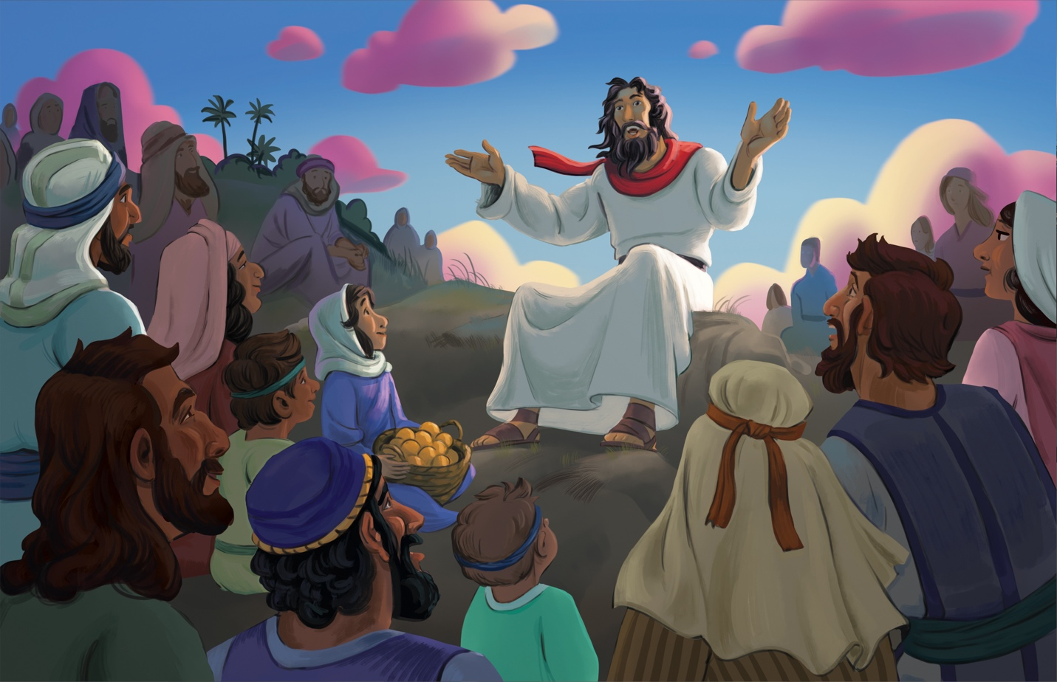
Jesus’ Sermon on the Mount (Matthew 5-7; Luke 6)

Dear families,
The Sermon on the Mount is one of the most well-known and recognizable sermons in all of history. The truth it contains, however, is quite polarizing, calling people into a new way of life that runs counterintuitive to our sin nature.

When Jesus taught His followers the ways of His Father’s kingdom, He shared truths meant to guide them in repentance, obedience, and love for God and one another. Much of what Jesus shared in the Sermon on the Mount reinforced the reality that God’s ways are not like those of the world (Isaiah 55:8⁠–9). Life in God’s kingdom runs opposed to the world’s wisdom, but the God who created us knows how we can flourish in the world He made—by seeking the Lord as our greatest treasure and submitting to His authority.

Jesus declared that those who seek God’s kingdom first will experience His loving provision, both in this lifetime and for all eternity. The way of the kingdom is not by means of earthly power but by Christlikeness; it’s not by ruling over others but by submitting to God’s rule over our lives. Jesus declared that our faith is meant to impact every detail of our lives—from surrendering our will to His (Matthew 6:10), taking our worries to Him (Matthew 6:25), and building our lives on the foundations of His Word (Matthew 7:24⁠–27).

In His Sermon on the Mount, Jesus spoke to people who knew what it was like to be hungry, dismissed, and oppressed. While the scribes and Pharisees hoped to achieve righteousness by rigorously obeying the law, Jesus explained that He came to earth to fulfill the law—to make the way for His followers to be counted as righteous by faith in Him alone. Through faith, we receive new hearts that help us obey our Father.

This week, lead your children to see that the ways of the kingdom become our ways when we surrender our plans to God's will. Pray that they will desire to live as He lived through the transformative power of the Holy Spirit in their lives.

Check out The Gospel Project At Home for resources designed to help you lead a family worship experience as well as suggestions for morning and evening prayer times and family activities.

FAMILY TALKING POINTS

STORY POINT
This is the main point to emphasize from today’s Bible story.

- Preschool: Jesus taught about God’s kingdom.
- Kids: Jesus taught how people in God’s kingdom live.

CHRIST CONNECTION
This is the big idea of how this week’s Bible story points to Jesus.

- Babies & Toddlers: When we follow Jesus, He saves us from sin and shows us how to live.
- Younger Preschool: Jesus taught people how to live God’s way. When we follow Jesus, He helps us live in a way that makes God happy.
- Older Preschool: Jesus taught how people live in God’s kingdom. Jesus came to save His people from sin and change how they live. When people follow Jesus, He changes their hearts so they can live in a way that honors Him.
- Kids: Jesus taught how people in His kingdom have hearts that love God and love others. But because of sin, no one always does what is right and good. When we trust in Jesus, God forgives our sin and changes our hearts so we can live in ways that glorify Him.

BIG PICTURE QUESTION & ANSWER
This is an important biblical truth that your child will encounter each week of this unit.

- Younger Preschool: What did Jesus teach when He was on earth? Jesus taught about God and His kingdom.
- Older Preschool: What did Jesus teach when He was on earth? Jesus taught about God and His kingdom.
- Kids: What did Jesus teach when He was on earth? Jesus taught about God and His kingdom. He taught that all Scripture is about Him.

KEY PASSAGE
This is a Bible verse that relates to what your child will encounter each week of this unit.

- Babies & Toddlers: Shine your light so others see your good works and give glory to God. Matthew 5:16
- Younger Preschool: Shine your light before others so they see your good works and give glory to God. Matthew 5:16
- Older Preschool: "Let your light shine before others, so that they may see your good works and give glory to your Father in heaven." Matthew 5:16
- Kids: "Let your light shine before others, so that they may see your good works and give glory to your Father in heaven." Matthew 5:16

** Next week: John the Baptist in Prison (Matthew 11; 14; Mark 6; Luke 3; 7)

Unit 24, Session 1
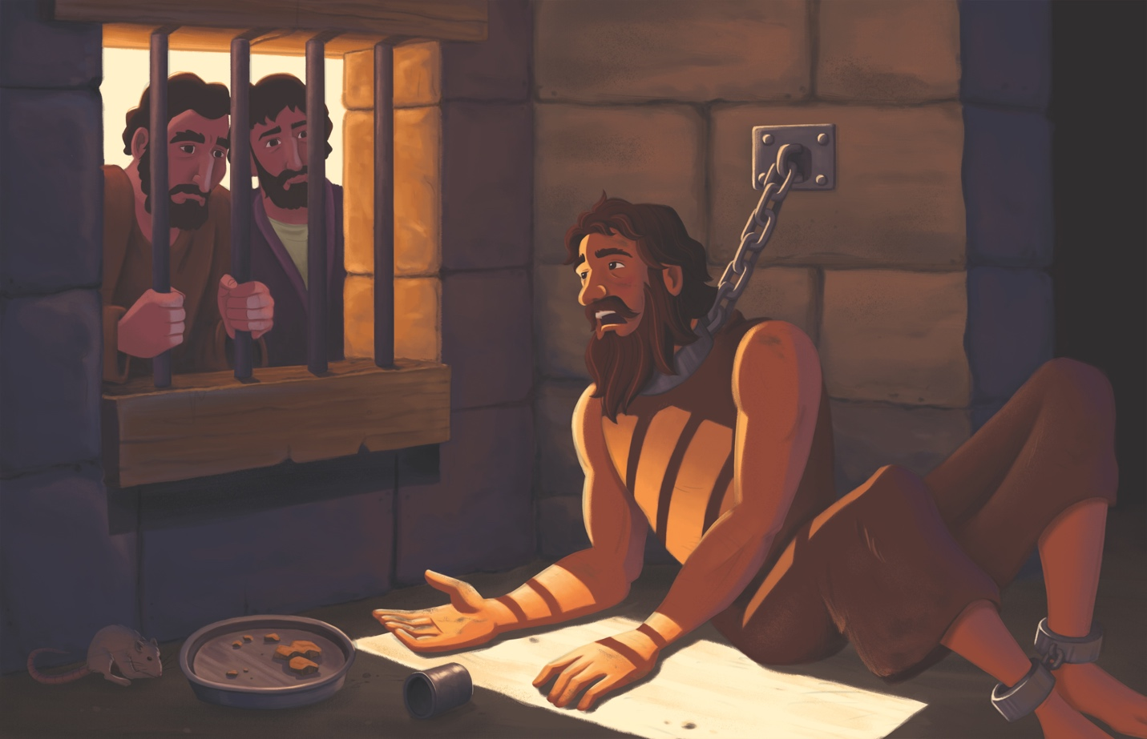
John the Baptist in Prison (Matthew 11; 14; Mark 6; Luke 3; 7)

Dear families,
John the Baptist was a faithful messenger of the gospel. Though he was persecuted by a wicked leader, he was commended by Jesus for his faith. Scripture’s accounts of John’s imprisonment and beheading illustrate his devotion to Jesus, even as John suffered for advocating for the truth.

John was arrested for publicly rebuking Herod’s affair with a young woman who was both his niece and his brother’s wife. Herod wanted to kill John but was mindful of the crowd’s support of him as a prophet. Herod didn’t fear God but was swayed by the opinions of people.

Though John the Baptist centered his ministry on proclaiming Jesus as Messiah, John needed to be reminded that Jesus is truly the one God promised to send. Confined to a prison cell, John relayed his questions in his time of need to Jesus’ disciples and sent them to get an answer from the Lord. “Are you the one who is to come,” John asked Jesus, “or should we expect someone else?”

Jesus offered words of assurance to John and his followers by quoting Isaiah 35:5–6 and pointing to His miracles and proclamation of the gospel. Jesus’ purpose in coming to earth wasn’t to be a political hero for the Jews against the Romans, but to restore the relationship between God and man. Jesus asked the crowd why they followed John in the first place and declared that John was indeed a prophet.

John the Baptist’s message was even greater than that of the Old Testament prophets who preceded him. While the prophets of old declared the Messiah was coming, John declared that He was there among them—Jesus, their Emmanuel! Yet even though John had such an esteemed role in heralding the long-awaited Messiah, Jesus declared that the least in the kingdom of heaven is greater than John was. How blessed are partakers of the new covenant of Christ’s blood!

Just as John needed to be reminded of Jesus’ role as the Messiah, we, too, must be reminded of the good news of the gospel. John the Baptist trusted Jesus’ words of life and knew the threat of death was nothing compared to His promise of eternal life. May your kids who hear this story experience the power of the gospel in their own lives, trusting in Jesus as Messiah and Lord.

Check out The Gospel Project At Home for resources designed to help you lead a family worship experience as well as suggestions for morning and evening prayer times and family activities.

FAMILY TALKING POINTS

STORY POINT
This is the main point to emphasize from today’s Bible story.

- Preschool: John was reminded that Jesus is the Messiah.
- Kids: John was reminded that Jesus is the promised Messiah.

CHRIST CONNECTION
This is the big idea of how this week’s Bible story points to Jesus.

- Babies & Toddlers: When we believe in Jesus, we know what Jesus did and can tell others about Him. Jesus is the Messiah!
- Younger Preschool: John learned that Jesus really is the Savior. We can tell others about Jesus too. Some people may not want to listen, but we keep sharing because Jesus is worth it.
- Older Preschool When faced with hard times, John was reminded that Jesus is the Messiah who had come to bring good news. Followers of Jesus will face hard times, but they have hope: Everyone who trusts in Jesus for salvation will live in His kingdom forever.
- Kids: When faced with suffering, John was reminded that Jesus is the Messiah who had come to bring the good news of salvation. Followers of Jesus will face troubles, but they have hope: Everyone who trusts in Jesus for salvation will live in His kingdom forever.

BIG PICTURE QUESTION & ANSWER
This is an important biblical truth that your child will encounter each week of this unit.

- Younger Preschool: What is prayer? Prayer is talking with God.
- Older Preschool: What is prayer? Prayer is talking with God.
- Kids: What is prayer? Prayer is talking with God to praise Him, ask Him for help, and confess our sins.

KEY PASSAGE
This is a Bible verse that relates to what your child will encounter each week of this unit.

- Babies & Toddlers: Call on Me and pray, and I will listen. Jeremiah 29:12
- Younger Preschool: You will call to me and pray, and I will listen to you. Jeremiah 29:12
- Older Preschool: Call to me and come and pray to me, and I will listen to you. Jeremiah 29:12
- Kids: You will call to me and come and pray to me, and I will listen to you. You will seek me and find me when you search for me with all your heart. Jeremiah 29:12–13

** Next week: Jesus Raised a Widow’s Son (Luke 7)

Unit 24, Session 2
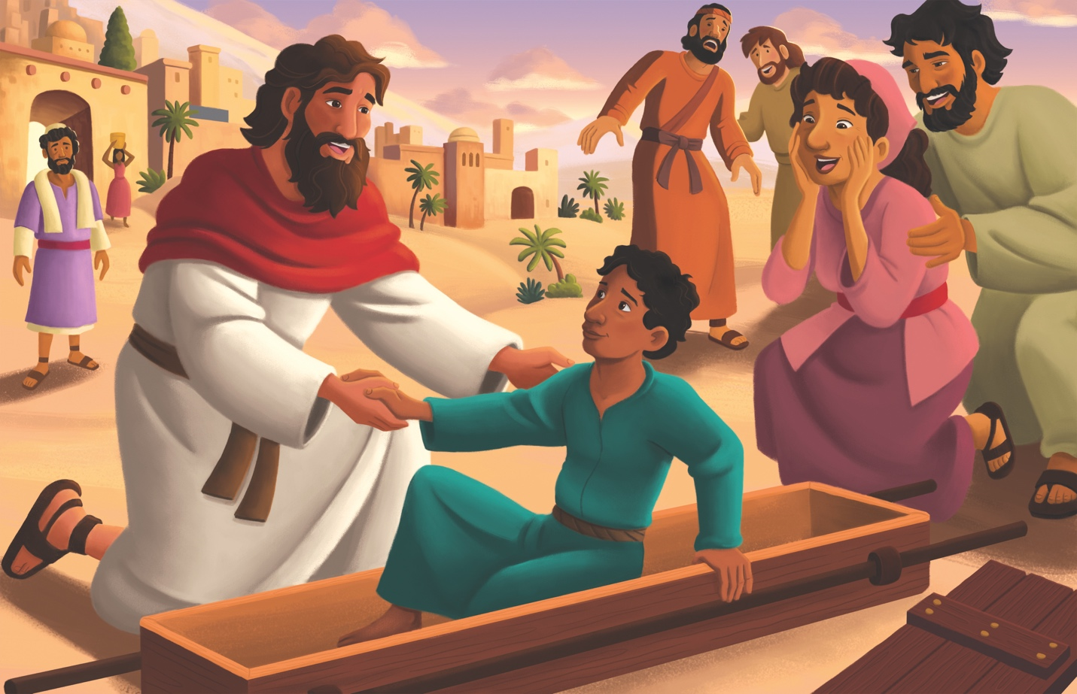
Jesus Raised a Widow’s Son (Luke 7)

Dear families,
Jesus had only just finished healing the centurion’s servant in Luke 7:1-10 when He came upon the funeral procession of a widow’s only son. Jesus didn’t merely feel sorry for the grieving widow; He demonstrated His compassion by publicly raising her son from the dead. In this passage, we witness the truth that only Jesus has the authority to restore the dead back to life.

The timing in which Jesus entered the woman’s life is interesting as it appears that He came on the scene just a little too late. Perhaps the woman’s son had been sick or had received a mortal wound from an accident. Either way, his time for hanging on to life had passed, and people were now carrying the son’s dead body through the streets on the way to the grave. Despite this tragedy, Jesus told the woman not to weep.

This wasn’t because He lacked emotion; Scripture tells us Jesus is the man of sorrows acquainted with our grief, suffering, and sickness (Isaiah 53:3). No, Jesus understood the depths of the woman’s despair, and He embodied the greatest hope in her time of need. The widow no longer needed to cry because Jesus would soon resurrect her son—a precursor to His promise to one day wipe away all tears and bring an end to suffering and death.

This week, lead your children to see that Jesus offers the gift of eternal, resurrected life to anyone who believes Him. Just as the widow’s son was physically dead but raised to life, Christ will raise all who call on Him to immediate new spiritual life and resurrected physical life at His return.

Check out The Gospel Project At Home for resources designed to help you lead a family worship experience as well as suggestions for morning and evening prayer times and family activities.

FAMILY TALKING POINTS

STORY POINT
This is the main point to emphasize from today’s Bible story.

- Preschool: Jesus brought a widow’s son back to life.
- Kids: Jesus raised a widow’s son to life.

CHRIST CONNECTION
This is the big idea of how this week’s Bible story points to Jesus.

- Babies & Toddlers: Jesus has power over death. When we trust in Jesus, He makes us alive with God forever.
- Younger Preschool: Jesus is stronger than death. He died and came back to life. When we trust in Jesus, we will live with God forever.
- Older Preschool: Jesus has power over death. After Jesus died on the cross, He rose from the dead. When people repent and trust in Jesus, He makes them alive with God forever.
- Kids: Jesus has the power to bring the dead to life. We are all dead in our sins, but Jesus will give us new life in Him if we repent and trust in His life, death, and resurrection.

BIG PICTURE QUESTION & ANSWER
This is an important biblical truth that your child will encounter each week of this unit.

- Younger Preschool: What is prayer? Prayer is talking with God.
- Older Preschool: What is prayer? Prayer is talking with God.
- Kids: What is prayer? Prayer is talking with God to praise Him, ask Him for help, and confess our sins.

KEY PASSAGE
This is a Bible verse that relates to what your child will encounter each week of this unit.

- Babies & Toddlers: Call on Me and pray, and I will listen. Jeremiah 29:12
- Younger Preschool: You will call to me and pray, and I will listen to you. Jeremiah 29:12
- Older Preschool: Call to me and come and pray to me, and I will listen to you. Jeremiah 29:12
- Kids: You will call to me and come and pray to me, and I will listen to you. You will seek me and find me when you search for me with all your heart. Jeremiah 29:12–13

** Next week: Jesus Was Anointed (Luke 7)

Unit 24, Session 3
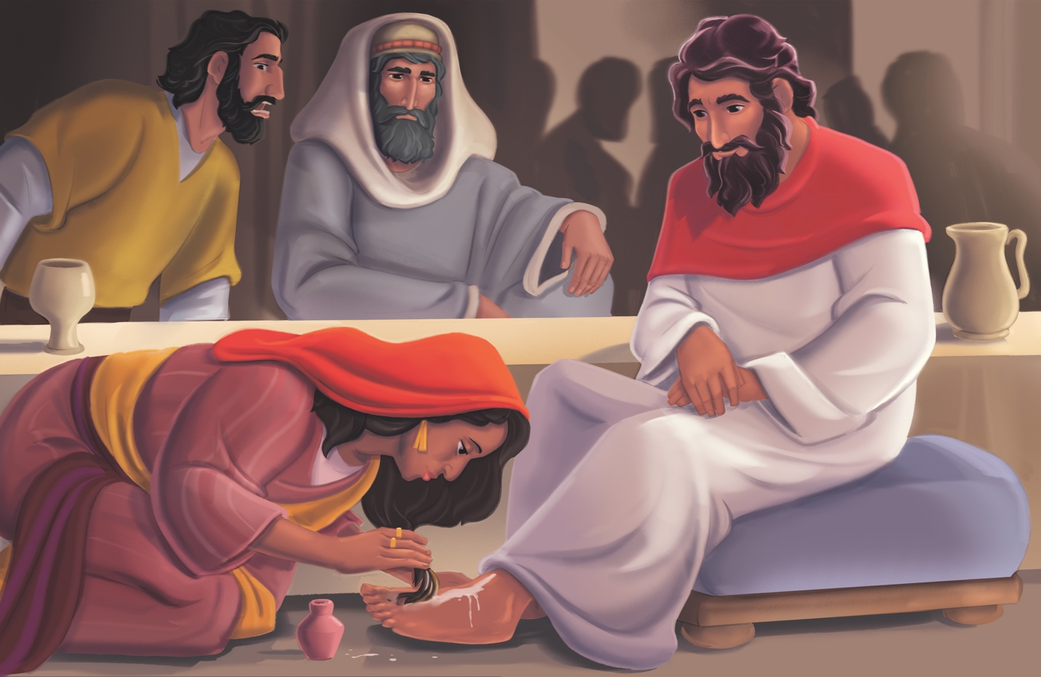
Jesus Was Anointed (Luke 7)

Dear families,
It can be easy to believe the lie that we need to attain a certain standard of productivity or purity before approaching the Lord. Today’s passage, however, reveals that the Lord is pleased when we approach Him in humility and in our weakness.

In Luke 7, we find Jesus in the home of Simon the Pharisee, reclining at a table in the presence of a notable sinner. This woman sought out Jesus but hadn’t come empty-handed. She knew she wasn’t invited, yet she pursued Jesus’ presence and offered Him a costly gift. Not allowing guilt, shame, fear, lack, or social niceties to stop her, she was led by faith to worship the Savior.

Watching this interaction unfold in his home, Simon said to himself, “If this man were really a prophet, He would know who and what kind of woman was touching Him… she’s a sinner!” Yet the woman’s sins are not what she is known for today; she has been remembered in Scripture for her bold belief and costly sacrifice.

Ironically, Simon thought Jesus didn’t know the woman’s heart, but Jesus proved He knew about the woman’s history and what Simon was thinking as well. Jesus shared a parable about a creditor with two debtors, one owing more than the other. The creditor was gracious and forgave both debts, so who would love him more? Simon understood it was the one who received more forgiveness than the other.

Jesus reminded the Pharisee that when He entered his house, Simon didn’t wash His feet, kiss Him in greeting, or anoint His head with oil. This woman, however, went so far as to find Jesus, wash and wipe His feet with her hair, kiss His feet, and anoint them. Both the Pharisee and the woman needed a Savior, yet she was the only one aware of this need.

This week, lead your children to understand they too owe God a debt they cannot repay due to sin. But help them also see that God does not expect them to repay Him because Jesus willingly took our place on the cross—taking sin and providing righteousness for all who believe in Him.

Check out The Gospel Project At Home for resources designed to help you lead a family worship experience as well as suggestions for morning and evening prayer times and family activities.

FAMILY TALKING POINTS

STORY POINT
This is the main point to emphasize from today’s Bible story.

- Preschool: Jesus forgave a woman’s sins.
- Kids: Jesus forgave a woman’s sins.

CHRIST CONNECTION
This is the big idea of how this week’s Bible story points to Jesus.

- Babies & Toddlers: Jesus came to rescue sinners. Jesus died on the cross and rose again so we can be part of God’s family forever if we believe in Him.
- Younger Preschool: Jesus came to forgive sinners, even people who did very wrong things. He died and came back to life so we can be part of God’s family.
- Older Preschool: Everyone has sinned and deserves punishment from God. But Jesus, the only sinless One, died in our place to take the punishment for our sin. When we trust in Jesus, we are forgiven of all our sins and are made right with God.
- Kids: Everyone has sinned and owes a debt they could never repay. Jesus, the only sinless One, died in our place to pay the debt for our sin. When we trust in Jesus, we are forgiven of all our sins and are credited with Jesus' perfect life.

BIG PICTURE QUESTION & ANSWER
This is an important biblical truth that your child will encounter each week of this unit.

- Younger Preschool: What is prayer? Prayer is talking with God.
- Older Preschool: What is prayer? Prayer is talking with God.
- Kids: What is prayer? Prayer is talking with God to praise Him, ask Him for help, and confess our sins.

KEY PASSAGE
This is a Bible verse that relates to what your child will encounter each week of this unit.

- Babies & Toddlers: Call on Me and pray, and I will listen. Jeremiah 29:12
- Younger Preschool: You will call to me and pray, and I will listen to you. Jeremiah 29:12
- Older Preschool: Call to me and come and pray to me, and I will listen to you. Jeremiah 29:12
- Kids: You will call to me and come and pray to me, and I will listen to you. You will seek me and find me when you search for me with all your heart. Jeremiah 29:12–13

** Next week: Jesus Taught about Prayer (Luke 11; 18)

Unit 24, Session 4
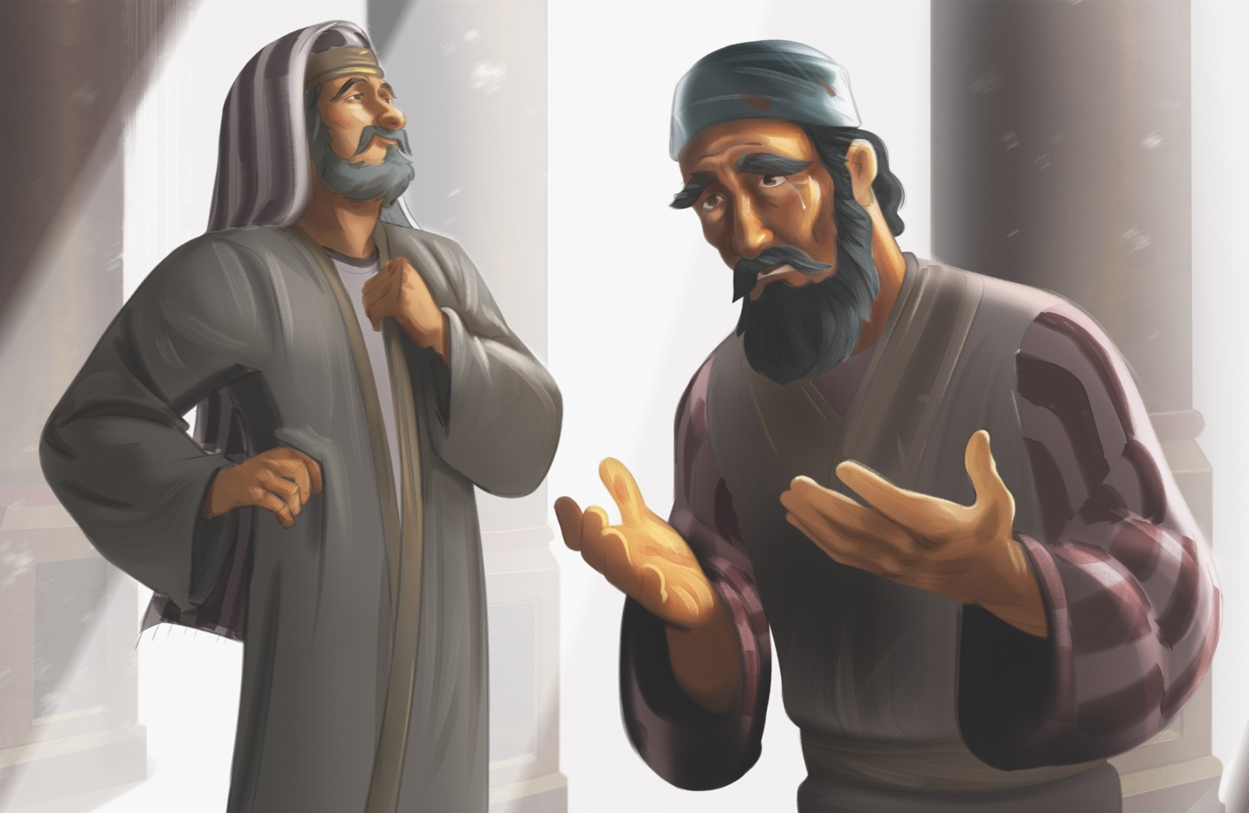
Jesus Taught about Prayer (Luke 11; 18)

Dear families,
The disciples often witnessed Jesus communing with His Father in prayer. They recognized this spiritual discipline as one He committed much time to when He drew away from the crowds. Jesus’ followers became curious about this practice and desired to better understand it.

One disciple stepped up and boldly asked Jesus to teach them how to pray. Rather than lecturing them on the insufficiencies of their own prayer lives or directing them to make long, wordy recitations, Jesus taught them how to commune with God using a simple but profound framework now commonly known as the Lord’s Prayer.

Jesus modeled a style of prayer that addressed God as “Father”–-not as a distant, unloving, unknowable, or far-off figure. He also prayed in the second person (“Our Father,” “give us,” “as we forgive”), reminding the disciples that faith is lived out in community. Jesus engaged in a communal prayer that asked for God’s power, provision, forgiveness, mercy, and spiritual protection.

He then told a parable about opening the door to a friend who inconveniences you, revealing to us the boldness and passionate persistence we should employ in prayer. He shared another story about an apathetic judge intervening for justice, and how much more God compassionately desires to intervene in our lives. Through it all, Jesus taught them not to simply beg God for what He can give us, but to leverage prayer as a reminder of God's presence and sovereign control over our lives.

As you reflect on the prayer Christ modeled to His earliest followers, remember that the nature of prayer hasn’t changed in the thousands of years since the Lord’s Prayer was first uttered. Lead your kids to see that God desires to hear from them, save them from their sins, and provide for their needs. Lead them to see that God hears the prayers of those who seek Him and that He stands ready to provide them with their greatest need: salvation from sin. Pray they would come to understand the nearness of God through prayer.

Check out The Gospel Project At Home for resources designed to help you lead a family worship experience as well as suggestions for morning and evening prayer times and family activities.

FAMILY TALKING POINTS

STORY POINT
This is the main point to emphasize from today’s Bible story.

- Preschool: Jesus taught people to keep praying.
- Kids: Jesus taught people to keep praying to God.

CHRIST CONNECTION
This is the big idea of how this week’s Bible story points to Jesus.

- Babies & Toddlers: Jesus taught people to keep praying and asking for forgiveness. Jesus died on the cross and rose again so sinners can be made right with God.
- Younger Preschool: Jesus told people to keep praying. God is a good Father. The best prayer we can pray is to say we are sorry for our sin. Jesus died and came back to life so we can be close to God.
- Older Preschool: Jesus taught people to keep praying. The most important prayer we can pray is to tell God we have sinned and ask for His forgiveness. Jesus died on the cross and rose again so sinners can be made right with God.
- Kids: Jesus taught people to keep praying. God is a good Father who will give His people what they need. The most important prayer we can pray is to tell God we have sinned and ask for His forgiveness. Jesus died on the cross and rose again so sinners can be made right with God.

BIG PICTURE QUESTION & ANSWER
This is an important biblical truth that your child will encounter each week of this unit.

- Younger Preschool: What is prayer? Prayer is talking with God.
- Older Preschool: What is prayer? Prayer is talking with God.
- Kids: What is prayer? Prayer is talking with God to praise Him, ask Him for help, and confess our sins.

KEY PASSAGE
This is a Bible verse that relates to what your child will encounter each week of this unit.

- Babies & Toddlers: Call on Me and pray, and I will listen. Jeremiah 29:12
- Younger Preschool: You will call to me and pray, and I will listen to you. Jeremiah 29:12
- Older Preschool: Call to me and come and pray to me, and I will listen to you. Jeremiah 29:12
- Kids: You will call to me and come and pray to me, and I will listen to you. You will seek me and find me when you search for me with all your heart. Jeremiah 29:12–13

** Next week: Jesus Taught about Possessions (Luke 12)

Unit 24, Session 5

Jesus Taught about Possessions (Luke 12)

Dear families,
In our modern consumer-driven culture, Luke 12’s parable of the rich fool provides a relevant warning against the danger of greed, as well as a timely cure for the anxiety that ails us when we seek first our own kingdom rather than God’s.

In this chapter, we read about Jesus being interrupted from His teaching to break up a civil squabble between two brothers fighting over their inheritance. Jesus asked why they would want Him to serve as the judge between them and issued a serious warning, not just to the greedy brother, but to everyone in the crowd: “Be on guard against all greed, because one’s life is not in the abundance of his possessions.” The man who called out for Jesus’ help was probably not expecting a rebuke from Jesus in the form of a parable.

Jesus went on to teach them what it looks like to put God’s kingdom above their own, to seek His will for their lives rather than accumulating more money and possessions that won’t stand the test of time. He taught them what it means to treasure God above the things of this world and to receive the gift of everlasting life that will not perish.

Trusting in God’s power above your own ability to provide for yourself doesn’t come naturally to us. Though the kids hearing this story may not be as familiar with this reality as you are, reflect on what it means to trust in and treasure God above all else, to believe that we are worth more to our Creator than the beautiful sights we witness in nature. It takes faith to read these words of Scripture and to believe them with confidence and hope. Pray for a childlike faith to reign in your heart as you share this story with boys and girls this week.

Lead your children to see how worthy God is of our trust, obedience, and worship. Pray that God would soften their hearts and provide them with the peace that comes from knowing their lives are secure—both now and forever, when they trust in His Son’s words of life.

Check out The Gospel Project At Home for resources designed to help you lead a family worship experience as well as suggestions for morning and evening prayer times and family activities.

FAMILY TALKING POINTS

STORY POINT
This is the main point to emphasize from today’s Bible story.

- Preschool: Jesus taught people to seek God’s kingdom.
- Kids: Jesus taught people to seek God’s kingdom.

CHRIST CONNECTION
This is the big idea of how this week’s Bible story points to Jesus.

- Babies & Toddlers: God loves us. He gave us Jesus so we can trust God and seek His kingdom.
- Younger Preschool: God loves us and gives us what we need. His best gift is Jesus. We can trust God and live His way.
- Older Preschool: Jesus taught people to seek God's kingdom. When people trust in Jesus, they are welcomed into God's kingdom and can trust that God will take care of them.
- Kids: Jesus taught people to seek God's kingdom because knowing God is the greatest treasure. When people trust in Jesus, they are welcomed into God's kingdom and can trust that God will provide for all their needs.

BIG PICTURE QUESTION & ANSWER
This is an important biblical truth that your child will encounter each week of this unit.

- Younger Preschool: What is prayer? Prayer is talking with God.
- Older Preschool: What is prayer? Prayer is talking with God.
- Kids: What is prayer? Prayer is talking with God to praise Him, ask Him for help, and confess our sins.

KEY PASSAGE
This is a Bible verse that relates to what your child will encounter each week of this unit.

- Babies & Toddlers: Call on Me and pray, and I will listen. Jeremiah 29:12
- Younger Preschool: You will call to me and pray, and I will listen to you. Jeremiah 29:12
- Older Preschool: Call to me and come and pray to me, and I will listen to you. Jeremiah 29:12
- Kids: You will call to me and come and pray to me, and I will listen to you. You will seek me and find me when you search for me with all your heart. Jeremiah 29:12–13

** Next week: Jesus Taught in Parables (Matthew 13; Mark 4; Luke 8)

