Ministry Leaders: A suggested email is provided for you to customize if you desire and share with your families.

Bonus Christmas Session
Jesus is our Rescuer (Luke 2)
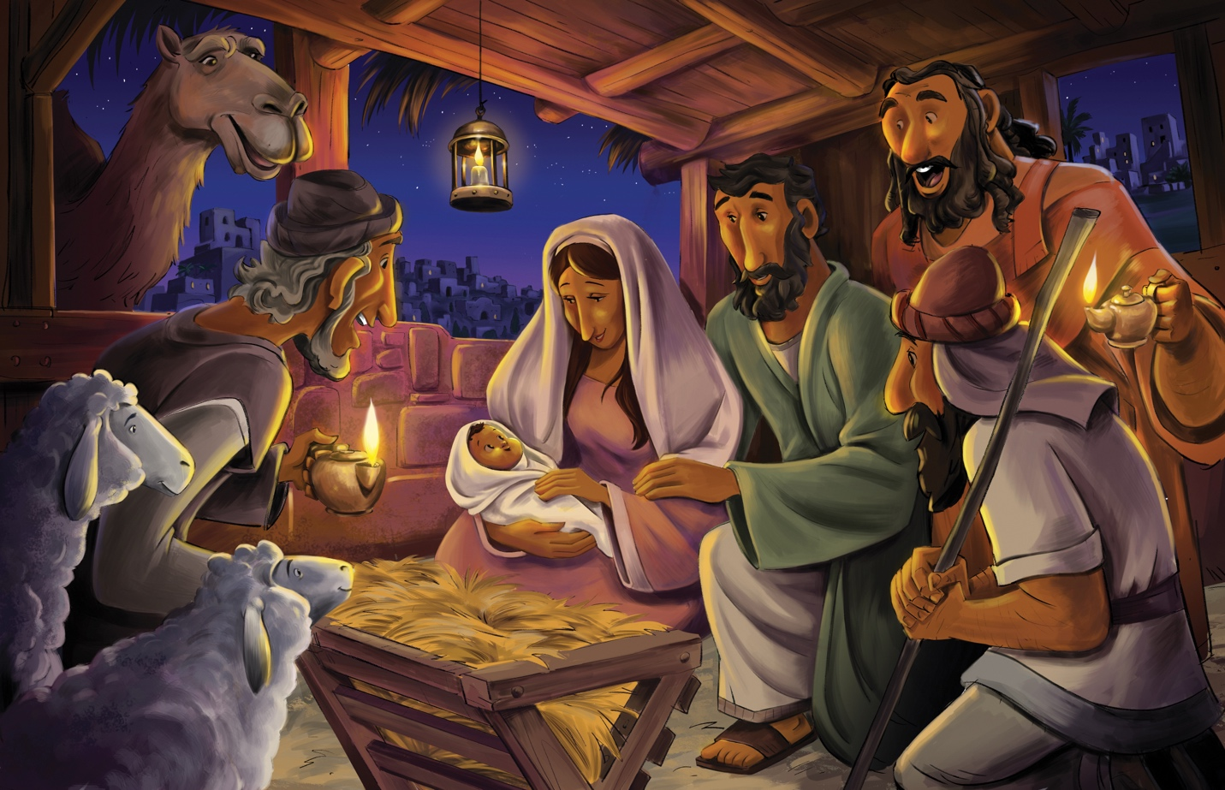
Dear families,
The announcement of the birth of Jesus came in a completely unexpected way. Instead of announcing the birth of the Savior in the halls of power or the seats of religion, God chose for a group of shepherds on the outskirts of Bethlehem to be the first to hear of Christ’s birth. The announcement from angels to the shepherds watching over their flocks was significant not only because of the message they gave, but also for the people to whom it was given.
Shepherds spent their days on the fringes of society taking care of animals. Living on the outskirts made it difficult for these men to make it to synagogue and participate in the daily spiritual life of their community. Because these men constantly worked with livestock and were regularly exposed to manure and dead animals, they would have been considered unclean according to Jewish law.
It was no accident that God chose often overlooked and outcast shepherds as the ones to whom the angels would give the announcement of Jesus’ birth. This announcement was a powerful statement about the nature of the kingdom of God. God’s kingdom is for all people, and no one is outside of God’s plan to know of His love.
The long expected announcement was remarkable. Jesus had been born for all people in the city of David. Three significant titles are used here to describe why that is good news for all people. First, Jesus is the Savior, the one who rescues people from sin. Next, He is the Messiah, the anointed one of God who came to lead God’s people into God’s kingdom. Finally, He is the Lord, the ruler of all the universe.
The shepherds’ response to this glorious news included curiosity, awe, and obedience. This Christmas, may we do everything we can to see Jesus, adore Him for who He is, and boldly proclaim the truth that Jesus is Savior, Messiah, and the Lord.

Check out The Gospel Project At Home for resources designed to help you lead a family worship experience as well as suggestions for morning and evening prayer times and family activities.

FAMILY TALKING POINTS

CHRIST CONNECTION
This is the big idea of how this week’s Bible story points to Jesus.

- Babies & Toddlers: Jesus, God’s Son, was born to save people from their sins.
- Younger Preschool: Jesus was born! This is very good news because Jesus is God’s Son who came to earth to save people from their sins.
- Older Preschool: Jesus was born! This was very good news. Jesus was not like other babies; He is God’s Son. God sent Jesus to earth from heaven to save people from their sins.
- Kids: The angels told the shepherds the birth of Jesus was good news for all the people. Anyone who believes the good news that Jesus lived, died, and rose again for their sin will be saved.

BIG PICTURE QUESTION & ANSWER
This is an important biblical truth that your child will encounter each week of this unit.

- Younger Preschool: How can we glorify God? We can glorify God by loving and obeying Him.
- Older Preschool: How can we glorify God? We can glorify God by loving Him and obeying Him.
- Kids: How can we glorify God? We can glorify God by loving Him and obeying Him.

KEY PASSAGE
This is a Bible verse that relates to what your child will encounter each week of this unit.

- Babies & Toddlers: Do everything for the glory of God. 1 Corinthians 10:31
- Younger Preschool: Do everything for the glory of God. 1 Corinthians 10:31
- Older Preschool: Do everything for the glory of God. 1 Corinthians 10:31
- Kids: So, whether you eat or drink, or whatever you do, do everything for the glory of God. 1 Corinthians 10:31

