Ministry Leaders: A suggested email is provided for each session for you to customize if you desire and share with your families. You can also access a social media share square for each session on the Additional Resources page at gospelproject.com.
The Gospel Project At Home content is available in Ministry Grid for you to share with your families.

Unit 16, Session 1
Daniel Obeyed God (Daniel 1)
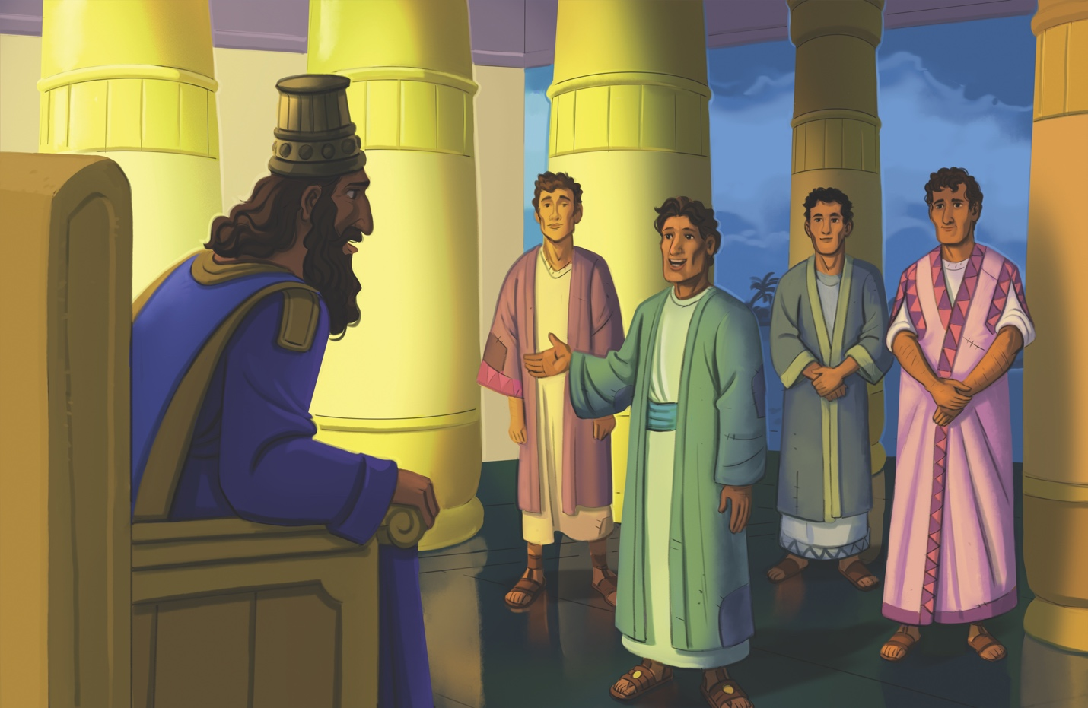
Dear families,
Some see Daniel as a book filled with epic adventures and fascinating prophecies–yet the heart of Daniel’s narrative goes much deeper. At its essence, Daniel is a survival guide, a bold blueprint for thriving in a world that’s hostile to those who place their faith in the one true God.

Daniel and his friends found themselves in a situation far removed from what they may have expected for their lives. Their people had been captured by the leading power of their day, the Babylonians. God’s people were exiled from their home to a foreign land where they would face severe persecution as they boldly lived out their faith in God.

What made this nation such a hostile environment for these young men? First, Babylon had a godless king who was known for murdering his enemies and those who defied him. Secondly, Daniel and his friends were forced to receive a Babylonian education that focused heavily on religious practices directly in contrast to their own, including a strong emphasis on astrology and the occult. These young men were not just to be removed from their homeland; rather, they were to be transformed into followers of the Babylonian way of life.

Imagine for a moment the pain of being removed from the only place you have ever known, isolated from friends and family, and inundated with daily teachings that contradict your fundamental beliefs. How would you react?

Daniel and his friends reacted with humble obedience. Even in the seemingly small matters, like eating the correct foods, Daniel and his friends desired to obey God and remain faithful to Him. Daniel and his friends decided they would stick to the diets prescribed in the Law instead of indulging in the king’s food, regardless of the consequences. Like Jesus in His time of temptation, Daniel and his friends realized that “man does not live by bread alone.” These young men trusted God to honor their obedience, and that is exactly what God did by giving them wisdom beyond their years.

As you teach kids this story, help them see how obedience to God is always better than following the ways of the world and how Jesus provides Christians with the Holy Spirit to help them obey God. Remind kids that we can glorify God in the small everyday choices we make and in everything we do.

Check out The Gospel Project At Home for resources designed to help you lead a family worship experience as well as suggestions for morning and evening prayer times and family activities.

FAMILY TALKING POINTS

CHRIST CONNECTION
This is the big idea of how this week’s Bible story points to Jesus.

- Babies & Toddlers: Daniel listened to God. Jesus also listened to God. When we trust Jesus, God sees us as perfect, just like Jesus.
- Younger Preschool: Daniel listened to God even in small things, like what he ate. Jesus listened to God in everything. When we trust Jesus, God sees us as if we lived a perfect life, just like Jesus did.
- Older Preschool: Daniel obeyed God even in small things, like what he ate. Jesus obeyed God in everything. When we trust in Jesus, God sees us as if we lived a perfect life, just like Jesus did.
- Kids: Daniel was faithful to obey God, even in the small matters like eating the correct foods. Jesus was faithful to obey God in every way. When we trust in Jesus as Savior, God credits us with the perfect life Jesus lived.

BIG PICTURE QUESTION & ANSWER
This is an important biblical truth that your child will encounter each week of this unit.

- Younger Preschool: How can we glorify God? We can glorify God by loving and obeying Him.
- Older Preschool: How can we glorify God? We can glorify God by loving Him and obeying Him.
- Kids: How can we glorify God? We can glorify God by loving Him and obeying Him.

KEY PASSAGE
This is a Bible verse that relates to what your child will encounter each week of this unit.

- Babies & Toddlers: Do everything for the glory of God.1 Corinthians 10:31
- Younger Preschool: Do everything for the glory of God.1 Corinthians 10:31
- Older Preschool: Do everything for the glory of God. 1 Corinthians 10:31
- Kids: So, whether you eat or drink, or whatever you do, do everything for the glory of God. 1 Corinthians 10:31

** Next week: Shadrach, Meshach, and Abednego (Daniel 3)

Unit 16, Session 2
Shadrach, Meshach, and Abednego (Daniel 3)
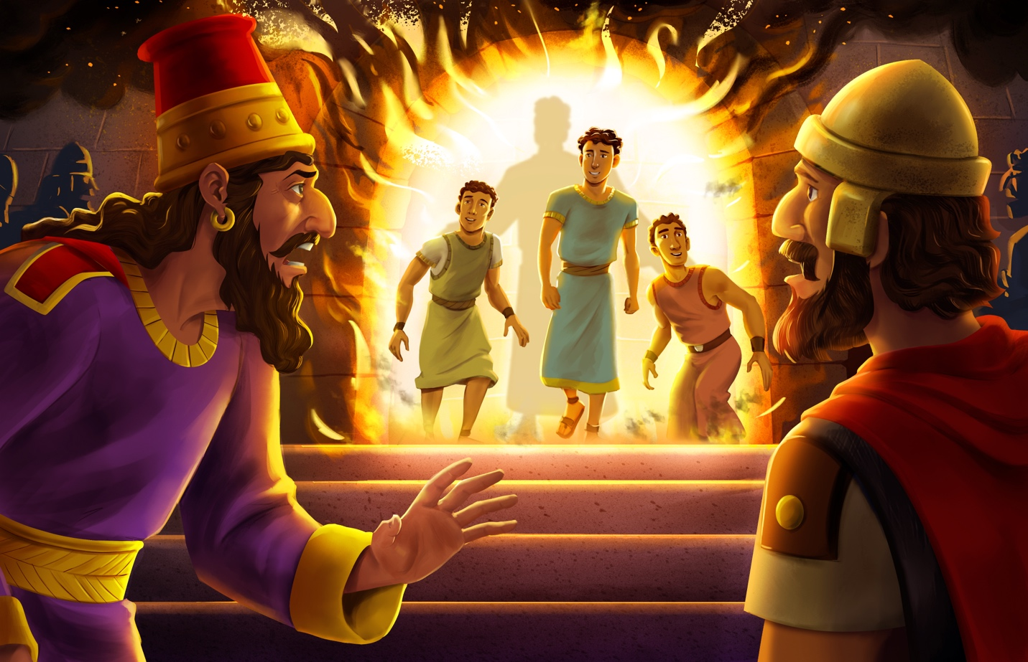
Dear families,
Daniel 3 contains one of the most powerful declarations in the Bible—a declaration so bold that it has inspired believers to stand firm in their faith, regardless of hardships or persecution. But before we get to that declaration, we must understand the situation in which it was given.

Shadrach, Meshach, and Abednego faced a seemingly impossible situation. King Nebuchadnezzar had set up a massive golden statue and invited everyone to join him in commemorating the event by bowing down and worshiping the idol. When the call went out to bow down, everyone obeyed the king’s command except for Shadrach, Meshach, and Abednego. King Nebuchadnezzar was furious. He summoned the men and gave them a second chance to bow to the statue while reminding them that if they refused to bow, he would have them thrown into a fiery furnace where they would surely die.

Given the ultimatum, the three men declared, “If the God we serve exists, then he can rescue us from the furnace of blazing fire, and he can rescue us from the power of you, the king. But even if he does not rescue us, we want you as king to know that we will not serve your gods or worship the gold statue you set up” (Daniel 3:16-18). The boldest part of that statement comes in the second sentence, when they say, “even if he does not.” They stood before this powerful king and declared that they would not bow regardless of what happened to them.

Ultimately, Shadrach, Meshach, and Abednego were thrown into the fiery furnace where a mysterious fourth man walked with them. God rescued them from death, and His name was praised among the people. As we read the story of these three men, we see them refuse the temptation to bow down to anyone or anything other than the one true God. Encourage kids to be ready to stand firm in their faith like these three men and to remember that Jesus has promised to be with those who trust in Him.

Check out The Gospel Project At Home for resources designed to help you lead a family worship experience as well as suggestions for morning and evening prayer times and family activities.

FAMILY TALKING POINTS

CHRIST CONNECTION
This is the big idea of how this week’s Bible story points to Jesus.

- Babies & Toddlers: When we trust in Jesus, we worship only Him. He is the one true God.
- Younger Preschool: Shadrach, Meshach, and Abednego only worshiped God. When we trust in Jesus, we worship only Him because He is the one true Savior.
- Older Preschool: Shadrach, Meshach, and Abednego only worshiped God. When we trust in Jesus, we worship only Him because He is the one true Savior.
- Kids: Shadrach, Meshach, and Abednego refused to bow down to anything but God. When we trust in Jesus and God brings us from death to life, we turn away from worshiping anything else. Jesus is Savior and Lord over our lives.

BIG PICTURE QUESTION & ANSWER
This is an important biblical truth that your child will encounter each week of this unit.

- Younger Preschool: How can we glorify God? We can glorify God by loving and obeying Him.
- Older Preschool: How can we glorify God? We can glorify God by loving Him and obeying Him.
- Kids: How can we glorify God? We can glorify God by loving Him and obeying Him.

KEY PASSAGE
This is a Bible verse that relates to what your child will encounter each week of this unit.

- Babies & Toddlers: Do everything for the glory of God.1 Corinthians 10:31
- Younger Preschool: Do everything for the glory of God.1 Corinthians 10:31
- Older Preschool: Do everything for the glory of God. 1 Corinthians 10:31
- Kids: So, whether you eat or drink, or whatever you do, do everything for the glory of God. 1 Corinthians 10:31

** Next week: Daniel in the Lions’ Den (Daniel 6)

Unit 16, Session 3
Daniel in the Lions’ Den (Daniel 6)
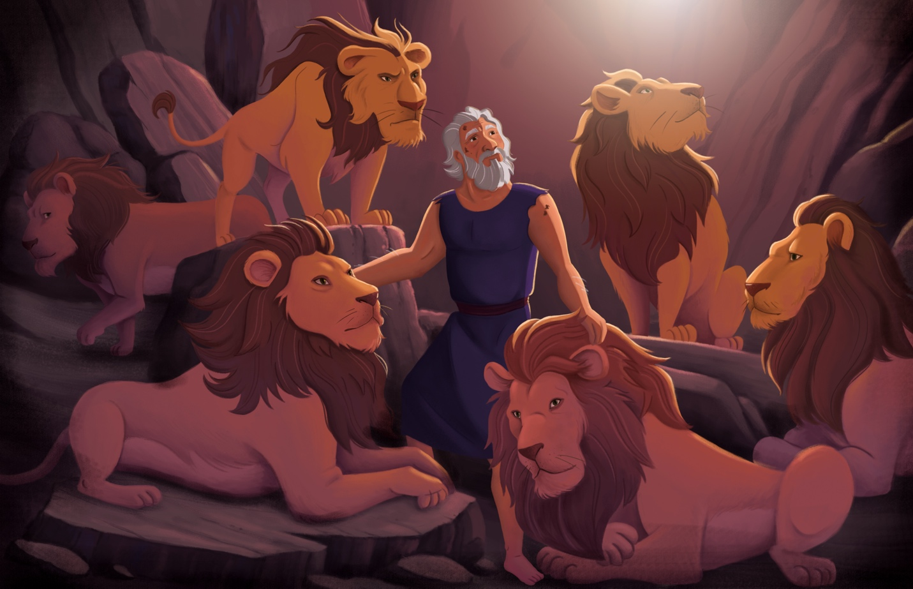
Dear families,
As Daniel grew into an older man, God continued to show him favor as Daniel served under a new king—King Darius. Yet, Daniel’s place in the government of Babylon was a subject of jealousy. In an attempt to trap Daniel, royal officials petitioned Darius to enact a law forbidding anyone from praying to any god other than the king. Just as the officials suspected, Daniel continued praying to the one true God.

The Bible points out that Daniel prayed as an act of defiance to the new law. When Daniel was faced with the possibility of death if he prayed, he made a courageous decision. Daniel 6:10 says, “When Daniel learned that the document had been signed, he went into his house. The windows in its upstairs room opened toward Jerusalem, and three times a day he got down on his knees, prayed, and gave thanks to his God, just as he had done before.” Instead of hiding his prayers, Daniel boldly walked in obedience, knowing his life would be put in danger.

In the garden of Gethsemane, Jesus faced a similar decision with even greater consequences. Following the Last Supper, Jesus spent time with the Father in prayer. Jesus wrestled with His coming death as He asked the Father to take the cup from Him if possible. Luke describes the agony that Jesus went through in this decision by telling us Jesus’ sweat fell like blood due to the intensity of His time with God. Jesus surrendered to the will of the Father even though it led to death. God honored the obedience of both men. He delivered Daniel from the lion’s den, and He delivered Jesus—the only person to always obey God perfectly—from the grave in victory over death.

One final detail of this story should challenge us in our walk with God: Darius was rooting for Daniel. Right before Daniel was thrown into the lions’ den, the king hoped out loud that Daniel’s God would deliver him from death. Eventually, after Daniel’s deliverance, the king declared all people must respect Daniel’s God. This week, encourage the kids in your class to live a life that honors God, even when others around them are making different choices. May we model lives that are so honorable to God that even people who disagree with us might want us to be right about God.

Check out The Gospel Project At Home for resources designed to help you lead a family worship experience as well as suggestions for morning and evening prayer times and family activities.

FAMILY TALKING POINTS

CHRIST CONNECTION
This is the big idea of how this week’s Bible story points to Jesus.

- Babies & Toddlers: Daniel loved God, and God kept him safe. When we trust Jesus, He saves us and gives us life with God forever.
- Younger Preschool: Daniel trusted God, and God saved him from the lions. When we trust Jesus, He saves us and gives us life with God forever.
- Older Preschool: Daniel trusted God and was saved from the lions. When we trust in Jesus, He saves us from our sins and gives us life with God forever.
- Kids: Daniel continued to trust God even though it meant he might be thrown into the lions’ den. Jesus was faithful to follow God’s plan even through it meant He would die on the cross for sinners.

BIG PICTURE QUESTION & ANSWER
This is an important biblical truth that your child will encounter each week of this unit.

- Younger Preschool: How can we glorify God? We can glorify God by loving and obeying Him.
- Older Preschool: How can we glorify God? We can glorify God by loving Him and obeying Him.
- Kids: How can we glorify God? We can glorify God by loving Him and obeying Him.

KEY PASSAGE
This is a Bible verse that relates to what your child will encounter each week of this unit.

- Babies & Toddlers: Do everything for the glory of God.1 Corinthians 10:31
- Younger Preschool: Do everything for the glory of God.1 Corinthians 10:31
- Older Preschool: Do everything for the glory of God. 1 Corinthians 10:31
- Kids: So, whether you eat or drink, or whatever you do, do everything for the glory of God. 1 Corinthians 10:31

** Next week: Daniel’s Prophecies (Daniel 7-12)

Unit 16, Session 4
Daniel’s Prophecies (Daniel 7-12)
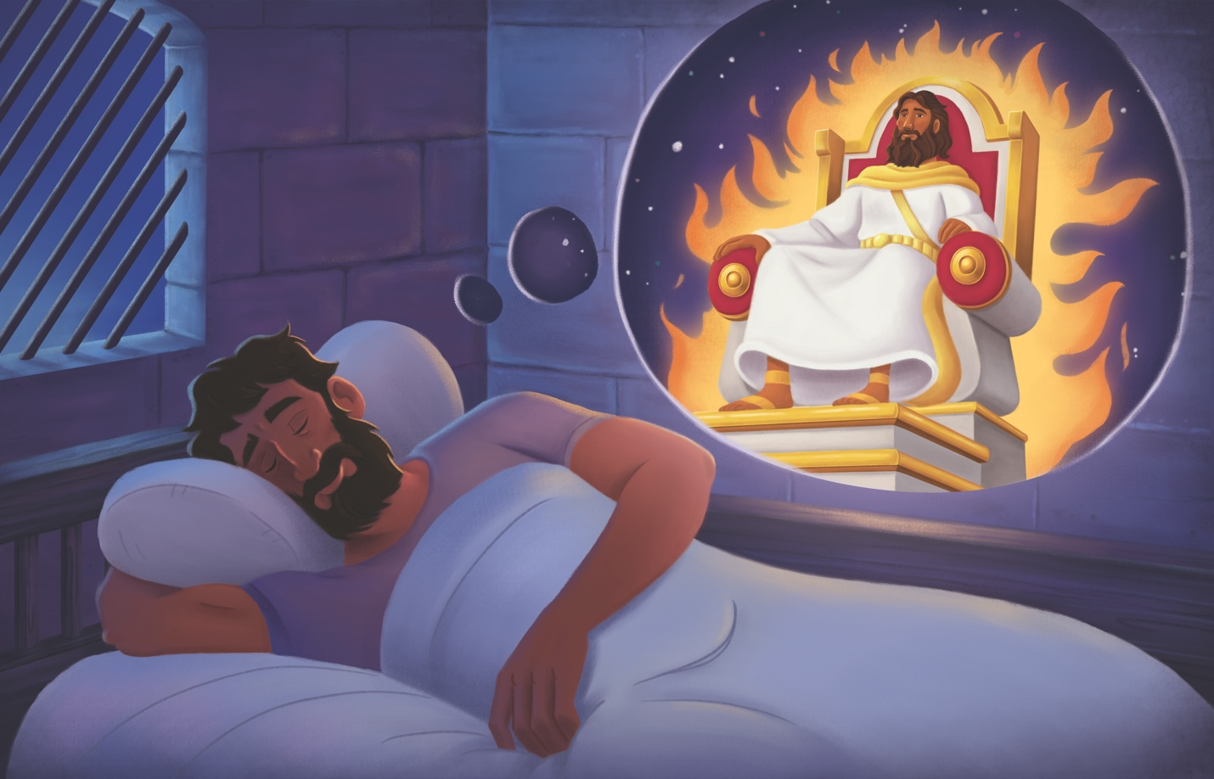
Dear families,
Prophecy passages are often some of the most difficult passages in all of Scripture to understand. As verses are filled with mysterious visions and future descriptions, we might be challenged to determine what the symbols represent and how we should think about them in relation to the past, present, and future. And while specific interpretations for prophecies can be disputed, the point of prophecy in Scripture is clear—God is in absolute control of everything—past, present, and future.

Daniel’s prophecies, in particular, are interesting because they contain such detailed descriptions of the rise and fall of earthly kingdoms. Strange apocalyptic visions are mixed with real-world historical prophecies to form a complex understanding of God’s power over the present and His plan for the future. God uses prophecy literature to remind us that even though we don't know the future, He does.

These chapters in Daniel remind us that God is completely sovereign over human affairs and governments. Daniel sees visions that represent great kingdoms of the world. All of them pale in comparison, however, to the greatness of the kingdom that God will establish and that the Son of Man will rule over. God’s reign is not temporary or limited. Daniel reminds us that we can trust God—who controls all of history—with whatever may be happening in our own lives.

Additionally, Daniel 10 points to the reality of spiritual warfare. An angel revealed that Daniel’s prayer had been heard, but that a delay had happened in the spiritual realm. If we are honest, most of us live without a thought about the spiritual battles happening around us. The delay of the angel showed that the battle in the spiritual realm was intense and real. And while the battle may rage, even the most powerful forces of the spiritual world offer no real opposition to the will and power of God. Even when answers seem distant or delayed, God is working in ways we may never be able to comprehend to bring about His good plan.

Encourage kids to remember the Ancient of Days, who is ruling over every part of their lives for His glory and the good of His people. Point them to the King of kings whose kingdom will never end.

Check out The Gospel Project At Home for resources designed to help you lead a family worship experience as well as suggestions for morning and evening prayer times and family activities.

FAMILY TALKING POINTS

CHRIST CONNECTION
This is the big idea of how this week’s Bible story points to Jesus.

- Babies & Toddlers: Daniel’s dreams pointed to Jesus. Everyone who trusts in Jesus will live with God forever.
- Younger Preschool: Daniel’s dreams pointed to Jesus, who is with God right now. One day, Jesus will come back, and everyone who trusts in Him will be with God forever.
- Older Preschool: Daniel’s dreams pointed to Jesus, the Son of Man, who is ruling with God right now. One day, Jesus will come back, and everyone who believes in Him will be with God forever.
- Kids: Daniel’s visions pointed to the truth that God is more powerful than all earthly kingdoms. Jesus, the Son of Man, rules over the kings of the earth, and His kingdom will never end. One day, all who trust in Him will be with God forever.

BIG PICTURE QUESTION & ANSWER
This is an important biblical truth that your child will encounter each week of this unit.

- Younger Preschool: How can we glorify God? We can glorify God by loving and obeying Him.
- Older Preschool: How can we glorify God? We can glorify God by loving Him and obeying Him.
- Kids: How can we glorify God? We can glorify God by loving Him and obeying Him.

KEY PASSAGE
This is a Bible verse that relates to what your child will encounter each week of this unit.

- Babies & Toddlers: Do everything for the glory of God.1 Corinthians 10:31
- Younger Preschool: Do everything for the glory of God.1 Corinthians 10:31
- Older Preschool: Do everything for the glory of God. 1 Corinthians 10:31
- Kids: So, whether you eat or drink, or whatever you do, do everything for the glory of God. 1 Corinthians 10:31

** Next week: God Brought His People Home (Ezra 1-3)

Unit 17, Session 1
God Brought His People Home (Ezra 1-3)
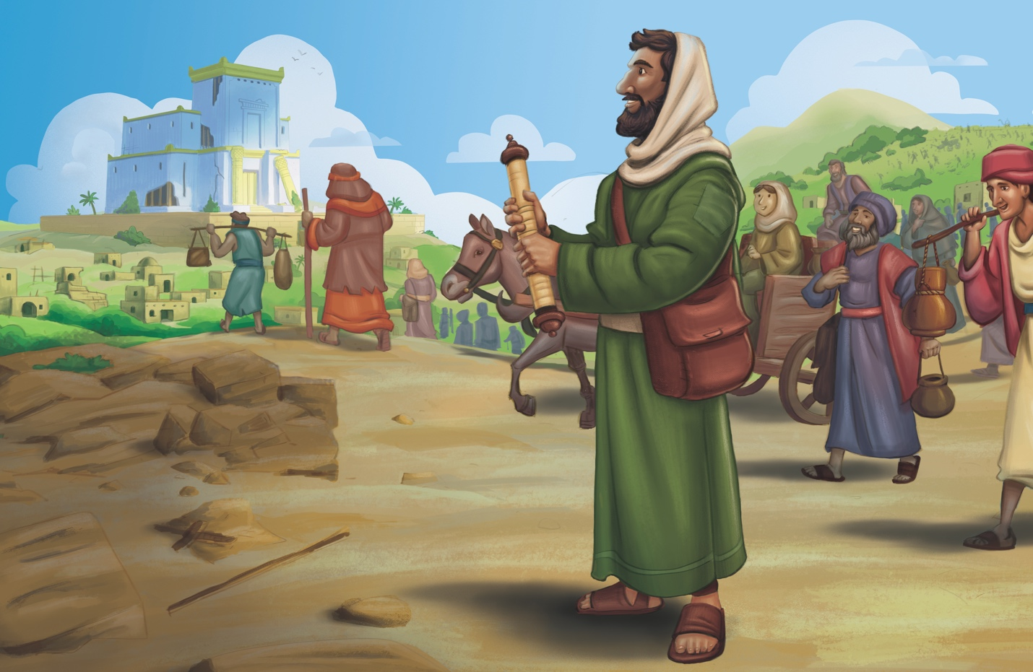
Dear families,
The Bible is described as a book about God fulfilling His promises to His people, and in Ezra 1–3, we see how God fulfilled the promise He made to bring His people home after 70 years in captivity. God used King Cyrus of Persia to issue a decree that allowed the Israelites to return home.

Just as the prophecies of Daniel remind us of God’s control over the kingdoms of the world, so do the first few verses of Ezra. We learn how God “roused” the spirit of King Cyrus to move him to release the Israelites. God’s control over kings and kingdoms was even more evident because Cyrus didn’t send the Israelites home empty-handed. They returned with resources provided by the king and their neighbors. Only God could reverse the Israelites’ fortunes in such a quick way—from exiles with nothing to a returning remnant with resources to rebuild.

God often works through a remnant of people, no matter how small that group may be. Once this remnant of God’s people returned to their homeland, they set about the process of rebuilding Jerusalem and the temple. At the center of their rebuild, the leaders of the people rightly recognized the importance of worship. Just a few months after returning from exile, they began rebuilding the altar of God so they could restart their worship according to God’s commands. They knew the rebuild would only succeed when God's people turned to Him in proper worship, turning away from their sin and obeying Him.

Before the foundation of the temple was laid, the leaders rebuilt the altar, demonstrating their desire for God's people to atone for their sin. Through opposition and uncertainty, they established a place for the priests to offer burnt sacrifices on behalf of the people.

Like the remnant of Israelites, we need to remember that true restoration begins with a reconnection of God through worship. We were created to worship God and glorify His name. Encourage kids to remember that before we try to rebuild the outer elements of our lives, we must first prioritize the exaltation of our Savior.

Check out The Gospel Project At Home for resources designed to help you lead a family worship experience as well as suggestions for morning and evening prayer times and family activities.

FAMILY TALKING POINTS

CHRIST CONNECTION
This is the big idea of how this week’s Bible story points to Jesus.

- Babies & Toddlers: Everyone who believes in God will one day live with Him, be happy, and worship Him forever in heaven.
- Younger Preschool: God kept His promise and brought His people home. One day, God will bring all His people together to a new, perfect place where no one will cry anymore, and everyone will be happy and worship God forever.
- Older Preschool: God kept His promise and brought His people back to Jerusalem. One day, God will bring all His people together in a new, perfect place where no one will cry anymore, and everyone will worship Him forever.
- Kids: Just as God promised, He brought His people back from exile to Jerusalem. One day, God will bring all His people together—all who trust in Jesus to save them from sin. There will be no crying that day. The people will worship Him in the new heaven and new earth.

BIG PICTURE QUESTION & ANSWER
This is an important biblical truth that your child will encounter each week of this unit.

- Younger Preschool: How did God fix what sin broke? God sent Jesus.
- Older Preschool: How did God plan to fix what sin broke? God planned to send Jesus.
- Kids: How did God plan to fix what sin broke? Before He created the world, God planned to send the Messiah.

KEY PASSAGE
This is a Bible verse that relates to what your child will encounter each week of this unit.

- Babies & Toddlers: This is our God. He saved us. Let’s rejoice and be glad! Isaiah 25:9
- Younger Preschool: This is our God. We waited, and He saved us. Isaiah 25:9
- Older Preschool: “Look, this is our God; we have waited for him, and he has saved us. Isaiah 25:9
- Kids: On that day it will be said, “Look, this is our God; we have waited for him, and he has saved us. This is the LORD; we have waited for him. Let’s rejoice and be glad in his salvation.” Isaiah 25:9

** Next week: Rebuilding the Temple (Ezra 4-6; Haggai 1-2)

Unit 17, Session 2
Rebuilding the Temple (Ezra 4-6; Haggai 1-2)
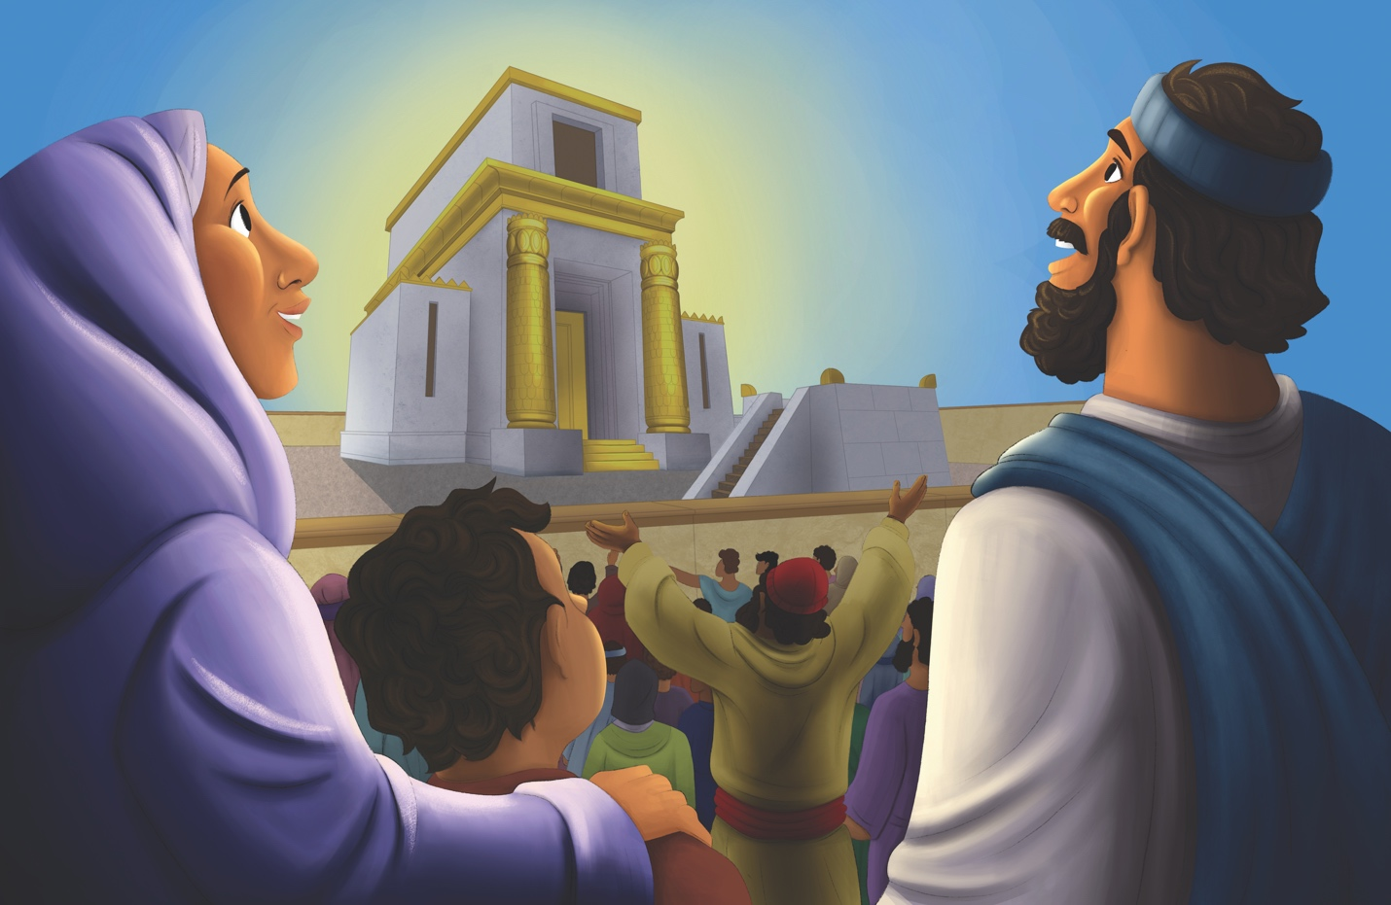

Dear families,
Like many projects, rebuilding the temple began with enthusiasm and purpose, but eventually the work stopped. Upon their return from exile, God’s people were excited about rebuilding the temple and having a place to worship their God. Eventually their passion for rebuilding diminished due to the opposition they faced from their enemies. Instead, the people turned their efforts to work on their own dwellings.

God used the prophet Haggai to remind His people of the importance of rebuilding the temple. Specifically, the prophet asked the people why their houses were completed and adorned beautifully when the house of the Lord lay in ruins. Because of the encouragement of the prophet, the people returned to rebuilding the temple. This time, they would persevere through all of the challenges to complete the rebuild.

So why was the rebuilding of the temple so important for the people of God who had returned from exile? For them, the temple was the place where the presence of God dwelt among them. Following the Exodus, God’s manifest presence was experienced by His people in a number of ways. He dwelt with His people in the cloud and fire that guided and protected the Israelites on their journey. He dwelt with His people in a movable tabernacle where they were able to worship. And eventually, God dwelt with His people in Solomon’s temple in Jerusalem. When the temple was destroyed, it was symbolic of God removing His presence from His people. When God's people returned, the rebuilding of the temple demonstrated God was with His people, inviting them to return to Him in prayer and worship (2 Chronicles 6:36-39).

Today, we are reminded that our God does not dwell in a house made by the hands of people. When Jesus died on the cross, a symbolic act occurred in the temple. At the moment of Jesus’ death, the curtain in the temple separating the people from God’s presence split from top to bottom.

The splitting of the curtain demonstrated our new reality that Jesus’ death and victory over sin and the grave gives us direct access to the Father. Remind kids that God desires to be with them, and through faith in Christ, believers are promised His presence forever.

Check out The Gospel Project At Home for resources designed to help you lead a family worship experience as well as suggestions for morning and evening prayer times and family activities.

FAMILY TALKING POINTS

CHRIST CONNECTION
This is the big idea of how this week’s Bible story points to Jesus.

- Babies & Toddlers: God’s people built a house to be with God. We can be with God forever when we trust in Jesus.
- Younger Preschool: Long ago, people built a temple to meet with God. We do not need to go to a temple anymore to be close to God because God sent Jesus to be with us always.
- Older Preschool: God’s people rebuilt the temple so they would have a place to worship God. Years later, God sent His Son, Jesus, to be with His people on earth. When we trust in Jesus, He is with us wherever we go.
- Kids: God’s people rebuilt the temple so they would have a place to worship God. Years later, God sent His Son, Jesus, to be with His people. Jesus provides something better than the temple; He gives us Himself.

BIG PICTURE QUESTION & ANSWER
This is an important biblical truth that your child will encounter each week of this unit.

- Younger Preschool: How did God fix what sin broke? God sent Jesus.
- Older Preschool: How did God plan to fix what sin broke? God planned to send Jesus.
- Kids: How did God plan to fix what sin broke? Before He created the world, God planned to send the Messiah.

KEY PASSAGE
This is a Bible verse that relates to what your child will encounter each week of this unit.

- Babies & Toddlers: This is our God. He saved us. Let’s rejoice and be glad! Isaiah 25:9
- Younger Preschool: This is our God. We waited, and He saved us. Isaiah 25:9
- Older Preschool: “Look, this is our God; we have waited for him, and he has saved us. Isaiah 25:9
- Kids: On that day it will be said, “Look, this is our God; we have waited for him, and he has saved us. This is the LORD; we have waited for him. Let’s rejoice and be glad in his salvation.” Isaiah 25:9

** Next week: The Prophet Zechariah (Zechariah)

Unit 17, Session 3
The Prophet Zechariah (Zechariah)
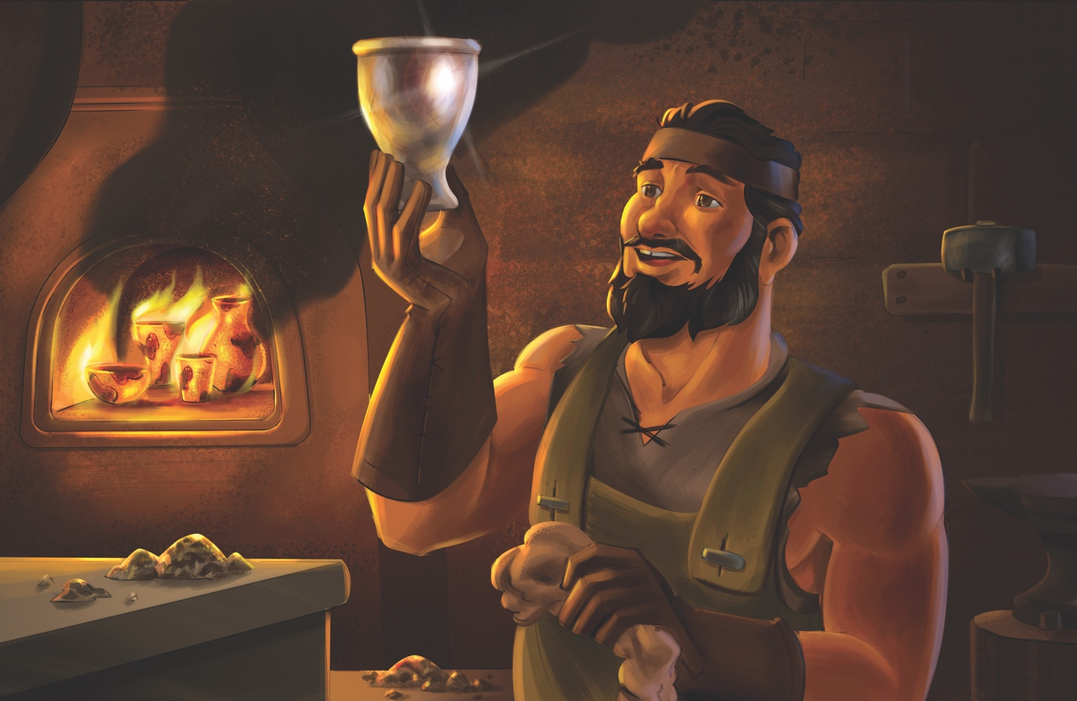
Dear families,
Zechariah was a prophet during the same time as Ezra and Nehemiah. Zechariah’s words were an encouragement to the people of God as they rebuilt the temple.

Zechariah reminded people that they were building a temple to not only be a place of worship, but a temple that would serve as a reminder of God’s everlasting promises. Zechariah prophesied about the coming of the Messiah. He reminded people that God’s kingdom will last forever and that the coming Messiah will reign eternally.

More specifically, Zechariah prophesied that the Messiah would come to them humbly, riding on a donkey. Jesus fulfilled this prophecy on Palm Sunday when He entered Jerusalem to crowds carrying palm branches, declaring Him to be the one who comes in the name of the Lord. As Jesus entered the town that day, He came riding on a donkey. Jesus knew the prophecy from Zechariah would declare boldly and publicly that He is the Messiah.

Another prophecy in Zechariah 6:12-13 declares: “You are to tell him: This is what the Lord of Armies says: Here is a man whose name is Branch; he will branch out from his place and build the Lord’s temple. Yes, he will build the Lord’s temple; he will bear royal splendor and will sit on his throne and rule. There will also be a priest on his throne, and there will be peaceful counsel between the two of them.” In this prophecy, Zechariah reminded the people that the temple they were building was a foreshadowing of one who would come and bring the presence of God to us. Through Jesus' life, death, and resurrection, He made the way to bring people into God's presence forever. Jesus is now seated at the Father's right hand, exalted to reign forever.

The book of Zechariah reminds us that Jesus is fulfillment of God’s plan to send a Messiah who would save people from sin. Remind kids that Jesus invites them to trust in Him to be saved, and that one day, He will return to establish His kingdom forever.

Check out The Gospel Project At Home for resources designed to help you lead a family worship experience as well as suggestions for morning and evening prayer times and family activities.

FAMILY TALKING POINTS

CHRIST CONNECTION
This is the big idea of how this week’s Bible story points to Jesus.

- Babies & Toddlers: God promised the King is coming. This promise came true with Jesus, who came to save us and be our King.
- Younger Preschool: Zechariah talked about a special King who would come to gently lead the people. This promise came true with Jesus, who came to save us and be our kind King.
- Older Preschool: Zechariah talked about a special King who would come gently and be a shepherd to His people. God’s promise came true with Jesus, who came to save us and be our humble King.
- Kids: Zechariah prophesied about the Messiah, saying He would be a humble King who would build a new and better kingdom. Jesus is the Messiah King. Those who trust in Him are forgiven of their sin and welcomed into His kingdom.

BIG PICTURE QUESTION & ANSWER
This is an important biblical truth that your child will encounter each week of this unit.

- Younger Preschool: How did God fix what sin broke? God sent Jesus.
- Older Preschool: How did God plan to fix what sin broke? God planned to send Jesus.
- Kids: How did God plan to fix what sin broke? Before He created the world, God planned to send the Messiah.

KEY PASSAGE
This is a Bible verse that relates to what your child will encounter each week of this unit.

- Babies & Toddlers: This is our God. He saved us. Let’s rejoice and be glad! Isaiah 25:9
- Younger Preschool: This is our God. We waited, and He saved us. Isaiah 25:9
- Older Preschool: “Look, this is our God; we have waited for him, and he has saved us. Isaiah 25:9
- Kids: On that day it will be said, “Look, this is our God; we have waited for him, and he has saved us. This is the LORD; we have waited for him. Let’s rejoice and be glad in his salvation.” Isaiah 25:9

** Next week: Esther Saved Her People (Esther)

Unit 17, Session 4
Esther Saved Her People (Esther)
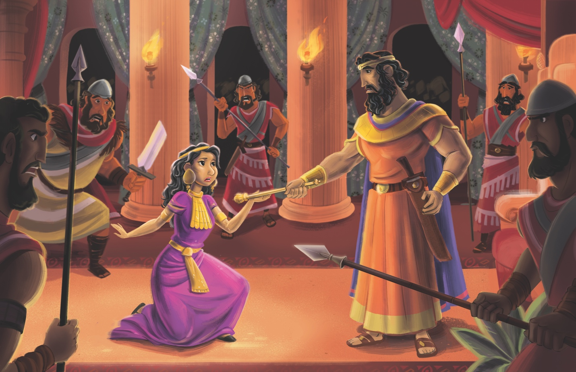
Dear families,
The book of Esther tells a fascinating story of courage and demonstrates how God works to protect His people to carry on His mission. Esther takes place during a time when some of the Jewish people were living under the rule of the Persians. During that time, God elevated a young Jewish woman named Esther to a place in the king's palace that would allow her the opportunity to save her people.

One of the interesting aspects of the book of Esther is that the name of God is not mentioned. Although His name is not mentioned in the book, God is present in every aspect of the story. Perhaps this is most clearly seen in Mordecai's words to Esther. In Esther 4: 14, Mordecai, Esther's cousin, tells her that perhaps she has been elevated as queen in the king's palace exactly for this moment. The phrase “for such a time as this” describes how God works seemingly behind the scenes to accomplish His will, proving He rules over every aspect of our lives.

The main theme of the book of Esther is that God is sovereign over all of history. God will deliver His faithful remnant when they face threats from enemies. Even when circumstances seem hopeless, God is at work. God delivered His people in this story by thwarting the plans of Haman, an advisor to the king. Haman's plan was not just a political move but a spiritual attack on the very people of God. But God, in the sovereignty of His will, had placed Esther in the perfect place at the perfect time to defeat the enemies of His people.

The book of Esther points us to the day when Jesus would come at just the right time in just the right place to deliver us from our sins. Help kids see how Romans 5:6 tells us that at just the right time, Jesus came to die for us while we were helpless. Encourage kids to understand that in God's sovereignty, He determined the exact right place and time for Jesus to be born and to die for their sins.

Check out The Gospel Project At Home for resources designed to help you lead a family worship experience as well as suggestions for morning and evening prayer times and family activities.

FAMILY TALKING POINTS

CHRIST CONNECTION
This is the big idea of how this week’s Bible story points to Jesus.

- Babies & Toddlers: Like Esther helped her people, God sent Jesus to help us and rescue us from sin.
- Younger Preschool: Like Esther helped her people, God sent Jesus to help us and rescue us from sin.
- Older Preschool: The Jews were in danger, and they needed someone to save them. God made Esther the queen so she could help the Jews. Everyone sins and is in danger. God sent His Son, Jesus, to save people from sin.
- Kids: Even though Haman tried to hurt God’s people, God was in control and had a plan to save the Jews. Sin hurts us and breaks our relationship with God, but God had a plan from the very beginning to save us through Jesus’ death on the cross.

BIG PICTURE QUESTION & ANSWER
This is an important biblical truth that your child will encounter each week of this unit.

- Younger Preschool: How did God fix what sin broke? God sent Jesus.
- Older Preschool: How did God plan to fix what sin broke? God planned to send Jesus.
- Kids: How did God plan to fix what sin broke? Before He created the world, God planned to send the Messiah.

KEY PASSAGE
This is a Bible verse that relates to what your child will encounter each week of this unit.

- Babies & Toddlers: This is our God. He saved us. Let’s rejoice and be glad! Isaiah 25:9
- Younger Preschool: This is our God. We waited, and He saved us. Isaiah 25:9
- Older Preschool: “Look, this is our God; we have waited for him, and he has saved us. Isaiah 25:9
- Kids: On that day it will be said, “Look, this is our God; we have waited for him, and he has saved us. This is the LORD; we have waited for him. Let’s rejoice and be glad in his salvation.” Isaiah 25:9

** Next week: The Walls Rebuilt (Nehemiah 1-6)

Unit 18, Session 1
The Walls Rebuilt (Nehemiah 1-6)
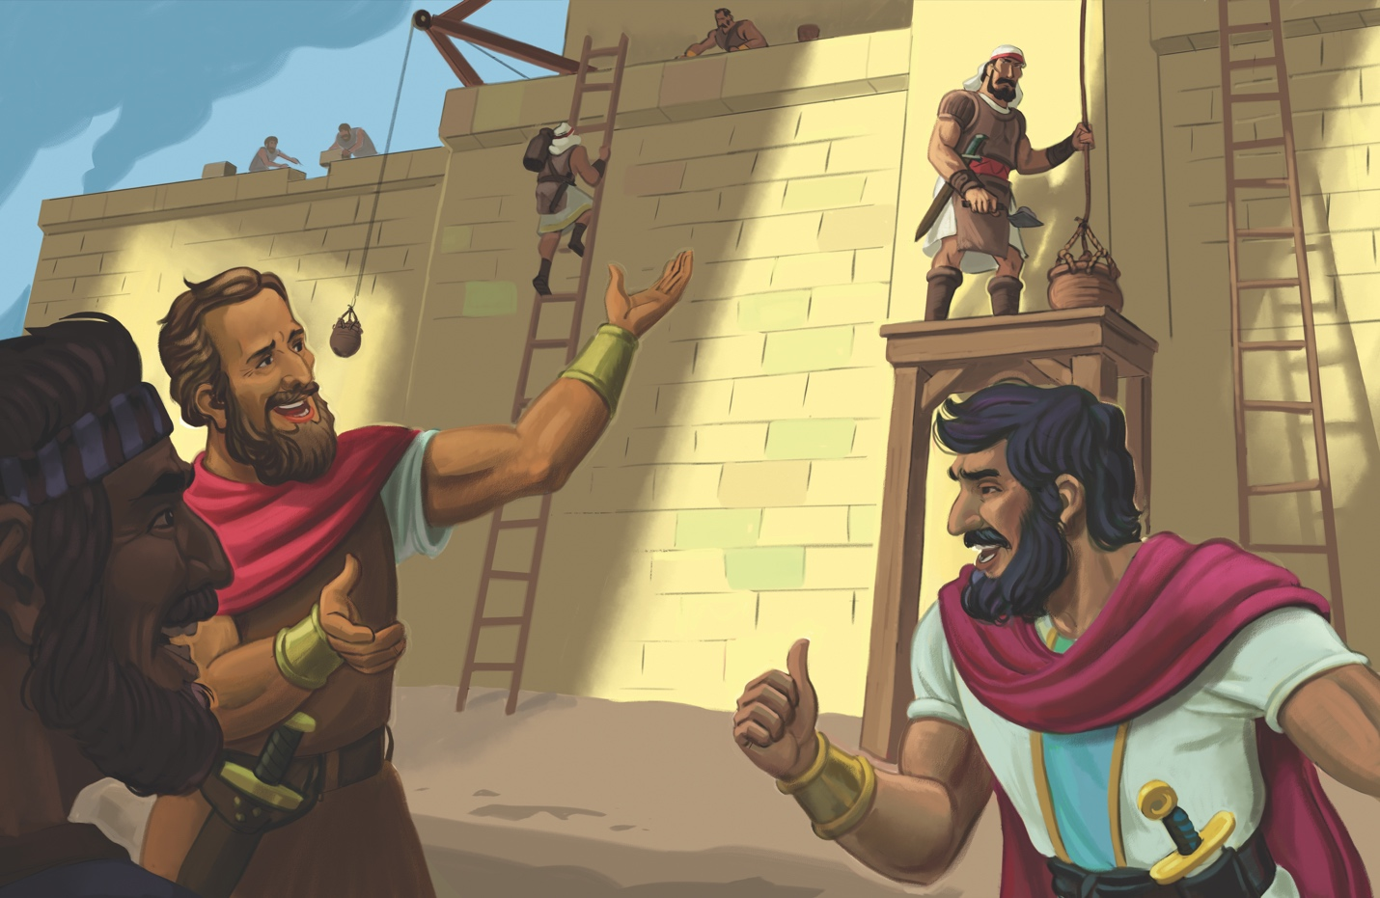
Dear families,
In the first chapter of Nehemiah, we learn that Nehemiah’s heart was broken when he heard that the walls around the city of Jerusalem were in disrepair. While Nehemiah was in a place of prestige and importance, he was willing to sacrifice that position, travel back to Jerusalem, and dedicate himself to rebuilding the walls of Jerusalem. Nehemiah understood that without walls around the city, Jerusalem was in danger of being destroyed or ransacked again by other groups of people living around them.

Once Nehemiah began the work of getting the people together to rebuild the walls, opposition quickly came in the form of a neighboring group of people. The opposition leaders decided that they needed to stop the work by killing Nehemiah if necessary. When confronted with the opposition, Nehemiah refused to give up his place working on the wall. He said to his enemies, “I am doing a great work and cannot come down” (Nehemiah 6:3). The Bible tells us Nehemiah had to refuse their request five times. Despite this opposition and much more in the days ahead, God strengthened His people, and they completed the walls in only 52 days.

Nehemiah reminds us of the importance of staying focused on the task to which God has called us. It is so easy to get distracted in the world in which we live, and yet God has called us to be focused on doing His will. Point kids to see how they can ask God to help them remain focused on His will and His plan for their lives. Invite kids to ponder God's mercy and power, knowing He will help them to accomplish whatever He calls them to.

Check out The Gospel Project At Home for resources designed to help you lead a family worship experience as well as suggestions for morning and evening prayer times and family activities.

FAMILY TALKING POINTS

CHRIST CONNECTION
This is the big idea of how this week’s Bible story points to Jesus.

- Babies & Toddlers: Like Nehemiah helped keep his friends safe, Jesus keeps us safe too. When we follow Jesus, He will give us life with God forever.
- Younger Preschool: Like Nehemiah helped keep his friends safe, Jesus rescues us from sin and death. When we follow Jesus, He is with us and will give us life with God forever.
- Older Preschool: Nehemiah helped rebuild the walls to protect the people from their enemies. Jesus protects us from our enemies of sin and death. When we follow Jesus, He keeps us safe, and we will live with Him forever.
- Kids: God’s enemies tried to stop His people, but they still rebuilt the wall. God’s enemies tried to stop Jesus by killing Him, but God planned for Jesus’ death and resurrection to be the only way for people to be saved.

BIG PICTURE QUESTION & ANSWER
This is an important biblical truth that your child will encounter each week of this unit.

- Younger Preschool: What is the Bible about? The Bible is about God’s plan to save people through Jesus.
- Older Preschool: What is the Bible about? The Bible is about God’s plan to save people through Jesus.
- Kids: What is the Bible about? The Bible is the story of God’s plan to save people through Jesus.

KEY PASSAGE
This is a Bible verse that relates to what your child will encounter each week of this unit.

- Babies & Toddlers: These are written so you may believe Jesus is God’s Son.
John 20:31
- Younger Preschool: These are written so that you may believe that Jesus is the Messiah. John 20:31
- Older Preschool: These are written so that you may believe that Jesus is the Messiah, the Son of God. John 20:31
- Kids: These are written so that you may believe that Jesus is the Messiah, the Son of God, and that by believing you may have life in his name. John 20:31

** Next week: Ezra Taught God’s Law (Ezra 7-10; Nehemiah 8)

Unit 18, Session 2
Ezra Taught God’s Law (Ezra 7-10; Nehemiah 8)
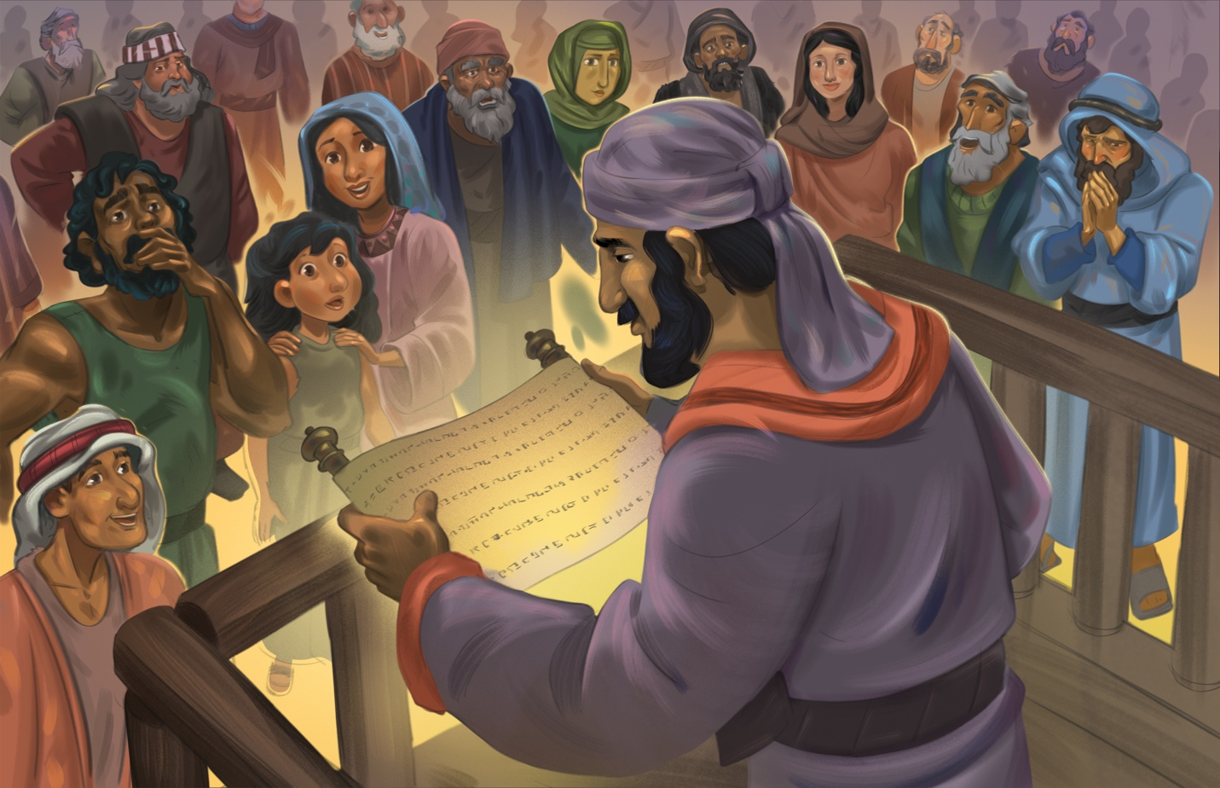
Dear families,
In His providence, God raised up Ezra to be a leader who realized the people of God needed to do more than just rebuild the buildings and walls in Jerusalem. If all the buildings and infrastructure of Jerusalem were completely rebuilt, but the people did not know God and His good commands, then all their rebuilding would be in vain.

Ezra was a faithful scribe and priest who returned to Jerusalem with a clear mission: to teach the law of God to the people. Ezra 7:10 tells us that Ezra had determined to know the law, obey the law, and teach the law to the people of God in Jerusalem. Ezra's commitment and desire to teach the law was not merely to speak its truth; he intended to live the truth of it as well.

From dawn until noon, Ezra read from the law of Moses, instructing God's people in His commands and reminding them of God's faithfulness. The response of the people to the reading of the law was overwhelming. They wept when they heard God's Word because they were confronted with the reality of their sin. Ultimately, the people repented of their sins and made a commitment to follow God's law.

Ezra's commitment to living and teaching the law reminds us of the importance of devoting ourselves to knowing, understanding, and living out God's Word. This opens our lives to God's transformative work through His truth and the power of the Holy Spirit who conforms us into the image of Jesus. Through our study of God's Word, we also realize our absolute need for Him. God's Word reveals our sin and reminds us that we are incapable of saving ourselves. Because of God's faithful love, He sent His Son to take our sin upon Himself so that we can be forgiven and receive eternal salvation.

Ezra’s ministry reminds us of the power of Scripture to transform lives. God's Word reveals our sin, leads us to repentance, and shows us the way to restoration. Point kids to see how followers of Jesus are called to know, understand, obey, and share God's words as they point others to the gospel.

Check out The Gospel Project At Home for resources designed to help you lead a family worship experience as well as suggestions for morning and evening prayer times and family activities.

FAMILY TALKING POINTS

CHRIST CONNECTION
This is the big idea of how this week’s Bible story points to Jesus.

- Babies & Toddlers: Jesus taught and obeyed God’s Word, died for our sins, and came back to life to rescue us.
- Younger Preschool: Like Ezra, Jesus also taught people about God’s rules. But Jesus did even more! He obeyed all of God’s rules perfectly, died for our sins, and came back to life.
- Older Preschool: Ezra taught the people about God’s rules. Jesus also taught about God’s rules, but Jesus did even more—He followed all of God’s laws perfectly, died for our sins, and came back to life!
- Kids: Ezra taught God’s law, and the people recognized their sin. Jesus came to fulfill the law and gives us power to turn away from sin through His death and resurrection. Through faith in Jesus, our hearts are changed so we can love and obey God.

BIG PICTURE QUESTION & ANSWER
This is an important biblical truth that your child will encounter each week of this unit.

- Younger Preschool: What is the Bible about? The Bible is about God’s plan to save people through Jesus.
- Older Preschool: What is the Bible about? The Bible is about God’s plan to save people through Jesus.
- Kids: What is the Bible about? The Bible is the story of God’s plan to save people through Jesus.

KEY PASSAGE
This is a Bible verse that relates to what your child will encounter each week of this unit.

- Babies & Toddlers: These are written so you may believe Jesus is God’s Son.
John 20:31
- Younger Preschool: These are written so that you may believe that Jesus is the Messiah. John 20:31
- Older Preschool: These are written so that you may believe that Jesus is the Messiah, the Son of God. John 20:31
- Kids: These are written so that you may believe that Jesus is the Messiah, the Son of God, and that by believing you may have life in his name. John 20:31

** Next week: The People Worshiped God (Nehemiah 7-13)

Unit 18, Session 3
The People Worshiped God (Nehemiah 7-13)
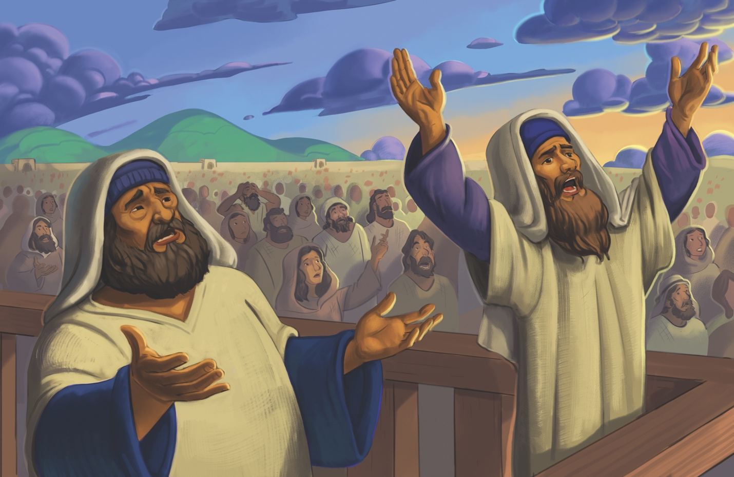
Dear families,
The second half of the book of Nehemiah shows a remarkable rededication of the Israelites to God and His law. As Ezra read from the book of the Law, the people were confronted with their sin and overwhelmed by God's faithfulness toward them despite their unfaithfulness. Nehemiah 9 tells us that the people stood and listened to the book of the Law for many hours. As they listened, they were reminded of the history of God's people. They recognized their ancestors' sinful patterns of unfaithfulness to God's covenant, and yet God was always faithful. The people heard that, amid their rebellion, God always called them back.

In Nehemiah 9:17, we are reminded of a description of God that is found throughout the Old Testament. Nehemiah 9:17 says, “But you are a forgiving God, gracious and compassionate, slow to anger and abounding in faithful love, and you did not abandon them.” This description of God throughout the Old Testament reflected His unwavering commitment to Israel despite their repeated rebellion. Echoes of this description are found in Exodus 34, Psalm 103, and Jonah 4. As God's people declared this truth, they understood how God remained faithful to them, just as He had been faithful in the past. And because God's character is unchanging, His faithfulness remains true today.

One of the most beautiful descriptions of God in this passage is found in the word gracious. The Hebrew word used here conveys the idea of unmerited favor, such as a king stooping down to give favor to one of his subjects or an adult stooping down to comfort a child in need.

This concept of God's graciousness, however, finds its fullest expression in Jesus Christ coming to earth. Philippians 2 reminds us that Jesus did not consider equality with God something to be held on to; rather He descended to us. Jesus stooped down to our level to grant us something that we never deserved. Point kids to God's unchanging character and His faithfulness to His people. Help kids see how God's faithfulness to His people was a part of His gracious plan to send Jesus to into the world.

Check out The Gospel Project At Home for resources designed to help you lead a family worship experience as well as suggestions for morning and evening prayer times and family activities.

FAMILY TALKING POINTS

CHRIST CONNECTION
This is the big idea of how this week’s Bible story points to Jesus.

- Babies & Toddlers: We all do wrong things. Only Jesus obeyed God perfectly, so we can trust Him to save us from our sin.
- Younger Preschool: The people promised to obey God, but no one can obey all the time. We all do wrong things. Only Jesus obeyed God perfectly, so we can trust Him to help us when we sin.
- Older Preschool: The people promised to obey God, but no one can keep that promise perfectly. We all do wrong things. Only Jesus obeyed God perfectly, and that’s why we need to trust Him to save us from our sins.
- Kids: God’s people remembered all He had done, and they promised to be faithful. God is gracious and compassionate. All along, God has been faithful to people who are unfaithful. We experience God’s grace and compassion in Jesus, who gave His life so we can receive mercy and life forever.

BIG PICTURE QUESTION & ANSWER
This is an important biblical truth that your child will encounter each week of this unit.

- Younger Preschool: What is the Bible about? The Bible is about God’s plan to save people through Jesus.
- Older Preschool: What is the Bible about? The Bible is about God’s plan to save people through Jesus.
- Kids: What is the Bible about? The Bible is the story of God’s plan to save people through Jesus.

KEY PASSAGE
This is a Bible verse that relates to what your child will encounter each week of this unit.

- Babies & Toddlers: These are written so you may believe Jesus is God’s Son.
John 20:31
- Younger Preschool: These are written so that you may believe that Jesus is the Messiah. John 20:31
- Older Preschool: These are written so that you may believe that Jesus is the Messiah, the Son of God. John 20:31
- Kids: These are written so that you may believe that Jesus is the Messiah, the Son of God, and that by believing you may have life in his name. John 20:31

** Next week: The Prophet Malachi (Malachi)

Unit 18, Session 4
The Prophet Malachi (Malachi)
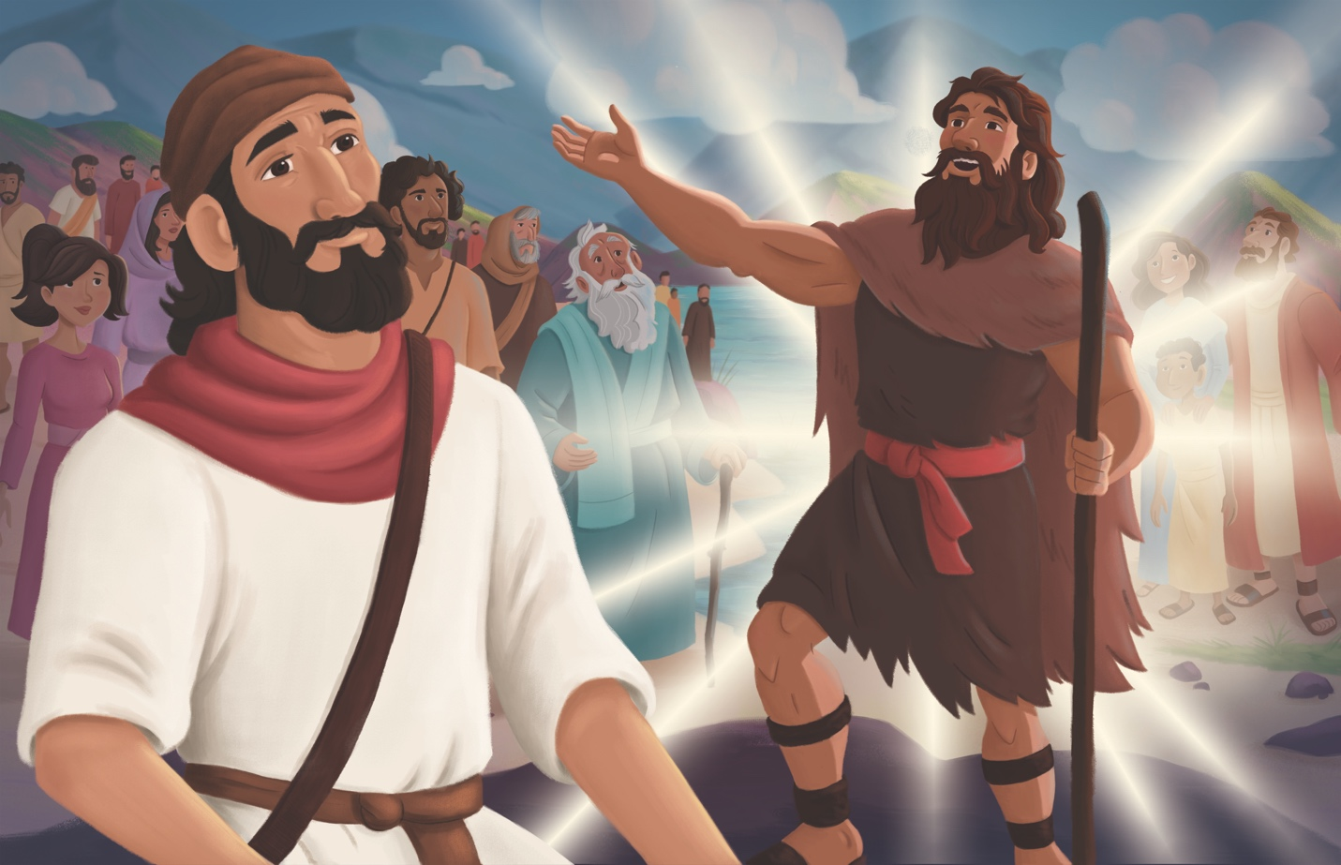
Dear families,
The book of Malachi reveals how people who have experienced God's miraculous works can quickly turn away from following Him. God had delivered His people from captivity and helped them restore Jerusalem and rebuild the temple. And yet, shortly after their promise to obey the Lord’s commands, they were living in a way that was displeasing to Him. Complacency and corruption had replaced faithfulness to God’s Word.

Malachi told the people they were offering blemished sacrifices. He revealed how their leaders—particularly the priests—were leading the people astray. Malachi also told the people they had dishonored God in their marriages in two ways: First, they married women of foreign descent who worshiped other gods. Secondly, men were divorcing their wives for unjust reasons that were selfish—treating marriage as if it were disposable.

Despite the unfaithfulness of God's people, God again remained faithful. In Malachi 3, God told them that He had not destroyed them because they are His people. He called them to return to Him. He promised that if they returned to Him, He would return to them. God invited them to repent and return to Him just as He did time and time again throughout the Old Testament.

As Malachi urged the people to return to God, he also foretold the coming Messiah—Jesus. Malachi spoke of the sun of righteousness who would bring healing—a picture of Jesus as the light of the world who would bring redemption. Specifically in Malachi 3, God shared His plan to send a messenger who would clear the way for the Messiah. In His sovereignty, God fulfilled this prophecy through the birth of John the Baptist, the forerunner of Jesus, as one crying out in the wilderness: "Prepare the way for the Lord; make his paths straight" (Luke 3:4).

The book of Malachi serves to remind us of the dangers of growing apathetic in our walk with the Lord. Help kids see how Malachi also reminds us that when we do fall short, God is faithful and ready to restore us when we turn back to Him. Through Jesus, we see God's grace and mercy to redeem and restore all who trust in Him.

Check out The Gospel Project At Home for resources designed to help you lead a family worship experience as well as suggestions for morning and evening prayer times and family activities.

FAMILY TALKING POINTS

CHRIST CONNECTION
This is the big idea of how this week’s Bible story points to Jesus.

- Babies & Toddlers: Malachi told the people to get people ready for Jesus, God’s Son, who came to save people from their sins.
- Younger Preschool: Malachi told everyone that another messenger, John the Baptist, would come to get people ready for Jesus, God’s Son, who came to save people from their sins.
- Older Preschool: Malachi was a messenger for God. He told about another messenger—John the Baptist—who would get people ready for the last messenger, Jesus! Jesus is God’s Son who came to rescue people from sin.
- Kids: Malachi told the people to turn away from sin as they looked forward to the promised Messiah. Years later, God sent John the Baptist to prepare the way for Jesus—the Messiah. Jesus brought a message of repentance and salvation.

BIG PICTURE QUESTION & ANSWER
This is an important biblical truth that your child will encounter each week of this unit.

- Younger Preschool: What is the Bible about? The Bible is about God’s plan to save people through Jesus.
- Older Preschool: What is the Bible about? The Bible is about God’s plan to save people through Jesus.
- Kids: What is the Bible about? The Bible is the story of God’s plan to save people through Jesus.

KEY PASSAGE
This is a Bible verse that relates to what your child will encounter each week of this unit.

- Babies & Toddlers: These are written so you may believe Jesus is God’s Son.
John 20:31
- Younger Preschool: These are written so that you may believe that Jesus is the Messiah. John 20:31
- Older Preschool: These are written so that you may believe that Jesus is the Messiah, the Son of God. John 20:31
- Kids: These are written so that you may believe that Jesus is the Messiah, the Son of God, and that by believing you may have life in his name. John 20:31

** Next week: The Old Testament Points to Jesus (Luke 1; John 1)

Unit 18, Session 5
The Old Testament Points to Jesus (Luke 1; John 1)
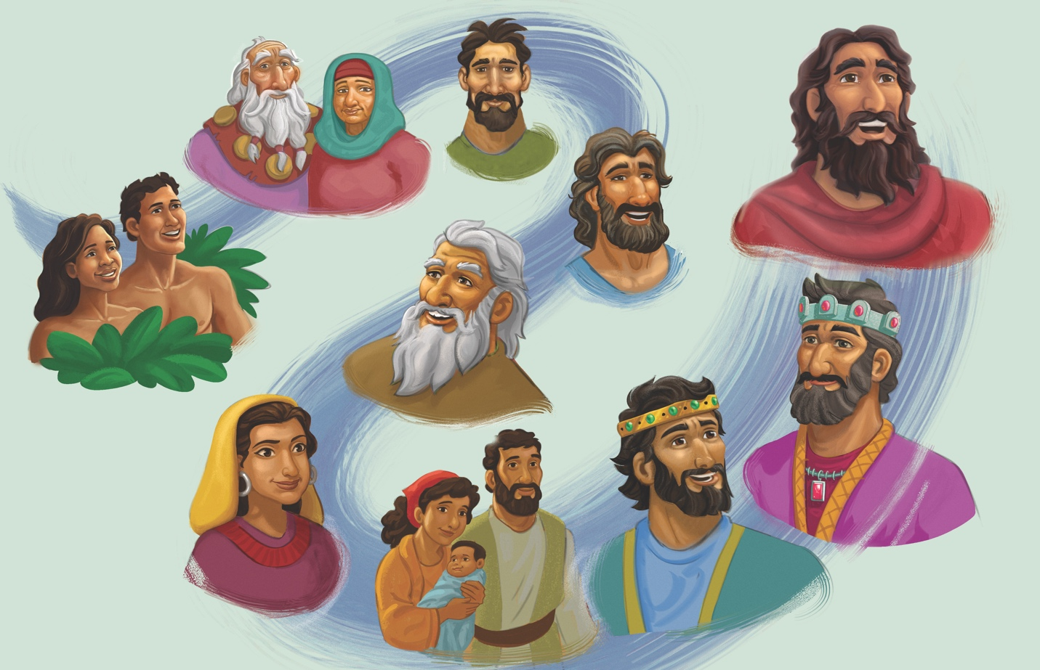
Dear families,
As we turn the page in the Bible from the Old Testament to the New Testament, we remember that the Bible tells one grand story, and at the center of that story is Jesus. From Genesis to Malachi, the Old Testament weaves a story of God's love and compassion for His people and of their inability to be faithful to Him. The Old Testament leads to the moment when God sent His Son to fulfill His plan to save people from their sin.

The first verse of John echoes the first verse of Genesis, reminding us of the cohesiveness of the Old Testament and the New Testament. This echo also reveals that Jesus is not merely a prophet or a teacher—He is God Himself, who became human. The Word of God, who spoke creation into existence, humbled Himself, taking the form of man, and dwelt among sinners so that those who believed in Him would become children of God (John 1:11-14).

In another Gospel account, Luke 1 introduces us to another person vital to God's plan. An angel appeared to a priest named Zechariah. Zechariah and his wife, Elizabeth, like many couples in the Old Testament, had not been able to have children. The angel told Zechariah not only would they have a child, but their child would have the power of Elijah and would be the forerunner to God's Messiah. John's birth and ministry was the fulfillment of Isaiah and Malachi’ prophecies, where God promised to send a messenger to prepare the way for the Messiah. John's ministry can be viewed as a bridge between the Old Testament and the New Testament.

Reflect on the foreshadowing of Christ seen all throughout the Old Testament and help kids see how it revealed what was to come in the New Testament. The sacrifices of the law point toward the ultimate sacrifice of Jesus. To David, God promised an everlasting kingdom—a promise that finds its fulfillment in Christ's everlasting reign. Jesus is the Prophet, Priest, and King that Israel longed for throughout their history. The Savior God promised in the garden of Eden—the One who would crush the serpent’s head—had finally come. Jesus would defeat evil and sin and make the way for people to be saved. But this victory would come at a great cost—His own life.

Check out The Gospel Project At Home for resources designed to help you lead a family worship experience as well as suggestions for morning and evening prayer times and family activities.

FAMILY TALKING POINTS

CHRIST CONNECTION
This is the big idea of how this week’s Bible story points to Jesus.

- Babies & Toddlers: John told people about Jesus, our Rescuer and King forever.
- Younger Preschool: John told people to get ready for Jesus, the Savior coming to be our Rescuer and King forever.
- Older Preschool: God’s prophets said, “One day, Jesus will come!” John said, “Jesus is almost here!” John told people to get ready for Jesus, the Savior, who came to be our Rescuer and King forever.
- Kids: God spoke through His prophets in the Old Testament, like Isaiah and Malachi, and shared His plan to send Jesus into the world to save people from sin. When the time had come, God called John to be a witness for Jesus. Anyone who trusts in Jesus will be saved.

BIG PICTURE QUESTION & ANSWER
This is an important biblical truth that your child will encounter each week of this unit.

- Younger Preschool: What is the Bible about? The Bible is about God’s plan to save people through Jesus.
- Older Preschool: What is the Bible about? The Bible is about God’s plan to save people through Jesus.
- Kids: What is the Bible about? The Bible is the story of God’s plan to save people through Jesus.

KEY PASSAGE
This is a Bible verse that relates to what your child will encounter each week of this unit.

- Babies & Toddlers: These are written so you may believe Jesus is God’s Son.
John 20:31
- Younger Preschool: These are written so that you may believe that Jesus is the Messiah. John 20:31
- Older Preschool: These are written so that you may believe that Jesus is the Messiah, the Son of God. John 20:31
- Kids: These are written so that you may believe that Jesus is the Messiah, the Son of God, and that by believing you may have life in his name. John 20:31

** Next week: Jesus Was Born (Matthew 1; Luke 1-2)

