Ministry Leaders: A suggested email is provided for each session for you to customize if you desire and share with your families. You can also access a social media share square for each session on the Additional Resources page at gospelproject.com.
The Gospel Project At Home content is available in Ministry Grid for you to share with your families.

Unit 10, Session 1
The Israelites Wanted a King (1 Samuel 7-10)
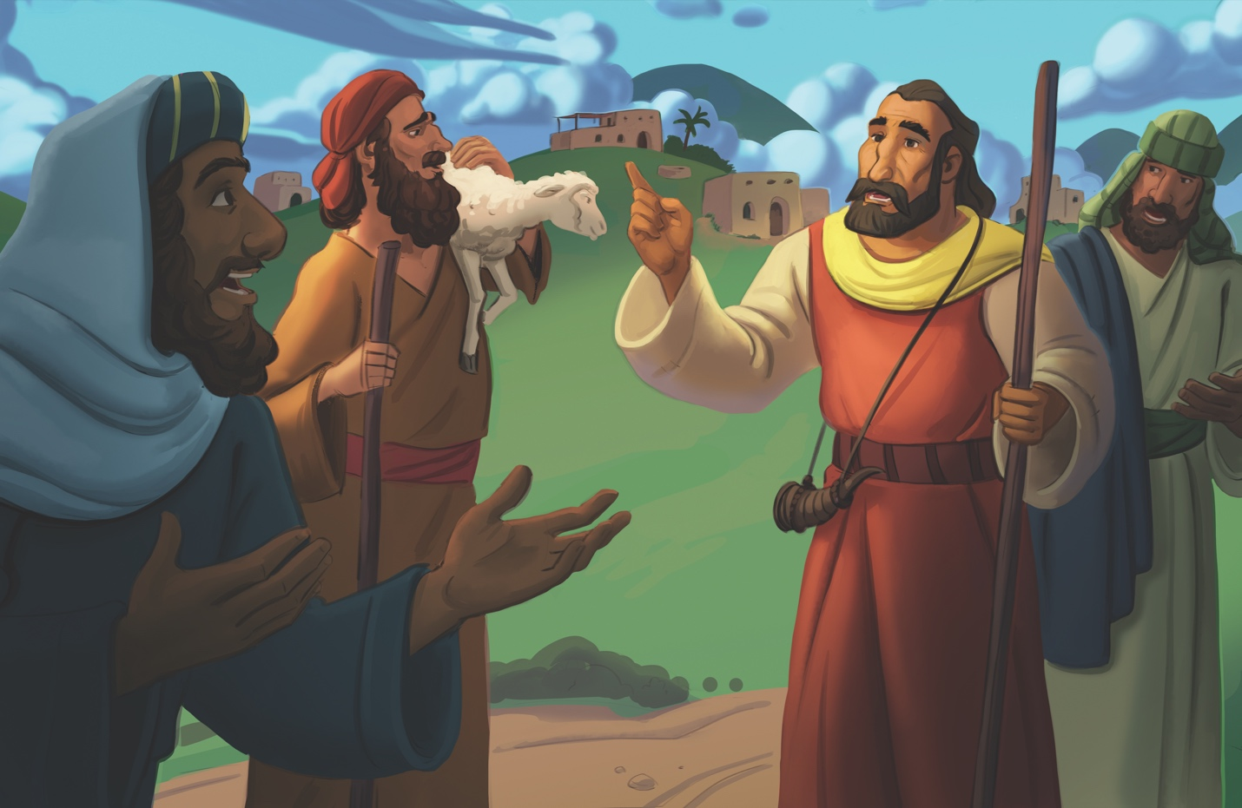
Dear families,
As the time of the judges came to an end, God's people grew discontent with the leadership of Samuel’s sons. The elders of Israel, desiring to be more like the nations surrounding them, commanded Samuel to appoint a king to rule over them. In His perfect wisdom, God would give His people over to their desire for an earthly king. Yet, God revealed how Israel's desire for an earthly king ultimately showcased their rejection of Him as their one true King.
What were the spiritual implications of the Israelites’ desire for a king? How does Christ fit into the narrative?

The Israelites once again found themselves in a season of discontentment—unhappy with their circumstances, as well as God’s provision and leadership in their lives. Like their ancestors before them, they forgot how He freed them from slavery and preserved and provided for them as His chosen people. Rather than seeking the Lord with hearts of worship, the Israelites placed their focus on the nations around them. They did not trust God to continue providing for them.

Consider the ways we are tempted to place our hope in earthly things rather than on the things above (Colossians 3:2). The people rejected God as their King, and we fall into the same pattern when we seek the things of the world in place of the God who created it.

Lead the children in your care to see how Israel had a divided heart toward God and how Christ came to free us from the power of sin that separates us from Him. When we trust in Jesus by faith, He gives us new hearts that worship Him alone as King. Pray for your children’s eyes to be opened to the love Christ has shown us through His life, death, and resurrection—freeing us to follow the God who rules and reigns with all power and care for His creation.

Check out The Gospel Project At Home for resources designed to help you lead a family worship experience as well as suggestions for morning and evening prayer times and family activities.

FAMILY TALKING POINTS

CHRIST CONNECTION
This is the big idea of how this week’s Bible story points to Jesus.
- Babies & Toddlers: God chose Saul to be king. God sent Jesus to save us from our sins so we can follow God. God is our good and kind King.
- Younger Preschool: God’s people chose Saul to be king. When we sin, we choose ourselves instead of God. Jesus came to save us from our sins so we can follow God. God is our good and kind King.
- Older Preschool: God gave the Israelites a king, but He had a plan to send His Son, Jesus, to be King over the whole world. Jesus would be the perfect King. Jesus would bring peace and save people from sin.
- Kids: The Israelites rejected God as King and chose Saul to be their king. When we sin, we also reject God’s rule in our lives as King. Jesus, the King of kings, died for our sin and rose again so we could be forgiven.

BIG PICTURE QUESTION & ANSWER
This is an important biblical truth that your child will encounter each week of this unit.
- Younger Preschool: Who is our King? Jesus is our King.
- Older Preschool: Who is our King? Jesus is our King and He rules over the world.
- Kids: Who is our King? Jesus is our King forever, and He rules over the world.

KEY PASSAGE
This is a Bible verse that relates to what your child will encounter each week of this unit.
- Babies & Toddlers: The LORD is over all things. Psalm 103:19
- Younger Preschool: The LORD rules over everything. Psalm 103:19
- Older Preschool: The LORD ... rules over all. Psalm 103:19
- Kids: The LORD has established his throne in heaven, and his kingdom rules over all. Psalm 103:19

** Next week: Saul Rescued Israel (1 Samuel 11-13)

Unit 10, Session 2
Saul Rescued Israel (1 Samuel 11-13)
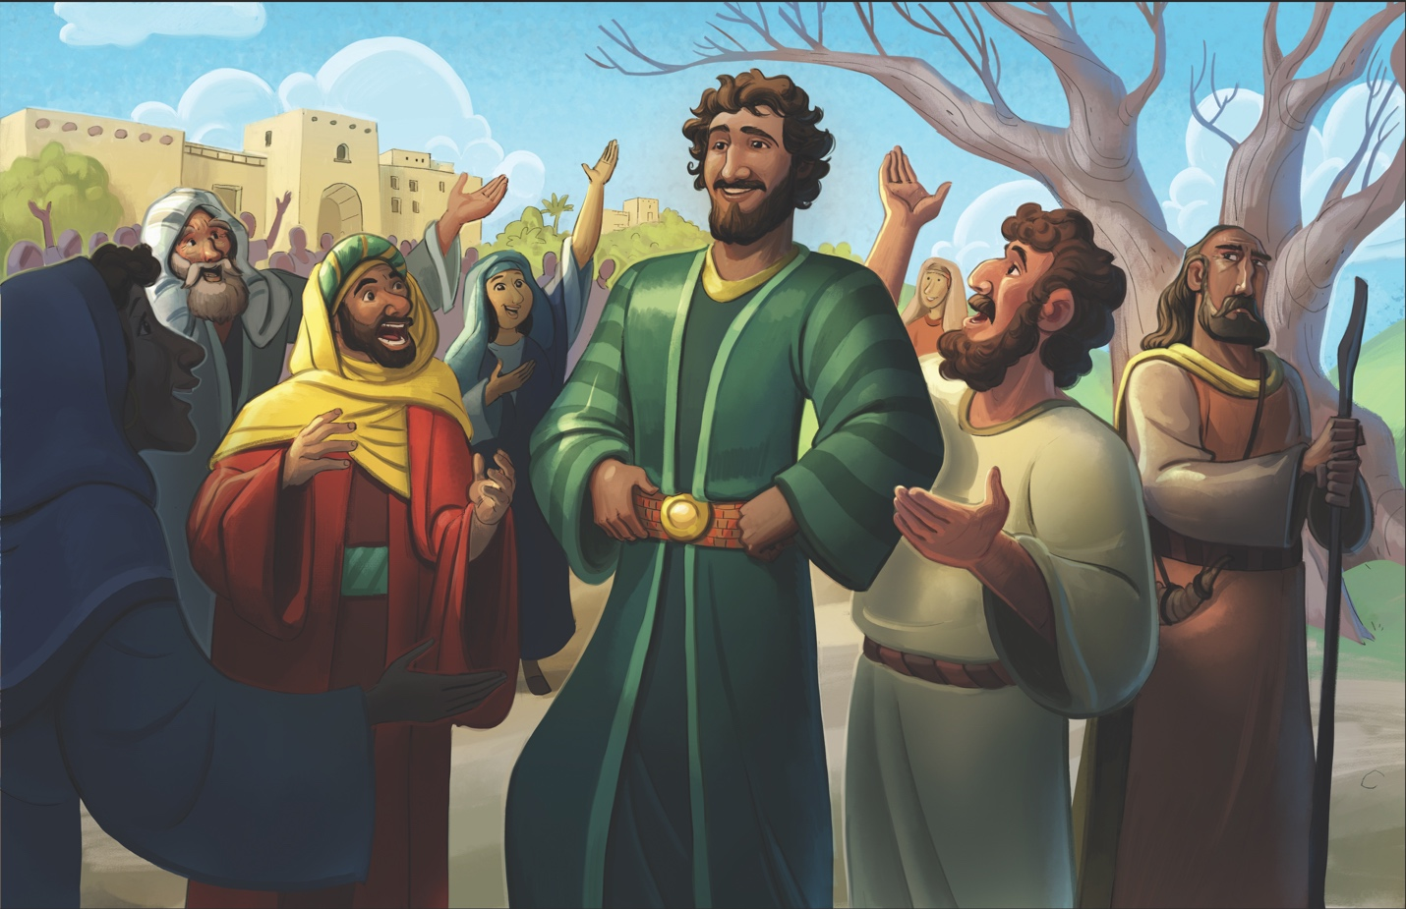
Dear families,
The beginning of Saul's reign as king over Israel brought great promise. He was a fierce warrior, and by the power of the Holy Spirit, was moved to defeat the Ammonite army. However, Saul's foolish choice revealed that he was not the king the people needed. We see Samuel’s warnings come true: an earthly king could never fulfill the role of the eternal God.

What did Saul’s disobedience reveal about his view of God? How do we see the need for Jesus in this passage?

Saul's willingness to defend the people of Jabesh and secure a victory over the Ammonites only served to encourage the people's hope in him as their king. All the people went to Gilgal, where they made Saul their king.

After Saul's victory over the Ammonites, Samuel gathered the people of Israel for a final public speech. Samuel acknowledged the callousness of the people’s hearts after the threats of Nahash, going so far as to call their actions evil in the sight of God (1 Samuel 12:17). Samuel reminded the people to continue walking in obedience if they wanted God’s protection over them. However, Samuel also added the warning that if they disobeyed God or turned away from God, both they and their new king would be swept away.
A wise proverb reminds us, “Pride comes before destruction, and an arrogant spirit before a fall” (Proverbs 16:18), and Saul's pride led him to a foolish choice. Saul sinned against God by offering a burnt sacrifice on his own accord, rather than waiting for Samuel to perform this duty as priest. Saul did not honor God as holy and ultimately revealed that his heart was not after the things of the Lord but his own selfish desires as king.
Samuel condemned Saul for his foolishness and spoke of the king who would replace him—one who would be a man after God’s own heart. Though in the short term, we see this prophetic word fulfilled through King David, its ultimate fulfillment would come through his lineage to bring us King Jesus.

Lead your kids to see that only Jesus has ever been able to perfectly obey God and change the hearts of His people. By placing faith in Him as Savior and Lord, we can receive the gift of salvation that leads us to desire the things of the Lord instead of our own selfish gain. Jesus is the perfect King our hearts were made to worship.

Check out The Gospel Project At Home for resources designed to help you lead a family worship experience as well as suggestions for morning and evening prayer times and family activities.

FAMILY TALKING POINTS

CHRIST CONNECTION
This is the big idea of how this week’s Bible story points to Jesus.
- Babies & Toddlers: Jesus is the king who always obeyed God. When we trust in Jesus, He saves us from sin and death and gives us life with God forever.
- Younger Preschool: Saul was a good king sometimes, but he disobeyed God. Jesus always obeyed God. Jesus saves us from our greatest enemies—sin and death. He gives us life with God forever.
- Older Preschool: Saul was a strong king who won battles—but he disobeyed God. Jesus is the perfect King and always obeyed God. Jesus came to save us from our sin by dying on the cross and coming back to life. All who trust in Jesus receive life with God forever.
- Kids: Saul defeated enemy armies for Israel but failed to obey God. Jesus defeated our greatest enemies––sin and death–– and always obeyed God. All who trust in Jesus will be saved and receive changed hearts that desire to obey God.

BIG PICTURE QUESTION & ANSWER
This is an important biblical truth that your child will encounter each week of this unit.
- Younger Preschool: Who is our King? Jesus is our King.
- Older Preschool: Who is our King? Jesus is our King and He rules over the world.
- Kids: Who is our King? Jesus is our King forever, and He rules over the world.

KEY PASSAGE
This is a Bible verse that relates to what your child will encounter each week of this unit.
- Babies & Toddlers: The LORD is over all things. Psalm 103:19
- Younger Preschool: The LORD rules over everything. Psalm 103:19
- Older Preschool: The LORD ... rules over all. Psalm 103:19
- Kids: The LORD has established his throne in heaven, and his kingdom rules over all. Psalm 103:19

** Next week: Saul Disobeyed God (1 Samuel 14-15)

Unit 10, Session 3
Saul Disobeyed God (1 Samuel 14-15)
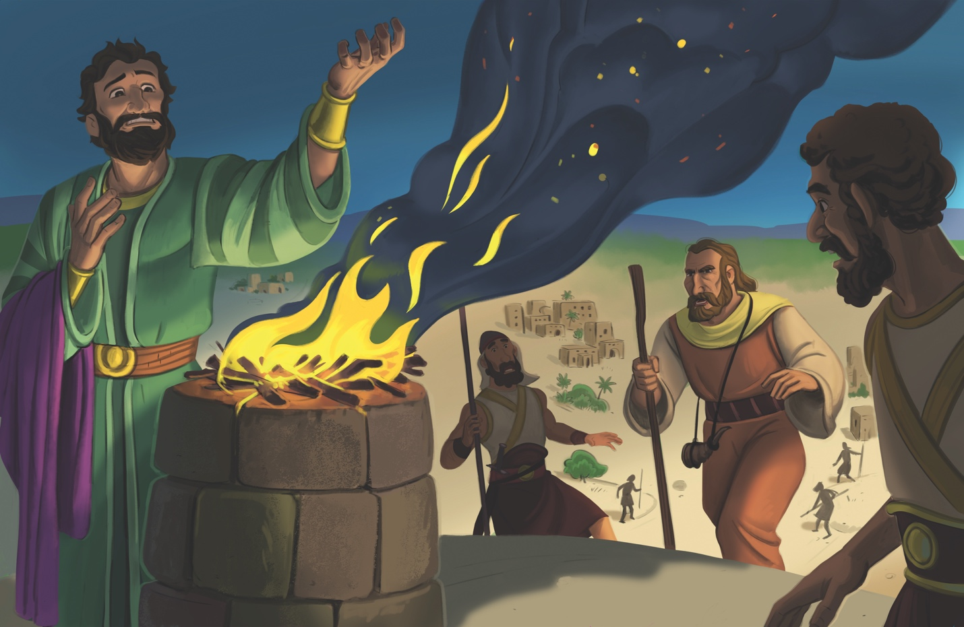
Dear families,
Rather than follow the instructions of the Lord, King Saul relied on his own strength, wisdom, and timeline to achieve success. God had promised to extend favor to Saul on the condition that he remain obedient to His commands. The devastating impact of King Saul’s disobedience, however, and its effect on his legacy is seen in 1 Samuel 14—15. Through the disobedience of Saul, we see our need for the sinless, sacrificial Savior—Jesus.

How did Saul’s disobedience impact God’s people? How did Jesus show His desire to always obey His Father?

Saul’s hasty decisions in leadership led the Israelites to pursue uncleanliness and irreverence toward the Lord. Saul placed his troops under a strict oath not to eat until the battle was over. The rashness of his oath led to the attempted execution of his son, Jonathan, and the sin of consuming impure food. Later, Saul led his men to disobey God’s commands by not completely destroying the Amalekites and everything they had. Saul led his people down a path of destruction, not seeming to care how his disobedience impacted the nation he led.

While Saul, led by pride and impulsiveness, was willing to execute his son to make an example of him, we see a stark contrast between his actions and God’s love for us. Jesus, God in flesh, laid down His own life to make redemption possible for those who trust in Him.

Consider Saul’s disobedience, which was motivated by foolishness and selfish ambition. Now, reflect on the redemption we receive through Christ’s pure and perfect obedience. While Saul’s poor leadership and disobedience led to God rejecting him as king, the perfect King Jesus leads us toward redemption and forgiveness of sin. Lead the children in your care to see the reward of obedience to God—yet to see with even greater clarity, the gift of grace we don’t deserve through Christ’s sacrificial love.

Check out The Gospel Project At Home for resources designed to help you lead a family worship experience as well as suggestions for morning and evening prayer times and family activities.

FAMILY TALKING POINTS

CHRIST CONNECTION
This is the big idea of how this week’s Bible story points to Jesus.
- Babies & Toddlers: Our sin keeps us from God. Only Jesus has no sin. When we trust in Jesus, God forgives our sin so we can be with Him forever.
- Younger Preschool: Like Saul, our sin keeps us from God. Only Jesus has no sin. When we trust in Jesus, God forgives our sin so we can be with Him forever.
- Older Preschool: Saul disobeyed God and was rejected as king. Sin is disobeying God. Only Jesus perfectly obeyed God. When we believe in Jesus and ask Him to forgive our sin, He forgives us.
- Kids: Saul disobeyed God’s commands and was rejected as king. We all disobey God’s commands when we sin. Only Jesus perfectly obeyed God at all times. When we believe in Jesus, we are made right with God and accepted by Him.

BIG PICTURE QUESTION & ANSWER
This is an important biblical truth that your child will encounter each week of this unit.
- Younger Preschool: Who is our King? Jesus is our King.
- Older Preschool: Who is our King? Jesus is our King and He rules over the world.
- Kids: Who is our King? Jesus is our King forever, and He rules over the world.

KEY PASSAGE
This is a Bible verse that relates to what your child will encounter each week of this unit.
- Babies & Toddlers: The LORD is over all things. Psalm 103:19
- Younger Preschool: The LORD rules over everything. Psalm 103:19
- Older Preschool: The LORD ... rules over all. Psalm 103:19
- Kids: The LORD has established his throne in heaven, and his kingdom rules over all. Psalm 103:19

** Next week: Samuel Anointed David (1 Samuel 16)

Unit 10, Session 4
Samuel Anointed David (1 Samuel 16)
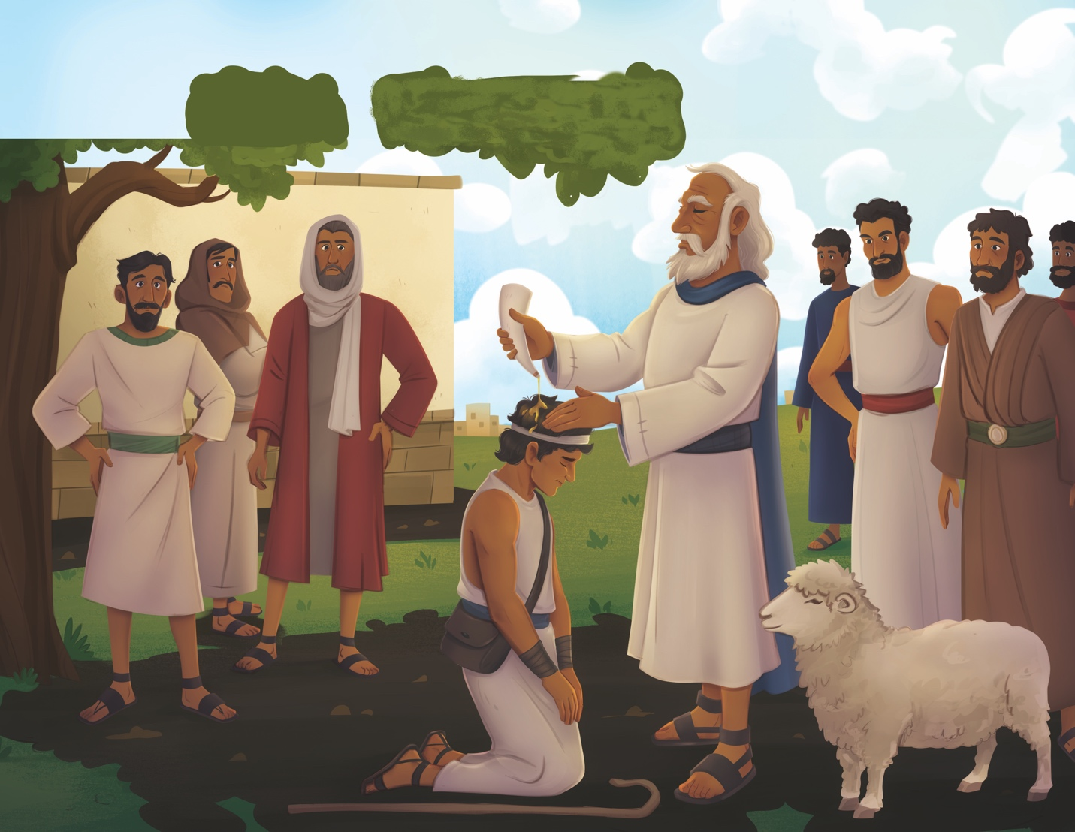
Dear families,
In 1 Samuel 16, we come to a turning point in the storyline of God’s leadership over His people. What began with Samuel mourning for Saul’s rejection as king, soon becomes a celebration of God’s faithfulness in fulfilling His word in 1 Samuel 13:14: “The LORD has found a man after his own heart, and the LORD has appointed him as ruler over his people.”

While the young David did not have the same impressive appearance as Saul, he had something greater: a heart that honored the Lord.

What was God trying to teach Samuel and His people by selecting David as the next ruler over Israel? How does this story lead us to consider the state of our own hearts?
Samuel had a front-row seat to God’s rejection of the impressive King Saul. Yet, as Samuel looked upon the older, stronger sons of Jesse, he didn’t seem to truly grasp what God was doing. By mere outward appearance, one might assume one of David’s older brothers to be next in line for the throne. It would be David, however—the youngest son of Jesse—whom God would select as the next king of Israel. David was chosen, not because of his strength or stature, but because God saw his heart. As Psalm 147:11 reminds us, "The LORD values those who fear him, those who put their hope in his faithful love."

Prepare to teach your children what it means to be someone after God’s own heart. Though David would not be a flawless leader, he would be faithful to trust in God, repent of his sin, and delight in God's words. Yet, one greater than David would come. Jesus Christ, the sinless King, lived, died, and rose again to make righteous all who trust in Him for salvation.

Consider the state of your own heart—which only God can see. Thank God for the miraculous work of salvation He has done in your own life, as well as His desire to save those who will hear this story. Pray for the Lord to open your kids’ eyes to what He can do with ordinary people who believe in Him by faith.

Check out The Gospel Project At Home for resources designed to help you lead a family worship experience as well as suggestions for morning and evening prayer times and family activities.

FAMILY TALKING POINTS

CHRIST CONNECTION
This is the big idea of how this week’s Bible story points to Jesus.
- Babies & Toddlers: God chose David to be the king of Israel, and God sent Jesus to be the King of everything! Jesus is the perfect King who loves us.
- Younger Preschool: David was a surprising choice to be the king of Israel. When Jesus came to earth, He seemed like a surprising choice to be king! Jesus is the perfect King who loves us.
- Older Preschool: God’s choice of David to be Israel’s next king was surprising. David was the youngest in his family, but God saw David’s heart. When Jesus came to earth, He seemed like a surprising choice for a king. Jesus is the perfect King who saves us from our sin and reigns forever.
- Kids: David did not look like a king on the outside, but God saw his heart and chose him to be the next ruler. Jesus looked like an ordinary man to the people around Him, but He is God’s Son and the Savior of the world.

BIG PICTURE QUESTION & ANSWER
This is an important biblical truth that your child will encounter each week of this unit.
- Younger Preschool: Who is our King? Jesus is our King.
- Older Preschool: Who is our King? Jesus is our King and He rules over the world.
- Kids: Who is our King? Jesus is our King forever, and He rules over the world.

KEY PASSAGE
This is a Bible verse that relates to what your child will encounter each week of this unit.
- Babies & Toddlers: The LORD is over all things. Psalm 103:19
- Younger Preschool: The LORD rules over everything. Psalm 103:19
- Older Preschool: The LORD ... rules over all. Psalm 103:19
- Kids: The LORD has established his throne in heaven, and his kingdom rules over all. Psalm 103:19

** Next week: David Played for Saul (1 Samuel 16)

Unit 10, Session 5
David Played for Saul (1 Samuel 16)

Dear families,
In 1 Samuel 16, we see how the newly anointed future king of Israel served his predecessor with humility and grace. Though David was promised the throne of Israel, his time had not yet come. Therefore, David returned to his life as a shepherd. God would use the period of waiting and the trials for David’s good and to point us toward the Suffering Servant, Jesus, in whom we place our ultimate hope.

How did God use David’s humility for His glory and David’s good? How do we see this idea fully exemplified in Jesus?

When God rejected Saul as king, the Spirit of the Lord left him, and an evil spirit tormented him day and night. After one of Saul's young men heard David play the lyre, Saul sent his servants to retrieve the young David, believing he could relieve his distress. Previously, we learned that David was a man after God’s own heart, and here we see a humble, servant-like heart as David played the lyre in Saul's time of distress.

Saul didn’t know then that David would be his successor. Saul loved David so much that he even gave him the role of armor-bearer, asking Jesse for permission for David to remain in his service. David faithfully and humbly served Saul.

We see an even greater picture of service in Christ, depicted as the Suffering Servant in Isaiah 53. While David's humble service offered temporary relief for King Saul, Jesus' humble and sacrificial death offers eternal rescue from sin for all who believe in Him.

May a humble, obedient adoration of the Lord mark us as His faithful followers. Pray the children in your care see Christ’s humility both as our example and the means of our salvation through faith. Like Saul, we need the peace that only God can provide through Christ.

Check out The Gospel Project At Home for resources designed to help you lead a family worship experience as well as suggestions for morning and evening prayer times and family activities.

FAMILY TALKING POINTS

CHRIST CONNECTION
This is the big idea of how this week’s Bible story points to Jesus.

- Babies & Toddlers: David would be the king, and he still helped Saul. Jesus is the King, and He still helps us. Jesus came to earth, died on the cross, and rose again to save us from our sin.
- Younger Preschool: David knew he would be a king one day, and he still helped Saul. Jesus, the most special King, came to earth to help us by dying on the cross and coming back to life.
- Older Preschool: David knew God chose him to be the next king, but he still served King Saul. Jesus, the King of everything, came into the world as a servant. He gave His life and rose again so sinners can have forgiveness and be happy forever.
- Kids: Even though David knew he would be king one day, he served King Saul faithfully. Even though Jesus is God, He humbled Himself and took the form of a servant. He served His disciples by washing their feet, and He served His people by dying on a cross for their sin and rising again.

BIG PICTURE QUESTION & ANSWER
This is an important biblical truth that your child will encounter each week of this unit.
- Younger Preschool: Who is our King? Jesus is our King.
- Older Preschool: Who is our King? Jesus is our King and He rules over the world.
- Kids: Who is our King? Jesus is our King forever, and He rules over the world.

KEY PASSAGE
This is a Bible verse that relates to what your child will encounter each week of this unit.
- Babies & Toddlers: The LORD is over all things. Psalm 103:19
- Younger Preschool: The LORD rules over everything. Psalm 103:19
- Older Preschool: The LORD ... rules over all. Psalm 103:19
- Kids: The LORD has established his throne in heaven, and his kingdom rules over all. Psalm 103:19

** Next week: David Defeated Goliath (1 Samuel 17)

Unit 11, Session 1
David Defeated Goliath (1 Samuel 17)

Dear families,
The story of David and Goliath reveals more than a battle between a shepherd boy and a giant. Through this showdown, we recognize how the powers of this world set themselves in opposition to the one true God. While Israel needed someone to face Goliath on their behalf, we too, need a Savior to defeat our enemies––sin and death.

Where did David find strength to fight against Goliath? How does the story point us to the true Hero, Jesus?

David was no stranger to the faithfulness and protection of God. He said to Saul, “The Lord who rescued me from the paw of the lion and the paw of the bear will rescue me from the hand of this Philistine.” David saw the threat of Goliath, yet recognized he had what Goliath didn’t—the favor of the Lord of Armies. David trusted that God would secure the victory for His own name’s sake. Just as God had proven Himself faithful in David's battles against lions and bears, David knew that Goliath posed no threat to those whose faith is in God.

David's faith in the Lord of Armies encourages us to remember how God has provided us with victory through His Son, Jesus. The true hero of this story is Jesus––the foreshadowed victor in the battle against sin and death––who took to the cross to defeat the grave and rose again so we may find new life in Him.
Lead the children in your care to see that, like David, we can trust in God for salvation and in every circumstance we face. While we may not find ourselves going to war with a giant like Goliath, we do face the reality of sin and death and cannot save ourselves. We need a Savior who has already won the battle! Pray that your children place their hope not in themselves or the things of this world but in Christ alone.

Check out The Gospel Project At Home for resources designed to help you lead a family worship experience as well as suggestions for morning and evening prayer times and family activities.

FAMILY TALKING POINTS

CHRIST CONNECTION
This is the big idea of how this week’s Bible story points to Jesus.

- Babies & Toddlers: God sent David to help the Israelites. God sent His Son, Jesus, to help all of us. When we trust in Jesus, we have life with God forever.
- Younger Preschool: God sent David to help the Israelites fight their enemies. God sent His Son, Jesus, to help all of us. Jesus fought against sin and death and won. When we trust in Jesus, we have life with God forever.
- Older Preschool: God provided judges to rescue His people from their enemies. God provided Jesus to rescue us from our sin. When we choose to trust in Jesus and follow Him, we are forever saved from our sin.
- Kids: The Israelites needed God’s help to defeat Goliath, so God sent David. We all need help to fight against sin. God sent His Son, Jesus, to win against sin so we can have life with God forever.

BIG PICTURE QUESTION & ANSWER
This is an important biblical truth that your child will encounter each week of this unit.
- Younger Preschool: Is anything greater than God? No, God is greater than everything.
- Older Preschool: Is anything greater than God? No, God is greater than everything.
- Kids: Is anything or anyone greater than God? No, God is greater than everything and everyone.
KEY PASSAGE
This is a Bible verse that relates to what your child will encounter each week of this unit.
- Babies & Toddlers: LORD, no one is like you. You are great. Jeremiah 10:6
- Younger Preschool: LORD, there is no one like you. You are great. Jeremiah 10:6
- Older Preschool: LORD, there is no one like you. You are great; your name is great in power. Jeremiah 10:6
- Kids: LORD, there is no one like you. You are great; your name is great in power. Who should not fear you, King of the nations? It is what you deserve. Jeremiah 10:6-7a

** Next week: David Showed Mercy (1 Samuel 24)

Unit 11, Session 2
David Showed Mercy (1 Samuel 24)

Dear families,
In 1 Samuel 24, we see the tension between Saul and David come to a head, as David turns down an opportunity to rid himself of King Saul once and for all. We see David’s heart for the Lord as he chose to pursue obedience over safety. David’s mercy in this story gives us a glimpse of Christ’s incredible mercy toward sinners who place their faith in His name.

Why did David spare Saul’s life? How do we see an even greater pardon for sin in the lives of Christ followers?

Back in chapter 18, Saul had grown jealous of of David’s popularity after his many victories in battle. By chapter 24, Saul had attempted to kill David multiple times and refused to give up the fight. In fact, he brought 3,000 men on a mission to search for David in the wilderness of En-gedi. David soon found himself in a cave with his own men, who tempted him to kill the vengeful King Saul.

Yet, David knew what the Lord called him to do (1 Samuel 24:6). He extended honor to Saul, though he did not deserve such mercy. David even swore to never harm his king, an oath that would continue to be tested as Saul would go back on his word to preserve the life of his young successor.

David trusted God to deliver him from Saul and refused to take matters into his own hands, believing God’s word would come to pass and that David would become king in God’s perfect timing. David’s willingness to grant mercy came from his trust in God's perfect justice and righteousness (v. 15). Rather than seeking vengeance, David extended mercy, recognizing God alone would enact judgment on Saul's sin.

In an even greater act of mercy, Christ died for sinners. He prayed for forgiveness for those who nailed Him to the cross, and He took the judgment for our sin. The mercy of God is available to all who place their faith in Jesus Christ (Ephesians 2:4-5). Lead the children in your care to see the immeasurable gift of Christ’s mercy, that they, too, might experience forgiveness of sins and new life in Christ Jesus.

Check out The Gospel Project At Home for resources designed to help you lead a family worship experience as well as suggestions for morning and evening prayer times and family activities.

FAMILY TALKING POINTS

CHRIST CONNECTION
This is the big idea of how this week’s Bible story points to Jesus.
- Babies & Toddlers: David was kind and showed mercy to Saul. God was kind and showed us mercy by sending Jesus to rescue us from sin and death.
- Younger Preschool: Saul wanted to be mean to David, but David was kind and showed mercy to Saul. Our sin makes us God’s enemies, but He showed us mercy by sending Jesus to rescue us from sin and death.
- Older Preschool: Saul wanted to hurt David, but David showed mercy to Saul. We all deserve to die for our sin, but God shows us mercy when we trust in Jesus, who died for our sin and rose again.
- Kids: Saul was trying to kill David, but David chose to show Saul mercy. When the people were killing Jesus, He showed them mercy and said, “Father, forgive them.” We all sin, but God shows us mercy through Jesus, who died for our sin and rose again.

BIG PICTURE QUESTION & ANSWER
This is an important biblical truth that your child will encounter each week of this unit.
- Younger Preschool: Is anything greater than God? No, God is greater than everything.
- Older Preschool: Is anything greater than God? No, God is greater than everything.
- Kids: Is anything or anyone greater than God? No, God is greater than everything and everyone.
KEY PASSAGE
This is a Bible verse that relates to what your child will encounter each week of this unit.
- Babies & Toddlers: LORD, no one is like you. You are great. Jeremiah 10:6
- Younger Preschool: LORD, there is no one like you. You are great. Jeremiah 10:6
- Older Preschool: LORD, there is no one like you. You are great; your name is great in power. Jeremiah 10:6
- Kids: LORD, there is no one like you. You are great; your name is great in power. Who should not fear you, King of the nations? It is what you deserve. Jeremiah 10:6-7a

** Next week: David Became King (2 Samuel 5; 7)

Unit 11, Session 3
David Became King (2 Samuel 5; 7)
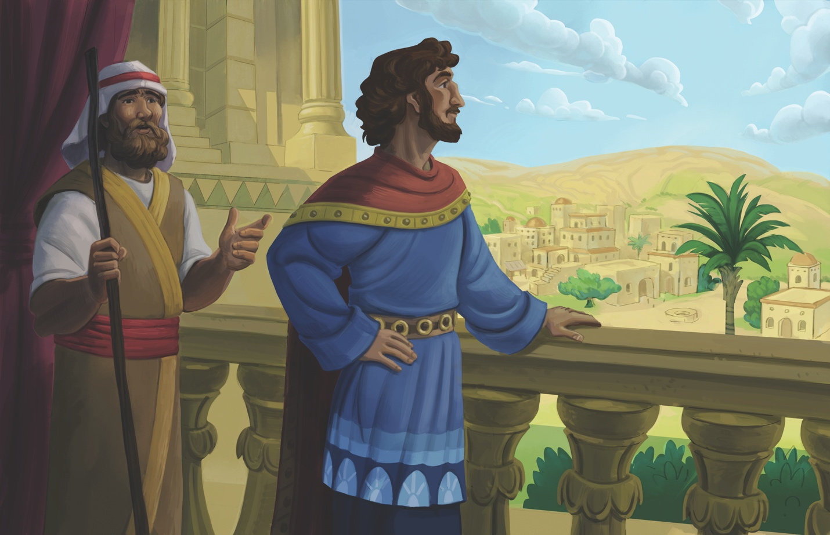
Dear families,
God is always faithful to His word, and David became king over Israel just as God promised. During the initial reign of King David, he voiced his desire to build a house for God. And yet, David was not permitted to build a temporal house for God. Rather, God promised an everlasting covenant where He would establish His kingdom through David's descendant.

How would God establish this everlasting kingdom? What does it mean to be brought into God’s family?

God promised He would raise up a descendant from David's family, and that He would establish His kingdom forever. While this promise had a near fulfillment in David’s son, Solomon, it also had a distant and complete fulfillment in Jesus Christ. Solomon would build the temple, but Jesus would tabernacle on earth as God in flesh. Jesus would announce the kingdom of God had come and call people to repent. Jesus taught that to enter the kingdom of God we must be born again. Through David, God continued the promise He first made to Abraham: “I will make you extremely fruitful and will make nations and kings come from you” (Genesis 17:6).

Through His life, death, and resurrection, Christ made the way for people to be reunited with their Father in heaven. Anyone who trusts in Jesus for salvation will find his or her place in God’s family—a legacy that started with Abraham, continued through David, and ultimately came to pass through Jesus.

Lead the children in your care to see the wonder that we might be brought into God’s family on no merit of our own, but because God loved us enough to send us His Son. Christ paid the debt we owed and welcomed us into His free gift of eternal life. Pray for your kids to see the wonder of God’s kingdom being extended to us as His children.

Check out The Gospel Project At Home for resources designed to help you lead a family worship experience as well as suggestions for morning and evening prayer times and family activities.

FAMILY TALKING POINTS

CHRIST CONNECTION
This is the big idea of how this week’s Bible story points to Jesus.
- Babies & Toddlers: God promised that David’s family would have kings forever. Jesus came from David’s family. Jesus is the King of everything forever.
- Younger Preschool: God promised that David’s family would have kings forever. Jesus made God’s promise come true. Jesus came from David’s family. He is the King of everything forever.
- Older Preschool: God promised that David’s family would be full of future kings forever. God’s promise came true in Jesus. Jesus came from David’s family and is the King of everything forever.
- Kids: God promised to build a forever kingdom through David's family. This promise is fulfilled in Jesus, a descendant of David. Jesus is King over everything, and anyone who trusts in Him is welcomed into His forever kingdom.

BIG PICTURE QUESTION & ANSWER
This is an important biblical truth that your child will encounter each week of this unit.
- Younger Preschool: Is anything greater than God? No, God is greater than everything.
- Older Preschool: Is anything greater than God? No, God is greater than everything.
- Kids: Is anything or anyone greater than God? No, God is greater than everything and everyone.
KEY PASSAGE
This is a Bible verse that relates to what your child will encounter each week of this unit.
- Babies & Toddlers: LORD, no one is like you. You are great. Jeremiah 10:6
- Younger Preschool: LORD, there is no one like you. You are great. Jeremiah 10:6
- Older Preschool: LORD, there is no one like you. You are great; your name is great in power. Jeremiah 10:6
- Kids: LORD, there is no one like you. You are great; your name is great in power. Who should not fear you, King of the nations? It is what you deserve. Jeremiah 10:6-7a

** Next week: David Sinned and Was Restored (2 Samuel 11-12; Psalm 51)

Unit 11, Session 4
David Sinned and Was Restored (2 Samuel 11-12; Psalm 51)
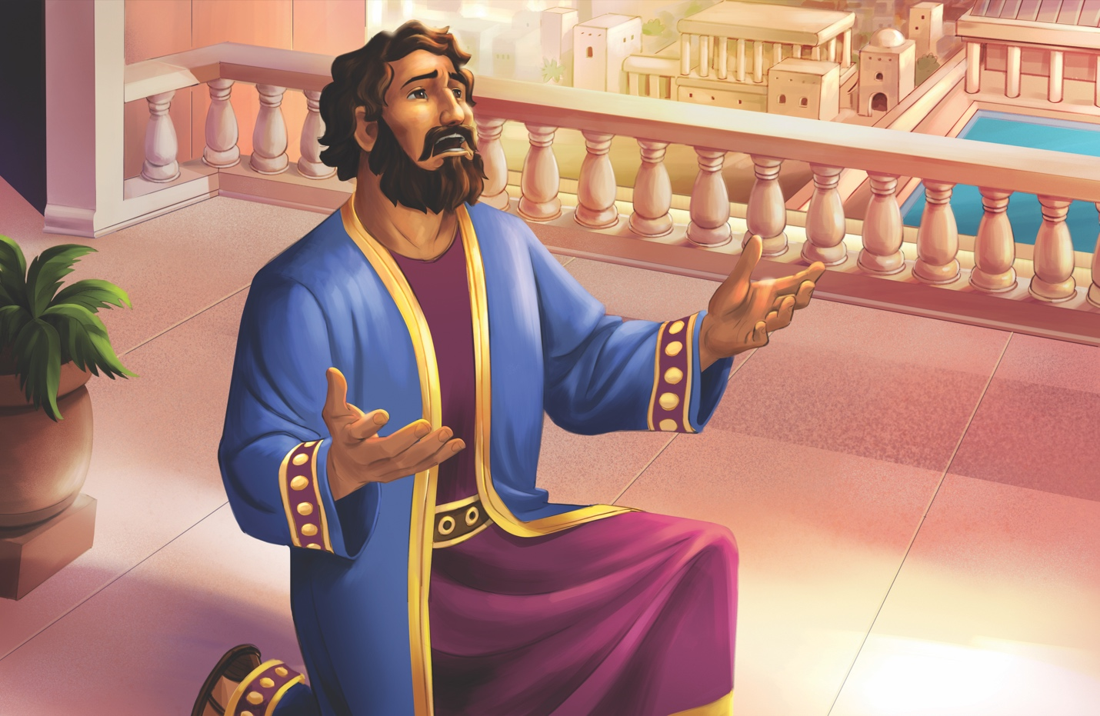
Dear families,
David was a king after God's own heart, but he was also a sinner. As we study 2 Samuel 11–12, we learn how David fell into temptation and sinned against God and others. Yet, we also witness the incredible mercy offered to those who repent of their sin. Out of David’s brokenness, we see what it looks like to have a broken and contrite heart, and we gain a glimpse of the redemption offered to us through faith in Christ.

What transformations do we see in David’s life? How do these passages lead us to walk in restoration rather than in sin?

In our previous session, we read that David was established as king over Israel. Yet from the start of 2 Samuel 11, we see how David's temptation to follow his heart led to sin. As other kings and soldiers went to war, David idly passed his time in Jerusalem. Rather than lead his men in battle, David allowed the lust of his eyes to rule him. Through one choice at a time, David plummeted into covetousness, adultery, lying, and murder.

Only after being confronted by the prophet Nathan did David repent of his sin, leading him to pen the words of Psalm 51. In this psalm, David declared God’s righteousness in contrast to his own unrighteousness. He begged God to cleanse him of his sin. He asked for a new heart and spirit to be able to teach sinners the way of repentance.

This psalm models repentance to us, showing us what it looks like to turn from sin and to receive the mercy only God provides. David’s hope was in the God of His salvation who promised a future descendant to rule with justice and righteousness. Unlike David, Christ lived a perfect, sinless life and died for sin so that our hearts may be made clean.

Through confession of sins and profession of faith in Christ, we are saved, forgiven, and cleansed of our unrighteousness. Lead the children in your care to see the weight of the sins that separate us from God and the gift of grace that reunites us with the Father who sent His Son to redeem us. Pray your kids will see their need for the Savior and to cling to the hope only He provides.

Check out The Gospel Project At Home for resources designed to help you lead a family worship experience as well as suggestions for morning and evening prayer times and family activities.

FAMILY TALKING POINTS

CHRIST CONNECTION
This is the big idea of how this week’s Bible story points to Jesus.
- Babies & Toddlers: David told God he was sorry, and God forgave him. When we trust in Jesus and are sorry for our sins, God will forgive us too. Jesus died and rose again to rescue us from our sins.
- Younger Preschool: When David was sorry and repented, God forgave him. God wants us to be sorry for our sins and trust in Jesus. Jesus died and rose again to rescue us from our sins.
- Older Preschool: When David was sorry and repented of his sin, God forgave him. God wants us to be sorry for our sin and trust in Jesus, who died to rescue us from sin. When we do, He forgives all our sin.
- Kids: When David admitted his sin before the Lord, he was forgiven. When we confess our sins to the Lord and believe in Jesus, God is faithful and just to forgive our sins and cleanse us from all unrighteousness.

BIG PICTURE QUESTION & ANSWER
This is an important biblical truth that your child will encounter each week of this unit.
- Younger Preschool: Is anything greater than God? No, God is greater than everything.
- Older Preschool: Is anything greater than God? No, God is greater than everything.
- Kids: Is anything or anyone greater than God? No, God is greater than everything and everyone.
KEY PASSAGE
This is a Bible verse that relates to what your child will encounter each week of this unit.
- Babies & Toddlers: LORD, no one is like you. You are great. Jeremiah 10:6
- Younger Preschool: LORD, there is no one like you. You are great. Jeremiah 10:6
- Older Preschool: LORD, there is no one like you. You are great; your name is great in power. Jeremiah 10:6
- Kids: LORD, there is no one like you. You are great; your name is great in power. Who should not fear you, King of the nations? It is what you deserve. Jeremiah 10:6-7a

** Next week: Solomon Became King (1 Kings 2-3)

Unit 12, Session 1
Solomon Became King (1 Kings 2-3)

Dear families,
As King David neared the end of his life, he desired for his son, Solomon, to walk in God’s ways, obey His commands, and honor the Lord as he continued their family line on Israel’s throne. Though Solomon would not be a perfect king over Israel, he was able to lead the people with the wisdom he received from God. In the wisdom of King Solomon, we see a picture of the Lord Jesus Christ, the true embodiment of godly wisdom in human form.

What was the significance of Solomon asking for wisdom? How is Jesus greater than Solomon?

Perhaps it was David’s last words to his son which prompted Solomon to ask for wisdom. After all, when God spoke to Solomon in the dream, Solomon responded by recalling how his father walked in God’s ways. In any case, Solomon told God that he was inexperienced and just a youth. Solomon’s humble request for wisdom pleased God, and He generously bestowed Solomon with wisdom, wealth, and honor. Solomon’s request for wisdom revealed a heart that desired to esteem God by governing His people and discerning between good and evil.

Still, the wisdom of Solomon pales in comparison to the wisdom of Christ. Jesus fully embodied wisdom by perfectly fearing and obeying the Lord. Infinitely greater than Solomon is the wisdom of God’s Son, who formed the world, rules the world, and sustains the world. 1 Corinthians 1:30 tells us that Jesus, “became wisdom from God for us—our righteousness, sanctification, and redemption.” Only through Jesus can we receive the wisdom to walk in God’s ways with hearts that desire to glorify Him. When we know Jesus, we know wisdom.

Reflect on the wisdom of God offered to us through Jesus Christ. Consider His gift of wisdom in your own life as you have matured in your faith. Pray for the Lord to open your children’s hearts to their need for not only wisdom, but the salvation that grows our wisdom as we continue to walk in the Lord’s ways.

Check out The Gospel Project At Home for resources designed to help you lead a family worship experience as well as suggestions for morning and evening prayer times and family activities.

FAMILY TALKING POINTS

CHRIST CONNECTION
This is the big idea of how this week’s Bible story points to Jesus.
- Babies & Toddlers: Solomon asked for wisdom, and God gave it to him. When we ask God for help, He will help us. God helped us by giving us His Son, Jesus, to rescue us from our sins.
- Younger Preschool: Solomon asked for wisdom, and God gave it to him. When we ask God for help, He will help us. God helped us in the greatest way by giving us His Son, Jesus, to rescue us from our sins.
- Older Preschool: Solomon asked God for wisdom to know right and wrong. Jesus had perfect wisdom, and He never did anything wrong. Jesus is the best King. He lived a perfect life to rescue sinners by dying on the cross and rising again.
- Kids: God gave Solomon wisdom to lead His people. Jesus is wisdom, and He leads those who trust in Him to eternal life. When we follow Jesus, we become wise.

BIG PICTURE QUESTION & ANSWER
This is an important biblical truth that your child will encounter each week of this unit.
- Younger Preschool: What does God know? God knows everything.
- Older Preschool: What does God know? God knows everything.
- Kids: What does God know? God knows everything about the past, present, and future.

KEY PASSAGE
This is a Bible verse that relates to what your child will encounter each week of this unit.
- Babies & Toddlers: Obey the LORD and do what is right. Proverbs 3:7
- Younger Preschool: Fear the LORD and turn from evil. Proverbs 3:7
- Older Preschool: Fear the LORD and turn away from evil. Proverbs 3:7
- Kids: Don’t be wise in your own eyes; fear the LORD and turn away from evil. Proverbs 3:7

** Next week: Solomon Built the Temple (1 Kings 6-8)

Unit 12, Session 2
Solomon Built the Temple (1 Kings 6-8)
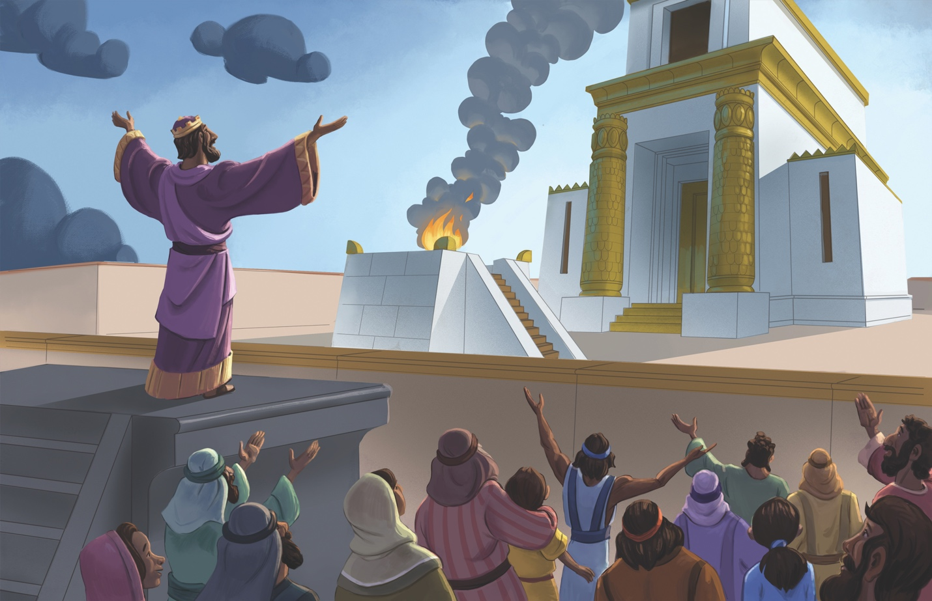
Dear families,
In 1 Kings 6-8, Solomon embarked on the project his father, David, had first envisioned: building a temple for God. It was no small task, yet Solomon set out to create a place for God to dwell with His people. Though the fullness of our omnipresent God cannot be contained by man-made structures, the temple represents a greater fulfillment: God would send His Son to live, die, and rise again so that God’s people would dwell in His presence forever.

What was the temple’s purpose? Why do we no longer need the temple today?

Solomon built the temple as a place for God’s people to worship and experience His presence, similar to the role the tabernacle had previously held for Israel. The temple was a reminder of God’s promise never to leave or forsake Israel and to remain faithful to His covenant promises. Because Solomon sought to honor the Lord as holy, he spent seven years thoughtfully and intricately designing the temple’s every detail.

Solomon dedicated the temple to the Lord and blessed Israel as they stood before it. He recalled God’s faithfulness in rescuing their ancestors from Egypt and then in establishing the throne of his father David. Solomon prayed to the Lord, esteeming Him as the gracious God who keeps His promises. Solomon recognized God’s glory and might, stating that He could not be contained by a man-made temple. Solomon asked the Lord to hear their prayers, forgive them, righteously judge them, and uphold their cause for His glory. Lastly, Solomon urged Israel to be devoted to God’s ways.

In Jesus, we see the fulfillment of God’s promise to dwell among His people. Jesus came to earth to provide the way for God’s people to worship Him in Spirit and in truth wherever they are. Before Jesus’ ascension, He promised His followers that the Holy Spirit would come, giving them power to share the gospel and follow Jesus’ commands. Now, believers become living temples of God, indwelled by the Holy Spirit and being built up together into one house of worship. (1 Peter 2:5)

Lead the children in your care to see that Jesus has made the way for believers to dwell with God forever. Remind your kids that Christians can worship God anywhere through His Spirit living in them and that one day, God's people will worship Him face to face.

Check out The Gospel Project At Home for resources designed to help you lead a family worship experience as well as suggestions for morning and evening prayer times and family activities.

FAMILY TALKING POINTS

CHRIST CONNECTION
This is the big idea of how this week’s Bible story points to Jesus.
- Babies & Toddlers: God met with His people in the temple, but God wants to be with us now wherever we are. God loves us, and He sent Jesus to be with people and save them from their sin.
- Younger Preschool: The temple was where God met with His people. God wants to be with us. Because God loves us, He sent Jesus to earth to be with people and save them from their sin.
- Older Preschool: The temple was where God met with His people. God wants to be with us. As part of His plan to save people from sin, God sent Jesus to earth to be with people.
- Kids: Solomon built the temple, but he knew that the fullness of God did not live there. Jesus is the fullness of God, and He came to dwell on earth (John 1:14). Only those who trust in Him will be forgiven of their sin and live with God forever.

BIG PICTURE QUESTION & ANSWER
This is an important biblical truth that your child will encounter each week of this unit.
- Younger Preschool: What does God know? God knows everything.
- Older Preschool: What does God know? God knows everything.
- Kids: What does God know? God knows everything about the past, present, and future.

KEY PASSAGE
This is a Bible verse that relates to what your child will encounter each week of this unit.
- Babies & Toddlers: Obey the LORD and do what is right. Proverbs 3:7
- Younger Preschool: Fear the LORD and turn from evil. Proverbs 3:7
- Older Preschool: Fear the LORD and turn away from evil. Proverbs 3:7
Kids: Don’t be wise in your own eyes; fear the LORD and turn away from evil. Proverbs 3:7

** Next week: Solomon Thought about Life (Ecclesiastes 1)

Unit 12, Session 3
Solomon Thought about Life (Ecclesiastes 1)
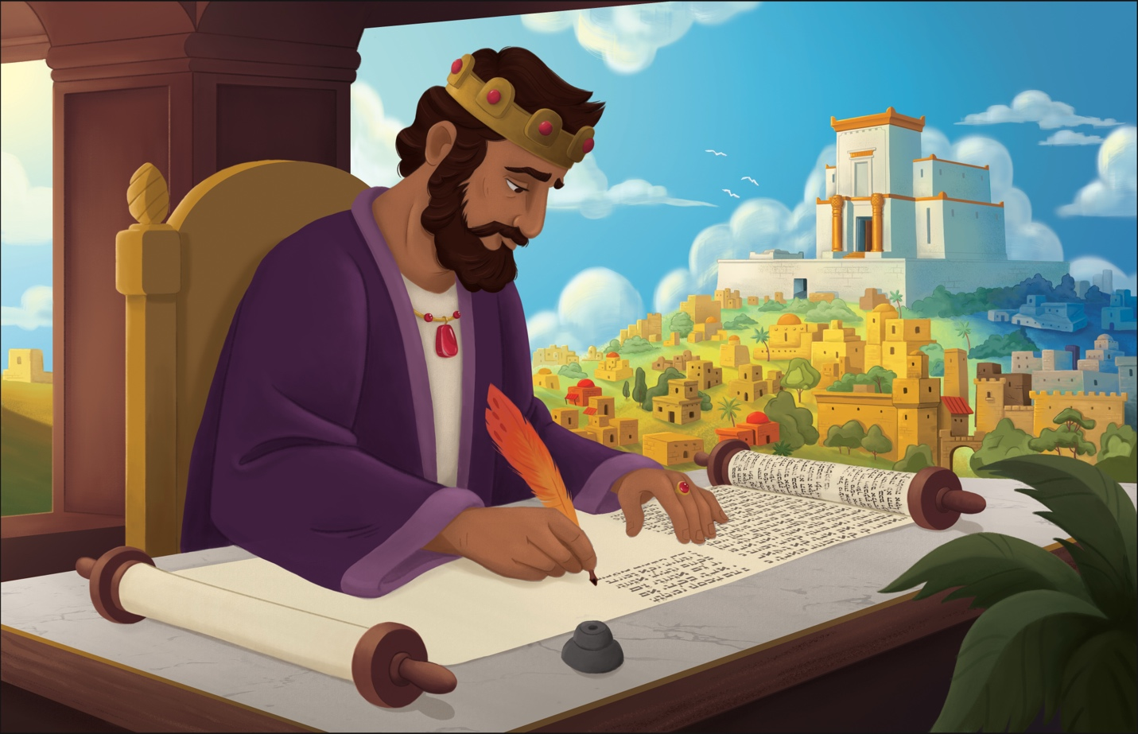
Dear families,
The book of Ecclesiastes is part of the Old Testament poetry and wisdom division. Ecclesiastes was written by King Solomon toward the end of his life as he reflected on his legacy and leadership. Though he had all the riches and wisdom life had to offer, he relayed in this writing that nothing matters apart from fearing the Lord and walking in His ways.

If everything is worthless, how are we to live meaningful lives as Christ followers? How is Jesus able to redeem our purpose in life?

The overall tone of Ecclesiastes seems pretty dreary. Solomon spoke of the meaninglessness of all our hard work and effort as people in a fallen world. These ideas seem to be in stark contrast to the ideas of God’s beautiful, wonderful creation that we find throughout Scripture. A deeper look reveals that Solomon wasn’t commanding his readers to stop caring about working hard, investing in the next generation, or experiencing what life has to offer. Instead, he poetically explained how lives spent on pursuing only the things of this world have no eternal meaning and will not be remembered.

The pursuits of this life are done in vain when we place them above our pursuit of the Lord and the wisdom He provides. Everything loses its meaning when held up against the cross of Jesus Christ. Only a life built on faith in Jesus will matter in the end.

When we order our lives with Jesus as our main pursuit, we experience the purpose and meaning that Christ died for us to receive; we experience life everlasting here and now. The gospel frees us from chasing after temporary, empty things and transforms our hearts to love and serve God. Christ died so that we may have life and have it in abundance (John 10:10).

Lead the children in your care to see the beauty of a life spent pursuing Christ! When all else seems meaningless, in Him we find our meaning as creations lovingly fashioned by a good Creator. Pray they would turn from their sins and receive the gift of abundant life.

Check out The Gospel Project At Home for resources designed to help you lead a family worship experience as well as suggestions for morning and evening prayer times and family activities.

FAMILY TALKING POINTS

CHRIST CONNECTION
This is the big idea of how this week’s Bible story points to Jesus.
- Babies & Toddlers: This world won’t last forever, but Jesus does. Trusting in Jesus is all that matters. Jesus came to save people from sin so we can be with God forever.
- Younger Preschool: The things we get in this world don’t last forever. Only trusting in Jesus really matters. Jesus came to save people from sin so we can be with God forever.
- Older Preschool: Nothing we get in this world lasts forever. Only trusting in Jesus really matters. Jesus came to rescue sinners so we can have life with God forever.
- Kids: People spend their lives trying to get riches, power, and fame, but none of it lasts. Only a life spent trusting in Jesus as Savior and following Him will matter in the end. Jesus lived, died, and rose again so we could find purpose in Him and be with God forever.

BIG PICTURE QUESTION & ANSWER
This is an important biblical truth that your child will encounter each week of this unit.
- Younger Preschool: What does God know? God knows everything.
- Older Preschool: What does God know? God knows everything.
- Kids: What does God know? God knows everything about the past, present, and future.

KEY PASSAGE
This is a Bible verse that relates to what your child will encounter each week of this unit.
- Babies & Toddlers: Obey the LORD and do what is right. Proverbs 3:7
- Younger Preschool: Fear the LORD and turn from evil. Proverbs 3:7
- Older Preschool: Fear the LORD and turn away from evil. Proverbs 3:7
- Kids: Don’t be wise in your own eyes; fear the LORD and turn away from evil. Proverbs 3:7

** Next week: The Queen of Sheba Visited Solomon (1 Kings 10)

Unit 12, Session 4
The Queen of Sheba Visited Solomon (1 Kings 10)

Dear families,
By 1 Kings 10, word had spread to the queen of Sheba about the amazing wisdom of King Solomon. She traveled to his courts with an entourage of great abundance—camels, spices, gold, and precious stones. Solomon's acclaim, however, served a greater purpose for the queen: blessing the Lord of Israel (1 Kings 10:9).

What did the queen of Sheba discover during her visit? How does the queen’s amazement demonstrate the same amazement that the crowds experienced through the teachings of Jesus?

When the queen of Sheba surveyed the king’s wisdom in conversation, as well as the splendor of life in his palace, it took her breath away. The rumors of his wisdom and prosperity didn’t offer the full picture of what life in his kingdom was really like. She recognized the king’s justice and righteousness. She acknowledged God's eternal love for His people and how happy Solomon's men were because of his wisdom. The queen recognized how people who have a wise leader and a loving God are truly blessed.

Jesus is the all-wise and perfect Ruler, surpassing Solomon in all his wisdom. Just as the queen of Sheba was amazed at Solomon, the crowds Jesus spoke to were also amazed at His wisdom and authority. And yet, unlike the queen of Sheba who blessed the God of Israel, many refused to believe in Jesus. Jesus spoke about the wisdom of Solomon, but regarding Himself and His own wisdom said, “... something greater than Solomon is here” (Matthew 12:42). Jesus had come to lead people into true wisdom: faith in Him.

Lead the children in your care to see that Jesus is who He says He is: the mightiest King with the greatest wisdom, authority, and power. Pray they would be amazed by King Jesus and trust in Him. Ask the Lord to show them how to walk by faith in His wisdom.

Check out The Gospel Project At Home for resources designed to help you lead a family worship experience as well as suggestions for morning and evening prayer times and family activities.

FAMILY TALKING POINTS

CHRIST CONNECTION
This is the big idea of how this week’s Bible story points to Jesus.
- Babies & Toddlers: King Solomon, David’s son, was wise, but Jesus, God’s Son, is wiser. Jesus is the King of everything who came to show us how to live and to save us by dying and coming back to life.
- Younger Preschool: Like the queen was surprised by King Solomon’s wisdom, people were also surprised by Jesus’ teaching. Jesus is God’s Son. He taught with power because He is the King of everything. Jesus came to show us how to live and to save us by dying and coming back to life.
- Older Preschool: Like the queen was amazed by the wisdom God gave King Solomon, people were amazed by Jesus’ teaching. Jesus is God’s Son. He taught with power because He is the King of everything. Jesus came to earth to show us how to live and to save us by dying and coming back to life.
- Kids: The queen of Sheba was amazed at the wisdom God had given King Solomon. The people who heard Jesus teach were amazed at His wisdom, authority, and power. Jesus has all wisdom, authority, and power because He is God's Son who came to live, die, and rise again.

BIG PICTURE QUESTION & ANSWER
This is an important biblical truth that your child will encounter each week of this unit.
- Younger Preschool: What does God know? God knows everything.
- Older Preschool: What does God know? God knows everything.
- Kids: What does God know? God knows everything about the past, present, and future.

KEY PASSAGE
This is a Bible verse that relates to what your child will encounter each week of this unit.
- Babies & Toddlers: Obey the LORD and do what is right. Proverbs 3:7
- Younger Preschool: Fear the LORD and turn from evil. Proverbs 3:7
- Older Preschool: Fear the LORD and turn away from evil. Proverbs 3:7
- Kids: Don’t be wise in your own eyes; fear the LORD and turn away from evil. Proverbs 3:7

** Next week: Wisdom of God’s People (Proverbs 1; 3-4)

Unit 12, Session 5
Wisdom of God’s People (Proverbs 1; 3-4)
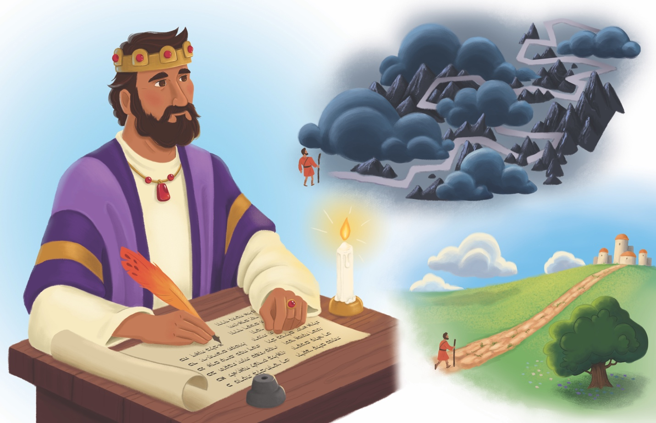
Dear families,
God’s gift of wisdom to King Solomon did not end with Solomon; he shared this wisdom through his proverbs. Solomon wrote in Proverbs 1:2 that these words were for learning wisdom and discipline, understanding insightful sayings, receiving instruction, and teaching the inexperienced. Through all the insight he gained as the wisest man on earth, he came back to this truth: “The fear of the LORD is the beginning of knowledge” (Proverbs 1:7).

What does it mean to fear the Lord? How can we know that we have true wisdom?

Fearing the Lord means honoring Him as holy and revering Him as God alone. Solomon recognized the folly of a life lived in his own strength and wisdom. He knew that pursuing the Lord through genuine trust and obedience is the only way to live a life that matters. He beckoned readers to trust in the Lord with all their heart and not depend on their own understanding. The proverbs reveal to us that wisdom is not a mere intellectual exercise. Wisdom is a Person, Jesus, and by trusting in Him we find salvation.

Many proverbs offer practical guidance for interacting with the world: avoiding peer pressure, pursuing the path of peace, and treating others fairly. However, all of the practical guidance is grounded in following God's wisdom above any earthly knowledge. Solomon wrote of the favor God’s people experience when they cling to His ways above all else.

Consider your relationship to godly wisdom. Reflect on the seasons of life that have led you closest to the Lord and in obedience to Him. Remember God’s generosity and kindness toward His followers: “Now if any of you lacks wisdom, he should ask God—who gives to all generously and ungrudgingly—and it will be given to him” (James 1:5).

Invite the children in your care to see the beauty of pursuing God’s ways and trusting Him, both for the promise of His presence and the wisdom He provides in our everyday lives. Life everlasting begins when we come to faith in Him!

Check out The Gospel Project At Home for resources designed to help you lead a family worship experience as well as suggestions for morning and evening prayer times and family activities.

FAMILY TALKING POINTS

CHRIST CONNECTION
This is the big idea of how this week’s Bible story points to Jesus.
- Babies & Toddlers: Solomon taught that people should trust in God. Jesus trusted in God and followed His plan to rescue sinners. When we trust in Jesus, we have forgiveness and life with God forever.
- Younger Preschool: Solomon taught that people should trust in God. Jesus trusted in God His Father and followed His plan to rescue sinners. When we trust in Jesus, we have forgiveness and life with God forever.
- Older Preschool: Solomon taught that people should trust in God. Jesus trusted in God, His Father, and followed His plan by coming to earth to die on the cross for our sins. Jesus rose again. When we trust Him, we have forgiveness and life with God forever.
- Kids: Solomon’s proverbs encourage God’s people to trust in the Lord. Jesus trusted in God His Father throughout His life on earth, all the way to His death on the cross for our sins. He rose again and continues to lead us to love and trust God the Father.

BIG PICTURE QUESTION & ANSWER
This is an important biblical truth that your child will encounter each week of this unit.
- Younger Preschool: What does God know? God knows everything.
- Older Preschool: What does God know? God knows everything.
- Kids: What does God know? God knows everything about the past, present, and future.

KEY PASSAGE
This is a Bible verse that relates to what your child will encounter each week of this unit.
- Babies & Toddlers: Obey the LORD and do what is right. Proverbs 3:7
- Younger Preschool: Fear the LORD and turn from evil. Proverbs 3:7
- Older Preschool: Fear the LORD and turn away from evil. Proverbs 3:7
- Kids: Don’t be wise in your own eyes; fear the LORD and turn away from evil. Proverbs 3:7

** Next week: The Kingdom Divided (1 Kings 12-13)

