Ministry Leaders: A suggested email is provided for each session for you to customize if you desire and share with your families. You can also access a social media share square for each session on the Additional Resources page at gospelproject.com.
The Gospel Project At Home content is available in Ministry Grid for you to share with your families.

Unit 4, Session 1
God Called Moses (Exodus 1-4)

Dear families,
Moses’ life was characterized by miraculous encounters with the God of Israel. The same God who called Moses into leadership promised to use His faithful servant to rescue the Israelites from Egyptian rule. As His people cried out, God heard and remembered His covenant with their forefathers.
How did God direct Moses into these divine purposes? How did Moses 'calling foreshadow the One who would lead God’s people into even greater victory?
From Moses’ first mention in Scripture, we read how God’s purposes for Moses’ life would prevail despite people’s wicked schemes. Though Pharaoh called for the Israelite boys to be put to death, God saved Moses from such a fate. As Moses fled his familiar life in Egypt, God directed Moses’ path toward a magnificent encounter with the great I AM at the burning bush. God called the wandering Moses by name, leading him forward in obedience with the promise of His faithful presence.
While Moses would not flawlessly follow God nor perfectly trust in His promises, God promised to provide Moses with help and demonstrate His power. Moses was aware of his own shortcomings as a leader, yet God still used him mightily to rescue the Israelites.
Later in his life, Moses prophesied that a new leader would one day emerge from among the Israelites. We see this promise fulfilled in Jesus Christ who, like Moses, was born in a time of turmoil under a king who called for His death. Unlike Moses, however, Jesus lived a sinless life and saved God’s people from a different kind of bondage—the tyranny of sin and death. Moses led God’s people to offer sacrifices to the Lord. Jesus, however, became the perfect sacrifice for His people, conquering death and raising to new life all who would believe in Him.
As you teach the kids in your family to see God at work in the life of Moses, pray that they would lift their gaze to see Jesus’ work on their own behalf. Though Moses was a distinguished leader who sought to obey God, this story goes beyond a moral example and is about the One who is worthy of our obedience and trust. Pray for the children in your family to heed Christ’s call to salvation.
Check out The Gospel Project At Home for resources designed to help you lead a family worship experience as well as suggestions for morning and evening prayer times and family activities.

FAMILY TALKING POINTS

CHRIST CONNECTION
This is the big idea of how this week’s Bible story points to Jesus.

- Babies & Toddlers: God sent Moses to rescue the Israelites from Egypt. God sent Jesus to rescue us from sin.
- Younger Preschool: God’s people in Egypt needed to be rescued. God sent Moses to save them. We all need to be rescued from sin, so God sent Jesus to rescue us.
- Older Preschool: God saw His people hurting as slaves in Egypt. God sent Moses to rescue them. We all suffer as slaves to sin, so God sent Jesus to rescue us by dying and rising again.
- Kids: God saw His people suffering as slaves in Egypt and sent Moses to rescue them. We all suffer as slaves to sin, and God sent Jesus to rescue us by dying and rising again.

BIG PICTURE QUESTION & ANSWER
This is an important biblical truth that your child will encounter each week of this unit.

- Younger Preschool: Why does sin keep us from God? Sin keeps us from God because He is holy.
- Older Preschool: Why does sin separate us from God? Because God is holy.
- Kids: Why does sin separate us from God? Because God is holy, sin has broken our relationship with God.

KEY PASSAGE
This is a Bible verse that relates to what your child will encounter each week of this unit.

- Babies & Toddlers: God hears and rescues. Psalm 34:17
- Younger Preschool: The LORD hears, and rescues. Psalm 34:17
- Older Preschool: The righteous cry out, and the LORD hears, and rescues them from all their troubles. Psalm 34:17
- Kids: The righteous cry out, and the LORD hears, and rescues them from all their troubles. Psalm 34:17

** Next week: Moses Confronted Pharaoh (Exodus 5-12)

Unit 4, Session 2
Moses Confronted Pharoah (Exodus 5-12)
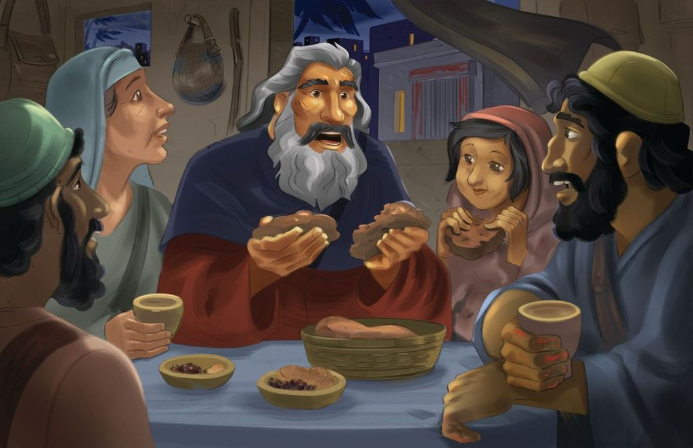
Dear families,
The confrontation between Moses and Pharaoh revealed the stark contrast between the powerful compassion of God toward His people and the heart-hardened pride of the Egyptian ruler. While challenging Pharaoh seemed an impossible task, God used Moses to showcase His glory through Moses’ willingness to obey. Though Pharaoh’s pride led to the demise of his people, we see in this story a picture of God’s mercy to the Israelites. This serves as a foreshadow of the mercy Christ displayed on the cross by taking on Himself the punishment sinners deserved so that they might enjoy eternal life with Him.
Why was Pharaoh’s heart so hardened against God? How did Moses and the Israelites trust God despite their circumstances?
Pharaoh’s first response to Moses was to question God: “Who is the Lord that I should obey him by letting Israel go?” (Exodus 5:2). Pharaoh did not recognize God’s power, nor did he wish to submit himself under any other authority. Pharaoh’s disobedience was already leading him on a path of destruction, so God saw fit to further harden the ruler’s heart as a means of displaying His own power over Pharaoh and the fake gods of Egypt.
Moses, despite communing with God so closely, still doubted His faithfulness amid the Israelites’ suffering. Moses even accused God of causing trouble and making a mistake by choosing him as leader. Yet, God declared that the Egyptians would see His power, and in the end, surrender to His will. God repeated His covenant promises and reminded His people that He would be faithful to deliver them from Egypt and bring them to the land of promise. Through the suffering of slavery and desolation of the plagues, God’s people waited. And upon hearing God’s Passover instructions, they did as He commanded.
Consider Moses’ difficulties in confronting Pharaoh, a man of great prestige. Then, reflect on the grace and mercy of God who reigns in sovereign power. Though it appeared impossible, God made good on His promises. Help the kids in your family see that Christ’s sacrifice was the ultimate fulfillment of God’s promise to redeem people from the bondage of sin. Just as the blood of the lamb saved the firstborn sons at Passover, Christ’s blood now and forever frees us from sin.
Check out The Gospel Project At Home for resources designed to help you lead a family worship experience as well as suggestions for morning and evening prayer times and family activities.

FAMILY TALKING POINTS

CHRIST CONNECTION
This is the big idea of how this week’s Bible story points to Jesus.

- Babies & Toddlers: Jesus died on the cross and rose again so we can be saved
from sin.
- Younger Preschool: God showed His power so His people could be free. Jesus came to earth to rescue people from the power of sin. Everyone who trusts in Jesus will be free from sin and live with God forever.
- Older Preschool: Pharaoh did not want God’s people to be free. The people suffered, but God’s people were saved. Jesus came to set sinners free. He willingly suffered and died on the cross so we can be saved from sin.
- Kids: Because of Pharaoh’s hard heart, Egypt suffered by God’s people were saved. Because of Jesus’ loving heart, He willingly suffered on the cross so we could be saved from sin. His blood saves us from our sin just as the Passover lamb’s blood saved the firstborn of the Israelites.

BIG PICTURE QUESTION & ANSWER
This is an important biblical truth that your child will encounter each week of this unit.

- Younger Preschool: Why does sin keep us from God? Sin keeps us from God because He is holy.
- Older Preschool: Why does sin separate us from God? Because God is holy.
- Kids: Why does sin separate us from God? Because God is holy, sin has broken our relationship with God.

KEY PASSAGE
This is a Bible verse that relates to what your child will encounter each week of this unit.

- Babies & Toddlers: God hears and rescues. Psalm 34:17
- Younger Preschool: The LORD hears, and rescues. Psalm 34:17
- Older Preschool: The righteous cry out, and the LORD hears, and rescues them from all their troubles. Psalm 34:17
- Kids: The righteous cry out, and the LORD hears, and rescues them from all their troubles. Psalm 34:17

** Next week: Moses Parted the Red Sea (Exodus 13-15)

Unit 4, Session 3
Moses Parted the Red Sea (Exodus 13-15)
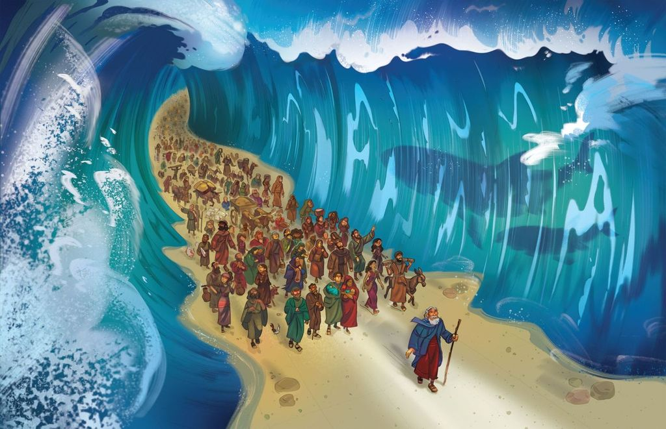
Dear families,
The parting of the Red Sea is one of the most incredible accounts in Scripture. After God freed His people through the events of the Passover, He performed this amazing miracle to deliver them from danger and secure their hearts in worship to Him alone. In this passage, we see glimmers of an even greater miracle––the salvation of God’s people, once and for all time, through Christ’s miraculous sacrifice on our behalf.
Why did God lead His people into the hardships of the wilderness? What was God’s intention for rescuing His people from slavery?
While God led His people on a route that took longer and was different than expected, His divine purpose in doing so was for their good. But even more, He knew the waywardness of His people’s hearts and that the external threat of war would only intensify their inclination to doubt His provision. God led them to the perfect location to display His power and test their trust in Him.
In Exodus 7, God instructed Moses to tell Pharaoh, “The Lord, the God of the Hebrews, has sent me to tell you: Let my people go, so that they may worship me in the wilderness.” The parting of the Red Sea was certainly enough to inspire worship as the people watched the Lord bring deliverance through the most surprising of means. Just as Moses had spoken, the threat of the Egyptians on that day would never worry them again. God revealed His awe-inspiring power through the parting of the Red Sea, though such a rescue seemed impossible. Like the Israelites, we can know that God will receive glory and that all who place their faith in Jesus will live in the hope of His salvation. Just as God’s people walked through the sea on dry ground, anyone who turns to Christ for salvation will pass through judgment and into eternal life.
Consider the internal and external factors that keep you from giving God the worship He deserves. Pray for the same understanding from the children in your family, that they would turn to Christ and receive His miraculous offer of salvation.
Check out The Gospel Project At Home for resources designed to help you lead a family worship experience as well as suggestions for morning and evening prayer times and family activities.

FAMILY TALKING POINTS

CHRIST CONNECTION
This is the big idea of how this week’s Bible story points to Jesus.

- Babies & Toddlers: God made a way to save His people from Pharaoh. God made a way to save us from our sin by sending Jesus to die on the cross and rise again.
- Younger Preschool: God made a way for His people to be saved. He parted the Red Sea so they could live. God made the way for us to be saved from our sin by sending Jesus. We can trust Him and be thankful.
- Older Preschool: God made a way for the Israelites to be saved. He parted the Red Sea so they could live. We are all sinners who deserve to die for our sin, but God miraculously made the way for us to be saved by sending Jesus to die in our place for our sin and rise again.
- Kids: The Israelites faced certain death, but God miraculously made a way for them to be saved by parting the Red Sea. We are all sinners and face certain death for our sin, but God miraculously made the way for us to be saved by sending Jesus to die in our place for sin and rise again.

BIG PICTURE QUESTION & ANSWER
This is an important biblical truth that your child will encounter each week of this unit.

- Younger Preschool: Why does sin keep us from God? Sin keeps us from God because He is holy.
- Older Preschool: Why does sin separate us from God? Because God is holy.
- Kids: Why does sin separate us from God? Because God is holy, sin has broken our relationship with God.

KEY PASSAGE
This is a Bible verse that relates to what your child will encounter each week of this unit.

- Babies & Toddlers: God hears and rescues. Psalm 34:17
- Younger Preschool: The LORD hears, and rescues. Psalm 34:17
- Older Preschool: The righteous cry out, and the LORD hears, and rescues them from all their troubles. Psalm 34:17
- Kids: The righteous cry out, and the LORD hears, and rescues them from all their troubles. Psalm 34:17

** Next week: God Provided for His People (Exodus 15-17)

Unit 4, Session 4
God Provided for His People (Exodus 15-17)
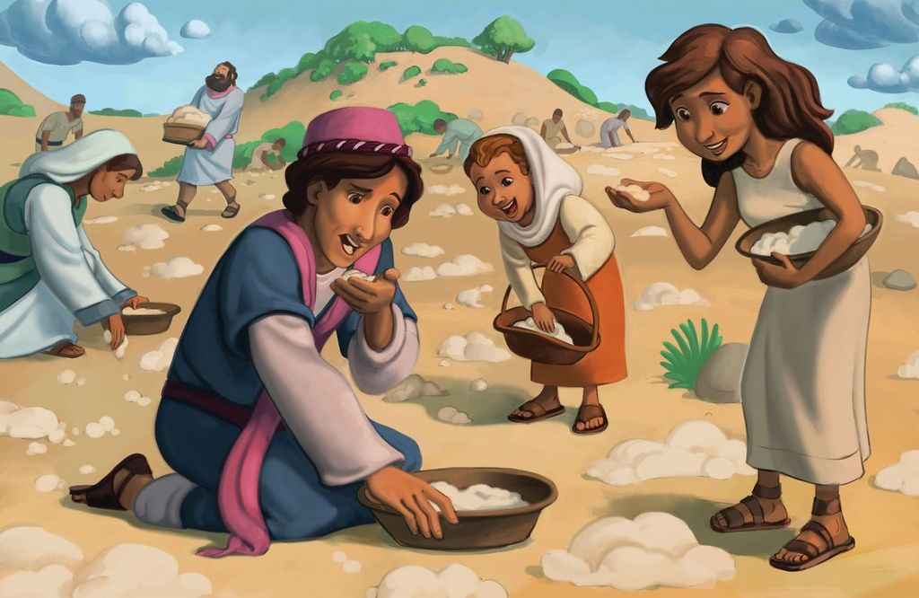
Dear families,
God’s miraculous provision for His people revealed His steadfast compassion despite their continual grumbling. In today’s passage, we read of God granting the Israelites far more than they deserved, heaping upon them more than they needed as they journeyed with Him to the Promised Land. Today, those who are in Christ receive undeserved grace and provision through His sacrificial love lavished upon us like manna in the wilderness.
What made the Israelites long for their old lives in Egypt? What does the Sabbath teach us about God’s provision?
Though not far removed from the miraculous parting of the Red Sea, the Israelites grew desensitized to God’s extraordinary power at work in their lives. Not only had He delivered them from slavery, but He kept His presence close, guiding them day and night as they journeyed through the wilderness. Now, after weeks of wandering, their grumbling grew louder. They would have rather died in Egypt than learn to depend on and trust God in a desolate place. They took for granted their freedom to worship God in the wilderness; they longed for their predictable lives in Egypt—forgetting the toils of slavery.
Despite what they deserved, God looked on them with compassion, causing bread to rain on them from heaven and for meat and water to become miraculously within reach. He called for His people to trust in His provision, only gathering what was necessary for the day. He desired them to thrive under obedience to Him. Just as God had fought their battle against Egypt, God called them to be still and rest in His provision. Rest requires the people of God to stop striving and simply trust and receive. God was helping His people learn this truth through the Sabbath.
Sadly, the Israelites turned a blind eye to God’s faithfulness in fighting their battles and meeting their needs. We are also prone to overlook God’s faithful provision in our own lives and perhaps even downplay the miraculous gift of salvation in Christ. Lead the children in your home to see the gift of God’s undeserved grace and to hunger and thirst for His gift of salvation.
Check out The Gospel Project At Home for resources designed to help you lead a family worship experience as well as suggestions for morning and evening prayer times and family activities.

FAMILY TALKING POINTS

CHRIST CONNECTION
This is the big idea of how this week’s Bible story points to Jesus.

- Babies & Toddlers: God gave the Israelites the food and water they needed. We are all sinners, but God gave us Jesus so that we might be saved from our sin.
- Younger Preschool: God took care of His people in the wilderness. All people need God. God gave us what we need the most: His Son, Jesus. Jesus died and rose from the dead to rescue us from our sins.
- Older Preschool: The people were unhappy with Moses and God, but God still chose to give them the food and water they needed. We are all sinners, but Jesus still chose to die for us so that we might be saved from our sin.
- Kids: The people complained against Moses and against God, but God still chose to give them the food and water they needed. We are all sinners and are enemies of God, but Christ still chose to die for us so that we might be saved.

BIG PICTURE QUESTION & ANSWER
This is an important biblical truth that your child will encounter each week of this unit.

- Younger Preschool: Why does sin keep us from God? Sin keeps us from God because He is holy.
- Older Preschool: Why does sin separate us from God? Because God is holy.
- Kids: Why does sin separate us from God? Because God is holy, sin has broken our relationship with God.

KEY PASSAGE
This is a Bible verse that relates to what your child will encounter each week of this unit.

- Babies & Toddlers: God hears and rescues. Psalm 34:17
- Younger Preschool: The LORD hears, and rescues. Psalm 34:17
- Older Preschool: The righteous cry out, and the LORD hears, and rescues them from all their troubles. Psalm 34:17
- Kids: The righteous cry out, and the LORD hears, and rescues them from all their troubles. Psalm 34:17

** Next week: Moses Led the Israelites (Exodus 17-18)

Unit 4, Session 5
Moses Led the Israelites (Exodus 17-18)
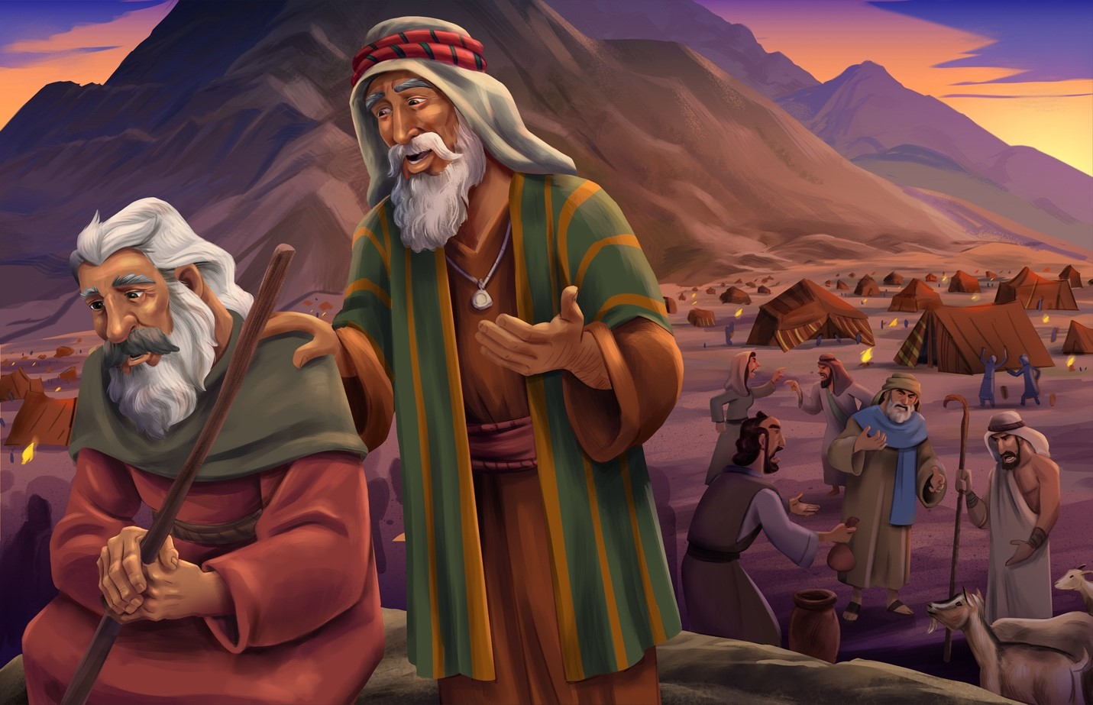
Dear families,
Exodus 17 and 18 reveal God’s faithfulness to help Moses in the difficulties of leadership. From the Amalekite battle to his daily struggle to teach and judge God’s people, Moses’ human limitations were evident as he came to the end of himself and depended on God to supply him with the support needed to fulfill his role as leader of the Israelites.
How was Moses ill-equipped to take on the strains of these circumstances? How do we see our own need for Jesus in today’s text?
Though Moses led with humble obedience, he could not independently fulfill all the requirements of his role. As Joshua led Israel in war, Moses was responsible for interceding on behalf of the Israelites. When the Israelites were battling the Amalekites, God allowed Aaron and Hur to assist Moses as his arms grew heavy, and God declared that He would blot out the memory of this foe under heaven. When God’s words rang true, Moses declared God to 8888be his victory, the One in whom he placed his trust.
Later, Moses recounted to his father-in-law God’s faithful deliverance in every hardship since their departure from Egypt and went on to explain his responsibilities as leader. Jethro believed Moses’ role was too big for one man and wisely instructed Moses to select other like-minded men to serve alongside him. He explained that the delegation of these roles would help not only Moses, but the rest of God’s people too. God, in His grace, provided the right men to assist Moses in these responsibilities. In both times of need, God graciously provided for Moses.
Teach the kids in your family that God helps us in our times of need, just as He did for Moses. Even more, God provides our greatest need: a Ruler like Moses to perfectly and completely instruct and judge His people––a role that could only be fulfilled through His perfect Son, Jesus. Moses’ leadership was a shadow of Christ’s greatness to come. Pray for the kids in your family to see the salvation Christ offers them today, our greatest help for our greatest trouble.
Check out The Gospel Project At Home for resources designed to help you lead a family worship experience as well as suggestions for morning and evening prayer times and family activities.

FAMILY TALKING POINTS

CHRIST CONNECTION
This is the big idea of how this week’s Bible story points to Jesus.

- Babies & Toddlers: Moses was not able to meet all the people’s needs. Jesus met our need to be rescued from sin by dying on the cross and coming back to life.
- Younger Preschool: Moses was a good leader, but only Jesus can hear and answer all our prayers. Jesus helped us in the best way. He saved us from our sins by dying on the cross and coming back to life.
- Older Preschool: Moses was a great leader, but he was not able to meet all the needs of the people. Jesus is able to hear and respond to all of our prayers. Jesus met our need to be rescued from sin by dying on the cross and coming back to life.
- Kids: Moses was a great leader, but he was just a man. He was not able to meet all the needs of all the people by himself. Jesus is fully man and fully God. He is able to hear and respond to all of our prayers, and His death and resurrection provides salvation to everyone who trusts in Him.

BIG PICTURE QUESTION & ANSWER
This is an important biblical truth that your child will encounter each week of this unit.

- Younger Preschool: Why does sin keep us from God? Sin keeps us from God because He is holy.
- Older Preschool: Why does sin separate us from God? Because God is holy.
- Kids: Why does sin separate us from God? Because God is holy, sin has broken our relationship with God.

KEY PASSAGE
This is a Bible verse that relates to what your child will encounter each week of this unit.

- Babies & Toddlers: God hears and rescues. Psalm 34:17
- Younger Preschool: The LORD hears, and rescues. Psalm 34:17
- Older Preschool: The righteous cry out, and the LORD hears, and rescues them from all their troubles. Psalm 34:17
- Kids: The righteous cry out, and the LORD hears, and rescues them from all their troubles. Psalm 34:17

** Next week: The Ten Commandments (Exodus 19-20; 31)

Unit 5, Session 1
The Ten Commandments (Exodus 19-20; 31)
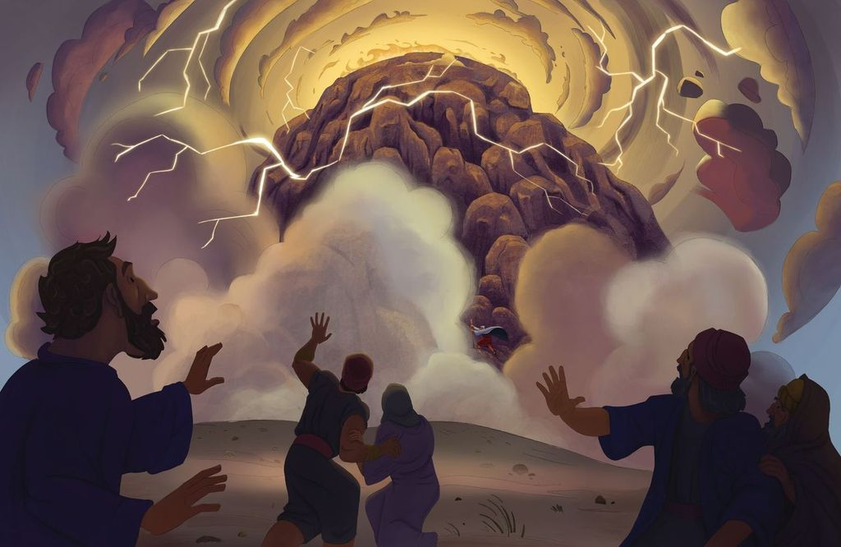
Dear families,
This week’s Scripture story takes place only three months after God delivered His people from Egyptian slavery. The Lord spoke to Moses concerning the way she was to lead Israel into their next season of life as God’s chosen and set-apart people. They were to worship God through holy lives that honored Him alone as God.

Why were the Ten Commandments necessary for God’s people? How do these commands show us our need for a Savior?

God reminded the Israelites of who He is and all He accomplished to free them from Egypt, drawing them away from slavery and into a place where they could freely worship Him as God. He instructed them to carefully listen to His commands, keep His covenant, and be His own special people. He decreed the Ten Commandments, explaining the lifestyle that would extend honor not only to Himself, but also to their neighbors. He explained how they were to revere Him as God and to love one another in all they said and did.

The external threat of slavery was not the only obstacle stopping the Israelites from freely worshiping God; they had to combat their internal inclinations to sin against Him and one another. God took great care to deliver His law to the Israelites in a way that evoked awe and reverence toward Himself. He presented these statutes to show His people how they were to be set apart or live differently from other people who didn’t follow Him. However, because of their sinful nature, the people could never achieve perfect obedience. So to fulfill His perfect law, God would send Jesus to do what sinners couldn’t—live in perfect obedience. Jesus offered Himself up for the forgiveness of sins and defeated the power of sin so we could be made right before the Father through faith in His Son.

The giving of the law was never the end goal; it was always God’s plan to redeem a people for Himself through the death and resurrection of His Son. Help the kids in your family see that because they cannot measure up to the law’s requirements, our hope rests in Christ alone. Lead them to see God’s greatness and what He has done to offer them salvation.

Check out The Gospel Project At Home for resources designed to help you lead a family worship experience as well as suggestions for morning and evening prayer times and family activities.

FAMILY TALKING POINTS

CHRIST CONNECTION
This is the big idea of how this week’s Bible story points to Jesus.

- Babies & Toddlers: Because of sin, we cannot obey God rules perfectly. God sent His Son, Jesus, to live a perfect, sinless life so we can be forgiven.
- Younger Preschool: God gave His people rules so they would know how to live. No one follows the rules all the time. That’s why God sent Jesus. Jesus never did anything wrong, and He died and came back to life so we can be forgiven.
- Older Preschool: God gave His people commandments so they would know how to live. Because of sin, no one is able to obey these commandments perfectly. God sent His Son, Jesus, to live a perfect, sinless life. Jesus died and rose again so that sinners can be forgiven.
- Kids: God gave His people commandments so they would know how to honor Him and live rightly. Because of sin, no one is able to keep these commandments perfectly. God sent His Son, Jesus, to live a perfect, sinless life. Jesus died and rose again so that sinners can be forgiven.

BIG PICTURE QUESTION & ANSWER
This is an important biblical truth that your child will encounter each week of this unit.

- Younger Preschool: Why do we need to be saved? We are sinful and need Jesus to rescue us from sin.
- Older Preschool: Why do we need to be saved? We are sinful and need Jesus to rescue us from sin.
- Kids: Why do we need to be saved? People are sinful and cannot save themselves.

KEY PASSAGE
This is a Bible verse that relates to what your child will encounter each week of this unit.

- Babies & Toddlers: There is no one like the Lord. 1 Samuel 2:2
- Younger Preschool: There is no one holy like the Lord. 1 Samuel 2:2
- Older Preschool: There is no one holy like the Lord. There is no one besides you! 1 Samuel 2:2
- Kids: There is no one holy like the LORD. There is no one besides you! And there is no rock like our God. 1 Samuel 2:2

** Next week: The Golden Calf (Exodus 32; 34)

Unit 5, Session 2
The Golden Calf (Exodus 32; 34)
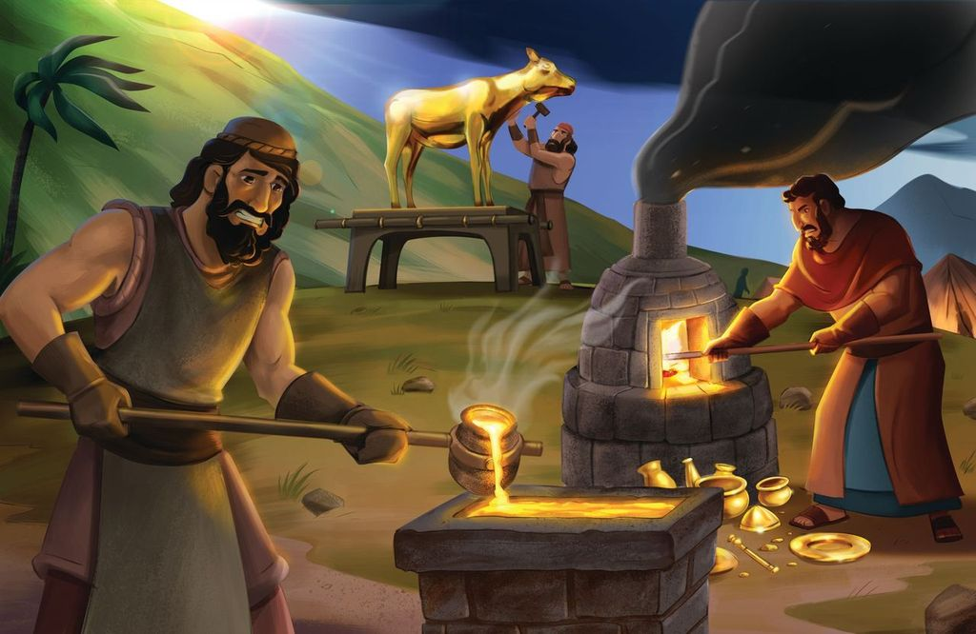
Dear families,
Exodus 32’s account of the golden calf showcases the sinful idolatry of people in contrast with the merciful nature of God. In the 40 days it took Moses to return from Mount Sinai, the people had grown impatient. They urged Aaron to join in their mission to find a new object they deemed worthy of worship and devotion: a golden calf.

What led God’s people to fall prey to this idolatry? How does Moses’ leadership foreshadow Christ’s intercession for God’s people?

An idol is anything we worship in the place of God. Unfortunately, the Israelites wrongly believed they needed a new god to go before them since Moses’ absence left them doubting if he would return and worried about who would lead them. How ironic it was that they sought to dethrone God while claiming to throw a festival in His honor (Exodus 32:5). Their impatient uncertainty led them to replace God’s sovereign plans and rightful worship with this golden god of their own creation.

As God’s anger grew against the Israelites’ sin, Moses reminded the Lord of all He had done for His people since Egypt and urged Him to relent from His planned destruction. In remembering His covenant with Abraham from long ago, and upon Moses’ urging, God did not completely destroy His people. God was faithful to uphold His covenant promises despite the unfaithfulness of His people. He instructed Moses to create two new stone tablets on which God Himself would engrave the Ten Commandments. Moses pleaded for the Lord to journey with His people, forgive them, and set them apart as His own nation and possession.

Moses was a sinful man, so his intercession for God’s people was not enough to bring everlasting forgiveness. A greater Intercessor would be needed to offer a greater sacrifice to atone for sin. We see the mercies of God through the intercession of Christ’s life, death, and resurrection so that all who trust in Him will be saved. Help the kids in your family see the greatness of God’s mercy through the faithful mediation of Moses and ultimately, Jesus.

Check out The Gospel Project At Home for resources designed to help you lead a family worship experience as well as suggestions for morning and evening prayer times and family activities.

FAMILY TALKING POINTS

CHRIST CONNECTION
This is the big idea of how this week’s Bible story points to Jesus.

- Babies & Toddlers: The people chose to sin, and Moses asked God to forgive them. When we choose to sin, we can pray and ask Jesus to forgive us. Jesus came to rescue us from sin.
- Younger Preschool: The people were wrong to worship a golden calf. Moses asked God to forgive them. When we do wrong, we can pray and ask Jesus to forgive us. Jesus died and came back to life to rescue us from our sins.
- Older Preschool: The people chose to sin when they worshiped the golden calf. Moses asked God to forgive their sin. When we choose to sin we can pray and ask Jesus to forgive us. Jesus died on the cross and came back to life to rescue us from sin.
- Kids: The people chose to worship a golden calf instead of God, and God’s anger burned against them. Moses interceded so that God would forgive them. We are all sinners who deserve the wrath of God, but Jesus interceded for us through His life, death, and resurrection so we can all be saved!

BIG PICTURE QUESTION & ANSWER
This is an important biblical truth that your child will encounter each week of this unit.

- Younger Preschool: Why do we need to be saved? We are sinful and need Jesus to rescue us from sin.
- Older Preschool: Why do we need to be saved? We are sinful and need Jesus to rescue us from sin.
- Kids: Why do we need to be saved? People are sinful and cannot save themselves.

KEY PASSAGE
This is a Bible verse that relates to what your child will encounter each week of this unit.

- Babies & Toddlers: There is no one like the Lord. 1 Samuel 2:2
- Younger Preschool: There is no one holy like the Lord. 1 Samuel 2:2
- Older Preschool: There is no one holy like the Lord. There is no one besides you! 1 Samuel 2:2
- Kids: There is no one holy like the LORD. There is no one besides you! And there is no rock like our God. 1 Samuel 2:2

** Next week: Building the Tabernacle (Exodus 35-40)

Unit 5, Session 3
Building the Tabernacle (Exodus 35-40)
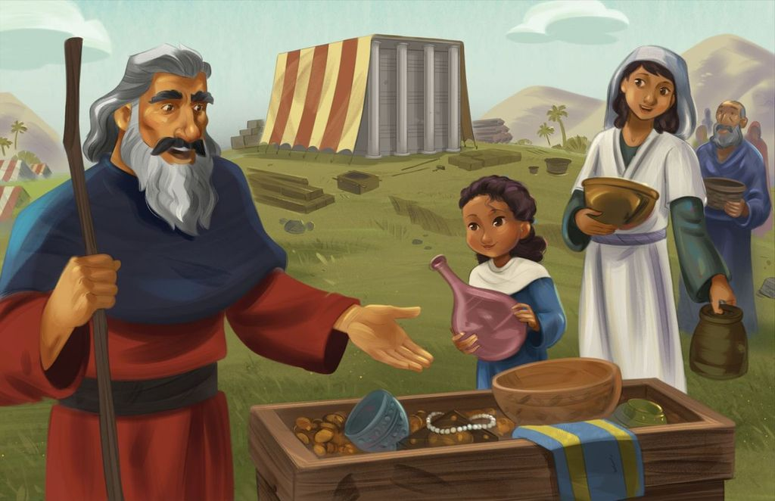
Dear families,
This week's Bible passage highlights the wonder that a holy God would desire to dwell among His people. In the previous chapter, God instructed the Israelites to obediently abide within His covenantal love. Now, it was time to build the place where God would dwell with His people as they journeyed toward the Promised Land.

What was the significance of the people’s tabernacle offerings? Why don’t Christians meet with the Lord in a tabernacle today?

God’s instructions were for each of the tabernacle’s components to be freely given by all who were willing. He called for artisans to use their skills to construct, create, and design the tabernacle and all its furnishings. Scripture details that everyone whose heart was moved and whose spirit was prompted brought an offering to the Lord for the tent of meeting and its services, as well as for the priest’s holy garments. The people offered up their finest jewelry, textiles, spices, and oils—all of which were initially provided by God Himself when the people fled Egypt. Skilled designers were even gifted the ability to teach others their craft. Together, these craftsmen lent their time and skills to the work of the tabernacle. Eventually, people brought much more than was needed, so Moses ordered them to stop! They had more than enough materials to construct a tent according to God’s commands and worthy of His presence.

Today, though we gather at local churches to worship God and commune with fellow believers, it is not in physical structures where God dwells among His people. Instead, those who are in Christ receive the gift of the Holy Spirit who dwells within us. Jesus tells us in John 16:7 that the gift of the Holy Spirit is greater than His physical presence was as He walked among His disciples! Pray for the Lord to prompt the kids in your family to heed His call of salvation, that He would dwell within them as their Lord. May we read of the tabernacle’s splendor and respond, not out of obligation, but in awe of the closeness and kindness of our Lord.

Check out The Gospel Project At Home for resources designed to help you lead a family worship experience as well as suggestions for morning and evening prayer times and family activities.

FAMILY TALKING POINTS

CHRIST CONNECTION
This is the big idea of how this week’s Bible story points to Jesus.

- Babies & Toddlers: When we trust and believe in Jesus, we are given the Holy Spirit, who is always with us.
- Younger Preschool: God wanted to be with His people, and He met with them in the tabernacle. Today when we trust in Jesus, God gives us His Holy Spirit to always be with us.
- Older Preschool: God told Moses to build the tabernacle so He could be with His people. We do not need a tabernacle, because when we trust and believe in Jesus, we are given the Holy Spirit, who is always with us.
- Kids: God told Moses and the people to build the tabernacle so that He could dwell among them. We no longer need a tabernacle because those who trust in Jesus’ life, death, and resurrection have been given the Holy Spirit so that God lives in us, not merely near us.

BIG PICTURE QUESTION & ANSWER
This is an important biblical truth that your child will encounter each week of this unit.

- Younger Preschool: Why do we need to be saved? We are sinful and need Jesus to rescue us from sin.
- Older Preschool: Why do we need to be saved? We are sinful and need Jesus to rescue us from sin.
- Kids: Why do we need to be saved? People are sinful and cannot save themselves.

KEY PASSAGE
This is a Bible verse that relates to what your child will encounter each week of this unit.

- Babies & Toddlers: There is no one like the Lord. 1 Samuel 2:2
- Younger Preschool: There is no one holy like the Lord. 1 Samuel 2:2
- Older Preschool: There is no one holy like the Lord. There is no one besides you! 1 Samuel 2:2
- Kids: There is no one holy like the LORD. There is no one besides you! And there is no rock like our God. 1 Samuel 2:2

** Next week: Worship at the Tabernacle (Leviticus 16; 19; 26)

Unit 5, Session 4
Worship at the Tabernacle (Leviticus 16; 19; 26)
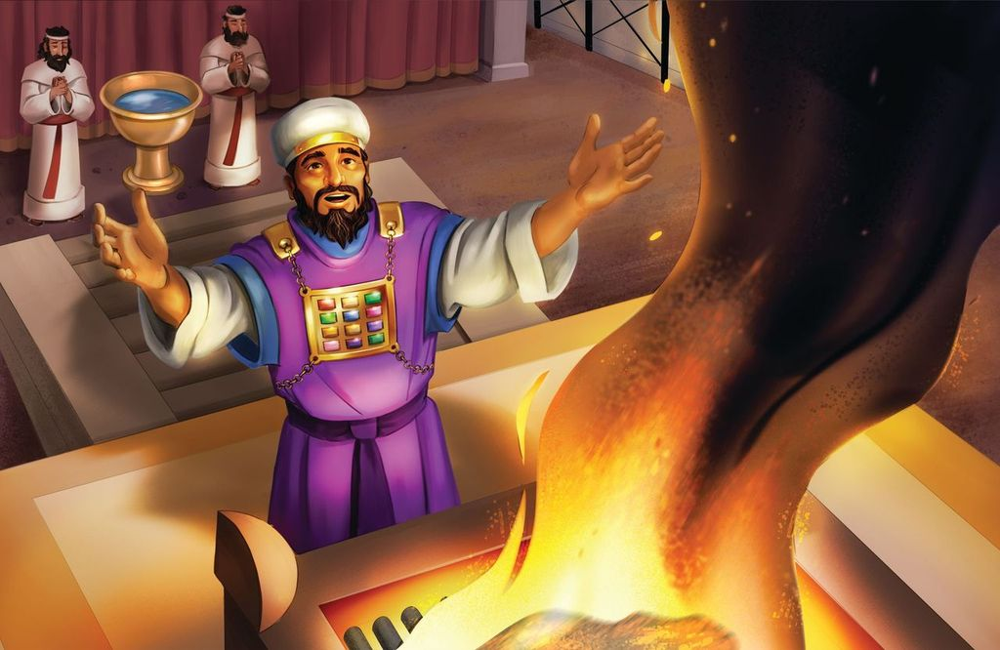
Dear families,
God’s levitical commands for atonement emphasize the gravity of people’s sin, as well as His graciousness to redeem their trespasses. Though our modern-day context seems so far removed from this sacrificial system, these guidelines from Scripture foreshadow the great, eternal sacrifice on which we place our hope: Christ’s life, death, and resurrection.

Why did God enact so many requirements for worship and sacrifice? How does Jesus fit into each of these God-ordained regulations?

God created stipulations for His people’s sacrifices because He, as a holy God, cannot tolerate sin. There was a weightiness to all the high priest did throughout the year and on the Day of Atonement. God called the Israelite community to practice holiness in every area of their lives––from respecting their elders and upholding the Sabbath to fleeing idolatry, offering sacrifices, and caring for those in need. He revealed His character through these expectations of holiness; they were to be set apart and known in the world by how they conducted themselves, treated others, and demonstrated justice.

While God knew perfect obedience would be impossible for His people, He promised to bless them as they sought to live in obedience. What’s more, He swore to dwell among them! However, He also swore that their disobedience would bring consequences. He explained that His people did not have to walk on the path of destruction but were invited to walk the path of abundant life through a covenant relationship with Him. God offered them lives marked by repentance and remembrance of His covenant with Abraham, Isaac, and Jacob. He promised to never reject His people, destroy them, or break His promises.

We see the fulfillment of these promises through One who became God incarnate and lived in perfect obedience to God’s commands. While the priests offered sacrifices daily for themselves and others, Jesus provided an eternal sacrifice to settle the debts of God’s people for all time. His righteousness is counted to us when we place faith in Him. Lead the kids in your home to see God’s kindness in providing forgiveness and eternal life through Jesus. May you show them the true meaning of worship as you guide them to see God’s worthiness through today’s passage.

Check out The Gospel Project At Home for resources designed to help you lead a family worship experience as well as suggestions for morning and evening prayer times and family activities.

FAMILY TALKING POINTS

CHRIST CONNECTION
This is the big idea of how this week’s Bible story points to Jesus.

- Babies & Toddlers: God gave His one and only Son, Jesus, as the perfect sacrifice for sin. Anyone who trusts in Jesus is forgiven of their sins forever.
- Younger Preschool: God told His people to show they were sorry for their sins. The people could not pay for their sins, so God sent His Son, Jesus, to pay for their sins. Anyone who trusts in Jesus has forgiveness and life with God forever.
- Older Preschool: God told the Israelites to sacrifice animals to show the forgiveness of sin. God gave His one and only Son, Jesus, as the perfect sacrifice for sin. Anyone who trusts in Jesus is forgiven of their sins forever.
- Kids: God instructed the Israelites to sacrifice animals to demonstrate the forgiveness and removal of sin. God gave His one and only Son, Jesus, as the perfect and final sacrifice for sin. Anyone who trusts in Jesus is forgiven of their sins and made clean forever.

BIG PICTURE QUESTION & ANSWER
This is an important biblical truth that your child will encounter each week of this unit.

- Younger Preschool: Why do we need to be saved? We are sinful and need Jesus to rescue us from sin.
- Older Preschool: Why do we need to be saved? We are sinful and need Jesus to rescue us from sin.
- Kids: Why do we need to be saved? People are sinful and cannot save themselves.

KEY PASSAGE
This is a Bible verse that relates to what your child will encounter each week of this unit.

- Babies & Toddlers: There is no one like the Lord. 1 Samuel 2:2
- Younger Preschool: There is no one holy like the Lord. 1 Samuel 2:2
- Older Preschool: There is no one holy like the Lord. There is no one besides you! 1 Samuel 2:2
- Kids: There is no one holy like the LORD. There is no one besides you! And there is no rock like our God. 1 Samuel 2:2

** Next week: The People Grumbled (Numbers 11-12)

Unit 6, Session 1
The People Grumbled (Numbers 11-12)
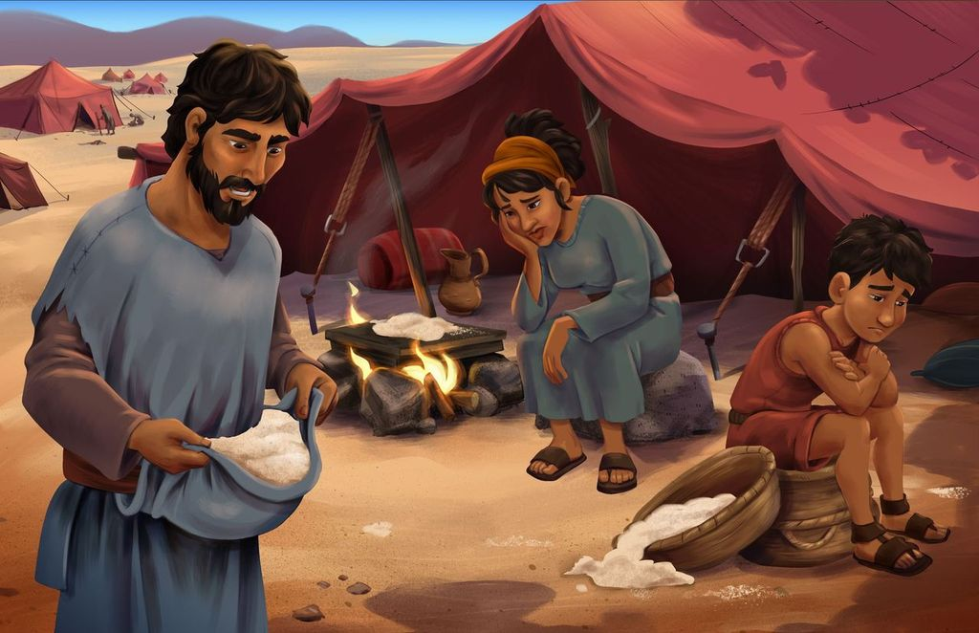
Dear families,
The Israelites’ grumbling in Numbers 11 and 12 showcases God’s graciousness to provide abundantly more than their ungrateful hearts deserved. Though He made His presence visible among them, they did not believe He offered them His best. God’s people began to treat God’s miraculous provision as though it were mundane.

Why were the Israelites so prone to overlook God’s mercies? How are we tempted to fall into these same patterns?

The Israelites faulted God—and by default, Moses—for not providing the comforts they desired. They openly grumbled, not holding back their objections. Though God faithfully provided for them, they fixated on only the good parts of the lives they left behind, from the delicious food to the consolation found in knowing what to expect each day. Their view of God’s goodness shrank, and their desire for worldly comfort grew with each step they took away from Egypt.

We witness the cycle of unbelief in today’s story: the people grumbled, Moses intervened, God relented from destruction, and they began this pattern all over again. They overlooked God’s provision for their journey and the guidance Moses provided. This pattern is one we can fall prey to as we neglect to express gratitude for God’s provision in our lives. When we, like the Israelites, focus on what we perceive as lacking in our lives, we neglect the undeserved mercy and grace He grants us each day.

Moses was a set-apart leader who interceded for the Israelites and desired that God would redeem them from sin; however, he could not put an end to the pattern of their wayward hearts. But One was coming, a prophet like Moses, who could offer the gift of eternal salvation and forgiveness of sin. The long-awaited Messiah, Jesus, would be the fulfillment of all God’s promises. Help the kids in your family see that God supplies our every need—most supremely, our need to be made right with Him forever. Pray that they see God’s goodness and kindness to them in Christ.

Check out The Gospel Project At Home for resources designed to help you lead a family worship experience as well as suggestions for morning and evening prayer times and family activities.

FAMILY TALKING POINTS

CHRIST CONNECTION
This is the big idea of how this week’s Bible story points to Jesus.

- Babies & Toddlers: God had given the people everything they needed. God has given us what we need too—His Son, Jesus—who died on the cross for our sin.
- Younger Preschool: The people grumbled even though God gave them everything they needed. We sometimes grumble too, but God gave us what we need most: Jesus! Jesus died and rose again to save us from our sins.
- Older Preschool: The people grumbled even though God had given them everything they needed. We also grumble when we think we need more. But God has already given us what we need most—His Son, Jesus, who died and rose again so we could be saved.
- Kids: The people grumbled because they thought they needed more than God had provided. We also grumble when we wish God would give us more of the things we want. But God has already provided what we need most—His Son, Jesus, who died and rose again so we could be saved.

BIG PICTURE QUESTION & ANSWER
This is an important biblical truth that your child will encounter each week of this unit.

- Younger Preschool: Why should we obey God? We should obey God because He loves us.
- Older Preschool: Why should we obey God? We should obey God because He made us and He loves us.
- Kids: Why should we obey God? We should obey God because He made us, He loves us, and His plans are good.

KEY PASSAGE
This is a Bible verse that relates to what your child will encounter each week of this unit.

- Babies & Toddlers: God makes all things good. Romans 8:28
- Younger Preschool: All things work together for the good of those who love God. Romans 8:28
- Older Preschool: We know that all things work together for the good of those who love God, who are called according to his purpose. Romans 8:28
- Kids: We know that all things work together for the good of those who love God, who are called according to his purpose. Romans 8:28

** Next week: The People Doubted (Numbers 13-14)

Unit 6, Session 2
The People Doubted (Numbers 13-14)
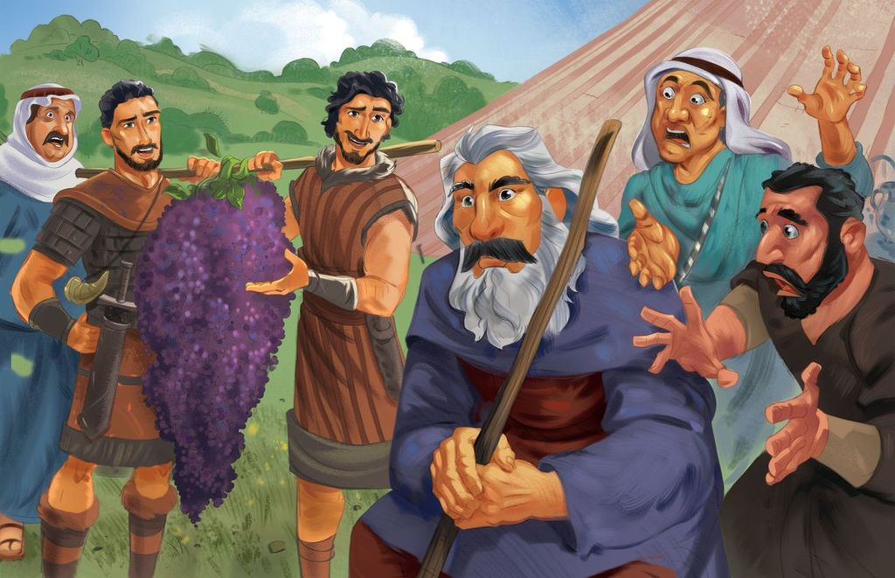
Dear families,
Numbers 13 and 14 describe the culmination of the Israelites’ dilemma of doubt. Though God continued to prove Himself faithful, the Israelites clung to their perception of certain death rather than the assurance of their God-given victory. They trusted in their own understanding rather than in God’s covenantal promises.

What stopped God’s people from entering the land of Canaan? How do our doubts keep us from worshiping God as He leads us through difficult circumstances?

For 40 days, the Israelite spies traveled and scouted out the Promised Land before returning with their report. Indeed, the land flowed with milk and honey—just as God promised. However, it was also brimming with strong men inside fortified city walls. The fearful Israelites lacked faith in God and in the leadership He provided.

Moses urged God to relent from His anger, reminding Him of His perfect character and how the Egyptians would try to defame Him. God pardoned them yet swore these unbelievers would not witness the fulfillment of God’s promises for themselves. Only Caleb, Joshua, and the next generation of Israelites would inherit the land. Upon hearing this, the people tried to circumvent God’s plan by now going to battle on their own. This failed, of course, and many of the people were struck down by the Amalekites and Canaanites. Doubt and disobedience became the Israelites’ downfall. Rather than experience rest in the land of Canaan, they were left to die in the wilderness.

Though Israel failed to believe God and trust His Word, God remained faithful to His people. Today, because of the finished work of Jesus, we can turn from unbelief and turn to Him as the object of our trust. Though we may not know what is next on our journey with Jesus, we can trust that eternal communion with the Father awaits us and that the gift of eternal life is available to all who abide by faith. Lead the kids in your family to see the great mercy of God in allowing the next generation of His people to enter into His promises. May the children who learn this Bible passage recognize God’s call to abide in His love through faith in His Son.

Check out The Gospel Project At Home for resources designed to help you lead a family worship experience as well as suggestions for morning and evening prayer times and family activities.

FAMILY TALKING POINTS

CHRIST CONNECTION
This is the big idea of how this week’s Bible story points to Jesus.

- Babies & Toddlers: If we believe in Jesus and follow Him, we will be saved from our sin and live with Him forever.
- Younger Preschool: Joshua and Caleb believed God, and God let them go into the Promised Land. God wants us to believe Him and trust in His Son, Jesus. He will save us from our sins, and we will live with Him forever.
- Older Preschool: Joshua and Caleb believed the words God had spoken, and they were allowed to enter the Promised Land. If we believe the words that God has spoken about Jesus and choose to follow Him, we will be saved from our sin and will be with Him forever.
- Kids: Joshua and Caleb believed the words that God had spoken, and they were eventually allowed to enter the Promised Land. The people who did not believe would die in the wilderness. If we believe the words God has spoken about Jesus and place our faith in Him, we will be saved from our sin and will enter the new heaven and new earth.

BIG PICTURE QUESTION & ANSWER
This is an important biblical truth that your child will encounter each week of this unit.

- Younger Preschool: Why should we obey God? We should obey God because He loves us.
- Older Preschool: Why should we obey God? We should obey God because He made us and He loves us.
- Kids: Why should we obey God? We should obey God because He made us, He loves us, and His plans are good.

KEY PASSAGE
This is a Bible verse that relates to what your child will encounter each week of this unit.

- Babies & Toddlers: God makes all things good. Romans 8:28
- Younger Preschool: All things work together for the good of those who love God. Romans 8:28
- Older Preschool: We know that all things work together for the good of those who love God, who are called according to his purpose. Romans 8:28
- Kids: We know that all things work together for the good of those who love God, who are called according to his purpose. Romans 8:28

** Next week: The People Complained (Numbers 16; 20-21)

Unit 6, Session 3
The People Complained (Numbers 16; 20-21)
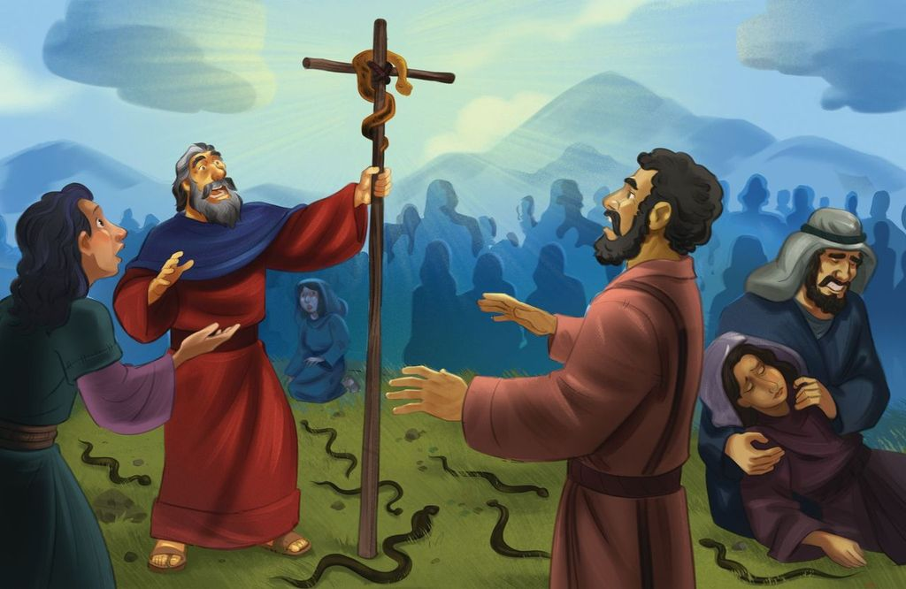
Dear families,
When we reflect on the Israelites’ journey to the Promised Land, nothing seems to more greatly characterize the posture of their hearts than their complaints. Despite the signs, miracles, protection, and provision they experienced, they remained reluctant to trust the Lord. Today’s passage highlights the Israelites’ inclination to disobey and disbelieve God.

What led the Israelites to sin against God and Moses in today’s reading? How does the passage of the bronze snake foreshadow Christ’s once-and-for-all sacrifice?

Korah’s goal in the rebellion was to raise his own status by lowering the God-given calling of Moses. He believed that the people were holy enough and that God was near enough, deeming Moses’ leadership unnecessary and unfruitful. Continuing to blame Moses, the people’s same old complaints resurfaced: the Israelites expressed envy toward generations past and discontentment regarding their current state of wandering.

The people trusted in their own perceptions of their circumstances rather than persevering by faith in God’s Word and in their leader’s guidance. Their distrust and disobedience led them to be more characterized by complaints than by confidence in God.

Despite these complaints, God extended grace by miraculously intervening. He allowed Moses and Aaron to supply water to the Israelites from the rock. Yet time passed, and the people’s impatience came back into play. They persisted in complaining toward both God and Moses, expressing discontentment toward the provision they thought they lacked. Because of this, the Lord sent poisonous snakes among the people, and many people died.

Moses interceded for the people, and God miraculously provided them rescue. By looking at the bronze snake mounted on a pole, the people would recover. This was a glimmer of the eternal salvation that would one day come through the Son of God lifted up on the cross to bear the consequences of sin. Though the Israelites did not deserve this rescue, God saved them by His grace. Likewise, the Son of Man lifted up on the cross provided a once-and-for-all sacrifice for those who look to Him for salvation. Pray for the kids in your family to sees God’s gracious provision, that they would put their confidence in Christ for salvation.

Check out The Gospel Project At Home for resources designed to help you lead a family worship experience as well as suggestions for morning and evening prayer times and family activities.

FAMILY TALKING POINTS

CHRIST CONNECTION
This is the big idea of how this week’s Bible story points to Jesus.

- Babies & Toddlers: When we look to Jesus and trust in Him, we are saved from our sin.
- Younger Preschool: When God's people looked at the bronze snake, they were healed. When we look to Jesus and trust in Him, we are saved from our sin.
- Older Preschool: When the Israelites looked at the bronze snake, they were healed. When we look to Jesus and trust in Him, we will be saved from our sin.
- Kids: Like the Israelites, we sin when we complain and do not trust God. The Israelites faced death for their sin, but when they looked to the bronze snake they were healed. The consequence for our sin is also death, but when we look to Jesus and trust in Him, we will be saved.

BIG PICTURE QUESTION & ANSWER
This is an important biblical truth that your child will encounter each week of this unit.

- Younger Preschool: Why should we obey God? We should obey God because He loves us.
- Older Preschool: Why should we obey God? We should obey God because He made us and He loves us.
- Kids: Why should we obey God? We should obey God because He made us, He loves us, and His plans are good.

KEY PASSAGE
This is a Bible verse that relates to what your child will encounter each week of this unit.

- Babies & Toddlers: God makes all things good. Romans 8:28
- Younger Preschool: All things work together for the good of those who love God. Romans 8:28
- Older Preschool: We know that all things work together for the good of those who love God, who are called according to his purpose. Romans 8:28
- Kids: We know that all things work together for the good of those who love God, who are called according to his purpose. Romans 8:28

** Next week: Moses’ Farewell (Deuteronomy 31-34)

Unit 6, Session 4
Moses’ Farewell (Deuteronomy 31-34)
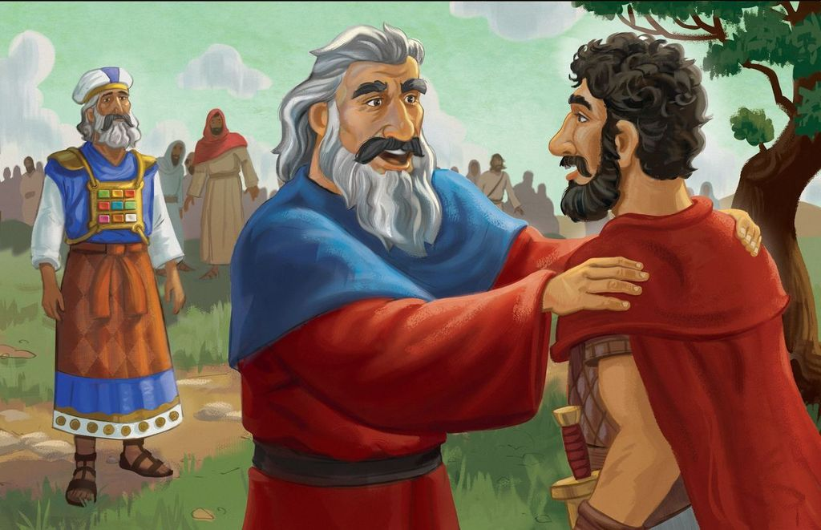
Dear families,
Moses was an esteemed Old Testament figure who led God’s people faithfully, though imperfectly, away from Egyptian slavery and toward the Promised Land. As we follow his biblical narrative to Deuteronomy 31, we read how Moses began his parting speech to those he shepherded for 40 years.

In what ways do we see how Jesus is the better Moses—the victorious leader who leads us into eternal triumph, united with Him forever?

In his farewell address, Moses acknowledged his role as provisional leader over the Israelites, humbled before the sovereignty of God. He recited all God promised to do for them: faithfully lead them, destroy their enemies, go with them, and never leave or abandon them. He called for the Israelites to be strong and courageous, not trusting in their own strength but in His almighty power. Though Moses was counted righteous by faith, he was not a sinless leader for the people of God.

Though Moses’ own failure to obey God kept him from entering the Promised Land, God, in His kindness, allowed Moses to see a glimpse of the land from atop Mount Nebo before he passed away. Moses blessed the Israelite people, reminding them of the faithful love of God over the tribes of Israel. When Moses died, the people wept for many days. Joshua, filled with the spirit of wisdom, was called by God to be Israel’s new leader, though he did not know the Lord face-to-face as Moses did.

As we read of Moses’ passing the baton to his successor, we must recognize the goodness of God in sending an even greater Leader to shepherd God’s people for all eternity: Jesus Christ. Though Moses sinned, Jesus was sinless. While Moses could not lead the Israelites into the land, Jesus fulfilled every requirement as a good and faithful servant of the Lord, therefore leading us into the eternal promise of His kingdom. Ask God to soften the hearts of kids in your family, that they may glean these great gospel truths as you faithfully teach this passage. May they see the faithful kindness of the loving God who desires to dwell with them not only today, but for all eternity.

Check out The Gospel Project At Home for resources designed to help you lead a family worship experience as well as suggestions for morning and evening prayer times and family activities.

FAMILY TALKING POINTS

CHRIST CONNECTION
This is the big idea of how this week’s Bible story points to Jesus.

- Babies & Toddlers: Jesus died so that all who believe in Him would be forgiven of their sins and be with Him forever.
- Younger Preschool: Moses was a good leader, but he was not perfect. Jesus is perfect. Jesus died so everyone who follows Him will be forgiven of their sins and be with Him forever.
- Older Preschool: Moses led God’s people, but Moses was not perfect. Jesus leads us in perfect faithfulness. He died so that all who trust and believe in Him would be forgiven of their sins and be with Him forever.
- Kids: Moses led God’s people faithfully but died unable to bring them into the Promised Land. Jesus leads us in perfect faithfulness. He died so that all who place their faith in Him will join Him in the new heaven and earth.

BIG PICTURE QUESTION & ANSWER
This is an important biblical truth that your child will encounter each week of this unit.

- Younger Preschool: Why should we obey God? We should obey God because He loves us.
- Older Preschool: Why should we obey God? We should obey God because He made us and He loves us.
- Kids: Why should we obey God? We should obey God because He made us, He loves us, and His plans are good.

KEY PASSAGE
This is a Bible verse that relates to what your child will encounter each week of this unit.

- Babies & Toddlers: God makes all things good. Romans 8:28
- Younger Preschool: All things work together for the good of those who love God. Romans 8:28
- Older Preschool: We know that all things work together for the good of those who love God, who are called according to his purpose. Romans 8:28
- Kids: We know that all things work together for the good of those who love God, who are called according to his purpose. Romans 8:28

** Next week: Crossing the Jordan River (Joshua 1; 3-4)

