Ministry Leaders: A suggested email is provided for each session for you to customize if you desire and share with your families. You can also access a social media share square for each session on the Additional Resources page at gospelproject.com.
The Gospel Project At Home content is available in Ministry Grid for you to share with your families.

Christmas Bonus Session
Jesus Is Our Greatest Gift (Luke 2)
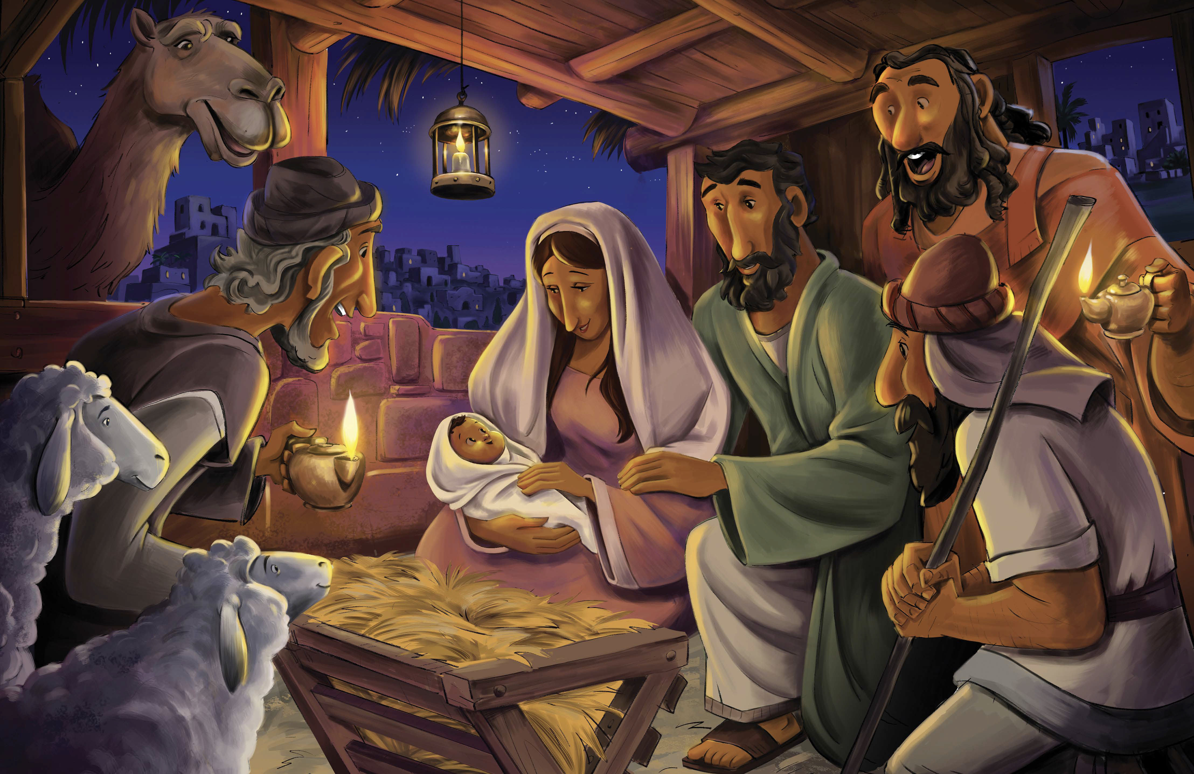
Dear families,
In the Gospel accounts of Christ’s birth, the miraculous plans of God coincide with the seemingly mundane events of humanity to reveal the promised Messiah. God used modest means to bring about the divine incarnation of His only Son who would deliver us from the death we deserve.
Where was Jesus’ birth prophesied in the Old Testament? How does His birth make a way for people to receive the gift of eternal life?
Jesus’ genealogy, found in Matthew 1, demonstrates how the long-awaited Savior can be traced back to Abraham. Later, in verse 23, we read the prophecy first relayed in Isaiah 7:14: “Therefore, the Lord himself will give you a sign: See, the virgin will conceive, have a son, and name him Immanuel.” In today’s passages—written about 700 years after the words of Isaiah—an angel of the Lord appeared first to Mary, then to Joseph, and later to the shepherds in the field, announcing this newborn baby as the Savior of the world. These ordinary people experienced God’s great power at work through the miraculous birth of Jesus.
Consider the grandness of the nativity story. Reflect on the wonder of Jesus coming to earth in such lowly form. The humble birth of Christ would lead to His humbling death: crucified and left to die among wretched sinners. Yet this would not be the end of His story—nor for those who trust in His name! In three days, Jesus would rise from the grave, and by faith in His finished work on the cross, we can be reconciled to God as recipients of His grace.
Pray for the children in your care who are discovering this spectacular passage of Scripture. May they find their place within God’s redemption story, placing true faith in the Savior born to bring us eternal life. May they turn from their sins and call upon Immanuel, our “God with us” forever. And like the shepherds in today’s passage, may you faithfully share this good news, giving praise to the God of our salvation for the great gift we have in Jesus!
Check out The Gospel Project At Home for resources designed to help you lead a family worship experience as well as suggestions for morning and evening prayer times and family activities.

FAMILY TALKING POINTS

CHRIST CONNECTION
This is the big idea of how this week’s Bible story points to Jesus.

- Babies & Toddlers: Jesus came into the world to rescue us from sin.
- Younger Preschool: Jesus was born! This was very good news! Jesus came into the world to rescue us from sin.
- Older Preschool: Jesus was born! This was very good news! Jesus was not like other babies. Jesus is God’s Son. God sent Jesus to earth from heaven. Jesus came into the world to rescue people from their sins.
- Kids: The birth of Jesus was good news! Jesus was not an ordinary baby. He is God’s Son, sent to earth from heaven. Jesus, the promised Savior, came into the world to show us what God is like and to deliver us from sin and death.

BIG PICTURE QUESTION & ANSWER
This is an important biblical truth that your child will encounter each week of this unit.

- Younger Preschool: Why does sin keep us from God? Sin keeps us from God because He is holy.
- Older Preschool: Why does sin separate us from God? Because God is holy.
- Kids: Why does sin separate us from God? Because God is holy, sin has broken our relationship with God.

KEY PASSAGE
This is a Bible verse that relates to what your child will encounter each week of this unit.

- Babies & Toddlers: God hears and rescues. Psalm 34:17
- Younger Preschool: The LORD hears, and rescues. Psalm 34:17
- Older Preschool: The righteous cry out, and the LORD hears, and rescues them from all their troubles. Psalm 34:17
- Kids: The righteous cry out, and the LORD hears, and rescues them from all their troubles. Psalm 34:17

