Ministry Leaders: A suggested email is provided for each session for you to customize if you desire and share with your families. You can also access a social media share square for each session on the Additional Resources page at gospelproject.com.
The Gospel Project At Home content is available in Ministry Grid for you to share with your families.

Unit 7, Session 1
Crossing the Jordan River (Joshua 1; 3-4)
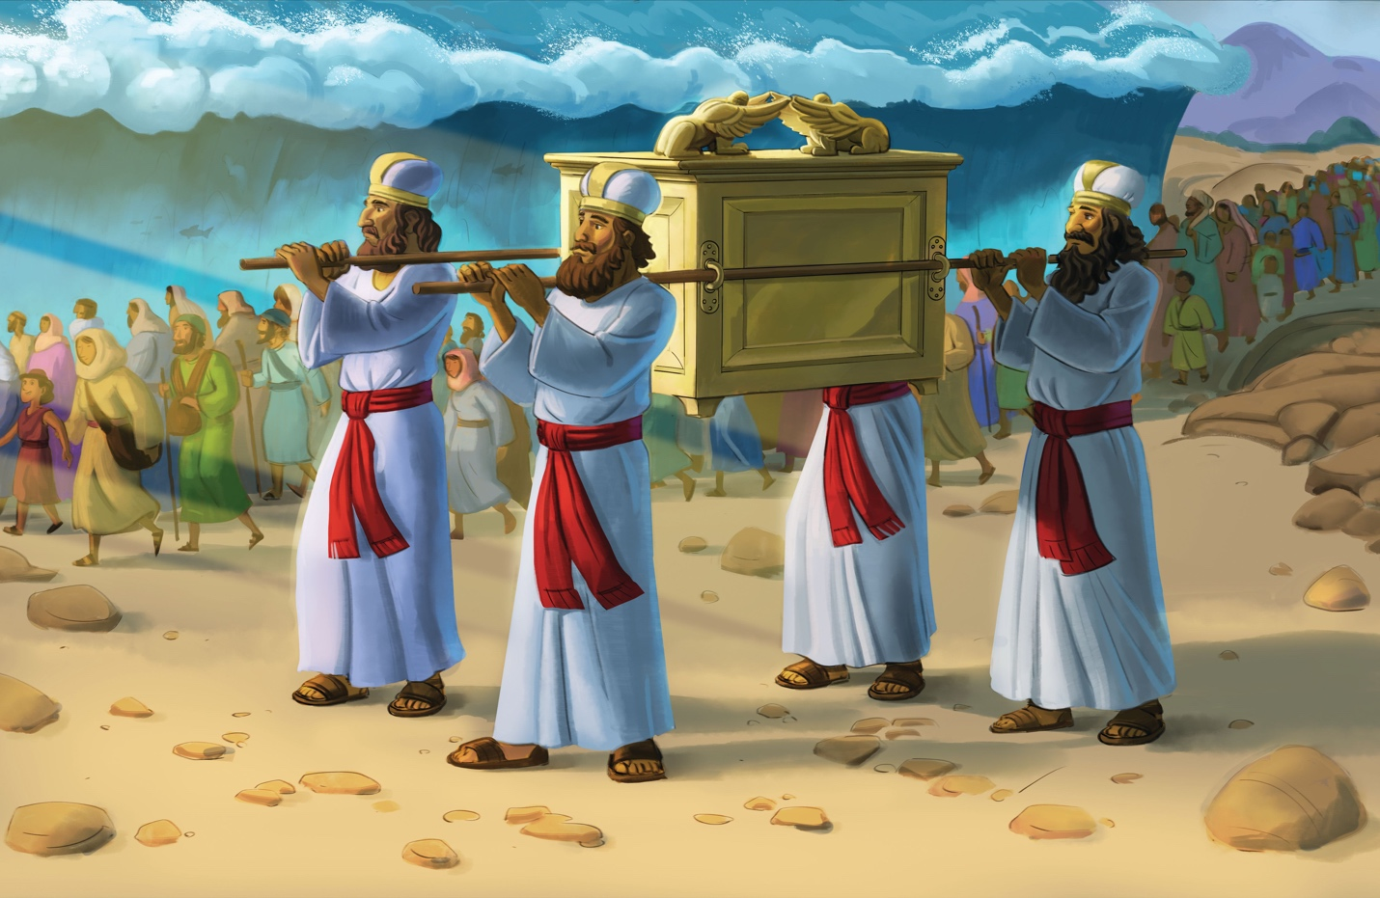
Dear families,
In Joshua 1, we learn the Israelites were preparing to enter the Promised Land following the death of Moses. God spoke directly to Joshua, commissioning him as the new leader of His people. The Lord commanded Joshua three times to be strong and courageous as he was about to guide the Israelites across the Jordan River.
What instructions did God impart to Joshua? How would God reveal to Joshua—and the rest of the Israelites—that He would be with them, just as He promised?
God urged Joshua to continue walking in the promises He made to Moses (Joshua 1:3, 5). To do so, Joshua would have to commit to walking in God’s ways: being strong and courageous, observing Moses’ commands, and meditating on God’s Word. God reminded Joshua of His faithfulness and affirmed that He would exalt Joshua before all Israel. No one would be able to doubt that God chose Joshua to fulfill His promises.
Joshua commanded the Israelites to get ready for a miraculous move of God (Joshua 3:5)—a feat that would require faith. He then relayed God’s instructions for crossing the Jordan River. As the priests stepped into the river, the waters stopped flowing, and God’s powerful presence made a way for His people to safely cross into the Promised Land.
Teach the boys and girls in your care that, like the Israelites awaited God’s provision on their journey, we, too, need a miracle: to be made right with God the Father through faith in the Son. This gift of salvation cannot be earned; it is a gracious gift that demonstrates God’s power and love.
Also consider the impact of children’s curiosity in this story. God commanded the Israelites to memorialize this event by setting out 12 stones. When Israelite children and future generations asked the meaning of these stones, the people could use it as an opportunity to recount the Lord’s faithfulness. May this story instill within your kids the same sense of wonder the Israelites experienced. God’s faithful promises never fail, including His promise to save anyone who repents of sin and turns to Jesus by faith. Be prepared to share the story of how God saved you through faith in His Son. Pray for His gracious love to begin transforming your kids’ hearts and minds today.
Check out The Gospel Project At Home for resources designed to help you lead a family worship experience as well as suggestions for morning and evening prayer times and family activities.

FAMILY TALKING POINTS

CHRIST CONNECTION
This is the big idea of how this week’s Bible story points to Jesus.
- Babies & Toddlers: God helped Joshua, and He helps us too. God sent Jesus so we can trust Him and live with Him forever.
- Younger Preschool: Just like God helped Joshua and the Israelites, He also sent Jesus to help us. Jesus showed His power so we can trust Him and live with Him forever.
- Older Preschool: God made a way for Joshua and the Israelites to enter the Promised Land. God made the way for us to be with Him forever through the life, death, and resurrection of Jesus.
- Kids: God’s presence went before the people, and the waters of the Jordan were stopped. God’s people crossed safely into the Promised Land. Jesus went before God on behalf of sinners. All who trust in His life, death, and resurrection are saved from judgment and enter into eternal life.

BIG PICTURE QUESTION & ANSWER
This is an important biblical truth that your child will encounter each week of this unit.
- Younger Preschool: Why can we trust God? We can trust God because He is faithful.
- Older Preschool: Why can we trust God? We can trust God because He does what He says He will do.
- Kids: Why can we trust God? We can trust God because He is faithful and does everything for His glory and our good.

KEY PASSAGE
This is a Bible verse that relates to what your child will encounter each week of this unit.
- Babies & Toddlers: The LORD is strong and mighty. Psalm 24:8
- Younger Preschool: Who is the King of glory? The LORD, strong and mighty. Psalm 24:8
- Older Preschool: Who is this King of glory? The LORD, strong and mighty. Psalm 24:8
- Kids: Who is this King of glory? The LORD, strong and mighty, the LORD, mighty in battle. Psalm 24:8

** Next week: Conquering Jericho (Joshua 2-4; 6)

Unit 7, Session 2
Conquering Jericho (Joshua 2-4; 6)
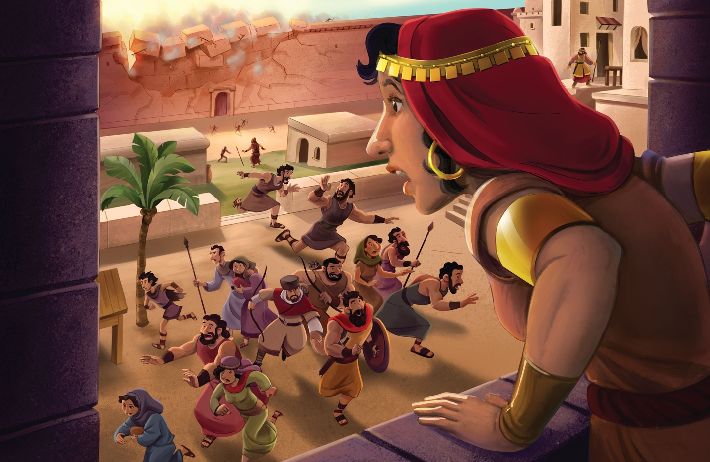
Dear families,
After the Israelites crossed the Jordan River, they faced their next obstacle in the Promised Land: capturing the city of Jericho. Though Jericho was strongly fortified, God promised to hand over the city to His people. Only by trusting in God could the Israelites experience victory against Jericho.
How do we see God’s faithful provision amid the battle of Jericho? How does this story foreshadow an even greater victory for those who profess faith in Jesus?
God promised His people the land of Canaan, and God was faithful to remind Joshua of the victory that lay before him: “Look, I have handed Jericho, its king, and its best soldiers over to you” (Joshua 6:2). Then God once again gave His people the instructions they needed to follow—instructions that displayed faith in action.
An unlikely battle plan of walking, being silent, and then shouting revealed the power of God, who fights for His people and gives them victory. The Israelites brought nothing to this battle except their obedient faith, which they are commended for in Hebrews 11:30. The Israelites’ victory over Jericho was not of their own accord but a result of the faith they placed in the God of their salvation. Likewise, the rescue of Rahab and her family came not through her own power but by the faith she placed in the God of Israel.
Like the Israelites, we bring nothing to the table except our need for God’s saving grace. Yet by trusting in the Lord’s power to save us through faith in His Son, His victory is our reward. Help the boys and girls in your care see the power of God at work in this story, as well as in their own lives—that God has the power to break the walls of sin and deliver us into the kingdom of His Son. Pray that the children in your care will trust in Jesus for His gift of salvation.
Check out The Gospel Project At Home for resources designed to help you lead a family worship experience as well as suggestions for morning and evening prayer times and family activities.

FAMILY TALKING POINTS

CHRIST CONNECTION
This is the big idea of how this week’s Bible story points to Jesus.
- Babies & Toddlers: God sent Jesus to win the battle over sin and death. When we trust in Jesus, He keeps us safe and invites us into His family forever.
- Younger Preschool: Joshua trusted God to help him win the battle. We can trust God too. God sent Jesus to win the battle against sin and death. When we trust in Jesus, He keeps us safe and invites us into His family forever.
- Older Preschool: The Israelites kept Rahab and her family safe, and she joined God’s people. Jesus has won against sin and death. Everyone who trusts in Jesus is safe and becomes part of God’s family forever.
- Kids: God’s people could not bring down Jericho’s walls in their own power. They trusted God and were victorious. We cannot defeat sin and death in our own power. When we trust in Jesus, we are saved from sin and death.

BIG PICTURE QUESTION & ANSWER
This is an important biblical truth that your child will encounter each week of this unit.
- Younger Preschool: Why can we trust God? We can trust God because He is faithful.
- Older Preschool: Why can we trust God? We can trust God because He does what He says He will do.
- Kids: Why can we trust God? We can trust God because He is faithful and does everything for His glory and our good.

KEY PASSAGE
This is a Bible verse that relates to what your child will encounter each week of this unit.
- Babies & Toddlers: The LORD is strong and mighty. Psalm 24:8
- Younger Preschool: Who is the King of glory? The LORD, strong and mighty. Psalm 24:8
- Older Preschool: Who is this King of glory? The LORD, strong and mighty. Psalm 24:8
- Kids: Who is this King of glory? The LORD, strong and mighty, the LORD, mighty in battle. Psalm 24:8

** Next week: Achan’s Sin and the Defeat of Ai (Joshua 7-8)

Unit 7, Session 3
Achan’s Sin and the Defeat of Ai (Joshua 7-8)
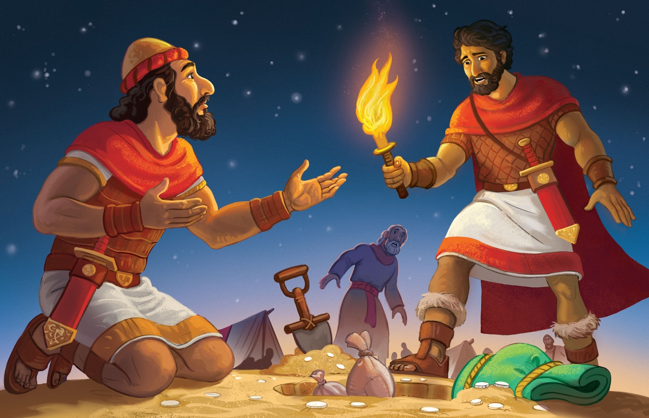
Dear families,
Joshua’s account of Achan’s sin and Ai’s defeat serves as a “part two” of the Israelites’ time in Jericho. Immediately following Israel’s victory over Jericho, we read of disobedience and God’s declaration to no longer be with Israel unless they removed what was set apart for Him (Joshua 7:12). God demonstrated His holiness by punishing sin, and through this story, we see the reality of God’s judgment and our need for a Savior.
What does this passage teach us about God? How do we see God’s faithful deliverance in this story despite His people’s sin?
First, we witness God’s justice and holiness in this passage. Before entering Jericho, God gave His people these instructions: “But keep yourselves from the things set apart, or you will be set apart for destruction. If you take any of those things, you will set apart the camp of Israel for destruction and make trouble for it” (Joshua 6:18). God had already spoken about the consequences of disobedience. Because He is holy and likewise calls His people to pursue holiness, the Israelites were to purge the sin from among them.
The Lord had promised victory to His people if they would walk in His ways. The Israelites, however, were unfaithful regarding God’s command to set Jericho’s spoils apart for destruction. Sadly, their disobedience led to punishment.
Lead the boys and girls in your care to see that this story does not end with dismal destruction; rather, we see the Lord faithfully keep His promise to deliver His people from their enemies. God set Achan apart for destruction, just as He said He would. Destruction, however, does not have to be our end. By placing faith in Jesus, the punishment we deserve has been placed on God’s Son instead. Remind your kids of God’s faithfulness in providing a sacrifice on our behalf and an eternal victory secured in His Son—a victory that transforms hearts and frees people from the destruction they deserve.
Check out The Gospel Project At Home for resources designed to help you lead a family worship experience as well as suggestions for morning and evening prayer times and family activities.

FAMILY TALKING POINTS

CHRIST CONNECTION
This is the big idea of how this week’s Bible story points to Jesus.
- Babies & Toddlers: We sin, and we deserve to be punished. If we trust in Jesus, God forgives us when we are sorry for our sin.
- Younger Preschool: Achan disobeyed God and was punished. Because we sin, we deserve to be punished. Jesus came to take the punishment for us. God forgives us when we are sorry for our sin and trust in Jesus.
- Older Preschool: Achan disobeyed God and was punished because of his sin. Because we sin, we deserve to be punished. But Jesus came to take our punishment for us. God forgives us when we confess our sin and trust in Jesus.
- Kids: Achan disobeyed the command of God, and his punishment was death. We also deserve the punishment of death for our sin. Jesus, God’s sinless Son, was punished in our place for our sin. Those who trust in Him are forever forgiven of their sin.

BIG PICTURE QUESTION & ANSWER
This is an important biblical truth that your child will encounter each week of this unit.
- Younger Preschool: Why can we trust God? We can trust God because He is faithful.
- Older Preschool: Why can we trust God? We can trust God because He does what He says He will do.
- Kids: Why can we trust God? We can trust God because He is faithful and does everything for His glory and our good.

KEY PASSAGE
This is a Bible verse that relates to what your child will encounter each week of this unit.
- Babies & Toddlers: The LORD is strong and mighty. Psalm 24:8
- Younger Preschool: Who is the King of glory? The LORD, strong and mighty. Psalm 24:8
- Older Preschool: Who is this King of glory? The LORD, strong and mighty. Psalm 24:8
- Kids: Who is this King of glory? The LORD, strong and mighty, the LORD, mighty in battle. Psalm 24:8

** Next week: Taking the Land (Joshua 10-11)

Unit 7, Session 4
Taking the Land (Joshua 10-11)
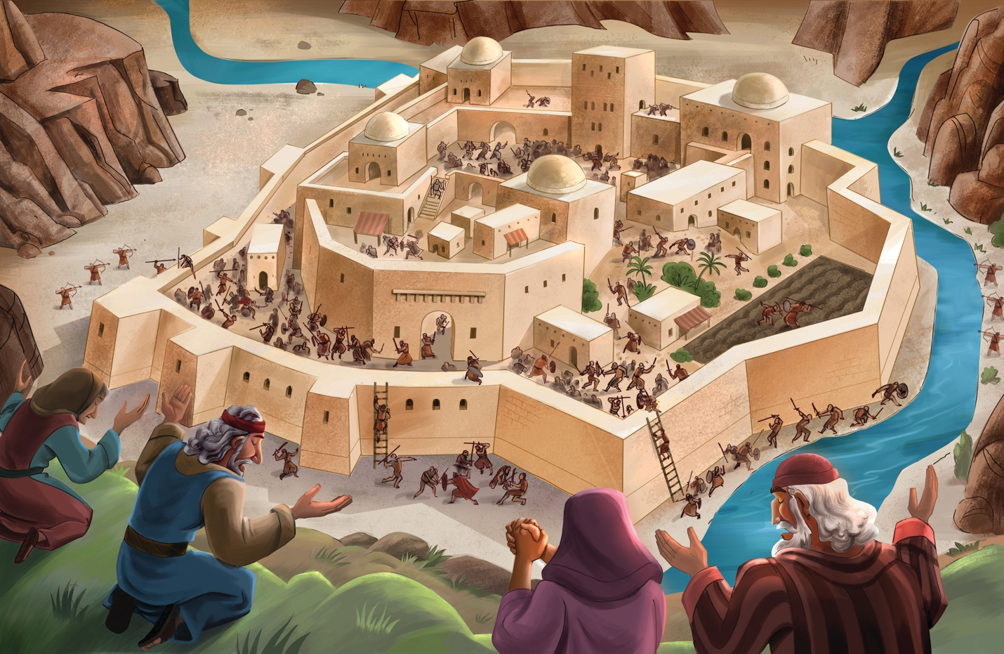
Dear families,
The promises of God never fail. Indeed, as Joshua continued to lead the people, God’s promise to give them the land of Canaan came true. God’s intervention and faithful provision were unmistakable as He fought for the Israelites in every battle to take the Promised Land.
How do we see God’s omnipotence at work in today’s Bible passage? How do we see Joshua’s faith at work?
In Joshua 10, the Lord spoke directly to Joshua to instill comfort and confidence and to remind him that the Lord had already established victory for His people. God brought destruction on His enemies by throwing them into confusion, leading them to run away in panic, striking them down with hailstones, and causing the sun to stand still so His people could win the battle. Following this, even more armies rallied their forces against Israel. But God promised Joshua that all of Israel’s opponents would soon be killed (Joshua 11:6). God proved Himself all-powerful by intervening against the forces of both man and nature to grant His people victory in battle.
Joshua took God at His Word and faithfully fulfilled his role as Israel’s leader. Joshua moved in confident submission toward the things of the Lord and trusted in God’s promised deliverance. Scripture even tells us that on a day like no other, Joshua asked the Lord for the sun to be still, and God listened to His servant! Joshua trusted in God’s promise of victory and led the Israelites to do the same.
Consider what an act of faith it was for God’s people to fight each battle, one city at a time, trusting God’s promises despite the opposition ahead. The belief that God is all-powerful not only aided the Israelites in their mission to conquer the land; it also serves to encourage us as we live by faith and not by sight. God trampled over the Israelites’ flesh-and-blood enemies. He has likewise vanquished the powers of sin and darkness by sending His Son. Lead the boys and girls in your care to see the power of God who fights on our behalf and the love of His Son who died on the cross in our place and rose again.
Check out The Gospel Project At Home for resources designed to help you lead a family worship experience as well as suggestions for morning and evening prayer times and family activities.

FAMILY TALKING POINTS

CHRIST CONNECTION
This is the big idea of how this week’s Bible story points to Jesus.
- Babies & Toddlers: God sent Jesus who fights for us and helps us win the battle over sin and death.
- Younger Preschool: God helped His people, and He helped us by sending Jesus. Jesus fought for us and gave us victory over sin and death.
- Older Preschool: God fought for His people by saving them and giving them victory over their enemies. God saved sinners by sending His Son, Jesus, to die on the cross and rise again. Jesus gives us victory over sin and death.
- Kids: God fought for Israel, and all their enemies were defeated. Jesus lived a sinless life and defeated our enemies—sin and death—when He died on the cross. If we believe in Him, we receive His righteousness.

BIG PICTURE QUESTION & ANSWER
This is an important biblical truth that your child will encounter each week of this unit.
- Younger Preschool: Why can we trust God? We can trust God because He is faithful.
- Older Preschool: Why can we trust God? We can trust God because He does what He says He will do.
- Kids: Why can we trust God? We can trust God because He is faithful and does everything for His glory and our good.

KEY PASSAGE
This is a Bible verse that relates to what your child will encounter each week of this unit.
- Babies & Toddlers: The LORD is strong and mighty. Psalm 24:8
- Younger Preschool: Who is the King of glory? The LORD, strong and mighty. Psalm 24:8
- Older Preschool: Who is this King of glory? The LORD, strong and mighty. Psalm 24:8
- Kids: Who is this King of glory? The LORD, strong and mighty, the LORD, mighty in battle. Psalm 24:8

** Next week: Joshua’s Farewell (Joshua 23-24)

Unit 7, Session 5
Joshua’s Farewell (Joshua 23-24)
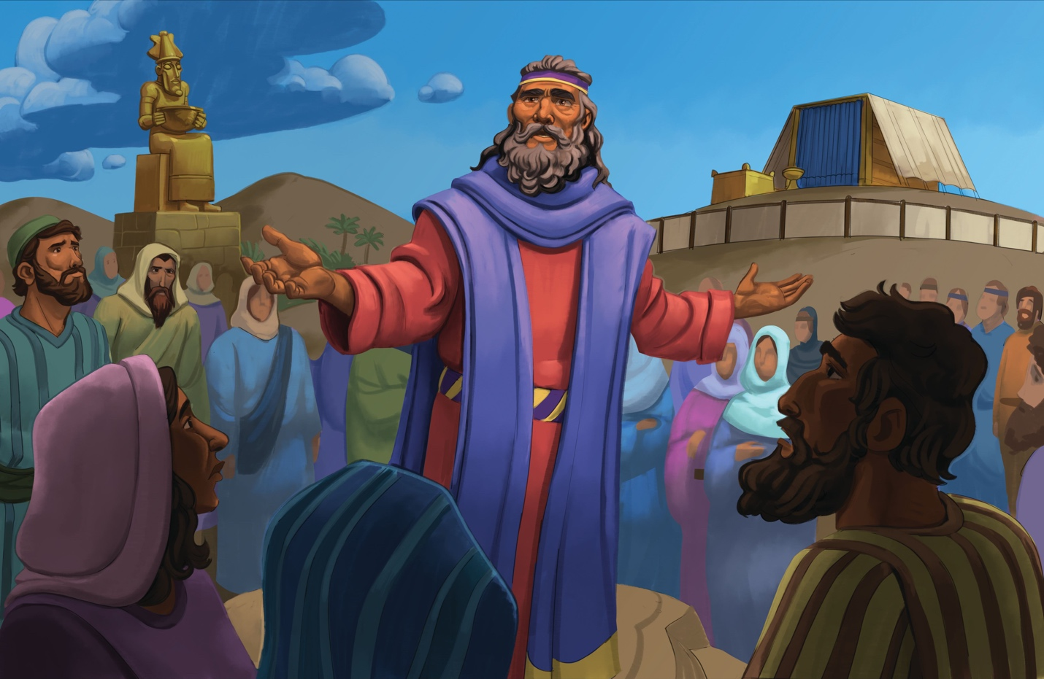
Dear families,
The book of Joshua ends with a farewell address to God’s people about 20 years after they first found rest in the Promised Land. Joshua took one last opportunity to challenge the people to continue following the Lord and remind them how they were called to live in view of what God had already accomplished on their behalf.
What did Joshua commission the Israelites to do in his farewell address? How does this parallel with how Christ followers should live today?
Joshua spent his last moments on earth reminding the Israelites of the grace God had shown them by giving them the land He promised to Abraham long ago. Joshua led them through the history of their people, through the patriarchs and battles that brought them to the land. He also impressed upon them the truth that God’s promise to bless them had been fulfilled, but the rest they were experiencing in the land was contingent upon their covenant loyalty to worship God alone.
The Israelites were commissioned to get rid of the foreign gods that were among them and turn their hearts to the Lord (Joshua 24:23). We, like the Israelites, are called to lead lives of obedient worship, turning away from idols in our midst. By the grace of God, we can have hearts that desire to follow His commands through faith-filled obedience as we live through the power of the Holy Spirit.
Lead the boys and girls in your care to see the awe-inspiring deliverance God extends to the people He has sworn to provide for––those who place their faith in His Son. Help kids see that God’s greatest act of love is found in Jesus, whose sacrifice atoned for the sins of His people long ago and for us today. Ask the Lord to instill upon the children in your class a deep desire to know and worship Him in light of the promise of eternal life in Christ’s presence.
Check out The Gospel Project At Home for resources designed to help you lead a family worship experience as well as suggestions for morning and evening prayer times and family activities.

FAMILY TALKING POINTS

CHRIST CONNECTION
This is the big idea of how this week’s Bible story points to Jesus.

- Babies & Toddlers: Joshua told God’s people to love and obey God. After Jesus died on the cross and rose again, Jesus reminded His followers to obey God and tell others about Him.
- Younger Preschool: Joshua reminded God’s people to love God and obey Him. After Jesus died on the cross and rose again, Jesus reminded His followers to love and obey Him too.
- Older Preschool: Joshua reminded God’s people to worship and obey God. After Jesus’ death and resurrection, Jesus appeared to His disciples and left them with a task: obey Him by telling others about Him.
- Kids: Joshua reminded the people that God saved them from Egypt and gave them the Promised Land. He told them to worship God alone. Jesus is worthy of all worship because He saves those who trust in Him from sin and gives them eternal life.

BIG PICTURE QUESTION & ANSWER
This is an important biblical truth that your child will encounter each week of this unit.
- Younger Preschool: Why can we trust God? We can trust God because He is faithful.
- Older Preschool: Why can we trust God? We can trust God because He does what He says He will do.
- Kids: Why can we trust God? We can trust God because He is faithful and does everything for His glory and our good.

KEY PASSAGE
This is a Bible verse that relates to what your child will encounter each week of this unit.
- Babies & Toddlers: The LORD is strong and mighty. Psalm 24:8
- Younger Preschool: Who is the King of glory? The LORD, strong and mighty. Psalm 24:8
- Older Preschool: Who is this King of glory? The LORD, strong and mighty. Psalm 24:8
- Kids: Who is this King of glory? The LORD, strong and mighty, the LORD, mighty in battle. Psalm 24:8

** Next week: The First Judges (Judges 3)

Unit 8, Session 1
The First Judges (Judges 3)
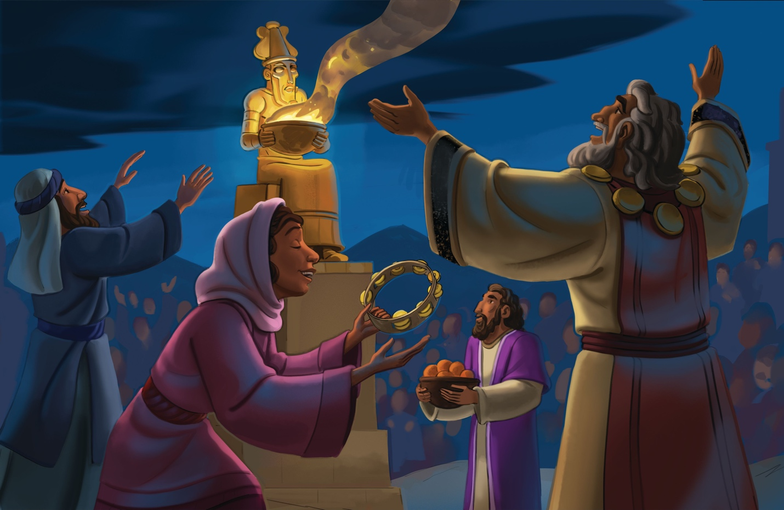
Dear families,
This week’s story ushers in a new chapter for God’s people: the era of the judges. These short-term rescuers pointed to the need for an eternal Rescuer and Savior with the power to redeem and transform the hearts of God’s people once and for all.

What pattern began to unfold in the lives of the Israelites? How did God prove Himself faithful and gracious in the lives of the Israelites, despite their sin?

The generations of Israelites who fought to conquer the land and renewed their commitment to God’s law had died. Judges 3:4 tells us how God left some nations to test His people and determine if they would walk in obedience to His commands. Unfortunately, the Israelites began to worship the gods of the nations around them.

The same phrase is repeated throughout Judges: “The Israelites did what was evil in the Lord’s sight.” They forgot the Lord who swore to never forget His people. God allowed His people to be ruled and oppressed by foreign nations as a consequence for their sin. The cycle of apostasy was at work: Israel sinned, received consequences, and cried out to God for help; He sent a judge or deliverer, the people repented, and the cycle began anew.

In this chapter, we are introduced to three judges: Othniel, Ehud, and Shamgar. Through their leadership, God continued to prove Himself faithful by intervening and delivering His people, always preserving and setting them apart from the world. These earthly judges, however, could never save the people from their sins or produce new hearts with the desire to obey God. The peace these judges provided could not offer lasting change.

Lead your kids to see that only Jesus has the power to give us new hearts and transform us into His image. While judges provided temporary peace, Jesus has established an eternal peace for those who place their faith in His finished work on the cross. Even the mightiest earthly hero pales in comparison to the Prince of Peace who was resurrected to bring us new life! Pray that awe would mark children’s hearts as they reflect on God’s provision to secure everlasting peace and salvation.

Check out The Gospel Project At Home for resources designed to help you lead a family worship experience as well as suggestions for morning and evening prayer times and family activities.

FAMILY TALKING POINTS

CHRIST CONNECTION
This is the big idea of how this week’s Bible story points to Jesus.

- Babies & Toddlers: God loved His people and sent judges. God loves us too and sent Jesus to save us from our sins when we trust in Him.
- Younger Preschool: Like God sent judges to help His people, He also sent Jesus to help us. Jesus saves us from our sins when we trust in Him.
- Older Preschool: God provided judges to rescue His people from their enemies. God provided Jesus to rescue us from our sin. When we choose to trust in Jesus and follow Him, we are forever saved from our sin.
- Kids: God brought consequences to His people for their sins, but He also raised up judges to save them from their enemies. We also have consequences for our sins, but God sent Jesus to save us from our sins once and for all.

BIG PICTURE QUESTION & ANSWER
This is an important biblical truth that your child will encounter each week of this unit.
- Younger Preschool: What is repentance? Repentance is turning away from sin and turning to Jesus.
- Older Preschool: What is repentance? Repentance is turning away from sin and turning to Jesus.
- Kids: What is repentance? Repentance is turning away from sin and turning to Jesus.

KEY PASSAGE
This is a Bible verse that relates to what your child will encounter each week of this unit.
- Babies & Toddlers: If we pray, God will hear and forgive our sins. 2 Chronicles 7:14
- Younger Preschool: If my people pray and turn from sin, I will forgive them. 2 Chronicles 7:14
- Older Preschool: [If] my people pray and turn from their evil ways, then I will forgive their sin. 2 Chronicles 7:14
- Kids: [If] my people, who bear my name, humble themselves, pray and seek my face, and turn from their evil ways, then I will hear from heaven, forgive their sin, and heal their land. 2 Chronicles 7:14

** Next week: Deborah Led Israel (Judges 4-5)

Unit 8, Session 2
Deborah Led Israel (Judges 4-5)
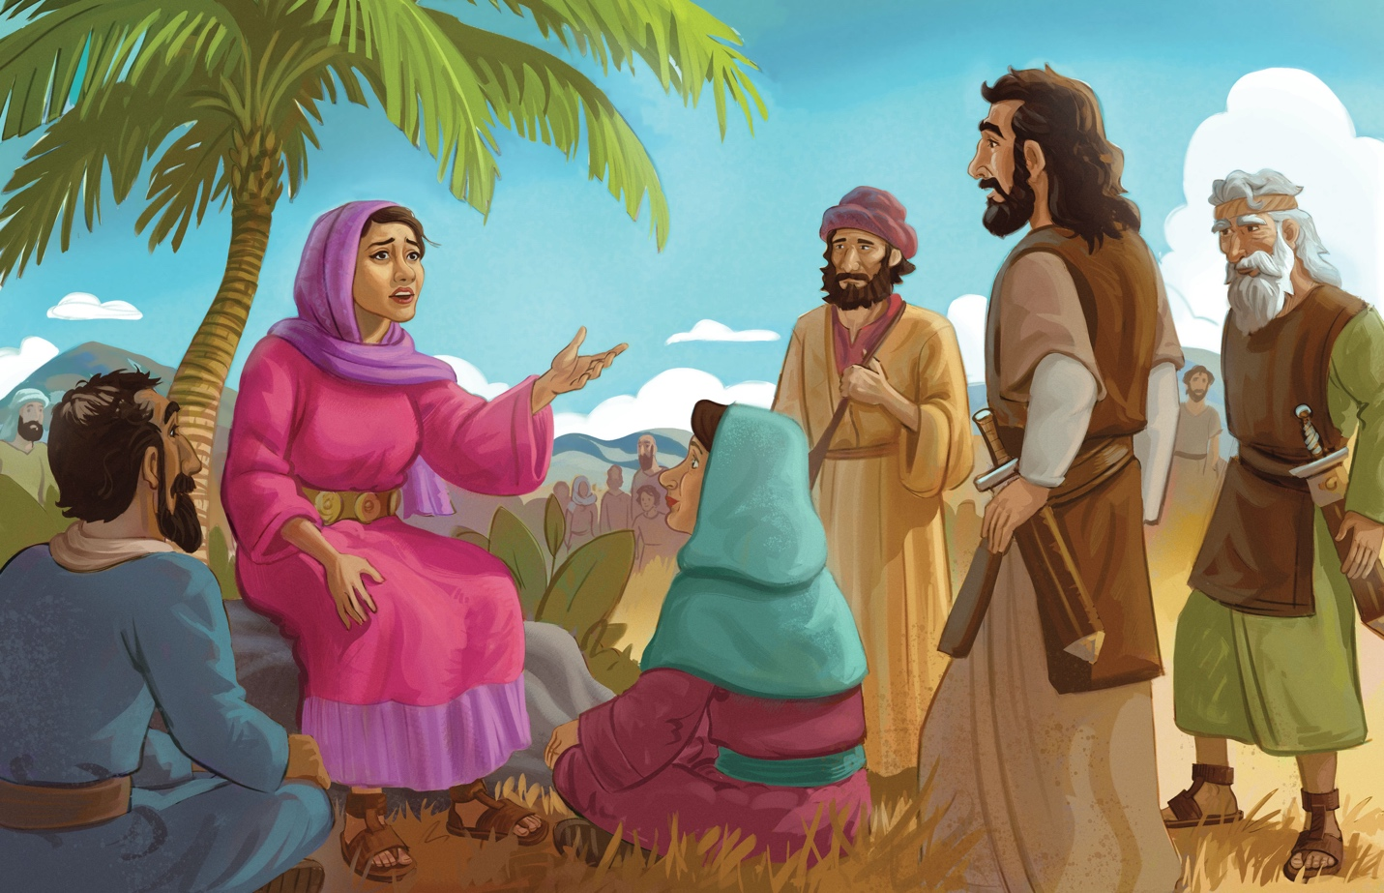
Dear families,
Judges 4 and 5 reveal God’s heart for delivering His people despite the consequences their sin deserved. Again, the Israelites sinned by committing evil in the sight of the Lord. Even still, God provided victory for His people against Sisera and his army.

How did Deborah’s leadership bring glory to God? Why is Jesus worthy of all glory?

In the prophecy she shared with Barak, Deborah revealed that God had already promised the Israelites victory in battle. Deborah rallied Barak to lead Israel’s army against Sisera. Even though Barak was hesitant to go without Deborah, he eventually led 10,000 troops to fight the enemy army. The Lord threw Sisera’s army into confusion, demonstrating His promised power. Forced to flee, Sisera died in an unsuspecting tent of a woman named Jael. On that day, Deborah and Barak praised God in song for the victory He alone accomplished.

Deborah and Barak’s song of praise revealed a right response to God’s rescue: worship. God was glorified because He alone provided rescue. Likewise, Jesus alone is worthy of worship for how He has provided the only way for sinners to be saved. God has exalted Jesus above every name because of His humble obedience to die on the cross for sinful people. One day, every knee will bow, and every tongue will confess Jesus as Lord.

We, like the wayward Israelites, are sinners who deserve punishment for our sins against God. Yet, by choosing to put our faith in Christ and in His perfect obedience and finished work on the cross, we receive the gift of everlasting life in place of the condemnation we deserve. In His goodness, God made the way for us to receive the grace we did not earn and allowed for His Son to bear the consequences our sin deserves. May it likewise be true for the boys and girls who hear this story and place their faith in our greatest deliverer—Jesus.

Check out The Gospel Project At Home for resources designed to help you lead a family worship experience as well as suggestions for morning and evening prayer times and family activities.

FAMILY TALKING POINTS

CHRIST CONNECTION
This is the big idea of how this week’s Bible story points to Jesus.
- Babies & Toddlers: God used Deborah, Barak, and Jael to help His people. God sent Jesus to help us by dying on the cross and coming back to life.
- Younger Preschool: Like God used Deborah, Barak, and Jael to help His people, God sends people to help us and teach us about Jesus. Jesus won the greatest battle against sin by dying on the cross and coming back to life.
- Older Preschool: God used Deborah to lead His people and help them win battles. God sent His Son, Jesus, to win the battle against sin by dying on the cross and being raised back to life.
- Kids: God used Deborah to lead Israel in victory over their enemies, and God received the glory. God sent Jesus to reign victorious over sin and death. Jesus is worthy of all honor, glory, and power (Revelation 4:11).

BIG PICTURE QUESTION & ANSWER
This is an important biblical truth that your child will encounter each week of this unit.
- Younger Preschool: What is repentance? Repentance is turning away from sin and turning to Jesus.
- Older Preschool: What is repentance? Repentance is turning away from sin and turning to Jesus.
- Kids: What is repentance? Repentance is turning away from sin and turning to Jesus.

KEY PASSAGE
This is a Bible verse that relates to what your child will encounter each week of this unit.
- Babies & Toddlers: If we pray, God will hear and forgive our sins. 2 Chronicles 7:14
- Younger Preschool: If my people pray and turn from sin, I will forgive them. 2 Chronicles 7:14
- Older Preschool: [If] my people pray and turn from their evil ways, then I will forgive their sin. 2 Chronicles 7:14
- Kids: [If] my people, who bear my name, humble themselves, pray and seek my face, and turn from their evil ways, then I will hear from heaven, forgive their sin, and heal their land. 2 Chronicles 7:14

** Next week: Gideon Led Israel (Judges 6-7)

Unit 8, Session 3
Gideon Led Israel (Judges 6-7)
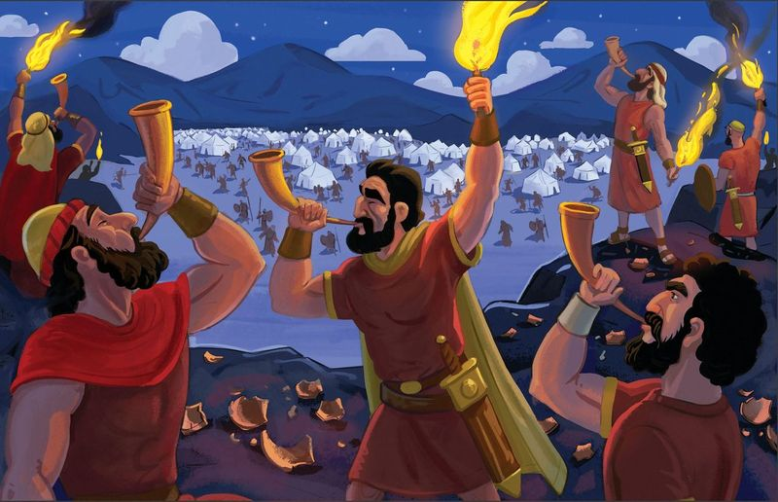
Dear families,
The story of Gideon in Judges 6-8 reveals the power of God at work in the lives of His people and how victory belongs to Him alone. God’s call on Gideon’s life demonstrates how the Lord often chooses what is weak to shame the strong (1 Corinthians 1:27).

Why would God choose to drastically limit the number of Gideon’s soldiers in battle? How does God’s provision in this story point to an even greater salvation—our hope in Christ?

Once again, the Israelites had committed themselves to doing evil in the sight of the Lord. The Lord allowed the Midianites to rule over His people as a consequence for their sin. Yet, God again acted mercifully as He responded to their cries for deliverance in the face of oppression. God graciously sent a prophet to His people to remind them of the faithful love He had shown them since their days in Egypt. He urged them to remember His covenant with His people.

God called Gideon to be a judge for the Israelites and to deliver them from Midian. Not wanting His people to claim victory on behalf of their own strength, God told Gideon to pare down his troops. God showed His power by limiting the Israelites’ manpower in battle. This way, they could only attribute their victory to the Lord’s goodness on their behalf. Gideon and his army of 300 had no logical way of winning a battle against so many Midianite troops. Yet, God proved He is Lord over creation and the One who pursues His people and delivers them unto Himself.

God provided salvation to His people by delivering them from the hand of the Midianites, but even more, He has provided eternal deliverance to all who trust in His Son for salvation. In the battle against sin and death, we—like the Israelites—have no means of securing victory on our own. Yet through Jesus, the battle is already won. Lead the boys and girls in your care to see God’s ability to make a way where there is no way, as well as His heart for sinners who deserve death. May your children walk forward in faith, trusting in the Lord for His victory over sin and death.

Check out The Gospel Project At Home for resources designed to help you lead a family worship experience as well as suggestions for morning and evening prayer times and family activities.

FAMILY TALKING POINTS

CHRIST CONNECTION
This is the big idea of how this week’s Bible story points to Jesus.
- Babies & Toddlers: When we do wrong things, we need God’s help. God sent His Son, Jesus, to help us and to save us from our sins.
- Younger Preschool: The Israelites needed Gideon to help them. We need help, too. We need God to save us from our sins. God sent His Son, Jesus, to help us and save us forever.
- Older Preschool: The people of Israel asked God to help them. God used Gideon to help the people, and God fought for them. We need help too. We need God to save us from sin. We cannot save ourselves. God sent His Son, Jesus, to save us.
- Kids: Gideon could have never won the battle without God’s power. Victory came from God alone. We cannot save ourselves from sin. Only Jesus can save us from our sin.

BIG PICTURE QUESTION & ANSWER
This is an important biblical truth that your child will encounter each week of this unit.
- Younger Preschool: What is repentance? Repentance is turning away from sin and turning to Jesus.
- Older Preschool: What is repentance? Repentance is turning away from sin and turning to Jesus.
- Kids: What is repentance? Repentance is turning away from sin and turning to Jesus.

KEY PASSAGE
This is a Bible verse that relates to what your child will encounter each week of this unit.
- Babies & Toddlers: If we pray, God will hear and forgive our sins. 2 Chronicles 7:14
- Younger Preschool: If my people pray and turn from sin, I will forgive them. 2 Chronicles 7:14
- Older Preschool: [If] my people pray and turn from their evil ways, then I will forgive their sin. 2 Chronicles 7:14
- Kids: [If] my people, who bear my name, humble themselves, pray and seek my face, and turn from their evil ways, then I will hear from heaven, forgive their sin, and heal their land. 2 Chronicles 7:14

** Next week: Samson and the Philistines (Judges 13-16)

Unit 8, Session 4
Samson and the Philistines (Judges 13-16)
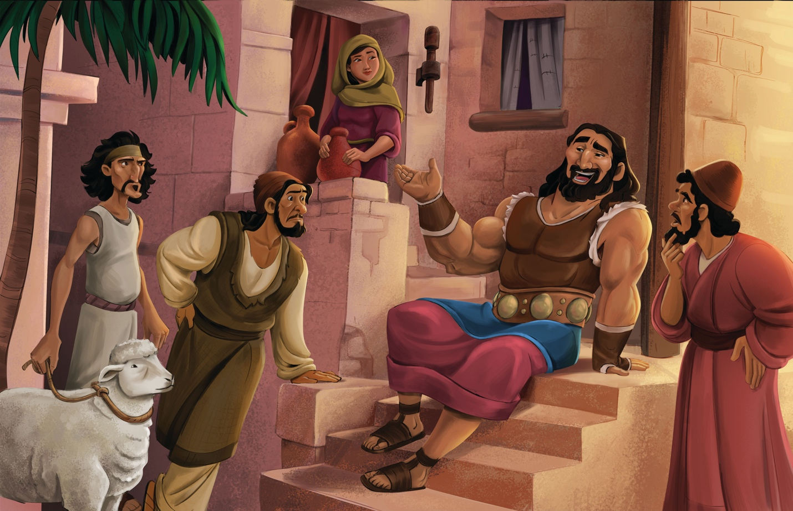
Dear families,
The life of Samson showcases the downfall of a mighty hero whose story draws some similarities to Jesus. Samson’s shortcomings, however, reveal the need for a greater deliverer. Only by faith in the Son of God can we please our Father in heaven and get a proper view of where true strength comes from.

What comparisons and contrasts can we make between Samson and Jesus? What can Christians glean about the source of their strength?

In Samson’s story, the angel of the Lord delivered the news that a woman who was unable to conceive would have a son. This has similarities to the New Testament’s even greater account of the miraculous conception of Jesus to the virgin Mary. We later read that Delilah, whom Samson loved, was bribed with silver to betray him into the hands of his enemies, just as Judas did to Jesus. Both Samson and Jesus were called to bring salvation to God’s people amid the oppression they faced, though only Jesus was able to do so in a lasting way by perfectly obeying God’s commands.

Samson’s strength came from the Spirit of God and Samson’s adherence to the angel’s command that he not cut his hair. As a Nazirite, Samson was called to be set apart in holy service to God, though he disobeyed God’s call to abstain from the unclean and idolatrous ways of the world. The downfall of Samson revealed the need for a greater hero who could fulfill God’s commands and deliver His people once and for all.

Though Samson was an esteemed warrior, his strength was not his own; it came from God who called him to walk in holiness. Like Samson, we cannot please God on our own. We need the power of His Spirit to help us walk in His ways (Galatians 5:16). Jesus is the better Samson—our perfect sacrifice who suffered in our place to create lasting transformation amid our helpless and hopeless state. Lead the boys and girls in your care to see that when we place our trust in Jesus, the Holy Spirit dwells within us, allowing us to walk victoriously in faith.

Check out The Gospel Project At Home for resources designed to help you lead a family worship experience as well as suggestions for morning and evening prayer times and family activities.

FAMILY TALKING POINTS

CHRIST CONNECTION
This is the big idea of how this week’s Bible story points to Jesus.
- Babies & Toddlers: God used Samson to save His people. God sent His Son, Jesus, to save us from our sins and give us life with God forever.
- Younger Preschool: Like Samson helped his people, Jesus helps us. Jesus died and came back to life to save us from our mistakes and give us life with God forever.
- Older Preschool: God made Samson strong and used Samson’s death to save His people from the Philistines. Jesus died on the cross and rose again to rescue us from sin and give us life with God forever.
- Kids: Samson’s great strength came from God alone. He had no power to defeat the Philistines on his own. We cannot please God on our own. Through faith in Jesus, people are saved from sin and receive the Holy Spirit, who helps them live to please God.

BIG PICTURE QUESTION & ANSWER
This is an important biblical truth that your child will encounter each week of this unit.
- Younger Preschool: What is repentance? Repentance is turning away from sin and turning to Jesus.
- Older Preschool: What is repentance? Repentance is turning away from sin and turning to Jesus.
- Kids: What is repentance? Repentance is turning away from sin and turning to Jesus.

KEY PASSAGE
This is a Bible verse that relates to what your child will encounter each week of this unit.
- Babies & Toddlers: If we pray, God will hear and forgive our sins. 2 Chronicles 7:14
- Younger Preschool: If my people pray and turn from sin, I will forgive them. 2 Chronicles 7:14
- Older Preschool: [If] my people pray and turn from their evil ways, then I will forgive their sin. 2 Chronicles 7:14
- Kids: [If] my people, who bear my name, humble themselves, pray and seek my face, and turn from their evil ways, then I will hear from heaven, forgive their sin, and heal their land. 2 Chronicles 7:14

** Next week: The Story of Ruth (Ruth)

Unit 9, Session 1
The Story of Ruth (Ruth)
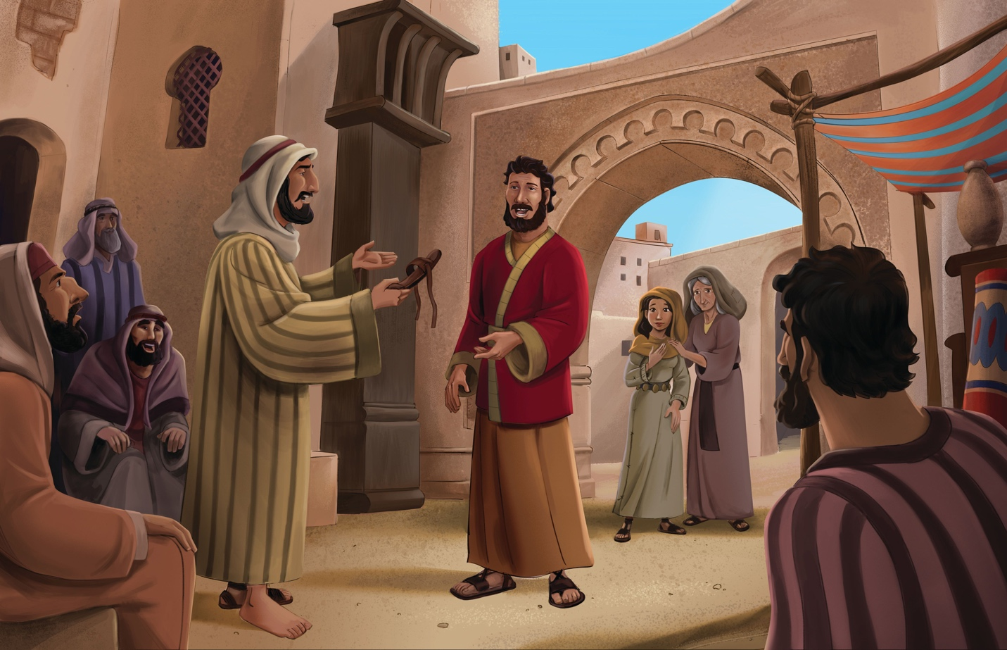
Dear families,
The book of Ruth weaves a redemption story that begins with one family from Bethlehem and points toward the Messiah born in the same city. In the story of Ruth, we see how God sees and cares for His people, even demonstrating His love for the nations through a Moabite woman who became a part of Jesus’ lineage. God’s provision for not only Ruth, but all people, is revealed through the theme of a redeemer.

What does Ruth’s story teach us about our need for redemption? How does faith play a role in this book of the Bible?

In the time of the judges, famine overtook the land of Judah. So, a man named Elimelech traveled with his family to the land of Moab. Eventually, Elimelech and his two sons died, leaving his wife Naomi and her two daughters-in-law seemingly without provision or protection in their time of need. Naomi granted her late sons’ wives to return to their homelands, yet Ruth swore to remain with Naomi and declared that Naomi’s God would be her God too.

Ruth remained faithful to Naomi and took to the fields to glean grain for them both. It was there she received kindness from the field’s owner Boaz, whom she soon learned was their family redeemer. Boaz had the power to bring Ruth and Naomi back into Elimelech’s family so their lineage would continue. He took Ruth as his wife to provide her with the food and protection she needed. Like Ruth, we need provision, but our need goes even further: salvation from sin. The kindness of Jesus led Him to the cross to redeem us amid our sinful state.

Lead the kids in your care to see that this story goes beyond mere physical provision to reveal a God who made the way to offer us salvation. Pray that your children will see God’s sovereign hand at work in this story and that they will trust in Jesus as the perfect and final Redeemer.

Check out The Gospel Project At Home for resources designed to help you lead a family worship experience as well as suggestions for morning and evening prayer times and family activities.

FAMILY TALKING POINTS

CHRIST CONNECTION
This is the big idea of how this week’s Bible story points to Jesus.
- Babies & Toddlers: God helped Ruth and Naomi. God helped us too. God sent Jesus to save us and rescue us from all our sins.
- Younger Preschool: Like Boaz helped Ruth and Naomi, God sent Jesus to help us. Jesus is like our Rescuer who saves us from all our sins.
- Older Preschool: Ruth was in great need, and God provided Boaz as her family redeemer. We are in great need and unable to save ourselves from our sin. God provided Jesus as our Redeemer.
- Kids: Ruth was in great need and unable to provide for herself. God provided Boaz as her redeemer. We are in great need and unable to save ourselves from our sin. God provided Jesus as our Redeemer.

BIG PICTURE QUESTION & ANSWER
This is an important biblical truth that your child will encounter each week of this unit.
- Younger Preschool: How does God care for His creation? God loves and rules over all He made.
- Older Preschool: How does God care for His creation? God loves and rules over all He made.
- Kids: How does God care for His creation? God loves and rules over His creation according to His perfect plan.

KEY PASSAGE
This is a Bible verse that relates to what your child will encounter each week of this unit.
- Babies & Toddlers: God gives us all we need in Jesus. Philippians 4:19
- Younger Preschool: My God will supply all your needs in Christ Jesus. Philippians 4:19
- Older Preschool: My God will supply all your needs according to his riches in glory in Christ Jesus. Philippians 4:19
- Kids: My God will supply all your needs according to his riches in glory in Christ Jesus. Philippians 4:19

** Next week: Samson Was Born and Called (1 Samuel 1-3)

Unit 9, Session 2
Samson Was Born and Called (1 Samuel 1-3)
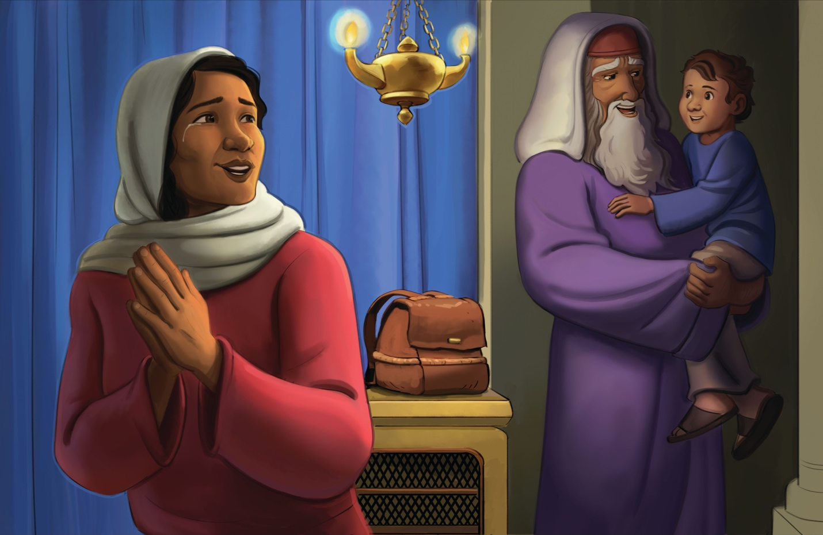
Dear families,
First Samuel 1–3 reveals God’s call of salvation and the response of faith that follows for all who belong to Him. In the dark of night, God called to Samuel and invited him to become His prophet who would shed the light of His words to His people. God’s call upon Samuel’s life is one that followers of Christ still respond to today: to trust in Him as the hope of salvation and to lead others to do the same.

How do we see God at work in Samuel’s life? How does trust in the Lord play a recurring role in this story?

Samuel was an answered prayer in his mother’s life. She spent years praying to God for a son whose life she promised to dedicate back to the Lord’s service. She allowed her precious son to grow up in the Lord’s house under the care and supervision of Eli the priest. It was Eli’s instructions to Samuel that prepared the young boy to receive the Word of the Lord and to share it as instructed. Though the call to repentance was not an easy message to share, Samuel did so and grew up to become a prophet. All of Israel knew he walked with the Lord.

From an early age, Samuel was brought up to recognize the Lord and His provision. From the prayers of Hannah to the instructions of Eli, Samuel was led in the ways of the Lord and responded to God’s call with open-handed faith. Samuel’s obedience flowed from His trust in the God of His salvation. He listened to God and dedicated his life to His service. Like Samuel, we can respond to God’s call by placing faith in Jesus, turning from sin, and proclaiming His truth to the world.

Consider the relationship between trust and obedience. Does your life reflect the truth that God’s ways are good and worthy of your trust? Lead the boys and girls in your care to see the fruit of a faith-filled life in service to God. Show them that, like Samuel, they can begin leading others to follow the Lord in faith.

Check out The Gospel Project At Home for resources designed to help you lead a family worship experience as well as suggestions for morning and evening prayer times and family activities.

FAMILY TALKING POINTS

CHRIST CONNECTION
This is the big idea of how this week’s Bible story points to Jesus.
- Babies & Toddlers: When we listen to God and follow Jesus’ example, He will show us the right way to go.
- Younger Preschool: Like Samuel listened to God, we can listen to Jesus, who always shows us the right way to go.
- Older Preschool: Samuel heard God’s voice and obeyed. Jesus perfectly obeyed God when He came to earth, died on the cross, and rose again to save people from their sin.
- Kids: God called to Samuel, and Samuel responded. God calls people to turn from sin and follow Jesus. Everyone who responds by trusting in Jesus is saved from sin.

BIG PICTURE QUESTION & ANSWER
This is an important biblical truth that your child will encounter each week of this unit.
- Younger Preschool: How does God care for His creation? God loves and rules over all He made.
- Older Preschool: How does God care for His creation? God loves and rules over all He made.
- Kids: How does God care for His creation? God loves and rules over His creation according to His perfect plan.

KEY PASSAGE
This is a Bible verse that relates to what your child will encounter each week of this unit.
- Babies & Toddlers: God gives us all we need in Jesus. Philippians 4:19
- Younger Preschool: My God will supply all your needs in Christ Jesus. Philippians 4:19
- Older Preschool: My God will supply all your needs according to his riches in glory in Christ Jesus. Philippians 4:19
- Kids: My God will supply all your needs according to his riches in glory in Christ Jesus. Philippians 4:19

** Next week: The Ark Was Captured (1 Samuel 4-6)

Unit 9, Session 3
The Ark Was Captured (1 Samuel 4-6)
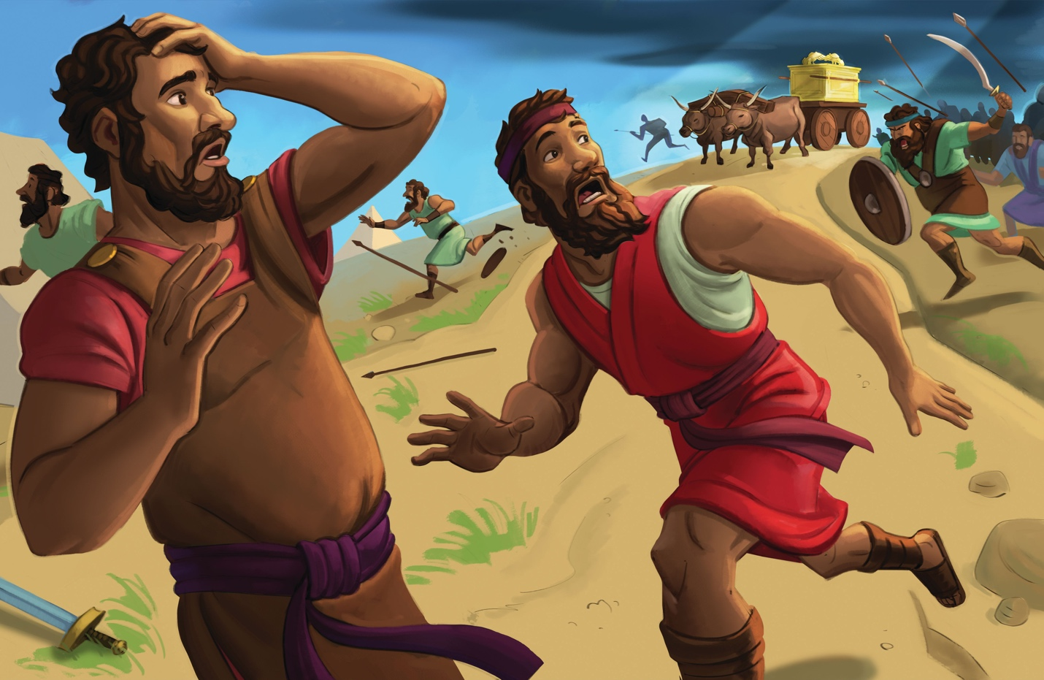
Dear families,
The Philistines’ capture of the ark of the covenant reveals the folly of seeking God’s blessing over God Himself. The Israelites realized they were no match for the Philistines, so they pursued worldly wisdom instead of seeking God in prayer. Reducing the significance of the ark to a good luck charm set off a chain reaction of disastrous events. Yet, God provided His people a victory they did not deserve.

What was the significance of the ark? How does the Lord prove His might against false gods and among the nations of the world?

The ark served as a reminder of God’s promise to dwell among His people. Inside it was some manna from heaven, Aaron’s rod, and the tablets of the Ten Commandments. Each item demonstrated God’s provision, as well as His covenant promise to remain with them through the ages. 1 Samuel 4:5 tells us that when the Israelites entered the camp with the ark, their shouts were loud enough to shake the ground. These shouts, however, were empty praise not fueled by a right view of the Lord or His righteous cause among the nations.

God responded to the Israelites’ sin by allowing the Philistines to capture the ark that represented His presence and glory among God’s people. Yet, God used what looked outwardly like defeat to bring glory to His name by demonstrating His power over the enemy and His judgment of sin. This foreshadowed an even greater story of God claiming glory through what looked like defeat—when Jesus allowed Himself to be captured by people and crucified to satisfy God’s judgment on sin. Likewise, the surprising return of the ark by the unmistakable power of the Lord foreshadowed Christ’s resurrection to be with His people.

Lead the boys and girls in your care to see that the source of our hope lies not in our wishes of good fortune from the Lord, but rather in the salvation secured by Christ through faith in His name. Like the Israelites, we deserve judgment for our sin. By faith in Christ, however, we receive forgiveness and His righteousness. Pray for your kids to see the weight of their sins and the price Christ paid to secure them as His own forever.

Check out The Gospel Project At Home for resources designed to help you lead a family worship experience as well as suggestions for morning and evening prayer times and family activities.

FAMILY TALKING POINTS

CHRIST CONNECTION
This is the big idea of how this week’s Bible story points to Jesus.
- Babies & Toddlers: God sent us His Son, Jesus, to remind us that God is always with us.
- Younger Preschool: The ark was special, but later God gave people something even better: His Son, Jesus. Jesus reminds us that God is always with us.
- Older Preschool: The ark of God reminded the Israelites that God was with them. Many years later God gave His people something even better to remind them that He was with them. God sent His Son, Jesus. One of Jesus’ names is Immanuel, which means “God with us.”
- Kids: God is holy and punished the Israelites and Philistines for misusing the ark. All people sin and deserve God’s judgment, but Jesus took that judgment when He died on the cross. All who trust in Jesus are forgiven of sin and saved from judgment.

BIG PICTURE QUESTION & ANSWER
This is an important biblical truth that your child will encounter each week of this unit.
- Younger Preschool: How does God care for His creation? God loves and rules over all He made.
- Older Preschool: How does God care for His creation? God loves and rules over all He made.
- Kids: How does God care for His creation? God loves and rules over His creation according to His perfect plan.

KEY PASSAGE
This is a Bible verse that relates to what your child will encounter each week of this unit.
- Babies & Toddlers: God gives us all we need in Jesus. Philippians 4:19
- Younger Preschool: My God will supply all your needs in Christ Jesus. Philippians 4:19
- Older Preschool: My God will supply all your needs according to his riches in glory in Christ Jesus. Philippians 4:19
- Kids: My God will supply all your needs according to his riches in glory in Christ Jesus. Philippians 4:19

** Next week: Freedom from the Philistines (1 Samuel 7)

Unit 9, Session 4
Freedom from the Philistines (1 Samuel 7)
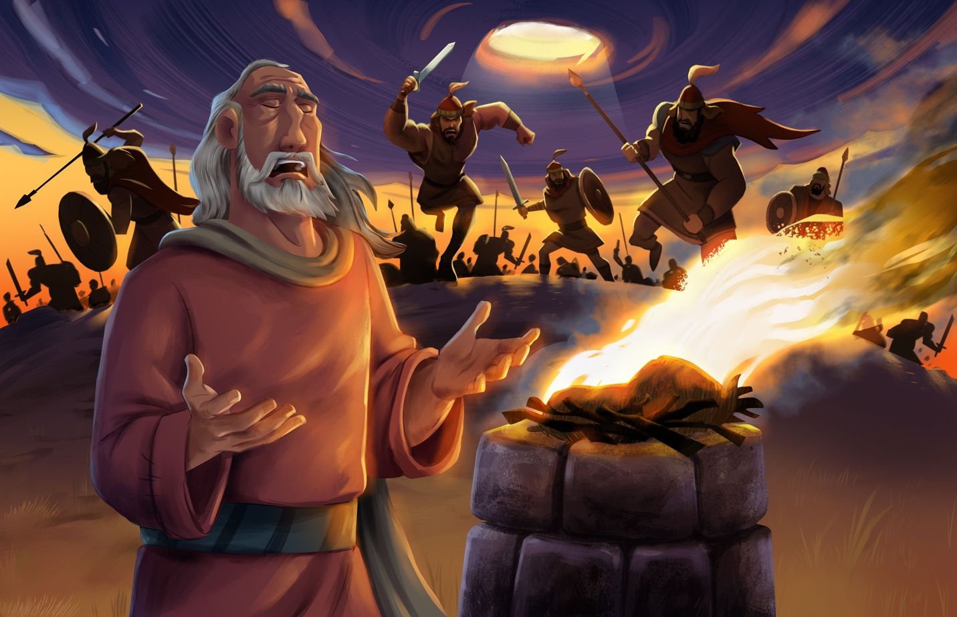
Dear families,
First Samuel 7 reveals the Israelites’ victory over the Philistines after God’s people turned to the Lord and away from their pagan gods and idols. Samuel interceded for the people as they began to long for the Lord after having pursued the ways of the world for so long. The Lord granted His people victory over their enemies in a way that foreshadowed how He has established an eternal victory for those in Christ.

What did Samuel lead the people to do in their helpless state? How is Jesus an even better intercessor than Samuel was?

After so many chapters of disobedience and helplessness, it is refreshing to read that the Israelites finally longed for the Lord. Realizing the emptiness of idol worship, the people stood before Samuel and sought next steps from their leader. His instructions to the people were not dissimilar to the words we need to hear today: return to the Lord with all your heart, get rid of your false gods, set your heart back on the Lord, and worship only Him. In doing so, Samuel explained, they would again see God’s deliverance.

The Israelites did as Samuel instructed, and they fasted and confessed their sins. They pleaded with Samuel to continue interceding for them so that they would experience the victory of God’s promise. Samuel offered a sacrifice to the Lord on His people’s behalf, and it pleased the Lord.

Although Samuel was an upright man called to prophesy and judge God’s people, he was not the Messiah. Instead, Samuel’s life points us to the only One able to secure a permanent victory over sin and death through a once-and-for-all sacrifice for God’s people. Those who are in Christ do not need an earthly judge to mediate between God and man; instead, they can place their hope in the finished work of Jesus.

Share with the boys and girls in your care your story of how the Lord has helped you thus far (1 Samuel 7:12). Lead them to see how Christ has transformed your heart and granted you an eternal victory by faith in His name.

Check out The Gospel Project At Home for resources designed to help you lead a family worship experience as well as suggestions for morning and evening prayer times and family activities.

FAMILY TALKING POINTS

CHRIST CONNECTION
This is the big idea of how this week’s Bible story points to Jesus.
- Babies & Toddlers: God sent Jesus to die on the cross and rise again so that we can be forgiven. When we know and love Jesus, God forgives our sin.
- Younger Preschool: God wants people to be sorry for their sin. Jesus came to die on the cross and rise again. When we know and love Jesus, God forgives our sin.
- Older Preschool: The Israelites confessed their sin, and God saved them from the Philistines. When we confess our sin to God, He forgives us and saves us through the death and resurrection of His Son, Jesus.
- Kids: Samuel called the people to turn away from false gods and to worship God, and God gave them victory over their enemies. God calls us to turn away from sin and to trust in Jesus who gives us victory over our enemies of sin and death.

BIG PICTURE QUESTION & ANSWER
This is an important biblical truth that your child will encounter each week of this unit.
- Younger Preschool: How does God care for His creation? God loves and rules over all He made.
- Older Preschool: How does God care for His creation? God loves and rules over all He made.
- Kids: How does God care for His creation? God loves and rules over His creation according to His perfect plan.

KEY PASSAGE
This is a Bible verse that relates to what your child will encounter each week of this unit.
- Babies & Toddlers: God gives us all we need in Jesus. Philippians 4:19
- Younger Preschool: My God will supply all your needs in Christ Jesus. Philippians 4:19
- Older Preschool: My God will supply all your needs according to his riches in glory in Christ Jesus. Philippians 4:19
- Kids: My God will supply all your needs according to his riches in glory in Christ Jesus. Philippians 4:19

** Next week: The Israelites Wanted a King (1 Samuel 7-10)

