Ministry Leaders: A suggested email is provided for each session for you to customize if you desire and share with your families. You can also access a social media share square for each session on the Additional Resources page at gospelproject.com.
The Gospel Project At Home content is available in Ministry Grid for you to share with your families.
Unit 1, Session 1
God Created the World (Genesis 1–2)

Dear families,
In Genesis 1–2, we encounter one of Scripture’s most well-known passages: the creation story. This account is foundational to recognizing God as Creator and King over everything. Yet, as foundational as this account may be, faith is still a necessary component of understanding this biblical account and in trusting the goodness of the triune God—Father, Son, and Spirit—whose good creation makes known His glory and His purposes.
So, how do we find Jesus within the creation account?
To understand Jesus within the context of Genesis 1–2, we must focus on how God chose to create the heavens and the earth. He did not simply point at the formless void and silently fashion it into existence; rather, He used His voice to speak. Hebrews 11:3 declares, “By faith we understand that the universe was created by the word of God, so that what is seen was made from things that are not visible.” In His speaking, out of nothing (ex nihilo) came creation.
In the New Testament, Jesus is referred to as “the Word” to specifically demonstrate that God has revealed Himself to us through Jesus. Just as God spoke creation into existence, making His glory and will known through His words, so did He also make Himself known by the Word of God coming to earth. In fact, John 1:1 teaches us that “In the beginning was the Word, and the Word was with God, and the Word was God.” Jesus is God in flesh who came to dwell in the very creation He created. Jesus, the Word, was there at the dawn of creation and present as the Father spoke and the Spirit hovered over the waters (Genesis 1:1-3).
The apostle Paul later wrote in Colossians 1:16-17 that everything was created by Jesus, through Jesus, and for Jesus. He was before creation, and by Him all things are held together; the Word has been present since the beginning.
Pray that God reveals His glory in the person of Jesus Christ to your kids’ hearts and minds. Ask for clarity in your words as you proclaim His truths. May God grant faith to the hearers of this story, helping them trust the truth of His Word.
Check out The Gospel Project At Home for resources designed to help you lead a family worship experience as well as suggestions for morning and evening prayer times and family activities.

FAMILY TALKING POINTS

STORY POINT
This is the main point to emphasize from today’s Bible story.

- Preschool: God made all things good.
- Kids: God created everything for His glory.

CHRIST CONNECTION
This is the big idea of how this week’s Bible story points to Jesus.

- Babies & Toddlers: Jesus is King over everything.
- Younger Preschool: Jesus is Lord over all of creation. Everything was created by Him and for Him. He rules over everything.
- Older Preschool: God made the whole world just by speaking. Jesus is Lord over all of creation. Everything was created by Him and for Him. God the Son has always existed, and He rules over everything.
- Kids: By faith, we believe that God created the whole world by His word. (Hebrews 11:3) Jesus, the Word of God, is Lord over all of creation. Everything was created by Him and for Him. The Son has always existed, and He holds everything together. (Colossians 1:16-17)

BIG PICTURE QUESTION & ANSWER
This is an important biblical truth that your child will encounter each week of this unit.

- Younger Preschool: Who is God? God is our Creator and King.
- Older Preschool: Who is God? God is our Creator and King.
- Kids: Who is God? God is our Creator and the King of everything.

KEY PASSAGE
This is a Bible verse that relates to what your child will encounter each week of this unit.

- Babies & Toddlers: God made our wonderful world. Psalm 104:24
- Younger Preschool: The earth is full of God’s creatures. Psalm 104:24
- Older Preschool: How countless are your works, LORD! ... The earth is full of your creatures. Psalm 104:24
- Kids: How countless are your works, LORD! In wisdom you have made them all; the earth is full of your creatures. Psalm 104:24

** Next week: Sin Entered the World (Genesis 2–3)

Unit 1, Session 2
Sin Entered the World (Genesis 2–3)

Dear families,
Genesis 2–3 recounts sin’s entrance into the world through Adam and Eve’s disobedience. From the earliest pages of the Old Testament, we are introduced to the gravity of sin and people’s need for redemption––a redemption promised by God through an offspring of Eve. A Rescuer would come to undo the curse of sin and crush the serpent.
How has God provided for His people since the beginning of time, from before the fall of man until this very moment? What evidence do we see of His kindness and care—especially in light of Christ?
God revealed His glory through Eden, a thriving garden where His people’s needs were lovingly met. His beautiful creation was all theirs for the taking with only one exception: “ … you must not eat from the tree of the knowledge of good and evil, for on the day you eat from it, you will certainly die” (Genesis 2:17). God's command was not a means to withhold good. Rather, His command was for their good. That is, by obeying Him, they would actually find life.
When faced with the serpent’s lies, Eve failed to believe God's words. She was enticed by the fruit's appearance, the proposition to be like God, and the allurement of obtaining wisdom. She and her husband’s eyes had indeed been opened to the knowledge of good and evil; however, because they disobeyed God’s command, they would now experience sin's consequences and the reality of death.
Despite His people’s disobedience, God sought them in their sin. He provided them with clothing from animal skins to cover their nakedness and shame. However, the sacrifice of this animal was not a once-and-for-all event, but the foreshadowing of a greater death to repair this severed relationship between God and man—Christ’s sacrifice on the cross. God's merciful promise in Genesis 3:15 provides all people with the opportunity to be freed from the curse of sin and find life in Christ. As Romans 5:19 reminds us, "For just as through one man’s disobedience the many were made sinners, so also through the one man’s obedience the many will be made righteous."
While you ponder today's truths, take time to meditate on God’s care for His people—from the beauty of creation to the mercy revealed in Jesus’ sacrifice. Consider God’s provision in redeeming His people and drawing close despite their sin. May you relay His truths clearly to your kids as you also make evident the faith you have in Jesus Christ.
Check out The Gospel Project At Home for resources designed to help you lead a family worship experience as well as suggestions for morning and evening prayer times and family activities.

FAMILY TALKING POINTS

STORY POINT
This is the main point to emphasize from today’s Bible story.

- Preschool: Sin is disobeying God.
- Kids: Sin is disobeying God and His commands.

CHRIST CONNECTION
This is the big idea of how this week’s Bible story points to Jesus.

- Babies & Toddlers: God planned to send Jesus to make everything right.
- Younger Preschool: Adam and Eve disobeyed God. Sin keeps us from God, but God had a plan. Jesus came to earth to die on the cross and come back to life to rescue people from sin.
- Older Preschool: Adam and Eve did not follow God’s good plan. They sinned by disobeying God’s command. Sin separates people from God, but God had a plan all along. Jesus came to earth as a man to live a sinless life, die on the cross, and rose again to rescue people from sin.
- Kids: Adam and Eve sinned when they rejected God’s good plan and disobeyed His command. Sin separates people from God, but God didn’t leave them without hope. God sent His Son, Jesus, to live as Adam didn’t—perfectly sinless. God the Son came to earth as a man to rescue people from sin.

BIG PICTURE QUESTION & ANSWER
This is an important biblical truth that your child will encounter each week of this unit.

- Younger Preschool: Who is God? God is our Creator and King.
- Older Preschool: Who is God? God is our Creator and King.
- Kids: Who is God? God is our Creator and the King of everything.

KEY PASSAGE
This is a Bible verse that relates to what your child will encounter each week of this unit.

- Babies & Toddlers: God made our wonderful world. Psalm 104:24
- Younger Preschool: The earth is full of God’s creatures. Psalm 104:24
- Older Preschool: How countless are your works, LORD! ... The earth is full of your creatures. Psalm 104:24
- Kids: How countless are your works, LORD! In wisdom you have made them all; the earth is full of your creatures. Psalm 104:24

** Next week: The First Family (Genesis 4)

Unit 1, Session 3
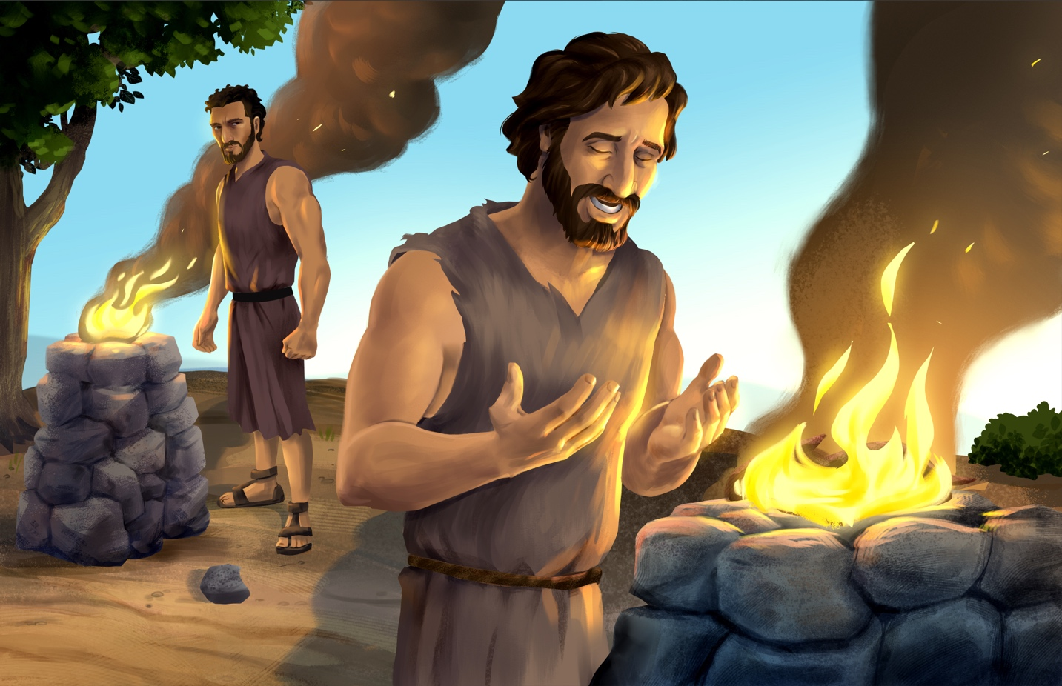The First Family (Genesis 4)

Dear families,
Genesis 4 offers insight into the first family in history—showcasing the deathly reality of sin and merciful nature of God. Here, we read of Abel’s blood that was wrongfully shed, which cried out for condemnation. In contrast, however, the gospel speaks of a different firstborn Son whose blood provides everlasting life to us instead.
How does Cain’s life differ from Eve’s expectations for her firstborn son? What can we learn about sin, sacrifice, and the God who is worthy of worship?
Brothers Cain and Abel both offered sacrifices to God, but the former’s offering wasn’t truly a sacrifice—pleasing to God and reflective of His true worth. God spoke directly to Cain asking him to consider why he felt so rejected by His response to the offering. God also warned him that though sin’s temptations were strong, he could rule over it. Yet Cain did not heed the words of his Creator. Instead, he chose destruction and would soon end his own brother’s life.
God drew near to Cain and addressed his wrongdoings, acknowledging the unjust death of the righteous Abel. God told Cain that he was now cursed. As a result, Cain would not receive back from the earth the fruit of his labors and would wander for the rest of his days. Even still, God protected Cain from the fate he forced upon his brother; he received protection against the threat of death by another’s hands. However, this act was only a glimmer of God’s mercy toward sinners. The greatest picture we see of His mercy is in Jesus’ blood shed at the cross, the ultimate offering to satisfy God’s wrath toward our unrighteousness.
Reflect on the Jesus’ righteousness in light of the unrighteousness of Cain, Adam and Eve, and the rest of mankind. The promised descendant who would redeem us amidst our sin wasn’t Eve’s firstborn son, but Jesus, the firstborn of all creation. God’s plan has always been to redeem us through faith in His Son. Pray that your kids hearts will be opened to the mercy of their Creator who leads us away from destruction and into everlasting life.
Check out The Gospel Project At Home for resources designed to help you lead a family worship experience as well as suggestions for morning and evening prayer times and family activities.

FAMILY TALKING POINTS

STORY POINT
This is the main point to emphasize from today’s Bible story.

- Preschool: Sin keeps us from God.
- Kids: Sin separates us from God.

CHRIST CONNECTION
This is the big idea of how this week’s Bible story points to Jesus.

- Babies & Toddlers: Jesus came from Adam and Eve’s family to save people from sin.
- Younger Preschool: Cain sinned like his parents did. Cain was not the Rescuer that God promised to send. Families grew and sin spread, and people waited for God to keep His promise. One day, God would send Jesus to rescue sinners.
- Older Preschool: God had promised that someone from Eve’s family would put an end to sin and death. Cain was not that person. As families grew and sin spread, people waited for God to keep His promise. At just the right time, God would send His Son, Jesus, to save sinners.
- Kids: God had promised that one of Eve’s descendants would put an end to sin and death. Cain was not that descendant. He was sinful like his parents, Adam and Eve. As families grew and sin spread, people waited for God to keep His promise. At just the right time, God would send His Son, Jesus, to save sinners.

BIG PICTURE QUESTION & ANSWER
This is an important biblical truth that your child will encounter each week of this unit.

- Younger Preschool: Who is God? God is our Creator and King.
- Older Preschool: Who is God? God is our Creator and King.
- Kids: Who is God? God is our Creator and the King of everything.

KEY PASSAGE
This is a Bible verse that relates to what your child will encounter each week of this unit.

- Babies & Toddlers: God made our wonderful world. Psalm 104:24
- Younger Preschool: The earth is full of God’s creatures. Psalm 104:24
- Older Preschool: How countless are your works, LORD! ... The earth is full of your creatures. Psalm 104:24
- Kids: How countless are your works, LORD! In wisdom you have made them all; the earth is full of your creatures. Psalm 104:24

** Next week: The Great Flood (Genesis 6–9)

Unit 1, Session 4
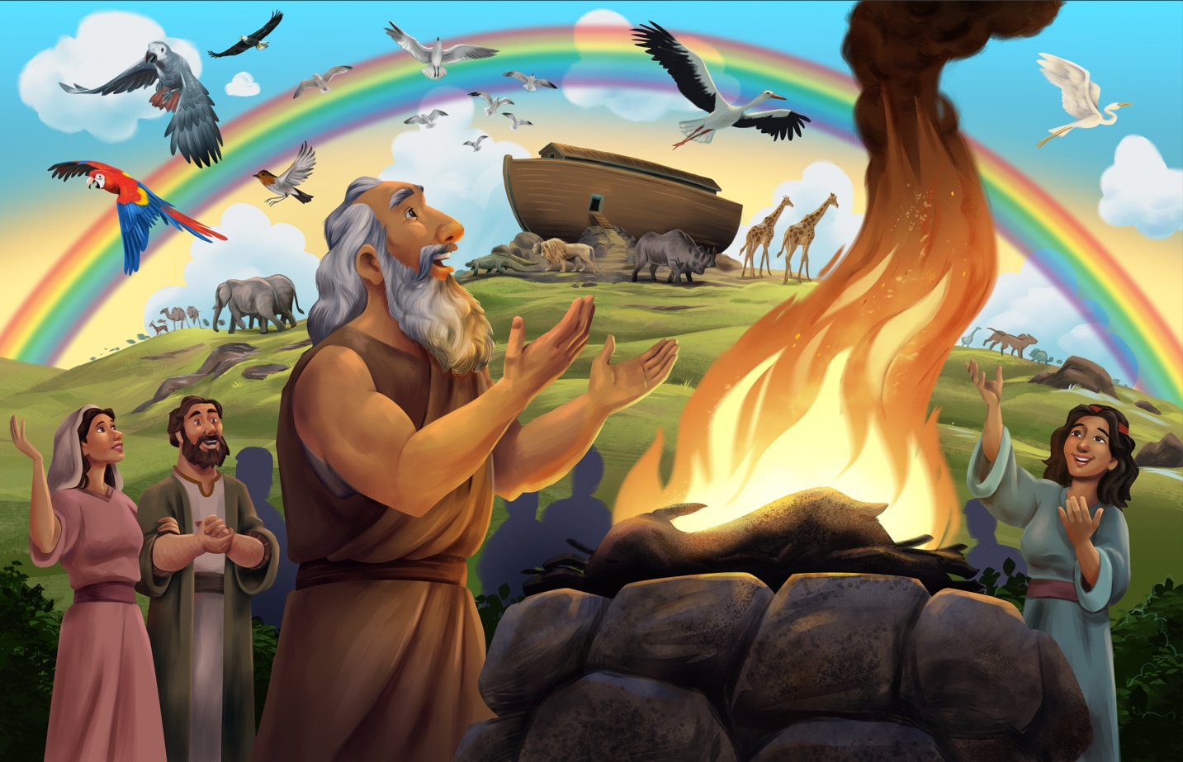The Great Flood (Genesis 6–9)

Dear families,
Genesis 6 gives us an understanding of the growth of early civilization. After Adam and Eve were cast out of the garden of Eden, the sinful state of humanity spread as far and wide as their family trees. God saw that every inclination of the human heart was evil all the time. And God regretted that He had made man. Yet, God had a plan to redeem His created world from sin that leads to death.

How did God provide salvation for Noah and his family? How has God provided redemption for us?
Though God was deeply grieved by the lifestyles of humanity, He found favor with righteous Noah. God chose to spare Noah from the destruction to come. He explained to Noah that, through faith-led obedience, he and his family would be spared from the flood waters. God instructed him to build an ark and to supply it with everything the people and animals needed while onboard.
As the water surged on the earth for 150 days, God remembered Noah and the ark and caused the storms to cease. Then God established a covenant with Noah, that He would never again curse the ground as He had with the flood. He blessed Noah’s family, instructing them to be fruitful and multiply. Even though God’s judgment on sin resulted in the waters flooding the earth, God provided a means of salvation that would result in a greater rescue to come through the family line of Noah.

Still, Noah’s obedience was not enough to secure mankind’s ultimate salvation. Even after the rescue of Noah and his family, God knew the inclination of the human heart was still evil. (Gen 8:21). A greater rescue and superior sacrifice were needed to rescue people from sin. God would send His own Son to take on the wrath they deserved. Noah’s faithfulness in building the ark is but a glimpse of Christ’s faithfulness in taking to a different wooden vessel—the cross—and securing the salvation of all who would place faith in Him. Help your kids see the mercy of God through the story of Noah’s ark, that the God who created them has been faithful to provide the way back to Him through faith in His Son, Jesus.
Check out The Gospel Project At Home for resources designed to help you lead a family worship experience as well as suggestions for morning and evening prayer times and family activities.

FAMILY TALKING POINTS

STORY POINT
This is the main point to emphasize from today’s Bible story.

- Preschool: God is right to punish sin.
- Kids: God is right to judge sin.

CHRIST CONNECTION
This is the big idea of how this week’s Bible story points to Jesus.

- Babies & Toddlers: God sent Jesus to rescue people from sin.
- Younger Preschool: God must punish sin, but God is loving. He rescued Noah and his family. God planned an even greater rescue: to send His Son, Jesus, to save people from their sins.
- Older Preschool: God is serious about sin. He will not leave sin unpunished. But God is loving. He rescued Noah and his family. God had a plan for an even greater rescue through His Son, Jesus. When we trust in Jesus, we are saved from the punishment our sin deserves.
- Kids: God rescued Noah and his family from the flood. The story of Noah points to an even greater rescue. God’s Son, Jesus came to take the punishment for our sin. By trusting in Him, we are saved from the power of sin and death.

BIG PICTURE QUESTION & ANSWER
This is an important biblical truth that your child will encounter each week of this unit.

- Younger Preschool: Who is God? God is our Creator and King.
- Older Preschool: Who is God? God is our Creator and King.
- Kids: Who is God? God is our Creator and the King of everything.

KEY PASSAGE
This is a Bible verse that relates to what your child will encounter each week of this unit.

- Babies & Toddlers: God made our wonderful world. Psalm 104:24
- Younger Preschool: The earth is full of God’s creatures. Psalm 104:24
- Older Preschool: How countless are your works, LORD! ... The earth is full of your creatures. Psalm 104:24
- Kids: How countless are your works, LORD! In wisdom you have made them all; the earth is full of your creatures. Psalm 104:24

** Next week: The Tower of Babel (Genesis 11)

Unit 1, Session 5
The Tower of Babel (Genesis 11)

Dear families,
Scripture’s Tower of Babel account tells of man’s disobedience and God’s intervening mercy to keep people from their own destruction. Not long after God’s covenant to never again destroy the earth by a flood, people chose to follow their own sinful plans rather than obey God’s good commands. Despite God’s mercy, people failed to trust Him and walk according to His ways.
In what ways is the Tower of Babel story marked by disobedience? How do we see God’s kindness in scattering His people and scrambling their language?
After blessing Noah and his sons, God decreed that they were to “be fruitful and multiply; spread out over the earth and multiply on it” (Genesis 9:7). This command seems like it would be easy to obey, but sin’s deception fueled an already present danger: mankind’s pride-fueled ambition.
God commanded His people to spread out over the earth and fill it with His glory. However, they decided to stay put and build a name for themselves. They were supposed to make much of God, but they decided to make a name for themselves instead. In His love, God drew near to them and saved them from their plans for self-glorification.
God’s decision to scatter His people and scramble their languages was part of a plan that emphasized His own glory above the people’s self-glorification efforts. Jesus, the Son of God, became man so that He would one day gather His people unto Himself—those of every tribe, tongue, and nation—not to worship or build a name for themselves, but to worship the only worthy One, King Jesus. His grace unites us, saves us, and brings us back into relationship with Him.
Consider the ways God has redirected the plans you have made for yourself. Are you, in hindsight, able to see His redirection as a means of grace upon your life? Reflect on His goodness in intervening. Pray for your kids, that they would place their trust in the God whose plans are for our good and for His ultimate glory.
Check out The Gospel Project At Home for resources designed to help you lead a family worship experience as well as suggestions for morning and evening prayer times and family activities.

FAMILY TALKING POINTS

STORY POINT
This is the main point to emphasize from today’s Bible story.

- Preschool: God is the greatest.
- Kids: God is great and deserves all worship.

CHRIST CONNECTION
This is the big idea of how this week’s Bible story points to Jesus.

- Babies & Toddlers: One day, everyone will worship Jesus together.
- Younger Preschool: People tried to make themselves look great, but God is the greatest. God mixed up their language and made them spread out all over the earth. One day, Jesus will come back. People from all over the earth will worship Him together. (Revelation 7:9-10)
- Older Preschool: Instead of obeying God, people tried to make themselves famous, so God mixed up their language and made them spread out all over the earth. One day, Jesus will come back and people from all nations, speaking many languages, will worship Him together. (Revelation 7:9-10)
- Kids: People ignored God’s plan and tried to make a name for themselves, so God confused their language and scattered the people all over the earth. One day, Jesus will gather together all of God’s people—people from every tribe and people who speak all kinds of languages—and they will worship Him. (Revelation 7:9-10)

BIG PICTURE QUESTION & ANSWER
This is an important biblical truth that your child will encounter each week of this unit.

- Younger Preschool: Who is God? God is our Creator and King.
- Older Preschool: Who is God? God is our Creator and King.
- Kids: Who is God? God is our Creator and the King of everything.

KEY PASSAGE
This is a Bible verse that relates to what your child will encounter each week of this unit.

- Babies & Toddlers: God made our wonderful world. Psalm 104:24
- Younger Preschool: The earth is full of God’s creatures. Psalm 104:24
- Older Preschool: How countless are your works, LORD! ... The earth is full of your creatures. Psalm 104:24
- Kids: How countless are your works, LORD! In wisdom you have made them all; the earth is full of your creatures. Psalm 104:24

** Next week: Abraham Followed God (Genesis 11–13)

Unit 2, Session 1
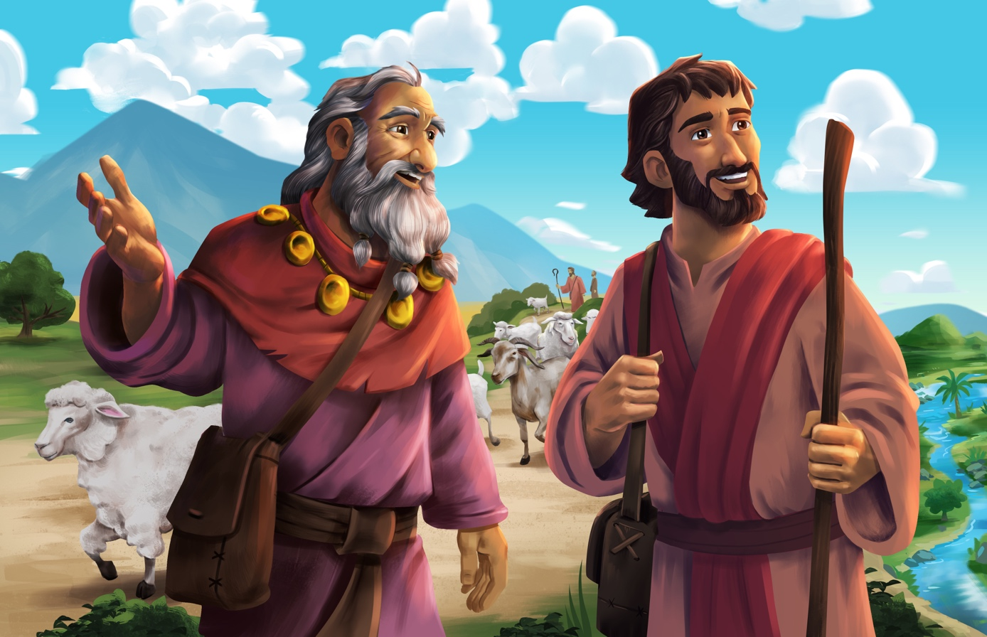Abram Followed God (Genesis 11–13)

Dear families,
In today’s passage, we read how Abram began his journey of following God. He showed marvelous faith by believing the promises God made to him, and he walked in obedience to the command of God. God proved Himself faithful and used Abram to display the glories of His promises, which would one day be fulfilled through the sacrifice and resurrection of the only truly righteous One, Jesus Christ.
How did God use Abram’s story to demonstrate His faithfulness? How is Abram’s call to follow God similar to our own stories today?
We learn from Joshua 24:2 that Abram was not raised by a family that worshiped God, but by idol worshipers. He did not know the Word of God until the day he heard it spoken to him as an old man: “Go from your land... to the land that I will show you. I will make you into a great nation” (Genesis 12:1-2). In the very next verse, Abram promptly obeyed and began his journey, just as the Lord had told him. God called him to leave the comforts of his familiar life in pursuit of God and His glory. Abram did not follow God perfectly, and still he was called a friend of God (James 2:23).
God drew near to Abram, calling him out of darkness and into His light. Today, the same God calls us to believe this same promise of rescue that was brought to completion through His Son, Jesus, who left the comforts of heaven and came into the world to save sinners. Jesus is the better Abram who trusted and obeyed the Father, “becoming obedient to the point of death—even to death on a cross” (Philippians 2:8). The steps Abram took were out of faith—faith that God would keep him safe, provide for him, and keep His promises. Abram believed God was worthy of forsaking all else. When your kids hear this Bible story, may they take steps toward trusting the same God who is worthy of our love, trust, and faithful devotion.

Check out The Gospel Project At Home for resources designed to help you lead a family worship experience as well as suggestions for morning and evening prayer times and family activities.

FAMILY TALKING POINTS

STORY POINT
This is the main point to emphasize from today’s Bible story.

- Preschool: Abram obeyed God.
- Kids: Abram obeyed God’s call.

CHRIST CONNECTION
This is the big idea of how this week’s Bible story points to Jesus.

- Babies & Toddlers: God blessed Abram and the whole world by sending Jesus to rescue sinners.
- Younger Preschool: God promised to bless Abram and the whole world through someone in Abram’s family. God kept this promise when He sent Jesus into the world to rescue sinners.
- Older Preschool: Abram believed God’s words and obeyed Him. God promised to bless Abram and the whole world through someone in Abram’s family. God kept this promise when He sent Jesus, who came into the world to rescue sinners.
- Kids: bram believed God’s words and obeyed God's call to leave his land and his family. God promised to bless Abram and the whole world through one of Abram’s descendants. God kept this promise when He sent Jesus, who left heaven and came into the world to rescue sinners.

BIG PICTURE QUESTION & ANSWER
This is an important biblical truth that your child will encounter each week of this unit.

- Younger Preschool: Who keeps His promises? God keeps His promises.
- Older Preschool: Does God keep His promises? Yes, God always keeps His promises.
- Kids: T Does God keep His promises? Yes, God always keeps His promises because He is faithful.

KEY PASSAGE
This is a Bible verse that relates to what your child will encounter each week of this unit.

- Babies & Toddlers: God is good, and His love is forever. Psalm 100:5
- Younger Preschool: The LORD is good, and His love lasts forever. Psalm 100:5
- Older Preschool: For the LORD is good, and his faithful love endures forever. Psalm 100:5
- Kids: For the LORD is good, and his faithful love endures forever; his faithfulness, through all generations. Psalm 100:5

** Next week: God’s Covenant with Abraham (Genesis 12; 15; 17)

Unit 2, Session 2
God’s Covenant with Abraham (Genesis 12; 15; 17)

Dear families,
In today’s reading, we see how God kept and demonstrated His faithfulness to Abraham by establishing a covenant with him. The faithfulness of God is shown through Abraham's family lineage as God's promises were ultimately fulfilled in the life, death, and resurrection of Jesus––a descendant of Abraham.
How did God establish His covenant with Abraham? What was the significance of Abram’s name change?
Though the promises of Genesis 15:4 were years away from fulfillment, God made a covenant to show that He would be faithful to do what He promised Abraham no matter what. God wagered His namesake through establishing this covenant, promising on behalf of His own name and reputation that His promises would indeed come to pass. Animal blood was shed through this ceremony and was used to seal the covenant, demonstrating the gravity of what was at stake. God spoke to His servant’s questions regarding his inheritance of both a nation and a land to call their own.

In chapter 17 when Abram received his new name from God, he was 99 years old—still childless, yet still believing by faith. For him to father not only a son, but an entire nation seemed implausible. Yet, God changed Abram’s name from “The Father is Exalted” to Abraham, “Father of a Multitude.” Though the promise of a descendant was not yet in his reach, God spoke to him and over him that His Word was true and worthy of his obedience.

The bloodshed in this covenant agreement foreshadowed the blood to be shed as God’s promises would find ultimate fulfillment in Jesus. Through His Son, God would do what seemed more impossible than Abram’s unlikely fatherhood—God would make the way for the unrighteous to be brought into His family forever. Like Abraham, we are counted as righteous when we place our faith in Christ and in His finished work on the cross. Reflect on the great lengths God demonstrated to prove that His covenant was trustworthy and how He brought it to completion through Jesus. Now is time to proclaim this covenant love to your kids. May you speak clearly about the loving faithfulness of your Father in heaven.

Check out The Gospel Project At Home for resources designed to help you lead a family worship experience as well as suggestions for morning and evening prayer times and family activities.

FAMILY TALKING POINTS

STORY POINT
This is the main point to emphasize from today’s Bible story.

- Preschool: God made a promise to Abraham.
- Kids: Abraham believed God’s promise.

CHRIST CONNECTION
This is the big idea of how this week’s Bible story points to Jesus.

- Babies & Toddlers: Jesus came to earth as part of Abraham’s family.
- Younger Preschool: God sent Jesus to earth as part of Abraham’s family. Jesus saves people from their sins.
- Older Preschool: God promised to bless all the people in the world through Abraham. God sent Jesus to earth as part of Abraham’s family. God blesses all the people on earth through Jesus because Jesus saves people from their sins.
- Kids: God kept His promises to Abraham. Abraham became the father of the nation of Israel. Jesus came into the world as a descendant of Abraham to fulfill God’s promise. All who place their faith in Jesus are part of God’s family forever.

BIG PICTURE QUESTION & ANSWER
This is an important biblical truth that your child will encounter each week of this unit.

- Younger Preschool: Who keeps His promises? God keeps His promises.
- Older Preschool: Does God keep His promises? Yes, God always keeps His promises.
- Kids: T Does God keep His promises? Yes, God always keeps His promises because He is faithful.

KEY PASSAGE
This is a Bible verse that relates to what your child will encounter each week of this unit.

- Babies & Toddlers: God is good, and His love is forever. Psalm 100:5
- Younger Preschool: The LORD is good, and His love lasts forever. Psalm 100:5
- Older Preschool: For the LORD is good, and his faithful love endures forever. Psalm 100:5
- Kids: For the LORD is good, and his faithful love endures forever; his faithfulness, through all generations. Psalm 100:5

** Next week: Abraham and Isaac (Genesis 22)

Unit 2, Session 3
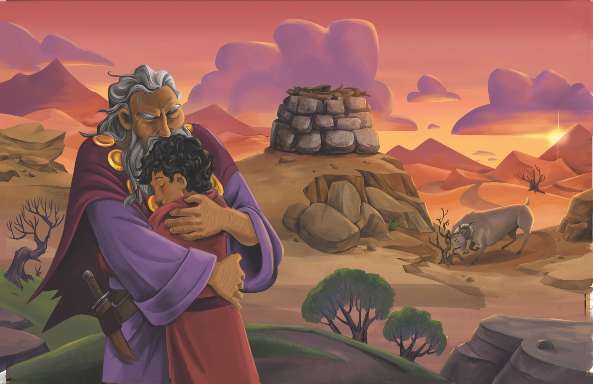Abraham and Isaac (Genesis 22)

Dear families,
In Genesis 22, we read how God tested Abraham and led him to place an awe-inspiring trust in the faithful God over all creation. Abraham revealed a faith in God which reflected the trustworthiness of His character and promises. In today’s story of Abraham and Isaac, we learn what it looks like to entrust everything to God and to believe He is worthy of our ultimate obedience.
What role does worship play in today’s passage? How do we see God’s faithfulness depicted from Genesis 22 throughout the rest of Scripture?
God called Abraham to offer up his only son as a sacrifice. Abraham’s response to what seemed like such an outlandish command from God was to get up early and begin his journey to the unknown place God would reveal to him. In verse 5, we see the first use of the Hebrew word for “worship” in the Bible, spoken in reference to the sacrificial offering Abraham was willing to lay down before his God.
When Isaac inquired about the lamb for the offering, Abraham replied, “God himself will provide.” Though, logically, the death of Abraham’s son would make God's promises impossible, God would faithfully provide the ram they needed, and make good on His promises to bless Abraham through his only son.
Hebrews 11:19 states that Abraham “considered God to be able even to raise someone from the dead.” Abraham’s faith-filled obedience demonstrated that God could be trusted in any circumstance. With each new command he received from God, his response was to obey. He did not shrink back or busy himself with the lesser concerns of the world because God had proven Himself faithful over and over.
Abraham’s deep love for his one and only son points us to the greater love God has for His Son, Jesus. Though this story tells of one man’s obedient willingness to give back to God his most prized gift, we can know that God’s love for His own Son reveals His great love for us as His people. Pray that God would reveal this same love to your children and that they, too, would be willing to offer back to Him their lives as living sacrifices of worship.

Check out The Gospel Project At Home for resources designed to help you lead a family worship experience as well as suggestions for morning and evening prayer times and family activities.

FAMILY TALKING POINTS

STORY POINT
This is the main point to emphasize from today’s Bible story.

- Preschool: Abraham trusted God.
- Kids: Abraham trusted God even when he did not understand God’s plan.

CHRIST CONNECTION
This is the big idea of how this week’s Bible story points to Jesus.

- Babies & Toddlers: God loves us and gave His Son, Jesus, to save the world from sin.
- Younger Preschool: Abraham loved God, and God provided a ram. God loves us and gave His Son, Jesus, to save the world from sin.
- Older Preschool: Abraham was willing to give up his son, but God provided a ram instead. God was willing to give His Son for us. Jesus died and rose again so we can have forgiveness and life with God forever.
- Kids: Abraham was willing to give his only son for God, but God provided another way. God was willing to give His only Son for us. Jesus knew there was no other way to save God’s people, so He died and rose again to provide them with forgiveness and life with God forever.

BIG PICTURE QUESTION & ANSWER
This is an important biblical truth that your child will encounter each week of this unit.

- Younger Preschool: Who keeps His promises? God keeps His promises.
- Older Preschool: Does God keep His promises? Yes, God always keeps His promises.
- Kids: T Does God keep His promises? Yes, God always keeps His promises because He is faithful.

KEY PASSAGE
This is a Bible verse that relates to what your child will encounter each week of this unit.

- Babies & Toddlers: God is good, and His love is forever. Psalm 100:5
- Younger Preschool: The LORD is good, and His love lasts forever. Psalm 100:5
- Older Preschool: For the LORD is good, and his faithful love endures forever. Psalm 100:5
- Kids: For the LORD is good, and his faithful love endures forever; his faithfulness, through all generations. Psalm 100:5

** Next week: A Wife for Isaac (Genesis 24–25)

Unit 2, Session 4
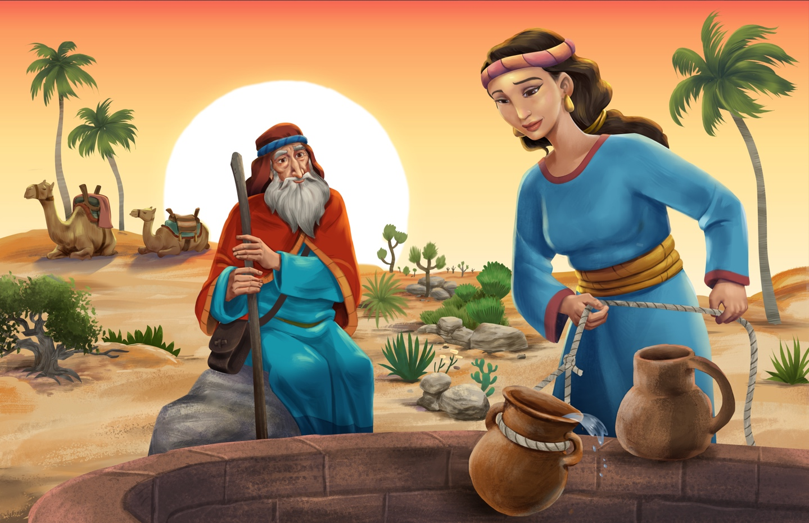A Wife for Isaac (Genesis 24–25)

Dear families,
In Genesis 24-25, we find the next step in God’s plan for Abraham: finding a wife for Isaac. The first verse reveals that God blessed Abraham in everything. Abraham had trusted in God, who had taken him from his native land and had sworn to provide for his every need. Now, he trusted God to fulfill the next step in His promises, believing God would guide his servant’s steps in the search for Isaac’s wife.
How do we see God's continued faithfulness to His promise in the story of Rebekah and Isaac? How can that encourage us today?
Abraham wanted to make sure his son’s wife would be from his own land and people, not from the land of Canaan. So, he sent his trusted servant on a mission to find the wife God would provide. Prayerfully, the servant asked God for favor on this journey. But before he had finished asking God to bless him on this mission, God was already answering his prayer.
God had gone before Abraham's servant to provide for Isaac. The servant’s immediate response to Rebekah's kindness was worship to the God who “has not withheld his kindness and faithfulness.” Rebekah’s family knew Abraham’s servant had likewise been blessed by God and answered in response to this marriage proposal: “This is from the LORD; we have no choice in the matter.” They trusted in God’s goodness on their behalf and allowed His plans to unfold, just as He had spoken.
God’s promise to bless Abraham hinged upon His provision of a wife for Isaac. Yet, God's provision is not contingent upon human reason or ability. God demonstrated His sovereign kindness to Abraham, his family, and his servant through fulfilling His Word to them. The same is true in God’s plan of redemption; He provided the ultimate One we needed–Jesus–to fulfill the covenant He made in Genesis! Jesus was sent to us to be the Servant we needed to fulfill God’s mission of restoring our relationship to Him.
Ask God to continue revealing Himself to your kids. Pray that He would make His ways know to them, that redemption and salvation would take hold of their lives as they grow to understand His great love for them in Jesus.

Check out The Gospel Project At Home for resources designed to help you lead a family worship experience as well as suggestions for morning and evening prayer times and family activities.

FAMILY TALKING POINTS

STORY POINT
This is the main point to emphasize from today’s Bible story.

- Preschool: God gave Isaac a wife to keep His promises.
- Kids: God gave Isaac a wife to keep His promises to bless the nations.

CHRIST CONNECTION
This is the big idea of how this week’s Bible story points to Jesus.

- Babies & Toddlers: We can know and love Jesus.
- Younger Preschool: God provided a wife for Isaac to know and love. God sent His servant—Jesus—to earth. Jesus died and rose again so people could know and love Him.
- Older Preschool: God provided a wife for Isaac. Abraham's servant brought back Rebekah so Isaac could know and love her. God sent His servant—Jesus—to seek and save people from sin and death. Jesus was faithful. He died and rose again so that people could know and love Him.
- Kids: God was faithful to provide a wife for Isaac. Abraham's servant brought back Rebekah so Isaac could know and love her. God sent His servant—Jesus—to seek and save people from sin and death. Jesus was faithful. He died and rose again so that people could know and love Him.

BIG PICTURE QUESTION & ANSWER
This is an important biblical truth that your child will encounter each week of this unit.

- Younger Preschool: Who keeps His promises? God keeps His promises.
- Older Preschool: Does God keep His promises? Yes, God always keeps His promises.
- Kids: T Does God keep His promises? Yes, God always keeps His promises because He is faithful.

KEY PASSAGE
This is a Bible verse that relates to what your child will encounter each week of this unit.

- Babies & Toddlers: God is good, and His love is forever. Psalm 100:5
- Younger Preschool: The LORD is good, and His love lasts forever. Psalm 100:5
- Older Preschool: For the LORD is good, and his faithful love endures forever. Psalm 100:5
- Kids: For the LORD is good, and his faithful love endures forever; his faithfulness, through all generations. Psalm 100:5

** Next week: Jacob and Esau (Genesis 25; 27)

Unit 3, Session 1
Jacob and Esau (Genesis 25; 27)

Dear families,
The story of God’s faithfulness to Abraham continues as we venture into the lives of Jacob and Esau in Genesis 25 and 27. Isaac prayed that God would bless their family with an heir, and God responded. We witness God's sovereignty in the lives of brothers Jacob and Esau as God's promises are fulfilled.
Earlier in Genesis 25, God revealed to Rebekah that she had conceived twins, and that in the end, the older would serve the younger. Before either had done good or bad, God chose Jacob to become the nation of Israel. (Rom. 9:10-11) In His kingdom, the ways and logic of the world do not prevail; God destined Jacob to be the one whose lineage would one day bring us the promised Savior, Jesus.
God’s ways came to pass in accordance with His own wisdom and will. Isaac blessed Jacob as an act of passing on the covenant of his father Abraham. Nothing could intercept God’s promise to bless Abraham’s family through Jacob; in the opposite way, no scheming on behalf of this family could interfere with this blessing being passed down to the younger son.
Each member of Isaac’s family had to trust, by faith, that God’s ways were best, however confusing His plans seemed. In the end, God’s plan to provide the way to redeem and restore mankind through the lineage of Jacob would be accomplished. Just as Isaac, Rebekah, and Jacob and even Esau had to surrender to God’s plans by faith, so, to do we surrender to God’s plan of restoring all things through His Son, Jesus. In Him, we receive the birthright promised to Abraham in its greatest and fullest measure, as God has “blessed us with every spiritual blessing in the heavens in Christ” (Ephesians 1:3).
True salvation comes to all who place their trust in Jesus. Pray that your children, whose hearts have been entrusted to you, would hear of God’s sovereign goodness and surrender their lives to His will. May they place their trust in Him and receive the ultimate gift of everlasting life through His Son, Jesus.
Check out The Gospel Project At Home for resources designed to help you lead a family worship experience as well as suggestions for morning and evening prayer times and family activities.

FAMILY TALKING POINTS

STORY POINT
This is the main point to emphasize from today’s Bible story.

- Preschool: Jacob took Esau’s blessing.
- Kids: Rebekah and Jacob tricked Isaac into blessing Jacob.

CHRIST CONNECTION
This is the big idea of how this week’s Bible story points to Jesus.

- Babies & Toddlers: God keeps His promises.
- Younger Preschool: God’s promise for Abraham was a promise for Jacob too. One day, God would send Jesus to earth through Jacob’s family.
- Older Preschool: God’s promise for Abraham was a promise for Isaac and Jacob too. When Esau gave up his birthright, that meant Jacob would get the blessings God promised. One day, God would send Jesus to earth through Jacob’s family.
- Kids: God’s covenant with Abraham continued to the next generation. Esau sold his birthright, giving Jacob the right to the wonderful blessings God promised to his father Abraham. Through Jacob’s family, God would send the promised Savior to bring blessing and salvation to the world.

BIG PICTURE QUESTION & ANSWER
This is an important biblical truth that your child will encounter each week of this unit.

- Younger Preschool: Who is in control? God is in control.
- Older Preschool: Who is in control of everything? God is in control of everything.
- Kids: Who is in control of everything? God is in control of everything in heaven and on earth. Nothing is outside of God’s good plan.

KEY PASSAGE
This is a Bible verse that relates to what your child will encounter each week of this unit.

- Babies & Toddlers: God can make bad things good. Genesis 50:20
- Younger Preschool: God can make bad things good. Genesis 50:20
- Older Preschool: You planned evil against me; God planned it for good. Genesis 50:20
- Kids: You planned evil against me; God planned it for good to bring about the present result—the survival of many people. Genesis 50:20

** Next week: Jacob Fled from Canaan (Genesis 28; 32)

Unit 3, Session 2
Jacob Fled from Canaan (Genesis 28; 32)

Dear families,
In today’s passage, God continued His faithfulness to Abraham by extending kindness to Jacob amidst a time of great turmoil. God promised to bless Jacob, be with him, watch over him, and never leave him until His faithful promises had been fulfilled. Jacob found himself at a crossroads, seemingly alone, and was tasked with finding a wife in accordance with God’s plan to bless their family.
What can we learn from Jacob’s time of trial and his wrestling with God? How can this help us when we are suffering or wrestling with God ourselves?
After receiving his father’s blessing, Jacob was instructed by his mother and father to flee Esau’s wrath and find a wife. While on the run, God visited Jacob in a dream by which He confirmed the promises He had made to Abraham. Even in Jacob's sinfulness, God's faithful lovingkindness was shown to him as God declared that His covenantal promises would continue through Jacob's family. Then, Jacob made a vow, just as God had made one to him: “If God remains with me, watches over me, provides for me, and returns me safely as He says He will, then He will be my God.”
Later in chapter 32, we see the next phase of Jacob’s journey with God, as he wrestled with Him unknowingly. Jacob said to the man, “I will not let you go unless you bless me.” The man—whom we know to be God—changed Jacob’s name from that of a deceiver to “Israel” Israel, meaning “He Sstruggled with God.” Despite Jacob's struggles with God, he prevailed and was blessed by Him. In the end, Jacob realized that God spared his life in this encounter. By grace, he was granted a new name and identity and was able to return home.
Today, we come to a similar crossroads as we wrestle with the role Jesus deserves in our lives as Savior and Lord. Those who surrender to Him by faith can, like Israel, experience new life in He who redeems and restores sinners, bringing them into His family forever. No longer are we bound by our old selves but given a new identity in Jesus.
Ask God to reveal to your kids the reality of the new life He offers in Jesus. Though we may not always understand His ways, God gives us grace as we come to surrender to His will for our lives. May His truth become clear in their hearts and minds as you teach them about His love.
Check out The Gospel Project At Home for resources designed to help you lead a family worship experience as well as suggestions for morning and evening prayer times and family activities.

FAMILY TALKING POINTS

STORY POINT
This is the main point to emphasize from today’s Bible story.

- Preschool: God promised to be with Jacob.
- Kids: God promised to be with Jacob.

CHRIST CONNECTION
This is the big idea of how this week’s Bible story points to Jesus.

- Babies & Toddlers: God calls us His children.
- Younger Preschool: God gave Jacob a new name, Israel. When we follow Jesus, God calls us His children.
- Older Preschool: God changed Jacob’s life and gave him a new name, Israel. By dying and rising from the dead, Jesus made the way for us to be adopted into God’s family. When we trust in Jesus, we get a new name, too—children of God.
- Kids: God changed Jacob and gave him a new name, Israel. Jesus came so that we might have a changed life, forgiven of sin. Jesus’ death and resurrection provided sinful people the way to be welcomed into God’s family forever.

BIG PICTURE QUESTION & ANSWER
This is an important biblical truth that your child will encounter each week of this unit.

- Younger Preschool: Who is in control? God is in control.
- Older Preschool: Who is in control of everything? God is in control of everything.
- Kids: Who is in control of everything? God is in control of everything in heaven and on earth. Nothing is outside of God’s good plan.

KEY PASSAGE
This is a Bible verse that relates to what your child will encounter each week of this unit.

- Babies & Toddlers: God can make bad things good. Genesis 50:20
- Younger Preschool: God can make bad things good. Genesis 50:20
- Older Preschool: You planned evil against me; God planned it for good. Genesis 50:20
- Kids: You planned evil against me; God planned it for good to bring about the present result—the survival of many people. Genesis 50:20

** Next week: Joseph Taken to Egypt (Genesis 37; 39-46; 50)

Unit 3, Session 3
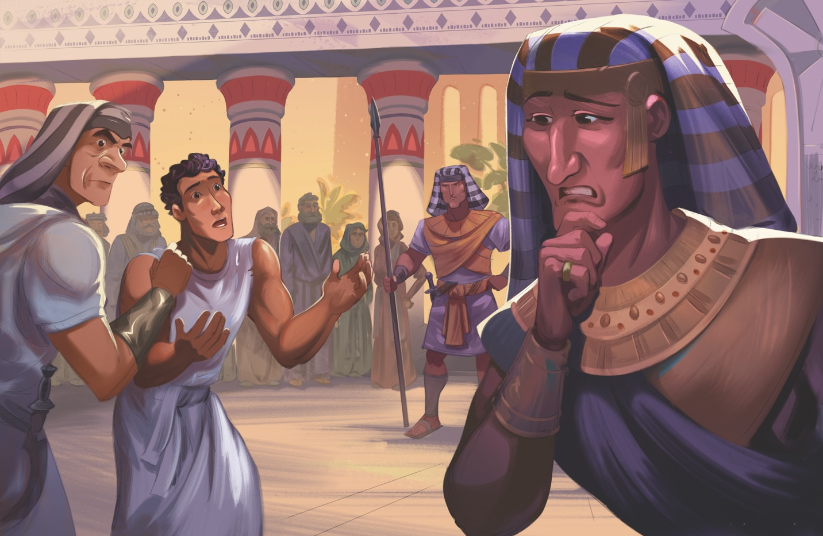Joseph Taken to Egypt (Genesis 37; 39-46; 50)

Dear families,
Today’s passage tells of God’s faithful covenant being carried from Abraham to Isaac, then to Jacob, and now Joseph. Jacob loved Joseph more than his brothers because he was born to Jacob in his old age. Jacob’s favoritism toward Joseph caused the others to feel deep anger toward Joseph.
Beyond Jacob's treatment of Joseph, his sons grew even angrier after hearing of their brother's dream, in which Joseph would reign over each of his siblings and their parents, too. The brothers’ jealousy and anger loomed so large that they schemed to take Joseph’s life; however, they settled with selling him into slavery instead, making it appear as though an animal had killed him.
In Egypt, Joseph became a slave of the officer Potiphar, who promoted him over his household. God gave Joseph great success in serving his new master. Joesph obeyed God amidst life’s challenges, even against the temptation of Potiphar’s wife, in which he declared, “...how could I sin against God?” Though this refusal would send Joseph to prison, God was with him and granted him favor despite his terrible circumstances. Even the warden knew God was with him.
God gave Joseph the ability to interpret his fellow prisoners’ dreams and Pharaoh’s dreams as well. God's sovereign care to be with Joseph and give him the ability to interpret dreams resulted in him being raised to oversee Pharaoh's entire household. As Joseph served Pharaoh, God granted him wisdom to provide grain during a famine, not just for others in the land, but for his brothers as well. This is a full-circle story of God's sovereign provision, faithfulness, and grace through trials.
At the closing of Genesis, Joseph—in the aftermath of slavery, famine, and injustice—declares that God used his brothers’ evil plans to bring about flourishing for His people. Joseph extended words of comfort, courage, and kindness his brothers did not deserve.
In Christ, we receive an even greater gift—everlasting life, the undeserved bestowal of immeasurable peace, courage, and kindness. Christ experienced injustice and suffering on our behalf so that we might gain eternal life and redemption. As faithful to God as Joseph was, Jesus is even more faithful, forever renowned as the suffering Servant who takes away our sin. Pray for your kids to place their faith in the One who redeems our sins and suffering for His glory and our good.
Check out The Gospel Project At Home for resources designed to help you lead a family worship experience as well as suggestions for morning and evening prayer times and family activities.

FAMILY TALKING POINTS

STORY POINT
This is the main point to emphasize from today’s Bible story.

- Preschool: God was always with Joseph and took care of him.
- Kids: God was always with Joseph and blessed him.

CHRIST CONNECTION
This is the big idea of how this week’s Bible story points to Jesus.

- Babies & Toddlers: God’s plans are good.
- Younger Preschool: Even when bad things happened, God had a good plan. Jesus was killed on a cross, but He rose again to rescue people from sin.
- Older Preschool: Even when bad things happened, God had a plan for good. Jesus never sinned, but He was arrested, beaten, and killed on a cross to bring about our good—so people could be saved from sin through Jesus’ life, death, and resurrection.
- Kids: Even when bad things were happening in Joseph's life, God had a plan for good. Bad things also happened to Jesus. Jesus never sinned, but He was arrested, beaten, and killed on a cross. Those things happened to bring about our good—so people could be saved from sin and death through Jesus’ life, death, and resurrection.

BIG PICTURE QUESTION & ANSWER
This is an important biblical truth that your child will encounter each week of this unit.

- Younger Preschool: Who is in control? God is in control.
- Older Preschool: Who is in control of everything? God is in control of everything.
- Kids: Who is in control of everything? God is in control of everything in heaven and on earth. Nothing is outside of God’s good plan.

KEY PASSAGE
This is a Bible verse that relates to what your child will encounter each week of this unit.

- Babies & Toddlers: God can make bad things good. Genesis 50:20
- Younger Preschool: God can make bad things good. Genesis 50:20
- Older Preschool: You planned evil against me; God planned it for good. Genesis 50:20
- Kids: You planned evil against me; God planned it for good to bring about the present result—the survival of many people. Genesis 50:20

** Next week: The Suffering of Job (Job)

Unit 3, Session 4
The Suffering of Job (Job)

Dear families,
Job’s story is an impactful passage on human suffering and God’s sovereign goodness that transcends any circumstance. The book of Job shares of a God-fearing, virtuous man who continually turned from evil. Though he was not sinless, Job was counted righteous by his faith in God until the end.
How does Job respond when unexpected suffering comes to him? How does Job’s story encourage us in our own suffering?
In the beginning of Job, we see an interaction between Satan and God, in which the Creator allows Satan to test Job to see if he would continue to follow God amidst suffering. Job would lose his sheep, camels, servants, and children. In response to this loss, Job worshiped God and refused to blame Him. Next, Job would become afflicted by painful boils. Despite Job's tragic sufferings, he refused to speak ill of God, even when his own wife told him to give up his faith.
In the following chapters, Job wrestled with his experiences in suffering, as his three friends tried in vain to comfort and help him in his pain. They could not fathom that Job’s suffering did not result from sin. However, another voice, that of Elihu, spoke into Job’s circumstances with true wisdom: God is greater than man, holy, and just; only He is righteous and sinless.
God met Job amidst his questions, reminding him of man’s place within His created universe. Though mankind is unworthy of God’s goodness, the Creator delights in showcasing His glory to the ones He has made. After Job prayed for his friends, his fortune was not only restored, but it was doubled.
Although God allowed Job to suffer, His hand was there to guide him, and His comfort remained by his side. What we glean from Job’s story is that God’s righteousness is so much greater than our own, that He is worthy of worship despite our circumstances. In 2 Corinthians 4:17, Paul declared that “our momentary light affliction is producing for us an absolutely incomparable eternal weight of glory.”
There is only one truly righteous person who suffered unjustly: Jesus Christ, the Son of God. Help kids see that God is good, and His full worthiness is displayed in Jesus, the only truly righteous One. By faith in His finished work on the cross, we are counted as righteous and granted eternal hope. Pray that your kids will experience God's goodness and place their faith in Him alone.
Check out The Gospel Project At Home for resources designed to help you lead a family worship experience as well as suggestions for morning and evening prayer times and family activities.

FAMILY TALKING POINTS

STORY POINT
This is the main point to emphasize from today’s Bible story.

- Preschool: God is always good.
- Kids: God is good even in suffering.

CHRIST CONNECTION
This is the big idea of how this week’s Bible story points to Jesus.

- Babies & Toddlers: God is strong and mighty and good.
- Younger Preschool: God is all-powerful and good. When we face hard times, we can trust God. God sent Jesus to die on the cross and rescue people from sin.
- Older Preschool: Job saw that God is all-powerful and good. When we face hard times, we can trust God. God sent Jesus, who never did wrong, to suffer and die so that everyone who trusts in Him can have life with God forever.
- Kids: In his suffering, Job recognized that God is all-powerful and good. When we face suffering, we can hope in God. God sent Jesus, the only truly innocent One, to suffer and die so that everyone who trusts in Him can have forgiveness and eternal life.

BIG PICTURE QUESTION & ANSWER
This is an important biblical truth that your child will encounter each week of this unit.

- Younger Preschool: Who is in control? God is in control.
- Older Preschool: Who is in control of everything? God is in control of everything.
- Kids: Who is in control of everything? God is in control of everything in heaven and on earth. Nothing is outside of God’s good plan.

KEY PASSAGE
This is a Bible verse that relates to what your child will encounter each week of this unit.

- Babies & Toddlers: God can make bad things good. Genesis 50:20
- Younger Preschool: God can make bad things good. Genesis 50:20
- Older Preschool: You planned evil against me; God planned it for good. Genesis 50:20
- Kids: You planned evil against me; God planned it for good to bring about the present result—the survival of many people. Genesis 50:20

** Next week: God Called Moses (Exodus 1–4)

