Ministry Leaders: A suggested email is provided for each session for you to customize if you desire and share with your families. You can also access a social media share square for each session on the Additional Resources page at gospelproject.com.

The Gospel Project At Home content is available in Ministry Grid for you to share with your families.
Unit 10, Session 1
Israel Demanded a King (1 Samuel 8–10)
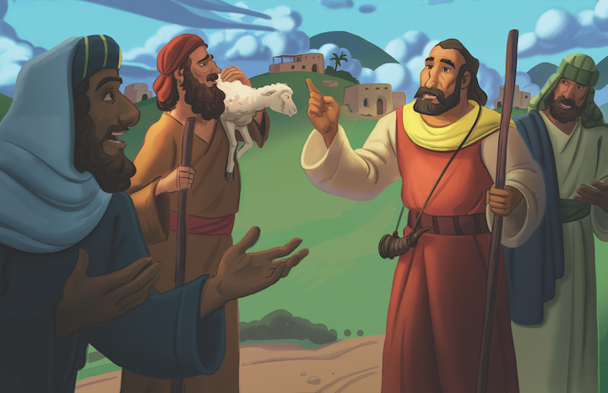
Dear families,

It can happen to any of us: We look at our circumstances, forecast a coming trial or opportunity, and act accordingly—only to find out that the situation doesn’t play out quite like we expected.
This is precisely what happened in 1 Samuel 8–10. The people of Israel, while assessing their circumstances, discerned that Samuel’s days were numbered. They recognized that his sons, Joel and Abijah, had turned to dishonesty and against the ways of their father. So, they predicted that they would soon have no one to lead them and that something must be done.
The elders of Israel believed they knew what was best and demanded that Samuel appoint a new king who would lead them “the same as all the other nations” (1 Sam 8:5).
We can do the same. With the best of intentions, we can hastily seek what we believe is best without consideration of the Lord’s plans, desires, or wisdom. This may happen in search of a new job, in response to conflict, in making family decisions, or even in determining how to best minister to people in our church or community.
How do we know that our decisions, desires, and actions align with what God wants? Be encouraged to do three things as you seek the Lord’s wisdom in these moments of decision: Pray, read God’s Word, and seek counsel.
When we pray, we humble ourselves before the Almighty God and submit our desires to Him. When we read God’s Word, we discover His desires, plans, and will in the most clearly revealed way so that we might walk in them. And when we seek counsel, we open ourselves to the community of believers to be shaped, formed, sharpened, and corrected.
Proverbs 3:5-6 remind us, “Trust in the LORD with all your heart, and do not rely on your own understanding; in all your ways know him, and he will make your paths straight.”
Taking the time to pray, read the Bible, and seek the counsel of brothers and sisters in Christ is an act of refusal to rely on our own understanding, instead submitting ourselves to God’s authority and ensuring that we don’t get ahead of Him.
Check out The Gospel Project At Home for resources designed to help you lead a family worship experience as well as suggestions for morning and evening prayer times and family activities.

FAMILY TALKING POINTS

CHRIST CONNECTION
This is the big idea of how this week’s Bible story points to Jesus.

- Babies & Toddlers: God sent His Son, Jesus, to be king over the world.
- Younger Preschool: God gave the Israelites a king, but He had a plan to send His Son, Jesus, to be king over the whole world. Jesus would be the perfect King.
- Older Preschool: The Israelites did not trust God. They wanted a king. God gave the Israelites a king, but He had a plan to send His Son, Jesus, to be king over the whole world. Jesus would be the perfect King. Jesus would bring peace and save people from sin.
- Kids: God intended for a heavenly king to rule over Israel, but the Israelites did not trust God’s plan. They wanted a king like the nations around them. God had a better plan: to eventually send His Son, Jesus, to be the perfect King forever.

BIG PICTURE QUESTION & ANSWER
This is an important biblical truth that your child will encounter each week of this unit.

- Younger Preschool: Why does sin separate us from God? Because God is holy.
- Older Preschool: Why does sin separate us from God? Because God is holy.
- Kids: Why does sin separate us from God? Because God is holy, sin has broken our relationship with God.

KEY PASSAGE
This is a Bible verse that relates to what your child will encounter each week of this unit.

- Babies & Toddlers: My eyes have seen the Lord. Isaiah 6:5
- Younger Preschool: My eyes have seen the Lord. Isaiah 6:5
- Older Preschool: I said: Woe is me ... because I am a man of unclean lips ... and ... my eyes have seen the ... LORD. Isaiah 6:5
- Kids: Then I said: Woe is me for I am ruined because I am a man of unclean lips and live among a people of unclean lips, and because my eyes have seen the King, the LORD of Armies. Isaiah 6:5

** Next week: God Made Saul King (1 Samuel 11)

Unit 10, Session 2
God Made Saul King (1 Samuel 11)
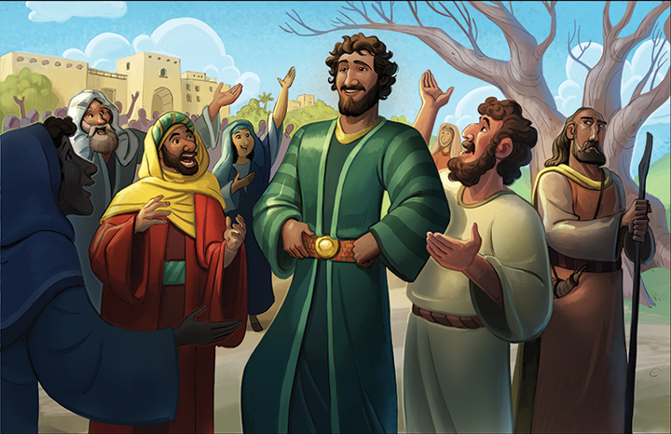
Dear families,

Gilgal was a place the Israelites knew well. It was the first place their ancestors set foot in the promised land; the place where they built a memorial of 12 stones after crossing the Jordan with the ark of the covenant; a place that they looked back on and remembered the power, greatness, and provision of God. Gilgal wasn’t a place of convenience, but rather a place of significance.
Have you ever taken the time to revisit places of your past? Maybe you’ve driven past your childhood home and school, your first home, or the hospital where a family member was born. These nostalgic journeys can bring back all sorts of memories of heartbreak and victory, sadness and joy. Revisiting the past might flood your heart and mind with things you had long forgotten as well as things that can never be forgotten.
In the fast-paced world we live in today, we don’t go back often enough. For many, thinking about the past only slows down productivity. We rely on timeline photos as reminders but then quickly scroll to the news of the day and our plans for tomorrow.
What if we regularly returned to the past? What if we frequented the memorials of God’s power, greatness, and provision? It may be that part of why we run so hard after the tyranny of the urgent is because we’ve lost sight of God’s faithfulness through the ages.
It may not be a nostalgic drive through your hometown or a trip to the mountaintop where you were first gripped by the greatness of God, but a stroll down memory lane recalling the work that God has done is so very good for the soul.
The Israelites didn’t return to Gilgal because it was easy. They returned to Gilgal because amid their present circumstances, they needed to remember. And so do we.
Reflect on the great things that God has done—the ways you’ve seen His power, greatness, and provision. And as you do, let it grow your gratitude and hopefulness. For, as James 1:17 says, “Every good and perfect gift is from above, coming down from the Father of lights, who does not change like shifting shadows.”
Check out The Gospel Project At Home for resources designed to help you lead a family worship experience as well as suggestions for morning and evening prayer times and family activities.

FAMILY TALKING POINTS

CHRIST CONNECTION
This is the big idea of how this week’s Bible story points to Jesus.

- Babies & Toddlers: God sent Jesus to be our King.
- Younger Preschool: God chose Saul to be the king in Israel. With God’s help, Saul brought the Israelites together to win the battle. God sent His Son, Jesus, to be our King forever. Jesus came to rescue people from sin and death.
- Older Preschool: God chose Saul to be the king in Israel. With God’s help, Saul brought the Israelites together to win the battle. God sent His Son, Jesus, to be our King forever. Jesus came to rescue people from sin and death.
- Kids: God chose Saul to be the Israelites’ king. With God’s help, Saul brought the Israelites together to defeat their enemy. God sent His Son, Jesus, to be our King forever. Jesus brings together everyone who trusts in Him and gives us victory over sin and death.

BIG PICTURE QUESTION & ANSWER
This is an important biblical truth that your child will encounter each week of this unit.

- Younger Preschool: Why does sin separate us from God? Because God is holy.
- Older Preschool: Why does sin separate us from God? Because God is holy.
- Kids: Why does sin separate us from God? Because God is holy, sin has broken our relationship with God.

KEY PASSAGE
This is a Bible verse that relates to what your child will encounter each week of this unit.

- Babies & Toddlers: My eyes have seen the Lord. Isaiah 6:5
- Younger Preschool: My eyes have seen the Lord. Isaiah 6:5
- Older Preschool: I said: Woe is me ... because I am a man of unclean lips ... and ... my eyes have seen the ... LORD. Isaiah 6:5
- Kids: Then I said: Woe is me for I am ruined because I am a man of unclean lips and live among a people of unclean lips, and because my eyes have seen the King, the LORD of Armies. Isaiah 6:5

** Next week: Saul Sinned and Was Rejected (1 Samuel 13–15)

Unit 10, Session 3
Saul Sinned and Was Rejected (1 Samuel 13–15)
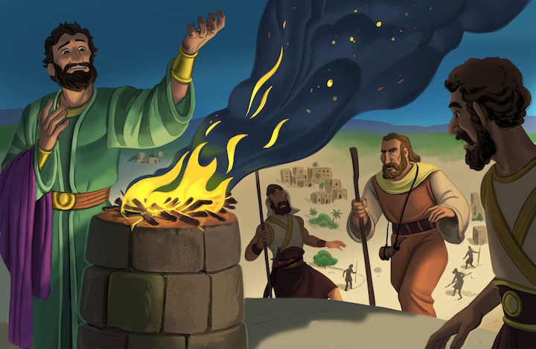
Dear families,

The sacrificial system of the Old Testament was the rhythm and practice of the people of God for many generations. It brought about reminders of the authority of God and the sin of the people. God used these sacrifices as temporary atonement for sin and a foreshadowing of the permanent sacrifice of Jesus that was to come.
Some Old Testament figures practiced these sacrifices with precision as prescribed by God. For others, the sacrifices were a good luck charm or “Get Out of Jail Free” card. In 1 Samuel 14–15, Saul built an altar and used sacrifice to try to earn back the favor of both God and Samuel.
Samuel’s response to these things cut Saul deeply. “Does the Lord take pleasure in burnt offerings and sacrifices as much as in obeying the Lord? Look: to obey is better than sacrifice, to pay attention is better than the fat of rams” (1 Sam. 15:22).
The answer to Samuel’s rhetorical question is a resounding “No!” God does not desire sacrifice more than obedience; He desires obedient sacrifice. Though it was possible to sacrifice and disobey, it was never possible to obey and not sacrifice. God’s desire was for sacrifice to come from a broken and contrite heart that understood the weight of one’s sin and the need for forgiveness before a holy and righteous God. To practice sacrifice with any other motivation was to disobey.
Though we don’t live under the ceremonial law of the Old Testament, we do live under the authority of God. And though we don’t use the blood and meat of animals to try to satisfy God, we are certainly guilty of trying to please Him with religious practices.
For some Christians, there is a quiet hope that checking the boxes of daily disciplines will satisfy God’s wrath toward our sin. For some Christians, the applause of men drives the public display of their faith. In either instance, Christians are seeking to earn the favor of both God and man through their “sacrifice,” when God’s desire is for our whole-hearted obedience out of love for Him.
Consider today what areas you may be tempted to try and impress God or earn back His love. Confess those things and be reminded that what God wants is your love for Him above all else and your confidence that His sacrifice of Christ is sufficient to make you right before Him.
Check out The Gospel Project At Home for resources designed to help you lead a family worship experience as well as suggestions for morning and evening prayer times and family activities.

FAMILY TALKING POINTS

CHRIST CONNECTION
This is the big idea of how this week’s Bible story points to Jesus.

- Babies & Toddlers: King Jesus obeyed God in everything He did.
- Younger Preschool: God made Saul king, but King Saul did not obey God. God sent His Son, Jesus, to be king over everything. King Jesus obeyed God perfectly.
- Older Preschool: God made Saul king, but King Saul did not obey God. God sent His Son, Jesus, to be king over everything. King Jesus obeyed God perfectly and died so we can be forgiven.
- Kids: God gave the Israelites a king, but Saul did not obey God. God had a plan to send His Son, Jesus. King Jesus trusted and obeyed God perfectly and died so sinners could be forgiven and accepted.

BIG PICTURE QUESTION & ANSWER
This is an important biblical truth that your child will encounter each week of this unit.

- Younger Preschool: Why does sin separate us from God? Because God is holy.
- Older Preschool: Why does sin separate us from God? Because God is holy.
- Kids: Why does sin separate us from God? Because God is holy, sin has broken our relationship with God.

KEY PASSAGE
This is a Bible verse that relates to what your child will encounter each week of this unit.

- Babies & Toddlers: My eyes have seen the Lord. Isaiah 6:5
- Younger Preschool: My eyes have seen the Lord. Isaiah 6:5
- Older Preschool: I said: Woe is me ... because I am a man of unclean lips ... and ... my eyes have seen the ... LORD. Isaiah 6:5
- Kids: Then I said: Woe is me for I am ruined because I am a man of unclean lips and live among a people of unclean lips, and because my eyes have seen the King, the LORD of Armies. Isaiah 6:5

** Next week: God Is Good to Judge Sin (Genesis 18)

Unit 10, Session 4
God Is Good to Judge Sin (Genesis 18)
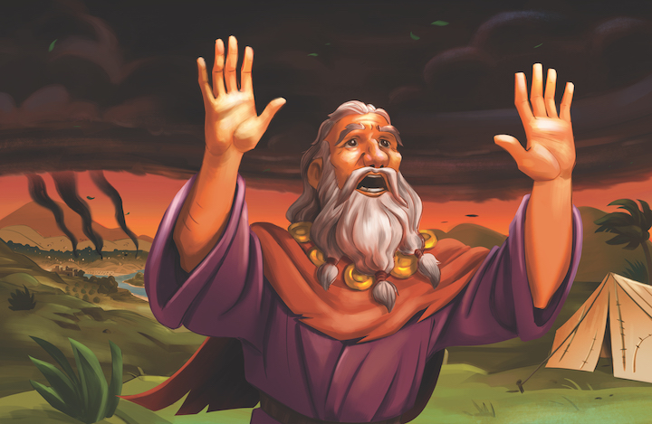
Dear families,

There is something inside of each of us that longs for justice. When your family or community is impacted by an atrocity, there is an innate wiring to every person that desires to those responsible be punished. Where does this come from and what should we do with this?
Our desire for justice comes as a result of our being made in the image of God. We learn from Scripture that God formed each of us (Ps. 139:13) and created us in His image (Gen. 1:27). Being created in the image of God and by the hand of God leaves us with certain characteristics informed by our Creator.
So, what should we do? Should we respond to every act of sin with an act of justice? Should we point and scream when another image bearer demonstrates her sinful nature? Should we ignore evil acts and simply “let God take care of it”?
Genesis 18 speaks to some of this. As God began to unfold His plan to punish the people of Sodom and Gomorrah, Abraham stepped in. Abraham knew firsthand just how sinful these people were, how distorted their views of the world were, and how extreme their culture had turned as a result. Yet, he pleaded for God to show mercy.
It’s likely that there were people that Abraham knew and worried about. It’s clear that Abraham didn’t want those who followed God to be punished along with those who did not. But it seems there was something in Abraham that desired God to show mercy to other sinners because he knew his own great need for God’s mercy as well.
When we see that the ground is level at the foot of the cross, our desire for justice is often—at least in part—overcome by a desire for mercy. When we see ourselves in need of the same mercy as the offender we have in our sights, it may likely change how we think and pray.
Ultimately, God is the judge who discerns where there is mercy. Scripture reminds us, “What should we say then? Is there injustice with God? Absolutely not! For he tells Moses, I will show mercy to whom I will show mercy, and I will have compassion on whom I will have compassion.” (Rom. 9:14-15)
Check out The Gospel Project At Home for resources designed to help you lead a family worship experience as well as suggestions for morning and evening prayer times and family activities.

FAMILY TALKING POINTS

CHRIST CONNECTION
This is the big idea of how this week’s Bible story points to Jesus.

- Babies & Toddlers: Jesus took the punishment for our sins.
- Younger Preschool: God is good to judge sin, and He always does what is right. Jesus took the punishment for our sin, and Jesus gives life to everyone who trusts in Him.
- Older Preschool: God is good to judge sin. He is the Judge of all the earth, and He always does what is right. The good news of the gospel is that Jesus took the punishment our sin deserves, and Jesus gives His righteousness to everyone who trusts in Him.
- Kids: God is good to judge sin. He is the Judge of all the earth, and He always does what is right. God will punish the guilty. The good news of the gospel is that Jesus took the punishment our sin deserves, and everyone who trusts in Him is declared righteous before God.

BIG PICTURE QUESTION & ANSWER
This is an important biblical truth that your child will encounter each week of this unit.

- Younger Preschool: Why does sin separate us from God? Because God is holy.
- Older Preschool: Why does sin separate us from God? Because God is holy.
- Kids: Why does sin separate us from God? Because God is holy, sin has broken our relationship with God.

KEY PASSAGE
This is a Bible verse that relates to what your child will encounter each week of this unit.

- Babies & Toddlers: My eyes have seen the Lord. Isaiah 6:5
- Younger Preschool: My eyes have seen the Lord. Isaiah 6:5
- Older Preschool: I said: Woe is me ... because I am a man of unclean lips ... and ... my eyes have seen the ... LORD. Isaiah 6:5
- Kids: Then I said: Woe is me for I am ruined because I am a man of unclean lips and live among a people of unclean lips, and because my eyes have seen the King, the LORD of Armies. Isaiah 6:5

** Next week: God Chose David to be King (1 Samuel 16)

Unit 11, Session 1
God Chose David to be King (1 Samuel 16)
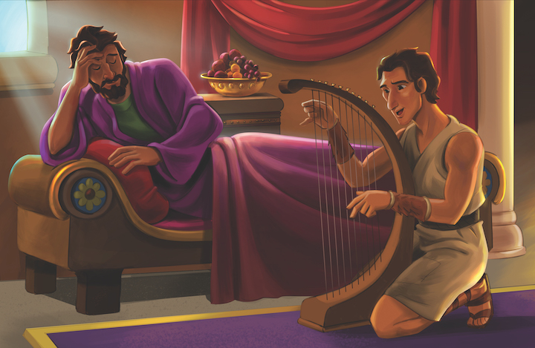
Dear families,

One of God’s good gifts to us is the way He uses the most unexpected people in the most unexpected ways. We’ve all probably seen this happen at times. A young man or woman that rises to prominence in his or her vocation, but no one saw it coming.
We see this in sports, in business, and other arenas. But in the kingdom of God, it’s not just something you might see occasionally; it’s standard.
Isaiah 55:9 says, “For as heaven is higher than earth, so my ways are higher than your ways, and my thoughts than your thoughts.”
God has been in the business of bringing about surprising stories of unsung heroes since the beginning of time. In 1 Samuel 16, we find one more example of this. God chose to use David, a young boy with a shepherd staff and some musical ability, to lead Israel in a time of desperation.
Do you ever find yourself trying to hone the skills that God has used in others in hopes that He might use you too? Have you ever wished you were wired or gifted differently so you could do something specific for the Lord? Rest assured, God is not interested in only a specific set of gifts or a particular personality type. God desires to use you just the way He made you.
Find comfort in knowing that He didn’t mess up when He made you. He won’t waste a gift He has given you, and He wants you to grow in those ways so that at just the right time and in just the right way, your gifts can be used for His kingdom purposes.
Who would have thought that David’s ability to play the lyre would get him into Saul’s inner circle? God did. It was His plan all along. And it is His plan to use you in great ways too. He will not waste the gifts He’s given you. Be open and willing to serve Him for His glory and your joy.
Check out The Gospel Project At Home for resources designed to help you lead a family worship experience as well as suggestions for morning and evening prayer times and family activities.

FAMILY TALKING POINTS

CHRIST CONNECTION
This is the big idea of how this week’s Bible story points to Jesus.

- Babies & Toddlers: Jesus is the perfect King.
- Younger Preschool: People were surprised God chose David to be Israel’s next king. When Jesus came to earth, He seemed like a surprising choice for a king. Jesus is the perfect King who saves us from our sin.
- Older Preschool: God’s choice of David to be Israel’s next king was surprising. David was the youngest in his family, but God saw David’s heart for the Lord. When Jesus came to earth, He seemed like a surprising choice for a king. Jesus is the perfect King who saves us from our sin and reigns forever.
- Kids: Samuel anointed David, setting him apart to be the next king. God’s choice for Israel’s king was surprising; David was the youngest in his family, but God saw David’s heart for the Lord. When Jesus came to earth, He seemed like a surprising choice for a king. Jesus is the perfect King who saves us from our sin and reigns forever.

BIG PICTURE QUESTION & ANSWER
This is an important biblical truth that your child will encounter each week of this unit.

- Younger Preschool: What is grace? Grace is when God gives us something good even when we do not deserve it.
- Older Preschool: What is grace? Grace is when God gives us something good even when we do not deserve it.
- Kids: What is grace? Grace is when God gives us something good even when we do not deserve it.

KEY PASSAGE
This is a Bible verse that relates to what your child will encounter each week of this unit.

- Babies & Toddlers: God forgives our wrong choices. Ephesians 1:7
- Younger Preschool: God forgives our wrong choices. Ephesians 1:7
- Older Preschool: In him we have redemption through his blood, the forgiveness of our trespasses, according to the riches of his grace. Ephesians 1:7
- Kids: In him we have redemption through his blood, the forgiveness of our trespasses, according to the riches of his grace that he richly poured out on us with all wisdom and understanding. Ephesians 1:7-8

** Next week: David Fought Goliath (1 Samuel 17)

Unit 11, Session 2
David Fought Goliath (1 Samuel 17)
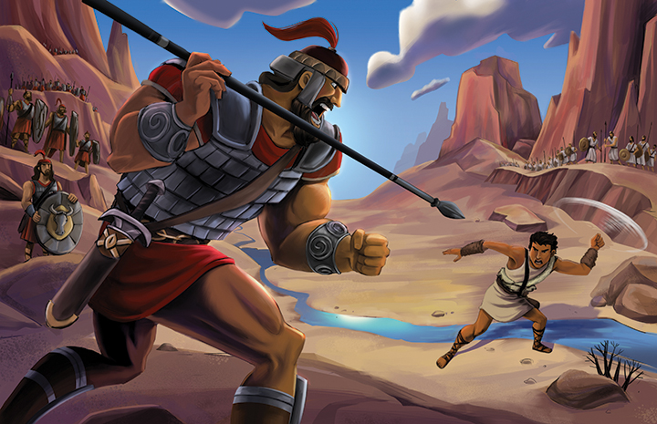
Dear families,

The name of the Lord is holy and set apart. For those who follow Christ, the name of God is one which ought to be held in high regard, above all other names.
In 1 Samuel 17, Goliath, the giant warrior of the Philistines, showed little regard for the God of the Israelites. He mocked not only the armies of Israel, but their God as well. Though Goliath had his own gods by whom he cursed David, he did not count the God of Israel to be of any value.
When Goliath mocked the name of the Lord by mocking David and the Israelites, the power of God was unleashed through the most unlikely of people. As the Philistines ran for their lives, they were reminded that there is more power in the youngest and weakest of God’s children than there is in the largest and strongest of the rest of the world.
The power of God is revealed in every instance in Scripture where the name of the Lord is used. When God-fearing prophets, priests, and ordinary people call on the name of the Lord God, we see time and again the power of God put on display.
When David encountered the giant, he said, “I come against you in the name of the LORD of Armies, the God of the ranks of Israel” (1 Sam. 17:45). David knew the power of God’s name. And once again, God proved to be unwilling to be mocked and unshakable in power.
The power of the name of God is seen most notably in the person and work of Jesus Christ. Paul wrote in Philippians 2:9-11, “For this reason God highly exalted him and gave him the name that is above every name, so that at the name of Jesus every knee will bow—and every tongue will confess that Jesus Christ is Lord, to the glory of God the Father.”
Jesus guarded God’s name in that even though He was tempted in every way, He was without sin. Jesus demonstrated the power of God’s name through His death, burial, and resurrection. That power will never fail or be defeated, and that power is yours in Christ.
Check out The Gospel Project At Home for resources designed to help you lead a family worship experience as well as suggestions for morning and evening prayer times and family activities.

FAMILY TALKING POINTS

CHRIST CONNECTION
This is the big idea of how this week’s Bible story points to Jesus.

- Babies & Toddlers: Jesus came to save us from sin and death.
- Younger Preschool: The men in Israel’s army were afraid of Goliath, but God gave David power to beat Goliath. David reminds us of Jesus. Jesus came to save us from sin and death.
- Older Preschool: The men in Israel’s army were afraid of Goliath, but God gave David power to beat Goliath. David reminds us of Jesus. Jesus came to save us from our biggest enemies: sin and death. Jesus is the hero who saves us so we can live with Him forever.
- Kids: The Israelites were not strong enough to fight Goliath, the mighty Philistine warrior, on their own. God gave David power to defeat Goliath. David reminds us of Jesus, who came to save us from our greatest enemies: sin and death. Jesus, the ultimate hero, saves us from our sin and gives us eternal life.

BIG PICTURE QUESTION & ANSWER
This is an important biblical truth that your child will encounter each week of this unit.

- Younger Preschool: What is grace? Grace is when God gives us something good even when we do not deserve it.
- Older Preschool: What is grace? Grace is when God gives us something good even when we do not deserve it.
- Kids: What is grace? Grace is when God gives us something good even when we do not deserve it.

KEY PASSAGE
This is a Bible verse that relates to what your child will encounter each week of this unit.

- Babies & Toddlers: God forgives our wrong choices. Ephesians 1:7
- Younger Preschool: God forgives our wrong choices. Ephesians 1:7
- Older Preschool: In him we have redemption through his blood, the forgiveness of our trespasses, according to the riches of his grace. Ephesians 1:7
- Kids: In him we have redemption through his blood, the forgiveness of our trespasses, according to the riches of his grace that he richly poured out on us with all wisdom and understanding. Ephesians 1:7-8

** Next week: God Made a Covenant with David (2 Samuel 6–7)

Unit 11, Session 3
God Made a Covenant with David (2 Samuel 6–7)
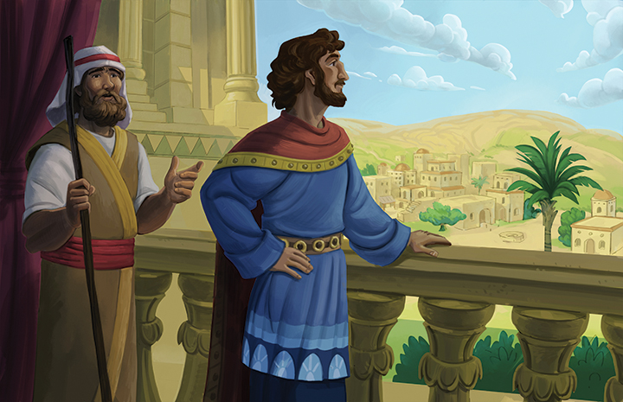
Dear families,

David is described in the Bible as a man after God’s own heart. (1 Sam. 13:14) Though at times David showed the depth of his depravity, he also demonstrated a love for God that was radical. In 2 Samuel 6, we see this take the form of David dancing with all his might before the Lord.
There was much external evidence of David’s love for God, including his praising and rejoicing, dancing, and playing instruments. We also see in David’s life a depth of love for God as evidenced in the way that he prayed.
In 2 Samuel 7:18, after David heard from the Lord through Nathan, we find the beginning of an incredibly humble prayer of thanksgiving to God. David’s first response to the great things that God had promised Him was to say, “Who am I, Lord GOD, and what is my house that you have brought me this far?”
David didn’t stand up taller or display an attitude that suggested he deserved God’s blessing. He did just the opposite of that. David recognized that he simply didn’t deserve the good things that God had done and had promised to do.
When you think about God’s great work in your life or when you read His Word and recall His precious and very great promises, what is your response? Do you find yourself believing you deserve it and wishing there was more, or do you rightfully understand that God alone has brought you this far, leading you to respond in praise and thanksgiving?
This week, take the time to remember some of the great things that God has done in your life, how He saved you and others in your life. Remember how He has given you victory over sin. Remember the things you’ve seen God do in the lives of friends and family members.
Humbly thank God for what He’s done, and boldly ask Him to continue to work—not because you deserve it but because you desire to see, know, and love God more.
Check out The Gospel Project At Home for resources designed to help you lead a family worship experience as well as suggestions for morning and evening prayer times and family activities.

FAMILY TALKING POINTS

CHRIST CONNECTION
This is the big idea of how this week’s Bible story points to Jesus.

- Babies & Toddlers: Jesus will be King over God’s people forever.
- Younger Preschool: God promised that future kings of Israel would come from David’s family. God kept His promise. God sent His Son, Jesus. Jesus will be King over God’s people forever.
- Older Preschool: God promised David that future kings of Israel would come from David’s family. God kept His promise. God sent His Son, Jesus, as part of David’s family. Jesus is our King. Jesus is alive, and He will be King over God’s people forever.
- Kids: God promised David that future kings of Israel would come from David’s family, and David’s kingdom would last forever. God kept His promise by sending His Son, Jesus, as one of David’s descendants. Jesus is our King who will rule over God’s people forever.

BIG PICTURE QUESTION & ANSWER
This is an important biblical truth that your child will encounter each week of this unit.

- Younger Preschool: What is grace? Grace is when God gives us something good even when we do not deserve it.
- Older Preschool: What is grace? Grace is when God gives us something good even when we do not deserve it.
- Kids: What is grace? Grace is when God gives us something good even when we do not deserve it.

KEY PASSAGE
This is a Bible verse that relates to what your child will encounter each week of this unit.

- Babies & Toddlers: God forgives our wrong choices. Ephesians 1:7
- Younger Preschool: God forgives our wrong choices. Ephesians 1:7
- Older Preschool: In him we have redemption through his blood, the forgiveness of our trespasses, according to the riches of his grace. Ephesians 1:7
- Kids: In him we have redemption through his blood, the forgiveness of our trespasses, according to the riches of his grace that he richly poured out on us with all wisdom and understanding. Ephesians 1:7-8

** Next week: David Sinned and Was Forgiven (2 Samuel 11–12)

Unit 11, Session 4
David Sinned and Was Forgiven (2 Samuel 11–12)
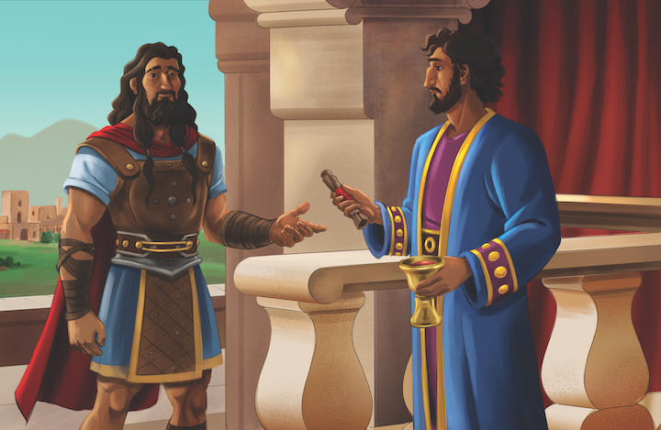
Dear families,

Why is it that we can be so quick to see the sins of others, but have such a hard time seeing our own? In 2 Samuel 12, after David had grievously sinned against Bathsheba, Uriah, and ultimately the Lord, he was confronted by Nathan and forced to see the disgust of his own failure.
Nathan came to David with a word from the Lord intended to help him see the significance of his own sin, but David’s response suggests that he wished judgment on another for the very same thing he had done himself.
David’s sin had snowballed as he tried to cover it up. Ultimately, David’s sin escalated to the point of murder. David quickly moved on to the next phase of his cover-up operation and seemed to have satisfactorily dealt with his failure, keeping the circle of those who knew the truth as small as possible. But Nathan was able to confront David in his sin. Nathan helped David see the sickness of his own heart and actions, and he shared with David what he could expect as a consequence of his sin.
David needed what each of us needs as well: someone else to help us walk with the Lord and show us what we are sometimes unwilling to see about ourselves. What Nathan did for David was painful but powerful. Nathan helped David see sin in his life that needed to be dealt with.
Who in your life has the Lord used or could the Lord use to help you see the dark places in you that no one else knows? Who in your life that the Lord might use to help bring about true repentance?
Proverbs 27:17 says, “Iron sharpens iron, and one person sharpens another.” Iron is sharpened by one surface rubbing against another so that the imperfections can be broken away. As we follow Jesus, we need one another to walk in the light and find forgiveness in the Lord.
Check out The Gospel Project At Home for resources designed to help you lead a family worship experience as well as suggestions for morning and evening prayer times and family activities.

FAMILY TALKING POINTS

CHRIST CONNECTION
This is the big idea of how this week’s Bible story points to Jesus.

- Babies & Toddlers: God forgives our sin when we trust in Jesus.
- Younger Preschool: When we sin, God forgives us because Jesus took the punishment for our sins when He died on the cross.
- Older Preschool: God hates sin because it dishonors Him and hurts us and other people. When we sin, God forgives us because Jesus took the punishment for our sins when He died on the cross. Jesus changes our heart so that we no longer want to sin.
- Kids: When David repented of his sin, God forgave him, but sin always comes with a price. God spared David’s life, but David’s son died. When we sin, we deserve death. But we can receive God’s forgiveness because God sent His Son, Jesus, to pay the price for our sin.

BIG PICTURE QUESTION & ANSWER
This is an important biblical truth that your child will encounter each week of this unit.

- Younger Preschool: What is grace? Grace is when God gives us something good even when we do not deserve it.
- Older Preschool: What is grace? Grace is when God gives us something good even when we do not deserve it.
- Kids: What is grace? Grace is when God gives us something good even when we do not deserve it.

KEY PASSAGE
This is a Bible verse that relates to what your child will encounter each week of this unit.

- Babies & Toddlers: God forgives our wrong choices. Ephesians 1:7
- Younger Preschool: God forgives our wrong choices. Ephesians 1:7
- Older Preschool: In him we have redemption through his blood, the forgiveness of our trespasses, according to the riches of his grace. Ephesians 1:7
- Kids: In him we have redemption through his blood, the forgiveness of our trespasses, according to the riches of his grace that he richly poured out on us with all wisdom and understanding. Ephesians 1:7-8

** Next week: God Is Good to Give Grace (Psalm 51)

Unit 11, Session 5
God Is Good to Give Grace (Psalm 51)
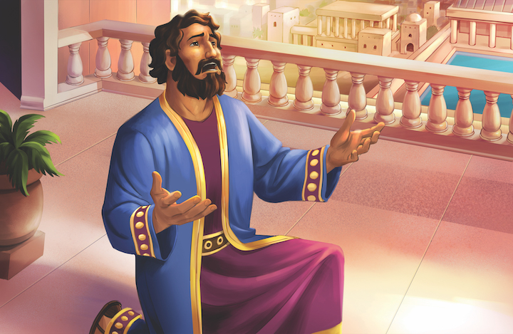
Dear families,

One of the most glorious ways God shows us His grace is through salvation. Though there are many common graces that apply to everyone—life, breath, relationships, and more; salvation is a gift of God’s grace experienced by only some.
In Psalm 51, David recalled the holiness of God, repenting of his sin and ultimately seeking to enjoy the nearness of His gracious God once again. Amid this confession, David asked God for many things, one of which was to restore to him the joy of salvation.
Why, in the middle of this moment of confession and repentance, did David ask God to bring back the joy of salvation? If you’ve ever felt the true weight of your sin, you know that these moments can bring the temptation to lose all joy. Sin can take you to a place that brings misery and heartache more than a sense of nearness and happiness.
In David’s lowest moment, he knew what he needed was not just forgiveness for a sin, but a reminder that through faith in the Lord, he had total forgiveness.
David had come to know the depth of his own sin. He understood the implications of the thoughts and actions derived from his wicked heart. And as he discerned these things, he couldn’t help but realize that he needed God’s full forgiveness. And so David asked the Lord to take him back to the elementary principles of God’s salvation.
In moments of failure, it is good for us to return to the cross. It is good for us to return to the salvation that God has given us. When we do, we can recall the fullness of God’s forgiveness through the sacrifice of Christ—the shed blood of our Savior who has provided what we need for every moment.
Would you pray today for God to restore the joy of His salvation to you? Ask God to help you remember with gladness the blood of Jesus shed to pay for your sin. Jesus takes our sin and completely frees us to live for Him. God is good to give grace, and He is worthy of all praise.
Check out The Gospel Project At Home for resources designed to help you lead a family worship experience as well as suggestions for morning and evening prayer times and family activities.

FAMILY TALKING POINTS

CHRIST CONNECTION
This is the big idea of how this week’s Bible story points to Jesus.

- Babies & Toddlers: God forgives everyone who trusts in Jesus.
- Younger Preschool: David asked God to forgive his sin and God forgave him. We can tell God about our sin and ask Him to forgive us. Jesus died and rose again to take away our sin.
- Older Preschool: David was sorry for his sin and asked God to change his heart. We can tell God about our sin and ask Him to forgive us. Jesus died and rose again to take away our sin and change our hearts so we can live with God forever.
- Kids: David confessed his sin and asked God to change his heart so that he would not want to sin again. When we realize our sin, we can confess to God and ask for His forgiveness. Jesus covers our guilt and changes our hearts so we can have life with Him forever.

BIG PICTURE QUESTION & ANSWER
This is an important biblical truth that your child will encounter each week of this unit.

- Younger Preschool: What is grace? Grace is when God gives us something good even when we do not deserve it.
- Older Preschool: What is grace? Grace is when God gives us something good even when we do not deserve it.
- Kids: What is grace? Grace is when God gives us something good even when we do not deserve it.

KEY PASSAGE
This is a Bible verse that relates to what your child will encounter each week of this unit.

- Babies & Toddlers: God forgives our wrong choices. Ephesians 1:7
- Younger Preschool: God forgives our wrong choices. Ephesians 1:7
- Older Preschool: In him we have redemption through his blood, the forgiveness of our trespasses, according to the riches of his grace. Ephesians 1:7
- Kids: In him we have redemption through his blood, the forgiveness of our trespasses, according to the riches of his grace that he richly poured out on us with all wisdom and understanding. Ephesians 1:7-8

** Next week: God Gave Solomon Wisdom (1 Kings 2–3)

Unit 12, Session 1
God Gave Solomon Wisdom (1 Kings 2–3)
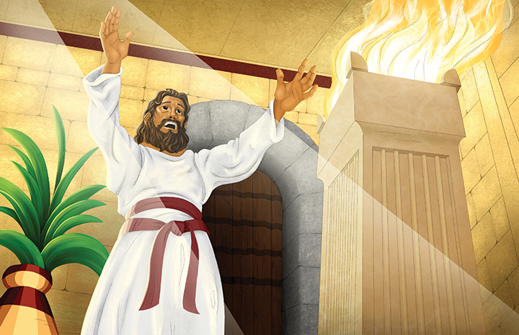
Dear families,

What exactly do you pray for the next generation? When you ask God to move and work in the coming generations, what is it that you are asking Him to do? You may hope for them to be good and productive citizens. It may be that you hope to see them make good decisions, marry the right person, and raise a beautiful family. It may be that you hope they will become committed to the local church and even show evidence of their love for God in how they serve others.
In 1 Kings 2, we see an incredible example of how to pray for the next generation. Whether your own kids, your future kids, the kids you are investing in through your church, or others that you influence, consider David’s desire. David’s hope for his son demonstrates what we ought to hope and pray for the next generation.
The first four verses of 1 Kings 2 contain David’s dying words to his son Solomon. David knew his days were few, and he took the opportunity to call Solomon to what he knew would be best. Ultimately, David told Solomon to grow into a godly man who is faithful to the Lord in every way. Specifically, David called Solomon “to walk in his ways and to keep his statutes, commands, ordinances, and decrees.”
When you think about the way you pray for the next generation, does it sound like this? Does it sound like the words of a dying father who knows his child’s only hope is to trust in God and follow Him faithfully? Or does it sound more like a hopeful fan who wants a good, moral societal participant that they will be associated with and maybe even reap the benefits of their success?
We ought to want what God wants for our own lives and the lives of the next generation that we are investing in. It shouldn’t matter if they are our biological kids, adoptive kids, foster kids, or church kids. Our hope should be that they would faithfully follow God as they grow into godly people who are faithful to the Lord in every way.
Check out The Gospel Project At Home for resources designed to help you lead a family worship experience as well as suggestions for morning and evening prayer times and family activities.

FAMILY TALKING POINTS

CHRIST CONNECTION
This is the big idea of how this week’s Bible story points to Jesus.

- Babies & Toddlers: Jesus is the wisest king of all.
- Younger Preschool: Solomon was a wise king who wanted to follow God’s plan. God had a plan to send a wiser king—Jesus. Jesus trusted God and followed God’s plan.
- Older Preschool: Solomon was a wise king who wanted to follow God’s plan, but Solomon was not perfect. God had a plan to send a greater and wiser king—Jesus. Jesus trusted God and followed God’s plan by dying on the cross for our sin.
- Kids: Solomon was a wise king who wanted to do God’s plan. Solomon wasn’t perfect, but God had a plan to give His people a greater and wiser king—His Son, Jesus. Jesus completely trusted God. Jesus surrendered His own life to die on the cross for our sin.

BIG PICTURE QUESTION & ANSWER
This is an important biblical truth that your child will encounter each week of this unit.

- Younger Preschool: What is mercy? Mercy is when God does not give us the punishment that we deserve.
- Older Preschool: What is mercy? Mercy is when God does not give us the punishment that we deserve.
- Kids: What is mercy? Mercy is when God does not give us the punishment that we deserve.
KEY PASSAGE
This is a Bible verse that relates to what your child will encounter each week of this unit.

- Babies & Toddlers: The Lord is a kind and loving God. Exodus 34:6
- Younger Preschool: The Lord is a kind and loving God. Exodus 34:6
- Older Preschool: The LORD is a compassionate and gracious God, slow to anger and abounding in faithful love and truth. Exodus 34:6
- Kids: The LORD—the LORD is a compassionate and gracious God, slow to anger and abounding in faithful love and truth, maintaining faithful love to a thousand generations, forgiving iniquity, rebellion, and sin. Exodus 34:6-7

** Next week: Solomon Built the Temple (1 Kings 6–9)

Unit 12, Session 2
Solomon Built the Temple (1 Kings 6–9)
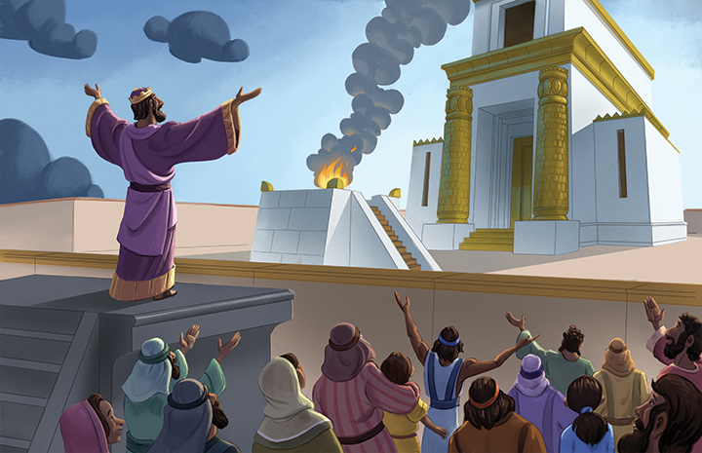
Dear families,

Moments of distress or pain and moments of rebellion or wandering often function as God’s classroom for His children to learn to trust Him. These experiences force us to either lean in to God or to leave—to turn from God or to trust in God. These moments are not obstacles to our faith but opportunities that God provides to grow our faith like no other.
In 1 Kings 8:22-53, King Solomon was praying at the dedication of the temple. God had fulfilled His promise to King David, and the people had a tangible reminder of God’s faithfulness and provision.
In Solomon’s prayer, we see several things that He believed about God. Among those, we learn that Solomon believed the only right response to feeling far from God is to turn the direction of our focus from ourselves to God as our only hope and to turn the direction of our lives from rebellion toward obedience to the Lord.
The temptation for believers when we feel far from God is not to move toward Him but rather to sit at a distance or move further away, in fear that what has caused our sense of distance prevents Him from wanting us near. But this is simply not true.
Solomon’s prayer reveals that God wants His people near. Even amid rebellion or trial, the Lord is the only way to turn.
When you hit moments of distress, pain, rebellion, or wandering, is your tendency to move away from God or remain at a distance? Or do you find yourself turning your focus away from yourself and toward Him? If there is any rebellious way in you, turn toward God’s gracious hand of forgiveness. “LORD God of Israel, there is no God like you in heaven above or on earth below, who keeps the gracious covenant with your servants who walk before you with all their heart” (1 Kings 8:23).
This is the God who wants you near when you wander and wants your heart when you are hurting. Do not doubt Him, for He longs for us to draw near to Him as He has drawn near to us through Christ. Because of the work of Jesus, who drew near to us by humbling Himself, taking on the form of a man and enduring death on a cross, we too can humbly draw near to God.
Check out The Gospel Project At Home for resources designed to help you lead a family worship experience as well as suggestions for morning and evening prayer times and family activities.

FAMILY TALKING POINTS

CHRIST CONNECTION
This is the big idea of how this week’s Bible story points to Jesus.

- Babies & Toddlers: When we trust in Jesus, He forgives us and is always with us.
- Younger Preschool: The temple was a place where God was with His people and people could worship God. When we trust in Jesus, He forgives us and is always with us, ready to help us.
- Older Preschool: The temple was a place where God met with His people. God wants to be with us. As part of His plan to save people from sin, God sent Jesus to earth to be with people.
- Kids: The temple was a place where God met with His people. The people could go there to make sacrifices and worship God. Today, when we trust in Jesus, He is with us wherever we go. We can look to Him for forgiveness and help.

BIG PICTURE QUESTION & ANSWER
This is an important biblical truth that your child will encounter each week of this unit.

- Younger Preschool: What is mercy? Mercy is when God does not give us the punishment that we deserve.
- Older Preschool: What is mercy? Mercy is when God does not give us the punishment that we deserve.
- Kids: What is mercy? Mercy is when God does not give us the punishment that we deserve.
KEY PASSAGE
This is a Bible verse that relates to what your child will encounter each week of this unit.

- Babies & Toddlers: The Lord is a kind and loving God. Exodus 34:6
- Younger Preschool: The Lord is a kind and loving God. Exodus 34:6
- Older Preschool: The LORD is a compassionate and gracious God, slow to anger and abounding in faithful love and truth. Exodus 34:6
- Kids: The LORD—the LORD is a compassionate and gracious God, slow to anger and abounding in faithful love and truth, maintaining faithful love to a thousand generations, forgiving iniquity, rebellion, and sin. Exodus 34:6-7

** Next week: Solomon’s Sin Divided the Kingdom (1 Kings 10–12)

Unit 12, Session 3
Solomon’s Sin Divided the Kingdom (1 Kings 10–12)
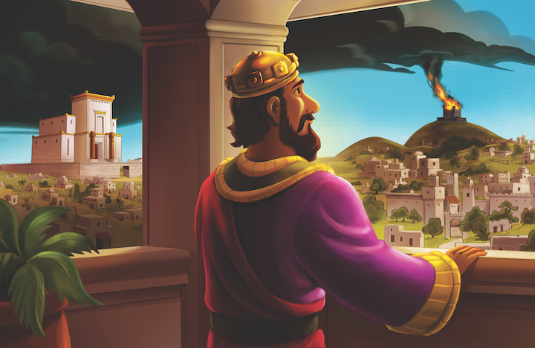
Dear families,

When you read the description of Solomon’s wealth in 1 Kings 10, it is hard not to have some sense of jealousy about the amount of money and power he had amassed. Solomon is described as having 25 tons of gold come into his possession every year as only a portion of his annual increase of wealth.
Solomon made everything imaginable out of gold and ivory. In fact, he had so much gold that silver lost its value in his kingdom because it was so accessible to the people. He was a man who had anything and everything that one could ever want.
Who wouldn’t want all that Solomon had? Solomon had anything a person could ever want in terms of both possessions and wisdom. But after his reign of 40 years came to an end, Solomon’s life ended too. He was buried alongside his ancestors and carried none of his riches with him.
Psalm 50:10 says, “Every animal of the forest is mine, the cattle on a thousand hills.” The currency of the days of Asaph, writer of Psalm 50, was animals. And for God to describe Himself as the owner of the livestock roaming on the earth was for God to say that He owns it all. In the same way that the cattle on a thousand hills represents unimaginable wealth, we could never calculate the wealth and richness of God.
When we consider the desirable wealth of Solomon, we ought to be reminded of the unimaginable wealth of God. He is a good God who doesn’t gather for Himself and leave the leftovers to His children; rather, God gives to His children out of His abundance that we too might enjoy His wealth of grace and mercy both now and in eternity.
If you’re looking for wealth, look no further than the cross. The cross is where we find the evidence of God’s gracious hand providing for His children and where we look to find access to His generous heart for eternity.
Check out The Gospel Project At Home for resources designed to help you lead a family worship experience as well as suggestions for morning and evening prayer times and family activities.

FAMILY TALKING POINTS

CHRIST CONNECTION
This is the big idea of how this week’s Bible story points to Jesus.

- Babies & Toddlers: Jesus is a perfect King who brings people together.
- Younger Preschool: Solomon sinned, and Israel was divided into two kingdoms. God’s people needed a perfect king. God sent His Son, Jesus, to be King. Jesus is a perfect King who brings God’s people together.
- Older Preschool: Solomon sinned, and Israel was divided into two kingdoms. God’s people needed a perfect king. God would send His own Son, Jesus, to be King. Jesus is better than Solomon. Jesus is a perfect King who brings God’s people together.
- Kids: King Solomon’s sin led to the division of the kingdom. God’s people needed a better king. Through David’s family, God would send His own Son, Jesus, to be a perfect King over God’s people forever. Jesus is greater than Solomon. Jesus brings His people together and leads them back to God.

BIG PICTURE QUESTION & ANSWER
This is an important biblical truth that your child will encounter each week of this unit.

- Younger Preschool: What is mercy? Mercy is when God does not give us the punishment that we deserve.
- Older Preschool: What is mercy? Mercy is when God does not give us the punishment that we deserve.
- Kids: What is mercy? Mercy is when God does not give us the punishment that we deserve.
KEY PASSAGE
This is a Bible verse that relates to what your child will encounter each week of this unit.

- Babies & Toddlers: The Lord is a kind and loving God. Exodus 34:6
- Younger Preschool: The Lord is a kind and loving God. Exodus 34:6
- Older Preschool: The LORD is a compassionate and gracious God, slow to anger and abounding in faithful love and truth. Exodus 34:6
- Kids: The LORD—the LORD is a compassionate and gracious God, slow to anger and abounding in faithful love and truth, maintaining faithful love to a thousand generations, forgiving iniquity, rebellion, and sin. Exodus 34:6-7

** Next week: God Is Good to Give Mercy (Luke 18)

Unit 12, Session 4
God Is Good to Give Mercy (Luke 18)
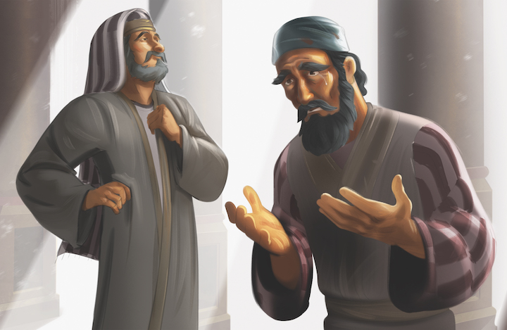
Dear families,

In Luke 18, Jesus shared several parables and encounters to illustrate the richness and surprising nature of God’s mercy toward sinners. From the widow, to the tax collector, to the blind man, Jesus repeatedly proved Himself to be a merciful Savior who takes great joy in extending the hand of mercy to the most unlikely of people.
Throughout the Bible, we discover that God is merciful. We see it in His gracious act to preserve Noah and his family from the flood, in the kindness of God to provide a lamb so Abraham would not have to sacrifice his son Isaac, in Jesus’ kindness toward Peter even after his denial, and so much more. God is clearly merciful.
In Luke 18:6-8, we see that the question of God’s mercy is really no question at all. “Will not God grant justice to his elect who cry out to him day and night? Will he delay helping them? I tell you that he will swiftly grant them justice. Nevertheless, when the Son of Man comes, will he find faith on earth?”
The question is not, ‘Will God show justice and mercy?’ The question instead is, ‘Will God find faith?’
In Hebrews 11:1, we find this explanation of faith: “Now faith is the reality of what is hoped for, the proof of what is not seen.” If God’s mercy is shown to people of faith, we must cling tightly to that which is unseen—namely to the work of God in the world. We must grasp that there is an invisible God who has made Himself visible through Jesus Christ. And we must not forget that it is by grace that we are saved, through faith.
The mercy of God, though undeserved, should not be surprising. People with faith in the invisible God, who works in ways that bring great delight to His people, can have great confidence that God will show mercy. And that mercy is ours to be enjoyed because of the finished work of Christ.
As you consider God’s wondrous acts of mercy, let it stir up faith. And as faith arises in your own heart, be reminded that you will receive mercy as well.
Check out The Gospel Project At Home for resources designed to help you lead a family worship experience as well as suggestions for morning and evening prayer times and family activities.

FAMILY TALKING POINTS

CHRIST CONNECTION
This is the big idea of how this week’s Bible story points to Jesus.

- Babies & Toddlers: God will forgive our wrong choices because of Jesus.
- Younger Preschool: Everyone has sinned and needs God’s mercy and forgiveness. We can ask God for forgiveness and because of Jesus, God will forgive our sin.
- Older Preschool: Everyone has sinned and needs God’s mercy and forgiveness. Jesus came to take the punishment we deserve for our sin by dying on the cross. We can ask God for forgiveness and because of Jesus, God will forgive our sin.
- Kids: The tax collector knew he needed God to forgive him, and he cried out to God. Everyone is a sinner who needs God’s mercy and forgiveness. Jesus took the punishment for our sin by dying on the cross. We can cry out to God like the tax collector and because of Jesus, God will have mercy on us.

BIG PICTURE QUESTION & ANSWER
This is an important biblical truth that your child will encounter each week of this unit.

- Younger Preschool: What is mercy? Mercy is when God does not give us the punishment that we deserve.
- Older Preschool: What is mercy? Mercy is when God does not give us the punishment that we deserve.
- Kids: What is mercy? Mercy is when God does not give us the punishment that we deserve.
KEY PASSAGE
This is a Bible verse that relates to what your child will encounter each week of this unit.

- Babies & Toddlers: The Lord is a kind and loving God. Exodus 34:6
- Younger Preschool: The Lord is a kind and loving God. Exodus 34:6
- Older Preschool: The LORD is a compassionate and gracious God, slow to anger and abounding in faithful love and truth. Exodus 34:6
- Kids: The LORD—the LORD is a compassionate and gracious God, slow to anger and abounding in faithful love and truth, maintaining faithful love to a thousand generations, forgiving iniquity, rebellion, and sin. Exodus 34:6-7

** Next week: Jeroboam Disobeyed God (1 Kings 12–13)

