Ministry Leaders: A suggested email is provided for each session for you to customize if you desire and share with your families. You can also access a social media share square for each session on the Additional Resources page at gospelproject.com.

The Gospel Project @ Home content is available in Ministry Grid for you to share with your families.
Unit 1, Session 1
God Created the World (Genesis 1)

Dear families,

This week, your child learned about God creating the world from Genesis 1:1-25. The true story of the Bible begins where we would expect it to begin—at the beginning of all creation. Everything in the universe has a starting point except God. He alone is eternal—He has no beginning and no end. He has always existed. So the beginning in this week’s Bible story is the beginning from our perspective. It is humanity’s beginning.

You might notice that the Bible story stops a little earlier than you might be used to—before God created Adam and Eve. That happened on Day 6, along with the animals of the earth, but it is not included here because that will be covered next week in much more detail.

Instead, during this week, be sure to emphasize three things:

First, that God created everything from nothing. God did not create like we do—by taking some raw materials like clay and making a beautiful sculpture. Instead, God made everything that exists—everything we see and even that we don’t see—simply by speaking it into existence from nothing. That’s important because it teaches us that everything belongs to God because He made it all and also how powerful He is to be able to create the universe by speaking it into being.

Second, that God created everything with order. Not only do we see that God created the different kinds of plants and trees as well as animals according to their different kinds, but we also see an orderly pattern in the days of creation. God created by separating things on days 1-3 (light from darkness; sky from water; and then land from oceans) and then He filled what He had created on days 4-6 (the stars, sun, and moon in the heavens; birds and fish in the sky and waters; animals on the land).

Third, that God created everything for a reason—to bring Himself glory. We will talk a lot more about this during the next few weeks, and all of our study through Scripture. But for now help your child see that everything exists to show how good God is—to show His glory for all to see.

Check out The Gospel Project At Home for resources designed to help you lead a family worship experience as well as suggestions for morning and evening prayer times and family activities. Your child can also access free Gospel Project learning games and activities in the LifeWay Kids app reader available in the iTunes or Google Play stores.

FAMILY TALKING POINTS

CHRIST CONNECTION
This is the big idea of how this week’s Bible story points to Jesus.

- Babies & Toddlers: Jesus makes everything work.
- Younger Preschool: The Bible says everything was created by God and for God and that Jesus makes it all work. Everything shows how good God is!
- Older Preschool: Jesus is Lord over everything. The Bible says everything was created by Him and for Him. Jesus holds everything together and everything brings God glory.
- Kids: Jesus is Lord over all of creation. The Son has always existed. The Bible says everything was created by Him and for Him, and He holds everything together. All of creation exists to bring God glory.

BIG PICTURE QUESTION & ANSWER
This is an important biblical truth that your child will encounter each week of this unit.

- Younger Preschool: Why did God create everything? God created everything to show He is great.
- Older Preschool: Why did God create everything? God created everything for His glory.
- Kids: Why did God create everything? God created everything for His glory and our good.

KEY PASSAGE
This is a Bible verse that relates to what your child will encounter each week of this unit.

- Babies & Toddlers:The heavens show God is great! — Psalm 19:1
- Younger Preschool: The heavens show God is great! — Psalm 19:1
- Older Preschool: The heavens declare the glory of God, and the expanse proclaims the work of his hands. — Psalm 19:1
- Kids: The heavens declare the glory of God, and the expanse proclaims the work of his hands. — Psalm 19:1

** Next week: God Created People (Genesis 1–2)

Unit 1, Session 2
God Created People (Genesis 1–2)


Dear families,

Humans are at the center of everything God created. Only God Himself is more important. That is why the creation of the first man and woman—Adam and Eve—deserved its own session.

As you talk with your kids about this week’s session, there are two words that might be unclear or even confusing. The first is our in Genesis 1:26. “Let us make man in our image.” This can be confusing because the Bible is clear that there is only one God (see Deuteronomy 6:4 and 1 Timothy 2:5). Why then does God say our image and not my image?

Bible scholars have long debated what is meant by this word, but here are two of the most common explanations. The first is that this word is affirming the doctrine known as the Trinity—that God is one in three Persons: God the Father, God the Son, and God the Holy Spirit. Our in this verse is drawing from that important aspect of who God is. This would make sense here because a common, but wrong, belief of why God created people was because He was lonely. But God as three Persons in one is never alone. He has always enjoyed a perfect relationship of love within who He is. It would make sense that God wants to make that clear here.

A second explanation for our is that it is the use of what is called the “plural of majesty.” In this case, God is establishing from very early on how glorious He is, even in how He refers to Himself.

The second word that deserves a note is image. Once again, scholars have debated for ages about what this word means. But we can know what it does not mean: physical form. God is spirit (see John 4:24), so we are not made with a body like God’s body; He has no body. Instead, being made in God’s image includes attributes of people that separate us from the rest of creation (such as our ability to reason, our morality, our will, and our emotions) and our unique role in creation as ruling over it under God’s greater rule.

While we might not know what these two words mean exactly, we do know this for sure: our glorious God has made people to be special in all of His creation and designed us to be in relationship with Him.

Check out The Gospel Project At Home for resources designed to help you lead a family worship experience as well as suggestions for morning and evening prayer times and family activities. Your child can also access free Gospel Project learning games and activities in the LifeWay Kids app reader available in the iTunes or Google Play stores.

FAMILY TALKING POINTS

CHRIST CONNECTION
This is the big idea of how this week’s Bible story points to Jesus.

- Babies & Toddlers: We can know and love God.
- Younger Preschool: People are special because God made us to know and love Him. Through Jesus, we can know and love God.
- Older Preschool: God created people in His own image. He loves us and gives us everything we need. People are special because God made us to know and love Him. Through Jesus, we can know and love God just as He planned.
- Kids: God created people in His own image and provides for everything He made. People are special because God made people to live forever in a relationship with Him. Through His Son, Jesus, we can have eternal life with God just as He planned.

BIG PICTURE QUESTION & ANSWER
This is an important biblical truth that your child will encounter each week of this unit.

- Younger Preschool: Why did God create everything? God created everything to show He is great.
- Older Preschool: Why did God create everything? God created everything for His glory.
- Kids: Why did God create everything? God created everything for His glory and our good.

KEY PASSAGE
This is a Bible verse that relates to what your child will encounter each week of this unit.

- Babies & Toddlers:The heavens show God is great! — Psalm 19:1
- Younger Preschool: The heavens show God is great! — Psalm 19:1
- Older Preschool: The heavens declare the glory of God, and the expanse proclaims the work of his hands. — Psalm 19:1
- Kids: The heavens declare the glory of God, and the expanse proclaims the work of his hands. — Psalm 19:1

** Next week: Creation Glorifies God (Psalm 19)

Unit 1, Session 3
BIG TRUTH SESSION
Creation Glorified God (Psalm 19)


Dear families,

In the first two sessions of this unit, we have seen a common thread of God’s glory. God created everything, including people, to display His glory. In this session, we want to make sure that our kids understand what that means. What is God’s glory?

God’s glory can be thought of as God’s greatness. The Bible often uses the picture of a brilliant white light when it comes to God’s glory. When Moses came down from Mount Sinai after spending time with God, his face shone. When Jesus was transfigured, He shined like a brilliant white light. And when Paul encountered Jesus on the road to Damascus, he saw a blinding light. Such an intense light helps us understand how pure and powerful God’s glory is.

But we don’t just see God’s glory revealed in bright light. In this session, we looked at a Psalm that King David wrote many years after Adam and Eve. David used creation to speak of God’s glory. For David, it was easy to see God’s glory—at least its fingerprints—all around him.

If you have ever looked up into the heavens on a clear, dark night, maybe you have sensed it too as you consider all the stars that cannot be counted and think that each is a giant sun, like ours—only our sun is relatively modest in comparison—and that they stretch over billions and billions and trillions and trillions of miles. And that is just what we can see!

Or maybe you have caught a glimpse of God’s glory as you looked over a stunning mountain range or walked on a beach. Creation is full of beauty, wonder, and power—all of which hints at the greater beauty, wonder, and power of the Creator who made it all. God is glorious indeed.

But one of the greatest ways we can know of God’s glory is that the Creator who made everything not only made us too, but wants to have a friendship with us. That is why He gave us the Bible—so that we might come to know Him, love Him, and live for Him.

As you talk with your kids, seek to leave them in awe of how big and how good and how loving God is.

Check out The Gospel Project At Home for resources designed to help you lead a family worship experience as well as suggestions for morning and evening prayer times and family activities. Your child can also access free Gospel Project learning games and activities in the LifeWay Kids app reader available in the iTunes or Google Play stores.

FAMILY TALKING POINTS

CHRIST CONNECTION
This is the big idea of how this week’s Bible story points to Jesus.

- Babies & Toddlers: All creation shows God is great.
- Younger Preschool: All of creation shows how great God is. Jesus is God. Jesus is the best way we can know how great God is.
- Older Preschool: All of creation shows how great God is. Jesus is God. Jesus is the best way we can know how great God is.
- Kids: All of creation displays the glory of God—how great He is—although not perfectly. The perfect revelation of God’s glory is found in Jesus, who came to show us exactly what God is like. Because Jesus is God, He is the perfect display of God’s glory.

BIG PICTURE QUESTION & ANSWER
This is an important biblical truth that your child will encounter each week of this unit.

- Younger Preschool: Why did God create everything? God created everything to show He is great.
- Older Preschool: Why did God create everything? God created everything for His glory.
- Kids: Why did God create everything? God created everything for His glory and our good.

KEY PASSAGE
This is a Bible verse that relates to what your child will encounter each week of this unit.

- Babies & Toddlers:The heavens show God is great! — Psalm 19:1
- Younger Preschool: The heavens show God is great! — Psalm 19:1
- Older Preschool: The heavens declare the glory of God, and the expanse proclaims the work of his hands. — Psalm 19:1
- Kids: The heavens declare the glory of God, and the expanse proclaims the work of his hands. — Psalm 19:1

** Next week: Sin Entered the World (Genesis 3)

Unit 2, Session 1
Sin Entered the World (Genesis 3)
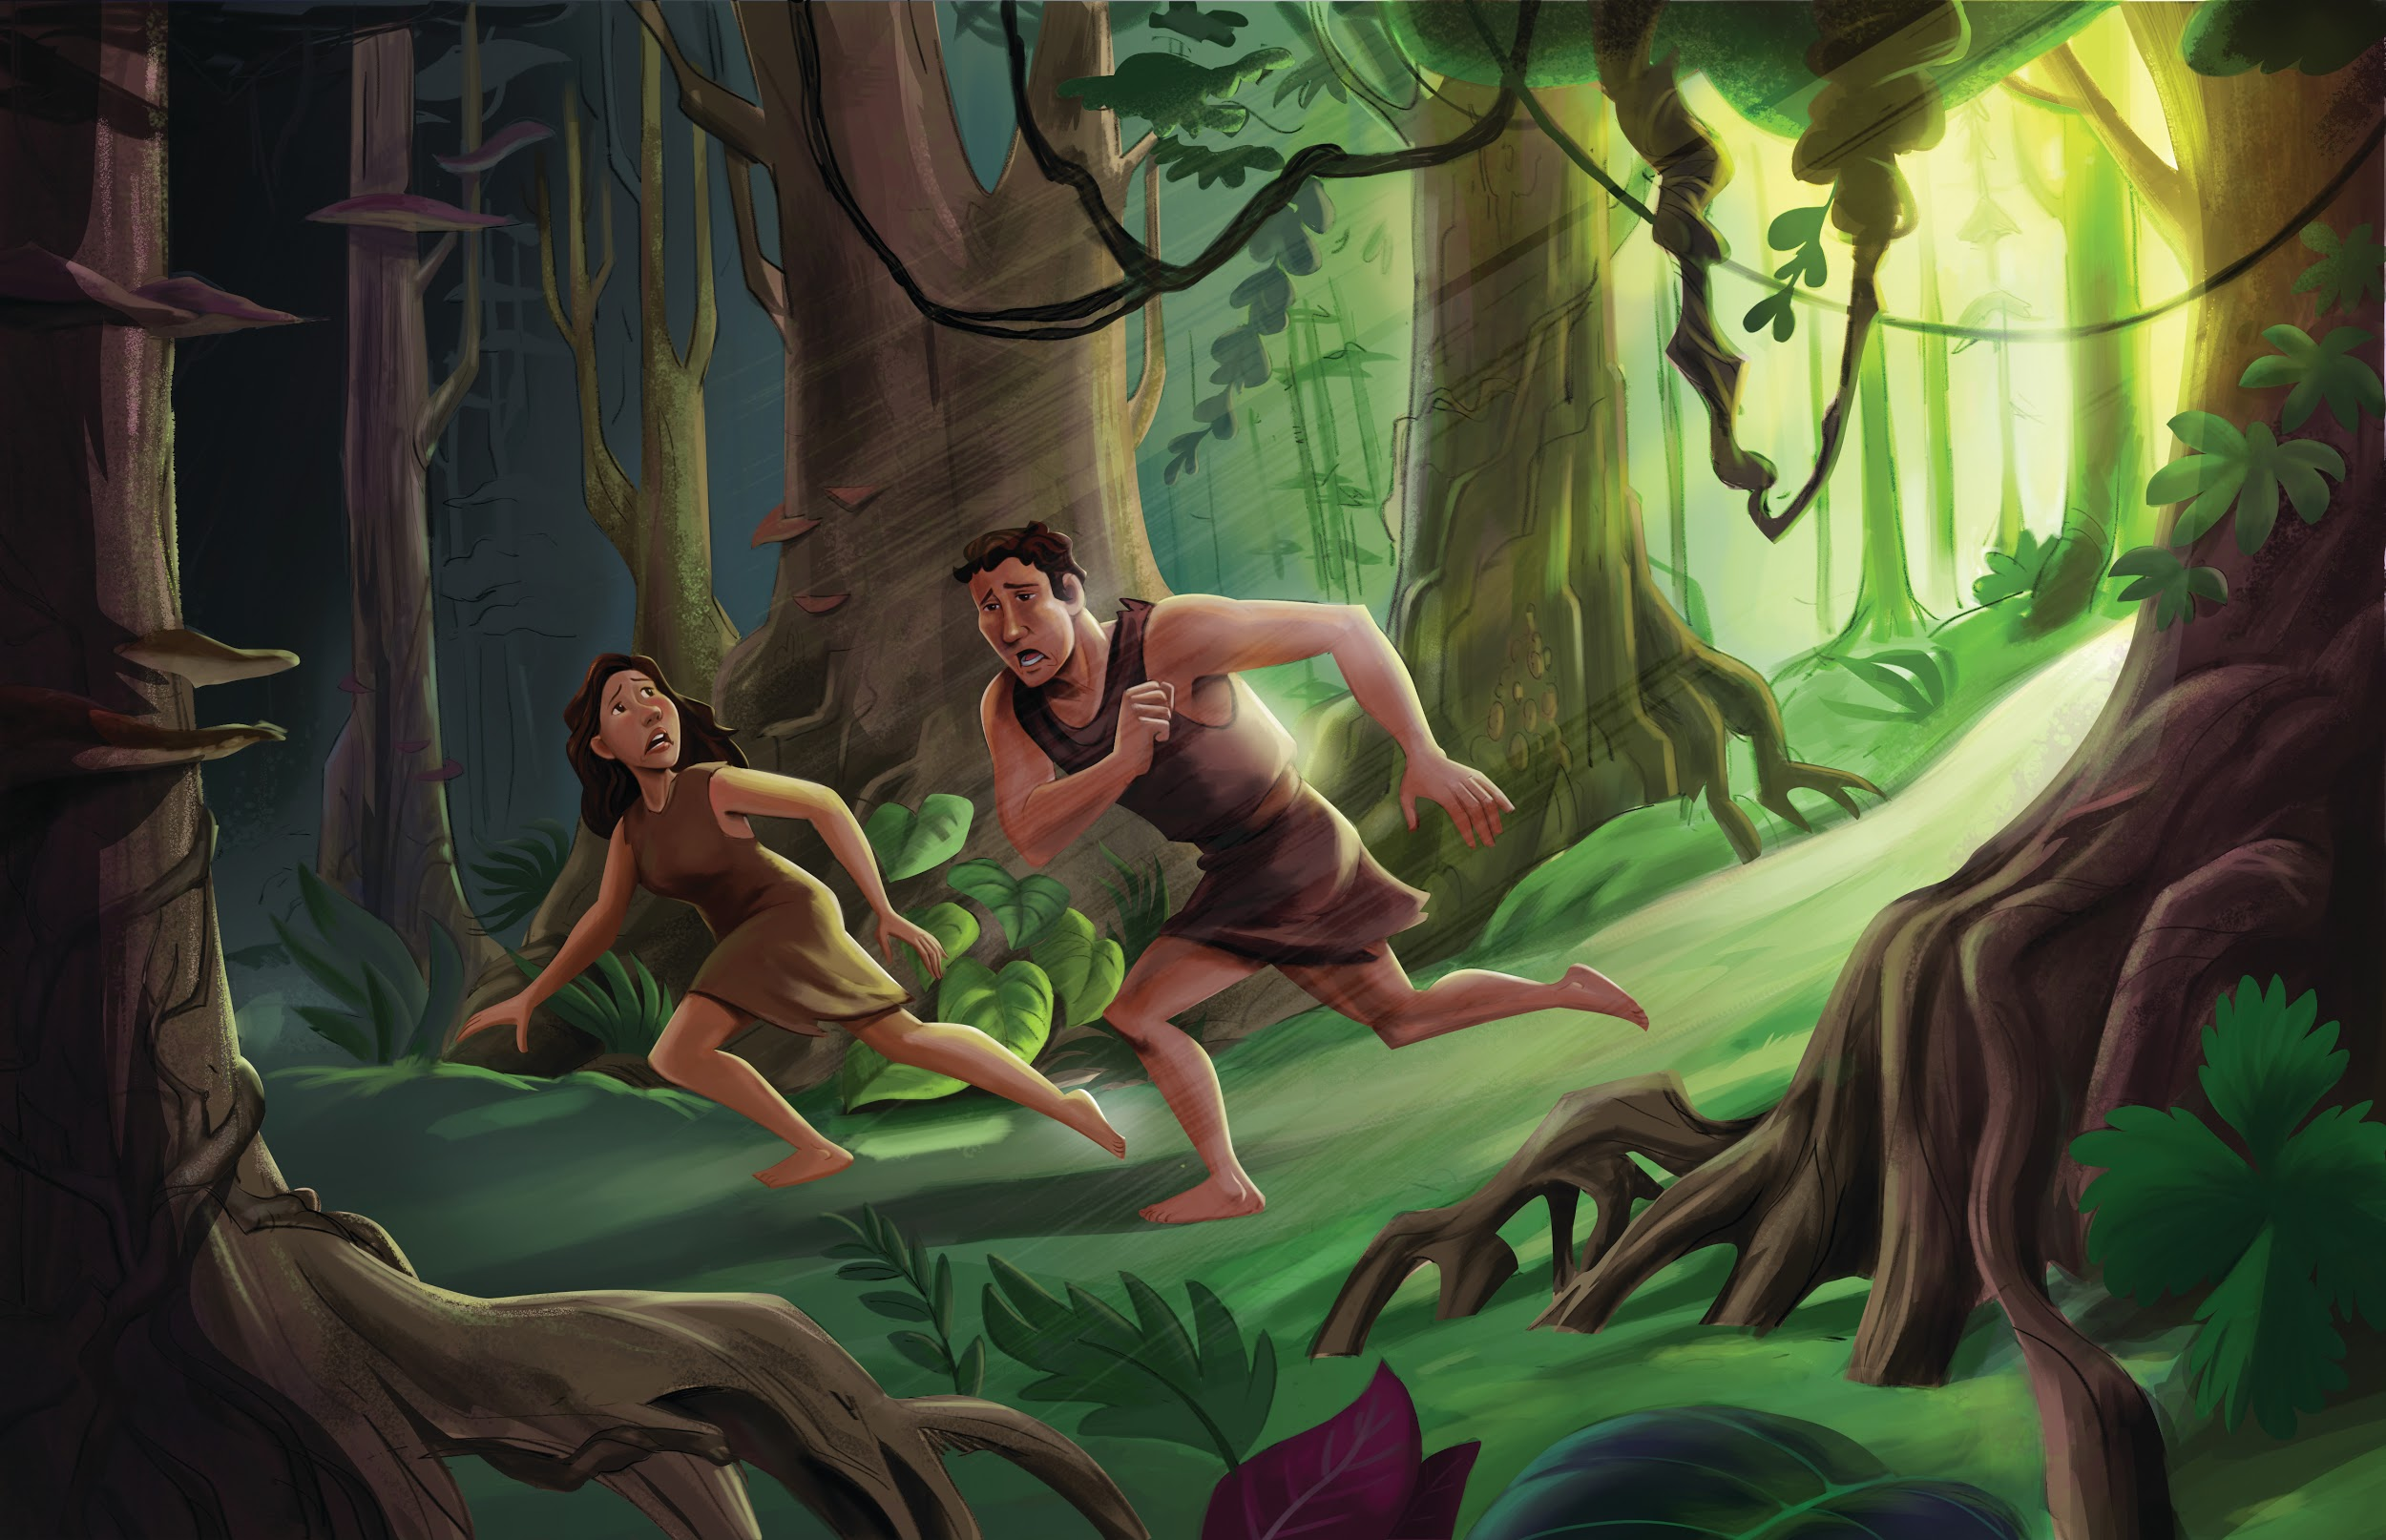
Dear families,

Does the story of the fall surprise you? How could Adam and Eve—who had everything they needed—rebel against a loving God? Do you think you would have acted differently?

Adam and Eve’s story is our story. Think about the last time you blatantly sinned. What lies were you believing in that moment? Satan wants us to believe the same lie that Eve believed: Maybe God is holding out on me. Maybe He isn’t good or loving. Maybe I would do a better job than Him. Do you ever wonder if you know better than God?

Before the fall, Adam and Eve enjoyed a loving, two-way relationship with God. The garden was a true paradise. God filled the garden with good gifts so that they might enjoy them and give Him thanks. This glorifies God. All of that changed when Adam and Eve gave in to the serpent’s temptation.

Adam and Eve desired something more: the wisdom the fruit offered. But when their eyes were opened, they didn’t get what they hoped for. Instead, they were aware of their nakedness. They felt ashamed. Surely the Lord’s heart broke at their act of disobedience and rebellion. Can you think of a time your own sin produced regret and sorrow?

Because of their sin, God cast Adam and Eve out of the garden. Though they did not die right away, sin’s effect was immediate and thorough. Their lives and their children’s lives—and the lives of all of humanity—would be forever affected by their choice. We see this in the world around us. We experience God’s grace, but we are very aware that the world is broken. It was not meant to be this way.

Sin is a big problem that needs a big solution. At just the right time, God sent His Son into the world, born as a baby. Matthew 1:21 says, “You are to name him Jesus, because he will save his people from their sins.”

As your kids become increasingly aware of the bad news—that we are all sinners from birth—rejoice with them over the good news: “Christ Jesus came into the world to save sinners” (1 Tim. 1:15).

Check out The Gospel Project At Home for resources designed to help you lead a family worship experience as well as suggestions for morning and evening prayer times and family activities. Your child can also access free Gospel Project learning games and activities in the LifeWay Kids app reader available in the iTunes or Google Play stores.

FAMILY TALKING POINTS

CHRIST CONNECTION
This is the big idea of how this week’s Bible story points to Jesus.

- Babies & Toddlers: God planned to send Jesus to make everything right.
- Younger Preschool: Since Adam and Eve, all people have been sinners. God sent Jesus to rescue us from sin.
- Older Preschool: Everything was different after Adam and Eve sinned. Since then, all people have been sinners. Sin keeps us from God, but God never stops loving us. He sent His Son, Jesus, to rescue people from sin and bring them back to God.
- Kids: Ever since Adam and Eve sinned, all people have been born as sinners. Sin separates us from God, but God still loves us. God promised a Rescuer would come from Eve’s family. God sent His Son, Jesus, to rescue people from sin and bring them back to God.

BIG PICTURE QUESTION & ANSWER
This is an important biblical truth that your child will encounter each week of this unit.

- Younger Preschool: What does it mean to sin? We sin when we disobey God.
- Older Preschool: What does it mean to sin? To sin is to go against God and His commands.
- Kids: What does it mean to sin? To sin is to think, speak, or behave in any way that goes against God and His commands.

KEY PASSAGE
This is a Bible verse that relates to what your child will encounter each week of this unit.

- Babies & Toddlers: We all make wrong choices. — Romans 3:23
- Younger Preschool: Everyone makes wrong choices. — Romans 3:23
- Older Preschool: All have sinned and fall short of the glory of God. — Romans 3:23
- Kids: For all have sinned and fall short of the glory of God. — Romans 3:23

** Next week: Sin Spread to People (Genesis 4–5)

Unit 2, Session 2
Sin Spread to People (Genesis 4–5)
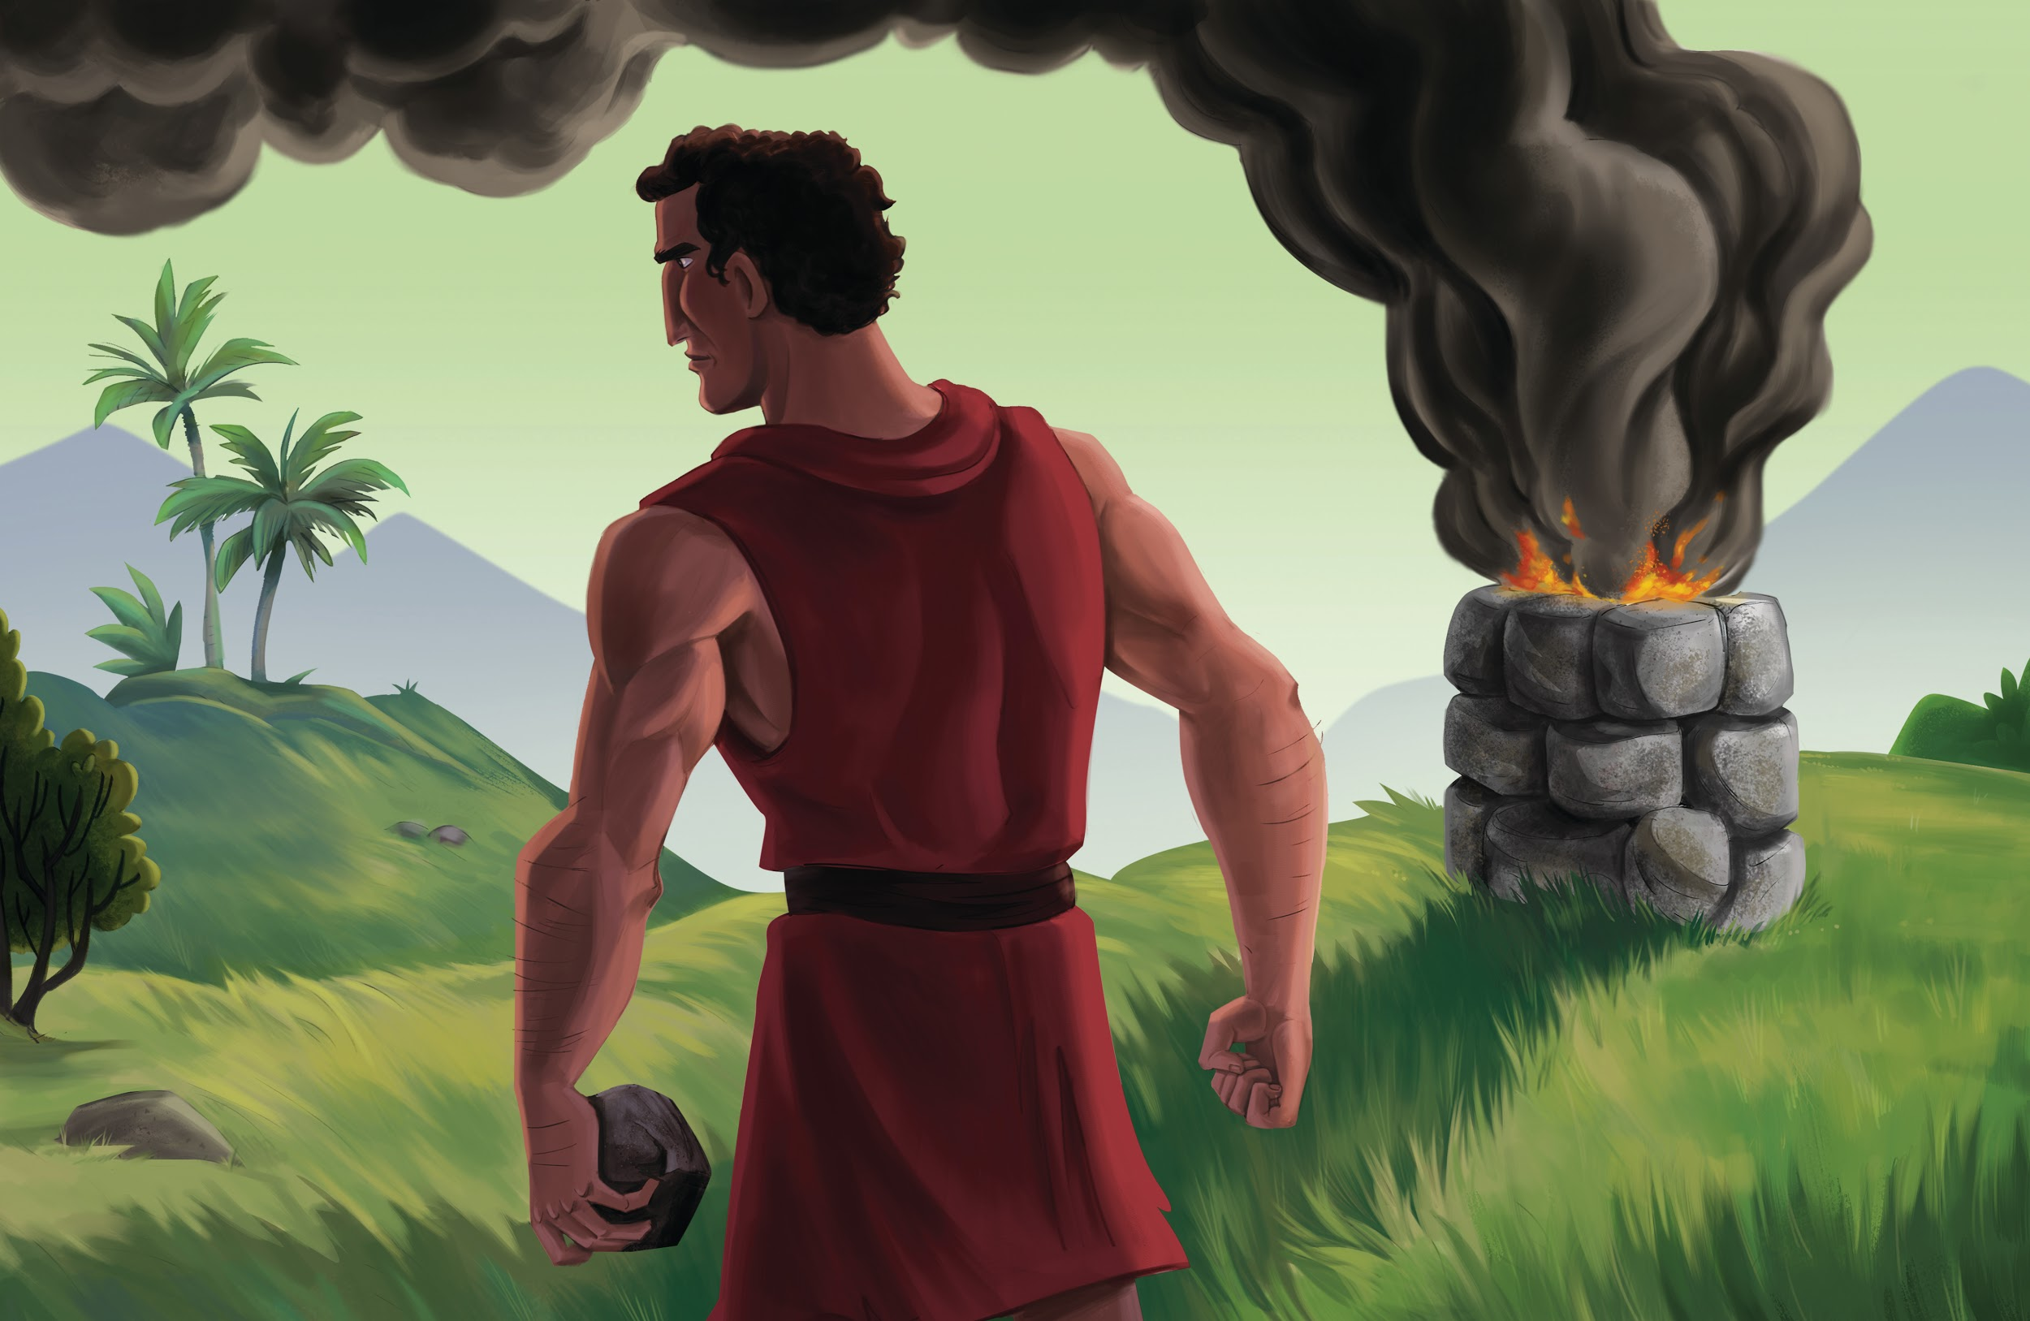
Dear families,

Siblings often fight and compete as children and even adults. It may be over something as innocent as who gets the last cookie or as serious as who inherits their parents’ prized heirloom.

The competition Cain felt toward Abel—the world’s first siblings—reminds us that these family tensions can cause great damage to our relationships with one another, with parents, and even with God.

In the story of Cain and Abel, we find a progressing pattern of jealousy, which leads to hatred, which leads to murder. The result is not one but two lost sons for Adam and Eve.

God’s disregard of Cain’s offering stirred an intense jealousy and anger within Cain. Cain raged not only because his offering was rejected by God, but also because his brother’s offering was accepted by the Lord. Cain’s jealousy led him into a pit of misdirected hatred of Abel, ultimately leading him to murder his brother. The consequence of sin—death—that God had warned Adam and Eve about had come to fruition.

Jealousy never produces anything godly in us. And why is that? It’s primarily because jealousy is nothing more than proof that we have staked our identity on what we have done or can do, rather than on what God has done for us through Christ.

When you are tempted to compare yourself to others, let that trigger a reminder of who you are in Christ.

Second Corinthians 5:17 tells us that “if anyone is in Christ, he is a new creation.” As a child of God, our identity is not dependent upon what we do, but instead upon what Christ has done to save us through His life, death, and resurrection. Rather than living in the comparison between ourselves and others, let’s live in the confidence that we have been made new. In Christ, we are fully loved and accepted.

Fight the temptation to compare. Fight the urge to compete with others before God. And trust in the finished work of Christ. For you are not your own; you were bought with a price. And that price is one you could never repay.

Check out The Gospel Project At Home for resources designed to help you lead a family worship experience as well as suggestions for morning and evening prayer times and family activities. Your child can also access free Gospel Project learning games and activities in the LifeWay Kids app reader available in the iTunes or Google Play stores.

FAMILY TALKING POINTS

CHRIST CONNECTION
This is the big idea of how this week’s Bible story points to Jesus.

- Babies & Toddlers: God promised to send Jesus.
- Younger Preschool: Everyone in Adam and Eve's family sinned too. God promised to send His Son, Jesus, to save sinners.
- Older Preschool: Adam and Eve’s sin spread to their family. But God did not forget His promise to send a Rescuer. At just the right time, God would send His Son to save sinners.
- Kids: Adam and Eve’s sin and its consequences spread to all of their descendants. But God did not forget His promise to send a Rescuer. At just the right time, God would send His Son to save sinners.

BIG PICTURE QUESTION & ANSWER
This is an important biblical truth that your child will encounter each week of this unit.

- Younger Preschool: What does it mean to sin? We sin when we disobey God.
- Older Preschool: What does it mean to sin? To sin is to go against God and His commands.
- Kids: What does it mean to sin? To sin is to think, speak, or behave in any way that goes against God and His commands.

KEY PASSAGE
This is a Bible verse that relates to what your child will encounter each week of this unit.

- Babies & Toddlers: We all make wrong choices. — Romans 3:23
- Younger Preschool: Everyone makes wrong choices. — Romans 3:23
- Older Preschool: All have sinned and fall short of the glory of God. — Romans 3:23
- Kids: For all have sinned and fall short of the glory of God. — Romans 3:23

** Next week: God Spared Noah (Genesis 6–10)

Unit 2, Session 3
God Spared Noah (Genesis 6–10)
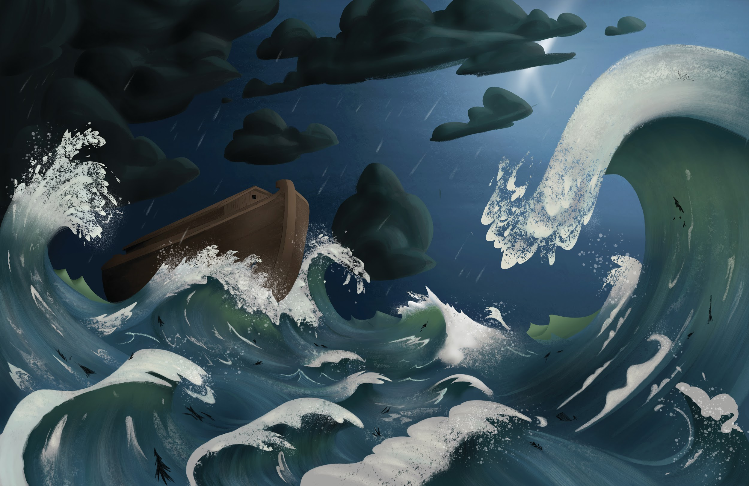
Dear families,

The Bible is full of promises. As early as the first few chapters of Genesis, we begin to see God make, and even fulfill, His promises: promises for punishment and for blessing, for death and for life, for separation and for salvation. In Noah’s journey to build an ark, survive the flood, and begin to repopulate the earth, we find multiple reminders that the Lord is faithful to fulfill His promises.

When God destroyed the entire population of the earth except for Noah and his family, we are reminded that God keeps His promise to preserve a remnant of His people always. When Noah sent a dove to find dry land and it returned with an olive leaf, we are reminded of God’s promise to show His people the way at just the right time. And when God painted His bow in the sky, we are reminded of God’s promise that He will always keep His Word.

In a world filled with fake news and false prophets, we are often skeptical of the stories and promises that we hear and read about. When it comes to the promises and claims of the world, we should be discerning. But when it comes to the promises of God, we should be trusting.

As you survey Genesis 6–10, may it stir a great reminder in your heart and mind that God is always faithful and true. God is no liar, and He will not turn back from His word. May these chapters of Genesis also give you hope that though everything around you may fail, God’s Word never will.
God is a God of great and magnificent promises. And every single one of them we can trust completely. When in doubt of this truth, look to the cross of Christ and His empty grave.

As Paul wrote in 2 Corinthians 1:20, “every one of God’s promises is ‘Yes’ in [Jesus].”

God will fulfill His promises. This week, pray that God would stir in you many reminders of how He keeps His word.

Check out The Gospel Project At Home for resources designed to help you lead a family worship experience as well as suggestions for morning and evening prayer times and family activities. Your child can also access free Gospel Project learning games and activities in the LifeWay Kids app reader available in the iTunes or Google Play stores.

FAMILY TALKING POINTS

CHRIST CONNECTION
This is the big idea of how this week’s Bible story points to Jesus.

- Babies & Toddlers: We can trust in Jesus..
- Younger Preschool: God rescued Noah and his family from the flood. Jesus came to save people from sin. When we trust in Jesus, He saves us from our sin.
- Older Preschool: God rescued Noah and his family from the flood. Later, there was an even greater rescue! Jesus came to save people from sin. When we trust in Jesus, He saves us from the punishment for our sin.
- Kids: God rescued Noah and his family from the flood. The story of Noah points ahead to a greater rescue. God’s Son, Jesus—the only perfectly righteous One—came to take the punishment for our sin. By trusting in Him, we are saved from the punishment our sin deserves.

BIG PICTURE QUESTION & ANSWER
This is an important biblical truth that your child will encounter each week of this unit.

- Younger Preschool: What does it mean to sin? We sin when we disobey God.
- Older Preschool: What does it mean to sin? To sin is to go against God and His commands.
- Kids: What does it mean to sin? To sin is to think, speak, or behave in any way that goes against God and His commands.

KEY PASSAGE
This is a Bible verse that relates to what your child will encounter each week of this unit.

- Babies & Toddlers: We all make wrong choices. — Romans 3:23
- Younger Preschool: Everyone makes wrong choices. — Romans 3:23
- Older Preschool: All have sinned and fall short of the glory of God. — Romans 3:23
- Kids: For all have sinned and fall short of the glory of God. — Romans 3:23

** Next week: People Rebel Against God (Genesis 10–11)

Unit 2, Session 4
BIG TRUTH SESSION
People Rebel Against God (Genesis 10–11)
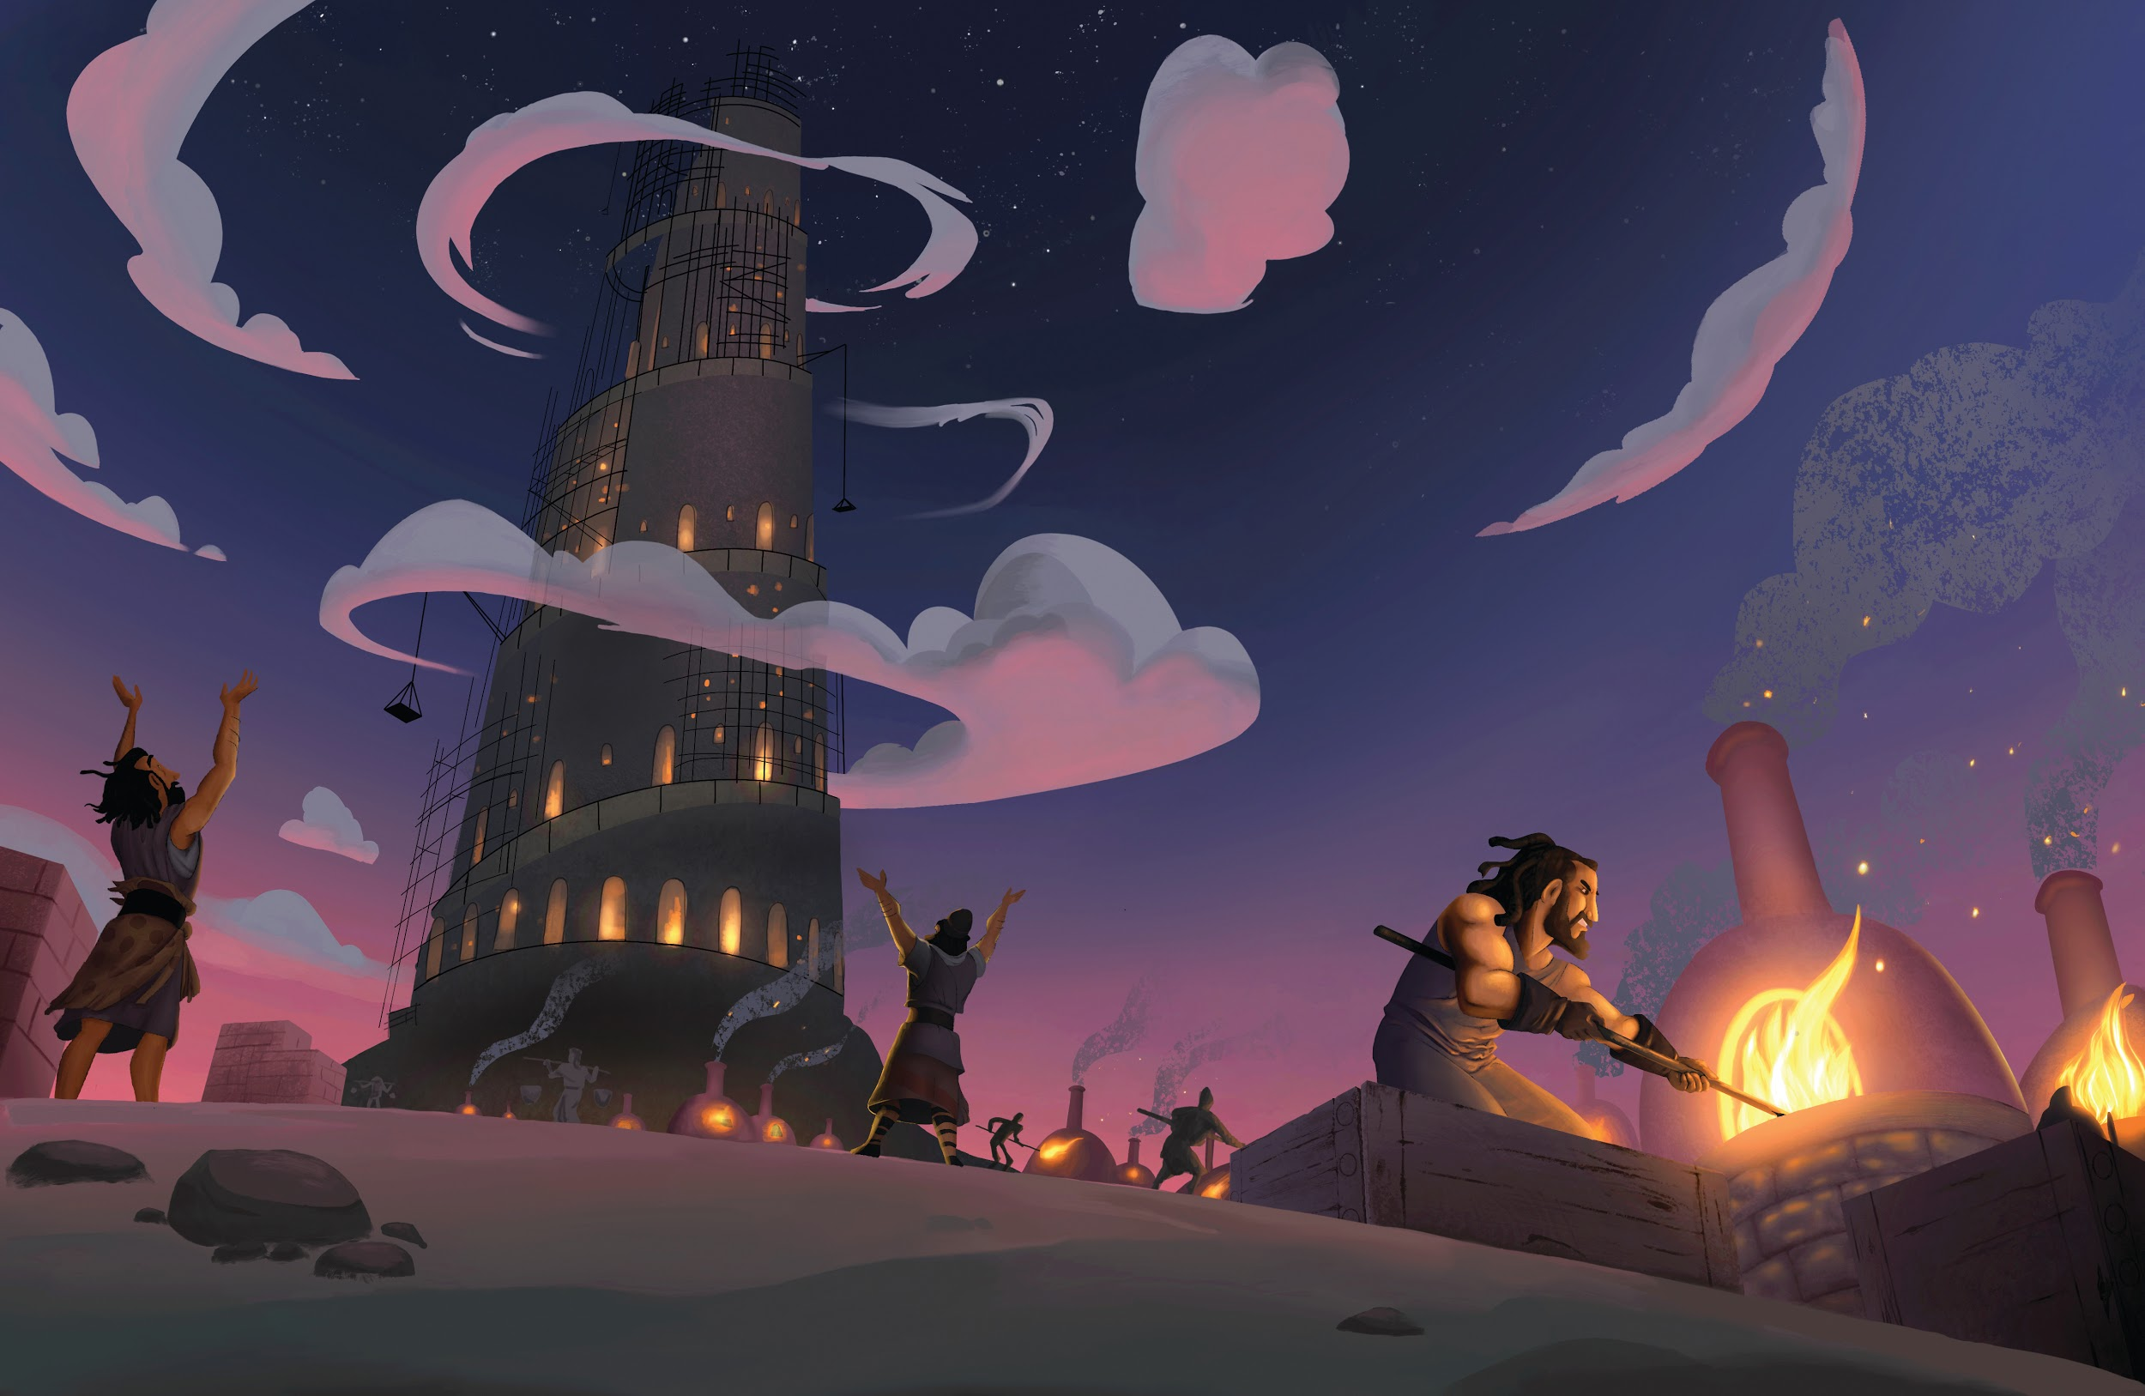
Dear families,

We love to measure the health, success, or sustainability of pretty much anything and everything. We measure our kids by their grades in school. We measure teams by their wins and losses. We measure people by their influence and following on social media. In a world obsessed with measuring “success,” we ought to be assessing in our own lives something we cannot see: our motivation.

We can define motivation simply as the reason we do something. Motivation is the driving force behind the decisions we make. There is a reason for everything that we do—both big and small—but what that motivation is might not be obvious to those around us.

In Genesis 11, Noah’s family had grown and began to rebuild the earth’s population. At some point along the way, they decided to ignore God’s command to spread out and subdue the earth for God’s glory. Instead, the people decided to build a tower to show their greatness. Their motivation was both obvious and arrogant.

Read Psalm 127:1-2. These verses provide a blatant reminder that God is the only true builder. His glory is our only proper motivation. Additionally, this psalm gives us a promise that those who love God will be able to rest from being driven by selfish motivation.

Doesn’t it sound pretty attractive to be able to rest from selfish motivation that plagues so much of our thinking and behavior? In God’s economy, He’s less worried with the outcome of our decisions and more concerned with the reason for our decisions. That’s not to say that it doesn’t matter what we do. Rather, if our motivation is right—if our hearts are right—our actions will follow. And not only will our motivation and behavior honor God, but much of the anxiety of life will fade away too.

When was the last time you measured your motivation? Is the driving force behind what you do making a name for yourself, your kids, or even your church? Or is the primary desire driving your life boasting in the name of Christ? Read Psalm 127:1 again. May we be driven by God’s glory and not our own.

Check out The Gospel Project At Home for resources designed to help you lead a family worship experience as well as suggestions for morning and evening prayer times and family activities. Your child can also access free Gospel Project learning games and activities in the LifeWay Kids app reader available in the iTunes or Google Play stores.

FAMILY TALKING POINTS

CHRIST CONNECTION
This is the big idea of how this week’s Bible story points to Jesus.

- Babies & Toddlers: People will worship Jesus.
- Younger Preschool: People disobeyed God, so God mixed up their language and spread the people over the earth. One day, Jesus will bring His people back together. People from every language will worship Him together.
- Older Preschool: People tried to make themselves famous instead of God. God mixed up their language so the people spread out over the earth. One day, Jesus will bring His people back together. People from every group and language will worship Him together.
- Kids: People wanted glory for themselves instead of God. They ignored God’s plan, so God confused their language and scattered them all over the earth. One day, Jesus will gather together all of God’s people—from every tribe and language—and they will worship Him together.

BIG PICTURE QUESTION & ANSWER
This is an important biblical truth that your child will encounter each week of this unit.

- Younger Preschool: What does it mean to sin? We sin when we disobey God.
- Older Preschool: What does it mean to sin? To sin is to go against God and His commands.
- Kids: What does it mean to sin? To sin is to think, speak, or behave in any way that goes against God and His commands.

KEY PASSAGE
This is a Bible verse that relates to what your child will encounter each week of this unit.

- Babies & Toddlers: We all make wrong choices. — Romans 3:23
- Younger Preschool: Everyone makes wrong choices. — Romans 3:23
- Older Preschool: All have sinned and fall short of the glory of God. — Romans 3:23
- Kids: For all have sinned and fall short of the glory of God. — Romans 3:23

** Next week: God Made a Covenant with Abraham (Genesis 12–20)

Unit 3, Session 1
God Made a Covenant with Abraham (Genesis 12–20)
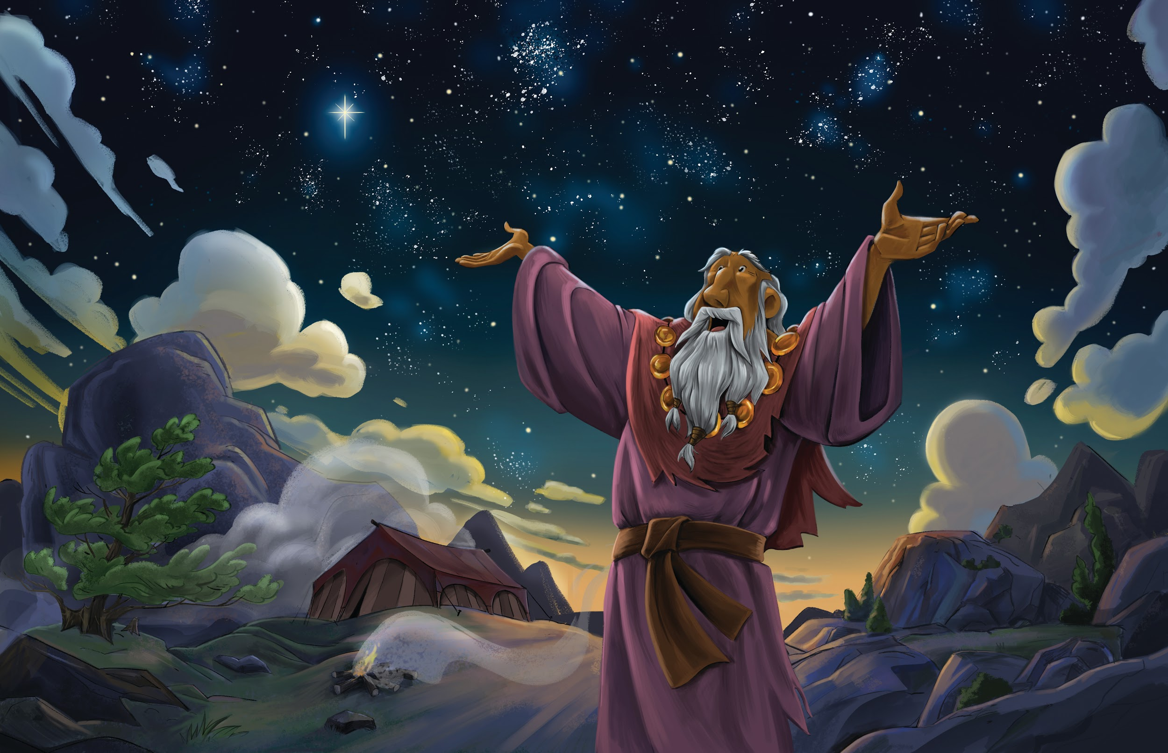

Dear families,

Think about all of the choices that we have each day. Just in the morning, we have dozens of different cereals to eat, perhaps that many varieties of milk to pour on top of the cereal, and nearly as many ways to make coffee to go with it. All of these are choices that we often take for granted.

Now think about all of the choices God had as He took a significant step in redemptive history and chose a couple to start a new people from whom the promised Rescuer would come. (Gen. 3:15) We see some of those choices at the tail end of Genesis 11, but we need to remember that God is not confined to choices like we are. He is all-powerful and sovereign; God had an infinite number of choices for this critical couple.

So whom did God choose? A man named Abram and his barren wife Sarai. Now that’s a curious choice, isn’t it? This is the couple whom God would give descendants as numerous as the stars? (Gen. 15:5) From the world’s perspective, this was a curious choice at best—and a laughable choice at worst.

But from God’s perspective, Abram and Sarai were a brilliant choice. First, God made it clear from the inception of this new people that He was the One bringing everything to pass. This family was special because God clearly worked in them to bring forth children. This is what Sarai understood when she said, “Who would have told Abraham that Sarah would nurse children? Yet I have borne a son for him in his old age” (Gen. 21:7). That the son of promise, Isaac, married a wife, Rebekah—who was also barren—is not a coincidence. (Gen. 25:21) Nor is it a coincidence that Jesus would be born to a virgin. (Luke 1:34) God is the God who makes possible that which is impossible, including rescuing people from sin.

Second, it took a while, but in the end, Abram’s faith in God came to fruition because of his wife’s barrenness. This was his barrier to faith in God. This is what he struggled with for so many years. But in the end, Abram’s greatest struggle became the greatest kindling of his faith. God didn’t just begin a people through barrenness; He began a faithful people through it.

God’s covenant with Abram was certainly amazing. But perhaps His choice of Abram in the first place is even more amazing.

Check out The Gospel Project At Home for resources designed to help you lead a family worship experience as well as suggestions for morning and evening prayer times and family activities. Your child can also access free Gospel Project learning games and activities in the LifeWay Kids app reader available in the iTunes or Google Play stores.

FAMILY TALKING POINTS

CHRIST CONNECTION
This is the big idea of how this week’s Bible story points to Jesus.

- Babies & Toddlers: God sent Jesus.
- Younger Preschool: God sent Jesus to earth as part of Abraham’s family. Jesus saves people from their sins.
- Older Preschool: God promised to bless all the people in the world through Abraham. God sent Jesus to earth as part of Abraham’s family. God blesses all the people on earth through Jesus because Jesus saves people from their sins.
- Kids: God promised to bless all the world through Abraham. God sent Jesus from His home in heaven to be born on earth into Abraham’s family. Through Jesus, all the nations of the earth are blessed because Jesus saves people from their sins.

BIG PICTURE QUESTION & ANSWER
This is an important biblical truth that your child will encounter each week of this unit.

- Younger Preschool: Who makes everything happen? God makes everything happen.
- Preschool: Who is in control of everything? God is in control of everything.
- Kids: Who is in control of everything? God is in control of everything in heaven and on earth. Nothing is outside of God’s good plan.

KEY PASSAGE
This is a Bible verse that relates to what your child will encounter each week of this unit.

- Babies & Toddlers: The Lord is great. — Psalm 135:5
- Younger Preschool: The Lord is great. — Psalm 135:5
- Older Preschool: The LORD does whatever he pleases in heaven and on earth, in the seas and all the depths. — Psalm 135:6
- Kids: I know that the LORD is great; our Lord is greater than all gods. The LORD does whatever he pleases in heaven and on earth, in the seas and all the depths. — Psalm 135:5-6

** Next week: Melchizedek Blessed Abraham (Genesis 14; Hebrews 5; 7)

Unit 3, Session 2
Melchizedek Blessed Abraham (Genesis 14; Hebrews 5; 7)
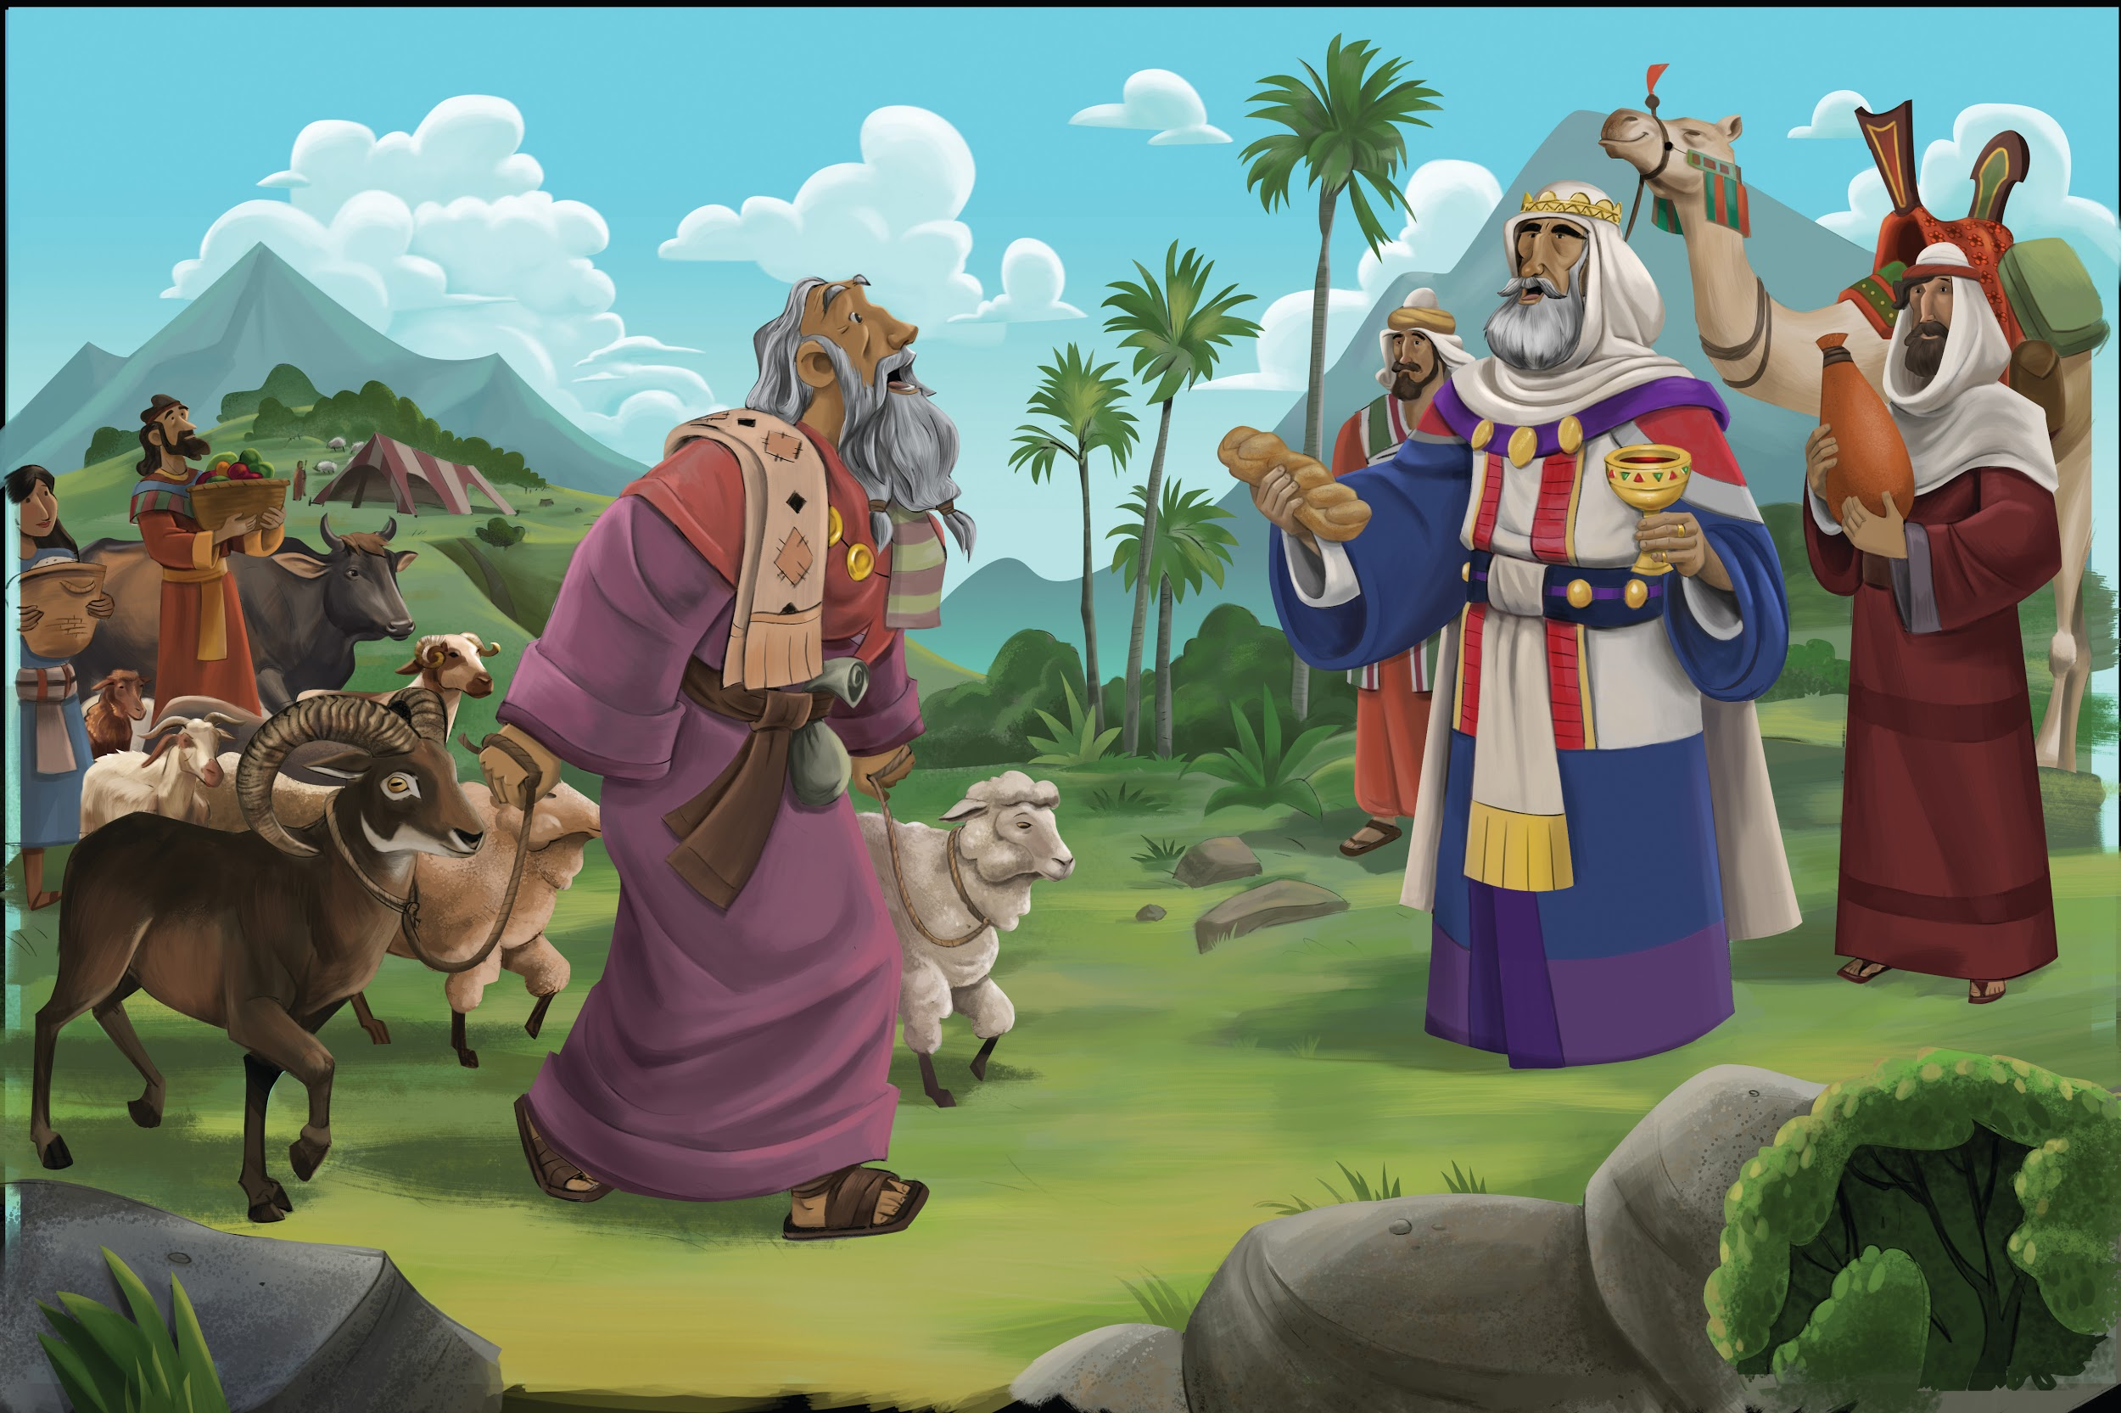

Dear families,

We marvel at stories with two characters who are total opposites of each other. This is why so many stories feature some form of a noble hero and an immoral villain. The contrast of character and conduct is what drives the tension of the story.

In Genesis 14, we find two completely opposite kings: the king of Sodom and the king of Salem. One sought to get; the other sought to give. One sought to curse; the other sought to bless. One sought to take life; the other sought to give life.

These two rulers illustrate the spirit of the world and the Spirit of God, two forces actively at work in our world and in our lives.

This is why Paul reminded us in Ephesians 6 to put on the full armor of God. “For our struggle is not against flesh and blood, but against the rulers, against the authorities, against the cosmic powers of this darkness, against evil, spiritual forces in the heavens. For this reason take up the full armor of God, so that you may be able to resist in the evil day, and having prepared everything, to take your stand” (Eph. 6:12-13).

We live in the middle of a real fight between two opposing forces seeking to own our hearts. One, the evil spirit in our present world, like the king of Sodom seeks to take from us and generate chaos and confusion. The other, the Spirit of the living God, like the King of Salem seeks to give life and bring peace and joy.

In our present world, we must recognize that this battle goes on inside of every believer. And we must put on the full armor of God daily that we might withstand the attack of the evil one and faithfully commit to full submission to the Spirit of God. It’s not enough that we deny the evil one; we must say “yes” to God.

This battle is real and raging. And the people of God must fight with great resolve to ensure our allegiance remains to the only good King, the Lord.

Check out The Gospel Project At Home for resources designed to help you lead a family worship experience as well as suggestions for morning and evening prayer times and family activities. Your child can also access free Gospel Project learning games and activities in the LifeWay Kids app reader available in the iTunes or Google Play stores.

FAMILY TALKING POINTS

CHRIST CONNECTION
This is the big idea of how this week’s Bible story points to Jesus.

- Babies & Toddlers: Jesus came to bless us.
- Younger Preschool: Jesus is a priest and king like Melchizedek was, but Jesus is better! Jesus came to bless us. He died on the cross and rose again to give us life with God forever.
- Older Preschool: Melchizedek means “king of righteousness.” Jesus is a priest and king like Melchizedek was, but Jesus is better! Jesus came to bless us. He died on the cross and rose again so everyone who trusts in Him can have life with God forever.
- Kids: Melchizedek means “king of righteousness.” Melchizedek reminds us of Jesus, an even greater priest and king who lives forever. Jesus died on the cross and rose again to bless all who trust in Him by providing forgiveness and eternal life.

BIG PICTURE QUESTION & ANSWER
This is an important biblical truth that your child will encounter each week of this unit.

- Younger Preschool: Who makes everything happen? God makes everything happen.
- Preschool: Who is in control of everything? God is in control of everything.
- Kids: Who is in control of everything? God is in control of everything in heaven and on earth. Nothing is outside of God’s good plan.

KEY PASSAGE
This is a Bible verse that relates to what your child will encounter each week of this unit.

- Babies & Toddlers: The Lord is great. — Psalm 135:5
- Younger Preschool: The Lord is great. — Psalm 135:5
- Older Preschool: The LORD does whatever he pleases in heaven and on earth, in the seas and all the depths. — Psalm 135:6
- Kids: I know that the LORD is great; our Lord is greater than all gods. The LORD does whatever he pleases in heaven and on earth, in the seas and all the depths. — Psalm 135:5-6

** Next week: God Provided Isaac (Genesis 21–22)

Unit 3, Session 3
God Provided Isaac (Genesis 21–22)
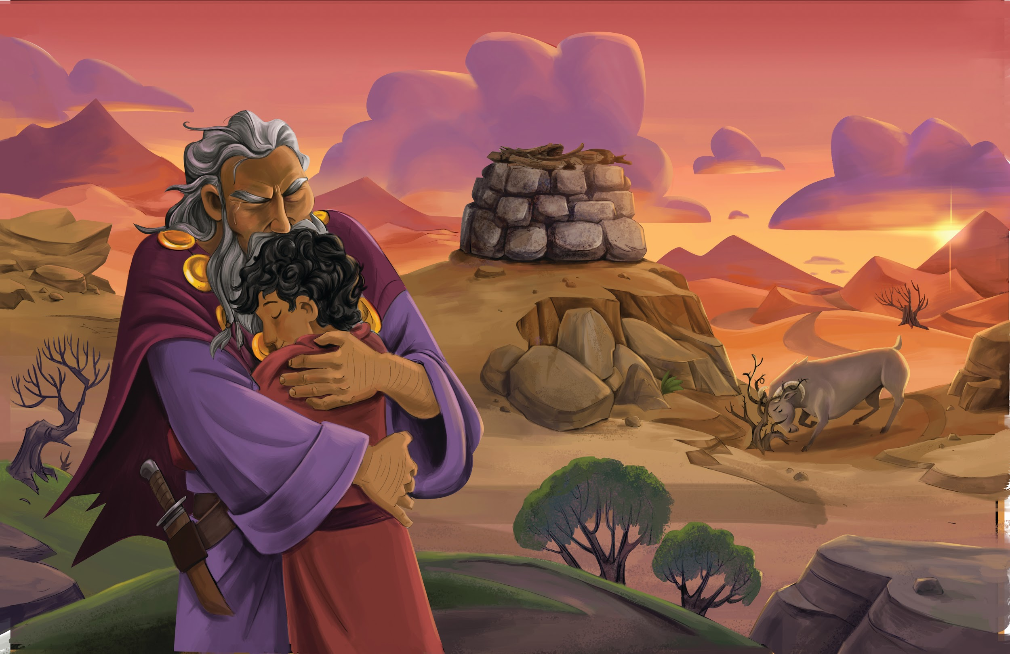

Dear families,

It’s been said that when a word or phrase is repeated in the Bible, we ought to pay close attention. In Genesis 22, Abraham repeated one phrase three times: “Here I am.”

Abraham first used “Here I am” on his journey when God called his name. Abraham’s eager response to God shows that he was ready and expectant to hear from God.

Abraham then used this phrase in response to his son, Isaac. On the journey to the place of sacrifice, Isaac called out to his father and Abraham responded, “Here I am.” Even though Abraham was surely wrestling with what God had commanded him to do, he was eager to hear from his son and help him understand what God was doing.

Third, Abraham responded to the angel of the Lord: “Here I am.” The angel called Abraham’s name twice as he was about to sacrifice his son in obedience to God. Even in a tense and emotional moment, Abraham was sensitive to the Lord and eager to hear from him.

Abraham’s use of this phrase clearly shows his open-handed readiness to serve. Abraham responded to the Lord, to his son, and to the angel from his humble heart and willing spirit. Instead of shutting down and stopping his ears to God because of the incredibly challenging task God had put before him, Abraham remained steadfast in His openness to the Lord.

God desires that we always be ready for however He may intend to use us for His glory and our good. It may be as we drive along in the car, as we hurry through a long list of tasks at work, or in the stillness of a quiet moment with the Lord early in the morning. It also may come in the intensity of grieving the loss of a loved one, navigating conflict in the body of Christ, or as we gather with others to worship. Whenever we sense the leading of the Spirit of God, may we take a posture similar to Abraham, always willingly to say, “Here I am.”

Check out The Gospel Project At Home for resources designed to help you lead a family worship experience as well as suggestions for morning and evening prayer times and family activities. Your child can also access free Gospel Project learning games and activities in the LifeWay Kids app reader available in the iTunes or Google Play stores.

FAMILY TALKING POINTS

CHRIST CONNECTION
This is the big idea of how this week’s Bible story points to Jesus.

- Babies & Toddlers: God loves us and keeps His promise.
- Younger Preschool: Abraham loved God. He was willing to give up his son Isaac, but God provided a ram. God loves us. He gave His Son, Jesus, to save the world from sin.
- Older Preschool: Abraham loved God. He was willing to give up his son Isaac, but God provided a ram so Isaac could live. God was willing to give up His Son, Jesus, to save the world from sin. Jesus offered His life as a sacrifice for our sin so we can live.
- Kids: Abraham showed his love for God by being willing to sacrifice his son Isaac. God provided a ram instead. This is how God showed His love for us: He sent His Son, Jesus, to die on the cross so that we could have eternal life through Him.

BIG PICTURE QUESTION & ANSWER
This is an important biblical truth that your child will encounter each week of this unit.

- Younger Preschool: Who makes everything happen? God makes everything happen.
- Preschool: Who is in control of everything? God is in control of everything.
- Kids: Who is in control of everything? God is in control of everything in heaven and on earth. Nothing is outside of God’s good plan.

KEY PASSAGE
This is a Bible verse that relates to what your child will encounter each week of this unit.

- Babies & Toddlers: The Lord is great. — Psalm 135:5
- Younger Preschool: The Lord is great. — Psalm 135:5
- Older Preschool: The LORD does whatever he pleases in heaven and on earth, in the seas and all the depths. — Psalm 135:6
- Kids: I know that the LORD is great; our Lord is greater than all gods. The LORD does whatever he pleases in heaven and on earth, in the seas and all the depths. — Psalm 135:5-6

** Next week: God Changed Jacob (Genesis 25–33)

Unit 3, Session 4
God Changed Isaac (Genesis 25–33)
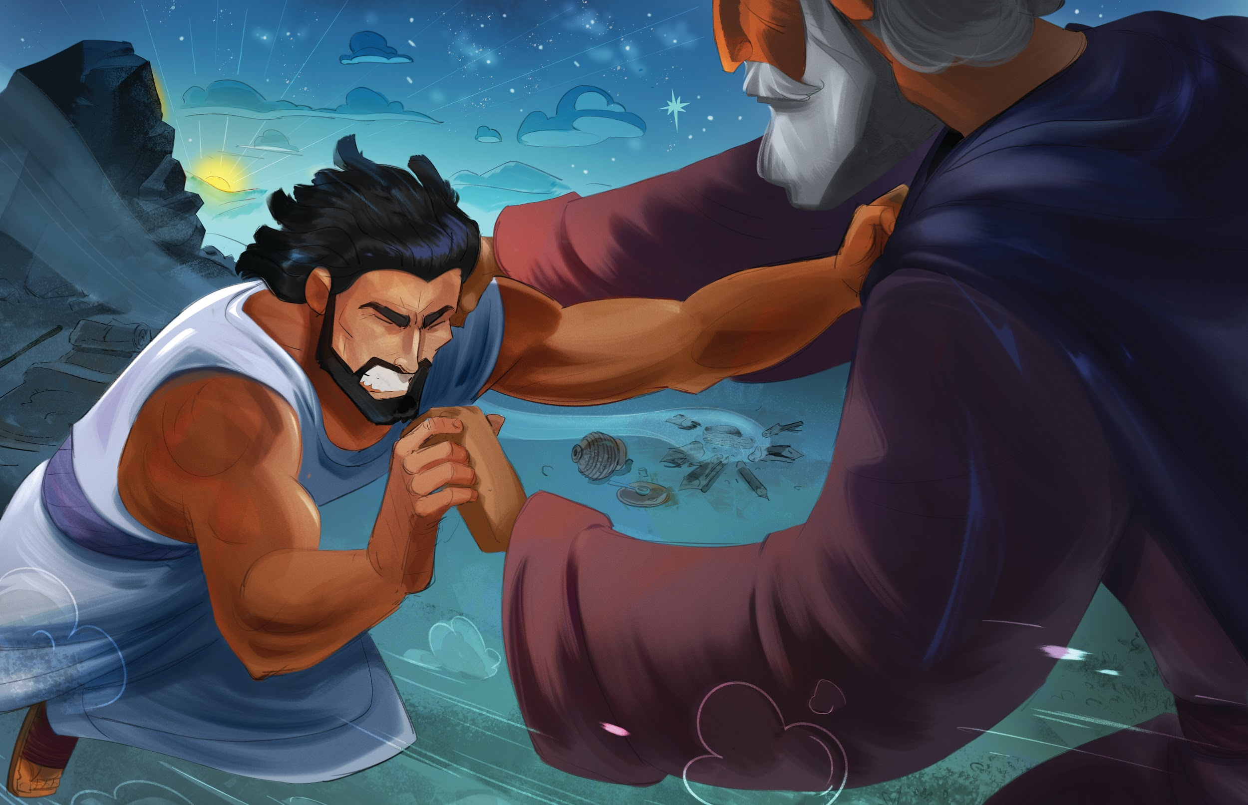

Dear families,

Jacob’s journey in Genesis is one of unexpected and undeserved blessing after blessing. With a name that literally means he cheats, Jacob was unlikely to receive the privilege and opportunity God gave him.

Jacob was a cheater, a liar, and a deceiver. He was quiet and not strongly gifted. And he was gullible, too. We cannot miss that the deceiver was deceived at times too—easily convinced by his mother and tricked by his uncle. But God would work through Jacob when no circumstances or characteristics made it seem possible.

In Genesis 32:10, Jacob expressed his own bewilderment to the Lord. “I am unworthy of all the kindness and faithfulness you have shown your servant. Indeed, I crossed over the Jordan with my staff, and now I have become two camps.”

Jacob came to realize that nothing that he had accomplished or accumulated was the result of his own doing. He was not capable or competent enough to produce the many good things he had received and especially not to be the recipient of the promise of God to make his family like the dust of the earth. Jacob was humbled by the reality that through him and his offspring, all of the families of the earth would be blessed.

Have you ever had a moment of astonishment at the magnitude of what God has given you through Christ? Have you taken the time to recognize that all that you have is from God? Does it cause you to rejoice when you think about God’s grace?

It’s easy to look at Jacob and say he didn’t deserve what God gave him. It’s hard to feel that way about ourselves. But it’s just as true.

Paul wrote in Romans 6:23, “For the wages of sin is death, but the gift of God is eternal life in Christ Jesus our Lord.” Salvation should bring about this astonishment in us as well. It should remind us that we are not worthy, and it should lead us to rejoice in the undeserving gift of God’s grace.

Check out The Gospel Project At Home for resources designed to help you lead a family worship experience as well as suggestions for morning and evening prayer times and family activities. Your child can also access free Gospel Project learning games and activities in the LifeWay Kids app reader available in the iTunes or Google Play stores.

FAMILY TALKING POINTS

CHRIST CONNECTION
This is the big idea of how this week’s Bible story points to Jesus.

- Babies & Toddlers: God calls us His children.
- Younger Preschool: God gave Jacob a new name, Israel. When we follow Jesus, God calls us His children.
- Older Preschool: God changed Jacob’s life and gave him a new name, Israel. By dying and rising from the dead, Jesus made the way for us to be adopted into God’s family. When we trust in Jesus, we get a new name, too—children of God.
- Kids: God changed Jacob’s life and gave him a new name, Israel. Jesus came so that we might have a changed life, forgiven of sin. Jesus’ death and resurrection provided sinful people the way to be adopted into God’s family. When we trust in Jesus, we also receive a new name—children of God.

BIG PICTURE QUESTION & ANSWER
This is an important biblical truth that your child will encounter each week of this unit.

- Younger Preschool: Who makes everything happen? God makes everything happen.
- Preschool: Who is in control of everything? God is in control of everything.
- Kids: Who is in control of everything? God is in control of everything in heaven and on earth. Nothing is outside of God’s good plan.

KEY PASSAGE
This is a Bible verse that relates to what your child will encounter each week of this unit.

- Babies & Toddlers: The Lord is great. — Psalm 135:5
- Younger Preschool: The Lord is great. — Psalm 135:5
- Older Preschool: The LORD does whatever he pleases in heaven and on earth, in the seas and all the depths. — Psalm 135:6
- Kids: I know that the LORD is great; our Lord is greater than all gods. The LORD does whatever he pleases in heaven and on earth, in the seas and all the depths. — Psalm 135:5-6

** Next week: God Had a Plan for Joseph (Genesis 37–50)

Unit 3, Session 5
God Had a Plan for Joseph (Genesis 37–50)
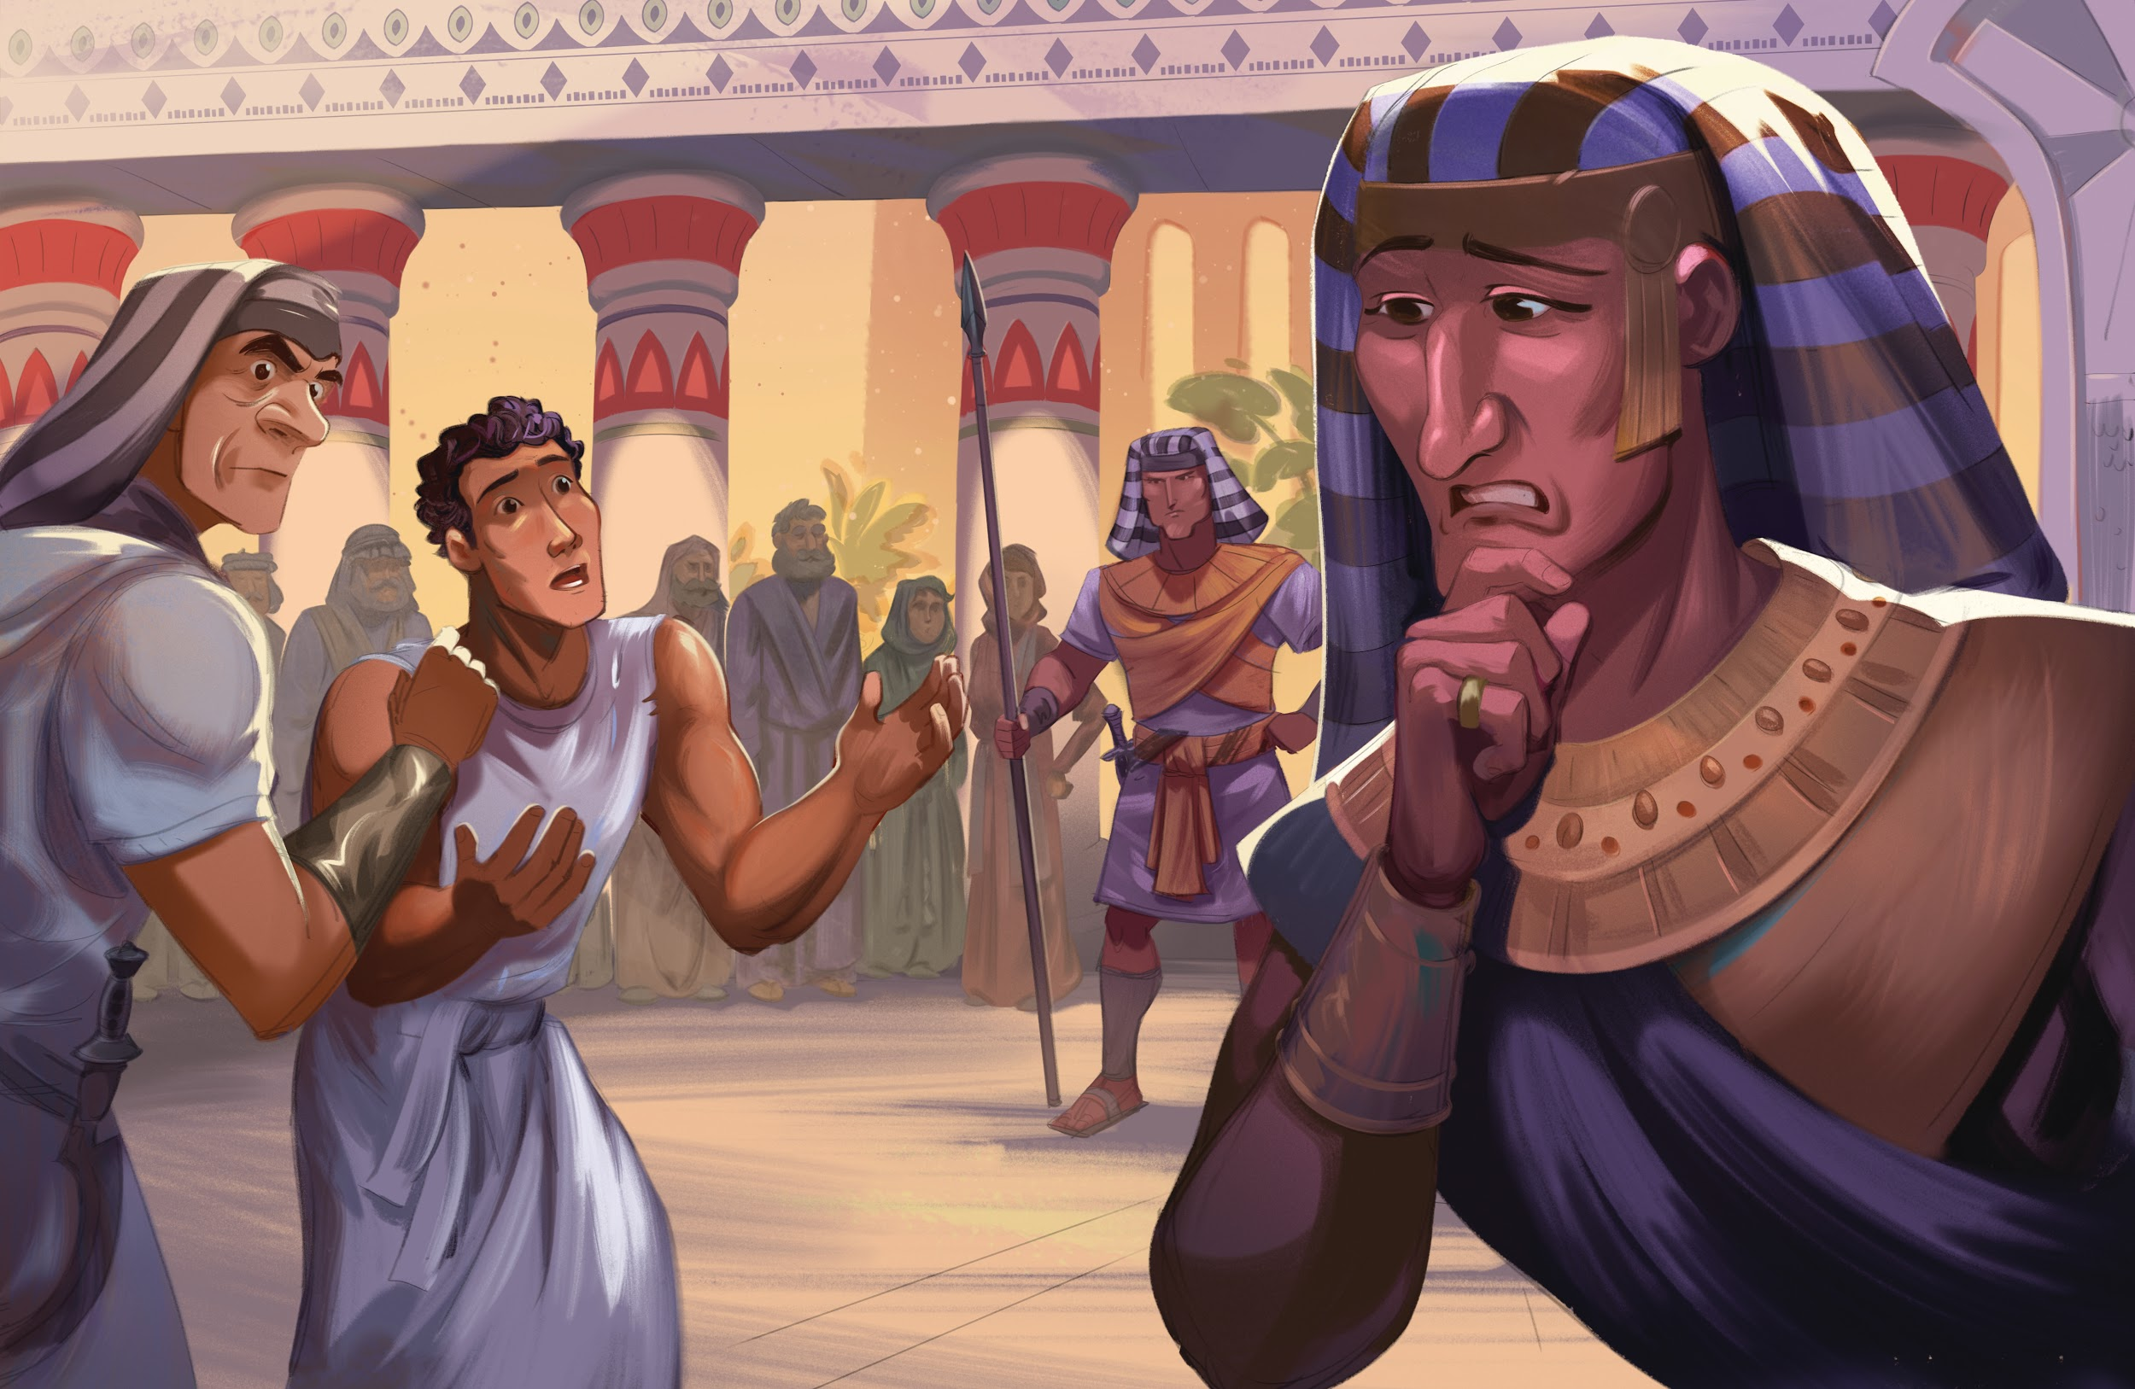

Dear families,

The story of Joseph is packed full of moments that resonate with us. Maybe you were the favorite child or the favorite child’s sibling. Some people resonate with being cast away from family or being undeservingly welcomed into a new family. Some resonate with finding favor with an enemy or showing favor to an enemy. In Joseph’s story, we can see ourselves and our need for Jesus in so many ways.

On at least four occasions in Joseph’s journey, others gave him tremendous blessings. Though Joseph lost some of these earthly treasures, he remained faithful to the Lord. We normally focus on Joseph’s adversity, but we can’t miss that both the lows and highs of Joseph’s life were also marked by God’s blessing through others.

First, Joseph’s father blessed him with a beautiful multi-colored robe as a representation of his favored status. This tangible symbol was taken from him when his brothers sold him into slavery. Yet Joseph remained faithful.

Next, Potiphar blessed Joseph by making him overseer of his entire household. The role lent itself to all the tangible and monetary things anyone could want. But when Joseph fled from the advance of Potiphar’s wife, it was all taken from him. Yet Joseph remained faithful.

Third, the prison warden blessed Joseph by making him overseer over the entire prison. Finally, Pharaoh blessed Joseph by placing him as second in command over all of Egypt, putting Joseph in a position to save his family from famine.

Joseph refused to let the evil actions of others steal his faith. When he had the chance to take away from others who had taken from him, Joseph showed generosity instead.

We experience various common grace blessings from the Lord every day. These blessings can tempt us to worship the gift rather than the Giver. Like Joseph, we must remain steadfast under trial and faithful to the Lord. In famine and in plenty, blessed be the name of the Lord. He is good and in control.

Check out The Gospel Project At Home for resources designed to help you lead a family worship experience as well as suggestions for morning and evening prayer times and family activities. Your child can also access free Gospel Project learning games and activities in the LifeWay Kids app reader available in the iTunes or Google Play stores.

FAMILY TALKING POINTS

CHRIST CONNECTION
This is the big idea of how this week’s Bible story points to Jesus.

- Babies & Toddlers: God’s plan was to send Jesus.
- Younger Preschool: Joseph's brothers hurt Joseph. One day, people would hurt God's Son, Jesus. God's good plan was to use Jesus' death to save His people from sin.
- Older Preschool: Joseph's brothers hurt Joseph, but God had a good plan. God used Joseph's hurt to save His people from hunger. One day, people would hurt God's Son, Jesus. God's good plan was to use Jesus' death to save His people from sin.
- Kids: God had a plan for Joseph’s life. He allowed Joseph to suffer in order to rescue a whole nation. God planned for Jesus to suffer so that many—people from all nations—would be saved.

BIG PICTURE QUESTION & ANSWER
This is an important biblical truth that your child will encounter each week of this unit.

- Younger Preschool: Who makes everything happen? God makes everything happen.
- Preschool: Who is in control of everything? God is in control of everything.
- Kids: Who is in control of everything? God is in control of everything in heaven and on earth. Nothing is outside of God’s good plan.

KEY PASSAGE
This is a Bible verse that relates to what your child will encounter each week of this unit.

- Babies & Toddlers: The Lord is great. — Psalm 135:5
- Younger Preschool: The Lord is great. — Psalm 135:5
- Older Preschool: The LORD does whatever he pleases in heaven and on earth, in the seas and all the depths. — Psalm 135:6
- Kids: I know that the LORD is great; our Lord is greater than all gods. The LORD does whatever he pleases in heaven and on earth, in the seas and all the depths. — Psalm 135:5-6

** Next week: God Controls Everything (Job)

Unit 3, Session 6
BIG TRUTH SESSION
God Controls Everything (Job)
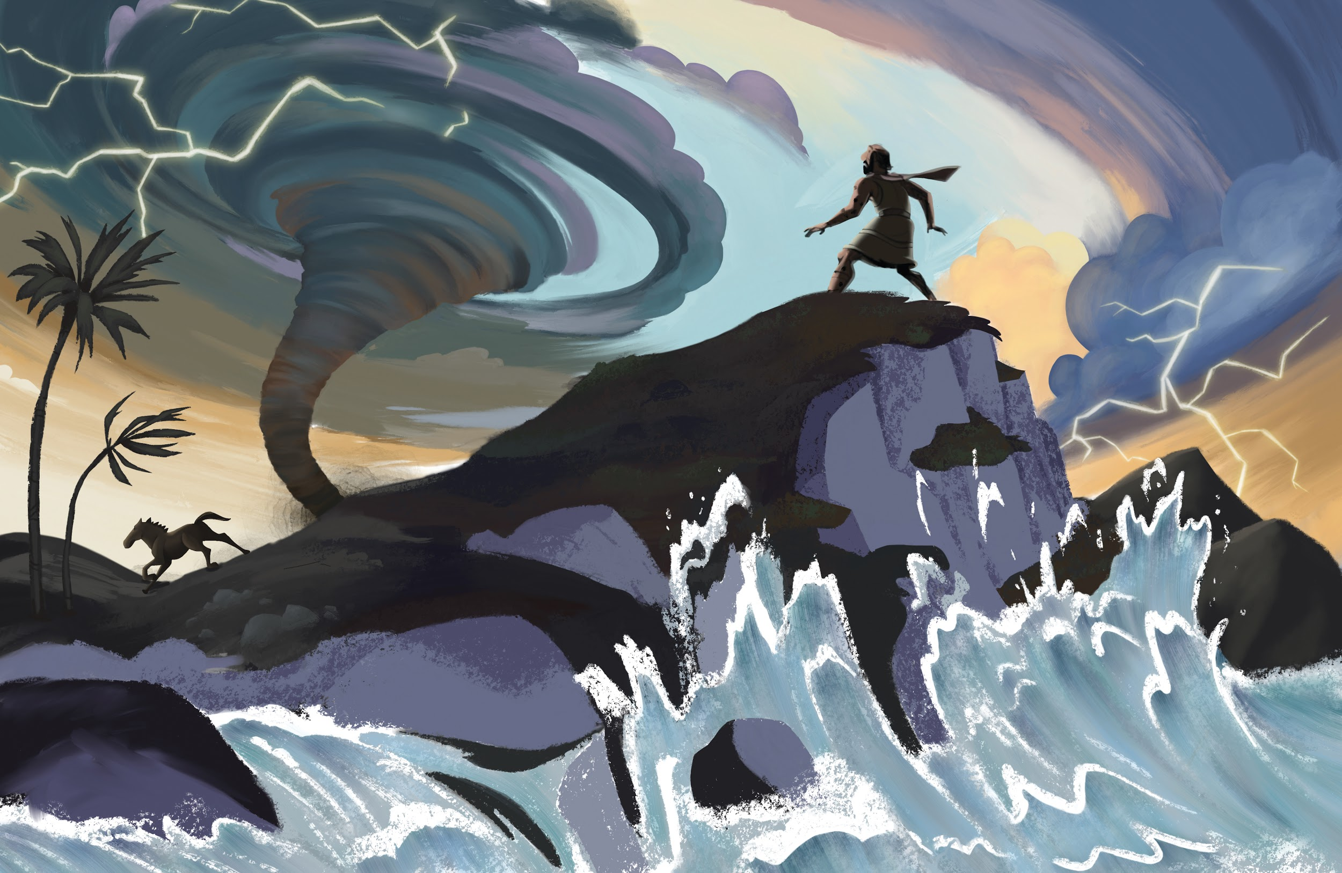

Dear families,

In research, there is a common practice used to measure data: the pre-test and post-test. The pre-test is a baseline, assessing the state of something prior to experimental factors being introduced. As is suggested by the name, this happens prior to the experiment.

The post-test is a comparison, designed to compare the outcome of the experiment to the pre-test results in order to assess change. As the name suggests, the post-test comes after the experiment.

In the life of Job, we find a man who goes through the most traumatic experiences imaginable. Job lost his kids, his wealth, his career, and his friends. His sheep even burned up! (It’s true, read Job 1:16.) Job’s life was turned upside down. His joy was low and his sorrow was high.

It’s fascinating to look at Job’s life before and after this series of trials. Prior to Job’s losing all he had, Job is described as blameless and upright, fearing God and turning away from evil. He had great spiritual fortitude and great material wealth.

Following his extended trial, Job repented of his wavering trust in God. Job was restored to God, and God restored his wealth to a greater degree than before.

The pre-test and post-test of Job’s journey demonstrate a man who, in the big picture, was unshakable in his relationship with God. Though he had high and low moments during the trial, Job was fully restored to God. Like Job, our faithfulness does not mean that there won’t be moments of struggle or slipping, but it does mean that overall, our faith in God remains and grows.

If you aren’t in the midst of a trial, know that God is strengthening your trust in Him so that when difficulty does come—and it will—your pre-test shows a strong faith that can endure. And if you are in the midst of great challenges right now, strive to endure so that a post-test might demonstrate that your love and trust of God has remained and even increased.

Trials are inevitable. Trust in God, who controls everything. Anticipate that trials will come, and aim for growth on the other side.

Check out The Gospel Project At Home for resources designed to help you lead a family worship experience as well as suggestions for morning and evening prayer times and family activities. Your child can also access free Gospel Project learning games and activities in the LifeWay Kids app reader available in the iTunes or Google Play stores.

FAMILY TALKING POINTS

CHRIST CONNECTION
This is the big idea of how this week’s Bible story points to Jesus.

- Babies & Toddlers: We can trust Jesus.
- Younger Preschool: The story of Job reminds us of Jesus. Job had hard times. Jesus had hard times, too, but He never sinned. He saves us from sin. Jesus comforts us when we hurt, and we can trust Him.
- Older Preschool: The story of Job reminds us of Jesus. Jesus is the only person who never sinned, but He suffered to take the punishment for our sin. Jesus comforts us when we suffer, and we can trust Him.
- Kids: Job learned that God is all-powerful, sovereign, and good. When we face suffering, we can hope in God. God sent Jesus, the only truly innocent One, to suffer and die so that everyone who trusts in Him can have forgiveness and eternal life.

BIG PICTURE QUESTION & ANSWER
This is an important biblical truth that your child will encounter each week of this unit.

- Younger Preschool: Who makes everything happen? God makes everything happen.
- Preschool: Who is in control of everything? God is in control of everything.
- Kids: Who is in control of everything? God is in control of everything in heaven and on earth. Nothing is outside of God’s good plan.

KEY PASSAGE
This is a Bible verse that relates to what your child will encounter each week of this unit.

- Babies & Toddlers: The Lord is great. — Psalm 135:5
- Younger Preschool: The Lord is great. — Psalm 135:5
- Older Preschool: The LORD does whatever he pleases in heaven and on earth, in the seas and all the depths. — Psalm 135:6
- Kids: I know that the LORD is great; our Lord is greater than all gods. The LORD does whatever he pleases in heaven and on earth, in the seas and all the depths. — Psalm 135:5-6

** Next week: Melchizedek Blessed Abraham (Genesis 14; Hebrews 5; 7)

