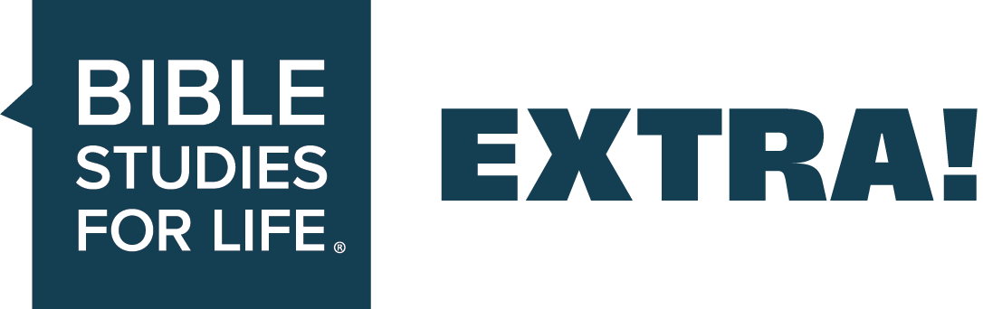
EXTRA Ideas for Adults // Essentials for Christian Living—Wisdom from God

EXTRA supports the group plans in the Bible Studies for Life leader guides.

Date: July 26, 2026
Session Title: Wisdom from God
The Point: Believers have the wisdom of God because we have the Spirit of God.
Podcast—Bible Studies for Life: Adults
_____________________________________________________________________________

Additional Teaching Options

Optional teaching ideas that incorporate current news, cultural trends, and real-world illustrations to help your group engage more deeply and view today’s issues through a clear biblical lens.
Getting Started
Read after discussing Getting Started—Question 1:
Swift Observatory Telescope was launched to orbit in 2004 to find large explosions around the universe. It has been slowly sinking out of orbit since launch, thanks to sun flares. Due to recent intense solar activity, Swift has been sinking more quickly. To try and save the telescope, NASA hired startup Katalyst Space Technologies to build a robot to boost Swift back into a higher orbit. The autonomous spacecraft, named Link, features three arms to help lift Swift back into a higher orbit. This is the first time an American space robot has been created to attempt this, and if it’s a successful mission, Katalyst plans on continuing to offer “lifting” services for all of NASA’s older satellites and telescopes. Once launched, it will take Link a month to get to and catch Swift, and another few months to lift its orbit by around 150 miles.
Deciding whether to save a telescope worth hundreds of thousands of dollars or let it fall is a huge choice the scientists in charge of Swift have had to make. They made their decision based on scientific data and the possibility of a rescue’s success. While you may never be asked to make a decision to save a telescope, you may be faced with several big decisions in your life. But regardless of the decisions you must make, if you are a believer, you never make decisions alone. All believers have the spirit of God within them, which means all believers have the wisdom of God if they choose to listen to it.
To learn more about this article, search “NASA races to save Swift telescope” or “Swift telescope’s falling orbit.”
Get Into the Study (Option for Adult Leader Guide)
In advance, enlist a volunteer to lead the group in singing a worship song that reminds us of the Holy Spirit’s work in our lives.

Study the Bible (Option for Adult Leader Guide)
Read after discussing Getting into the Study—Question 3:
How does the Holy Spirit reveal the mind of God to us?
Seth Taylor is a missionary in northern Africa who regularly connects with Muslims. He met a Muslim man named Andrew in a populated city, and the two struck up a friendship. They routinely meet to discuss the Bible, answer Andrew’s questions, and share life together. Andrew first heard the gospel from two other short-term missionaries, and later became a Christian.
Taylor later met another Muslim man named Asher, who was also interested in learning about Christianity. The two met regularly, and Asher would study the Bible and take notes in the margins. But Asher insisted that he wouldn’t believe the gospel without a dream that he could cling to as proof. Dreams and visions are a common expectation among Muslims. Taylor said that those dreams usually bring [Asher] to a person who can share the gospel, and Asher didn’t need that since Taylor was already sharing the gospel with him.
Asher and Andrew ended up being co-workers and now talk together about the Bible, though in secret to prevent persecution. Both of these men have had the Holy Spirit working in their lives by showing them things that caused them to become disillusioned with their Muslim faith. The Holy Spirit has begun to give understanding of biblical things to each man, one through dreams and one through local connections. While the Holy Spirit may not always work the same way among multiple people, the Spirit is at work to reveal God to those who believe or are searching for God. It’s important to always be ready when the Holy Spirit prompts believers into action because they might be how the mind of God is revealed to another person.
To read more about this article, visit IMB.org and search “Dreams, dangers, and a developing friendship in North Africa.”

Additional Questions
Optional, thoughtfully crafted questions designed to warm up group conversation and guide engagement throughout each Bible passage—helping your group think critically, connect personally, and process Scripture through a clear biblical lens.
Icebreakers
- Who is the wisest person you know?
- What is the hardest decision you’ve ever had to make and how did you navigate it?
- How do you choose between two equally attractive options?
1 Corinthians 1:20-25. Worldly wisdom amounts to foolishness.
- How can we as Christians discern between godly wisdom and worldly wisdom?
- Why do we need the wisdom of God?
- What are examples of this world’s wisdom amounting to foolishness?
1 Corinthians 2:9-11. The Holy Spirit reveals the mind of God.
- When you read that no eye has seen, no ear has heard the amazing plans of God, what thoughts and emotions surface for you?
- What kinds of things does God reveal to us by the Holy Spirit?
- How do people try to reason out God and His ways? What is the only way we can have accurate knowledge about God?
1 Corinthians 2:12-16. We must depend on the Holy Spirit to distinguish God’s will from human thinking.
- How would you describe the role of the Holy Spirit in helping you understand spiritual truth?
- When have you experienced trying to help an unspiritual person understand the things of God?
- What do you think it means to have the mind of Christ?
The week’s writer for EXTRA is Emily Duncan. Emily is a Southern California native who lives in west Georgia with her husband and daughter. God saved her from Wicca when she was sixteen while at a youth retreat. Emily’s a member of Midway Church in Villa Rica and mentors young women as they transition from high school to college.
[Linked material and sources serve as background illustration only and does not imply endorsement beyond our biblical application.]

